Q&A - The change of Leadership

Elder Tess Lambert – October 3, 2020
Contents
Q&A - The change of Leadership 1
Elder Tess Lambert – October 3, 2020 1
PART 1 1
The Meaning of October 3 1
A Brief Overview of the Last Two Years 3
Frequently Occurring Questions 6
PART 2 12
Questions Continued 12
Closing Prayer 21
______________________________________________________________________________________

PART 1
https://www.youtube.com/watch?v=lKj7pX8xYts

The Meaning of October 3
The last time I presented was at the Oceanic Camp Meeting September 18-20, 2020, two weeks ago now.
I'm not sure if people are aware of the day. What date is it today? It is October 3, 2020.
And what does that mean? October 3, 2018 was the day that time was presented in Arkansas.
It's the two-year anniversary of the Midnight Cry message in the United States. And I just wanted to mention something; it's not something profound or some great methodology, but we did find it fascinating at the time. It was presented October 3, 2020 in Arkansas; 10 days later where was it presented? On October 13 in France.
And we understood at the time that the Midnight Cry message had a foot where and a foot where? October 3 it had a foot on the Earth and October 13 it had a foot on the Sea; land and sea.
Ellen White speaks about the message having one foot on the sea and one foot on the land. So, it went from the United States which is the land to France which is the sea.
And where was the third place that the Midnight Cry message was shared? In December 2018 where was the message shared? Island of the Seas Ministry, which is what location? Fiji.
It went from the land, to the sea, to the Islands of the Sea, which was the three steps that the Midnight Cry message took in 2018. October 3, 2 years ago, was the United States, 10 days later France, a number of weeks later Fiji. And Fiji is led by the Islands of the Sea Ministry. And we saw at the time that that was a prophetic fulfillment; it was another stamp on the Midnight Cry message. I just wanted to note that, considering the interaction we had two weeks ago with the Islands of the Sea Ministry and considering the time frame that we are in.
Two years ago, that message was given; in some ways it feels like 20 years ago, in some ways it feels like two weeks. From the first three main times giving of that message in October, November, and December, through 2019, it went worldwide. And voice after voice joined that cry and it really swelled as country after country and individual after individual joined their voice to that message. Since then we have traced that history with the End of Ancient Israel, seeing the triumphal entry, through the Upper Room, through the separation, through the pain of Gethsemane, and through the Cross which we, prophetically, still don't understand completely, through November 9, and we entered into a new dispensation. We are in the dispensation of Jacob's Time of Trouble. Does anyone feel like we're not in Jacob's Time of Trouble? I think that is one subject we're all in Concord with. It Is a time of trouble.
That message that was given two years ago, it swelled and was taught throughout the world in 2019. It really came to a conclusion at the German International Camp Meeting in August and September of last year, 2019. The final touches were put on that message with World War 1, the 3rd Diadochi War, World War 1 completing our understanding of World War 3, and the Message of Eden to Eden. That soon became also the focal point of the shaking; the division that had been growing over some time came into the open. And God saw fit to direct us, now that the Midnight Cry message had reached a completion; God directed us back to reform lines, the lines of the beginning and end of Ancient Israel and the beginning and end of Modern Israel. And right when we came into the most critical parts of the history of the priests, these two back to back testing time periods, God saw fit to anchor us in those original Reform Lines. If you are familiar with the Canadian Zoom Camp Meeting of July 2020, that is what we tried to remind people of; we hold onto those cords and God gave us those cords at the exact same point as the first of two shakings came into the open. Those are the cords that were particularly to anchor us, the Midnight Cry Message and those reform lines given in 1989.
From August and September of last year, 2019, when the Midnight Cry message came to some type of completion through until about April and May of this year, 2020, about 6-7 months, we focused on the End of Ancient Israel. It is the pattern that we see behind us, the model that takes us from 4 B.C. to 100 A.D. and then the three groups of people called in that time period, two for the Jewish Nation and then finally, at 34 A.D., to the Gentiles.
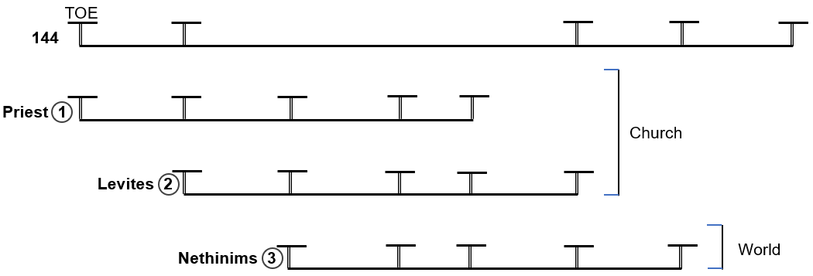
Particularly through the history of that first shaking and also into the second, from August/September through around April/May, we focused on the End of Ancient Israel and we largely established that Reform Line. I'm not saying there isn't still additions to be made, but that Reform Line became very well established. And if we believe in that Reform Line, it is a cord that would take us over both shaking time periods.
From about April/May, the end of the School in Portugal, through to now, about six months again, we have been focusing on the beginning of Modern Israel, Millerite history. And you will notice that we haven't actually gotten that far; it's only a few weeks since we actually even laid out a structure. I would suggest one of the reasons for that, one of the characteristics of this time that makes it so difficult to be able to lay out this history, is a result of the Pandemic. We are starting to have some Camp Meetings over Zoom, but we haven't been able to have Schools. It is at School that the message really becomes, if you picture it like bread dough, it gets stretched, it gets folded, it gets wrestled with, and kneaded, not just by the person at the front, but by the students who are participating. It becomes an open discussion, not just with the students there but by people following online who then message and ask questions and add their thoughts. One of the reasons Acts 27 is such a solid study is because it had three months at the School in Brazil early last year, 2019, where we wrestled with Acts 27. We haven't been able to do that with Millerite history. And it is the absence of having schools in this Movement that has impeded the rapid growth of this message and the ability of many people to feel established in that Reform line. But we have been going over it, Sabbath after Sabbath. We are missing schools.

A Brief Overview of the Last Two Years
I just want to give us a brief overview of the last two years from October 3, 2018, three main Camp Meetings, three main presentations in Arkansas (Land), France (Sea), Fiji (Islands of the Sea). Then it is spread through 2019, came to a conclusion in the German International Camp Meeting by September last year, 2019, then God gave us back the Reform Lines. They are particularly the cords that we're going to hold, to get us through the epicenter of two crises facing this Movement. We faced the first, that split in the Upper Room when Judas left, then through Gethsemane and the Cross, November 9, still properly to be understood, then entering into the Wilderness time period for 40 days, on two different models of the End of Ancient Israel. The 40 days of the Wilderness and the 40 days of the Disciples, you can take that and see that in other 40-day time periods. Like the Forty days of Goliath claiming to have defeated this movement; I won’t go into that any further. But that 40 days has now reached a conclusion and we are now in the Upper Room time period.
We have entered into a new dispensation from November 9, 2019 and we have been through that time needing to understand concretely the Beginning and End of Ancient Israel more commonly known as the Line of Moses and the Line of Christ and the Beginning and End of Modern Israel more commonly known as the Line of the Millerites and the Line of the 144,000. We have been impeded in the growth of that message by the absence of schools. I wouldn't say so much Camp Meetings; Camp Meetings are the more public Presentation of what is generally discovered and dug out through Schools and private studies. And we are missing that. But we also recognize that this is the dispensation where the focus of our work is also particularly on organization and that also requires more time than it ever has before.
We have been meeting over the last five months to study Millerite history together and we’ve gone on what might seem quite a lot of tangents. We started that study and realized that what we needed was to also lay at a couple of other things in place. First of all, why did Christ not come in Millerite history?
We would say it is because it is a history of failure. Then we need to understand, why is it a history of failure? We would say that they went back into the Laodicean condition. We wanted to understand what that meant. Why is this failure? Why is that the Laodicean condition?
We went back to Millerite History and we saw the Apis Bull and we saw what this Apis Bull was and represented. And then we were able to trace it and see, not why the End of Ancient Israel was failure because it was success, but we see why Ancient Israel, the Jewish Nation fell away. It is a history of success, but not for the Jewish Nation. So, we wanted to see what this Laodicean condition was and how it is carried through in such a way. Not that our history is a history of failure, but why for the Adventist institution it is a history of failure. Why they failed where this Movement succeeds. And what we recognized was that it was a returning to idolatry, the Apis Bull, idolatry of the Pagan Nations, the Laodicean condition, the idolatry of Apostate Protestantism.
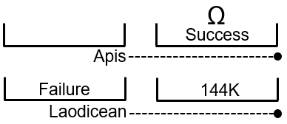
All that we have studied in this history that has seemed to be taking us away from Millerite history has been necessary to understand Millerite history. Now we know why they're a history of failure. They went back to Apostate Protestant idolatry. What was that idolatry? We began to look at conspiracy theories, at Nationalism, at Apostate Protestant thinking, as it developed from 1798 particularly, and then through all of that history even addressing the Conservative Protestant response to the League of Nations in 1919. The threat of globalism that they held to. And now we find that Ancient Israel, as a Jewish Nation, held on to that idolatry from pagan nations. Today Adventism has held onto the idolatry of Apostate Protestantism. The Jewish Nation would never have admitted to it. Adventism never admits to it; and you see that. Ancient Israel would say, “We look out at the wickedness of Rome, we are in opposition to Egypt, and to Babylon, and to Rome.” We can see that they don't follow God. We can see that they need to be destroyed; they’re in idolatry. They can't see how they’ve imbibed the exact same thinking.
Adventism today, they look out at the world, if I can give one example: they look at the Supreme Court and what does every good socially conservative Adventist think when they look at the Supreme Court? It’s horror. Why? Why do conservative Adventist fear the Supreme Court? Why are they horrified by the Supreme Court? What's the issue they have with it? It is Catholic! So many members of the Supreme Court are Catholic. So, a good socially conservative Adventist feels threatened by the Supreme Court because the Supreme Court is Catholic.
Who elected those Catholic Supreme Court Justices? It was not a Catholic President; it was not a Catholic Congress. Protestants elected those Catholic Supreme Court Justices. But Adventist look at those Supreme Court Justices and they're afraid. Why? Because sometime in the distant future, those Catholic Supreme Court Justices might institute a national Sunday Law. So, they're afraid because they see Catholic Supreme Court Justices, but in real life, how do they feel about that Supreme Court? Those Catholic Supreme Court Justices are socially Conservative, Republican leaning, Republican mentality judges. And those exact same Justices are ruling on what issues? Abortion. How does Adventism feel about that? Now they agree with those Justices. Gay marriage, how does Adventism feel about that? Now they agree with those Justices. LGBTQ rights, now where do they stand? They agree with those same Justices. The way those Justices define religious liberty.
We discussed a few weeks ago the 2014 Hobby Lobby decision where the Supreme Court ruled in favor of a company that did not want to give certain Healthcare options it did not agree with to its employees. So, a company that is a family business that is owned by a religious family wanted to control what Healthcare they could give to their employees based on their religious beliefs. And the Supreme Court decided in favor of that company. Ruth Bader Ginsburg was a dissenting voice in that Supreme Court case and she spoke out strongly against that case. But those Catholic, socially conservative Justices ruled in favor of this religious family that own the Hobby Lobby business.
How did Adventist respond to the Hobby Lobby court case? This is written July 1, 2014 in “Adventism Today”. The Seventh-Day Adventist Church in North America release an official statement yesterday saying that it was encouraged by the decision announced this week by the Supreme Court of the United States in the Hobby Lobby case. But there were Adventist who expressed reservations and concerns about the same decision; there are Levites. The denominations official statement gave emphasis to the fact that the decision reaffirmed the Religious Freedom Restoration Act which safe guards the broad religious liberty protections available to all people of faith.
One person commented and said, “Usually religious rights are defined in terms of being protected from the government restricting one from doing something that you feel God wants you to do. It seems to have moved; that the definition of religious rights has moved to a new thing altogether. When it's about a right to exercise authority or to dictate to employees your religious belief.”
An example of the hypocrisy of this ruling, those Justices on the Supreme Court are Catholic and Protestant, largely Catholic. So, if an employer decides they’re not going to provide birth control services in the Healthcare to their workers than it's the religious right of the employer to withhold that birth control funding. But then what happens if you are a Jehovah’s Witness? What happens if you're the employer and you're a Jehovah's Witness and you don't believe in blood transfusions? Now you own a company, you're a Jehovah's Witness, and you don't want to provide Healthcare to your employees that would supply them with blood transfusions. In that ruling, the Supreme Court put in a special clause that said that this does not apply to blood transfusions. Why? There is no good reason except they're not Jehovah Witnesses, and their personal bias is against birth control and for blood transfusions. So, this isn't a decision of belief or principle, it's about the right to force the religious beliefs of an employer on to an employee in a secular environment.
I just want us to see the danger that Adventism is in. It’s just a revision. And that they are afraid that somewhere down the track, they're going to disagree with these Catholic conservative Supreme Court Justices including the one currently being elected in the present day [Amy Coney Barrett]. They agree with the worldview and the decisions of that same faction. Because they are in Apostate Protestant idolatry and Apostate Protestants elected that Supreme Court.
All of that we did because we wanted to go back to Millerite history and understand why they failed. And we have had to make some applications and some compare and contrast to do that, and go back to other Reform Lines.

Frequently Occurring Questions
It isn't my purpose today to go back to Millerite history. Actually, what I'd like to do is address some frequently occurring questions that people have been asking especially in the last couple of months. These questions have been coming up so frequently I thought best to address them in a study or a couple of studies. This will be a Question and Answer with the questions already provided. Because of that I would encourage people to write in the chat your thoughts and perspectives of the questions and or the answers to the questions. I am encouraging chat participation.
Many of the questions that people have been asking are reasonable questions, questions I've had myself. They are honest hearted questions. There's nothing wrong with asking questions or having questions. But not all the questions are honest hearted, there is a mixture. Some are asked in good faith, some are not. An example of a question not asked in good faith is where someone asked, “How is the coming of Cambridge Analytica to the United States the Sunday Law of 2014?” We're going to come back to explain why that is not an honest hearted question.

Fractals
But we will begin with one question that has been asked by many people and I think it's a good reasonable question to ask. So, when we look at this pattern of the Omega structure, it applies for the End of Ancient Israel and for the End of Modern Israel. Two calls for the Church and one call for the World or the Gentiles. So, we are going to use both histories, End of Ancient and End of Modern, when we are writing on these lines.
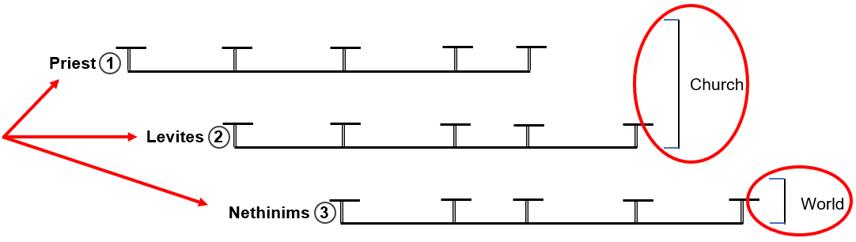
Question from Elder Tess: What do we call these three lines? What is our word for these three?
Answer from Chat: Fractals. Good! Good participation.

We call these lines fractals. What is the definition of a fractal? I'll give a visual representation. It's a structure, if I can simplify something that goes over my head easily. You have this pattern; it looks like a Y shape. If you take away the lower part of the shape and add a V shape to the line, this becomes a fractal of the original main Y shape. Can everyone see that? So, you have a pattern and then you have a repeat of that pattern. And you can do it to both sides. So, we started with one pattern, then we created another of the same, and then we created another; and they all become repetitive patterns. And you can continue to do this and this becomes a fractal tree. So, we started with one and we created another and another. But now we can see this little structure is a fractal of our large one. Can we see that? And you could zoom in and zoom in and you could continue to create smaller and smaller fractals. And you can do that to all the branches. So, it’s this pattern where the smaller has the characteristics of the larger.
Comment from Chat: Brother Brandon says it’s an amplification that repeats the same structure.
Response from Elder Tess: Correct; that's a nice brief way of explaining a fractal.
You could call the shape that we began with, the line of the 144,000. And then, the additional shapes, you could call Lines of the Priest, Levites, and Nethinims. A large template model and then you have these three smaller models on top of that.
Question from Elder Tess: When we come to our Reform Line, End of Ancient Israel, where is the Cross on the top line? What history?
Answer from Chat: Someone said Early rain. So early Rain is this history from 9/11 to Sunday Law.
Question from Elder Tess: What is this SL Waymark in the End of Ancient Israel?

34 A.D., the Gospel goes the Gentiles. The work is done for the church, for the Jewish Nation.
This Formalization of the Message mark before 34 A.D. is the second call to the church that begins here at COP on the Levites Line at the Second Harvest of the Jewish Nation. So, this Formalization Waymark is Pentecost and this IK Waymark is the Cross. This is where the Cross is on the line of the 144,000, the big template Line for the End of Ancient Israel.
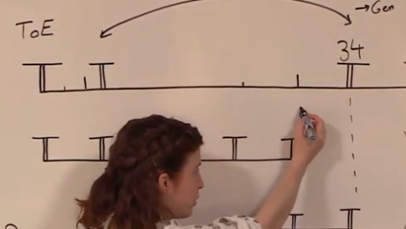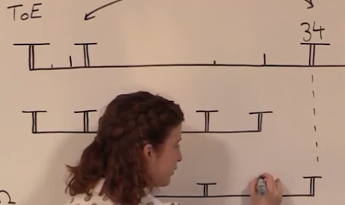
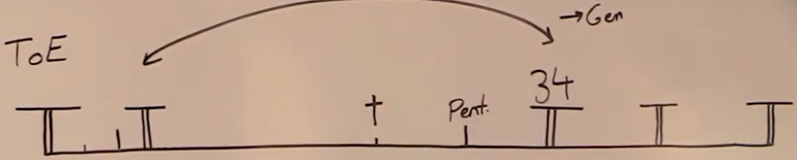
Question from Elder Tess: Where is the Cross for the first group called, the Disciples? Where does the Cross go? Fractalize it.
Answer from Chat: Someone says Forth Waymark; Close of Probation
Question from Elder Tess: What’s the problem with what you just did? What's the issue?
Answer from Chat: Sister Adrianna says, “That's not a fractal.” I agree.
Question from Elder Tess: Where would you place it if you're going fractalize that history?
Answer from Chat: People are still saying 2019. Early Rain.
Question from Elder Tess: What’s the year? We are taking this model of the 144,000 Line and we are going to fractalize it.
Answer from Chat: The Early Rain that begins in 2001.
Question from Elder Tess: What is this Waymark? 2009
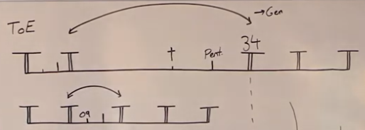
1Example of squishing history. It is wrong methodology.
Can you see what we just did? We took the large model which would take you from 4 B.C. to 100 A.D. and we created a fractal of it. If you create a fractal of this line you take the cross from the Concord Waymark of the Early Rain and bring it to the Concord Waymark of the Early Rain.
What I want to suggest is we need to be specific about what we mean when we say that these lines are fractals. If you look up fractals it goes into complex mathematics which can be a challenge. They list three different types of fractals. But, instead of going into detail, I'm going to show there are two varieties. The first type of fractal is called “Exact Self-Similar”. That is what we have drawn with the original Y shape. That's generally the pictures that you would have seen if you would Google the picture of a fractal. It will show you something like that and it's an exact self-similar fractal. So, this smallest Y shape is exactly what this medium Y shape is which is exactly what this largest Y shape is, an exact-self-similar fractal. But there are very few exact self-similar fractals in nature.
What is much more common is a “Quasi Self-Similar”. So, you have the exact and you have quasi. The third type is called “Statistical Self-Similar and I don't want to go into the difference between quasi and statistical. What you have are fractals that are exact and fractals that are not exact. Quasi means partly. So, it’s partly a fractal; it's like a fractal hybrid. You have exact fractals which tend to be shown in drawings and pictures that demonstrate fractals. But what is much more common is a quasi-fractal, which is a mixture, a Quasi Self-Similarity. So, without needing to be technical it really just means that you have fractals that are exact and you have fractals that are hybrid but are still considered a fractal.
What we have in Reform Lines are not exact fractals and we will save ourselves a lot of trouble if we come to terms with that fact. We are dealing with fractal hybrids, partial fractals. The reason that we have that is because of how we are using that history.
To fractalized the Cross, we would have to put the Cross at the Increase of Knowledge Waymark after 9/11 on the Line of the Priest, and Levites, and Nethinims, just like it is on the Line of the 144K. That would be to take this history and to fractalize it.
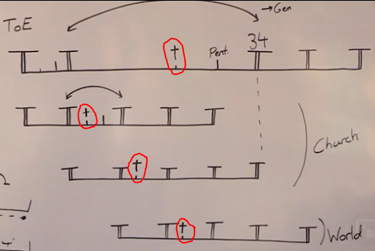
2Example of squishing history. It is wrong methodology.
If we were to see the End of Ancient Israel as one long history, what we would essentially be doing is cutting it up. To fit it into these models we would take it and we would squish it together, which is what we have done here; take the whole fractal and you're just going to squish it down until you can make the Cross fit over 2009. Or you are going to stretch it and you're going to make a small event fit on a larger model. You're going to manipulate that history. And this is the difference between our methodology and FFA’s methodology. They are fine with stretching, squishing, cutting up history until it fits on the dispensation that they wish it to, and we don't do that.
Question from Chat: “Do we have to hold these two concepts at the same time, the cross being 2019 and 2009?”
Response from Elder Tess: I would suggest, no. When we put the Cross at 2009, I would suggest that is wrong methodology because you have to manipulate the history to do that. What we have to do is be comfortable and familiar that when we use fractals, we are taking a whole expansive history from 4 B.C. to 100 A.D. and we are just dropping that in. So, we are seeing Disciples, Levites, Gentiles, John as the 144,000. We're not manipulating the history. You can go and create another whole Reform Line about Christ as a Disciple, but that becomes another Reform Line. It doesn't become a manipulation of this 144,000 Line.
What FFA would repeatedly do, that we were battling against, was manipulate that history. And you could do that if you believed in that exact definition of fractals, which would make the Cross not 2019 but 2009. And then you would have to go back to 2009 and try and force the Cross on to that Waymark. What happened in 2009? What great disappointment did the Movement face? What great crisis and test? What split occurred in 2009? How were we confronted with the crisis over the nature of the Kingdom? That challenge. You could look and you're not going to find it. And you would start manipulating not just their Reform Line to bring 2009 to here at IK after 9/11 on Priest Line, but you're going to have to start going back and reinventing our own history to try and see why the cross would be fulfilled in 2009. And it just frankly isn't, because the Cross is 2019.
What I mean when I say it is a manipulation to bring the Cross from here to here at IK on the 144K Line to IK on the Priest Line, you have to take that history and you have to manipulate it. I just mean you have to try and cut it up or condense it down.
[Describing the portion of the board blocked by the laptop.] The line is 4 B.C. to 100 A.D. and then it is understanding that this is just one part of that history in sequential order. So, you have the Disciples as the first group for the Jews, then you're going to see a second group for the Jews, and then you're going to see Gentiles called in, and then you're going to see the 144K typified by John the Revelator. We are not manipulating that history; we are not cutting it up.
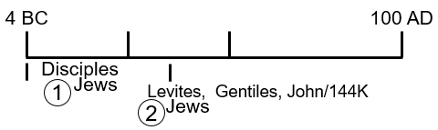
What is fractalize, is the structure.
Question from Chat: Do we see any disappointment in 2019?
Response from Elder Tess: I would suggest that we do, but there are two types of disappointments. The disappointment of the Disciples and Christ was not the same disappointment as that of the Millerites and Samuel Snow. The disappointment of Christ and the Disciples: Christ is disappointed, he's seeing the Disciples that couldn't stay awake to pray for him. He's seeing that scattering, but it's no surprise. It is painful but it's not a surprise; it is disappointing but not a surprise. There was no mistake in his message. The disappointment of the Millerites and Samuel Snow was different because there was a mistake in their message. So, it's two types of disappointments. We have that in 2019. We are disappointed by the shaking and the split though it really shouldn't have been a surprise. We are disappointed by the fact that we didn't understand November 9, which also shouldn't have been a surprise because we have Reform Lines that tell us we wouldn't at the time. So, it is disappointing, but none of that indicates a mistake in the message because there wasn't in the End of Ancient Israel. So, to answer a question, yes, the Cross falls on 2019. It cannot be put on 2009 for the Priest or 2016 for the Levites or 2020 for the Nethinims; it's 2019.
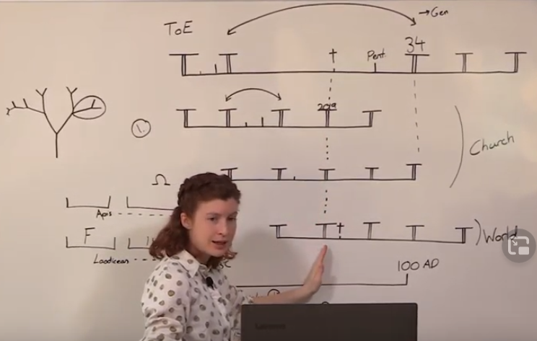

PART 2
https://www.youtube.com/watch?v=VeXQwmA4QeA

Questions Continued

Fractals Continued
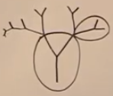
What we have to come to recognize then is there are differences through this history where it's not exact fractals, and I think we're already familiar a little bit with that concept. When you have the 144,000 as our template model, it's this main Y shape model.
When do the 144,000 join the movement? You know it's prior to the Harvest. When did the Gentiles join the movement at the End of Ancient Israel? In the Harvest. That all makes sense if you're willing to drop down the whole history and see that this is not a perfect fractal but there's differences between the groups. Because they are different.
Comment from Chat: Brother Russell says it is the same methodology of manipulation used by FFA saying that the Jordan is Panium, then saying they are expecting the second messenger in the future at the Jordan.
Response from Elder Tess: Yes. They have taken these histories and they've manipulated, stretched them, cut them up, condensed them. And when you do that you start making wrong applications, dangerous applications.
Question from Chat: So, you can't really fractalize the details, only the structure. But sometimes you can fractalize the experiences, like Jacob’s time of trouble, is that correct?
Answer from Elder Tess: We are fractalizing a basic structure. What we particularly have is a repeating pattern. Plowing, Early Rain, Later Rain, Harvest, that's fractalized. What we have fractalized is Increase of Knowledge, Formalization, Test. So, the Dispensations are fractals, the testing time in them is fractalized. That is the fractal. But there are details within that history that are not fractalized. There's a fractalized structure.
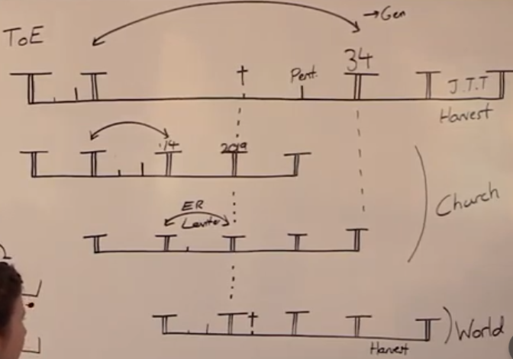
That helps us to see why there are differences in this history. You can't have the Gentiles coming in in their Plowing time. What are the Disciples going to teach them prior to the Cross? In fact, many people right now are worried because in this history in the Early Rain of the Levites between 2014 and 2019, they were telling Levites that Donald Trump is the last President of the United States. And now people feel shaken that they might have been wrong. What do you think the Disciples were telling people in this history? And now the Disciples have to go to those same people at Panium and apologize, don't they? That's the problem with dealing with real life events. We can talk about being hidden, but in reality, hidden can only go so far. We're not in an isolated bubble.
Now I’m dealing with a fictional story. When Peter goes back to the church at Pentecost or goes to the Gentiles after 34 A.D., he runs into the cousin of the man whose ear he cut off. And he's going to say, “I know who you are, you thought you were going to overthrow Rome. In fact, you cut off my cousin's ear.” Their mistakes and their training are visible, even though we can call that a hiding time period, even though that there is this layer of protection. Our training time period which we have been and are still in is a time period when we have to unlearn mistakes. That was a side point.
I’ve discussed before about this top line being like a body.
Question from Chat: So, the lines are quasi fractals?
Answer from Elder Tess: Yes
Comment from Chat: Sister Adriana. It's like what Elder Parminder said, we had it very simplified to help us understand but now we are getting more detail.
Answer from Elder Tess: Yes. And I don't think that more detail has to add a painful degree of complication to our message. It's what we've understood for some time, even when it comes to the difference between when the 144,00 join, in comparison to when the Nethinims join. We've always been dealing with quasi-fractals. And it's a manipulation of that history that is not another viable way to look at that history, but a dangerous manipulation of it.
What is fractalized is the Plowing, Early Rain, Later Rain, Harvest. The understanding that they have a Time of the End where their testing begins, that there is a Sunday Law here at the Midpoint on the Line, that's progressive to Daniel 11:41 that there is a shut door and a testing, and a time of trouble. All of that becomes fractalized. But, the details of the individual experiences of those groups, there are differences in.
The Disciples are devastated at the Cross. They've been forced to come to grips with not only that the nature of the kingdom is different to what they thought but also, they don't understand what just happened at that event. They are afraid. You can't fractalize that to 2009; the cross does not fit there.

Change of Leadership
I wanted to do this first before addressing this question that quite a number of people have raised about the study of the internal and external change of leadership in 2014. So, we go to our other Reform Lines, we see that there's a change of leadership at that middle Waymark. If we were to properly investigate the line of Moses to Joshua, we would see that. I’m sure. We've already touched on that. If we were to go to the End of Ancient Israel, we see that solidly here when we go from John to Christ. We see that already with our Millerite history when it goes from Miller to Snow. And there was a study done in the last two years which showed the external view of that.
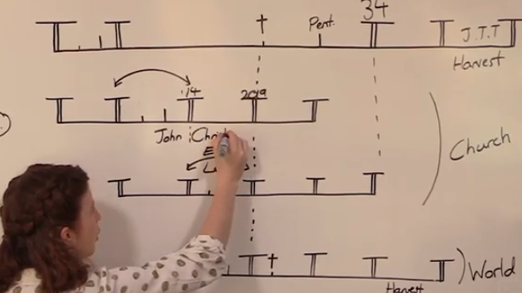
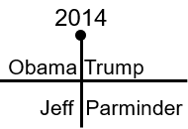
If I dealt with external and internal, that we went from Obama to Trump and we went from Elder Jeff Pippenger to Elder Parminder Biant. The internal and the external. And what Waymark did we place here? 2014. Did we care that Trump was not then even running for President? No. People can be really comfortable with a thought until they start feeling disenfranchised and then they can start to have trouble. The people who've asked this question, I’m not saying that of them. But I’ll explain that in a little while. 2014 we've marked as a change of leadership and we see that going from Obama to Trump, but we see a transition in how that becomes visible. It's already changed in 2014 but it's going to progressively become visible.
To simplify that, we saw that in 2014, but then in 2015 externally, Trump is campaigning. 2015 internally, Elder Parminder begins teaching. 2016 Trump is elected. 2016 internally, Elder Parminder is anointed. And you could trace that all the way through to 2020.
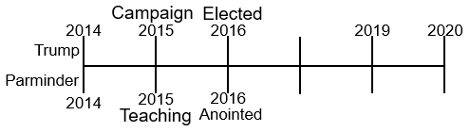
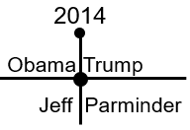
And we saw that 2014 was the change of leadership. It takes time to become visibly recognized and established, but it's already occurred in 2014. It is the turning point year. Just to repeat myself, we saw the external transition from Obama to Trump; it takes time for Trump to be established. Internally we saw the transition in leadership from Elder Jeff Pippenger to Elder Parminder Biant, it takes time for that to be visibly established. But it was concretely changed in the eyes of God in 2014. And it's the fault of the Movement of the people how slowly they come to recognize and implement that change.

2014 is the turning point. It's here, transition of leadership, at the Sunday Law Waymark for the first group called. We saw that John's methodology was no longer fit for purpose and there was a transition. Going back to the studies done in Uganda.
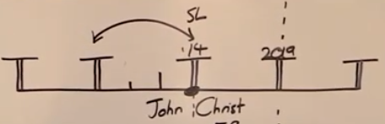
Question from Elder Tess: The Levites, not going into who has been leading them, but who leads the Levites now, today? Which is pretty much saying the whole of the Adventist Movement church.
Answer from Chat: Someone says our Movement. Sister Linda says we do.
Question from Elder Tess: From what Waymark? From 2019. Do the Levites recognize it yet? No. It takes time for them to recognize what has already taken place. The veil of the temple was torn November 9, 2019. There is no presence of Christ in the Sanctuary ministering to the Jewish nation; it's come to a concrete end. All it's going to take is for Pentecost for people to be told that. Down here on the Nethinims Line, at Pentecost, at the same time we're going to the Levites.
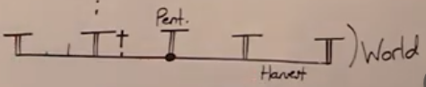
Who now lead the Nethinims? We do. They don't recognize it yet; they don't see it yet. They're not going to see it at Pentecost. It takes time for them to understand that, learn that, and accept that. So, at every point when we personally recognize that a change of leadership has taken place is after God has already established that change. Change of leadership in 2014, this is the Movement. Then this Movement takes over leadership of Adventism, the Levites in 2019. Then that combined Movement takes over leadership of the Gentiles, of the Nethinims at Pentecost in 2021.
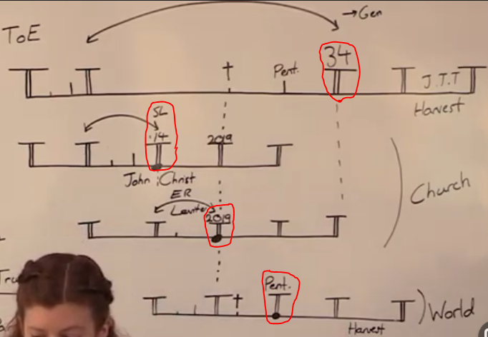
Question from Elder Tess: What's the change of leadership in 34 A.D.? Not the event.
Answer from Chat: Someone says Jews to Christians.
Response from Elder Tess: I’m not sure if they've changed their name, but they have the same...
Answer from Chat: Someone says Paul.
Response from Elder Tess: First of all, Paul is a Levite. And then when Paul is in Jerusalem and the Disciples come together and say, you need to go to the temple and he says, I don't want to and they say, you need to go to the temple, what does he do? He goes to the temple. Why? Because however much we build up Paul, he's in submission to the leadership; he does not take over the leadership of that Movement. He does as he is told. The whole reason he ends up in prison is because he did as he's told. He answered to his bosses. He's just a larger than life character.
Answer from Chat: John in charge of gentiles.
Response from Elder Tess: John is a symbol at this point in time. Who is John in 34 A.D.? I’m not referring to the seven deacons; that organization is becoming more established. They're getting better organized. But where is there a transition of leadership from one leadership to another leadership in the 144,000 themselves? What I want to suggest everyone is doing, is trying to use an absolute fractal. There is no change of leadership for the 144,000 at the Sunday Law.
You have a change of leadership internally in the Movement here at Sunday Law on the Priest line from John to Christ. Then that Movement takes over leadership of the Jews, then that Movement takes over leadership of the Gentiles. But in 34 A.D. it's the same Disciples, the same leadership, that are doing that work, that are leading.
John the Revelator, he's over here at the end of the 144K Line as a symbol of the 144,000. But back here at 34 A.D., he's one of the leaders of that Movement. And he has been a leader for quite some time. There is no internal change of leadership at the Sunday Law. There is no Reform Line where you can see that. There is no model of the 144,000 history when you can see that.
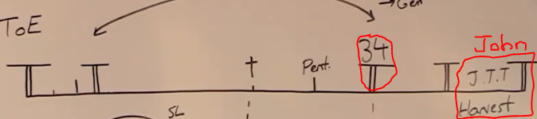
Question from Chat: Sister Linda ask, are there no more shakings after this?
Response from Elder Tess: If you hope so, I will hope so. But I believe there will be shakings all the way to the Second Advent, that they won't have the same characteristics or the same nature.
The major transition in leadership that happened at the End of Ancient Israel, it's all about this Waymark of Sunday Law on the Priest Line where leadership goes from John the Baptist to Christ. If you go to any history this is the Cross. If you asked anyone, Atheist, Adventist, Pentecostal, go to the New Testament and name the singular Waymark that stands out above any other, they will take you to the cross. 2019 has that characteristic. It's October 22. It's this history 2014 to 2019. It’s the history of the Gospels and the beginning of Acts. That is what is given so much time and attention. That is when there is this great transition in leadership that sets the scene for everything that comes after. Internally everything comes back in a special sense to that history, not just internally but externally. This from Sunday Law to Close of Probation is the history of 1844.
I hope we might have got that point a little from the last Camp Meeting [IPR/Gold Country Sept. 23-26, 2020]. 1844 was the turning point that set the United States on an irrevertible [irreversible] course to the Civil War. It all comes down to that transition when Poke was elected, the Civil War became inevitable. It all comes down to Poke. Regardless of what comes after Trump, if someone is elected in 2024 after a second term, regardless of who comes after, the course is irrevertible. You can't go back and unseat three members of the Supreme Court. You can't put QAnon back in its box. You can't undo the conspiracy theories, the destruction of the Republican Party, the destruction of the Judicial Branch. The work is done. Now all that we're going to see is the result of that work. Not saying we're not going to see significant events and changes.
Irrevertible = Not reverting, as a lease; not alterable.
Irreversible = Not able to be undone or altered.
Question from Chat: Someone asks, when do the Nethinims change leadership from AOC and Michael Moore?
Response from Elder Tess: Good question. I would suggest it's at their middle Waymark, which lines up for us with 2021. And why do they need a change in leadership? Why do they need to change?
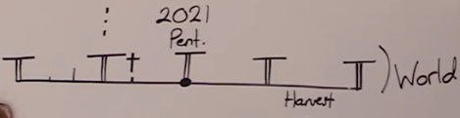
Comment from Chat: Because the leaders are compromised. Because they have errors too. They learn from us.
Response from Elder Tess: I agree. That First Angels work, if we can use it in that external sense, they're using wrong methodology. They don't understand the nature of the kingdom of God, and they're no longer fit for purpose. In fact, in our history that became evident in 2012. We already need to recognize that the great work that has been done by these external forces, if Nethinims can no longer safely trust those people to lead them, we should have a reasonable caution ourselves when we look at their methodology and their actions. Half right and half wrong.
Someone says they don't understand equality. I would suggest they don't correctly understand it which is why they have done their work and there will be a transition.

Review
We have the three fractals, Lines of the Priest, Levites, Nethinims. They’re quasi fractals; they're not concrete, not absolute fractals. And we can't manipulate, cut up that history. We may see another Reform Line built with a different theme, such as Christ in His role as Priest that's going to give us a neat view. But we can't take even that history and start to cut it down and manipulate it.
We come to this model of 2014. This study is showing this key change of leadership. We're not going to see another change of leadership like it, not internally and I would suggest not externally as well, not in the sense that there's going to be that degree of destruction due to US institutions. That work is already set on its course; what comes after is all already irreversibly set. So, when we come back to this study, the question that people have asked, I’m saying it's an honest question, I know these people, so if Trump is not the last President of the United States, if there is another President after him, and after and after, what does that do to our internal model? My answer would be the following: our Reform Line began in 1989, who's leading it in 1989 internally? Elder Jeff. Who's leading it externally in 1989? You have Reagan, Bush Senior, Clinton, Bush Jr, and then Obama. Prior to Elder Jeff, did we have four sequential leaders of the movement? No, we didn't. It was Elder Jeff all the way from 1989 through to 2014. Externally it's not the same, you have president after president after president after president. We took Obama as a symbol; we saw all that he represented, we saw this Movement that would take us to the Sunday Law, Trump and all that he represented, and we made an internal and external application of that history. And we applied it to 2014, but really to that whole dispensation. So, I would suggest that we should not discard that study and its application because there may be a B, C, B, and an R after Trump. What that external model is designed to do is give us that key transition in leadership. That is key, not only internal, but external in a different fashion.
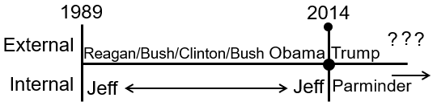
Question from Chat: What about the Catholics?
Response from Elder Tess: The Catholics. I’m going to leave the Counterfeit study for another day if that's okay. I think we have more to understand there as well. I don't know what that is, so I’m not trying to surmise. But they've had an interesting history. I hope everyone's been following what has occurred over the last two weeks. It's the true and the counterfeit model is still holding weight and the organization within that counterfeit structure is certainly being worked on in this history. So, over the last two weeks I hope we've all been seeing the working of Pope Francis and his cleaning up of the mess inside the Vatican. So, I will leave that for another study.
We have the external and the internal. It's all designed to show us this transition in leadership, 2014 is when that takes place regardless of how long it takes people to recognize that fact. And it sets the course for what must inevitably come after. Elder Jeff was the leader from 1989 regardless of changes in the US Presidents. Elder Parminder will continue to be a leader regardless of changes in the US presidents. It's not a model that's broken by that. If it isn't broken before, it's not broken in the history after. We would have to be consistent. If we're going to say that this election shows a change of leadership in the Movement here after Trump, then we would need to be consistent and start going to prior elections and doing the same thing.
Question from Chat: Someone asks, do we have that long to go we thought we were so much closer.
Response from Elder Tess: I really can't surmise about that. Millerite history, after 1844 they had another sixteen or so years, from the 1844 to 1850 history which we're in now. We have a lot of work to do. Which, as Elder Parminder said in the last IPR/Gold Country Camp Meeting, is dependent also on our own willingness to partake in that.
This question about change in leadership will naturally come to people's minds. So, I hope that becomes clearer. I wanted to begin by demonstrating what type of fractals we're using and how we're using history. We're not extending it; we're not condensing it. We are taking it as it's laid out in the Gospels, as it's laid out in Acts, and we're applying that to our own. We're doing the same with Millerite history. And when we come to it, we will do the same with the history of the beginning of Ancient Israel, Moses and Joshua.
We've seen that there are differences. There is a structural fractalization, but there are different details through that history. And that applies in the change of leadership, it applies when people join the movement etc. There are these changes. We can see that in Millerite history; they have a great disappointment at this Close of Probation Waymark. It doesn't mean that at 1850 there was a great disappointment and a mistake made by Nethinims; they didn't make a mistake in 1850. So, that doesn't go from fractal to fractal the same way either.
Question from Chat: When you say, extend or condense, are you speaking to progression?
Response from Elder Tess: I’m not sure if I quite understand the question. I would say it's cutting up the history. One of the points that Elder Jeff made in the shaking last year was that he said that the work of Elder Parminder and myself was the event when the man and the woman are together, the Apostasy at the Jordan [PP Chap. 41 Apostasy at the Jordan]. What mistake did he, Elder Jeff, make? If you have a line of history that begins with the birth of Moses, and I won't address when it ends, then that apostasy with the Midianites happens here at 2014. And when Elder Jeff said it was happening, it was happening over here where we were in 2019. And at a quick review of that history it would make more sense that this actually occurred in 2014, so he's going to take this event and he's going to stretch it over to the current shaking. The problem is you have to wrench it from its history. That's what I mean when I say manipulation. It's this use they have of history that makes them come up with error after error after error in their message, not just recently but going back into the time period when they were among us that caused so many problems and misunderstandings in this movement.
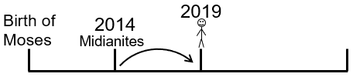
This presentation has been dealing with one question. I will make one point. I said at the beginning there are honest questions and there are dishonest questions. What we've had recently with the shaking that we've experienced particularly in Eastern Africa, particularly focusing in Kakuma. There are four men who particularly led in that shaking and one of those brothers contacted me a little while ago. I actually spoke in the presentation without naming him about what he had sent me. And what he had sent me in those messages, he stated that he had stopped watching anything I presented. He hadn't watched before and would not watch now. Because he says, I’m doing nothing but repeating the same thing over and over and over again. So, prior to a private or public split, what always happens first is people stop watching, and that is such a dangerous thing to do. That's what Elder Jeff did months before August and September of 2019. That's what these Brothers did months before August and September of this year, 2020, when the shaking began to be addressed more concretely.
In the Kakuma refugee camp and in their own capacity outside Kakuma there were people who depended upon these four Brother for access to presentations. As leaders they were given the opportunity to download and share presentations and they decided themselves to not only stop watching but also, they were preventing other people from watching. So, you have a large amount of innocent people, victims of this shaking, who are losing access to our presentations at the same time these brothers are preventing them, holding back our presentations from them and in that context, they start to ask questions.
When Elder Jeff finally left this Movement in September 2019, he could not land a solid blow on the Midnight Cry Message, because he didn't even know what it was. He didn't even understand it to such an extent that he could attack it. When Elder Jeff leaves, what he is saying is, he disagrees with our message of equality, of the Sunday Law, etc. But what he does say is that he believes in Acts 27; he believes in World War 1 and World War 2. He says they're structurally sound models. He believes in time setting. He believed in all of that. And what was said at that German Conference, the prediction that was made, was if he rejects this message, he's not just going to reject our understanding of the Sunday Law, he's going to go back and he's going to reject our understanding of 2016, of the Republican Party, and its responsibility for the Sunday Law. He's going to go back and reject World War 3, that entire model. He's going to go back and reject 2014 as the Sunday Law. He's going to go back and reject 2012 as time setting. And from September to July this year, 2020, their message was entirely based on time setting.
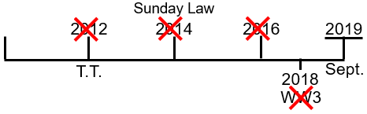
We said at the German Conference, if they start rejecting this, it's like a Jenga puzzle. If we know what they are. It's like that thread of a garment, you pull it you lose everything. And these four brothers who've led out, not only choosing to not follow the messages themselves, they have blocked and prevented others. And that will be fearful in the Judgment. The questions they are asking are questions such as: How can the work of Cambridge Analytica be the Sunday Law of 2014? How much more have we understood 2014 in the recent weeks, the Judicial Branch, the Legislative Branch. We say that the leadership changed in 2014. 2014 is a midterm election. Why were the Republicans able to block Obama in the last two years of his Presidency? In that midterm election, they win the greatest Republican majority in congress since world war 2. They take congress in 2014. They're already controlling legislation. That party took control in 2014 without Trump. So, when they say that the our understanding of the Sunday Law in 2014 is weak because all they can remember and attached to it is Cambridge Analytica, they not only have started to destroy their own faith, not just in the message of equality, not just in the Midnight Cry, they're already undoing World War 3, they've long undone equality, they're now undoing 2014 and the Sunday Law. It won't be long before they lose time. The fearful thing is they're not just responsible for their own souls, there are victims and casualties of their actions that never needed to be victims and casualties. And that's what we find confronting ourselves today.
3 Jenga Puzzel
So, that's what I meant when I said there are honest questions. This question about the change of leadership is an honest question. I’m not challenged by people wondering about a change of leadership. What is not an honest question is when people stop watching presentations, start rejecting the conclusions of the Midnight Cry, and then unraveling what has been formally put in place, those Waymarks which are rock solid. 2014 cannot be moved. Every investigation of it only makes it more and more sound. But when people begin, and they begin by ceasing to watch presentations and joining with us in those studies, they begin with that action, piece by piece as Elder Jeff did, they lose everything that they've ever gained before.
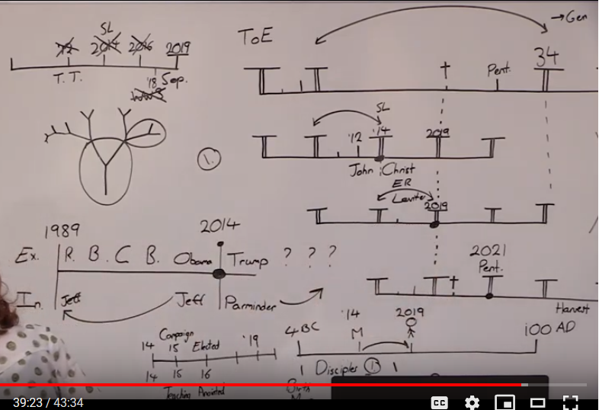

Closing Prayer
If you kneel with me, we're going to close in prayer. I’m sorry for going overtime. Dear Father in heaven, thank you for our blessings; thank you for how you have led and guided. We know Lord that we have much to learn and yet we see what you have taught us and if I pray if anyone looks at these messages and sees a lack of love that their eyes might be opened we pray for those in Adventism who are looking at chaos at pain at the whole world in revulsion and have no explanation except to think that maybe you are a deist god maybe you don't care enough to be involved to talk to us and tell us what's happening we know you do care. I pray for those lord who through no fault of their own are having the truth withheld from them I pray that the light will shine into those places that as many as possible might be reached with those message met this movement's message and as many as possible who have understood it and they are finding that that light is being withdrawn from them by the stranglehold of others that they might find another avenue another access to that light that they might be saved I pray that everyone will feel their individual responsibility in whatever capacity we can to share that light and also lord to share it with an understanding of correct organization through the model of a correct organization please help us in this process as we battle with so much in this dispensation I put this movement in your hands lord it is yours you will lead it to success but as Elder Parminder taught us in the last camp meaning we don't just pray for success we pray for overwhelming success in the number of souls saved in Jesus name I pray. Amen.

