Repetition, Repeated Patterns

Tess Lambert – March 2020 – SOTP
https://www.youtube.com/playlist?list=PLGRNyAWPE9R8gg5zmIJ3j23Ek4Jug7t42
Good afternoon. This is our first class. We have done now four Camp Meetings back to back, one in South Sudan [first], two in Uganda in the North and Southeast, and lastly, one in Brazil. I am quite happy to be back in a class setting; it’s much more enjoyable. If we can forget there are cameras here, this is about interaction. Please raise your hand and contribute. Please remember that this is a class and we can go a slowly or quickly as you like. I believe what was done [presented] in Brazil is extremely important for us to know. So, I want us to repeat some of what was done in Brazil. We will go more slowly and add some information along the way.
When I entered the Movement [I was taught a fundamental principle]. I don’t know if I was taught the same way you were, if it was fairly standard; we all came in at different points in time. I don’t know if the things that were first taught me were what you were first taught as well, but there was fundamental principle that I was taught when entering the Movement. Does anyone have any idea of what that was? [Someone in the class responds with ‘Line Upon Line.’] [Elder Tess responds.] ‘Line Upon Line,’ that isn’t the one I was thinking of, but that still is a good answer. [Someone in the class responds with “God declares the End from the Beginning.”] [Elder Tess responds.] That’s the one I was thinking of. It was practically the first thing that I was taught. It was like the introduction to doing ‘Line Upon Line.’ In a simplistic way (because I was new) I would be told, we can do this methodolgy; we are going to show you how the history of Christ represents our history, or more specifically how the Millerite history represents our history. And the reason we are going to teach you that is because God declares the end from the beginning.
And what was everone’s favorite text? Isaiah 46:10.
Isaiah 46:10 Declaring the end from the beginning, and from ancient times [the things] that are not [yet] done, saying, My counsel shall stand, and I will do all my pleasure:
Isaiah 46:11 Calling a ravenous bird from the east, the man that executeth my counsel from a far country: yea, I have spoken [it], I will also bring it to pass; I have purposed [it], I will also do it.
I think this is one of the first text that I was approached with, and since then I am well aware that we have taken another view of these text. And now we would go back and look for the original intent, because we know the original intent is not saying Millerite history will teach the 144,000. In verse 46:11 is talking about the ravenous bird from the East; you know that the ‘King of the North’ (KoN) is coming. So, the context is not Millerite history, but even that, we took the principle in however roundabout way we did that. So, I want us to keep Isaiah 46:10 in our minds.
We do the line of the 144,00; I want us to put that to one side, and just come to the ‘Line of the Priest.’ So, we have these three groups: the Priests, the Levites, and the Nethiniums. And ours is the story of the first group, that of the Priest or the Disciples. To define it, this [on the board] is the ‘Line of the Priest’ (see Boardwork 9:18), and it began in 1989 [with the first Waymark]. [The other Waymarks are:] 2001, 2014, 2019, and 2021.
Boardwork 9:18
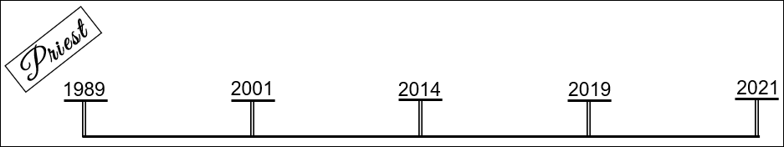
Our understanding of the ‘Reform Lines,’ it has refined over the last number of years, particularly, probably we would speak about 2014 (Ezra 7:9). And from 2014 to now it has been becoming more and more refined; and I would suggest that they actually have become more and more simple. They haven’t become more and more complicated, they are more and more simple. And how we understand them now, is if you were to describe them really simply is that God’s people are scattered and they are going to be gathered. And we know the text about how God does that, how God reaches out his right hand. [Ezekiel 20:34 And I will bring you out from the people, and will gather you out of the countries wherein ye are scattered, with a mighty hand, and with a stretched out arm, and with fury poured out.] God takes hold of his people (they are in captivity to Babylon), and God is going to draw them to himself. Does that make sense? So, this is the hand of God. This is God’s hand taking hold of a group of people and pulling them out of captivity.
It seems to fit that we have five primary Waymarks, just as you would see five fingers on a hand. Five primary Waymarks, and four dispensations: the Plowing, the Early Rain, the Later Rain, and the Harvest. So, five primary Waymarks are separating four histories; you could say the four steps of the agricultural process; we call them dispensations. You could call them a number of different things. So, you have the five primary Waymarks and they divide up the four steps of the agricultural process.
Boardwork 12:40
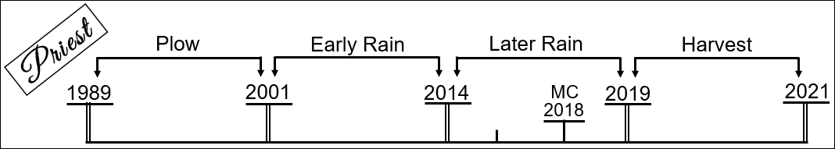
As the message was being refined we come to 2018; it’s the formalization of the message; it was the Midnight Cry. I won’t go into that history immediately, but many people think that the Movement was in unity then. I think a number of us [in this room] were there. Was there unity? No. So, there were a number of messages that were presented in September and October, and from a distance it may have seemed like everything was good, that there was some type of unity; but what were we divided over? ‘Two Streams of Information.’ I want to show how important that is.
There was not unity. Subtle attacks on the message began very early. They were not necessarily intentional attacks, but they were attacking the authenticity of the message just the same. Elder Parminder and myself [Elder Tess] knew exactly what was happening; they were rejecting the message, failing the test. But, you can’t step in front of a movement of people and just state, Future for America (FFA) is failing the test. So all that we tried to do throughout last year [2019], particularly from December of 2018, [was to] demonstate how strong the message was and the methodology behind it. The split in the Movement had already started; and all that we wanted to do was demonstrate the strength of the message. One study was particularly developed to prove one such attack made by FFA to be incorrect, and that was the ‘Repeating Pattern.’

‘Repeating Pattern.’
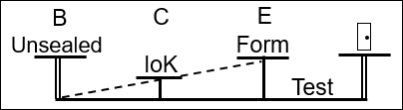
This ‘Repeating Pattern’ could fit in anyone of these four dispensations. What we recognized were the Waymarks of Boston, Concord, and Exeter. In every dispensation there is a message that is going to Plow; there is a message that will come as the Early Rain; there is a message that will come as the Latter Rain; and there is a message that will Harvest. Each experience is through a message, not a Spiritualistic experience. And when this message comes, it arrives/it’s ‘Unsealed,’ there is an ‘Increase of Knowledge’ that is ‘Formalized,’ and then you are ‘Tested’ upon it. So, you can fit this [pattern] into every dispensation as a ‘Repeating Pattern.’
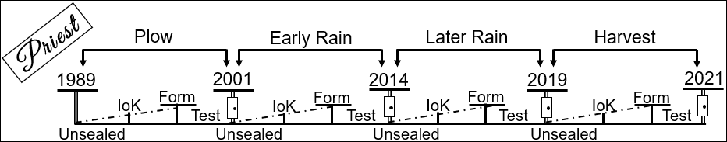
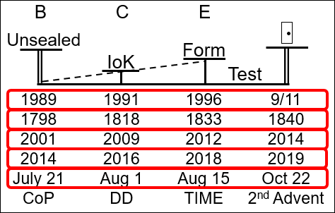
[For example] you could say 1989, 1991, 1996, 9/11. You could take the Millerite version of that [and it would be] 1798, 1818, 1833, 1840. So, that is from the ‘Time of the End’ to “9/11” or 1840. But, this is the first dispensation; it is the plowing. But then you could also say 2001, 2009, 2012, 2014. 2014 is a ‘Shut Door,’ but it is also the unsealing of another message. It is a ‘Shut Door’ for this [‘Early Rain’] dispensation, and the arrival of the ‘Latter Rain.’ [For the early rain it would be] 2014, 2016, 2018, 2019. You could do that in Millerite history; you could say July 21, August 1, August 15, October 22. So it’s this one [July 21]; this is the story of the Midnight Cry in Millerite history, where we take the names of these Camp Meetings (Boston, Concord, and Exeter) and we say Boston is the ‘Arrival’ of a message, Concord is the ‘Increase of Knowledge,’ and Exeter is the ‘Formalization.’ We call this study the ‘Repeating Pattern’ or ‘Boston, Concort, Exeter.’ Does that make sense?
We call this ‘Boston, Concort, Exeter’ or the ‘Repeating Pattern,’ because it doesn’t just fit into this ‘Plowing’ dispensation or the ‘Latter Rain;’ it is the pattern God uses every time he introduces a message. So you could come to the ‘Harvest’ of the ‘Line of the 144,000,’ there is the ‘Close of Probation,’ there is the ‘Death Decree,’ there is the voice of God giving the ‘Time of His Coming,’ and there is the ‘2nd Advent.’ In every dispensation you find that pattern. This study was done in December of 2018.
Boardwork 21:05
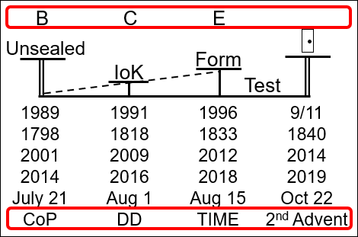
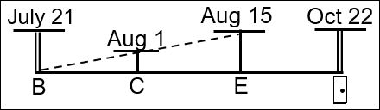
[A person from class asks a question. “You said at the beginning that maybe we need repetition. I am just wondering whether proof is for the same Boston, Concord, Exeter in all those four dispensations?”] [Elder Tess responds.] Well, you know you do here [pointing to the ‘Plowing’ and ‘Latter Rain’ dispensations]. [Person’s response, “How do we know?”] [Elder Tess responds.] Because this is Millerite history; and Millerite history is July 21, and there are three Camp Meetings, all that lead up to the Midnight Cry. So, if you were to go back into Millerite history back to this one [1798, 1818, 1833, 1840] (see Boardwork 21:05), there is a message presented [1798], there is an ‘Increase of Knowledge’ [1818], it is ‘Formalized’ [1833], and then it is ‘Tested’ in 1840; because they are testing the ‘Day for a Year’ principle. So, you know that this pattern, in Millerite history you can put it here [during the ‘Plowing’], and then you see the exact same pattern here [during the ‘Latter Rain’] when you have three Camp Meetings from July to October. And this direct application [to our line] is our ‘Latter Rain.’
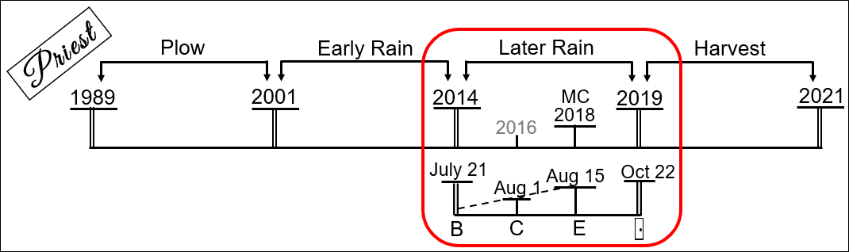
We know July 21 [lines up with 2014] and August 15 [lines up with 2018], then all you need is a Waymark in here [between 2014 and 2018 that would line up with Aug 1]; and we identify that externally and internally as 2016. So you can see it in Millerite history.
[Person’s response, “So the reason we can say July 21 is the unsealing was parallel to 1978 is because Snow introduced his message from an historical point of view?”] [Elder Tess nods yes and responds.] Sometimes this [‘Increase of Knowledge’] Waymark in a ‘Reform Line’ is harder to see. If you went to the ‘Line of Christ’ we haven’t yet identified this one, the ‘Increase of Knowledge’ as a Waymark; you know the ‘Formalization’ is when John starts teaching. So sometimes it’s harder to see all of them, but you can see that pattern more and more. We start to see it once we start looking into the history of Christ.
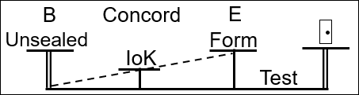
We demonstrated that it is in here [‘Plowing’] and here [‘Latter Rain’], and then we just had to consider these two, the ‘Early Rain’ and the ‘Harvest.’ We understand that these Waymarks have characteristics attached to them. This [‘Increase of Knowledge’] is Concord. What does ‘Concord’ mean? Harmony, unity. Like people coming into unity. And you can mark that in 2016; you can mark it in 2020. So, these Waymarks have specific characteristics, particularly when you come to the ‘Increase of Knowledge’ and the ‘Formalization.’ That this [‘Increase of Knowledge’ or ‘Concord’] would relate to unity, which is why you would see a ‘Death Decree’ (see Boardwork 26:22); because you see all of the enemies in unity against God’s people. Who do you see in unity in 2020? Who have we already seen in unity? [Response from class, “the enemies.”] [Elder Tess responds.] Who are the enemies? You go to the internal and it is easy to see that they are in unity. They don’t agree with each other on hardly anything, except for the fact that they all hate us.
Boardwork 26:22
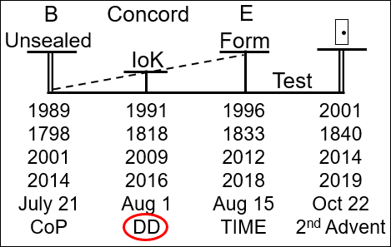
[Another person’s comment, “I was thinking that externally the Republicans are in unity with Donald Trump. Even during that impeachment even though you knew that some of those people didn’t really agree, they still came together.”] [Elder Tess responds.] You can see them coming into unity through that impeachment process. When it comes to the impeachment vote in the Senate, every single Republican (except one) voted no; [and that one] he just destroyed his political career. And now every other one that was even privately saying Trump might have done something wrong is getting purged from government. So you can see the enemy is coming into unity even though many of them hate each other. So, this Waymark has the characteristic of concord or unity between a group of people.
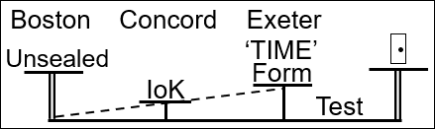
The ‘Formalization’ always has this characteristic of ‘Time,’ some sense of time attached to it. So, in 1996 it will be announced that we’re in the ‘Time of the End.’ It’s marking that the ‘Time of the End’ began, but it is also saying that the ‘Sunday Law’ is in your lifetime. It is a message based on time. 2012 is the ‘Formalization’ of a message, and it’s about ‘Time.’ 2018 brings with it ‘Time.’ [Note: This next statement is an “IF” example; but it did not occur in 2020.] And this is where we mark, if this was literally ‘Close of Probation’ to ‘2nd Advent,’ this [2020] would be the ‘Death Decree’ and here [at the ‘Formalization’ Waymark] the day and the hour is given of Jesus coming. TIME.
Boardwork 30:47 (“If” example)
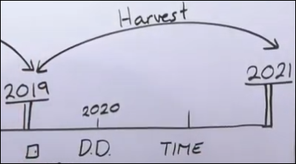
So, this Waymark, ‘Increase of Knowledge’ is ‘Concord,’ and always has the characteristics of unity. This Waymark, the ‘Formalization,’ ‘Exeter’ has the characteristic of ‘Time.’ That is the pattern we see in our ‘Reform Lines.’ And thoughts or questions so far?
This is just a reminder of what was taught in December 2018. This here is just one template. You can take it, plug it into any dispensation and then overlay the message that was to do that work. The reason that this was presented at that point in time is because Elder Jeff had just taught that the ‘Midnight Cry’ message was a message that was composed of many different parts and from quite a few different people, so someone from Canada, a message from Africa, and a message from Australia. He was saying these different messages from different people all composed the ‘Midnight Cry.’ So, the response was this study. Not to say in a strong fashion that he’s wrong (because that was not at that point politically correct), but to see this ‘Repeating Pattern;’ [to see] that there is no point in history where the ‘Formalization’ is a ‘Formalization’ of a message from many people with many messages. So, it was a direct response to something he was teaching that was error.
In September, after he [Elder Jeff] left the Movement, he spoke about this ‘Repeating Pattern;’ he said it’s powerful, it fits, and he still believes in it. I don’t think he would say that now. And I don’t think he knew it was presented because of what he was teaching. But, at least as of September [2019] he claimed to believe it. So do you have any questions or thoughts on the ‘Repeating Pattern?’
That’s how we visualized it for most of the last year, how I have. But, I want us to think about it a little differently, because I think we can become fixated on one way of looking at something. And I want us to try a different approach.

One Message Per Dispensation

‘Plowing’
What is the first message that God gives to this Movement? ‘Line Upon Line.’ In the light of Isaiah 46:10, how do you think that this ‘Reform Line’ [‘Line of the Priest’] will end? With what understanding? ‘Line Upon Line.’ I want to suggest right from the beginning, that if God declares the ‘End from the Beginning’ and we want to know what we specifically need to understand in the history of our ‘Harvest,’ it is going to be ‘Line Upon Line’ because our line began that way. So, the first study was ‘Line Upon Line’ and that began to open up in the year 1989, with the beginning of everything else.
I have friends that are Adventist and also friends that are not Christian. My friends who are not Christian, they find this concept fascinating. But then my Adventist friends… How many us have spoken to Adventist friends and introduced ‘Line Upon Line?’ How did they respond? [Elder Tess responds to a comment.] Your friends liked it? [Elder Tess responds to another comment.] Your friends left you? At what point did the friends leave? [Person responds with, “At that point where we should forget the old and we should accept the new one.”] [Elder Tess responds.] So, forgetting the old and accepting the new one. In 1989 [when] Elder Jeff is studying ‘Reform Lines,’ does he know that we are in a new one? No. So, when ‘Reform Lines’ opened up he didn’t know that we were in this new one. So, you may have noticed something different, but this was my experience. When I spoke to my friends who were Adventist, I would start with this concept of ‘Line Upon Line,’ and the response was always positive. [They would say,] it sounds interesting, a repeat of history; we like pictures, visualizing a line; no one was threatened by it.
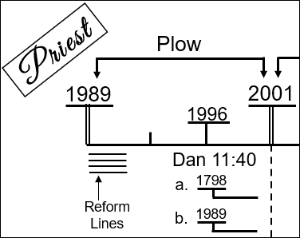
At what point does it become a threat? What opens up after ‘Line Upon Line?’ [Someone responds with, “Time.”] [Elder Tess responds.] How did we understand our ‘Time?’ That we were in our ‘Time?’ There was something special. [Someone responds, “Daniel 11:40-45.”] [Elder Tess responds.] Daniel 11:40-45; because it is that that gives us 1989. So, it is Daniel 11, specifically verse 40, that is going to say that there’s this ‘Reform Line’ here [the ‘Reform Lines’] that begins in 1989, because Daniel 11:40 has part (a) and part (b). Does that make sense?
The message starts innocently; it’s non-threatening. ‘Line Upon Line’ is non-threatening. Does it require you to change your behavior? No, not until Daniel 11:40-45 is introduced; and now it is teaching you that you are in a new ‘Reform Line,’ and that changes everything. This [‘Reform Lines’] is non-threatening; this [Daniel 11:40-45] is threatening. It starts innocently and it develops into something that becomes dangerous, something that is divisive, something that will require a ‘Change of Behavior.’ So, that is the dispensation of the ‘Plowing;’ that is the message that was introduced.
The reason I want us to think about that is because sometimes I think that we can tend to cut up our messages. We don’t see how they are connected; and we lose a lot when we cannot see how they fit. So, there are not two messages introduced in the ‘Plowing.’ It is not one message, ‘Line Upon Line,’ and another message, ‘Daniel 11;’ but they are one message. It is just that God is going to introduce a catalyst (a cause) that is innocent and it is going to lead to an effect that is serious that will require a ‘Change of Behavior;’ but they are intimately connected. Does that make sense?

‘Early Rain’
Next dispensation. What do we begin to understand here [‘Early Rain’], what is unsealed? The ‘2520.’ What does the ‘2520’ teach? What the ‘2520’ teaches is that there are 2520 days that will take you to 1798 and 2520 days that will take you to 1844 (see Boardwork 47:59). So, how threatening is that? It is not threatening. People who did not understand it, might have been afraid of it because it’s not what the Conference church teaches. I think you could argue that once we’re in the dispensation of the ‘Early Rain’ (at least in this context), you can forget about the Conference church. They had rejected Daniel 11:40-45. So, this test is not for the Conference church. So, the fact that they struggle with the ‘2520,’ I find irrelevant. Now these ‘Tests’ are inside the Movement.
Boardwork 47:59
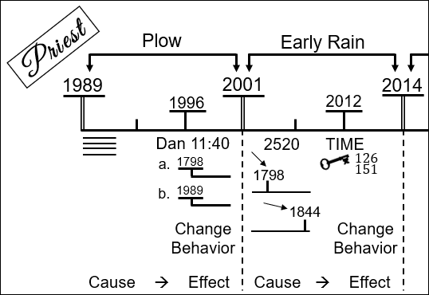
Are people inside the Movement greatly threatened by the ‘2520?’ I would suggest, no, because we already understand ‘Time’ prophecies and this is just another one to take you to Millerite history. It’s not threatening, and it requires no change of behavior. This [‘Reform Lines’] study is like a ‘Cause;’ it’s going to lead to an ‘Effect.’
The ‘2520’ is a ‘Cause’ and it’s going to lead to an ‘Effect.’ It starts innocently, when does it become a threat? The ‘2520’ is the key that unlocks ‘TIME’ (see Boardwork 47:59). So, these [‘2520’ and ‘TIME’] are not separate messages. It is not the ‘2520’ and [also] ‘Time’ setting; because this [‘Time’ setting] is based on the 126 and the 151. So, once you know you are in a ‘Reform Line’ it requires a ‘Change of Behavior.’ Once ‘Time Setting’ is introduced does it require a ‘Change of Behavior?’ Yes, because it says that you are about to face your ‘Sunday Law.’ And now what happens? A division. Do you have any thoughts or questions on that dispensation?
Boardwork 47:59
Now we come to our own. What began to open up in this [‘Latter Rain’] history at the beginning?
[Someone asks, “In this time period [‘Early Rain’] we had the topic about time setting yet the Movement seems to not have been made aware of that; it seems to be like it was a secret. That being said, how was the Movement tested upon that after the time we had in 2018?”] [Elder Tess responds.] I think it’s how you define the Movement. Do you talk of 50% or more? Or can the Movement be very small? So, you can go to many lines to look at this [2012] particular Waymark; and you can see that characteristic of leaders failing, but the Movement still has it correct. The complication is that the leader always has a ‘Cult of Personality;’ and for one reason or another, when the leader rejects, the vast majority of the people follow him. But the Movement isn’t defined by numbers or the majority. And every single person who rejected this [‘Time’ setting] (when I would suggest they shouldn’t have), has left the Movement by now. The ones that did reject, that are still here, I suggest that they rejected for different reasons, like Peter, who was scared; and they got a second chance like Peter did. But those who truly hated it and rejected it have all left. I don’t think it changes our pattern.
[Someone responds, “2012…” It is inaudible.] [Elder Tess responds.] This [2012] was the introduction of ‘Time’ setting. And the chief opponents of ‘Time’ setting, the ones who most ardently fought against Elder Parminder and made Elder Jeff do the same, were the ‘Path of the Just.’ They were the ones who came down hard when the subject was introduced. Anything more on that dispensation?

‘Latter Rain’
So, what about this one [‘Latter Rain’], what is the key subject that it all begins with? [Someone responds, “Two Information Streams.”] [Elder Tess responds.] It doesn’t begin with ‘Two Information Streams,’ that comes a little after. [Someone responds, “Ezra 7:9.”] [Elder Tess responds.] Not Ezra 7:9, that’s not the testing message. [Someone responds, “King of the North / King of the South.”] [Elder Tess responds.] It is the ‘King of the North’ verses the ‘King of the South.’ So, the message opened up with World War 2; it closed at the International Camp Meeting last year [2019] with World War 1. So, it centered around the triple application of the World Wars.
This subject, the ‘Plowing,’ is introduced through understanding ‘Line Upon Line,’ but it becomes a mechanism to unlock our own line. Daniel 11:40-45, that is the ‘Test,’ [which] requires a ‘Change of Behavior’ and divides two groups of people. Here we call ‘2520’ the key, which is another way of saying the catalyst or the ‘Cause.’ There is no challenge, but it is going to lead to ‘Time’ which is the ‘Test,’ the ‘Effect;’ and it requires a ‘Change of Behavior.’ So, what began to open up here [‘Latter Rain’ 2014] was the ‘King of the North’ verses the ‘King of the South’ through the application of the World Wars. World War 1 plus World War 2 equals World War 3, the triple application. That was presented in 2018 (see Boardwork 55:55). There are some elements missing, but World War 2 was presented along with all the history of Pyrrhus.
Boardwork 55:55
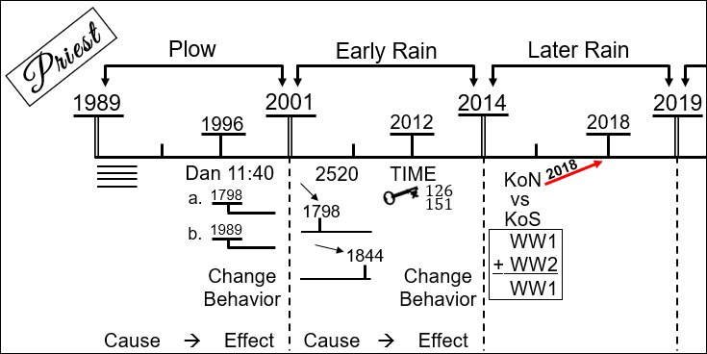
Why would World War 2 open up before World War 1? Why back [WWII] to front [WWI]? [Tamina responds, “Because World War 2 demonstrates the history of 2014-2019, while World War 1 is prior to 2014.”] [Elder Tess nods yes and responds.] So, World War 1 and World War 2 both [together] take you from 1989 to the ‘Sunday Law.’ But World War 1 focuses most of its information on this history [from 1989-2014]; and at the ‘Midnight Cry’ what we needed most was to understand this [2014-2019] history. World War 1 and World War 2 both take you from the ‘Time of the End’ to the ‘Sunday Law;’ you can overlay them, combine them. But most of the interesting information in World War 1 is condensed at the beginning, and most of the relevant information of World War 2 is condensed at the end. So, it makes sense to me [Elder Tess], that when God most needed our attention, he shown the torch and brought us to focus on our dispensation [‘Latter Rain,’ 2014-2019]. And then later on World War 1 came and we understand the Gulf War, the Iraq War, and Afghanistan; but it is World War 2 that we needed to understand here [‘Latter Rain’ dispensation], the 2016 election, the rise of Nationalism, Hitler, Stalin. We needed to understand them very clearly from the beginning, so World War 2 had to come first. Does that make sense?
It [‘Latter Rain’ dispensation] begins with this study of the ‘King of the North’ verses the ‘King of the South.’ That’s presented. Did anyone have any problems with that? No. I’ve never had anyone fight on those issues. Just from what they are teaching now, I know that people must reject it (who have left the Movement); but they have never been bold enough to actually try and attack the study; it’s water tight. And no one have ever fought on that point; because the understanding of the World Wars, is it actually that threatening? So, they were presented in Arkansas; at least everyone there sat through them, and seemed to enjoy them; people who like history, who like to see those patterns. There’s no challenge. So, everyone was really happy. And then the problem was this (see Boardwork 1:01:20) was presented; and you could say there were three things presented. (1) ‘King of the North’ verses ‘King of the South’ (2) November 9, 2019 (3) ‘Two Streams.’ So, you could say there were three things presented.
Boardwork 1:01:20
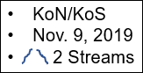
Now, the issue that people immediately had (they didn’t see it as an issue, we did) is which one of these three issues is the test? Is November 9 the test? No, because ‘Time’ is the ‘Test’ of this [‘Early Rain’] dispensation. So, November 9, by this stage, is testing no one; it is just interesting information. Is ‘King of the North’ verses ‘King of the South’ testing anyone? No, because it is just the ‘Cause,’ and it is leading to an ‘Effect.’ So, neither of those are the ‘Test.’ And almost everyone in the Movement thinks that they are. So, when they see Elder Jeff, FFA, worldwide, it looks like everyone has passed; because everyone accepts that we are in World War 3 and November 9, 2019. And everyone feels safe and complacent. But the problem was neither of those two things were ever the ‘Test;’ they are just the ‘Cause,’ part of the catalyst.
So, when Elder Jeff left the Movement, one of the things that he was saying (as soon as he left), was to claim that he believed all of the lines presented. So, he would argue, at the beginning of his separation from the Movement, that he still believed in the whole triple application of the World Wars. At the very least he would say, I have no problem with any of that. What did he have a problem with and rejected from the very beginning? ‘Two Streams of Information.’ And the ‘Two Streams of Information’ was just another way, another subtle introduction, of what would ‘Test’ us; equality. Because ‘Two Streams’ (see Boardwork 1:05:32), which you get from the study of the ‘King of the North’ and the ‘King of the South,’ says that on the side of one stream you have Obama and Clinton (a black man and a women), and on the other side you have Trump. So, ‘Two Streams of Information’ was already taking us to ‘Equality.’ We have the ‘Cause,’ ‘King of the North’ / ‘King of the South,’ and it is taking us to our ‘Test’ [Equality].
Boardwork 1:05:32
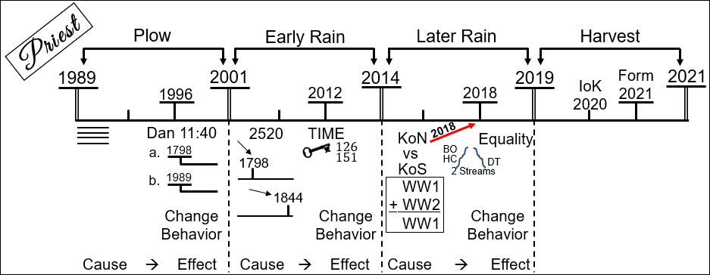

Getting From World War 3 to Equality
How do you go from ‘King of the North’ / ‘King of the South’ to ‘Equality’? Because people see ‘Line Upon Line’ and ‘Daniel 11:40-45’ as two different studies; and we have said they are one message. So how do you go from World War 3 to ‘Equality’? This is Elder Jeff’s number one problem, because he says you can’t do that; there is no connection. Someone (he would say me) has intentionally manipulated a good study to take from something that’s reasonable, World War 3, to unreasonable and completely disconnected, ‘Equality.’ So how are the two connected?
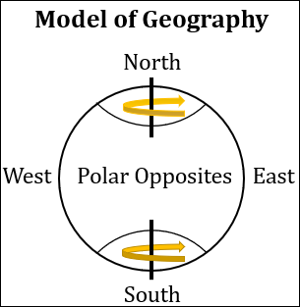
[Janice responds, “The ‘King of the North’ and the ‘King of the South’ demonstrate a relationship between the Church and the State which brings us to a relationship between a man and a woman.”] [Elder Tess responds.] So, the issue of ‘Equality’ was already taught in October 2018, but it wasn’t stated as emphatically (clearly) as it could have been. It was taught through the concept of the ‘Two Streams of Information.’ But the following was already there, and that was understanding the nature of the ‘King of the South’ through the ‘Model of Geography,’ that you have a North, a South, an East, and a West. So, if you were to look at the globe, how does it spin? It spins like this, like you have a pin here [at the North Pole] and a pin here [at the South Pole]; and it spins on the North and South [axis]. So, if you were to talk about the East and the West, they are vague concepts; that is why when we talk about the East Wind, we have no country to attach it to. The East Wind struck at 9/11; which country was that? Saudi Arabia, Afghanistan, Iraq, Iran? There are all of these countries that you could call the Middle East; but the term if very unprecise; so is the Western World. The North and the South are not vague; they are absolutes. You could put a pole down here [at the North] and a pole down here [at the South], the North Pole and the South Pole; and they are known as Polar Opposites.
What does ‘Polar Opposites’ mean? [Someone responds, “Opposite of one another.”] [Elder Tess responds.] Opposite of one another; how opposite? [Someone responds, “Completely.”] [Elder Tess responds.] Completely. [Someone responds, “North and South on a compass try to separate.”] [Elder Tess responds.] So, like the points of a compass they try to push away from each other. [Janice responds, “One is an extreme and the other is the opposite extreme.”] [Elder Tess responds.] So, you have two extremes. This is one of the most difficult things we have to do in the Movement; what is the most difficult thing we have to do (I think)? Juggle multiple concepts at the same time. Two concepts that seem to contradict. So, we would say, the North Pole and the South Pole are as opposite as you can possibly get from each other.
Kathrine, in the next breath what will we say? [Kathrine responds, “That they are equal?”] [Elder Tess responds.] That they are equal? [Kathrine responds, “That they are the same.”] [Elder Tess responds.] That they’re the same. There’s a couple of small differences, but they are almost identical. One has polar bears and one has penguins. But unless you saw one of those identifying marks (and if you were to be planted in that pole), you wouldn’t know where you were. So, they are ‘Polar Opposites,’ as different as you can get, and they are also almost identical. Can we see how the two things contradict, but both fit? And we find in the Movement that we have to juggle that concept over and over again. Are we liberals? Yes. Are we conservatives? Yes. There’s a lot of truth that we conserve. Different concepts [at the] same time.
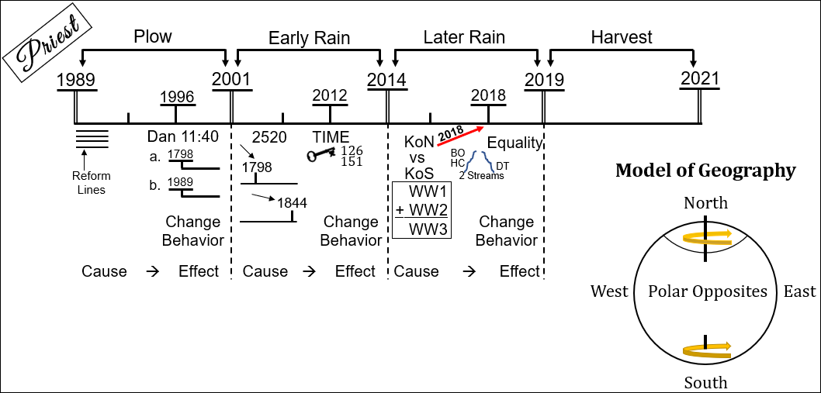
Through this study, directly through studying ‘King of the North’ / ‘King of the South,’ we looked at it from the ‘Model of Geography.’ And I want to give a bit of a vague update on what Vladimir Putin is doing. I don’t have the notes for this directly in front of me, unless I can find them [now on the computer], otherwise I’ll come back with better [notes] and review it tomorrow.
If we were to speak about Vladimir Putin… Now I understand that in the last little while, Elder Jeff has said that someone tricked him. Someone tricked him into believing that the United States is the ‘King of the North;’ he no longer believes that. But I am going to assume that they still believe that Russia is the ‘King of the South.’ And prior to 2018, people would approach (I’m sure they approached often, because I know that at least a couple did approach me; and from what I could see, this was something that troubled many people in the Movement.), defining the ‘King of the South.’ And how did we define the ‘King of the South?’ It’s an Atheistic Nation, hostile to (against) every form of religion.
Vladimir Putin takes office when Boris Yeltsin resigns in 1999 (see Boardwork 1:21:29). In the year 2000, he [Putin] is elected. He’s elected President. How many terms can he serve under the [Russian] Constitution? Two. And how many years are they? Eight total, four years each. So, he has two four-year terms. That takes him to when [what year]? 2008. So, in 2008 he can no longer be President. He doesn’t want to lose the grip on power, so what is he going to do? It’s a trick. What’s his trick? Co-rulership. It’s a nice way of saying it; really, it’s just he put in a puppet. Who was that puppet? [Someone responds, “Dmitry Medvedev.”] [Elder Tess responds with laughter.] Medvedev. I forgot his name; always ask the class a question when you forget, they will think you are just testing them. Then don’t tell them you did that. Medvedev; he’s just a puppet. So, Medvedev can serve for four years, and then in 2012 (because he is a puppet), he is not going to run for a second term because now Putin can come back. And Vladimir Putin announces he’s coming back. But he is always looking ahead. He prepared his puppet before the election; and he is going to plan early on how he can keep a grip of power longer. So, what is he going to do? He is going to say, “Why don’t we have six-year terms?” So, he changes the rules from four-year terms to six-year terms [during Medvedev’s Presidency]. The first term takes you to 2018; 2012 to 2018. He has another six-year term that will take him to 2024.
Terms were extended from four to six years in 2008, during Dmitry Medvedev's administration. ~Wikipedia
Boardwork 1:21:29
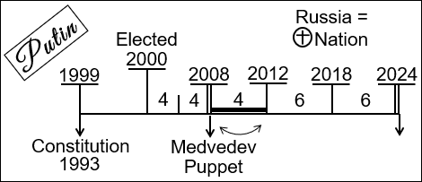
We’re in 2020; he is quickly running out of time again, because this is the second time, the second consecutive term. So, he is thinking ahead; what’s he going to do? In Russia, they have the President; this is Putin, and this has all the power. The President has all the power, and Vladimir Putin is the President. Now Vladimir Putin he can no longer be President in 2024. And this is the same thing that Recep Tayyip Erdogan did in Turkey. There’s the State Council in Russia; how much power do they have? None. So, if Vladimir Putin moves this power from the role of the President to that of the State Council. Then approaching 2024 he moves power from President to the State Council, and then he says this State Council doesn’t currently have a head, but it needs a head, it needs a Chairman. And in 2024, who do you think the Chairman will be? Putin. So, what he’s orchestrating is the same thing that was done in Turkey. Erdogan had been President for as long as he was allowed; so, he moved all of the power from the role of President to Prime Minister, and then became the Prime Minister. Putin is doing the same thing except he’s moving it from the role of the President to the State Council.
There is a problem; to do this, this goes against the [Russian] Constitution that was written back in the days of Boris Yeltsin after the fall of Communism. The Constitution says that you cannot do this. So, he now has to change the Russian Constitution. He doesn’t want to make this [changing power to President to Head of State Council] obvious, so he says, “All of you workers, your rights to health care, to a good wage, aren’t properly enshrined in the Constitution; so, you tell me everything you would like changed about the Constitution and we’ll rethink it. So, everyone knows it’s because he’s doing this [change of power], but he’s going to make this change of the Constitution a much bigger issue so he can try and keep everyone happy. And there will be many changes to their Constitution, not just this one [change of power].
What are some of those changes? Do we know? One of the key changes is coming from the Russian Orthodox Church. They say, “If we’re going to change the Constitution, we should properly enshrine in the Constitution that Russia is a Christian Nation. Now, American Protestants have been wanting that for about two to three hundred years, and they have never got it into the American Constitution. But it is about to be written into the Russian Constitution, who we define as being hostile to all religion.
We are out of time. I’ll find better articles and bring them tomorrow. But, in understanding the ‘King of the North’ and the ‘King of the South,’ we had to look at how we define the ‘King of the South’ and all our Church / State Models. So, that’s the beginning of helping us see how we went from World War 3 to Equality. Because the ‘King of the North’ and the ‘King of the South’ are all about Church / State relationships. So, we are looking not at the ‘Repeating Pattern’ in the same way, but one message that starts innocently, challenges no one, and leads to a ‘Test.’ The reason so many people looked like they were doing so well in October of 2018, is because they were doing so well on the part that was not the ‘Test,’ and already starting to reject that ‘Testing’ message.

Closing Prayer
If you kneel with me, we will close in prayer. Dear God in Heaven, we look back just so briefly on how you have led us and we are so grateful. Thank you for your faithfulness to us. I pray you will help us to understand and continue to give us your light. I pray that you will bless this school, not just in classes, but in the interactions in all the discussions and fellowships surrounding. I pray this is Jesus’ name, Amen.

