The Nature of the King of the South

Tess Lambert – March 2020 – SOTP
Note: It is important to review the March 2020 SOTP first presentation “1.) Wiederholung Wiederkehrende Muster / Repetition Repeated Patterns - 02.03.2020 - Tess Lambert” before this second presentation by Elder Tess on “4.) Die Art des König des Südens / The Nature of the King of the South - Tess Lambert.” It is important to understand the ‘Repeating Patterns’ first.

Playlist: https://www.youtube.com/playlist?list=PLGRNyAWPE9R8gg5zmIJ3j23Ek4Jug7t42
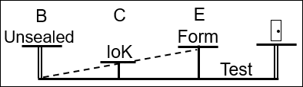
We started yesterday looking at the ‘Repeating Pattern.’ We spoke about our understanding particularly of ‘Reform Lines,’ and how those ‘Reform Lines’ have been refined. In part of that refinement, it became necessary (when people started intentionally or unintentionally attacking the Midnight Cry) to defend that message. To defend it, varies studies were presented that reinforced the logic behind the Midnight Cry message and defended its principles. I think we are all familiar with the study of ‘Half Right and Half Wrong,’ and how from that came the study of histories of ‘Success’ and ‘Failure.’ Understanding ‘Success’ and ‘Failure’ (‘Failure’ is the Alpha history and ‘Success’ is the Omega history) was developed because of an attack on the message, but it also refined our ‘Reform Line.’ It made us see the history of Moses, the Beginning and End of Ancient Israel, and the Beginning of Modern Israel in a much clearer fashion, where we could begin to explain their failures and disappointments. So, every time the message came under attack, the response to that (that was made using the lines) further refined our understanding of them. The first time that was done was in December of 2018, and that was the study of the ‘Repeating Pattern.’ We drew up that study, very briefly reviewed it, and then we put it to one side; because for about a year now (just speaking for myself), I have used that pattern every time I have approached ‘Reform Lines.’ And I wanted to think about them from a different perspective.
We have still taken our four dispensations and our five key waymarks. What we have done is actually traced the messages. This isn’t all the light that has come into the Movement in the last 31 years. There have been other elements, but these are the messages that have tested, that have done the work of plowing and watering this crop. We remined ourselves that it began with ‘Reform Lines’ in 1989 (see Boardwork 5:36). We made the statement (without proving it) that understanding the principle of ‘End from Beginning’ our ‘Reform Line’ would end through a study of ‘Reform Lines,’ that they would play a key part in this final dispensation.

Boardwork 5:36
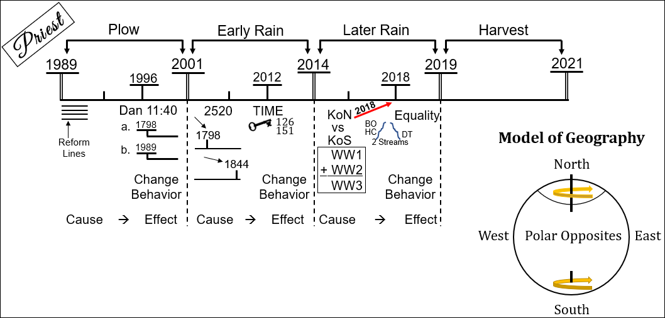
Question: Is every line that we draw a ‘Reform Line?’ No. We are going to take a Line of WW1 and a Line of WW2 and make a Line of WW3; is this (see Boardwork 7:06) a ‘Reform Line?’ No. So, not every line is a ‘Reform Line.’
WW1
+WW2
WW3
Boardwork 7:06
We take WW2 and we place it on a line. When we do that, is it a ‘Reform line?’ No. Why? Because a ‘Reform Line’ is to reform God’s people. So, WW2 is not a ‘Reform Line.’ The ‘Third Diadochi War’ is not a ‘Reform Line.’ Does anyone disagree? Is anyone confused?
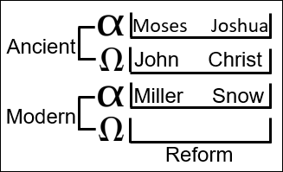
So, what opens up at the ‘Time of the End’ (ToE) is ‘Reform Lines.’ The whole concept is that God’s people need reformation. So, God is going to do something to His people to bring about a reformation. So, you will have something happen at the beginning of Ancient Israel under Moses and Joshua; this is captivity to Egypt. Then you will find God’s people in captivity to Rome during the time of John the Baptist and Christ. Then you will find them in captivity in the 1260 and you will find Miller and Snow. So, these are our ‘Reform Lines’. Now we have a 144,000 Line, our Omega history; and this is a line of reform because God’s people have been in captivity for 126 years.

What opens up in 1989 is the ‘Reform Line,’ because God is doing a work of reforming His people. So, when we go into history and we see battles of Raphia and Panium and Daniel 11 is that a ‘Reform Line?’ What reformation is happening? None.
This is what I suggest, we have ‘lines’ and we have ‘Reform Lines.’ So, we could go to the Third Diadochi War and it will take you from 1989 to the ‘Sunday Law.’ It is not a ‘Reform Line.’
Do we all know what those ‘glasses’ are? Where you have a pair of spectacles and you put a layer of glass over and you see more? It will give you some details. Usually there is one pane of glass that is the foundation then over that you can put layer over layer over layer. It can be used in a laboratory. The concept of a microscope is different, but you could use that.
Even if they are not glasses that go over your eyes. Sometimes they are a plate of glass. People do it with plates of glass to create a 3D picture. So, you have a layer of glass that has very little detail and you will take another layer of glass that might have a mountain etched into or painted on it (see Image 2). Then you will take another layer of glass and it might have a deer. Then you will take another layer of glass and it might have a tree. And adding these layers together make the picture three dimensional; it adds a layer of depth.
Image 2
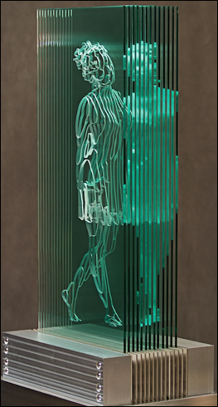
Example found on ‘My Modern Met’
More examples:
- http://www.jedmalitz.com/biblicalsoulsproject
- http://artofmiami.com/2011/12/26/miami-artist-freezes-lebron/
- https://mymodernmet.com/ardan-ozmenoglu-glass-tree-sculptures/
So, we have our ‘Reform Line,’ that is the key ‘Reform Line’ at the end of Modern Israel. Then to understand the ‘Reform Line,’ we can take these other lines (like the ‘Third Diadochi War’) and it’s like one of these layers of glass. You put it over our ‘Reform Line,’ and all of a sudden it will transform it; it will add depth. All of a sudden (out of our ‘Reform Line’), will become a story about the Gulf War, the Iraq War, the invasion of Ukraine. So, these other lines are laid over our ‘Reform Line’ and they add depth and meaning. Each layer is to help tell a particular story. So, one of the layers of glass that you would overlay our ‘Reform Line’ with might be the story of Isis, radical Islam. Another layer might be the First World War (WW1), the story of the King of the North (KoN) and the King of the South (KoS). Another layer of glass might be Church and State, and we would talk about the Moral Majority and Jerry Falwell. So, does that makes sense? Can everyone picture what we are doing?
So, we have all these other layers of glass and we don’t put them all over our ‘Reform Line’ at once. If we were to do that, we have such a quantity of information now that there would be no space between the letters; the whiteboard would be black. So, what we do is strip our ‘Reform Line’ down to the basics; just that base ‘Reform Line,’ that bottom layer of glass. And then we go through all of our stories, and we pick what story we want to tell. Here [what we have been covering today] we want to actually talk about the messages, the internal change. So, we are not going to add all of those layers, this is the messages. But we just take these added layers, and we pick which one we want to overlay depending on our story. It becomes important that we do not mix our stories.
I will give you an example. In October of 2018 we made a prediction. We said that in 2019 Donald Trump would be impeached. How did we do that? We went back to 1865 (see Boardwork 25:08). In 1865 Abraham Lincoln is assassinated. He is against slavery; he is for equality. He has been fighting for equality. He is assassinated in 1865 and the Vice President takes power, Andrew Johnson. Andrew Johnson is pro-slavery; he supports the South. Abraham Lincoln had only allowed him into his government to try to appease the South. Abraham Lincoln is against slavery and he is assassinated. Andrew Johnson becomes president and he is for slavery. Johnson has an interesting personality; he likes abusing people, giving nicknames to his political opponents, and conducting massive rallies. He gets so bad that in 1868 he is impeached.
Boardwork 25:08
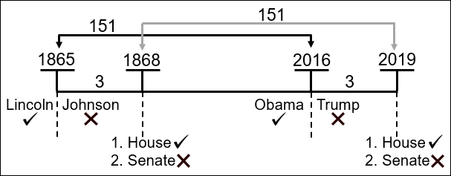
This is the first presidential impeachment. For someone to be impeached the House of Representatives votes. The House of Representatives draw up articles of impeachment and then they vote. The House voted to impeach him. Johnson was impeached by the House. But to be removed as president the Senate then has to vote to impeach him, but the Senate did not. So, Johnson was impeached, but he was not removed.
We went to this story and we used the 151 (see Boardwork 25:08). In 2016, which is 151 years from 1865, the president changed from Barack Obama, who was for equality, to Donald Trump, who was against equality. One is essentially for slavery and one against slavery. Andrew Johnson did not win an election. Trump did not win an election legally. Three years after Johnson became president, he was impeached. Three years after Trump became president, he also faced impeached. The House voted and he was impeached. Trump is [was] a president who has been impeached; but for him to be removed the Senate has to vote against him and they did not. So, you can see, it followed the same pattern [as Johnson’s impeachment] just as we expected that it would.
Boardwork 25:08
Elder Jeff launches an attack; he says that this is a failed prophecy, because the vote to impeach Donald Trump in the House did not take place on November 9 [2019]. He says it is a failed prophecy, because the vote in the House did not take place on the 9th of November. The problem is, he is doing what we can tend to do; we actually make the same mistake quite regularly. When we think about our layers of glass, we need to keep them separate. And this is a story of impeachment; it is not the story of November 9. So, Andrew Johnson was not impeached on November 9, 1868. There is no connection to November 9 when it comes to America’s history of impeachments; and it’s not part of our story. So, what people try and do is they try and fuse together these layers of glass, when they should be separated, studied, and if reasonable, overlaid; but you don’t fuse or force them together.
The House was never going to impeach Donald Trump on a Saturday; and we knew that November 9 was the Sabbath from the beginning before the message was even presented. We get into trouble when we start mixing our layers; and everyone who does not understand the message properly does this. And almost every time that Elder Jeff attacks this message, it’s because he is doing that. He doesn’t understand the layers.
Coming back to here [1989 on the line of the Priests]. We have key ‘Reform Lines;’ that’s our base. Then over our base we can place different stories. In 1989, what’s given us becomes the foundation of everything else that we study and do. Everything else is built on ‘Reform Lines;’ the first thing people have to abandon when they leave this Movement. If people actually believed ‘Reform Lines’ (which is what was given us at the ‘Time of the End’), no one would ever dare leave this Movement.
Boardwork 29:39
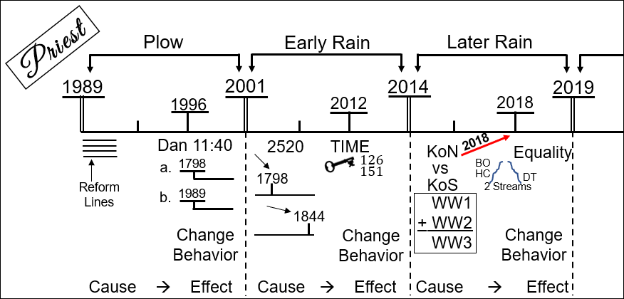
So, we approached each dispensation. ‘Reform Line’ themselves are innocent (see Boardwork 29:39), but they are going to develop into a challenge, a test. This doesn’t hurt [the first part of the message-the cause], this does [the second part of the message-the effect]. This doesn’t require a change of behavior [the first part of the message-the cause], this does [the second part of the message-the effect]. So, ‘Reform Lines’ became Daniel 11:40-45. Come to the ‘Early Rain.’ The ‘2520’ does not challenge you in any way; it’s a time prophecy that ended in 1844, the last one. But it is a ‘Cause’ that leads to an ‘Effect,’ time setting, that requires a change of behavior. This [‘Reform Lines’ and Daniel 11:40] is one message; cause and effect. One message [‘2520’ and TIME]; cause and effect. Then we came to the ‘Latter Rain’ [KoN vs. KoS and Equality]. How is this cause and effect? How do we go from WWI/WWII to study equality between men and women? Does someone want to answer that?
Boardwork 32:03
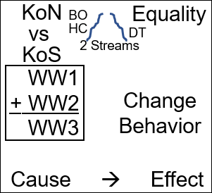
So, it is all encapsulated in the ‘Two Streams of Information’ (see Boardwork 32:03). So, equality is already there, but no one can easily define it. How do you go from World Wars to Church & State? So, we want to go from King of the North/King of the South (World Wars) to equality. Kathrine reminded us of ‘Two Streams of Information;’ this connects with the Battle of Ipsus (from the 4th Diadochi War), which connects to the invasion of Poland. So, ‘Two Streams of Information’ connects directly with the World Wars. Where do we go to next?
Answer from class: In the second World War you have an Information War where propaganda was used.
You can come back to the Information War model. So, one of the arguments that was used on October 3 [2019] when there was a fight with Elder Jeff about this subject of ‘Two Streams,’ he said, “Both sides are equal.” And every time he said “Both sides are equal,” our response was, “You have Churchill and Hitler, are both sides equal?” No. Was Churchill necessarily a good moral man? Probably not. But, do we care? Not really. Every time the argument was made, “Clinton is morally bad; therefore, she is equally as bad as Trump.” It is a rejection of ‘Two Streams,’ where one leads to the “Sea of Glass” and one to the “Lake of Fire.” We come back to this model, Churchill and Hitler. Let’s say it is 1933; Hitler is rising to power; Hitler has his propaganda machine. Does Churchill have a propaganda machine? Yes. Are they equally bad? Can you stand back and say, “I don’t care if we have Churchill or Hitler,” or “I’m just going to listen to no one, they are all as bad as each other.” Could you do that in 1933 Germany? No. You had to stand on the side of Churchill; because whether or not he was particularly moral in his private life, whether or not you thought he shared propaganda, all of that becomes irrelevant. Because, even prophetically (and people were required to see this separate from that), if you are standing in 1933 you don’t get to say they are as bad as each other, and I am supporting no one. You have to be able to choose between right and wrong. Does that make sense? So, I am just referring to what was mentioned, bringing this to an ‘Information war’ and propaganda.
We’ve looked at the ‘Two Streams.’ I had already brought this subject to the Movement. You could see that ‘Race’ was the issue under everything else, connected with this issue of ‘Sexism.’ But that wasn’t enough; ‘Two Streams’ weren’t enough to bring a solid message of equality in a way that gave people no excuse. So, what step had to be taken? What model has to be used? When you are talking about the King of the North and the King of the South, what model are you automatically forced to use before you get to Church and State? It involves the World Wars, that you have North and South. So, what model is that? Geography. So, King of the North/King of the South forces you to use the ‘Model of Geography.’ We don’t just rifle through our models and pick one; it is already given to us.

Boardwork 40:20
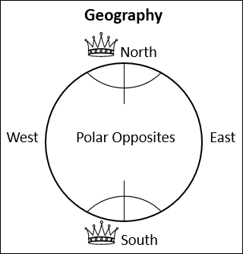
We have North and South, King of the North/King of the South (see Boardwork 40:20). So, once we have King of the North/King of the South, we bring them to the ‘Model of Geography.’ We think about the four directions of the compass, because Daniel 11 will tell you there are four, not two. There are four directions to consider; but it ends on focusing on North and South, because these are the ones that are polar opposites. These are the ones on which the rest of the World turns. It turns from the North and it turns from the South. And what did we say about the North and South, these two Poles? We had two thoughts. 1. They are opposites, as opposed to each other as they can possibly get. That’s why they are called polar opposites. 2. And, at the same time they are completely opposed to one another, they are the same; they are almost identical. One has ice and the other has ice. They are in many ways so similar that if you were standing in one you would not know which one you were at. It’s not like one is really cold and one is really hot.
[Someone from the class said, “Mirror image.”] [Elder Tess’s response] I like the concept of a mirror image, because it is completely switched but it is the same image; it’s not a new picture. That is a good analogy. So, the King of the North and the King of the South are a mirror image of each other. It isn’t as if the North Pole is really cold and the South Pole is really hot. And that’s the way we have kind of pictured it in the past. We would say the King of the North is all religious and the King of the South is all atheist. KoN, all religion; KoS, no religion. And that is not a mirror image. Instead, we find them both in this Church/State relationship.

Boardwork 44:13
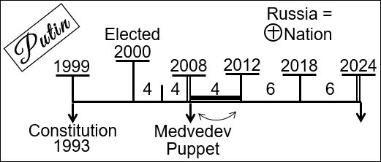
So, we began to consider Vladimir Putin. We saw how he became president in 1999 (see Boardwork 44:13). He is elected in 2000. He runs two consecutive four-year terms; that is all he is allowed in their constitution. He steps down. He places a puppet [in as president, Dmitry Medvedev], who runs just one term. So, Putin forms a plan before 2008 that helps him hold onto power. In 2012 he returns [as president], [with the term limits] changed [from] four-year terms to six-year terms, which give him an extra four years. So now it’s like he has been able to run for three terms, three of these four-year [terms]. So, these [the two six-year terms] end in 2024, and he already has a plan.
Terms were extended from four to six years in 2008, during Dmitry Medvedev's administration. ~Wikipedia
I’ll give you an article from The Guardian. It’s called “Russian Government Quits as Putin Plans to Stay in Power Past 2024.” So, Vladimir Putin has begun this attempt to completely reshuffle power in Russia. There was a constitution written in 1993 by Boris Yeltsin, and now Putin is working to amend that constitution, shaking up other sources of power. He announced that he was going to do that, that he would bring about a national referendum to remake the constitution in a way that would shift power away from any new president to the state council. Sometimes there is so much news right now we can miss major stories.
UPDATE April 5, 2021: Moscow Russian President Vladimir Putin signed into law on Monday a change to the country's constitution that will allow him to run for two more six-year terms, granting himself the chance to remain in power until 2036. ~CBS NEWS
Dmitry Medvedev, the president from 2008-2012, was his Prime Minister. Early middle January [2020] Putin announced this plan and Medvedev resigned as Prime Minister, and with him, resigned the entire Russian Government. They resigned in full, hours after Putin’s announcement. So, you can see how this has shaken up Russian. We spoke briefly about this change, moving the power from the President to the State Council. Some people are still suggesting that he might actually move it to the role of Prime Minister, and then become Prime Minister. That is exactly what [Recep Tayyip] Erdoğan did in Turkey [as President]; he changed the balance of power between President and Prime Minister. So, that is what Putin is currently doing [2020]. But to have peoples support in doing this, he is allowing everyone to send in their ideas for a new constitution.
And what were some of those ideas? What have Protestants in America wanted for two hundred years? To declare America a Christian Nation. So now, to get his change of power, Putin is willing to write into the constitution of the ‘King of the South’ that it is a Christian Nation. So, this [North] is not hot and [South] cold, for religion [North], against religion [South], it is much more subtle. Christians in America want it declared as a Christian Nation and Christian’s in Russian want it declared as a Christian Nation. And it is the ‘King of the South’ that is about to do that.
What else do Protestants want written into the Constitution of America? They have tried this one before and have never gotten it in. Prayer in schools is one of them, but not the one I am thinking of. It is not abortion, but you are heading in the right direction. What they want to write into the Russian Constitution is that marriage is only a union between a man and a woman. That is something Protestants in America have wanted, but never gotten in. So, the ‘The King of the South’ is about to declare his country a Christian Nation and introduce into the Constitution Christian morality.
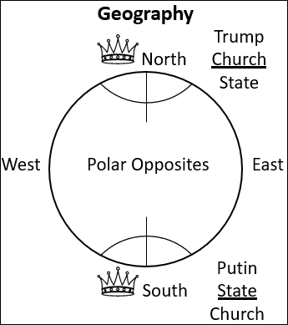
Those who reject this message, they say that America is not the ‘King of the North’ because it has an army. Question: The ‘King of the South,’ it has an army. Whose army is that? So, that is a different subject. But if they don’t want to call America the ‘King of the North,’ because it has an army, and they think the ‘King of the North’ can only be a church, they have to be consistent. The ‘King of the South’ is not the ‘King of the South;’ the ‘King of the South’ becomes a church fighting with an army. And you have to ask, on behalf of who [are they fighting]? So, that is a thought for those struggling with America being the ‘King of the North.’ But we assume they believe that Russia is the ‘King of the South,’ and that it is not an atheistic nation. So, if the ‘King of the North’ is Church over State, the ‘King of the South’ is the State controlling the Church. So, Donald Trump, he came to power because the Church allowed him. The Church gave Trump his power, and they can take it away from him anytime they choose. The Russian Orthodox Church did not give Vladimir Putin power. He, the ‘State,’ gave power to the Church, and he can take it away anytime he chooses. So, this comes back to the concept of mirror image that Sue Ellen introduced.
Do we all understand a mirror image? It’s the same image, but back to front. You don’t have an image of a phone, and the mirror image of that becomes a cup. It’s the same picture, but it is also opposite; it is switched, just like the North and South pole. Which is why there is no leading head of state in the world that is more nationalistic, white supremacist, sexist, and homophobic than Vladimir Putin. He is the one fighting for Jewish Christian morality, not for some Atheistic concept; he is fighting for the Church. So, do we have any thoughts or questions so far?
We have been talking about the ‘King of the North’ and the ‘King of the South’ as a mirror image, not as opposites as they have sometimes been portrayed. So, how do we get from that to Equality? We have gone from ‘King of the North’/ ‘King of the South,’ to the ‘Model of Geography,’ to Polar Opposites (mirror image), to ‘Church and State.’ Now, what is our next step?
People must have grown up with different sermons than I grew up listening to. Because, for the whole concept of this, Church over State, people would go to Revelation and see the woman riding the beast, Jezebel and Ahab. When they talk about Jezebel and Ahab, who is the really wicked one they hate? Jezebel. And it was always portrayed to me [Elder Tess], that they almost felt sorry for Ahab, this poor beaten down husband submitting to his wife. So, people always approached this [Church over State] and brought it to a relationship between a woman and a man, woman riding the beast. Does that make sense?
So, can someone please take us now back to the World Wars and step us through the logic to equality? Who is willing to do that?
[Elder Tess points to someone in the class.] Start with the World Wars.
[Person from the class.] So, you have the World Wars and they are taking place between the ‘King of the North’ and the ‘King of the South.’ They fight against each other. They have a Church and State relationship that is not balanced.
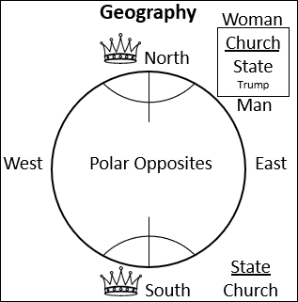
[Elder Tess pauses the person speaking.] Pause before you come the Church and State Model. We have gone World Wars to ‘King of the North’/ ‘King of the South,’ and what do you automatically have to do when you are given those names? So, we have World Wars (see Boardwork 1:02:53), they take us to ‘King of the North’ vs ‘King of the South;’ that takes us to? Geography. So, it takes you to the Model of Geography. Once you go to the Model of Geography, so this is what Daniel 11 gives you (North, South, East, and West); now what is next? You are lining them up on the Model of Geography. So, two things about them you can learn from this: 1. They are opposite, but 2. They are also the same. It’s a mirror image.
Boardwork 1:02:53
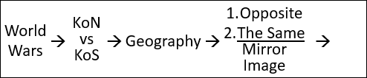
From there? [Parts of the response are inaudible.] Inaudible part. The model of Church over State or State over Church are false; they are a wrong model. The correct model should be where they are in balance. That would be where man equals woman.
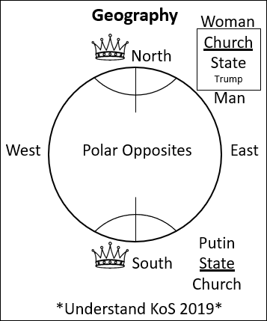
[Elder Tess.] So, we are going to go from World Wars to ‘King of the North’ vs ‘King of the South’ which forces you into a Model of Geography to a subject of Polar Opposites (1. Completely opposite 2. Almost entirely the same; it’s a mirror image). Then we see what is actually being mirrored. And the definition of the ‘King of the North’ is this Church/State relationship, where the Church controls the State. The ‘King of the South’ is a mirror image of that Church/State relationship, almost identical, but where the State controls the Church. And once we understand Church/State, State/Church, God’s people for centuries have gone to Revelation and seen that that relationship is wrong. What year did we first understand that the ‘King of the South’ is State over Church? When was that first introduced? 2019. We never understood this before last year [2019]. So, we have understood for centuries if not millennia this model of ‘King of the North.’ ‘King of the South’ we understand in 2019. It was identified in 2018, but it was not presented until 2019. Because we knew this was going to cause problems. And it had already started to cause problems just through people seeing it in the ‘Two Streams’ of information. So, do you have any questions on the ‘King of the South’ Model?
Boardwork 1:03:33
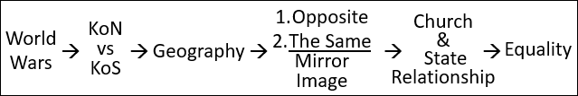
Give us some other ‘King of the South’ [examples] in history. What is another ‘King of the South’ we have in history? Ptolemy. So, Ptolemy in Egypt. That’s one. [Roland says] France. Another one? Stalin. [Elder Tess] Is it [France] a Church/State relationship? [Roland says] The State is above the Church. [Elder Tess says] So there’s a church? Because many people would argue that it is Atheistic France and that there is no church.
- Ptolemy (Egypt)
- France
- Stalin (USSR)
So, I want us to look at these three ‘King of the South’ [examples] and not go into great detail. But I know even if you don’t have questions now, this is what will come to your mind. Some may think Church/State relationship, then you will be lying in bed tonight and think ‘what about Atheistic France?’ I thought they killed the church. Does anyone want to add to that? You can pick anyone of these: Ptolemy, France, Stalin (Soviet Union).
[From the class.] Clovis adopted the Catholic Church, the Catholic faith. [Elder Tess.] Clovis did. Why did he do that? [From the class.] So, he would receive power. [Elder Tess.] So, who gave power to Clovis? [From the class.] The Catholic Church; the pope. [Elder Tess.] So, the Church gave the power to the State. So, you know that is a ‘King of the North’ Model, where Clovis only had power as the Church gave it to him. Does that make sense? So, the State wanted power; he had to get it from the Church. Donald Trump wanted power; he had to get it from Protestantism; same model as Clovis.
We will do Ptolemy last; if we work from the bottom up, Stalin. So, Stalin came to power and what did he do to the Church? At the beginning he just killed them all, burnt their churches, killed their priest. He just eradicated religion. Until when? What day did he stop? I’ll give you the year, 1941. Stalin stops crushing the church in 1941. He stopped shortly before he joined the allies. Why did he join the allies? So, Germany is the ‘King of the North;’ Germany invades him [Soviet Union]. The day they invade, Stalin’s first fear, he has put down all these Russian Orthodox Christians and other religions, and he is afraid all of those people would turn to Hitler as their savior. So, across all the radios [July 3, 1941] he transmits this message, ‘Rise up and save our Christian Fatherland from pagan Germany. He is trying to attack us like crucifying Christ, because we are this Christian nation.’ So, that is a paraphrase, but that is the essence of what Stalin had transmitted. So, we think that Stalin was just out to completely destroy the Church (he always maintained an iron grip on the Church), but he needed the Church. So, he quickly learned not to destroy it entirely. He starts by trying to eradicated it entirely, then he wakes up one day, realizes he has enemies, and realizes that he needs this Church to keep some control of the people. So, Stalin’s Soviet Union was a Church/State relationship, just where the State kept an iron grip on the Church but still allowed it to exist. Does that make sense? Any questions or thoughts on Stalin’s Soviet Union?
- Ptolemy (Egypt)
- France 1798 1801
- Stalin (USSR) 1941
Move up to France. France started the same way as the Soviet Union, the complete eradication of religion. And just like Stalin, what did they realize? It doesn’t work without religion. So, we might mock their ‘Goddess of Reason,’ but why did they do that? [Elder Tess agreeing with a comment from the class.] Because religion is the opium of the people. Problem is that someone asked Vladimir Putin if he believed that and he said, no. I would suggest he does believe that; it’s how he operates. But he sees it as something positive to manipulate. So, France, they start just like Stalin, stamping out religion. They realized fairly early that people need religion and it makes them malleable, controllable; and they tried to reintroduce a religion that they could control. That doesn’t go so well; in 1798 they take the pope captive. Three years later in 1801, what do they do? What does Napoleon do? They end the breach between France and the papacy and reaffirm the Catholic Church, not as ‘the’ religion of France, but permissible in France.
Prior to the French Revolution the Church controlled the State. They are going to turn from the Church controlling the State, the State tries to kill the Church, they realize that’s not very smart, so they accept the Church in 1801 as long as the State controls the Church, as long as they can flip that balance of power. Because the ‘King of the South’ is fine with the Church as long as it submits.
I’ll give a summary. At the beginning of the French Revolution, they are in a Church/State relationship where the Catholic Church controls the State of France. They’ve had enough of this Church, so their immediate reaction is to try to kill the Church, destroy it; but they soon realize that this isn’t very smart. It’s kind of like their ten-day work weeks, nothing operates well, smoothly. So, they try and reintroduce a Church; they bring in this ‘Goddess of Reason.’ That is kind of like a compromise; they are still trying to introduce some type of worship, even if it looks more pagan. That doesn’t work. Towards the end of the French Revolution, they take down the Catholic Church. They reintroduce the Catholic Church three years later; but the reason that they do that is because they have been able to switch the balance of power. They have no problem with the Catholic Church in France as long as it is in submission to the State. This is what they were fighting against, the Church over the State; but Napoleon is happy for a church that he controls. So, over that revolutionary history into the early years of Napoleon, it’s turning from the ‘King of the North’ to the ‘King of the South.’ And what changes inside France is that power balance, from the Church in power to the State in power. The king was in a Church/State relationship, but so was Napoleon. Napoleon was in a relationship with the Catholic Church, and he was fine with that as long as he was the one in power. Does that make sense? Are there any other thoughts or questions on France?
[Question from Tamina.] So, in this scenario Napoleon would be depicting the ‘King of the South’ and then we take the story of Napoleon and make him the ‘King of the North’ and show how he is Donald Trump? How do we do that? [Elder Tess answers.] Layers. Is Abraham Lincoln good or bad? It depends on your story. Are you telling a story of Church and State or a story of slavery? So, when Napoleon wants to be crowned emperor, he asks the pope to crown him. What’s the problem with doing that? If I got on my knees, and Tamina put a crown on my head, who is the one giving the power? The pope, the Church. So, what is Napoleon going to do. He is going to snatch the crown and crown himself, because he knows what he is doing. There is no way he going to allow the pope to put a crown on his head; he will put it on his own head. That is not the behavior of the ‘King of the North.’
Ptolemy. Was Ptolemy in a Church/State relationship? I want to give you a reference; it might only work if you use ‘Audible,’ but you might be able to find it online. There is a university lecturer, it’s a series called ‘The Great Courses.’ The topic is ‘History’ and the subtopic is ‘Ancient History.’ This one is called ‘Alexander the Great and the Hellenistic Age.’ Now, this is hours of listening; I would suggest you do what I did and skip the parts you don’t feel relevant. Professor Jeremy McInerney, he is very easy to listen to and it is a lecture that he does ‘Lecture 6: Egypt Under the Ptolemies.’ He is going to go through how Egypt operated. This one is about 30 minutes long. There are, all together, twenty-four lectures, 30 minutes each; so, there are twelve hours. It will go through the history of the Maccabees and Seleucus; there is a lot that is interesting, but if you are short on time like I am, the one I found relevant was ‘Lecture 6: Egypt Under the Ptolemies.’ And I can’t teach that like a university professor, I’ll just tell you his conclusions, his bullet points.
He would describe Egypt under the Ptolemies as the exact same system of economy as Stalin’s Soviet Union. You weren’t allowed to grow a crop in Egypt without permission of the government; and then they would tell you what to grow, where to grow, and when to plant. You weren’t allowed to own your own equipment. For example, if you wanted their equivalent of a shovel, you would need a letter of permission from the government, and then the government would lend you a shovel; you would have a sealed letter, and then when you were done with that shovel you would need to give it back. Then government inspectors would come that would look at your crop and they would say you are watering an hour to early or an hour too late or too much. Finally, an inspector would come; they would look at your crop and they would say, ‘tomorrow you are going to harvest.’ You have absolutely no choice, because that property is not yours. You would harvest it; and then you would sell it to the government. You were not permitted to sell independently.
So, Ptolemy’s Egypt, he would describe, as the exact same system as the Soviet Union under Stalin. Because, Ptolemy was not a native Egyptian, and he had to control this whole country. So, how is Ptolemy going to control this whole country? He is going to create a new religion, almost identical to their national religion, native religion, but he is going to change elements; and he is going to use religion to control the people. Then he goes into a deal with the priest; they have a contract. He will allow this religion to operate if they give complete loyalty to the government. So, Ptolemy is a Church/State relationship, but he used the Church, the whole pagan system, to control the people. In fact, if you were to look at the Rosetta Stone, the Rosetta Stone is a contract between a new Ptolemy, a new pharaoh and the priest. Because he was young, he was weak, and he had to make sure he had their support, so he writes up a new contract.
So, the ultimate ‘King of the South’ of Daniel 11, we should all know to look at the very beginning to understand the ‘King of the South.’ And Egypt under the Ptolemies was not an Atheistic kingdom. If the ‘King of the South’ of Daniel 11 is not Atheistic, we cannot define the ‘King of the South’ as Atheism. Does that make sense? The ‘King of the South’ in Daniel 11 was a Church/State relationship, but this new Greek government controlled and used the Church.
I’ll summarize. We have shown our steps for this final (our last) dispensation. What we are trying to prove is, just like our two previous dispensations, it is one message with a ‘Cause’ and ‘Effect.’ Reforms Lines / Daniel 11:40-45; 2520 / Time Setting; ‘King of the North vs King of the South’ / Equality (see Boardwork 1:36:01). The problem that most people have had, particularly those who have left, is that they think that these [KoN/KoS and Equality] are not connected. So, the message has been manipulated. And we are stepping through the history of how these opened up, to show that they are connected. That the ‘King of the North’ / ‘King of the South’ through the World Wars took us to the Model of Geography [which showed us] Polar Opposites / Mirror Image. And what they are mirror imaging is the Church/State relationship. The minute you come to a Church/State relationship, every Adventist I’ve ever met (who would talk about Revelation), understood you were talking about a relationship, even a marriage.
Boardwork 1:36:01
So, it was through the ‘King of the North’ / ‘King of the South’ that we studied and understood equality. It was ‘Cause’ and ‘Effect.’ No one had a problem with World Wars, but it was not the ‘Test,’ just like the 2520 was not a ‘Test,’ ‘Reform Lines’ were not a ‘Test.’ Our ‘Test’ was here [Equality].
There were three messages presented in October 2018: (1) ‘King of the North’ / ‘King of the South,’ the triple application of the World Wars (2) November 9, 2019 (3) Two streams of Information. People accepted the first two, and everyone thought they had passed the test; they thought that was easy, and now we can move onto other studies. This Movement was in unity; it was safe. But those weren’t the ‘Test.’ The ‘Test’ was ‘Two Streams of Information.’ So, it was the third one, that rejecting, became dangerous. And that is why from January of last year [2019], it was ‘Two Streams of Information’ that was over and over again presented. And people who didn’t understand what was happening would say, ‘You are too defensive of this message. This message is too strong. It is not such a big deal.’ But what they didn’t see developing was the crack the led directly to the split in September [2019]. Because the third one was the ‘Test,’ not the first two. It’s ‘Two Streams’ that encapsulate the subject of equality. Do you have any thoughts or questions before we close?
We used the repeating pattern [Unsealed, IoK, Formalization, Test], we stepped back from that, and then showed that there’s a ‘Testing’ message in each dispensation; and this is how the message develops. So, you can expect that in our dispensation there will be something introduced and it might seem easy at the start. If it seems easy, be careful; because if it is easy, it is not the ‘Test.’ It has an implication that we haven’t yet seen.
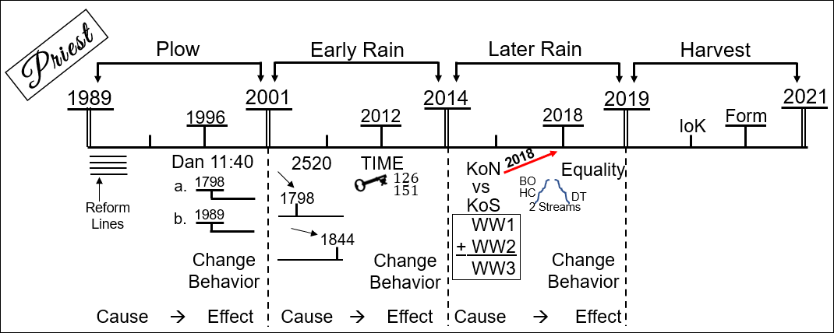

Summary of Getting from World Wars to Equality
World Wars with the Triple Application KoN/Kos Daniel 11 with the Model of Geography the North & South are Polar opposites with definite locations but mirror images Church/State relationships (difference between KoN & KoS is the balance of power) Two Streams of Information Equality (Race & Gender & Conspiracies)
Two Streams of Information
Message leads to Death | Message leads to Life
≠ (Conspiracy Theories based on Fear) | = {Parables (Eden to Eden, Compare & Contrast)}
Race | Race
Gender | Gender

Closing Prayer
If you kneel with me, we will close in prayer. Dear Father in Heaven, thank you for our blessings. Thank you for how you have led this Movement, and the opportunity to meet at this school. I pray that you will bless these classes; may people feel comfortable and accepted, that they can speak out their doubts, that they can question, as we wrestle with these things together. May we all leave here stronger in our faith. I pray this in Jesus’ name. Amen.

J.V. Stalin, Radio Broadcast, July 3, 1941: https://www.marxists.org/reference/archive/stalin/works/1941/07/03.htm

