#2 Understanding Feminism Part 2

Elder Tess Lambert 10.28.2021

Eden 2 Eden Camp Meeting – Make the Right Choice
https://www.youtube.com/watch?v=BbHHqSaRk94&list=PLIZggmlXUrw-nLY9n5gEUZt3F1KnJD8WO&index=3

Seriousness of Gender & Equality
This is not technically the first presentation of the camp meeting. [The] first presentation for me was the 24th of October. I’d intended to do a standalone presentation on the divisions within feminism, but it's going to take probably today and tomorrow to complete. So, we're definitely not discussing China at this camp meeting.
I want to explain a little bit of my priorities, because I know that some people aren't happy. Where are we on the reform line? I’m talking ‘144,000.’ On here [the ‘144,000’ ‘Reform Line’], where are we?
Where are we [October 28, 2021] on the 144,000 Reform Line?
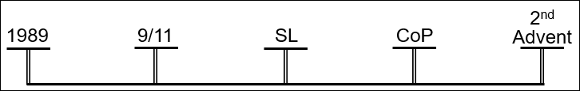
We're at the last major ‘Waymark’ before the ‘Sunday Law.’ We're just about here [‘Formalization’]. I’m not making any point about their dates. I’m not saying we're in ‘Panium.’ At minimum, I think we have the early stages of the ‘Waymark.’ We're at the early stages of ‘Panium.’ It’s the ‘Formalization’ of the Message of the ‘Sunday Law.’ So, back here in 2019, from January to August, everyone is expecting the ‘Sunday Law’ to be about the Sabbath. And then in August we say, it's not about the Sabbath, it's about gender. The ‘Sunday Law’ is a test on gender and sexism. And that's all well and good for the dispensation of the ‘Latter Rain.’ But you're not there anymore, now you're in the ‘Harvest’ [on the Priest Line]; but worse than that, now you're in the ‘Formalization.’
144,000 Reform Line
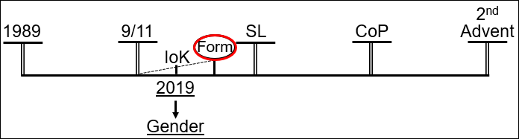
I know that some are questioning whether or not there can be a shaking in the ‘Harvest.’ I have taught from 2018 that there can and is a ‘Shaking’ in the ‘Harvest.’ But if you still reject that, consider where you are, ‘Formalization.’ It's the ‘Formalization’ of the ‘Test’ upon which the eternal destiny of every human being is decided. People are tired of me talking about sexism and gender. Consider where you are. How fearful is it that at this point in time, at the ‘Formalization’ of the ‘Test’ of the ‘Sunday Law,’ you want us to stop speaking about sexism and gender. To upset you further, I’ll be speaking about it here [at the Loud Cry before Close of Probation]. I’ve got a lot more to say. But separate to that, prophetically, do you really think that we fully understand the subject before the ‘Formalization?’ There’s too much comfort, and dislike of an uncomfortable topic. I would like to speak about China; it would be easier. It would be fun, but your eternal destiny is not decided over China. So, if we go through ‘Panium’ and don't discuss Russia once, I’m okay with that; we'll get to it later. It's fearful that people are tired of the subject of sexism in this history, and it shows still how little this subject is taken seriously. Remember the many that are overthrown here [at ‘Sunday Law’] and where they come from. They're people walking with you here [at the ‘Formalization’ before ‘Sunday Law.’]
144,000 Reform Line
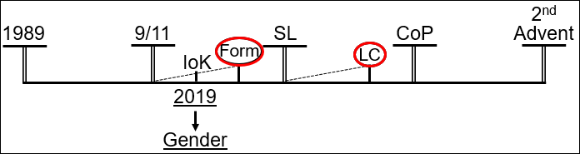

Review

Cultural Feminism
We'll review what was done a few days ago. I want to define feminism first with the Merriam-Webster dictionary. “Feminism is a belief in and advocacy for the political, economic, and social equality of the sexes. It's expressed especially through organized activity on behalf of Women's rights and interests, political, economic, and social equality.” So, in the ‘Latter Rain’ we said, “Feminism,” tick, “Freedom,” tick. In the ‘Harvest’ we look at the Democrat Party, Millerite history, and the Wig Party, COVID-19, and we say, “what does ‘freedom’ look like?” How do you define ‘Freedom?’ Because the Republicans are the party of individual freedom. Now we're looking at feminism. Do you have the same problem? In the time period of compromise (compromises of many who claim feminism), we have to divide truth from error. Our message on this subject: it has never and will never put us in a comfortable position with mainstream society. God's messages have never done that. If you zoom really far out and you look at the Sabbath and Sunday, it's possible to think that they're both the same. Zoom far out. You zoom in and you see the life and death difference. You zoom out and you compare them. Throw in the counterfeit, almost identical. You zoom in and you contrast them. And it's the contrast that is life and death. So, we're zooming in on feminism.
We discussed the broad waves of feminism. First [Wave] and Second [Wave], and introduced the Third [Wave]. Some say we are in the Fourth. But after 1991 there's much confusion, because it's more difficult to see victories. It's simple back in this [First and Second Wave] history to just see laws change, but now it's a fight over mindset; prejudice. It's harder to measure.
We discussed that there are three main branches of feminism. We began with the discussion of the first, Cultural Feminism. And that is the idea that there is a male culture and a female culture. And equality for them is lifting up female culture, which they see as cooperation, nurturing, caregiving.
I want a quote from the Guardian. Pope Francis “does acknowledge that it is ‘legitimate’ and ‘indeed desirable’ that women wish to study, work and have personal goals - but seems to set this against the need for women to fulfill their maternal duties, declaring in the same section: ‘The weakening of this maternal presence with its feminine qualities poses a grave risk to our world.’” So, Pope Francis, if he was feminist, he slides into this [Cultural Feminism] category. And when he wants to include women in the Catholic Church, it's so they can give their maternal presence, their feminine qualities, they're ethics of care. And when you see what that looks like in practice, it's not a quality. Which is why you would expect to see this in a counterfeit, because it's far from what this Movement teaches.
Early on we directly avoided heading into this [Cultural Feminism] channel of feminism, because we recognize this is not where the prophetic message brought us. And a true equality cannot come from this perspective. Understanding and accepting women's leadership in a deeply patriarchal organization like this Movement is impossible from this direction. Because if a woman is not bringing just her feminine qualities, as they define feminine qualities, no one listens; they just want mothering. And that is not equality or respect. So, this is one reason that the papacy can never achieve equality. “The pope's tentative overtures towards feminism are exciting, but they're meaningless if simply overlaid upon existing unequal foundations that he makes no attempts to change.”
To simplify the difference between the three factions, can you see the unequal foundations of society? And to what extent are you willing to tear them up? And what this article recognizes is that true feminism cannot be built upon unequal foundations; and Cultural Feminism, as long as they divide into their masculine, ‘Apis Bull’ ideas of what is male and Virgin Mary idea of what is female, it's an unequal foundation. If you believe in this [Cultural Feminism] you have no problem with the mindset of the ‘Apis Bull.’ That's all I want to say about Cultural Feminism, because I think that's simple enough to see, and as a Movement, enough people agree on this point.

What Feminist Are Fighting for and the Attacks Against Them
Before going into a more thorough discussion of what is liberal and what is Radical Feminism, we wanted to look at some of the goals of First and Second Wave Feminism, see what Radical Feminism was fighting for, and what was used to attack them. I want to go back though, to the 1850s, when women started wearing bloomers, a type of white trousers under their skirts.
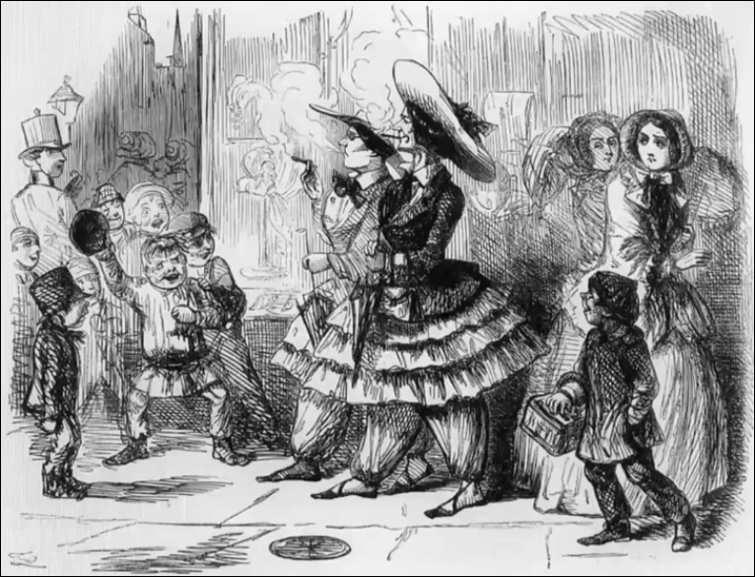
This is how they were characterized in the 1850s; compare their drawing of the women on the right to the women in the center. First of all, note the boldness [center], [and then] a degree of reserve and timidity in the women on the right. Arrogant boldness by the women in the center; note the inclusion of them as smokers, which was seen as inappropriate for women in that day. Particularly note the features [of each group of women]. Who would you describe as attractive and unattractive? This is from the earliest days, the attacks they make against women; it centers on cultural expectations of beauty. And from the very earliest days of First Wave Feminism every disagreeing man and woman knew how to attack and discredit suffragette feminists. They were taking down gender norms, beauty standards of the day. And to prevent women joining them, they were described as unattractive and unlovable.
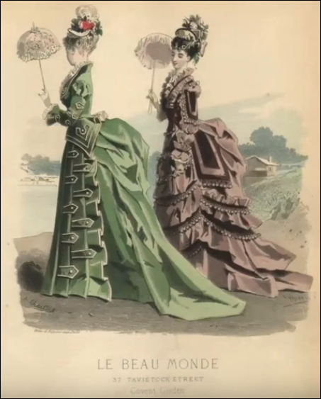
I want to make one point; in your mind where did you compare and contrast that perspective to, that photo? Because I think many people would have thought of that in the 1850s, and thought of Ellen White's position. We shouldn't do that; we should compare and contrast it with the cultural standard of the day, the beauty standards of the day. Ellen White didn't fit in with First Wave Feminism; she also didn't fit in with the beauty standards of the day. We should compare and contrast it with what was expected of women, which is more like this [dress photo on left]; and even women in poverty getting as close to that ideal as possible.
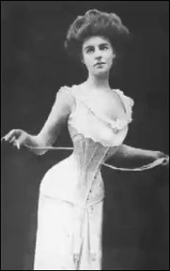
And under that kind of outfit this [underwear photo on right], because women do not need to exercise; that's unattractive. Women do not need to breathe; that's unattractive. The natural female form is not attractive enough. And the extent society will go to bring in an unhealthy, unrealistic standard.
Ellen White compared to today is not a feminist; but I would suggest that compared to her society she came much closer to equality than we give her credit for. She spoke of a man and woman's mind as having equal capability, if correctly trained; that's radical for her time. She spoke up of women needing to make their own decisions, maintain independence of thought, not being constrained to unhealthy, unrealistic, and distracting beauty standards. What she did say, are radical moves to equality for her time, in opposition to beauty standards of the external with the surrounding context of what they expected from a woman's mind. So, I wasn't comparing and contrasting the trousers with Ellen White's position; she's much better than the society around her. We should compare and contrast First Wave Feminism with mainstream society.
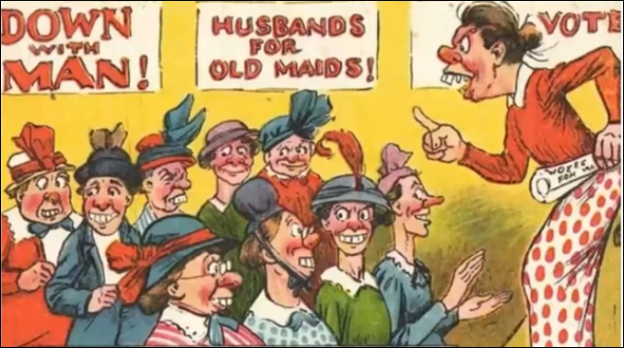
Then we come to the later days of the suffragette movement and the way they are characterized. Just in case you think anything has changed, I want to quote from the Spectator, their 2015 article, “The Decline of Feminism.” Just for context the Spectator is a far-right news source, and this article is written by a woman attacking feminism. So, we have a woman quite towards the right attacking feminism. “Making sure women are covered up in public, so their bare flesh doesn’t offend anyone, is something you’d expect in Saudi Arabia, not here, where we should be free to dress as provocatively as we please.” Just to remind you this is a far-right position. “Why shouldn’t we wear make-up, stockings and suspenders if we like? From Elizabeth I to Bette Davis, women have considered lipstick, high heels and killer hairdos to be legitimate weapons in our arsenal, as effective, in their own way, as crossbows and bazookas. But new feminists are determined to drain the fun from life …”
Like First Wave sexism and feminism and Second Wave, what's the response by the far right to feminism today? Just like Fox News screams against steps to combat climate change, they recognize and fear that true, often radical, feminism today is coming for their lipstick, their makeup, their high heels. So, if you were a Conservative Adventist in 2018, and you became a feminist by putting up on makeup, high heels, and jewelry, I have bad news; but our right would be quite pleased.
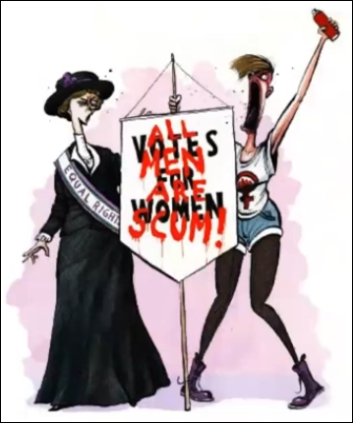
But I went to this [Spectator] article because I wanted to highlight their picture above the article. Feminism today. A woman who looks how they would characterize a lesbian and this old-fashioned woman on the left; old-fashioned and prudish, or lesbian. Remember our photo from Second Wave Feminism said, “down with men.” Now feminists, “all men are scum.” So, they give the same misrepresentation, but my focus is on appearance, old-fashioned, not feminine, unattractive, angry, unlovable, ugly. Nothing has changed from 1970 to today. As far as what true feminism fights for, and how they are misrepresented and attacked by not just the far right but the leaning right and more often than not the center and the mainstream, because that's where compromise comes in.
We went to 1968; that feminist uprising was conceived by a Radical Feminist. In fact, most of the victories of Second Wave Feminism came through Radical Feminism. And the woman who organized that 1968 uprising also made popular this main slogan for Radical Feminists, “The Personal is Political.” What that phrase means is that the choices a woman makes privately, in her home, in her marriage, in her dress, in her lifestyle, are political choices. This is in opposition to Mainstream Feminism that saw these things as private matters; they were happy for legislative changes, but they separated their private lives from political action. I would suggest that when they took that position (one that you could say is characterized by individual freedom), I would suggest they fall into the same trap as Cultural Feminism; and in leaving sexism within their personal lives, personal choices, that is trying to build equality on a foundation that is already unequal.
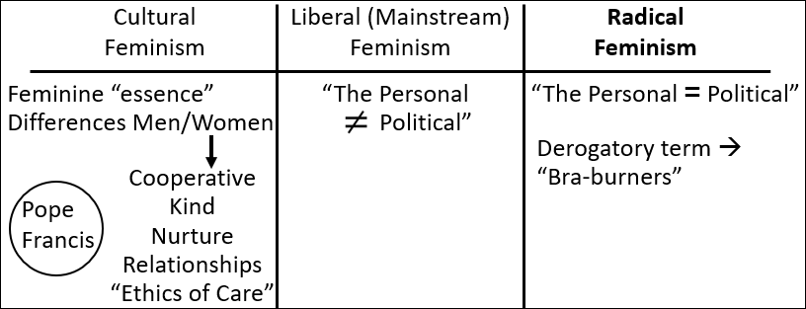
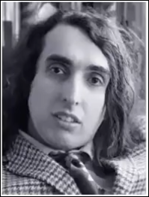
And one main personal choice that Radical Feminists were combating, were all the things they threw into the freedom trash can: shapewear, eyelash curlers, makeup, and women's magazines (that are full of things that make your brain dead and direct women's focus on the body). That freedom trash can is where the characterization of “bra-burners” came from, because it's easier to horrify people by saying “bra-burners,” than makeup-burners. And the response: “Art Buchwald spread the myth nationwide. ‘The final and most tragic part of the protest,’ he wrote, ‘took place when several of the women publicly burned their brassieres.’ ‘If the average American female gave up all her beauty products she would look like Tiny Tim and there would be no reason for the American male to have anything to do with her at all.’” Now Tiny Tim (see image on right) was a musician. They thought without makeup women would look like this or something close to it.
1970 Miss World. “’I am very, very happy to be here at this cattle market tonight,’ Bob Hope tells a packed-out Royal Albert Hall. ‘Moo. It’s quite a cattle market, I’ve been back there checking calves.’” There are more women in the audience cheering and out the back ready to be inspected, then they are there protesting. It's not a popular position. That's our review of what we discussed on the 24th.

Defining Feminism
Now I already have a position on Liberal and Mainstream Feminism; and I already have a position on Radical Feminism. So, I’m not going to pretend that I’m coming into this meeting without a position; but as far as I inspect every part of our prophetic message, I would argue that mine is the only one in agreement with it. One of the things that divides Mainstream Feminism from Radical Feminism is individual and personal freedom. Can we make personal choices that don't tie into wider issues of equality and affect women around us? It's best described with the phrase, “the personal is political.” But there is another way that Liberal Feminism thinks that was first said by a Radical Feminist (and it's said in a way that's clearly negative), “anything a woman chooses is empowered, because SHE chose it.” And this is an argument that gets used over and over and over again. So, the Liberal Feminists and the women at the beauty pageant say, “don't tell me I’m not a feminist, I chose this. I’m empowered to make my own choice.” We're going to come back to that issue.
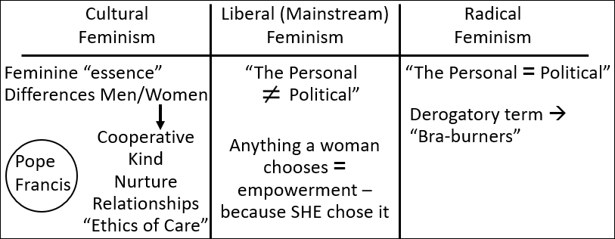

Liberal Feminism
“Liberal Feminism: this is the variety of feminism that works within the structure of mainstream society to integrate women into that structure.” This is a key difference. Liberal Feminism wishes to bring women into the structure of society. Radical Feminism wishes to deconstruct and remake society, because they see that sexism at that very foundation is built into society. To move this into a racial context, do you want more African American police officers, or do you want to defund the police system? Do you just want more representation, or do you want to deal with the institution, the construct? Moving that back to gender, Radical Feminism wants to take down the very foundation, and that's where it comes as the idea of being radical; because they see sexism everywhere, and they pay attention enough to see the damage it does.
“Abigail Adams and Mary Wollstonecraft were there from the start, proposing equality for women. As is often the case with liberals, they slog along inside the system, getting little done amongst the compromises until some radical movement shows up and pulls those compromises left of center. This is how it operated in the days of the suffragist movement and again with the emergence of the radical feminists.” I find it interesting how they discuss Liberal and Mainstream Feminism as full of compromising, because they're happy with the sexist foundations of society and culture, which is why it is what we are combating in this dispensation.
“Seen by many as the ‘undesirable’ element of feminism, Radical feminism is actually the breeding ground for many of the ideas arising from feminism; ideas which get shaped and pounded out in various ways by other (but not all) branches of feminism. Radical feminism was the cutting edge of feminist theory from approximately 1967-1975.” [1967-1975 are] the key years of Second Wave. “It is no longer as universally accepted as it was then.” So, what has gained the vast majority of ground within feminism after 1991 is Liberal/Mainstream Feminism, which is much more palatable. The core belief of Radical Feminism, connected to that core belief that it's the very foundations that are sexist. “The reason this group gets the "radical" label is that they view the oppression of women as the most fundamental form of oppression, one that cuts across boundaries of race, culture, and economic class. This is a movement intent on social change, change of rather revolutionary proportions.” “Early radical feminism, arising within second-Wave Feminism in the 1960s, typically viewed patriarchy as a ‘trans historical phenomenon’ prior to or deeper than other sources of oppression, ‘not only the oldest and most universal form of domination but the primary form’ and the model for all others.”
Eve, Cain, Ham; gender, worship, race. All those quotes are saying, ‘all that is, is an external description of the Eden-to-Eden Model.’ If it makes you uncomfortable, all that is, is verbalizing our prophetic model. Fifteen hundred years before Ham sinned, this was already introduced. And by the time you get to the flood, we have four women on that Ark and they've already lost every identifying characteristic accept who they belong to. And if you don't understand how horrific that is, what do you think it means when Ham uncovered the nakedness of his father? I won't answer that here; I’ll leave that to my dear friend. The oldest and most universal form of domination; it exists across every boundary of race, class, and border. It's worldwide. The history of a worldwide death. I have a feeling that some people will find it uncomfortable to view sexism that way. I would suggest that's just an issue of ignorance and denial.
Among the Radical Feminists of the 1968 protest were the authors of the following statement, “Women in our society are forced daily to compete for male approval, enslaved by ludicrous beauty standards that we ourselves are conditioned to take seriously.” The response to women wearing trousers was the same. The article says, “The public reception was not unlike the response to early dress reformers.” So, we're drawing a clear line through the history of feminism, from the women who fought for the right to wear trousers, the right to vote, and then the women fighting against makeup and beauty standards. And the public reception was the same. “Feminists were seen as ‘dowdy,’ ‘frumpy,’ ‘moralizers,’ who hated men because they could not attract them. Because radicals gained disproportionate media attention, the early feminist movement, in general, and its critique of beauty in particular, was often dismissed even by those who accepted most of its other egalitarian principles.” To quote a Liberal Feminist of the time, she “voiced a common concern: ‘The image of the movement comes from the individuals in it; if large numbers of them are unattractive the movement as a whole is bound to be so too.’”
So, that's a Mainstream woman's fear during Second Wave Feminism. We need to embrace beauty standards, have enough attractive people within feminism, if we want people to take it seriously. That was in her book published in 1987, The Skeptical Feminist.
Then we come to the very latest days of Second Wave Feminism, 1989. Keep in your mind “The personal is political.” Price Waterhouse vs Hopkins a case in the supreme court: “Hopkins an accountant who was turned down for partnership by Price Waterhouse claimed she was discriminated against because she did not conform to feminine stereotyped behaviour. She claimed assertive behaviour was considered offensive for her but acceptable in a man.” She wasn't exhibiting cultural feminism. “Even a male supporter urged her to conform more to feminine standards. As one member of the firm put it, her problem would be sold if she would quote, ‘walk more femininely, wear makeup, have her hair styled, and wear jewelry.’” She didn't fit into Mainstream Liberal Feminism. She won that supreme court case.
So, where do we look to understand feminism? Whatever issue we're looking at, whatever topic, we tend to find it summarized in the 1989-1991 history. Two things happened in 1989, one in 1991. Number one: intersectionalism - describing the added discriminations and oppression of women who are also fitting into another category. If a woman is woman and she's also African American (or a woman of color), those two issues intersect and make the discrimination she faces in society even more extreme. We would also include in that intersectionalism, issues of LGBT. 1) Intersectionalism. 2) Price Waterhouse versus Hopkins, discrimination based on a decision to not fit into mainstream beauty standards. 3) 1991 Anita Hill. How a woman is treated and believed when she speaks out against abuse, in her context sexual harassment. Those three issues in a nutshell are the issues that true feminism is identifying and fighting today.
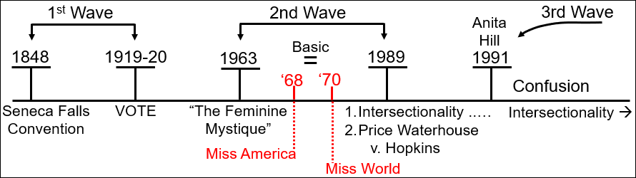
We'll try and finish this topic tomorrow. I think we've already laid a framework to discuss Liberal versus Radical. And I hope that we are clear enough on Cultural. And our need to understand this is connected to two issues, for priests, the dispensation of compromise, for 144,000, the formalization of the message of the Sunday Law, the formalization of understanding gender, sexism, feminism; not a popular position.

Closing Prayer
If you will kneel with me, we will close in prayer. Dear Lord, thank you that we can meet. As I see the people from all over the world, from South Sudan, Poland, Kenya, Colombia, Tahiti, how blessed that we can see each other. I pray as we prepare for the Sunday Law, may we, with the appropriate fear, consider our position and our witness. I pray for a blessing upon the other speakers. We know you are here with us, so I don't ask for that, because I know you are. May we see your character through looking at it directly, and also through understanding the counterfeit and what it is not. I pray this in Jesus name. Amen.

Merriam-Webster Dictionary. https://www.merriam-webster.com/dictionary/feminism
Bates, Laura. “Is the pope a feminist? Well, it’s complicated.” The Guardian. April 12, 2016. https://www.theguardian.com/world/womens-blog/2016/apr/12/pope-feminist-document-family-life-amoris-laetitia-feminism-progressive-head-catholic-church
Ibid.
Hill, Emily. “The end of feminism.” The Spectator. October 24, 2015
Ibid.
Gay, Roxane. “1968: The Year That Shattered America.” Smithsonian Magazine. January 2018. https://www.smithsonianmag.com/history/fifty-years-ago-protestors-took-on-miss-america-pageant-electrified-feminist-movement-180967504/
Hall, Harriet. “’We’re not ugly! We’re not beautiful! We’re angry!’ The feminists who flour bombed the 1970 Miss World pageant. Independent. Nov 27, 2020. https://www.scribd.com/article/486600293/We-re-Not-Ugly-We-re-Not-Beautiful-We-re-Angry-The-Feminists-Who-Flour-Bombed-The-1970-Miss-World-Pageant
Dr. Chatterjee, Subrata. “Feminism.” Module-15 of school curriculum. http://www.khejuricollege.in/doc/pdf/15%20FEMINISM.pdf
Ibid.
Ibid.
Ibid.
Ibid.
Shissler, Ada Holland. "Beauty Is Nothing to Be Ashamed Of: Beauty Contests As Tools of Women's Liberation in Early Republican Turkey." Comparative Studies of South Asia, Africa and the Middle East, vol. 24 no. 1, 2004, p. 107-122. Project MUSE muse.jhu.edu/article/181225.
Rhode, Deborah L. “Appearance as a Feminist Issue.” SMU Dedman School of Law. https://scholar.smu.edu/cgi/viewcontent.cgi?article=1450&context=law_faculty

