#4 The Personal is Political

Elder Tess Lambert 10.28.2021

Eden 2 Eden Camp Meeting – Make the Right Choice
https://www.youtube.com/watch?v=dBF38wg9YNk&list=PLIZggmlXUrw-nLY9n5gEUZt3F1KnJD8WO&index=7

Opening Prayer
If you'll kneel with me, we'll start with a prayer. Dear Lord, thank you for your Sabbath Day. We pray that you will be here with us as we meet together, understanding your character; may we learn to reflect it. I pray this in Jesus’ name. Amen.

Introduction
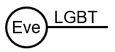
I just want to repeat, everything that we are discussing, as Elder Parminder has said, everything is being approached in a prophetic context; and I hope that we can see that through these messages as we divide feminism. I have had questions about the subject, LGBT, and why I have gone back and I’m pushing the subject of women's rights, women's treatment. When I taught in Sacramento, I spent the vast majority of that Camp Meeting discussing how the Ancient World from Assyria, Egypt, to Rome, viewed and treated Eve. We needed to understand how Greece viewed Eve. Only when we understood how Greece viewed Eve, could we understand how Greece viewed what we would describe today as homosexuality.
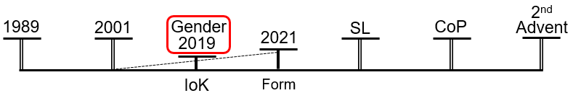
When I taught gender back here [2019], those in opposition to what we were teaching, then they said the next thing Tess and Parminder will do is except homosexuals. The reason that they knew it, is because it branches from here [from Eve, see Eve/LGBT image above]. And how society views a gay man today has a direct connection to how they view a woman; just like it did in ancient Greece. The seed of the issue is Eve; it continues to be the Sunday Law test. And for about 18 months now (especially the last year), I think to at least some extent members lost their focus on this [Eve]. And their approach to this [LGBT] was not prophetic but emotional. And I’m a lot more sympathetic to that than my words make me sound, but I would suggest it is dangerous because it [LGBT] won't be unpackaged properly unless this [Eve] is. That's the first issue.
The second issue is that abusive people within the movement feel that they have passed any test. [There is] nothing to learn about sexism; no need to change, because they say they accept this [LBGT]. But the person who irritates them on a daily basis is their wife or their daughter. It leaves people with a false sense of security. So, I don't mean to ignore this [LGBT] subject, but this [Eve/Sexism] is so deeply ingrained; this is what needs to continue to be unwrapped and pushed, which is why we are not stopping discussing it in the history of the ‘Formalization’ and we'll be continuing through to the ‘Close of Probation.’
We have a limited amount of time. I’m going to be cheeky and remind the French that they started late, and that's the excuse I’ll be hiding behind. I want to complete the subject this morning, in this presentation.
We looked at dress reformers, those in the 1800s wishing to put on some form of trousers. They were ridiculed, stoned, and that kind of died of death for a while. But within each attack was also a representation that they were unattractive. Suffragettes [were] imprisoned, force-fed, often sexually abused, labeled as unattractive, unlovable.
Second Wave Feminism. It's here that they launched the most solid attack against society's expectations of beauty. Labeled unattractive, men will want nothing to do with them; and that is a fear that Liberal Feminists spoke of, that they would not have success as a movement unless enough members were physically attractive. But Radical Feminism fought that.
1989, [Ann] Hopkins, she takes the famous law firm, Price Waterhouse, she takes them to court and wins, because this is just one example of something that happens prolifically. Without makeup, high heels, jewelry, she was discriminated against in her profession.
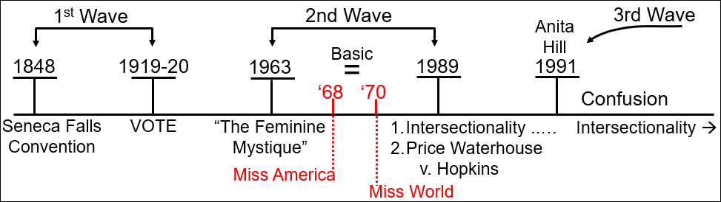
After 1991 feminism fragments. Since then, it's Liberal Feminism that has gained the loudest voice within feminism, and there are a few reasons for that. One reason: who here thought that bra burning was a thing? Disinformation sticks. That representation stuck on both men and women, and it was resented by women. The reason that appearance is so often targeted, is because it is so often effective; it stings. When someone goes for your appearance and your personality (and often you're in a situation to not offer society much else and you're raised in a way that leaves you without a reasonable amount of self-confidence), I can't describe how deep that runs and how hard it is to shed it and regain confidence in your appearance. And that's one reason that so many people found Liberal Feminism more palatable.
The second reason: what happens when you attack a group of people with something? When you attack African American men, that they will be poor, they will be powerless, and you use the n-word, what then happens? Go to a rap song and listen to it; they don't just take the n-word, they talk about power and money. They're not more greedy for money than a white person. They're taking what was made to make them feel powerless, they've taken it for themselves and they're throwing it back.
One thing that Second Wave Feminists fought for… I don't know if you know, there's a tv show called Madmen. Back in the history of Second Wave Feminism, as women try and enter the workforce, there are men and then there are girls; and Second Wave Feminism fought for people to stop calling women girls. There are men and girls; men and chicks, but what's a chick? It's a baby. What happens a lot within sexism, it's a type of objectification, but it's around being seen as childlike. At what stage of a woman's development is she perfect? If I was to say it in an ugly way, what age does she start growing body hair? She has to freeze herself, not at the age of a woman, but the age of a girl; we see that reflected in beauty standards today.
Back to the 90s, the rise of girl bands. They spell it something like this, ‘grlzz.’ They're all edgy. But they're looking at responses, or it is a psychological response to the fight that has only just ended. They take on and use words like ‘whore.’ They become more and more sexualized. And I want to change our perspective of them, not to defend and say that their response was right or helpful, but to understand why there is this response in society. Because what happens is the victim gets blamed. It's just that singer who can't keep her clothes on. I would like us to view them as the victim, if you look at cause and effect of an abusive society. That doesn't make their response right, in fact I would argue it's harmful to them and feminism. But it hasn't come from the place that a conservative would say it has; it's come from a response to the targeted attacks on Second Wave Feminism, on every wave and attempt for progress for women's rights. Nowhere in this series, if I’m listened to and understood correctly, am I meaning to shame these women. What I want to discuss, is why, and is it the best way.
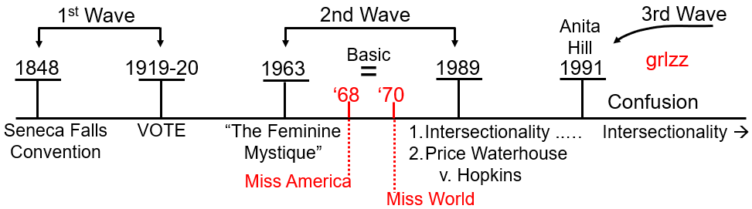
We're looking at Radical versus Liberal Feminism. Radical gets into your personal choices; Liberal does not. Liberal works within the framework of society; Radical is willing to dismantle elements of society, where sexism is too inbuilt. Liberal Feminism has this idea that if a woman is adamant that “she chose it,” then it is an act of empowerment. On all of those points, I would suggest Radical Feminism prophetically is the more accurate branch.
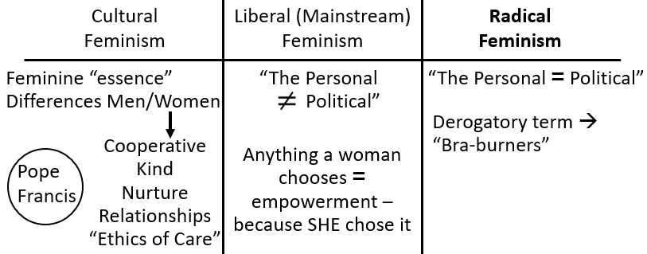
I want to deal with this idea of choice. One of the difficulties I faced in 2019 was that when I went to women in the movement and I said, headship is ugly; they said, no, it's beautiful. When I said, the patriarchal system is slavery; they said, no, it's freedom. And the reason that women fought for that, is they would tell me, they chose that for themselves. They read the conservative books on marriage, how a wife could understand her husband and make the marriage work. They have read all the quotes; they have decided for themselves that is how they would live their lives. This was the argument I encountered inside the movement in 2019. So, if a woman chooses headship, is that empowerment? Is that freedom?
A little while ago France started the discussion about banning the hijab. I’m not getting into a discussion of the rights or wrongs of that. But YouTube was flooded with Liberal Feminist Muslim women wearing that form of dress and saying, this is not sexism; this is not oppression, because I, a Muslim woman, chose to wear it. Where do you stand on that argument? If she chose to wear it, is that empowerment and freedom? Flip it. If a Mennonite woman in the United States chooses for herself to cover her head, because that's her choice, is that oppression or is that empowerment? And the position we took in 2019 was that we don't care if you chose to live under the headship model, because we were already thinking and operating like this [The Personal = Political], that there are no personal decisions that are not political. Where this side [Liberal Feminism] argues that choice is empowerment; this side [Radical Feminism] digs deeper. They go into the frameworks of society that this side [Liberal Feminism] isn't willing to challenge. And this side [Radical Feminism] says, why did you choose headship? Why did you choose to wear a burka? Why did you choose to wear a head covering? What makes something free choice when you're so impacted by your society?
Come to early 2020. Women, or actually the men speaking for the women, argue that dowry is freedom when the woman chooses to follow that path; and we are the conservatives (in their minds conservatives) and dictators, because we say, we don't care if she chooses dowry. We were absolutely consistent from our position in 2019; because we never approached it as a conservative, we approached it as a Radical Feminist.
Now we get to beauty standards, or what society frames as standard. Women say, they chose it, therefore it's empowerment. And a Radical Feminist asks, why did you choose that? What framework of society are you unwilling to dismantle? Because this side [Liberal Feminism] fits in; it doesn't dismantle, which is why they are not framed as radical. So, if you see a naked woman singing on a stage, the conservative looks at her and says, you immoral wicked woman tempting men. A Radical Feminist looks at her and says, what is this awful state of society in how it objectifies and oppresses this woman to where this is how she has to express herself, to have voice, to be heard, to be valued, to be seen as relevant. Neither side agree with how society objectifies women, neither side agree with the beauty standards that women are subjected to, but they think in different ways. So, I’m not wanting us to think like a social conservative. I want us to look at the sexism imbued through society, and think like a Radical Feminist.
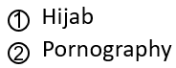
There are many areas where Liberal and Radical Feminists disagree. One would be on the burka. A second one would be on pornography, prostitution. This side [Liberal Feminism] says, women choose these industries. It can be an act of their empowerment to use and express their sexuality. This side [Radical Feminism] says, under what societal conditions are women choosing these industries?
I want to quote, “Radical feminists have written about a wide range of issues regarding the sex industry—which they tend to oppose—including but not limited to what many see as: the harm done to women during the production of pornography, the social harm from consumption of pornography, the coercion and poverty that leads women to become prostitutes, the long-term detrimental effects of prostitution, the raced and classed nature of prostitution, and male dominance over women in prostitution and pornography.”
“Feminists who oppose the acceptance and endorsement of ‘sex work’ are sometimes disparagingly labeled as ‘sex worker exclusionary radical feminists’ or ‘SWERF.’”
“Radical feminists argue that sexual liberation for women cannot be achieved so long as we normalize unequal sexual practices where a man dominates a woman.”
“It is crucial to understand pornography as a form of violence against women. Overwhelmingly, content is produced and consumed by men, with strikingly consistent themes.” “[They] reveal a dismal pattern of endless scenarios of male dominance and female subordination, categorized by specific acts, female body parts, race and age.”
“It doesn’t take a great awareness of cultural theory to grasp the social meaning of images of women being repeatedly penetrated in every orifice to a chorus of ‘slut,’ ‘bitch’ and ‘whore.’ It does, however, require a willingness to think beyond the rhetoric of ‘choice,’ ‘empowerment’ and ‘free speech’ that is invariably used by industry representatives to justify such content.”
I do want to say that while Liberal Feminism has been the most seen, since about 2017 with the chorus of voices from the #MeToo movement, people have been much more willing to see the logic in these arguments; and Radical Feminism is again growing, particularly driven by the #MeToo movement.
“This rhetoric [the framing of pornography as empowerment] attempts to distract attention from the nature of mainstream pornography and to frame those who object to its harms as censorious, illiberal and, of course, the old favorite — “prudish.” However, an examination of mainstream content reveals these arguments as little more than a defense of vested economic interests.”
“First and foremost, mainstream pornography consists of socially sanctioned acts of direct violence against women. What would be seen as sexual violence and brutality in other contexts is par for the course in pornography, as female survivors will confirm.”
“One of the things that pornography does extremely efficiently is provide an endless flow of narratives of women being treated as objects, violated or ‘done to.’”
“It is singularly unconvincing to argue that pornography is not influencing current sexual norms, and that those sexual norms do not primarily involve the objectification and violation of women’s bodies. Given the prevalence of pornography and pornified images in our image-saturated culture, one may as soon argue that being raised in an English-speaking country has no bearing on whether or not one grows up speaking English.”
She then discusses how, finally after pornography has become so prolific, there is a small but growing wave of Radical Feminists tired of negotiating with sexual harassment. So, Liberal Feminism accepts, even celebrates, these industries as empowerment. I would suggest this comes still down to two streams of information, because there is enough research, there is enough data for you to stand on this side [Radical Feminism] of the argument. The ‘True Stream’ of information is not hearing emotional arguments from the two sides; the ‘True Stream’ of information looks for evidence. And when Liberal Feminism says violent pornography doesn't affect how men treat women in society (I would say pornography in general) (they might make emotional arguments), you can't defend that from a ‘True Stream’ of information.
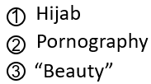
The third area they disagree, “beauty.” I just want to mention one, I guess, faction within Liberal Feminism, it's known as a branch within Liberal Feminism, it's called Lipstick Feminism. “Lipstick Feminism [believes or] proposes that a woman can be empowered – psychologically, socially, politically – by the wearing of cosmetic make up, sensually-appealing clothes, and the embrace of sexual allure for her own self-image as a confidently sexual being. The rhetoric of choice and empowerment is used to validate such overt sexual practices…” That sounds like the position of the conservative we read two days ago. I would argue that's a conservative perspective. If you want to be a woman with a platform on Fox News, if you want to work in the Donald Trump administration, I don't think a thorough investigation can excuse this as empowerment. If a woman, when she puts on lipstick, becomes psychologically, socially, politically, empowered, compare and contrast what that does when she doesn't. Use your prophetic brain, not your emotional one. She is saying, she's empowered; I think that's slavery.
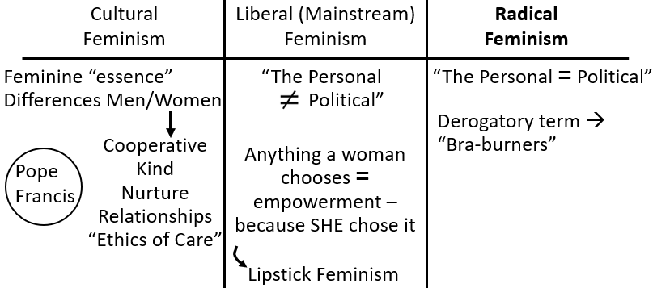
I want to go to a document; this is by Deborah L. Road. She is a Professor of Law at Stanford. She wrote this document titled Appearance as a Feminist Issue. “In 1929, in A Room of One's Own, Virginia Woolf maintained that every woman needed to consider ‘what is your relation to the ever-changing and turning world of gloves and shoes….’ Since then, that world has grown ever more complicated.” Virginia wolf is one of the most famous female authors of the time.
I just want to make one point without distracting, this is in the context, the framing of Radical Feminism. She's saying the same thing Ellen White was saying, fifty years later. Ellen white focused on freeing women's minds and their bodies, with wearing trousers and political action. But her efforts and her very existence, we should view as a feminist stepping stone. That the other becomes impossible without starting on the mind. The author then discusses the beginning of women wearing trousers, their treatment, then she moves on to Second Wave Feminism. “In the 1960s, the emergence of a ‘second wave’ of feminism brought a more fundamental and sustained challenge to the beauty industry.” “Among that group [She's discussing the 1968 protest. She says, in that protest] were authors of a statement accompanying that protest, which explained, ‘Women in our society are forced daily to compete for male approval, enslaved by ludicrous beauty standards that we ourselves are conditioned to take seriously.’”
I want to make one point; the comments made by the male journalists [Buckwalt] in 1968, they would never dare to make today. It's not so much comments from men that are now holding women in this position, though that subtly very much exists, now it's an entire social network, including social media, that exerts that pressure. Because women today say, it’s my choice. When we look at racism, slavery, easy to see; segregation, easy to see; you come past 1989, and why are even African American conservatives arguing that racism is no longer a problem, it’s gone? Because you no longer have white people back here [1960s-70s-80s] making obvious overtly racist comments. The problem that they see is that racism got baked into the way institutions operate; the book The New Jim Crow shows that. So, the fact that there are not as many overt comments from men now, does not mean that those ideas of a woman's value have not become baked into society and social media.
Beauty pageants are as ugly now as they were in 1970. The only thing that has changed is that the male host wouldn't dare call them cows. Was that the only change that needed to happen? “The public reception [to those women] was not unlike the response to early dress reformers. Feminists were seen as ‘dowdy,’ ‘frumpy’ ‘moralizers,’ who hated men because they could not attract them. Because radicals gained disproportionate media attention, the early feminist movement, in general, and its critique of beauty in particular, was often dismissed even by those who accepted most of the other egalitarian principles.”
I’m not going to read all of her [Rhode] publication, because it's quite long, but she goes into a discussion of the financial cost. “In her widely publicized account, The Beauty Myth, Naomi Wolf noted that women’s absorption with appearance ‘leeches money and leisure and confidence.’ Because women are held to unattainable ideals, their task is boundless. Almost all areas of the female body are in need of something. The result is to focus women’s attention on self-improvement rather than social action.” So, I’ve taken one part of what she says about cost; it's much longer than that.
Then she goes into the health risks; first of all, the physical, the eating disorders, the unhealthy dieting, which is about a billion-dollar industry in the United States. There's a lot of money in it. In 95 percent of the people who go on those diets, put it back on within two years; it doesn't even work. Surgeries, but worse the psychological, depression, anxiety, low self-esteem. Again, I would argue these aren't emotional arguments, they’re ‘True Stream’ of information arguments, because they can be evidenced.
I wanted to quote more heavily when she starts going into the argument about discrimination, because this is another area that can be evidenced, that I think is important and ignored. And when we talk about the beauty industry, we're not just talking about makeup, jewelry, nails, hair, all of that, we're also discussing the subject of body weight; it's very much part of it.
“Another cost of our cultural preoccupation with appearance is discrimination. Appearance skews judgments about competence. Resumes and essays get less favorable evaluations when they are thought to belong to less attractive individuals. Overweight individuals are seen as having less effective work habits and ability to get along with others. Less attractive teachers get less favorable course evaluations from students, and less attractive students receive lower ratings in intelligence from teachers. A meta-analysis that aggregated findings of over a hundred studies found that although less attractive individuals are perceived as less competent, the actual correlation between physical appearance and intellectual competence is “virtually zero.”
This is seen across all occupations, including ones like professors and lawyers, where you should not expect (not that you should ever expect it, but even then), you would not expect appearance to matter to the job function. “Discrimination on the basis of appearance carries both individual and social costs. It undermines self-esteem, diminishes job aspirations, and compromises efficiency and equity.”
“The overemphasis of attractiveness diminishes women’s credibility and diverts attention from their capabilities and accomplishments. In the long run, these are more stable sources of self-esteem and social power than appearance. The devaluation and sexualization of women based on appearance is particularly apparent for women in leadership positions.” She [Rhode] gives five examples and then her own: Condoleezza Rice, Kamala Harris, Hillary Clinton, Marissa Meyer (she was the CEO of Yahoo), Elena Kagan (who was nominated to the Supreme Court), and then she gives her own.
“I got a personal glimpse into the phenomenon just described after publicizing my book, The Beauty Bias. It was surprising how many men took time to send me comments like [one I can't read and] ‘Let's take up a collection to buy the professor a burka and improve the aesthetics at Stanford.”
Staying within the discussion of discrimination, I want to branch off into a connected issue. Prophetically, looking at it prophetically, remember we've gone from local to Christendom to worldwide. We need to say a popular quote, ‘Think globally, act locally.’ We should not think of these issues as ones that impact our own bubble. And what, perhaps, gets to me more than most of the other arguments is when we allow the structure of society, that connects empowerment to the beauty industry... I’ll read. “One other cost of discrimination on the basis of appearance is the exacerbation of economic and racial inequality. Appearance both reflects and reinforces class privilege. Prevailing beauty standards disadvantage individuals who lack the time and money to invest in attractiveness. Fashion, makeup, health clubs, weight loss products, and cosmetic procedures all come at a cost.”
“There are efforts to make the beauty industry more diverse.” I would argue those efforts are poor. And regardless of those efforts of diversity and appearance, it is impossible to avoid class. A wealthy woman in South Korea might be able to bleach her skin, but when that is connected to beauty and success, what about the woman who's subsistence farming who can't afford that? All of this comes at financial cost. And even the diversity in the beauty industry that's shown is by women from minority groups who are seen to have made it, and then attained the wealth to make these financial sacrifices for themselves.
But you want to take Lipstick Feminism and go teach at a Camp Meeting in Fiji, you don't walk those paths in high heels. And I think it is truly awful, and I mean awful, to build a society where the way a woman is viewed demands a financial sacrifice that possibly the majority of women in this world cannot access. I know white women eating the most poor and basic diets, so they can spend two hundred dollars on their hair and a new outfit, because you don't go to a Seventh-day Adventist church wearing the same dress twice and calling it empowerment. And those women have nothing, less when we move this into the subject of class and race. We can make this an emotional Movement, but think of the prophetic. This Movement against the Sunday Law is worldwide, therefore ’true freedom,’ acceptable, must be accessible worldwide.
She then discusses the double standard for men and women, the psychological impact, the fact that 90 percent of cosmetic surgery patients are women, with all the financial cost and physical risk. And then the other side of the coin, if they don't do that, they're judged. If they do all that and they don't look natural enough, they're judged. You have to do it to succeed, but you have to still look natural. She gives another example, “While women remain divided over cosmetic practices, they also often share discomfort about the culture that produces them. Appearance is an opportunity for self-expression and self-determination, but many women recognize that their options are far too ‘limited by circumstances which are not of their making.’”
They did a study of makeup in the workplace. Virtually all the women that took part argued that they had a choice, therefore it was their choice to wear or not wear makeup. But many also believed that if they did not wear makeup, or other women did not wear makeup, first they don't look healthy. Reminds me of some of my own stories. I never went to work without makeup, even in a kitchen, and I was quite sick at that time period. One day I felt better than I’d felt in weeks (and when I was sick my boss had not taken me seriously), but then the day I felt well, I went to work without makeup, and my male boss said (all the concern I needed a week ago), “Are you okay, you don't look well? So, they don't appear healthy. Second, women said that they would not look heterosexual, they look lesbian, which is code word for masculine. Three, they said women who declined to wear makeup did not look credible, and that goes deep into psychology. So, you don't promote people who don't look credible. So, while all the women in this study say, we have choice, Radical Feminism says, what are the conditions surrounding that choice? Where if you don't make the choice society likes, there are all these consequences.
Ellen White's position on beauty standards is clear. I would suggest that when we address that part of her writings, she's arguing as a Radical Feminist. One argument she takes is the amount of cost. People say that doesn't apply today, because things are cheaper. I would argue it applies even more, because the areas of a woman's body that need editing today are 50 times more than what she had. I have the quotes about how Jesus lived compared to the pharisees who chose to display themselves; because they thought that would gain them further influence with the people. “…luxuries of this life are not the portion of God's servants…” [DA 218.5] John, “…plain dress and self-denying life…” [DA 218.5] She asks, do we neglect spiritual things in order to adorn ourselves to attract attention to self? She says, “Self-denial in dress is a part of our Christian duty. To dress plainly, and abstain from display of jewelry and ornaments of every kind, is in keeping with our faith. Are we of the number who see the folly of worldlings in indulging in extravagance of dress as well as in love of amusements? If so, we should be of that class who shun everything that gives sanction to this spirit which takes possession of the minds and hearts of those who live for this world only, and who have no thought or care for the next.” [BEcho, September 19, 1898 par. 6]
These are principles that are not dispensational. We could argue and come to the same position in seconds. But the reason I’ve done this Camp Meeting, I want us to think of these things from the position of a Radical Feminist. Then when you see a woman who's subscribing to these beauty standards, it's looked at in a proper context, that what is wicked is not her character. What is wicked is the construct of society that connects her sense of value, her success in any form of career, the amount her voice is listened to, and the attraction she can receive from men, to a beauty industry that costs her financially and health of body and mind. For the women who do feel those pressures, I stand with you; it's painful and hard. I’m not trying to shame you; I have felt that pressure. I’ve often caved to that pressure, but I won't now, because prophetically I can't, not just for me but for all women. So, I’m not trying to shame you; I’m calling for understanding and solidarity. It's not possible to say, I’m empowered, because I chose this. I know how deep it runs, but we can fight it; and we can fight it easier together.
For men, I know pornography is an addiction for many. First of all, it has to be hated, because sexism is sin. But there are external programs that help with pornography addiction. I know that help can be needed. For the men, you have enough to work on yourself without looking at what women are wearing and doing. I want to clarify that; I still expect male leaders to understand, teach, and talk to women about these things, when those men understand equality and have a spiritual role.
But remember why women are in this position in the first place. And who was attacking Suffragettes and Second Wave Feminists? And who has played the major role in connecting their appearance to their worth. The men have their own psychological battle to play when they say, I stand against beauty standards, but I still find women that subscribe to them more attractive. What does that do to the other women watching, watching your behavior, your choices? It's a continual reinforcement of the connection between beauty and value. I hope that women feeling these pressures, first of all, agree with what I have said in this Camp Meeting, see that it agrees with a prophetic methodology, therefore see when it comes to a prophetic narrative, they don't have a choice. They can choose for themselves what to do, but prophetically they cannot frame that as empowerment, unless it stands on the side of Radical Feminism and is not willing to subscribe to society but dismantle it.
We've looked at the three waves of feminism. We looked at the three branches of feminism. I’d say this [Cultural Feminism] is Pope Francis. This [Liberal (Mainstream) Feminism] is compromise; just look at Fox. This [Radical Feminism] is a ‘True Stream.’ We're going to divide this [Radical Feminism] in the next meeting the road gets narrower.
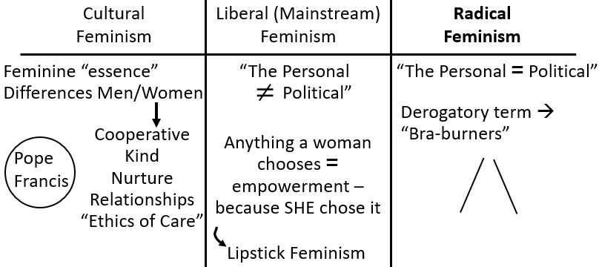

Closing Prayer
If you can kneel with me; we’ll close in prayer. Dear Lord, thank you for how you have led us. We see that your messages are sometimes hard to hear, but I pray Lord that we will see the value in them, that what is painful in the short term is empowerment in the long term and empowerment for all, not just white wealthy American women who are in slavery and often don't see it. I pray that as a Movement we'll stand in solidarity together understanding these pressures but finding our confidence in you, not in what the world offers. Through all of this may we become closer to you and your kingdom. We pray in Jesus’ name. Amen.

“Radical feminism.” Wikipedia. https://en.wikipedia.org/wiki/Radical_feminism
Ibid.
Ibid.
Long, Julia. “Opinion: Pornography is more than just sexual fantasy. It’s cultural violence.” The Washington Post. May 2016. https://www.washingtonpost.com/news/in-theory/wp/2016/05/27/pornography-is-more-than-just-sexual-fantasy-its-cultural-violence/
Ibid.
Ibid.
Ibid.
Ibid.
Ibid.
“Lipstick feminism.” Wikipedia. https://en.wikipedia.org/wiki/Lipstick_feminism
Deborah L. Rhode, Appearance as a Feminist Issue, 69 SMU L. Rev. 697 (2017) https://scholar.smu.edu/smulr/vol69/iss4/2
Ibid.
Ibid.
Ibid.
Ibid.
Ibid.
Ibid.
Ibid.
Ibid.
Ibid.
Ibid.
Ibid.

