#5 Ted Wilson and The Nature of Babylon

Elder Tess Lambert 10.30.2021

Eden 2 Eden Camp Meeting – Make the Right Choice
https://www.youtube.com/watch?v=x201X05uFKU&list=PLIZggmlXUrw-nLY9n5gEUZt3F1KnJD8WO&index=9

Opening Prayer
To begin, we will kneel for prayer. I will pray. Dear Lord, thank you for your Sabbath hour that we can meet, so we can discuss your character, this new kingdom. Whatever sounds hard to hear, help us Lord to see the glory in it; we're told it's beautiful. Open our eyes to see as you do. I pray this in Jesus’ name. Amen.

Feminism
I get to see you all twice in one day, a blessing for me. But I haven't slept, so I’m not responsible; that's my excuse.
This is my final presentation. We've taken a closer look at feminism. Feminism is the belief that men and women are equal, and it's the actions designed to try and bring that equality to a living reality. So, we should be able to see that direct correlation to our work as a Movement. It's not a simple message. Last dispensation, we could say now it was, at the time everyone complained, too much at once, too hard. Now when we look back it was simple. We need to understand what is freedom and what is feminism. So, we had a closer look at conservativism, feminism, and all the compromises in between, and how they are demonstrated in society. So, if you are confused, please go back, re-watch, to see the distinction between these three branches of feminism [Cultural, Liberal, Radical] and how we divide truth from error, how we see the links between the truth and correct methodology, and the messages of the movement.
[Playlist to re-watch those presentations: https://www.youtube.com/playlist?list=PLIZggmlXUrw-nLY9n5gEUZt3F1KnJD8WO]
As you go and read Ellen White, try and read her with new eyes. If you're going to take an external true stream of information, you need to be careful that you don't approach that external news source with an Adventist brain and an Adventist idea of what is a conservative. If you want to look at external source, you need to think (don't quote me) like a worldly person. What then becomes conservative? With a conservative brain, Adventist brain, Ellen White looks conservative. But if we understand the waves of feminism, the context of society, her objectives and goals, the opposition she faced, it certainly becomes clear in my mind that rather than being an obstacle to this Movement, she's a clear stepping stone to what we teach today, including on the subjects of dress. To see that, you need to not think like a conservative Adventist or with an Adventist idea of what is conservative. You need to think like a worldly person, where you have Conservatives, Centrists, Liberal Feminists, Lipstick Feminists; see the conservativism in those positions compared to a Radical Feminist. And when you think in that external context, Ellen White's positions were radical, a stepping stone to the position we take today. Methodology alone would teach you it had to be that way. I’m hoping with being able to see more clearly now, we can look at her writings in a new light. But you need to be able to switch between these lenses: an Adventist idea of conservative and the way the external feminist movement treats conservativism.
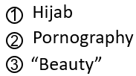
We compared and contrasted two streams of information in 2018. One way you can see what is conservative and what is liberal, check the women. Rachel Maddow versus Megan Kelly, you see conservativism in appearance; that is not how an Adventist defines conservativism and I don't want to approach these kinds of issues [hijab, pornography, “beauty”] from the position of a conservative. We should approach them from a well-researched position of what is feminism.
I want to ask people, as you go and study and teach, we are asking people to go back to the Apis Bull. Go back, cover the history between the ‘Increase of Knowledge’ and the ‘Formalization.’ But I know people will go and research these subjects; please remember to do it from a prophetic position, not an emotional one. Dissect articles, being willing to discard what does not agree, but do it with a prophetic brain and take it to reform lines.
Donald Trump, the human embodiment of the Sunday Law. If you want to know what conservativism looks like, he will show you.

Split in Radical Feminism
I wanted to just discuss one thing in a few moments and we won't spend long on this topic; so, I’m sorry if for some people it's not very thorough. But I said the prophetic position of this Movement agrees with the thread of Radical Feminism; but Radical Feminism is split into two camps right now. And I just want to make your life a little more complicated (I’d suggest the path [got] a little more narrow), and mention this split. But because it's not the topic of this presentation, I will be brief.
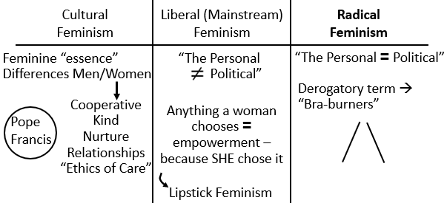
Radical Feminists are radical because they see and understand sexism, the many ways sexism is exhibited, how deep that sexism runs, how attached people are to that sexism, and the damage it does. When you have that kind of visibility, the extent of the problem comes into view; and it's a horrific sight to behold. It's not something you can just live with, like many do who live in ignorance. So, they are obviously passionate.
Now when you have (I’ll take this back to racism), you have a group of people that are suffering discrimination, and then you have these white people put on black face and mock them, for a Radical Feminist seeing and dealing daily with the extent of the problem of sexism, not all but some Radical Feminists, they look at someone who was born biologically male (with all the privileges that come with being born male), and then these (who they view as men) explain that they are trans women and then they come to society and expect to be treated as women, coming into women's bathrooms, women's private spaces, taking attention away from women's rights, and some Radical Feminists find that painful and offensive. They see correctly (I will make this point), they do see correctly the extent of gender stereotypes, but they make a mistake, because they cannot see trans women as women. They try to limit what they are fighting for, the equality they are fighting for, to cisgender women, and this has created a tension between many Radical Feminists and the trans community. They are Trans-Exclusionary Radical Feminists (TERF).
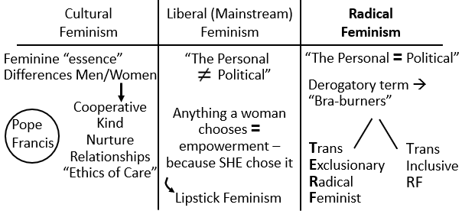
The reason Trans Exclusionary is added…I just want to tell one story I thought was nice, kind of. These Radical Feminists have a meeting one day and trans women came to that meeting. And everyone thought these trans women were there to protest against these Radical Feminists; but these trans women said, we're not here to protest. They said the only violence we are experiencing as trans women are from men, so we are here to show solidarity with Radical Feminists. What is sad is that they were still not accepted; because these Radical Feminists feel so passionately about the subject of gender, they are excluding this small group of persecuted women. And on this issue, you see the opposite sides of the spectrum unite, Radical Feminists and Radical Conservatives. But not all Radical Feminists exclude trans people; there are trans inclusive [Radical Feminist such as] Andrea Dworkin, Catharine MacKinnon, [and] John Stoltenberg (a man can be a Radical Feminist).
I just wanted to mention for your research, that when you look at Radical Feminism, many have this [TERF] wrong. Radical Feminists, some of them, are lesbians; so, they're supportive of most of that acronym [LGBT], but not the “T,” which is really sad. So, where I believe we should identify as a Movement, the only position that agrees with our prophetic message, because the vast majority even down to Eden to Eden come through this [Radical Feminism] channel. Much of the rest is compromise, or frankly, counterfeit [Cultural Feminism].

Adventism & LGBTQIA+
I want to discuss Adventism. Ted Wilson preached a sermon on October 9 [2021]. First of all, where is Adventism at? If we were to draw our reform line [see Boardwork 30:54] [Priest line] (first group called) [see info in black], 1989, 9/11, 2014, 2019, [2021], this [2019] is the shut door; this [2019] is the test. Now when you bring that to the second group, the Levites, there is that difference. Remember, we come in here [see info in blue] [see “P”], prior to the shut door. They [Levites] come in, in their time of ‘Harvest’ [see “L”]. So, I’m going to put their [Levite] ‘Reform Line’ under this [see info in red]; 9/11, 2014, 2019, 2021, ‘Harvest,’ ‘Sunday Law.’ So, they come in, in this [2021-SL red dates] history; but they're here [2021 red dates]. Where we were at in 2019, August-September of 2019, gender hit this Movement like a wrecking ball, and it made everyone think and many divide. I want to make a point, the Adventist Church is, for their ‘Reform Line,’ at the same point in time; because remember this [2021 red dates] is shut door, Harvest, Shipwreck. So, they're heading very fast for destruction.
Boardwork 30:54
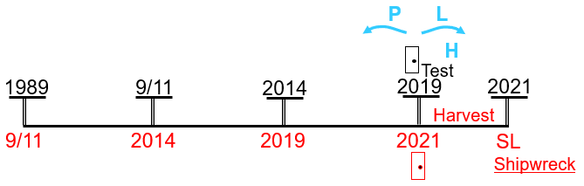
And I think as we go through Ted Wilson's sermon of the ninth of this month [October 2021], we should keep in mind where they stand as a Church. Now we are Seventh-day Adventists, so when I say their Church, I mean not Seventh-day Adventism broadly, but the General Conference.
Ted Wilson's sermon begins well. “II Peter 1:19-21 ‘And so we have the prophetic word confirmed, which you do well to heed as a light that shines in a dark place, until the day dawns and morning star rises in your hearts; knowing this first, that no prophecy of Scripture is of any private interpretation, for prophecy never came by the will of man, but holy men of God spoke as they were moved by the Holy Spirit.’”
“What a privilege to be part of God’s last-day Advent movement hurtling towards the impending conflict and the soon coming of Jesus Christ as explained in His Word.”
This is a really good start; it begins by discussing the prophetic word. Then he says, we are hurtling towards the Sunday Law. It's the prophetic word we need to understand because the Sunday Law is just about here. I would agree. He goes to Isaiah 8:20, and he says, “To the law and to the testimony!” He says, accept truth only to the word of God. I agree; I just say we need to take all God's words, all of them. You take the ones on slavery, I’ll take the ones on gender; and then we don't just take the words, we'll divide the word of God, rightly divide the word of truth.
He says, “We should expect aberrations.” An aberration means to depart from what is normal, and that is in a negative context; so, it’s a moving away from what is normal, what is right.
“The Spirit of Prophecy indicates we should read the Bible as it reads. Christ Triumphant, page 226, says: ‘The most learned men in the days of Christ—philosophers, legislators, priests, in all their pride and superiority—could not interpret God’s character. The earth was languishing for a teacher sent from God, but when He came just as the living Oracles specified He would come, the priests and instructors of the people could not discern that He was their Saviour, nor could they understand the manner of His coming.’”
So, he says, back there in Israel, the learned, the leadership, all got it wrong, couldn't see God's character, didn't recognize the Son of God. And he's saying that as a warning, because he's going to compare and contrast that with Adventism and say we could make mistakes as well. But he doesn't really compare and contrast; because in Ancient Israel who got it wrong? Where was the veil torn? Why was the veil torn? It wasn't because there were troubling members in Israel, that those good church leaders couldn't sort out. It was the leadership that couldn't see the Nature of the Kingdom, who couldn't see the impending conflict. And this is his introduction to discussing what he calls these aberrations.
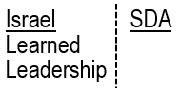
If he only understood the Apis Bull. Why did Israel not understand? Those good church leaders were still Pagan. So, if he is willing to compare and contrast and wonder why Adventism looks identical to Protestantism, he would see the danger correctly. He would say the impending conflict and the fact that the church is about to come into contact with that conflict. And the philosophers, legislators, priests, of the Seventh-day Adventist Church cannot see it coming, because they're still looking; I’ll come to that.
He discusses theological aberrations, and this is key, he says they are “absolutely connected with Babylon, confusion, and from the devil.” He said they, “blatantly and grossly misrepresent God and His Word.” So, what I want us to see is that whatever these aberrations are, they come from Babylon. Number twelve of those aberrations he shared in a tweet on twitter. “Adultery, fornication, and LGBTQIA+ are in direct opposition to God's law and heavenly plan for human sexuality. We must make a conscious choice, even though unpopular, to speak up for Bible truth and not simply go along with societal trends.”

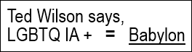
LGBTQIA+ is the full acronym for those who don't fit under the most simple gender model. What Ted Wilson here identified as this twelfth aberration, I want to remind you, he says this [LGBTQIA+], it's directly connected with Babylon. We'll come back to that.
Now I agree that we don't follow the trends of society. I agree that our positions are not meant to just be mainstream comfortable, that's part of the narrow road that we take. On October 14, by now it's already caused quite a fight within Adventism, but on October 14 [2021] Mark Finley preached. He is also assistant to the President of the General Conference. And in the midst of that civil war, he doubled down on this point.
Now we've already given our position on LGBTQIA+. But I wanted to put this sermon in a little bit of context and lay out some extra concerns about the wording he chose. What does the I stand for in LGBTQIA+? Spot quiz. Intersex. “Intersex people are individuals born with any of several sex characteristics including chromosome patterns, gonads, or genitals that, according to the Office of the United Nations High Commissioner for Human Rights, ‘do not fit typical binary notions of male or female bodies’.” According to experts, about 1.7 percent of the population is born intersex. So, 1.7 in 100 are born with this physical characteristic. You might need an x-ray, but you can see it. It's comparable to the number of people born with red hair. So, in society when you see people with red hair, that's about how often you would be passing someone who is intersex. They're born that way; you can see it. Are these people from Babylon? Do they represent a theological aberration? Are they a sin comparable to fornication?
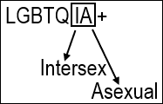
Spot quiz, “A.” Asexual. “Asexual is the lack of sexual attraction to others, or a low interest in sexual activity.” It's not the same as celibate. Celibacy is a choice. These people do not have a or do not have the same level of sexual desire. Some may marry, may have children, but they simply lack or have a lower sexual desire. Often going through puberty, being in those years, seeing the growing physical attractions between men and women, or men and men, or women and women, and an asexual youth is not relating; they're not understanding, often not understanding even themselves. And then when they discover that this exists, that some people are asexual, they understand why they are not fitting into this way society operates. So, little or no sexual attraction or desire. There can still be some. Is not desiring sex a sin? Do you think God is out there judging if people don't have enough sex? I know that sounds ridiculous, but I’m just stating the way that is now phrased. Because if Ted Wilson takes the time to lay out the full acronym, two of these he already has a problem with. Surely, they would see that that position is indefensible. When he says that people who are born with non-standard sexual characteristics or a lower level of sexual desire, but these are sin, theological aberrations from the Word of God, results of Babylon.
Third issue. I’m going to go to the guidelines for the Seventh-day Adventist Church. First, I’ll go to their official statement on homosexuality; it was written in 1999, voted on in 1999, and accepted by the General Conference. [It] was revised in 2012. They say, (Jesus) “offered caring ministry and words of solace to struggling people, while differentiating His love for sinners from His clear teaching about sinful practices.” Ted Wilson did not do this; that's the official statement standing today by the General Conference. Because he doesn't say, people who practice or act on their same-sex attraction; it's people who are lesbian, are gay, are bisexual, are trans, are queer, are born intersex, are born asexual; they're all born that way. He doesn't separate the people from the act.
2014. “Guidelines for the Seventh-day Adventist Church in Responding to Changing Cultural Attitudes Regarding Homosexual and Other Alternative Sexual Practices.” “These guidelines were voted by the General Conference of Seventh-day Adventists Executive Committee at the Spring Meeting session in Silver Spring, Maryland, 2014.” At the time of the Sunday Law, that turning point between 2013 and 2015, the Adventist Church cemented their position. Remember 2014 is their [Levites] 9/11; and they say that homosexuality “is inconsistent with the Church’s understanding of scriptural teaching to admit into or maintain in membership persons practicing sexual behaviors incompatible with biblical teachings.” There's so much in those guidelines that is concerning, so many parts that hint at the mindset of a covenanter. At least to me, it felt like I was reading parts of a covenanted document.
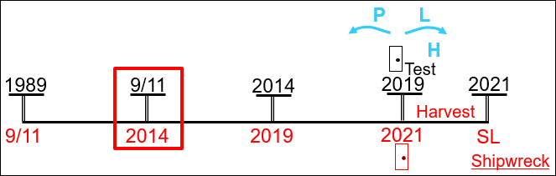
He includes intersex and asexual people in this description of sin. He never separates “sinner” from “sin.” The act, from the human being born this way. And it's cementing what they did in 2014. This community was again targeted in Issue 6, quoting them, “Moral Issues Deviating from Scripture”: “issues such as co-habitation, unbiblical divorce and remarriage, and LGBTQIA+ are confronting church leadership with increasing frequency.” “Is it unloving and unkind to take a stand against these practices?”
Note, when this quote was checked from the Adventist Review article online on 02/28/2022 the text was then written as LBGTQ+. The IA was not listed on the page, and the B and G were in the wrong order.
Now in the context of what I’m teaching on equality, please do not wrest my words from their meaning, twist them, and say that we are now accepting cohabitation and sex before marriage. Our movements to free women, are not taking us in that direction, however much some men are hoping it is. So, for those who are quoting me and twisting my words, at least to know that the person speaking those words thinks that your position is sexist and indefensible. That aside.
Is it unloving and unkind to call sin, sin? Of course not. But remember what we said before, take all the words, not just the ones you like. And when they say unbiblical divorce, remember, divorce because of abuse is not biblical. And the same church leaders who are teaching this subject, they know that. But then they try and skirt around that issue, because on that subject they don't dare, in today's society. But if they're going to take all their ‘Thus Saith the Lord's,’ and call everything else a theological aberration, their statements on divorce need to be a lot less vague. Because as Ted Wilson said, we can't just follow the trends of society. So, I would ask, be consistent, because we are consistent; we take everything to methodology. You take everything to your methodology, take a proper biblical position on slavery and divorce, and then when we come to talk, at least we'll have a stable platform to start a discussion.
Continuing to quote him, “The Seventh-day Adventist Church has carefully studied these topics and has issued voted statements by representatives of the world church that reflect the biblical view on human sexuality including statements on homosexuality and transgenderism. I encourage you to re-read these biblically-based official statements, which are available on the Church’s website.” And I want to remind us, this is a world church. And some of those representatives of Adventist leadership are speaking from countries such as Uganda, and speaking with the authority of the Seventh-day Adventist leader in the church supporting and promoting legislation that also criminalizes this community, criminalizes by the state, persecutes. Global church, global test.
The key thread I wanted to pull from his sermon is, when he takes these [LGBTQIA+] communities… I do think that some of this is ignorance rather than malicious, but what is ignorance is inexcusable. If he wants to speak with authority on this community he should go to Wikipedia and find out what it means to be intersex, and then I think he probably would not have included that. But then he needs to consider, if he doesn't even know what the acronym stands for, does he know, does he understand, this community at all? So, there's that point.
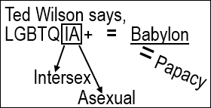
Then there's the fact that he connects this community to Babylon. And just to prove that he understands what Babylon is, we'll read further in his sermon. “Continuing in Revelation, we read in 14:8: ‘And another angel followed, saying, “Babylon is fallen, is fallen, that great city, because she has made all nations drink of the wine of the wrath of her fornication.”’ This is the church down through the Middle Ages that continues today led by the papacy.” So, LGBTQIA+ are theological aberrations from Babylon, and Babylon equals the papacy. I thought that this would be a good introduction to understanding the counterfeit.

The Counterfeit
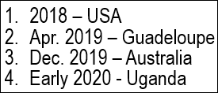
There have been four times that we have repeated and enlarged on the counterfeit, four key times. The first time was in 2018, USA. The second time was in early 2019; this was in Guadeloupe. The third time was in December 2019 in Australia. The fourth was the school, early 2020; and that was in Uganda. So, I would mark those four times, as the times where this subject has radically grown. And I have been worried that, especially this [Uganda] school (because it was a school and the others were camp meetings), it hasn't been much translated. I don't see that it has been watched much. Schools are a lot slower to watch. And I’ve never seen what was taught there repeated in English; I don't know if other languages have. And I’m not asking people to go back and watch it; there's too much from May last year to now. But I also don't want it to be lost.
So, at about the time I am to finish, I finished my introduction to the camp meeting, which was meant to be about the counterfeit, to take Ted Wilson to task for calling Babylon the papacy, and get them thinking that this [LGBTQIA+] subject is connected to Babylon. Our understanding of the Counterfeit has really refined. So, I’m not asking people to go back and watch from the school. At some stage soon I would like to condense that into a Camp Meeting format, and put in place what we know so far. Because it really becomes an incredible thought (in all that we have learned, even since May last year), where in that time we covered Adventism, Modern Israel, and Protestantism. If we just understand Protestantism, the daughter, we know the mother can never birth this [LGBTQIA+] community. What I want to do is add the mother. So, in the context of the ‘Increase of Knowledge,’ we can have all three sets of our reform lines, Adventism, Protestantism, Catholicism. Maybe we'll do that next time, and then maybe we'll do China.
But I hope people have come to terms with our priorities, that considering ‘Formalization’ of the Sunday Law, considering the seriousness of that impending conflict, this subject should absorb our attention, not that we are to neglect understanding the external war, Russia, China, proxy wars; very important. But if you're still sexist, none of that information helps you. So, we're going to stop; we're not going to go into the counterfeit now.
I just want to say one thing, one thing only. We understand that this history of what was for the Millerites was counterfeited in the history of World War I and World War II. We understand that there was William Miller and then Samuel Snow. We understand that William Miller rejected, in those final testing days, he rejected the message. We connect the leadership in this [1939] [see Boardwork 1:20:46] history to Pius XII, Hitler’s Pope. This [Miller-Snow] was in the history of slavery. This [1899-1945] was in the history of the holocaust. Racism, antisemitism. Alpha history. Six commandments [Slavery], six commandments [Holocaust]. We intend to add Pius XI into this [1917] history, connecting him to the First Angel [Miller].
Boardwork 1:20:46
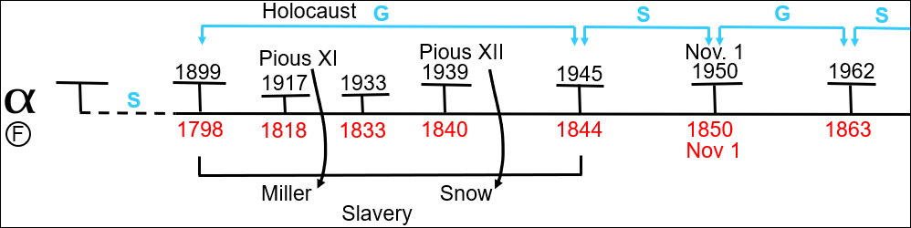
There's a famous book, Hitler’s Pope, that will explain Pious XII. In 2014 another book was published called The Pope and Mussolini, the history of Pious XI and his connection to fascism, until in 1939 on his deathbed, he rejected fascism. So, I’m going to post a link on the Media Broadcast to a panel held by a university in the United States, because this is one well-researched book written after a thorough investigation in Rome of the Vatican Archives and the Fascist Archives. There's a book panel at Brown University, the Watson Institute for International Studies, and some of the key points in the book are they discussed for those that don't have it. So, if you watch that panel discuss the book, it'll be simple in when we do get to it to just lay out the counterfeit with a few more details. Pious XI with Mussolini, Pious XII with Hitler, in the history of rampant racism. Introduction complete.
[David Kertzer Book Panel: The Pope and Mussolini ▬ February 26, 2014: https://www.youtube.com/watch?v=WQyDF6RwzDg]
I wanted that introduction to be taken through Ted Wilson's sermon, because I hope we see how serious it is, that this [LGBTQIA+ = Babylon] is the model built by the church we love. I hope we have come to the point in our experience where we see not just this [LGBTQIA+ = Babylon] has a great deal of ignorance, not just that it entirely lacks empathy, but also that it's prophetically indefensible.
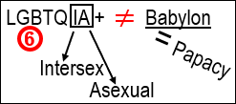
First of all, the biblical position he takes on these subjects, but second, how he connects them down through the papacy, issues that relate to the six commandments. And if Modern Babylon could be understood, then you need to see how they relate to the six commandments, therefore you cannot connect Babylon to this [LGBTQIA+] community. And for a church that claims to stand on the Word of God, I hope we can see that this isn't even in the Word of God. That even with his [Ted Wilson] quotes, he can't do that, that the right methodology can open the whole thing up. And regardless of feelings, I think that is love.
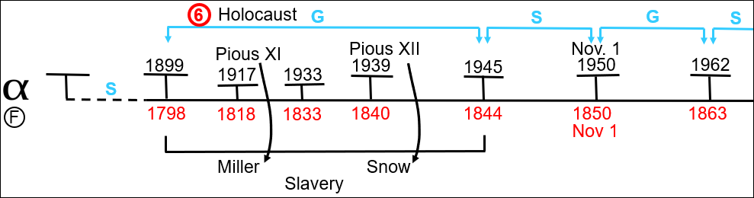

Closing Prayer
If you kneel with me, we'll close in prayer. Dear Lord, thank you that you are love. May we see your love in your messages; that while change is painful, often even freedom is painful, that our time on this earth is a war, we can still see your loving kindness. I pray that as we reach the formalization of the Sunday Law, through looking at this subject closely, carefully, we'll understand better the extent of sin and will hate it and turn from it. However much it hurts, please make our eyes see. I pray this in Jesus’ name. Amen. Happy Sabbath.

Comment From Book Panel Post on Media Broadcast
*The Counterfeit – Alpha – _The Pope and Mussollini_*
Towards the end of this last camp meeting, the subject of the counterfeit was re-introduced. While it was not covered at this camp for lack of time, elder Tess recommends the video below to add greater insight into the alpha history of the Counterfeit, covering the histories of WW1 and WW2, and the role of the Papacy in the rise of Fascism.
In the recording below the author of the book _The Pope and Mussollini_, David Kertzer, discusses the conclusions of the book with a panel of 3. This book was published in 2014 and covers the history of Pius XI, and is complimentary to the 1999 book _Hitler’s Pope,_ which discussed Pius XII.
The 1st panel member to speak does spend much of his time admiring the extent of research and value of the final result. But surrounding that, and particularly by the 2nd and 3rd panelists, and the concluding thoughts of the author, main points of the book are introduced and discussed.
https://www.youtube.com/watch?v=WQyDF6RwzDg

Wilson, Ted. October 2021 Sermon.
Ibid.
Ibid.
Ibid.
Ibid.
Ibid.
Wilson, Ted. Twitter.
“Intersex.” Wikipedia.
“Asexuality.” Wikipedia.
“Homosexuality.” Adventist.org
Ibid.
Ibid.
Adventist-Review.
Wilson, Ted. October 2021 Sermon.
Ibid.

