APS 2019: The New World Order - Tess Lambert
APS 2019: The New World Order - Tess Lambert
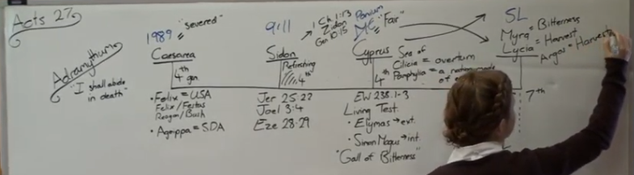
We went, quite quickly, through this history of Adramyttium in Acts 27 verses 1-5 in the last presentation. We went from Caesarea, Sidon, Cyprus, and Myra. I just want to mark the final waymark, Myra and Lycia. When we come to Myra, it comes from the word Myrrh. Which gives us the concept, the meaning, of bitterness. Myrrh means a bitter substance, so it means bitterness. Lycia has a couple of meanings, all of which are quite interesting. I don't understand the meaning of all the different concepts that come into this word. If you would go down to the root of this word, it means light, bright, brilliant for whiteness, and this is in the Thayer's Dictionary. When we consider Lycia, it is the color of grain at harvest time; it means white, but not just any white, it is like a glistening white color like when the grain is ripe. When you go to the line of Pyrus, which is a separate line, it is interesting, because at the same waymark as Sunday Law, Pyrus is at Argos. Argos means the same thing; it is the color of grain at harvest time. And the reason was, I believe, that city was next to a valley or plain known as the Argolic Plain where they would grow all their grain. And the city was named after the color of that grain at harvest time. They both have that same concept of harvest. Lycia also has the concept of a predator, which becomes interesting when we consider Brother Tyler's discussion about predator beast and the prey beast. Lycia also means a wolf in the predator kind of sense for its violence. I particularly want to mark the harvest there; we also mark the harvest of the world, the Nethinims, from Sunday Law to Daniel 12:1.
__________________________________________
I want to spend a decent amount of time just talking about the Sea of Cilicia and Pamphylia and the overturning, particularly the external because it becomes interesting to consider. You have this ship that from the time of the end, 1989, represents the United States and Adventism. We already know and teach that between Panium and the Sunday Law the United States falls as a sixth kingdom and what rises is the seventh. When we come to this history for the ship it is the sea of Cilicia and Pamphylia so you see an overturning, and what is coming up is a nation made up of every tribe. What I want us to consider is, there is an internal application as well when we come to Adventism, but first of all I want us to consider the external.

External
If this is the United States falling in this history, what does the sixth kingdom look like? It is the United States. What does the seventh kingdom look like? It is the United States. If we were to go back to this history, who brings in this seventh kingdom? This is at the waymark of Sunday Law, so we're marking the seventh kingdom at Sunday Law. What happens at Sunday Law? Who brings in the Sunday Law? The United States. And then who enforces it and enforces its spread? The United States. Is the United States more powerful in the history of the sixth kingdom or the seventh kingdom? The history of the seventh Kingdom.
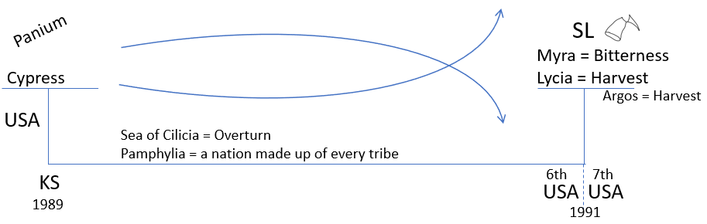
What do we mean when we say it is overturned? This is where it gets interesting to consider because we know that we are considering the Constitution in this history and the changes. If we just go on that first premise that the United States is more powerful after the Sunday Law than before, then what is being overturned? The Constitution, Republicanism. What happens at Sunday Law? The breaking of republicanism. You can make arguments to see that idea as progressive, but we usually mark that at Sunday Law, the breaking of the Republican horn. It ended as one type of power and it is coming up as another type of power. Why is the United States becoming more powerful between Panium and Sunday Law? What we are saying is this overturning is actually becoming more and more powerful not less powerful. Do you agree with that? Yes, because it is losing everything that makes it lamb like; the two horns are the only thing lamb like about that beast and when that other horn goes it is no longer lamb like. It is becoming less and less lamb like between Panium and Sunday Law.
Why is it that it is gaining more and more power in the history of the sixth kingdom? Why is it a dictatorship? How can it be a worldwide dictatorship? What gives them the power to now be a bully? Sanctions? Economics? Why can't they do that in the history of the sixth Kingdom as well? Why can't they do it now, because they have that economic power now, but they still don't have the ability to force, the way they can in the history of the Seventh Kingdom. They are going to force the world. The Constitution is impacting them internally, but why externally? What is holding them back during the Sixth Kingdom? How many superpowers are there? Two superpowers. What happens between Panium and Sunday Law? What happens at Panium? What happens to the King of the South? He gets defeated at 1989. Is he dead? He gets his deadly wound. What waymark is this? Panium. If we were to see this before in our history what waymark would this be? 1989.

In 1989 the King of the South is defeated, but is it done? When is it done? 1991. Between 1989 and 1991 what is happening to the King of the South? It is falling. In 1989 the Soviet Union is still united; it is a progressive fall. Prior to 1989 how many superpowers are there? Two. From 1989 to 1991 what happens? It goes from two superpowers to one superpower.
Right now, if we were Venezuela and Donald Trump wants their President to be overthrown, what happens? Donald Trump tries to overthrow their leadership and who does that Venezuela President hide behind? Putin. He goes to the King of the South and says "America's trying to bully me and change my sphere of influence." And Putin starts by putting troops on the ground in Venezuela, he has cargo ships sending them oil and all the materials to continue production, he has economically and physically propped up that government. Venezuela's hiding behind the King of the South.
Syria, who is keeping Assad in power? There's a video where, it was fascinating, Vladimir Putin visited Syria and he walks out like a strong man; he just does this kind of swagger strut. Because you always keep your right hand by your gun, he walks like a KGB agent. It is really quite psychological even his walk, it is as a strongman. In the video Assad is kind of trailing behind Putin and Assad tries to run to catch up with him and one of Vladimir Putin's agents grabs Assad by the arm and pushes him back. He's not even allowed to walk side by side with Vladimir Putin; he is in complete submission. If I was Assad I would have been so embarrassed. And when Assad tried to catch up with Putin he was put straight back in his place. He is in complete submission to the will of Putin, because Putin is keeping him in power. (View YouTube: Assad forced to walk behind his master (Putin))
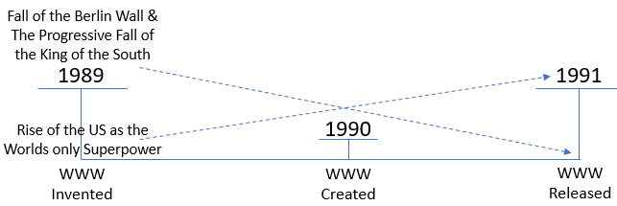
I want to talk about Syria and why that's an important area. But it is not just these (Venezuela & Syria), you come to all these different countries and when Donald Trump wants to get something done it is the King of the South that is standing in his way. There's a quote that I want us to look at. We're going to go through this history as well, I just want to reference it. This was in September 2018; Donald Trump released the National Cyber Strategy. We're going to discuss that, but he makes an interesting statement. This is Donald Trump writing, he says in the National Cyber Strategy, "The rise of the Internet and the growing centrality of cyberspace to all facets of the modern world corresponded with the rise of the United States as the world’s lone superpower." What period of history is he talking about? He is going backwards; he's talking about the rise of the Internet and the growing centrality of cyberspace. When did that happen? In 1989 the world wide web is invented. There's a paper written about it. In 1990 it is created, then in 1991 it is released. This is our increase of knowledge externally. It is at first a suggestion, then the creation, and then the release of the world wide web. It is one of the threads we can trace through all of our waymarks. So what Donald Trump is saying is that this history, 1989 to 1991, he words it as the rise of the Internet and the growing centrality of cyberspace. And he says that 1989 to 1991 corresponds with the rise of the United States as the world's only superpower. What else happened in 1989 to 1991? The fall of the Berlin Wall and then a progressive fall of the King of the South. He has actually brought together the two concepts of the world wide web and the information age. He has brought together the fall of the Soviet Union with the rise of the United States as the world's only superpower. What happens between Panium and Sunday Law? It is the rise of the United States as the world's only superpower. And it is interesting that he would choose to remind us of that, in that side of strategy.
If we were to go back to this history of 1989 to 1991, what should we see? We should actually see the exact same thing that we are going to see, but from Panium to Sunday Law. It is already happened in this history of 1989 to 1991, but what happened after 1991? After 1991 you had two powers come back, first of all Islam and then the King of the South. Both of them came back and stopped what was developing in this history of 1989 to 1991, otherwise the United States could have been the Seventh Kingdom from 1991. From 1989 to 1991 is the history of Panium to Sunday Law, because it is the fall of the King of the South and the rise of the United States as the only world superpower.
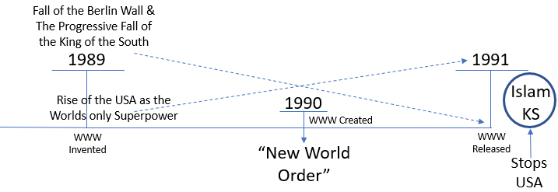
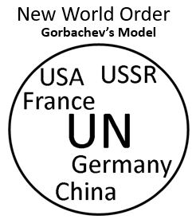
If we were to go to this history of 1989 to 1991 there is a particular phrase that is being used, and what is that phrase? We will talk about it as the New World Order. This is the phrase that I want us to consider. Who began to speak about the New World Order? Who introduced the phrase in the 1989 to 1991 history? Gorbachev. This is something Gorbachev introduces and this is what I want us to consider, when we consider what this looks like. What is happening to Gorbachev's empire? It is falling out from underneath him. To try and stop him from losing all global influence he starts to try and introduce the idea that we should have a new world order. He particularly starts this in 1988 when he can see the fact that his country is rapidly losing global influence. The first thing I want us to see is that this phrase comes from Gorbachev; he is the one that in 1988 starts to speak about it. In 1988 he actually makes Reagan and George Bush extremely uncomfortable with his use of this phrase. And I think George Bush actually wrote about it in a book of how uncomfortable he was, because what is Gorbachev's idea of the New World Order? Communism is falling, he is embracing capitalism, he needs another way to make sure that he is not bullied by the United States. If he knows that the Soviet Union is falling in this history of 1988, it is all about to fall, Gorbachev knows that his Soviet Union is falling, he knows that the United States will be the only world superpower and he wants protection from the United States. So, what does Gorbachev want? A stronger United Nations. So, Gorbachev has this idea of a one-world government, the new world order where you have the UN, with all these countries. So, you have the USA, you have whatever he thinks will be left of the Soviet Union, you have Germany, China, France. And what he hopes is that as the Soviet Union falls, he is not going to lose all his influence and the world is going to be protected from one superpower because of the UN. That this will somehow block the United States from acting like a global bully. When we talk about the New World Order, whenever I've heard this spoken about and it is from years of upbringing in very conservative independent Adventist groups watching Walter Veith, the New World Order and how it is dangerous and bad, we're always speaking about Gorbachev. This is what we think is dangerous and I want to suggest it is not.

The UN was placed there, I believe by God, to protect us from the United States. The UN is good. What is the United Nations composed of? All the countries of the world, so you have China, Israel, the Palestinians or the Middle East, Saudi Arabia, Ukraine, Russia, Mexico, USA, UK, Canada. How many of these get along? And yet we think they have some type of secret agenda where they are all friends behind the scenes and the UN is going to come together in one world government. If you've ever gone onto YouTube and watched them debate, it is actually kind of funny; it is humorous in a kind of sad way. It is like watching school children, none of them like each other. You watch one nation get up to speak and another nation will get up and they kind of kick their feet and they march out until the other nation has stopped talking. They don't like each other, but they are forced to get along. They are all forced to get along because it is in the law, it is in the UN. I want to suggest this is actually a good thing; this isn't a bad thing, because what this prevents is a global superpower. Within Gorbachev's idea the world is protected from the United States, because of the UN.

United Nations

- Mexico
- China
- Israel
- Palestine
- Saudi Arabia
- Ukraine
- Russia
- USA
- UK
- Canada
- All the countries of the world

[The United Nations member states are the 193 sovereign states that are members of the United Nations (UN) and have equal representation in the UN General Assembly. -wikipedia]
George Bush and Ronald Reagan did not like this, so what they decided was they were going to take this phrase and rework it. They were going to use his same phrase and redefine it. And this is a speech that George Bush makes in September 11, 1990. He does this intelligently; it is documented intentionally. There is a global crisis, a Middle East crisis, and I just want to read some excerpts from his September 11, 1990 speech before Congress. He said, "I've just returned from a very productive meeting with Soviet President Gorbachev. And I am pleased that we are working together to build a new relationship." He is talking here about Iraq and Kuwait; this is the gulf war. He said, "Clearly, no longer can a dictator count on East-West confrontation to stymie concerted United Nations action against aggression." He is saying for the last years in this history nations have been able to be aggressive, and they can get away with it, because of the conflict between the Soviet Union and the United States. They have been able to hide in a sense, and it is the exact same thing happening now; Syria can hide in a sense because of the conflict, the proxy war, between Russia and the United States. George Bush is saying that it can no longer happen, no longer can dictators hide behind east-west confrontation. He continues, "A new partnership of nations has begun. We stand today at a unique and extraordinary moment. The crisis in the Persian Gulf, as grave as it is, also offers a rare opportunity to move toward an historic period of cooperation. Out of these troubled times, our fifth objective -- a new world order -- can emerge: a new era -- freer from the threat of terror, stronger in the pursuit of justice, and more secure in the quest for peace." He is kind of talking like this: there is going to be a United Nations, everything that is held back that is working properly with the cold war is coming to an end, because the cold war is coming to an end. We are about to enter into a new world order. So, he has taken Gorbachev's phrase and he is redefining it. He said, "Today that new world is struggling to be born." He continues, "The test we face is great, and so are the stakes. This is the first assault on the new world that we seek, the first test of our mettle."
And I just want to mention this history of 1989 to 1991, in 1989 there begins to be tension between Iraq and Kuwait. In 1990 Iraq invades Kuwait, in 1991 the United States invades Iraq; this is just repeated in 2003. There are two Iraq wars, two George Bushes.
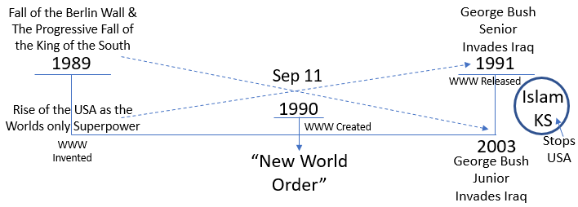
When we talk about the New World Order, I want us to see that concept was not just George Bush Senior; there is a father and son and they have the same concept of what a new world order looks like. You have this issue and he says this is the first test of what the new world order is meant to look like, how we are going to respond to Iraq. And then he says what this looked like, "This is the first assault on the new world that we seek, the first test of our mettle. Had we not responded to this first provocation with clarity of purpose, if we do not continue to demonstrate our determination, it would be a signal to actual and potential despots around the world. America and the world must defend common vital interests -- and we will. America and the world must support the rule of law -- and we will. America and the world must stand up to aggression -- and we will. And one thing more: In the pursuit of these goals America will not be intimidated." "Recent events have surely proven that there is no substitute for American leadership." What did he just say? There will be only one. It completely takes Gorbachev's argument and he rephrases it. What he has is a UN and he says the way it was originally designed to be, and you can have all kinds of countries they don't have to get along, China and France and Canada and Russia. They can all be part of this UN as long as you understand who the leadership is. What he does is he takes Gorbachev's concept of the New World Order and he reframes it and says this is what it is going to look like. This is George Bush Senior. George Bush Senior to demonstrate this he invades Iraq in the Gulf War.
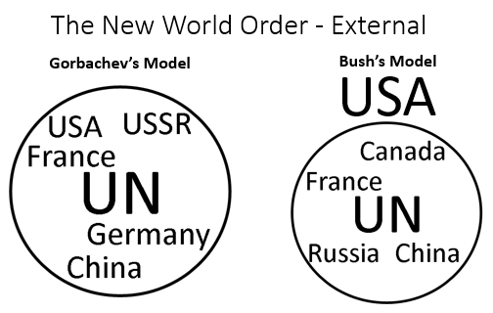
What they do in that war is despotic to put it mildly.
[DESPOTIC, DESPOTICAL, a.
1. Absolute in power; independent of control from men, constitution or laws; arbitrary in the exercise of power; as a despotic prince.
2. Unlimited or unrestrained by constitution, laws or men; absolute; arbitrary; as despotic authority or power.
3. Tyrannical.]
They actually said they warned Saddam Hussein we are going to take your country back to the pre-industrial age. It is a fully industrial country and they intentionally went in and they brought it down to after the Gulf War it was only able to come back to four percent of the power output that it had before as far as the electricity system. The electricity that was behind all of their innovation and their hospitals and their schools and everything. They decimated the country. George Bush and his government say in this history, we are making no distinction between the government and what they did and the Iraqi people. We are going to punish both and we are going to destroy that country to the point where they will be so dependent on foreign aid they will not question anything the United States does after that. They wanted to bring Iraq completely under their control and to do that they needed it dependent on foreign aid, so they intentionally destroyed their infrastructure beyond anything that was necessary. People say Saddam Hussein was a dictator, he did war crimes, so did Kuwait; they had mass graves in this history. This is not about war crimes and democracy. That is what the New World Order looks like.
George Bush Senior's son, George Bush Jr., in 2003, wants to invade Iraq, and what is his problem? Who stood in his way? George Bush Senior invades Iraq in 1991, George Bush Jr. wants to invade it in 2003. Russia stands in the way, and there are two others; Germany and France. Germany, France, and Russia, they, in 2003, said under international law you are not allowed to invade Iraq. And what did George Bush Jr. say? We don't need UN approval. Why? Because he has the same concept as his father and for him the United Nations was just in rebellion. They invaded Iraq against international law, because for him, this is what the New World Order was meant to look like. He invaded illegally while he was opposed by Russia, Germany, and France.
Father and son had the same concept of the role of the UN. And it is them, it is George Bush Senior and George Bush Jr. that give us an insight into what the Seventh Kingdom looks like. The Seventh Kingdom, seventh head does not look like Gorbachev's idea. This is where we have taken all the conspiracy theories and what do you find behind Trump supporters now? They are so afraid of this (Gorbachev's Model of UN). They actually, the supporters behind Trump, even those within his government, say there is a secret UN agenda to control the world, which is why the United States needs to take back control of the UN. They speak out against this (Gorbachev’s Model of UN), those supporting Trump, those that led to his election, they are terrified of the UN and this concept of the New World Order. This (UN) is not bad, this is safety, this is a safety net. The European Union is a safety net, but this is where our conspiracy theories come from. There is no secret UN agenda. This is what the UN looks like (Mexico, China, Israel, Palestine, Saudi Arabia, Ukraine, Russia, USA, UK all at the same level), they do not have a secret agenda to control the world, they cannot even control each other; some of them cannot even stand in the same room with each other. They are not putting out left-wing news. Saudi Arabia would not like what comes out of CNN, Russia certainly does not like it, The Palestinians do not like it, the Israelis do not like it, the Chinese do not like it; they are not putting out left-wing news. If anything, they like the right-wing, but they do not have a news stream that they are putting out. We have so many conspiracy theories tied to the role of the UN; it is not something to be feared, it is something that was designed to protect us. And what we see from 1989 to 1991, or from Panium to Sunday Law, or from the Sixth Head to the Seventh Head is not Gorbachev's idea, it is the concept of George Bush, and it is the United States as a dictatorship over the UN. When the United States wants a Sunday Law, whatever that looks like, China will implement it, Saudi Arabia, Palestine, Russia, all these countries that hate them will implement it because you are fighting the only global superpower. There is no longer anyone else to hide behind, so you are forced. Some will follow just like internally, some obey in the head, some obey in the hand. You want to look at what is happening with Brazil, some of these countries have populist right-wing leadership's coming up, they will obey willingly their governments. Other governments are not following. If you still have a Liberal government in Canada, they might be forced by the hand whether that is economic or in a different way where they just do not have a choice. We need to understand the concept of what the Seventh Head looks like, the difference between Gorbachev's model and George Bush's model. The majority of all the conspiracy theories we have about the UN come from this model (Gorbachev's) and it is a good model.

A question from the class is, “What about the religious side of the UN, the kind of occultic side?” How I see it is, they have their circle and, in this circle, they have Hinduism, and they have Islam, this is kind of what they have got beneath, and then they have Buddhism, all these different things and they kind of come together. What is wrong about this? This is a good thing; this is what we want under the Constitution. What does the United States want? You can be Hindu, Islam, Buddhist, Seventh-day Adventist, as long as you are under Protestantism; this is what it looks like in the United States, this is what they are trying to bring about. As long as you fit this model, as long as you come under Protestant control, you can do what you want but you need to follow our beliefs, our morality. You have to look like us, dress like us, practice like us, speak our language, as long as you can do that, then sure you will come under our leadership. This is part of the UN, morally we do not really agree with any of these religions, but for protection it is good because then we can put in the circle Seventh-day Adventist in that safety net. This is freedom of religion; everyone gets their own piece of the pie. If you want to practice Hinduism you have freedom. If you want to practice sabbath-keeping you have freedom. It is when we come into this model (Bush's) you lose all your freedom. In this model, (Gorbachev's) countries might not be able to do everything that they want, like invade Iraq, but it is safety. This model (Bush's/Protestant's) is not safe. Like Rome, as long as you think like us, you can be whoever you are. Their message has become quite political as they try to take over the government.

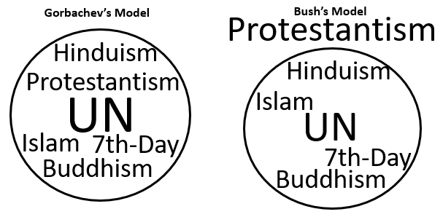
When we look at the sea of Cilicia and Pamphylia, we see the overturning and this is a nation made up of every tribe. What is coming up is the UN, but what that looks like is Bush’s Model of the UN with the USA in control, because at the Sunday Law the United States is more powerful than it was before. It is more powerful because the other world's superpower has fallen. We have already seen that in our reform line from 1989 to 1991, but God was really good to us and they still had two restraints that were going to make sure that this did not progress too quickly. So, we find Islam and the King of the South, both come into history and they start to hold back the United States from fulfilling its full purpose. We have described what the UN looks like. These conspiracy theories of Walter Veith, they are really conspiracy theories that you also find within Trump's White House, within his own administration, also within his supporters.
This was also written about in the New York Time in that history, it is an interesting statement. "A pivotal point came with Bush's September 11, 1990 speech toward a New World Order. It's a commitment to US strength. The Gulf Crisis was seen as a reminder that the US must continue to lead and that military strength does matter, but that the resulting New World Order should make military force less important in the future. A very few postulated a bipolar new order of US power and United Nations moral authority. The first is global policeman, the second is global judge and jury. The speech was indeed pivotal but the meaning was hidden. The main point is the following, it had been assumed that the old bipolar to power world would beget a multipolar world. The immediate post-Cold War world is not multipolar it is unipolar." It had been assumed that you would go from two to many under the United Nations, but you could immediately see after the end of the Cold War it did not go from two to many, it went from two to one. And that is what we see from Panium to Sunday Law. We already have in history an example of what the Seventh Head looks like. "And underlying theme in all the discussions is that the United States has now acquired a preeminent position in the international hierarchy. This situation has developed because of the precipitate decline of the Soviet Union. Bush himself has indicated that it is the new relationship with Moscow that creates the possibility for his new order. For many analyst therefore the new world's essential feature is not the values it is said to embody, nor the principles upon which it is to be based, but that it has the United States at its center." So, it was quite spoken of in that history, but this is what George Bush was bringing about. So, when we see these crises, we can see it in the Gulf War, but it is not a coincidence that you have two George Bushes and two Iraq wars.
Both of those wars were brought about by disinformation. For the first one when George Bush Senior invaded Iraq in 1991, what did they say? They made the claim that Iraq was about to invade Saudi Arabia. There is no evidence ever being release to back that up. The other thing they said was that Iraqi soldiers were going to hospitals and taking the babies and throwing them on the floor and killing all the babies. There was a young girl, I think she was about 15, and she went on US television and she said that she had worked in those hospitals and she had seen the Iraqi soldiers put all the babies on the floor and kill them. It was later revealed that she was the daughter of the Ambassador from Kuwait to the United States. The Ambassador from Kuwait trained up his daughter and she went on American television and pretended to be a crying damaged victim of Iraq's invasion and she made up these stories that had been fed to her about the babies. It was all built on a lie and because of those stories being shared through the US media George Bush was able to persuade the people that they needed to invade Iraq. He made the people afraid and angry.
- 1991 Invasion of Iraq – Disinformation
- 2003 Invasion of Iraq – Weapons of Mass Destruction
This first Iraq war was brought about by disinformation. What about the second? Weapons of mass destruction. What is happening right now? What is Iran doing? Iran just apparently hit some oil tankers and shot down a drone and the United States is saying, look at what Iran did. And what did the EU say to the United States? Now this time, you need to prove it. We have been through and we have been here before. The US has lost some credibility. We need to be able to question. I just want us to see the connection between these two invasions, both are built on disinformation, both are George Bush (father and son), both were an Iraq war, and both of them show us what the New World Order looks like. Sometimes the UN might follow in the mind, sometimes it might follow in the hand. Because like in 2003 George Bush Jr. says, you are either with me or against me. In 2003 the opposition of Russia, France, and China held no authority with him. I want us to consider how this impacts our conspiracy theories, when we talk about the United Nations. It does have an occult kind of base. It has this concept of all the religions coming together and some of them are quite pagan, a lot of this is paganism; but that in itself is not a bad thing, that is protection for us. Just like all of these nations coming together is protection for us. This is the EU and what do the populist leaders want to do with the EU? What does Steve Bannon want to do to the EU? Destroy it. Why? Because if you are a populist right-leaning leader the EU is a restraint on your power. They need to either destroy it or take it over and control it. They are trying to do one or the other. The EU is not a bad thing, it has kept us safe for decades.
We have this concept and I want to say it is wrong, but what we have to fear is globalist; this comes into 2016 and we are looking at Clinton and we are worried because she is a globalist, she is this (Gorbachev's model). We are worried about Clinton because of globalism. Globalism is not what brings about the Sunday Law. Globalism is safety, there is nothing wrong with globalism. What we needed to fear is populism. Populism is what brought about Adolf Hitler and Mussolini. Populism is what brought about Donald Trump, it is not globalism, it is populism. And populism requires the breakdown of this (Gorbachev's model) type of structure. When we talk about the globalists and George Soros and the Rothschilds, so much of that is fed from conspiracy theories. I think the richest Rothschild currently is around the 1,400 richest person in the world right now and yet we are still carrying on conspiracy theories that were created in the late 1800's and the early 1900's, because they were Jewish and it was anti-Semitism. Our conspiracy theories are based in racism. You can bring that back to our reform line in 1979, it keeps coming back to the same type of theme. Conspiracy theories are intimately linked with racism and sexism. We do not have anything to fear from the George Soros's and the Rothschilds. It is those conspiracy theories that fed the movement that elected Donald Trump. So why are they feeding into Adventism and why are they feeding into this movement? It is because we are drunk on the wine of the apostate Protestantism. We need to cleanse that as quickly as we can. It is not globalism; it is populism and this (Bush's Model) is what populism looks like.
[noun: globalism
- the operation or planning of economic and foreign policy on a global basis. https://www.google.com

Globalization is the connection of different parts of the world resulting in the expansion of international cultural, economic, and political activities. It is the movement and integration of goods and people among different countries. https://simple.m.wikipedia.org/wiki/Globalization

noun: populism
- a political approach that strives to appeal to ordinary people who feel that their concerns are disregarded by established elite groups.
- support for populist politicians or policies.
- the quality of appealing to or being aimed at ordinary people. https://www.google.com

Populism is the name of political movements. These movements usually make a difference between the common man, or the common people, and a political elite. These elites do not necessarily exist. The theme of populism is that the common man does not have certain privileges the elites have, or that he cannot do certain things the elites can do. The populist see themselves on the side of the common people. They want to help the common people get some of the rights and privileges of the elites. https://simple.m.wikipedia.org/wiki/Populism

The Rothschilds, a prominent family originating from Germany, established banking and finance houses in Europe beginning in the 18th century. Pioneers in providing capital for business and financing infrastructure projects, such as railways and the Suez Canal, the Rothschilds molded the way the international world of high finance works today. https://www.investopedia.com/updates/history-rothschild-family/#the-rothschild-family

George Soros, (born August 12, 1930, Budapest, Hungary), Hungarian-born American financier, author, philanthropist, and activist whose success as an investor made him one of the wealthiest men in the world. He was also known as a powerful and influential supporter of liberal social causes. https://www.google.com]
To understand the Seventh Head, when we see this overturning and the nation made up of every tribe it is this structure of the United States as a dictatorship. Like George Bush said, there is no alternative to American supremacy.
----------------------------- That is the external.

Internal
Just to consider the internal. If this, 6th Kingdom, is the United States and this, 7th Kingdom, is the United States, what is the internal? Adventism. What are we after Sunday Law? This is Adventism and this is Adventism. What is coming up is a new type of leadership and who is coming up between Panium and Sunday Law? I want us to go back, this will be in our second line, so we will probably address it more then.
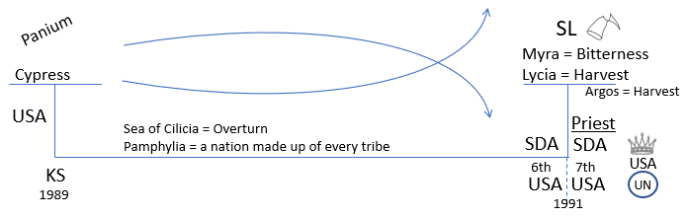
ML - My Life Today - 334.1 skipping 334.4
This is speaking of Paul in the second ship of Alexandria. But if we were to put it on the same reform line it is between Panium and Sunday Law in the same history on the line of the second ship.
"The same hope and cheerfulness is seen when he is upon the deck of the ship, the tempest beating about him, the ship going to pieces."
The same hope and cheerfulness is seen, the tempest beats around him, the ship is falling to pieces, the ship is Adventism.
"He gives orders to the commander of the ship and preserves the lives of all on board. Although a prisoner, he is really the master of the ship, …"
What is that saying? You have this ship representing Adventism all the way through. It is Adventism before based on the United States; we can also see Adventism after, but who is the boss? There is a change in leadership and what begins to rise up in this history between Panium and Sunday Law is Adventism under a new leadership. It is this movement. We are still Seventh-day Adventists. Seventh-day Adventism itself does not end. The institutions come to their end. The institutions of the United States fall here and the institutions of Adventism end here, but the United States itself is still a power and Adventism is still a power. But you start to see a change, the change in the leadership becomes visible. Paul becomes visible in this history as the leadership of the church. When we go to Adventism, Adventist, because we are bringing in Levites in this history, what are we saying to them? We are still Seventh-day Adventist, we accept Ellen White, all of that. Seventh-day Adventism itself has not ended, it is your leadership, you need to stop following the Conference structure, you need to follow this movement, because they have rejected the prophetic messages. We are repeating the history of Christ.
We have gone through the line of the ship of Adramyttium, they choose to abide in death and it results in their overthrow by Sunday Law, but you can particularly mark it between these two waymarks and then we went to see that this is already illustrated, like so much else, at the very beginning of our reform line from 1989 to 1991. We wanted to consider the phrase a New World Order and what it looks like, and we wanted to suggest that there are two different models. The fear of one is based on conspiracy theories, but it is this one (Bush's Model) that we need to dread, both when it comes to state control and from the church.

Closing Prayer
Dear Father in Heaven, thank you Lord for our blessings. Thank you that you have protected us for so long and you have been patient with us that if we had time to grow and develop and I pray that we will continue to grow and develop, that you will continue to water us and shine upon us. You have been so merciful and patient. I pray Lord that you will give us wisdom. I pray for those Levites and the Nethinims, they are afraid Lord and so many do not know what is happening or what the future holds. I pray that you will help us to have a pure message, a correct world view that we can give them some explanation of the times that they are living in and show them their value. I pray Lord we will see our high calling that you have given to us, the solemn responsibility of being part of the work that you have entrusted to this movement for the last 30 years. I pray that you will be with us and continue to bless our day in Jesus's name. Amen.

All of Tess’s Board work
