Babylon is Fallen
I want to continue the thoughts and ideas that we've been discussing about organization. I want to read from some spirit of prophecy quotes. Not sure the best way to do this so that people can keep up with what I’m going to be saying. I'm not sure if everything here is actually available in a different language. I'll give the reference. It's 1888 page 804 paragraph three. I'll give the codings, 1888 page 804 paragraph three. Does anybody else have it I don't know why it's not? I’ve sent it on the forum. Sometimes the pagination on a phone or the new apps are different to the one that I have. It can be one paragraph out. It's on the forum so everybody can translate it if it's not in your original language. So I’m going to read the whole paragraph in English and it'll give the translators time to catch up.

God has given the messages of Revelation 14 their place in the line of prophecy and their work is not to cease till the close of this earth's history. The first and second angel’s messages are still truth for this time and are to run parallel with this which follows. The third angel proclaims his warning with a loud voice. After these things said John, I saw another angel come down from heaven having great power and the earth was lightened with his glory. In this illumination the light of all the three messages is combined.

This is the famous spirit prophecy quote that we and other Adventists use frequently. I'm just going to briefly comment on it so that we can all have just a basic understanding of what we're reading. Ellen White speaks about Revelation 14. She speaks about the first, second and third angel. She says that the first and second angel’s messages are still truth for this time and not only are they truth for this time but they are also to run parallel to that which follows, and she tells you what is going to follow the third angel. So she's going to introduce the first, second and third angels messages and tell us that the first and second run parallel to the third. So if we were to lay out on a board what she's saying here, which I have done numerous times in the past. What we would lay out would describe what is written in this passage, but this is not the definitive way of explaining the history of Adventism. It's just a way, one way. So just because we draw what we read here does not mean this is the only way to understand Adventist history. We need to understand that concept and I think often we forget it.

So each of these messages in Revelation 14 have their place. Just because they have their place does not mean their work ends. She doesn't tell us how and where to place these messages but she gives us some clues. Second sentence she says that the first and second messages are still true for this time, the time in which she's living. This is chapter 103 from the compilation 1888 materials. The original document is a manuscript produced in 1890. So in 1890 the first and second messages are still truth. So what we want to do is use William Miller's rules to try to decode what we have here. In a class I would then ask in this sentence, what is the most important word for this study, at least this part of the study? The word would be still. It’s still truth, which means it was truth in the past.

So in 1890 the first and second angel’s messages are past history. So we're in 1890 and the first and second messages are in the past. It then says that these messages are to run parallel with this which follows. Now it doesn't tell you the placement of the third angel at least from my reading. It doesn't tell you if the third angel has already arrived or is about to arrive. It doesn't tell you if it's past, present or future from this simple statement. Have you finished? I don't remember what I said so, it says that the first and second angels are past history but it doesn't give you the placement of the third angel. It just gives you the sequencing because it says that the third follows afterwards. What else we can read is it that these messages run parallel. To go to the first sentence, it says that their work is not to finish until the end of earth's history and in 1890 those messages are still truth. So we're discussing the passage from 1888 materials page 804 paragraph 3 and we’re discussing the relationship between the first, second and third angel’s messages. We take the most important word in the second sentence which is the word still. We are able to discern that the first and second angel’s messages are past and they are still truth for today.

Then she speaks about the third angel which follows after them. Now this is only one passage from a larger document of course, Manuscript 31 1890. So we'd have to get a wider context to
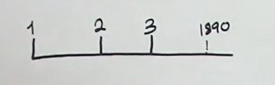
actually place the third angel but from the very little information that we have here, we could assume that the third angel is already present truth but we can't definitively say so from this short paragraph. So I’m going to place the third in history prior to 1890 because we know that from a wider reading or the context of this paragraph, the first and second we can define from the passage itself.

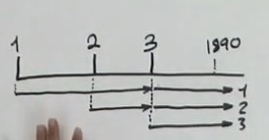
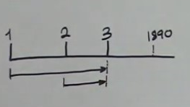
Now in another study the first and second angel’s messages would have finished their work already which in fact is what Ellen White infers in this passage. She doesn't tell you when they would have finished but from previous studies we know that the first and second finished when the third arrives, but the point that she wants to make is that these messages, the first and the second run parallel with the third which makes them concurrent. Technically this is where they would end and the third is running through history and now the first and the second are running parallel with it, and this is an important concept for us to be familiar with.

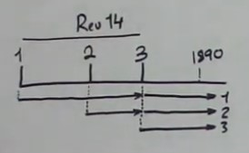
Now in the past when we've dealt with this passage, I think we have made mistakes. We've read too much into what she is saying. All I think she's saying is the following: the first and second angel have done their work. Their work finished yet the messages that they contained still have a bearing upon their present history. Now after the first second and third have begun and done their work, she's going to move chapters without telling you. So these are all chapter 14, and now she's going to introduce another angel. People call this the fourth angel. You can see why from this passage. After the things brought to view in Revelation 14, I John saw another angel, and now Ellen White is switching over to Revelation chapter 18.

If you turn to Revelation 18 you'll see that she is quoting from that chapter. Hopefully we can all see that. I’ll read from the document itself. She's quoting from verse one. She says I saw another angel come down from heaven having great power and the earth was lightened with his glory. In the illumination, sorry, in this illumination the light of all three messages is combined. Now what I’m going to say now cannot be drawn from this passage itself. When she says after these things in fact when she says the third angel proclaimed his warning with a loud voice, she's now talking about a future event which hasn't happened yet. So sometime after 1890 another angel is going to come, the angel of Revelation 18 verse 1 and in the illumination of this angel's work or message all of these three messages are combined together. We have spent nearly three decades trying to understand what this picture is saying and what this passage is addressing and we now have a mature message that has a good understanding of what all of this means.

I want to read another passage now. This one you should all have access to. Great Controversy page 603 paragraph 1 to 604 paragraph 1. So this is chapter 38 of the Great Controversy called The Final Warning. It's the introductory three paragraphs. The first paragraph is quoting Revelation 18 verses 1, 2 and 4. Before we look at these verses remember we're discussing organization, but before we deal with organization I want to layer a foundation or a groundwork for Babylon to try to have a simple understanding of what Babylon is. So 603 paragraph one quotes three verses of chapter 18:1, 2, 4. So obviously the introduction of this chapter ties into the previous passage we read because they deal with the same verse 18 verse one. So what she's going to do is address this issue that we spoke about, that the second angel is still present truth after it had finished its work back in 1844.

Maybe people will need me to put some data in. 45 years after the second angel had finished its work it still is present truth, and this is part of the complexity of the way the bible is structured and also the way Ellen White handles the language. She's going to explain the Great Controversy passage, how the second angel can still be present truth and she's going to do that by quoting from Revelation 18 verse 2 the sequential verse after this one. We're not going to read the verse because it's there in front of you from page 603 paragraph one. What you'll notice in verse 2 it's the identical language of the second angel’s message taken from Revelation 14.

Now in connection with this angel she's going to introduce a fifth angel. It's not called an angel in the bible it's just called a voice. So already you can begin to see that this model is becoming
exponentially complex. So I put verse 1 here but I’m going to add verse 2 to it. So according to the Great Controversy passage, I'm going to add the other voice which is Revelation 18 verse 4,
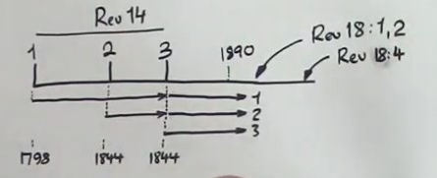
and now she's going to comment to give some kind of explanation. GC 603 paragraph two. This scripture points forward to a time when the announcement of the fall of Babylon made by the second angel of Revelation 14 is to be repeated.

So all I want to suggest is when she says that the second angel is present truth what she's actually dealing with is the following subject: You've got the second angel coming the first time and now it's going to be repeated and the repetition of the second angel is Revelation 18 verses 1 and 2. Another spirit pf prophecy passage which we're not going to look at which addresses this relationship in a really nice way is the following: Its Early Writings page 277 paragraph one.

So I’ll give you the reference there on your chat room. Reading on. We're going future to a time period where the second angel is repeated and when she says the scripture points forward to a time it doesn't necessarily mean forward to when it was written. The context is the book itself which means you'd have to go back to chapter 37, 36, 35 to understand the point that she's referring to or the point in time. So I hope everybody understands what I just said. She speaks essentially about Millerite history. Then the corruption that happens after that history and after that. She then has this final warning passage. Now we do know in the context of the book that it is future because the book is written that way. In fact in chapter 36 the title of the chapter is called The Impending Conflict or the conflict that is about to happen.

Reading on from the passage the announcement in Revelation, sorry, chapter 38 GC 603 paragraph two. She says the message of Revelation 14 is to be repeated with the additional mention of the corruptions which have entered the various organizations that constitute Babylon since that message was first given in the summer of 1844. So the second angel’s message was first given in the summer of 1844 and now it's going to be repeated with all the additional sins that had entered into the churches since that time period.

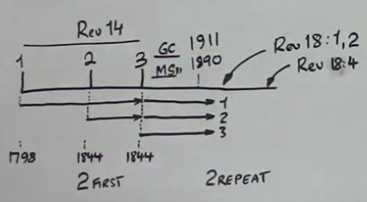
Now on the board we have 1890 but the book that we're reading from is 1911, and it's these events that are still future so even though we had 1890 here which was the original statement, this reference is 1911. This is the Great Controversy and this is manuscript 31. The structure remains the same just the dates are different. I want to argue by the time this book is published the statements that we're reading, the history of 1888 has already passed and failed. In the sentence we've just read it mentions the various organizations. It doesn't define what those organizations are. In the next sentence which is the second sentence of this paragraph. She defines what the organizations are. She says a terrible condition of the religious world is here described.

So we've read sufficient from the Great Controversy. That's all I wanted us to see thus far. What I want to do now, so what I want to do now is read from some pioneers. I'll give you the reference first. Its 1855 JNA TAR 51.2, 1855 JNA TAR 51.2. The coding TAR is referring to the following subject, the three angels of Revelation 14. TAR three angels Revelation. You'll see it's a relatively early document. The title of this section is called the second angel and the fall of Babylon.

So I’m hoping that's okay so I’ll cut and paste and put it onto the forum. I'm hoping people have got it now. Going to be reading from I think three or four passages. I'll read in the English first passage the fall of Babylon. What constitutes the fall of Babylon? Those who contend that the Babylon of Revelation is the city of Rome answer that the fall of Babylon is the burning
of Rome while those who make Babylon a symbol of the church of Rome only answer that this fall is the loss of her civil power. The fall of the woman from the beast we dissent we disagree from both these positions believing that the fall of Babylon is a moral fall and that it denotes her rejection as a body by God that the fall of Babylon is not the burning of Rome appears from the following facts.

So he begins to give proof of why it's not the burning of the city of Rome. Title is the fall of Babylon. Just that whole paragraph 51.2. So there are two definitions, sorry. There are two definitions of Babylon, one is the city of Rome in Italy and the other one is the papacy or the Church of Rome. He says it's neither the city of Rome nor the Church of Rome and he begins to give proof for this. He gives full proof that it's not the city and then he gives I think its three proofs that it's not Rome, no sorry, it's not the roman church.

We're going to not discuss the proofs. We're going to skip down a bit further. Now we're in 53.5. Should have the quote there. The second one I gave says this, it's labeled number one in his document. The nature of the reasons assigned for the fall of Babylon proves that it is the moral fall for it is because she has made the nations drunk with her wine. In other words it is her wickedness that has caused God to reject her. So we've already established that Babylon is an organization. Go ahead. We further established that this organization is religious and now we've established from Andrews that the fall of this religious organization is a moral one.

He proved it wasn't the city in Italy and he also proved that it was not the Roman church which lost its civil power. This is a good article to read if you have the time to go through it. It shouldn't take you that long but it's really useful to see his arguments, their strong powerful arguments. Next paragraph 54.1 It's in your notes 54.1 The cause of the fall of Babylon is thus stated, she made all nations drink of the wine of the wrath of her fornication. Her fornication was her unlawful union with the kings of the earth. The wine of this is that with which the church has intoxicated the nations of the earth. There is but one thing that this can refer to. This false doctrine.

Let's ask a question. Turn to Revelation chapter 17. We'll go to verse 4. We'll give the preamble first. John is taken into the wilderness and he sees a woman there. The woman is riding a beast
verse 4 and the woman was arrayed in purple and scarlet color and decked with gold and precious stones and pearls having a golden cup in her hand full of abominations and filthiness of her fornication and upon her forehead was a name written mystery Babylon the great the mother of harlots and the abominations of the earth.

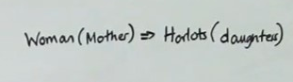
Now today if I were to ask you this question we would all know the answer. What we see in this story is a parable. I would ask is this the parable you'd say yes. My question, second question, so get ready to answer. We read verse 5. There's a woman who's a mother of harlots which are her daughters because she's a mother. So my question is, in this chapter there's an animal and human. We read verses four and five and I paraphrased verse three and verse one. I did one and three paraphrase them, ignored two. I read four and five.

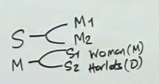
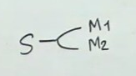
So my question is this: The woman and the daughters, how many organizations or how many people do these represent? State organizations. Give me the number. I don't see anything on my chat. Okay so I’ve got answers so far, remember our study is about Babylon. Now remember this is a parable. You need to understand how parables are working. So if I were to say symbols can have more than one meaning. Lion can mean Jesus and Babylon. Okay with that. If we can make that statement we can rotate it or flip it. I hope we all agree with that we can revert. So a meaning can have more than one symbol. Hopefully we agree with that and that doesn't give you a headache.

Okay we're in Revelation 17 verse 5 and how many symbols do we have? Mother, we won't call it mother because we'll call it what the verse says. Women and harlots. Mother and daughters. Now this is not definitive proof but this is the logic, the methodology that you can use to demonstrate that the woman and the mother are the same thing not two separate things. Now unlike what most of you accuse me of I do try to be consistent and logical. Let's go back to Andrews. He said this 51.2. What is Babylon? Is Babylon the city of Rome or the Church of Rome? He says no it's neither of them. He proves it which we didn't go through then he says the nature this is 53.5 the nature of the reasons assigned for the fall of Babylon proves it is a moral fall for it is because she has made the nations drunk with her wine.

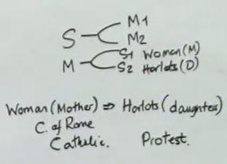
54.1. The cause of the fall of Babylon is because she made all nations drink of the wine of the wrath of fornication. Her fornication was the unlawful union with the kings of the earth. So he has already demonstrated that Babylon is not the papacy, only now without proving it which you can do from Revelation 17 verse 4. You just use classic Adventist logic and you'll see that the woman is the papacy. Call it the Church of Rome. So we know that the Church of Rome is not Babylon in its entirety so what else constitutes Babylon? Ellen White in GC 603 says it's the various religious organizations and that's only one organization.

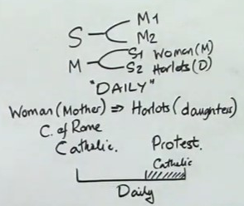
So there have to be others and if you were to go through the logic that he presents and another good source is Uriah Smith. They will show you what you already know. Catholicism and Protestantism. Ellen White might call it the old world and the new world. You might call it the beast and the false prophet. However you frame it whatever word you use the two symbols have one meaning. They're both a symbol of Babylon. So I’m hoping we can see that and I want to suggest it's only by using parabolic methodology that this becomes easy to see. Now for those people who said they were two separate things I had to go to prove that it was one using words, but if we were in, if we're in the frame of mind of parables, if we were thinking parabolically we could approach the passage and come up with the right answer because last week what did I say that the woman represented? Because I got a question on that last week and I just gave one word answer without any explanation. Anybody remember? Nope nobody can remember. It was the daily. Ah someone got it. So I said last week that the woman was the daily and just that model will show you by definition that the papacy cannot be the definitive statement of what the daily is. You all know that the daily is the continual and the papacy is only a part of that history. So the papacy is not the daily it's only part of it. There's plenty of daily beforehand.

So you can tackle this a number of ways and I wasn't trying to give a trick question by asking
Revelation 17 verse 5. Even though the symbology says a mother and multiple daughters,
remember a symbol can have more than one meaning but multiple symbols can have one meaning or a meaning can have more than one symbol. I just want to read from two more
passages from Andrews. This one is 57.1. At the time of the first angels message the people of God were in Babylon for the announcement of the fall of Babylon and the cry come out of her my people is made after the first proclamation has been heard. Here also we have a most
decisive testimony that Babylon includes protestant as well as Catholic churches. It is certain that the people of God at the time of the preaching of the hour of peace judgment were in all the popular churches and this fact is the most striking testimony as to what constitutes the great city of confusion. In a word Paul has well described the Babylon of the apocalypse and the duty of the people of God with reference to it in second Timothy chapter 3 verses 1 to 5.

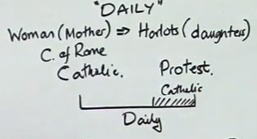
He says this. This know also in the last days perilous times shall come for men shall be lovers of their own selves, covetous, boasters, proud, blasphemers, disobedient to parents, unthankful, unholy, without natural affection, truth breakers, false accusers, incontinent, fierce, despisers of those that are good, traitors, heady, high-minded, lovers of pleasure more than lovers of God, having a form of godliness but denying the power thereof. From such turn away. Who would dare to limit this description to the Catholic Church? I want to ask another question. I asked the question is the woman or the harlots separate or the same thing? I asked the question is the woman here the daily? You all probably got different answers. Now my question is this? Are we dealing with a synecdoche or not? Is this a synecdoche or is this not a synecdoche? That's your test question and we have to be quick because I’m over time. I'll wait for a few answers. Good we'll go with the first two answers. Someone said yes and someone said no. Good. So obviously they're both wrong because the answer is yes and no.

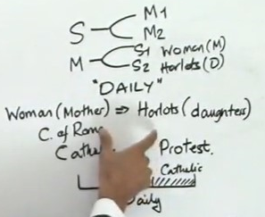
I don't mean to make light of the subject and I don't mean to make it unnecessarily complicated. This subject, this movement, this message is so complicated, I just can't keep track of everything, but I’m going to blame you for not keeping track of everything because I’ve told you time and again that these messages build one upon another. Camp meeting after camp meeting, presentation after presentation and before you answer the question you should have known this point I'm going to make because you have all the information that you need. So one of the points that we split over with FFA was the following: We'll just call it this. Model one is what? What do we split over with them? This is stretching your thinking now. Okay so no one can remember and I run out of time. Good two streams of information. Excellent so you've got two streams of information. You've got two streams of information and you're fighting against what? I have to swap it round because the right hand is the hand of strength. Two streams of information this is us. What's their model? Yeah we know it's wrong but what is this? Good it's not called three streams it's called Revelation 16. Excellent the threefold union. This is what the argument was. Threefold union model or two streams of information model because they teach that these are separate organizations.

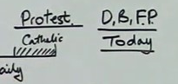
Last year I said, I say this in a generous way, protestant America is the dragon, the beast and the false prophet and I added a bit to that and the bit I added was context and I don't know if you remember what the context was. Today. I don't know what it's going to be tomorrow. So what I introduced last year into this mix, this issue that we have is the subject of dispensationalism not Darby and Scofield’s version. That was November 2019 camp meeting in Australia. So in any particular history the part, the Roman Church can equal the whole, the daily. So depending on your perspective this is a synecdoche and it's not a synecdoche. It becomes a dispensational issue and if you think I’m making that up let's read the next passage and we'll close.

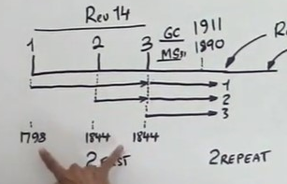
This is 57.2. Before we read that I’m just going to take some select portions from the previous passage that we've already read, second sentence. Here also we have a most decisive testimony that Babylon includes protestant as well as Catholic Churches. Drop down, the preaching of the hour of God's judgment and the immediate coming of the Lord was at once the test of the church and the means by which she might be healed. It was the test of the church in that it showed that her heart was with the world and not with her lord for when the evidences of his immediate advent was set before her she rejected the tidings with scorn and cleaved still closer to the world but it might have been the means of her healing had she received it. Andrews is talking about Millerite history these 46 years and when he says the test of the church he's not talking about the Catholic Church he's talking about Protestant America. Ellen White mirrors this model when she says the Protestant Churches close their doors in 1840. It's all about Protestantism and this is one of the arguments that we have used or that I use to demonstrate that Protestantism is Babylon is the daily as much as being part of it. It's both a synecdoche and not a synecdoche and it's important to understand that because Adventism teaches, I'm going to call it error, because when it talks about all nations in Revelation 18 and we try to identify that as the Papacy we know it's wrong. The papacy does not have that amount of influence over the world. It takes other entities, other organizations to fulfill that criteria.

These may seem minor points to you but these are the building blocks to demonstrate the fallacy of a Sunday law test at the end of the world. It comes down to a person's understanding of what constitutes Babylon. I'll ask one more question then we'll close. I asked about synecdoche’s here. The woman is this principle or policy. When we start talking about the woman of Revelation 17, is that a policy or a principle? You can answer the question for tomorrow.

Let's pray. Father we thank you for your goodness and mercy. We ask and pray that you would guide, direct and bless us. Help us to have a clearer, more mature, more developed understanding of Babylon so that we might understand the times in which we live. I pray in Jesus name amen.

