18. Come now, and let us reason together - Parminder Biant - 9-11-19
This week I've been looking at the midnight cry message from a particular perspective. And what was that perspective? From dispensationalism. We will be looking at the midnight cry message: 1st. from the perspective of dispensationalism, 2nd. the misunderstanding of those people who have left the movement, 3rd. what this word means, and 4th. what this idea means.
For those of us who have followed through with these studies it is my hope that each of us understands what we mean, when we say, from age to age or from dispensation to dispensation. We've taken that concept directly from the Bible, directly from the Spirit of Prophecy, and used it in the correct and appropriate fashion. So, most of us here have watched those studies and partook of them, and we can all say Amen, and that we're all in agreement. The way we're using dispensation is in agreement with inspiration.
I think it's important that each of you understand for yourselves the arguments that are being leveled on both sides, those of us who have remained in the movement and those of us who have left. And the reason for that is, because we understand at the Close of Probation is the end of a period of time, an end of a dispensation. But unlike those who have left, we realize, or we believe we teach that we are now beginning the new journey, a new dispensation, and whatever those people may or may not think about what a Close of Probation looks like, even If you take their position that it is Michael standing up for them, if that were to be true then they would know. Then if you go to Great Controversy or you went to early writings, then this was the last National Sunday law, and this was the Close of Probation and Second Advent. That this would be the time of Jacob's Time of Troubles, what we might call the seven plagues, the beginning of the seven plagues once Michael stands up That’s Daniel 12:1, and this is the new dispensation, there are new things happening that haven't happened before.
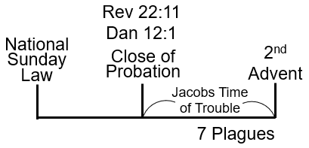
You could argue that it's an escalation of things that are occurring on the earth, but it’s something new. So even if you have to hold to the position that Future for America teach, that this is Daniel 12:1, it's Close of Probation, that there's no more mediation for a person, they have to be righteous and remain that way, you know that you're still at the beginning of a new dispensation. Something new is happening in your experience. We addressed this at camp, the Close of Probation is not the end of a reform line, and whatever a person may or may not think about that.
What I mean by that is if you take this line that's taken straight from inspiration, and Michael has stood up, and Revelation 22:11 has been fulfilled, there is still a work of development to be done in the hearts and minds of the lives of God's people. Not only hearts and minds and lives of God's people, but also of those who have become unjust, those who have rejected the truth, who’s probation has closed. They go through an experience which they have never done before, this is Daniel 12:1 and the verses that follow also in Revelation 22:11.
So whatever side of the argument you stand upon, we should all be aware that something new is about to happen. The difference between what they will teach, and what we will teach, is that what we are not doing is walking away, not disregarding a “Thus saith the Lord”. Now people are abusing and miss applying, misunderstanding this concept of what a “Thus saith the Lord” actually means, because people want to say that it's a literal reading of God's Word. Whatever was written that's what it must be. Now you've heard repeatedly, not only over this week, but in the preceding months, my position on what that concept actually means. It's a subject of controversy because those who have left the movement have actually stated repeatedly, in stronger language, as we move through these weeks and months, that we have now walked away into apostasy, into the world, into Satan's Kingdom. However, they want to phrase that because we are no longer holding or endearing to a “Thus saith the Lord”. This argument, this issue is important for each of us to understand. In fact, it is not any different, from the argument that was occurring in the history that Christ is here at his First Advent. People don't know how to read inspiration.
If you’re not clear on that, you can find it directly in the four Gospels, but Ellen White comments on this when Jesus was 12 years old. What does he do? And where is he taken? He's taken to Jerusalem to the temple, his first visit. It's a Passover visit that he goes to. And when they're leaving to then go back home, he gets separated from his family, because he wants to do what he wants to do, or be about, as he says, “my father's business”. So, he stays back and he goes to one of the schools of the prophets. During the classes, what does he attempt to do? He attempts to instruct or teach the teachers.
The subject matter that's at hand is just in a basic fashion. It's what the sacrifice of a lamb actually means. If you go back and check Ellen White's commentary, they're having a discussion, but they don't understand what sacrificing lambs actually represents and what it means. So, he attempts to instruct them as best as a twelve-year-old child can do. They don't really understand what he's talking about; they don't get the point, but what they do get, is they have a very clever twelve-year-old and they want to take control of his education. That is not what happened of course, it's clear and you can see that they don't know how to read inspiration.
Go back to the birth of Christ, the leadership of the church are struggling with how to read inspiration, they don't know what it looks like. So, this issue about a “Thus saith the Lord” is nothing new, it's a controversy that's been going on in the church from long before Christ’s First Advent, before the reform line of Christ, but that's our reference point that I've given at this moment.
I will read a passage to you taken from Testimonies to the Ministers page 507:1. The section begins the page before on page 506, taken from a Review and Herald article in 1897. The title is, Pray for the Latter Rain. Well, the title is actually a Bible verse you know from Zechariah 10:1. And another Bible verse that speaks about the Latter Rain, is Joel 2:23. We will read Zechariah first, then Joel.
Zechariah 10:1 Ask ye of the LORD rain in the time of the latter rain; [so] the LORD shall make bright clouds, and give them showers of rain, to every one grass in the field.
Joel 2:23 Be glad then, ye children of Zion, and rejoice in the LORD your God: for he hath given you the former rain moderately, and he will cause to come down for you the rain, the former rain, and the latter rain in the first [month].
I'm sure most of us have either seen a presentation or study or have studied for yourselves or heard speakers go to Zechariah 10:1 “asked ye the Lord rain in the time of the latter rain; so the Lord shall make bright clouds”. I don't know where you think this person is standing in relation to the latter rain. So, there are various trains of thought, many people in this movement take the position of Zachariah 10:1, that you are standing where in time? Are you standing in the time period of the latter rain or in the time period not of the latter rain? If you're not standing in a time of latter rain, you standing in another time period which is the time of the formal rain. So, both verses give you both pieces of information. So, that's just a title she (Ellen White) is going to quote.
Back in Testimonies of Minister's 506.1, "Ask ye of the Lord rain in the time of the latter rain; so the Lord shall make bright clouds, and give them showers of rain." "He will cause to come down for you the rain, the former rain, and the latter rain." You can see this is quoted from both passages; she's quoting from Zechariah and the book of Joel here.
She's going to explain about how agriculture works in that time period, and so the way she connects these two passages together, you know that you're staying in a time period of the former rain. Can we see that? Because it's not directly clear in Zechariah 10:1. Where you're standing, it doesn't mention where you are. You can tease it out from the words I think, but some people don't believe that. The reason why people are struggling with Zechariah 10:1, is they go to Acts 3:19 and they look at the connecting versus, the ones that precede and the ones that follow, and they put these two things together because it's dealing with the subject of the blotting out of sin.
So, five, six paragraph one she's going to talk about the agricultural model, in the second or third sentence in that paragraph it says the latter rain near the close of the season, ripens the gain and prepares it for the sickle. The morning plays these operations are major to represent the work of the Holy Spirit.
As the dew and the rain are given first that causes the seed to germinate, and then to ripen, so the Holy Spirit is given to carry forward from one stage to another the process of spiritual growth. Which he says one stage to another how do we express that, to one dispensation to another they're different things happening, remember what the definition of dispensation is, dispensation is the management of all the rules and regulations that are going to be applied to God's church, by whom by an overseer or a servant a minister or a pastor depending on the context that you want to see there as.
So, we know that when it says one stage to another, there are different operations that are going on, you go from germination to immature fruit and then that plant will no longer grow any more, you need a heavier rain for that fruit to ripen. It's a different operation, different rules and regulations. Ripening of the grain represents the completion of the work of God's grace, in the soul by the power of the moral image of God, is to be perfected in character, we have to be wholly transformed into the likeness of Christ.
I'm going to hold that thought, so we're talking about dispensationalism what is the other important concept or principle that I've tried to thread through the presentations this week. If you don't know I haven’t done a good job, dispensation is one, what's the other one. I'll jog your memory, juggling, you have to juggle things, what do we need to juggle? not balance progression and repeat an enlarged two different concepts two different balls. You can throw one ball up and down easily all of us can do that, throw it and catch it, what we struggle with is doing two at the same time, and that's the difficulty, and what we have to do, if you don't keep your eye on those two issues, repeat an enlarged and progression you will always trip up and come to a bad end.
This is the problem that the church, the seven-day Adventist church has fallen into, they don't know how to deal with both things. They can deal with one of them sometimes, repeat and enlarge we should record that the church does not ignore repeat and enlarge, they're not that foolish in their understanding, they definitely know progression, but what people are unable to do, is there with both them at the same time.
Our movement is as inept as the church in doing this and this is what has caused problems in our movement for the last 12 to 18 months. As the concept has been reinforced and developed, clarified, refined people have struggled today with both issues at the same time. So, then we're going to have this struggle over the Close of Probation. Now this one here is an Ellen White understanding of this, because this is Dan.11:41 this is the National Sunday law, we’re not discussing what the Sunday law looks like, we're developing a structure. This is what Ellen White says she has clearly been shown, and we got this from, last day events page 227 paragraph 1. Also written in selective messages is a letter in second selective messages page 81.
Who are the two people that we`ve discussed, Brother Garmire and Sister Anna Phillips so you can remember that, that's the story the backdrop of this issue? Hopefully we remember that Anna Phillips was a false prophet. This whole context of understanding the relationship between two-way marks, she doesn't call it the Sunday law, no, what does she call it, the Lord has showed me calling that the image of the beast, remember the image of the beast and its relationship to close the probation. She wants to address the relationship between the image of the beast and the Close of Probation and she's going to do it in a framework where there's an argument between whom Ellen White and Anna Phillips the true prophet and the false prophet the true messenger the false messenger the true message the false message.
You need to understand the context, now in the past this movement had a real problem dealing with inspiration contextually, and what I mean by that is that have been quite reactionary, this is another way of saying cause and effect it's a similar concept. Now the church has really lost its way, we're dealing with the concept of proof texting, and because we've taught that they've walked away from proof texting and all these apostate horrible theologians have instead gone to where?
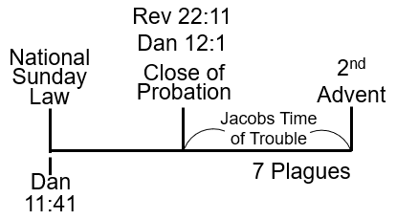
What methodology are they using, the historical grammatical methodology, or the historical critical methodology, and they're going with that Muck, so we sort of throw all of that away, and we say we are the faithful people in the church, we're upholding the foundations of our faith proof texting.
But we know that's not really true, you go to any regular what we might call liberal or apostate theologian and they believe in proof texting. They are not ignorant of that fact the struggle Adventism has, it`s that we're only willing to work in narrow bands, with very focused attention and blinker vision.
One of things that people have a problem with, is taking parables and understanding them to be prophetic. Good example of that the story of the Good Samaritan, so we really don't have much interest, and I'm saying I don’t think, we should, to say that we're going to tell you how to be a good person. A good person cares about people and they don't care about projects, what was the problem with the priest and the Levites. What they focused upon was their project or their job function and they weren't interested in the individual person that's what the Samaritan was interested in.
All of us know this, we may need occasional reminding of the fact we may forget, but it's not about a group of people, it's always about the individual, all of us know that you can go to the world, you go to you tube, you go to an atheist. Everyone knows how we should relate to one another, what we want to take from this parable is what? There are three groups of people priests, Levites and a Samaritan or a Nethinim, and once you see that hidden truth it's staring you right in the face someone points it out. Then you can see what that parable is teaching, it's teaching the whole of the New Testament message, first the church comes along, then the world comes along, the church is in two phases priest and Levite you go to Old Testament passages that deal with that.
So we will start talking about how our church has lost its direction and we are the epitome of skilled teachers. I want to remind us the we are not as skilled as we might think, and this is evident by the fact that we keep on getting separations in our movement, if we are good why do we keep on breaking ties with one with another. There is a component of people just not getting along with each other, inter- personal issues but it's always based upon some principle. Some balk or theological idea, some methodology that we don't agree on and that's where we are today.
The reason why future for America has split from the movement is they no longer hold to the same methodology as we do. Now see if you take their perspective, they're going to say that we're walking away, we’ve come off the platform and we are no longer following God's law his word, and we are no longer follow a thus saith the Lord.
I want to ask you a question we've spoken about TM 506 paragraph one, when the time period of the former rain and what are you required to do. Zacharia 10:1 what you're required to do, you need to pray for the latter rain to come. What will happen if you don't pray it's not going to come.
Sister Brittany spoke about Daniel chapter 10 this week, she spoke about the interaction between Daniel and Cyrus and how many of us have come to a wrong understanding the wrong conclusion of that interaction. But what I want to remind us is if Daniel had not prayed would all of this, what would Cyrus have been able to accomplish the work that God had given to him to do. No Daniel does not pray or do his work if you sat down and said you know what, we're coming to the end of the 70 years, Cyrus is in Isaiah 44, 45.
It's all going to happen, God doesn't need us to convert or to preach to the heathen, who said that, the British track society I think, it was when Kerry wanted to go to India and he said send me, and they said what, if GOD wants to convert the heathen he can do it without your help or mine and that's pretty much how most people think perhaps even us in this movement.
It's all going to happen without our participation, if we really want to understanding, it doesn't work that way unless you pray for the latter rain, it will not come, that's what Zakaria was teaching. It's not some automatic thing you wind up like a clock and it just continues on you have to pray, your part which means you have to know the time in which you're living.
So, what do you need to know to fulfill Zechariah 10 and Joel chapter 2, we need to know that we we're in a time period of the formal rain? If you don't know that there's no point to pray for the latter rain because if you pray for latter rain what would happen to your little crop it be destroyed wouldn't it.
I say these things as facts because I'm assuming that you understand the Jewish agriculture model, you've read up on it or you have some awareness of it or you just can take my word either one of those options. But if you get these little saplings, just come out from germination, if you put a heavy flood of water or rain upon them, they'll just flatten and die or they would drown before they even surface. So if you're going to pray for the latter rain you know you're where, you know you're in the period of the formal rain.
Do we get the point you can't say oh we're just about to tackle this field, it's got all these weeds and thorns and thistles in it, let’s pray for latter rain, that’s crazy you’ve just plowed the field you haven't sown anything, is there any point in praying for the latter rain, no you've have to plant the seed plant it in the ground, is it worth praying for the latter rain. No because you'd kill your seed, so the seed must have germinated the formal rain must have done its work, and you know if something doesn't happen, what's going to occur to those plants, they will die they need rain to come. Even though it doesn't say it in Zachariah it's clear if you just think carefully and understand the structure, that you must be standing in the period of the formal rain in order to pray for the latter to come and do its work.
She's going to connect Joel chapter 2: 23 to that, so this is Testimony to Ministers page 506 the title is praying for the latter rain. You pray for the latter rain because you're not in the latter rain.
Now this is written in 1897 so this is the Ministry of Ellen White which begins in 1844 and ends I'm not sure where it ends. It's in 1909 some people want to go to her death; I want to suggest that it goes a lot longer that longer that. So, she's the Prophet for which church, Seven Day Adventist church, or the Laodicea, let’s go to Revelation chapter 3 verse 13.
She's the Prophet for Laodicea, so when does Laodicea come to its end, at the time of the end. But it continues on we know it continues on. Let me just follow through that thought and I’ll come back to the point they want to make.
How do we know that it comes to its end, but it continues on? So, let’s do this in a very basic fashion this is the time of the end. What's the year? you don't know it, so because you don't know what time of the end this, don't get trapped. This is Isaiah chapter 44 chapter 45 so this is Cyrus, will call it the first angels’ message.
It's the first decree to restore and rebuild the temple, Ezra 6, we'll go to Ezra 6:14 because it's going to give you the three steps. Cyrus is a twofold message this is twofold message or it's a twofold work.
Let’s go to Daniel chapter 5, but we are not going to read it, what happens at the very last verse Daniel chapter 5, what happens to Belshazzar? he was killed and Darrius the Meade is made King. Who's Darrius’s right-hand man? Cyrus the general, Cyrus the king the Lords anointed one.
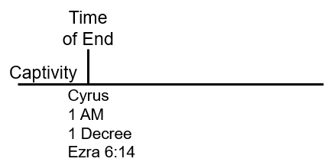
Cyrus his first job function is to destroy Babylon, his second job function is what, it’s the decree, what is the decree, it’s to leave Babylon and go back to Israel and restore the rebuild the temple.
So, this should be the end of what, time of darkness, captivity, so this is the end of the Babylonian captivity. Cyrus comes up, he's going to do a twofold work, he's going to destroy Babylon, it's the end of Babylon.
It's the first decree, we could call it the first angels message, when you put history over history, it's the procurement of Ezra 6:14, you can go to other places in the book of Ezra obviously because in the earlier chapters it talks about it actually gives you what the decree says and what the instruction is Cyrus told, you to leave the land, go back to your land and re-establish your lives and rebuild the temple.
The foundations are laid, sister Brittany went through all of that study for us, does every one leave under the decree of Cyrus, no they don't, if you go and read from Zechariah chapter 10.
And if you go to Zechariah chapter 2 verse 6, we went there earlier this week that’s Zechariah 2: 6 it begins with what words ho ho. It's an allusion to the second angels messages is to repeat, Gods does not repeat himself for no reason, when that statement is given I'm sure the people have no idea why he says ho ho, but we have a prophetic argument to show why he says that, Ho Ho, what are you telling people to do, he says flee, leave the land of the north, and what's the land of the north, Babylon this is where the medo-persian kings are.
But now the Medo empire is out of the story, and the Persians kings are reigning from Babylon they also have another city Shue Shine but they also are reigning from Shinenar, we called it Iraq today, and in the Bible, it's called Babylonia.
They are reigning from that place; Zechariah tells the people to leave. Now if we were to go to Ezra 6:14, it tells you that the temple is rebuilt in three steps. Thru three decrees, it's thru the Kings, Cyrus, Darrius and Artaxerxes.
Paraphrasing what that verse teaches, and he also says through the Ministry of the prophets Haggai and Zechariah, they are there, helping to rebuild the temple.
Now if you were to read this background story, why they go to the verse, is because it's going to give you the story of the temple. It going to begin to be rebuilt, they lay the foundations, and they get into trouble.
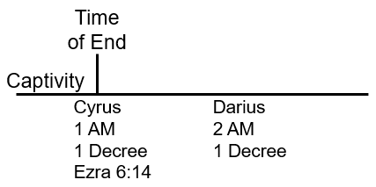
This was the studies that sister Brittany gave us, the trouble that they get into is, the Samaritans want to join in the rebuilding. But they're not allowed to, and they become vengeful, they want to take vengeance upon the Hebrews. Who don't want the Samaritans to join them, and they tell the Persian kings that these people are trouble makers and the temple work gets stopped?
All of this is happening in the time period of Cyrus, with his sons and history goes on, 2 prophets who are raised up Haggai and Zechariah who basically say that enough is enough. We need to stop all distractions and get focused on the job at hand which was to rebuild the temple.
So, it's through their ministry that the rebuilding of the temple begins to be instituted, now in connection with that work, there's already a decree given by the Persian kings. Who say you need to unilaterally rebuild your temple? So, under the authority of those prophets they begin to rebuild against the law.
Darrius is the fourth Persian King, it’s not the Darrius from Daniel chapter 5, this is a new Darrius. The new Darrius comes to the throne and he says I'm going to review the records, and check what Cyrus said, and he said yes you can rebuild.
So, you have your authority, a new law that you can continue to rebuild the temple. This is the work of Zachariah, it's at the second decree that they're going to say you can rebuild, the second decree, the second message is connected to ho ho second angels’ message.
They're telling people to come out of Babylon, if they're going to come out of Babylon, they're not coming out under the reign of Cyrus but Darrius. Can we see that, and we're just going to call that the second angels’ message, the second decree?
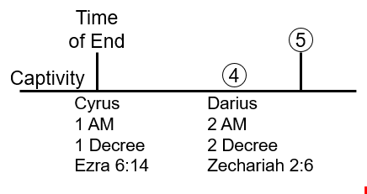
When does captivity end, does it end here, for some it did, for others it did not? So, the captivity goes beyond the 70-year captivity. They're already still captive in the time period of Darrius, in fact if you look at Ezra, which history is it connected to. Is it connected to the history of the first decree or the second decree, it's a trick question? Neither, he's connected to the third decree.
So, if he is connected to the third decree where is Ezra at this time period, in Babylon. So, Ezra stays put even when Zechariah says, come out. Ezra's not coming out yet, in fact if you go and check the story of this history there the second decree when he says come out of Babylon.
This is in connection to what Bible book what Bible story, so this is not an education of Old Testament history, but you really need to know these stories. Not only are you required to know the stories in and of themselves. Which most of us do, but if you don't understand the relationship or the connection that weaves them together.
it's really hard to put the Old Testament into a story that actually makes any sense, they are just disconnected stories and if you have disconnected story you can't take those stories and bring them to the end of the world, in a proper functioning way.
This is the problem that seven-day Adventists have, we know our stories but we don't know how to connect them and therefore we can't bring them to our own history. Now the reason why you need to flee from Babylon here, it's your last chance.
Let me take you to a story that you do know, Great Controversy chapter 38 39 and I think you go into chapter 40. So we're here the National Sunday law, if we went to Revelation 18 verse 4 what does that verse say, come out of her my people, does that sound like what Zachariah said here, Zachariah 2:6 he said flee from the land of the north what's the land of the North Babylon what said in Revelation 18 verse 4 come out of her, what's her, Babylon come out of Babylon my people is that exactly the same message, we can see the same message so Zachariah 2 is the same message as Revelation 18 you can see that connection good.
So that's just a surface understanding of how you take what Zachariah is teaching and bring it to the end of the world, hopefully you can see that if you're new to this concept. It's exactly the same message but Revelation 18:4 is in what history from the history of the Sunday law.
Now if you're not familiar with how these prophetic way marks operate, you might think that Revelation 18 verse 4 would go here at the National Sunday law, when the Sunday law is passed you might think that you go to the world and say come out of her my people. We now know that's not correct, and not only do we now know that you can go to spirit of prophecy and prove that. But we don't have time to study and show that, we are here and I will call this the loud cry, it's the loud cry Ellen White says the third angels’ message. This is some time after the Sunday law there's a time period here.
Why are you telling people to come out of Babylon? what's the reason you telling all these people you better come out of Babylon. What's about to happen, these plagues are about to happen and Babylon destroyed.
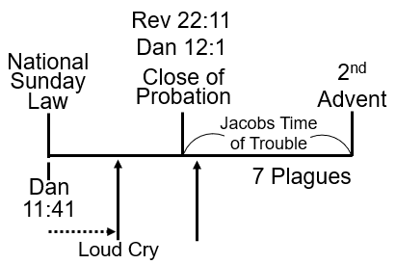
Now connected with this story so that's a frame work that we all understand, yes. Just after the Close of Probation an event occurs that Ellen White comments upon, and do you know what that event is just after Close of Probation? I'll give you the story to this, we are on Mount Carme. 1 Kings chapter 18 going to chapter 19. Elijah and the false prophets have had a fight, who won, Elijah he then prays for the latter rain, they`ve come off the mountain, and he leads King Ahab to his chariot, and Elijah will run before him by the bridle of his horse is there run to where, to Jezreel.
Then they part ways, Ahab goes inside so excited and happy, Elijah stands outside, then Elijah tells Ahab`s wife's Jezebel everything that happened and he's so excited he said we've figured out who the true prophet is.
What does Ahab`s wife say, don’t care. Elijah killed all of my prophets, and what am I going to do. I'm going to kill Elijah, so she issues a death decree upon Elijah. She issued a death decree upon Elijah what does Elijah do he runs, to the mountains, he flees to the mountains. Have you heard that when the Sunday law happens what are you supposed to do, flee to the mountains?
You've heard that before, it is in the Spirit of Prophecy, the story of Elijah fleeing from the mountains, is the story of God's people, at the end of the world. Doing what, fleeing to the mountains. Problem is, the version that you have been taught, is that you need to flee to the mountains at the National Sunday law, which is a crazy idea because how many people live in the mountains, zero.
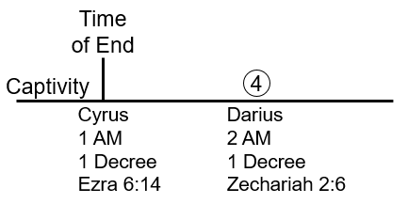
There's no one living in the mountains, why do you flee to move to the mountains. If you’re in the mountains, who are you going to give the loud cry to, you will need a megaphone or use the Internet. You can see how our models in Adventism don't work. So, we go with the perspective that our brothers said, Elijah flees to the mountain.
Why to save his life, if you flee for your life what does that mean, you're scared, the someone is going to do you harm. Check out Ellen White`s commentary on that, Ellen White says Elijah should have done, stood his ground against Jezebel, and he didn't.
In fact, he runs to the mountains, when you run to the mountains who's going to feed you. Angels, go check the story, he runs to the mountains and the angel feed him, that's where we get this idea, when Ellen White says in the little time of trouble you've got to feed yourself. With a big time of trouble God will take care of you, all of that story is taken straight out of the story of Mount Carmel.
After they killed all those prophets what does Elijah tell Ahab to do, have a feast because the rains coming. Have a feast before it's too late, so they all sit down and feed each other. The death decree comes he runs to the mountain, an angel feeds him.
So, there's a death decree, that Ellen White speaks about, and that comes straight from the story of Elijah. I put DD for death decree on the board, so in this story here is a death decree in this history.
Now in this history is there a death decree, ok let's count Kings Cyrus, Cambyses, False Smerdis, Darius, and Zechariah says what come out, he's knocking number two, he's king number four today we should know how many kings are there, there's seven Persian kings. The last king is Artaxerxes this is standard Adventist information, and you can see on charts (1844 & 1850) in 457 BC the start of the 2300-day prophecy.
Seven Persian kings three decrees #1, #4and #7, so before king number comes Zachariah was to say you need to leave. Because in this history what do we find, death decree, who issues a death decree, which book is that, that’s the book of Esther. So, the book of Esther has a connection to this history because God knows, that the next King number five, what's his name, depends who you ask if you ask the world, his name is Xerxes, if you ask the Bible, his name is has you Ahasuerus. So, this King is been an issue a death decree, that says all Jews are going to die, so these people need to leave Babylon. That's what this call is about, so the reason why we went to that story, is to show how we're supposed to read a thus saithe the Lord works.
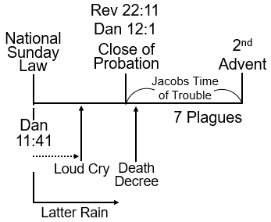
What I wanted to point out was, when we take this passage from testimonies to minister’s page 506 at the moment is at the time period of the formal rain, and you're going to now expect the latter rain to come.
Unless you pray nothing happens so, unless you pray or give a message unless you do something, nothing will occur. So just coming back to this history here, I’m not going to demonstrate or prove this because Ellen White does. This history here from the National Sunday law onwards, is the history of the latter rain hopefully we're all in agreement with that, this is the history of the latter rain.
Now if we were to go to Old Testament passages and New Testament passages, we can construct a broad a model and many models we can construct. A model of marriage, a model of construction building temples, we can think about geography geographical bodies are really important for us to understand.
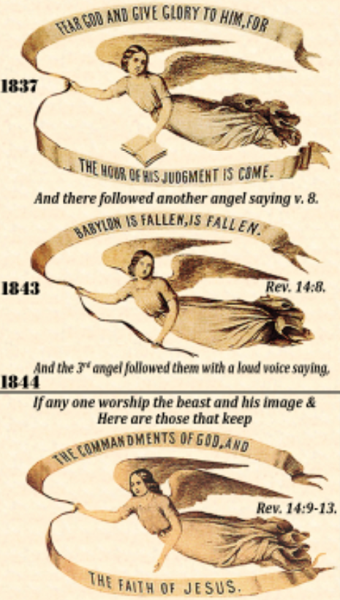
But the one that we think about most often is an agricultural model, the reason we do that we're all familiar with Revelation 14 the three angels’ messages. So, I know it's the low here perhaps at the back you can't see it but this is the 1850 chart you've got the 1st 2nd or 3rd angels’ messages 1 2 3. Then this is Revelation 14 you see, Christ coming here at the second Advent there's another angel beneath him right at the bottom.
So, we've got the 1st 2nd or 3rd angels’ messages, we've got Christ here and we've got another angel, so there are two people if you look carefully you see a sickle in each one of those hands. If you go to Revelation 14 the last part of the message which most people don't go to, you're going to see that there are two harvests, one that Christ is doing and one that this second angel is doing. But both of them have sickles in their hands.
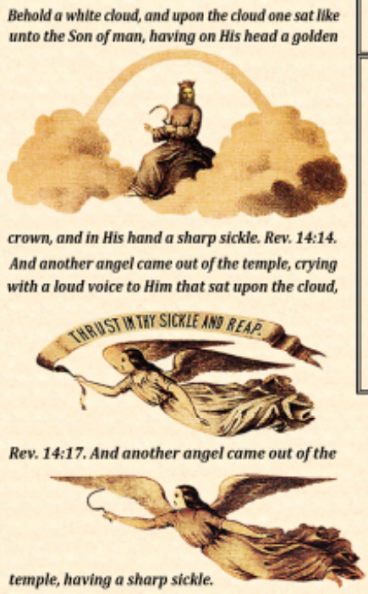
The context is that these are harvests to happen, here at the end of the world, after the third angels’ message has done its work. So, the three angels’ messages, are the everlasting gospel, and they're connected directly with the model of Agriculture, because i ends in harvest.
Today this will be settings prophetic messages, for all we know that, we can take four time periods, four dispensations, and these are the four dispensations of Agriculture, it ends with what, harvest.
If we went to Matthew chapter 13, beginning verse 24, it’s not 24 that we want think it might be verse 26, Matthew 13 we know when harvest occurs, it's the parable of the wheat and tares, verse 30 there is a discussion about what we should do, and the farmer says that both grow together until the harvest and in the time of harvest we'll do stuff.
So, we know that growth continues till harvest, and at harvest, that's when the reaping is going to occur. So, harvest here where it begins, ends growth. So, you only harvest is what kind of plants, immature plants or mature plants, mature plant, what causes maturity, the ladder rain, we already know that, we can see that from the passage we read from 506 paragraph 1, Ellen White gives us the agricultural model. So, we've got the latter rain here, what precedes the latter rain, it’s the former rain. Now, you have a field, you're not supposed to take a field that's fallow that has not been worked, and plant your seeds in there, because what will happen? the thorns and the thistles will do what? They would kill them. In fact, you can't even plant unless you plow the field, plowing the field has two functions, first it breaks up the fallow ground one, and what else does it do, it cuts down the existing weeds all plants and turns them into the ground.
So, we have ploughing, these are the four stages of Agriculture, remember this is the fourth stages of Agriculture, two thousand years ago in the Land of Israel it may not look like that today, ploughing, former rain, latter rain and harvest.
So, this is the period of the latter rain here, following the harvest, we can see that straight from Revelation 14. Revelation 14 you have the first second third angels message is occurring at the end of the third angel, depending on how you read there's verse 12 or 13 what happens? then it talks about the harvest, so there will be 2 harvest Christ is going to harvest and another angel is going to harvest, that’s the structure Revelation 14.
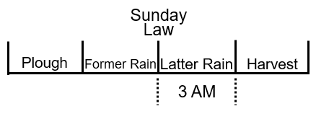
When would the third angel finish its work, before the harvest? It finishes before the harvest we all know that. This loud cry what does Ellen White call it? the loud cry of third angels message, so a third angel`s messages is in this history, third angels message and it comes to its end here, if you're not sure we read this earlier this week, you go to early writings (EW) the last part towards the end of the book, it lists that the closing that the third angels message occurs before the harvest so before the plagues.
This is the Sunday law, this is the latter rain, so you in the time of the formal rain to pray for the latter rain. Go back to testimonies to ministers, 507 paragraph one, Ellen White says pray for the latter rain, what does that mean? She's writing in 1897 and she's writing to the church, if she says pray for the latter rain what would that mean to you. It means we in what year? In the year that she writes 1897 there in the period of the formal rain. She doesn't know when the last rain is going to come, she's talking to a church, it's in the time period the formal rain.
She's going to say this, many have been a great measure of fail to receive the former rain, they have not obtained all the benefits that God has thus provided for them, they expect that the lack will be supplied by the latter rain, with the richest abundance of grace shall be bestowed, it's the Holy Spirit they intend to open their hearts to receive it.
They're making a terrible mistake, the work that God has begun, in the human hearts and given his light and, knowledge, must be continually going forward every individual must realize his own necessity. The heart must be emptied at every defilement, and claimed for the indwelling of the Spirit. It was by the confession and forsaking of sin by all his prayer and consecration of themselves to God, but the early disciples prepared for the outpouring of the Holy Spirit, on the day of Pentecost the same work only in greater degree, must be done now, then the human agent had only to asked the blessing right for the Lord to perfect the work concerning him.
It is God who began the work he will finish his work making man complete in Jesus Christ, but there must be no neglect of the grace represented by the former rain, and those who are living up to the light they had will received great light on this we are daily advancing in your exemplification of active Christian virtues, we shall not recognize the manifestations of the Holy Spirit in the latter rain. This is the famous sentence - most people are familiar with, it may be falling and hearts all around us, but we shall not discern or receive it. We don't have the time to connect all the quotes together, but when you see Ellen White's writings, a nice place to do this, would be go to acts of the Apostles chapter 5, beginning page 47 and going really to the end of the chapter, but definitely to page 55, acts the Apostles page 47 to page 55 it's chapter 5 it's called, I think it's got a gift of the Holy Spirit. If you look at all of her writings in connection to what we've just read, what she's going to tell you is this. Here is Ellen White this is Ellen White's ministry and she's living in the history of the former rain. The latter rain is ahead of us and the latter rain begins in the history of the Sunday law.
It's connected with the subjects of the loud cry, it takes some detective work to piece this together, but we're not the only people this movement, we're not the only people who recognize that the Sunday law, Revelation 13 that the latter rain is poured out upon the world, the latter rain is a message it's a special message that's given to whom to the world.
God`s people are going to stand up and they're going to say come out of her my people because Babylon is about to be destroyed. It's at that point that this cry is given which is symbolized are represented by the latter rain.
Now at that basic level this is where we in this movement begin to depart, from the way other Adventists understand what's going on here. Because they have a misunderstanding of the relationship between the rain, the people who give the message, and the people who receive the message. The people who receive the message is the world, the people who give the message are Seventh day Adventists.
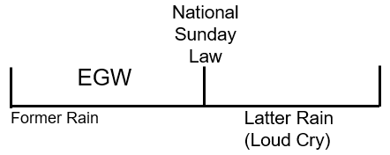
There's is this latter rain that's being sprinkled or poured upon planet Earth, if I say it that way ready for harvest. There are various components and to my experience most Adventists have got that relationship wrong in some details.
But the point that I want us to bring up, or want us to see is, a thus saith the Lord looks like this structure, you’re living in the former rain the latter rain begins at the National Sunday law. Now most of us most Adventists, understand that this is Revelation 13. Revelation 13 does not begin at the National Sunday Law; Revelation 13 begins in the year 1798 or 538 depending on how you want to understand what that chapter is dealing with.
But what it does it takes you back in time at leads you step-by-step to the Sunday law history. I won't prove that I'm just going to say it as a fact, but there's a passage in the Book of Daniel that deals with that same history. So, this is Revelation 13 and this is Daniel chapter 11 and I'm going to give the verse, is verse 41. If you're not familiar with why we would connect these two things together, I'll give you a simple connection, I've said this is Revelation 13 the Sunday law but I've also said, it's Revelation 18 verse 4 the loud cry, come out of her my people, you'll agree that that`s the Sunday law period.
So, there's a cry that says come out of her my people, this is God's people escaping or coming out of Babylon we agree with that. Go to Daniel chapter 11 verse 41 it says he shall also enter into the glorious land, so there he contextually if you go back to the previous verse is the king of the north who's the king of the north, is a king of the people of the country of the north which is the north country Babylon, so this is the king of Babylon it's talking about, Babylon is going to enter into the glorious we're not doing an exegesis of this verse and just will make one point, and many shall be overthrown, in italics it says countries, many countries, when things are italicized they are not in the original manuscripts. So, we're just going to say many are overthrown, but these shall escape, out of his hand, the king of the north hand, Babylon, and who is going to escape out of Babylon hand Edom, Moab and the chief of the children of Ammon, three groups of people escaped out of his hands.
I want us to see, not dealing with the who the three groups represent, in three sections should make this point, that people are going to escape from the king of the north. Who's the king of the north, Babylon, so Babylon is the king of the north and people are going to escape from Babylon. What is Revelation 18:4 say. Escape or come out of Babylon, so you can connect those two passages together, the reason why that becomes significant, is because we know that Daniel 11 verse 41 is a future event we haven't arrived there yet.
We're in the history of Daniel 11 verse 40, if you go to the writings of Ellen White or you went to Uriah Smith commentary on these passages, both would verify that fact verse 40 begins and at the time of the end. The time of the end in verse 40, Uriah Smith will tell you, in no uncertain terms, is the year 1798 and Ellen White will agree with that. Verse 40 begins in 1798, verse 41 begins at the National Sunday law Where the king of the north the papacy is going to enter into the most glorious land on this planet.
The word glorious can have different connotations, in this connotation the word glorious means powerful, the most powerful, illustrious, richest nation on this planet, is going to be entered into or taken over by Babylon, If you go to even a cursory reading of the Spirit prophecy, and the Great Controversy we know that this is when the Sunday law occurs in the United States, first in the United States then goes to all the world.
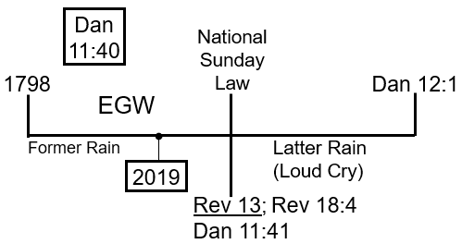
So, if you went to verse 42 it would say something along this line, even Egypt will not escape his grip, these are Old Testament stories that you could read about, where Egypt doesn't escape the punishment from Babylon. Now Egypt is a symbol of the world, it's a well-established symbol, so the papacy the king of the north is going to take control of the United States, and then the rest of the world that's what verse 41 and verse 42 is teaching.
All of this is standard understanding, for those who have understood this message for a length of time. Verse 40 begins in 1798 and brings you all the way to the Sunday law, verse 40 is a complex verse it has a simple version and a complex version, Uriah Smith's version is the simple version is it correct yes it has it place in history.
We don't have time to discuss Uriah Smith's version of verse 40, it found in Daniel and Revelation, it does have a correct application for the time period in which he lived. Today it's no longer, let me say it this way it's no longer fit for purpose, his perspective of what verse 40 looked like was correct for his time period. But would we understand it the same way today, could we understand it the same way today, no.
We couldn't because if you did, you'd have to take a literal reading of his words, and it would not fit in the geopolitical world that we have today. Especially when you go and read what he said, so you have two versions Uriah said, he obviously didn't know what he was talking about, or he was correct for his time, I mention whom Uriah Smith, am I correct you mentioned Uriah Smith in relationship to verse 40 am I correct to do that, no, I'm not correct to do that, the reason why we mention Uriah Smith is because Uriah Smith is the famous person that comments and verse 40. But you need to know something about Uriah Smith, Uriah Smith is not only a scholar, we might call him a theologian, he's also a historian, reason why that becomes significant, is that many of his comments on the books of Daniel Revelation are not his original thoughts. This is not original, Uriah Smith and his scholarship, he's not looking at these verses saying this is what these verses mean, he’s taking other people's works and putting them together, his collecting the information and put it into a book, called Daniel and Revelation.
Which first began as a series of articles and then turned into a book, so if you understand that, and then you go to verse 40, you'll know that, when Uriah Smith's talks about verse 40 this is not his work, what is it, it's just a commentary on someone else's work.
What would we want to know, who is he commenting from, who is he taking those words and putting them and applying to verse 40, this is not Uriah Smith understanding of verse 40, he agrees with it but he didn't invent that understanding? The understanding of those 40, did not come from Uriah Smith it came from who, it came from someone called Josiah Leach.
That becomes extremely significant, Josiah Leach is the person who understands verse 40, in the way most Adventists understand verse 40, when he talked about Turkey and Egypt and Syria and France and the United Kingdom all of those players evolving that history, and its Josiah Leach`s understanding that Uriah Smith is commenting on, so just want to make that clear.
Coming back to the point we want to see, Ellen White is talking about which history, the former rain, the latter rain is going to happen here, at the National Sunday Lord in verse 41. Today you're here, in 2019, we're living in what dispensation, according to this board work here? The dispensation of the former rain, is the fruit mature or immature? can you harvest the fruit? You can't do anything until you get to this way mark here which is Daniel 12 verse 1. Or Revelation 16 depending on which book you go to, history of the seven plagues begins we're in this history here. Now those brethren, who have left this movement and I'm now going to deal with the subject of the priests. They're going to look at the history of the priests and as they track through the history the priests using this modeling, They are going to come up with what dates, so this is the line of the priests, 1989, 9-11, 2014, 2019 and 2021.
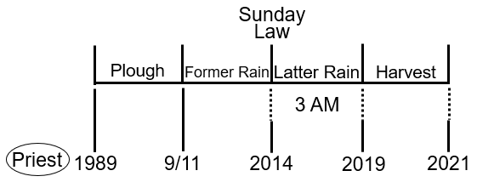
My brother said 2018 if you heard him, is because here's the loud cry, and what did we say there's a period of time between them, so here we are, the loud cry or the midnight cry would be 2018. They will take this model here, which is created from what model, it got created from this model, it’s the agricultural model but got constructed from this model here. The model that Ellen White gives us, former rain and latter rain etc., all those models that she gives us with the way marks that are attached to it she gave us that and we've constructed this for us.
So what you must do, is take not only the concept of dispensationalism, you need to do what else, juggle which means, progression and repeating and enlarge, you must factor in those things at the same time and if you don't you will come to your end. Progression and repeat and enlarge, what is the de facto premier verse that you would go to demonstrate and show that, Isaiah 46 verse 10 we're not going to read that but just want to give you a reference. When you start dealing with progression or repeat and enlarge you need to understand Isaiah 46 verse 10 the verse that explains progression and repeated large at the same time. What we need to do, is look at the line of the priests, and the line of the priests was created from this line here, that Ellen white gave us. This is the line of the priests, so I’m going to call this the line of Ellen White. I've never used that term before, this is the line of Ellen White. We are going to use the line of Ellen White, where would we begin our journey, 1798 right here where she tells us to begin. Where will we end our journey, right here second Advent. So, we need to do is populate those other three-way marks, we've already got this one here this is the National Sunday law. and this would be Daniel 12:1 where Michael stands up.
One of the hardest bitter pills for us as a movement (Adventists) to swallow is this 1844 Waymark. Remember all of this has to be obtained from a thus saithe the Lord, you have to get it from spirit of prophecy or the Bible. You can't create, because we're not God, we can't create anything. All of these every single one of us has seen those events, from the spirit prophecy we agree with that.
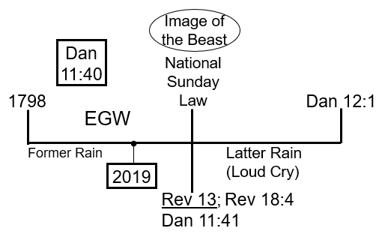
We read here 1897 testimonies to ministers (TM), that she says we're living in the time period of what, the former rain, can you see we live in the period of the former rain, from 1844 to the National Sunday law. We agree with that, easy to see that, that's what Ellen White is saying, and she says you need to get ready for the Sunday law, which is the history of the latter rain, what's the problem that most people are not doing, from what we read 507 paragraph 1.
There not getting their lives in the order, they're not partaking of the former rain, what are they doing they're praying for the latter rain, to do what to change them. They're saying we can live, how we want to in this time period, and when the latter rain comes, what will it do? It will fix us up and change us and we'll be ready to do our work. And she says, no, you need to prepare for this event now, the problem this is where we diverge from Adventism. If you take the regular Adventists, it's not that they don't believe any of the structure it's all there, they might not draw a structure like this, but you show them they would likely agree with it.
The question is what does preparation look like, that's the problem what does preparation look like, so typical Adventists especially the conservative folks. There is going to say preparation looks like living a good righteous life, you need to stop doing sin, and you know you can write books of books literally of what sin looks like, how long do your skirt is, the frequency of your meals, what you're allowed to eat, what you're not allowed to eat, how you should behave, how much tithe you pay, can you separate from the church or can't you separate from the church, what is a storehouse does all these arguments about what preparation looks like, and all of that is wrapped up with one word, we're in the a laodicean condition, and we need to get out of that laodicean condition, the laodicean condition is most Adventists think is all about reforms.
That's why we've had so many people leave the movement, or calling the church Babylon and wanted to do what they call reforms. This will fixed the problem, all people within the church say we need to stay in the church, can't leave and they just critique and criticize their conference or their local pastor everything looks wrong, I mean think about it, we've got the North American division, ordaining women pastors and women elders. I mean how low can you go, how bad can things get, when you do such apostasy, in this time of preparation, this is the mindset of Adventism.
I want to suggest an alternative version, which most of us are familiar with, we discussed this during the week, and this is where people become unstuck and agitated and they manipulate or are force to choose of what I and other people saying, the laodicean condition, is the condition where people are rejecting, the work that they've been given to do. Hold on to that thought, let me just tie up this loose end, because we're going to go back to where we finished our last presentation yesterday.
In this history we are here, and you can see 2019, lines up with Daniel 12:1, can we see that. That's one story, go here 2019, does 2019 line up with Daniel 12:1, they're not lining up, so which one's correct or which ones incorrect, because they're not lining up, and they're lining up, so one must be right, and one must be wrong. That's the dilemma that people are going to face, this is where juggling comes into its own, are you able to juggle two concerts at the same time, this is where people are struggling in our movement, because we're not able to multitask by in large.
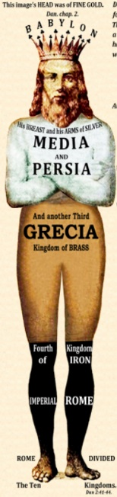
So, what you need to do, is to take this model and say this is correct, 2019 meets up and lines up with Daniel 12:1 100% correct, forget that now we'll go to here. Ellen White this is a straight thus saith the Lord, she's going to say we're living in the time of the former rain, the latter rain is the National Sunday law, followed by Daniel 12:1, the Close of Probation, this is last day events 227 paragraph 1, 2nd selected messages page 81. The Lord is showing me clearly, that the image of the Beast, shall be formed before the Close of Probation, why because it's the great test, that God's people must meet, National Sunday law, is the image of the Beast. This is Daniel, chapter 3, image of the beast, is the copy of the Beast is this here this is a symbol of Nebuchadnezzar. He's going to make a copy of himself in gold, so we can see that we're in 2019, and we haven't even got to the image of the beast, let alone Daniel 12:1, which is the Close of Probation, so is this correct, we know this is correct because this is inspiration.
So the problem that you're facing is, if this is a hundred percent correct, and this is a hundred percent correct what do you do, because we're going to say, hundred percent correct but you have to factor this in, and those people who have left future for America and their followers, they are not dealing with this issue, in the way that I'm explaining. That you have to deal with both concepts, at the same time and if you don't you're get in to problems.
This is where they get in to this dilemma of being half right and half wrong, because what they want to do, is say this is a hundred percent correct, we agree. 2019 is Daniel 12:1 what is Daniel 12:1 close the probation, it means no more, intercession from Christ. You can sin if you want, there's no more intercession from Christ, so after that if you sin, past Close of Probation, what does probation mean by the way the word probation proper definition or technical definition means test, no more testing the end of testing.
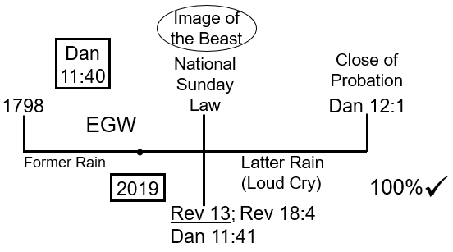
Matthew chapter 13 verse 24 to 30 the passage that we read, the wheat and the tares. This plant is growing, it begins here, and it grows, the growth of that plant can be understood in what way. I want to take synonymous terms this is William Miller`s rule # five, I got growth, equals what did we say probation is, test, when does growth stop, stops here when the harvest begins so no more growth, no more test.
You can show that growth is test, you can also which we're not going to do, see that this is righteousness, or what’s the other word we want to use, sanctification. When you die at the Close of Probation, when God cuts down the grain, growth in you stops, can you go any longer, once that nutrient that was coming from the ground, through the roots, comes through you and continues to help you to grow, once that gets cut off, can you continue to grow, no, you die, so sanctification ends here no more sanctification at Daniel 12:1
In the context of this story I, just want us to see that, now let me ask you a question, you’re a mature Adventists, when you get to heaven is the worker sanctification going to continue. Sanctification is growth, is your education going to stop the day you get into heaven, it's not, it can't, think of all the millions that have died before us, do you think Abel knows as much as you do about the plan of salvation, of course not, he think he needs to be more educated, of course he does, that means he's going to grow in grace, which means he needs to be sanctified. Sanctification is growth in your relationship and knowledge of God, for sanctification never end, no so why does Ellen White say it`s work of a lifetime because, your lifetime ends when you die.
Everything has to be understood contextually, even Ellen White's writings have to be understood contextually. Adventists have a huge problem because they say, at the Close of Probation no more sin, they take that from Revelation 22 verse 11, he who`s righteous remain righteous he who is unrighteous will remain that way. They take that and they think that's the beginning and ending of everything.
We just saw the death decree, did Elijah do some something wrong, some people to say no, Jezebel says I'm going to kill you, and what does he do, flees to the mountains, what was his motivation good or bad. He had fear in his heart, that's not a good motivation, Elijah was scared for his life, we know it's bad because what does he say to God.
When he sits underneath that tree, he says I wish I was dead, wish I was never born, why because I failed in my mission, he failed in his mission in this history, and he's already been identified by Revelation 22 verse 11 is being righteous.
Are our concepts of how to deal with the sin problem, what sin looks like is so shallow, so childish it beggars belief, until you start thinking about it. So, what people have done, is they've taken 2019, lined it up with Daniel 12:1, and said, these means no more intercession, 2019 means no more intercession, so if you sin here, afterwards is there any hope, for you after 2019. No hope this is the plan or this is the model the future for America are working on.
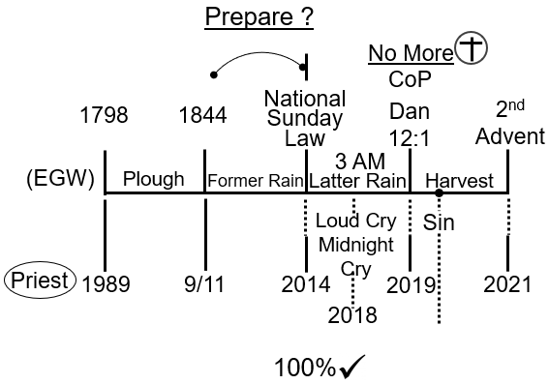
The problem is if that's all you had, they be a hundred percent correct, but that's not the only ball to deal with, you've got a whole other model, to deal with, which is this one, so we're not even in the latter rain are we, we're here in the former rain. Many people in this movement keep on forgetting that, not in this movement, those who followed the 1888 message has many misconceptions of false ideas about that history as well and, the impacts of that history upon our own.
You've got to factor this in, let's take this story forget all of this, in 2019 we're going to come, to an experience in 2019, is it the Close of Probation, in this story, there’s a Close of Probation. You can only have one Close of Probation in the line you can't have two.
This is not the Close of Probation, what is 2019, at this scale it's nothing, 2019, in fact you don't have anything, the way I`ve drawn this from 1798, but I just want to add this way mark here, because we developed this model, a bit more we've got 1844, and we've put the former rain in there, the period before the former rain, what would be this 46 year history. This history would be a plowing, preparation for Adventism.
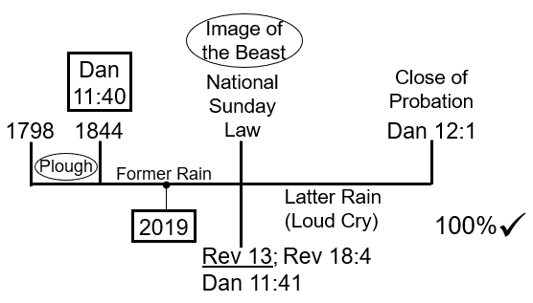
Millerites history from 1798 to 1844 is the preparation for God's people to be created, we can say it that way. There`s this former rain, we've just got this random date 2019, and it's going to bring us to the national Sunday law, bring us to Daniel 12:1. This is where intercession stops, not in 2019, so you have to take this into consideration when you start dealing with our history, which is our history the history of the priests. All of these dates we hold to, defend and believe in, however you can't take these dates in isolation to this model, because this model is based upon what idea, a thus saith the Lord. I want to ask you one question, this one here, I'm going to put Lord, the LORD has spoken that one, this way is based upon what, if that's the Lord's model what model is this.
Let's define the thus saithe the Lord, I read something from inspiration Ellen White says, pray for the latter rain, in 1897 she says you have failed to receive the former rain and you're going to be doomed to destruction when the latter rain comes, unless you get your house in order. We all understand what that means, this is a thus saith the Lord, we haven’t manipulated it changed it moved it if you look contextually.
Do you need to bring many other inspired statements, which she speaks about, they expect of the lack will be supplied by the latter rain, the latter rain is going, to happen here at the National Sunday law that's a thus saith the Lord. The former rain began when, in 1844, a thus saith the Lord, the year 1798, begins this plowing, all of this structure is based upon, a thus saith the Lord.
This one is not, this one is constructed, it's constructed by human beings, they're led admittedly by God. I'm not trying to diminish the truthfulness, or the importance of this line, but it doesn't stand in the same category as this one, why doesn't it. Because you can go nowhere in inspiration and do what, find 1989 can you, you can’t, you can`t go into even to Daniel 11 verse 40 and find it there, you have to construct it, and it needs to be the acknowledgment, an admission, but what we have done in constructing this line I believe led by God.
Look, I'm not saying this is not led by God, but you can't go to the spirit of prophecy, you can't go to which person, Daniel 11:40 who's the person, not Uriah Smith, its Josiah Litch, you cannot go to Josiah Leach, and find out 1989, why can't you, Before you answer that question the reason why this is important is because, we just didn't invent 1989. We didn't just pluck it out of thin air, we've got a very precise methodology, reasoning behind doing that. It's based upon structure so if you've seen studies hopefully on that.
But beyond the structure, you need to have a story, now the reason why you won't find, any inspired statements that this is 1989, is because when was Christ's supposed to come, when was this supposed to happen. It was not supposed to happen in our lifetime, it was supposed to happen over a century ago.
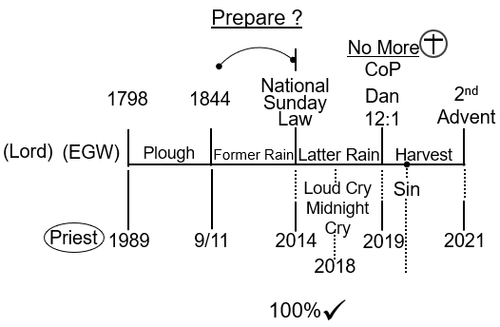
In 1844 Ellen White has said it in many places, but Christ was meant to come before 1888, long before that. If Christ is going to come before 1888 and you were to read Daniel 11:40 where would the time of the end be, 1798. How many generations would you have had, one generation, who would have been the final generation, the Millerites. Who'd have been 144,000 the Millerites, there would have been the final generation, those who were translated to see Christ coming in the clouds of heaven it would have been that group of people.
That's why Josiah Litch, already has the time of the end, that is 1798, that's why Ellen White already had that. Now they failed in that mission, 1888 comes and what is Ellen White holding on to, what hope does she have, Christ is about to return, imminently, even to her dying statement when she had her last thoughts, that she had, as she passes away. She still has this hope that Christ is about to return.
This is still the same generation that had come out of the Millerites movement, but that generation passes away and dies. Now you have to have a new generation, and it's because we have a new generation, you are forced to go back, into Daniel in verse 40, and find a new, time at the end. All of this is being led by God, but it's not based on upon, a thus saith the Lord. When you start saying the 2019 lines up with Daniel 12:1. This is not the way mark, where Christ no longer Ministers to a group of people. Even though he might be ministering, to another group of people you can't do that. This line was never meant to teach that, it was never meant to teach, when November the 10th, there is no more intercession for any of us. In the same way, it was never meant to teach that in 2021 Christ is about to return. It never meant to teach that, of course it wasn't.
2021 is here, we know 2021 is before, the image of the beast, so we know that this, was never meant to be the second Advent. It was never meant to be that this explanation is connected to a theme, a theme of the second Advent, and we could explore and explain what that theme would be, just like 2019 is connected to the theme of Daniel 12:1.
Just like 2014 is connected to the theme of the Sunday law, 911 connected to 1844, we need to understand the line of the priests in that way if you can see it that way. Then you can understand why you have the line of the Levites, the line of the nethinims without that, we are basically destroying what issue, a thus saith the Lord.
Once again we've dealt with the issue of Butler and Wagner, then we dealt with the issue of dispensationalism, whether we believe in going from literal to literal or literal to spiritual. Now we're coming to another one, how to understand the purpose and the nature of the line of the priests. In every one of those three examples that I've given the 1888 history, Wagner and Butler.
The issue of dispensationalism, this is Darvey and Scofield, the issue of the priests, this is Ellen White connected with Josiah Litch and then in connection with this movement. FFA followers have consistently maintained a model, of being half right and half wrong, and we need to see that in a really clear and simple fashion. You cannot take 2019, to be when intercession stops for you, because to do that would mean what, you’re not excepting, a thus saith the Lord, to those Adventists who say we only accept a thus saith the Lord.
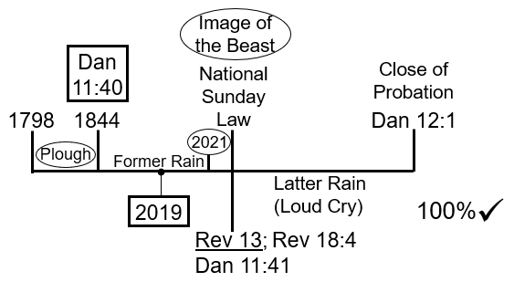
You're here 2019, 2021, 2014 they mean nothing to you, what you're stuck with then, is basically having no information, on how to do and how to prepare, for the National Sunday law, that's about to hit this planet. You have no idea of how to prepare for that, all you've got, I don't mean to say this disrespectfully for people who would listen to this, you've got some garbled understanding, some cobbled together ideas, of how to prepare and the only place you can go to, is the ditch of morality.
Because you have nothing, else you have no prophetic framework, in which to prepare and the reason you don't have a prophetic framework, you wish to prepare is, because your sights are clearly focused upon the papacy, if you look to the papacy, to give you your clues, or your hints about how close you are, so you can prepare for the National Sunday law, your looking in the wrong place. You're looking eastward, to Europe and you should be looking westward, to the United States.
People say we believe in the apostate Protestantism, Adventism doesn’t even know what apostate Protestantism looks like, and how do I know that, because the people who came out of Adventism, this movement, and the people who are going back into Adventism, future for America. Because they're holding to the same broken understanding, of what apostate Protestantism looks like in the 21st century, and that is a story that sister Tess led us through also this week, a misunderstanding what Protestantism looks like today.
Because it does not look the same as it did in Ellen White's day and age, that Protestantism Church there doesn't look like the church that you see today, and because you don't know, what you're looking for, you can't prepare and that's why this line here is necessary, for us to understand and except because it gives you the stepping stones that bring you to the National Sunday law.

