Daily Consecration
Let no corrupt communication proceed out of your mouth, but that which is good to the use of edifying, that it may minister grace unto the hearers. Ephesians 4:29. {UL 237.1}

Consecration is a very simple thing. When brought daily into our individual life in practice, we shall know far more by consecration than by trusting to an experience. Each day, each hour, let the heart go out after God: “Here, Lord, am I, Thy property; take me, use me today. I lay all my plans at Thy feet; I will have no way of my own in the matter. My time is Thine; my whole life is Thine.” Let the heart be constantly going forth to God for strength, for grace every moment. {UL 237.2}

Let not one evil word escape our lips, because our lips, our voice, belong to the Lord, and must be consecrated to the Lord and to His service. These lips must not dishonor Jesus, for they belong to Him. He has bought them and I must speak nothing that will offend Jesus. My ears must be closed to evil. Thus day by day we can consecrate ourselves to God. The ears must not be defiled by listening to any gossip that faultfinding ones would have us hear, for I not only cause them to sin in allowing them to talk of others’ faults, but I sin myself in listening to them. I can prevent much evil speaking in thus having ears consecrated to God. I can say before the evil is done, “Let us pray,” then ask God to enlighten both our minds to understand our true relation to one another and our true relation to God. {UL 237.3}

Let us open our hearts to Jesus with all the simplicity that a child would tell his earthly parents his perplexities and the things that trouble him. Thus we can restrain evil not only in ourselves but in others. Practice consecration to God daily; then there will be no danger in the life of service to God. We want gratitude brought into our life, words, and works. {UL 237.4}

Every word, every thought of complaining indulged in, is a reflection upon God, a dishonor to His name. We want our hearts attuned to His praise, full of thankfulness, talking of His love, our hearts softened and subdued by the grace of Christ, full of sweetness and peace and fragrance. We shall be patient, kind, tenderhearted, pitiful, courteous, even when dealing with those who are disagreeable. Oh, how many precious blessings we lose because we esteem self altogether too highly and have so little esteem for others.... {UL 237.5}

We must not demerit ourselves and lightly esteem the ability given us of God, neither should we overestimate our own importance and trust to our human ability.—Letter 7a, August 11, 1886, to a husband and wife working in England. {UL 237.6}

Sent Forth by God’s Blessing
1) Sent forth by God’s blessing,
Our true faith confessing,
The people of God from His dwelling take leave.
The Supper is ended.
O now be extended the fruits of this service in all who believe.
The seed of His teaching, Receptive souls reaching,
Shall blossom in action for God and for all.
His grace did invite us, His love shall unite us.
To work for God’s kingdom and answer His call.

2) With praise and thanksgiving
To God ever-living,
The tasks of our ev’ryday life we will face.
Our faith ever sharing,
In love ever caring,
Embracing His children of each tribe and race.
With Your feast You feed us,
With Your light now lead us.
Unite us as one in this life that we share.
Then may all the living,
With praise and thanksgiving
Give honor to Christ and His name that we bear.

Empathy vs. Sympathy
- Empathy is a term we use for the ability to understand other people’s feelings as if we were having them ourselves.
- Empathy can also mean projecting our own feeling onto a work of art or another object.
- Sympathy refers to the ability to take part in someone else’s feelings, mostly by feeling sorrowful about their misfortune.
- Sympathy can also be used in relation to opinions and taste, like when you say that you have sympathy for a political cause.

In 1855, Walt Whitman described his reaction to a person in pain in his poem “Song of Myself.”

I do not ask a wounded person how he feels, I myself become the wounded person, my hurt turns livid upon me as I lean on a cane and observe.

What did the poet mean when he said that he would “become the wounded person?” Would his transformation be an example of empathy or sympathy? What is the difference between empathy and sympathy? The words are easy to confuse. They are both derived from Greek, and the spelling only differs by a couple of letters. It is almost as if they were made to be used as synonyms. But they were not.
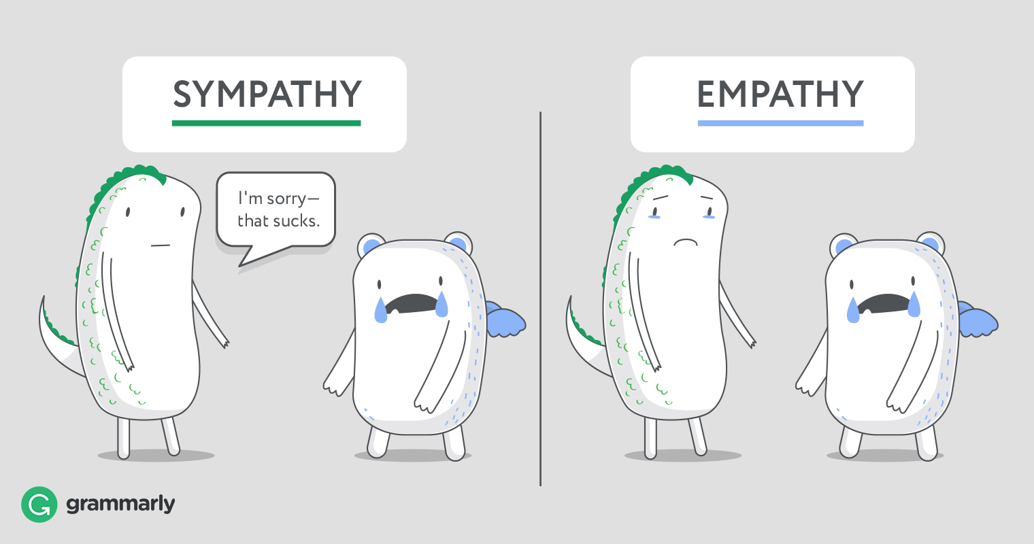

The Difference Between Sympathy and Empathy
Of the two words, empathy is the more recent entry into the English language. Sympathy was in use for almost 300 years before empathy’s first written record in the nineteenth century. You might notice that both words contain -pathy, and that’s what makes them sort of similar – they share the same Greek root word pathos, which means “feelings” or “emotion,” but also “suffering” or “calamity.” But while both words deal with emotions, they are still very far from being synonyms.

What Is Sympathy?
Sympathy derives from Greek words meaning “with feeling.” The word is most commonly used to describe the way we share someone else’s feelings, especially feelings of sorrow or trouble. Hence, greeting cards given to mourning families are called sympathy cards. Sympathy can also refer to the sense of harmony between people with the same tastes, disposition, or opinions. When a person feels sympathy toward a cause or an organization, he has feelings of approval, loyalty, or support.

What Is Empathy?
The Greek phrase that lends empathy its meaning is “passion from feelings or emotion.” Most people know empathy has to do with understanding and sharing the experiences, feelings, and emotions of another person. However, empathy can also refer to using imagination to ascribe your feelings or attitudes to an object, such as a painting or a natural object.
What is the main difference between empathy and sympathy?
Empathy can also mean projecting our own feeling onto a work of art or another object. Sympathy refers to the ability to take part in someone else's feelings, mostly by feeling sorrowful about their misfortune.
What are the three types of empathy
Empathy is an enormous concept. Renowned psychologists Daniel Goleman and Paul Ekman have identified three components of empathy: Cognitive, Emotional and Compassionate.
What is sympathy in simple words?
Sympathy is feeling bad for someone else because of something that has happened to them. We often talk about it and feel sympathetic when someone has died, or something bad has happened, saying 'Give them my sympathy', or 'I really feel for them'.
Why is sympathy a bad thing?
Yet in recent years, researchers have found that misplaced empathy can be bad for you and others, leading to exhaustion and apathy, and preventing you from helping the very people you need to. Worse, people's empathetic tendencies can even be harnessed to manipulate them into aggression and cruelty.

CLOSING THOUGHTS
Let not one evil word escape our lips, because our lips, our voice, belong to the Lord, and must be consecrated to the Lord and to His service. These lips must not dishonor Jesus, for they belong to Him. He has bought them, and I must speak nothing that will offend Jesus. My ears must be closed to evil. Thus, day by day we can consecrate ourselves to God. The ears must not be defiled by listening to any gossip that faultfinding ones would have us hear, for I not only cause them to sin in allowing them to talk of others’ faults, but I sin myself in listening to them. I can prevent much evil speaking in thus having ears consecrated to God. I can say before the evil is done, “Let us pray,” then ask God to enlighten both our minds to understand our true relation to one another and our true relation to God.

CLOSING PRAYER
Every word, every thought of complaining indulged in, is a reflection upon God, a dishonor to His name. We want our hearts attuned to His praise, full of thankfulness, talking of His love, our hearts softened and subdued by the grace of Christ, full of sweetness and peace and fragrance. We shall be patient, kind, tenderhearted, pitiful, courteous, even when dealing with those who are disagreeable. Oh, how many precious blessings we lose because we esteem self altogether too highly and have so little esteem for others. Father we ask forgiveness for our lack of love and empathy. We come before you and plead for Your spirit and a new heart. In Jesus precious name. Amen

