Introduction
3SM 338.1:
“Never are we absent from the mind of God. God is our joy and our salvation. Each of the ancient prophets spoke less for their own time than for ours, so that their prophesying is in force for us. “Now all these things happened unto them for ensamples: and they are written for our admonition, upon whom the ends of the world are come” (1 Corinthians 10:11). “Not unto themselves, but unto us they did minister the things, which are now reported unto you by them that have preached the gospel unto you with the Holy Ghost sent down from heaven; which things the angels desire to look into” (1 Peter 1:12).
This introductory paragraph makes a clear statement that each of those ancient prophets speak more about the times in which we live in, than their own times.
We want to reiterate this point that their prophesying is in force for us.
“Enoch, the seventh from Adam, was ever prophesying the coming of the Lord. This great event had been revealed to him in vision. Abel, though dead, is ever speaking of the blood of Christ which alone can make our offerings and gifts perfect.”
We are told in these 2 sentences that Enoch received visions about the end of the world. And even though Abel is dead his blood is speaking to us today.
The next sentence is import for us to understand:
“The Bible has accumulated and bound up together its treasures for this last generation.”
We want to make it very clear that WE are the last generation. This is not the focus of this presentation, but we have studies to show that we are in fact this last generation.
“All the great events and solemn transactions of Old Testament history have been, and are, repeating themselves in the church in these last days.” This sentence teaches that the ancient histories are repeating themselves in the day in which we live in.
This church, our church, believes these things. But unfortunately, when we consider how these histories are repeating, what is being taught today is that the only thing that repeat are the moral issues that are brought to view in these stories. But we understand that much more than the moral views are brought to view. The intricacies in these stories teach us specific and vital truth for us at the end of the world. This is the approach that we use when we are studying our Bibles.
As we study the book of Esther, we are going to look beyond the morality in this story.
We are going to focus on prophetic symbology used in this story.
“There is Moses still speaking, teaching self-renunciation by wishing himself blotted from the Book of Life for his fellow men, that they might be saved. David is leading the intercession of the church for the salvation of souls to the ends of the earth. The prophets are still testifying of the sufferings of Christ and the glory that should follow. There the whole accumulated truths are presented in force to us that we may profit by their teachings. We are under the influence of the whole.” 3SM 339.1
There again she brings up this concept that their “prophesying is still in force for us” today.
“We are under the influence of the whole.”
Because this church has taken the viewpoint that this is only a moral issue at the end of the world, the Seventh Day Adventists are NO LONGER under the influence of the WHOLE Bible. We read Bible stories with a single purpose of extracting a moral lesson that is why those passages don’t make any sense to us living at the end of the world. That is why many portions of the Scriptures are locked up to us. By and large, we as a church stand in opposition to the statements (3SM338-339)
“What manner of persons ought we to be to whom all this rich light of inheritance has been given. Concentrating all the influence of the past with new and increased light of the present.” This is another key point we want to focus on. We want to get all these past histories and concentrate them. But there is more to this. We need to add this concentration with new and increased light of the present. “Accrued power is given to all who will follow the light. Their faith will increase, and be brought into exercise at the present time, awakening an energy and an intensely increased earnestness, and through dependence upon God for His power to replenish the world and send the light of the Sun of Righteousness to the ends of the earth.”
We as a congregation have a varying levels of understanding. Since we can’t go back to the very beginning of this message, to lay foundation, I will have to assume that you already know. Another problem I came across repeatedly is that Adventists by and large are now unfamiliar with the Old Testament histories. Unless you understand the O.T. histories it is very hard to understand what we are teaching.
The book of Esther is a complicated book to understand on many levels, on level of morality and on the level of prophecy. For those of you who aren’t familiar with our previous presentation on morality and prophecy, I want to explain something. I will not be addressing the issues of morality in the book of Esther. I am fully aware of the arguments people bring forth when we present the prophetic viewpoint of this book, but I have already dealt with these issues in the previous series. I will be addressing the quote of Ellen white where it says that Vashti, the queen of Ahasuerus, is someone who is good, and she casts Ahasuerus, the king, in a bad light. I understand these issues and on a moral level I am not in disagreement with the SoP.
Why do we want to study the book of Esther? What possible use does the book of ancient queen has to us at the end of the world? We could ask that question of all OT stories, go to the book of Ruth, story of David and Goliath, in fact, the whole reign of David. There are many stories in the OT that we have understood as being moral stories, which were essentially children’s stories. Because we have confined these books to the moral level, we think that they have nothing to teach us at the end of the world, except how to be good people. But we have stated repeatedly that the everlasting gospel is not a moral test. It is a prophetic test. You might think that the book of Esther is only a short book, but we won’t be able to cover the book in a weekend. Some details of the book we won’t be addressing, but we will study the structure of this book and what relevance it has to us at the end of the world. Things are moving very rapidly in the world. We are in the midst of the struggle between the West and the East, two empires are clashing. And in the midst of this struggle we can see that in the last 12 months that a man is rising to fame and this man is shaping history, and he hasn’t risen to power yet. All of us should know who I am speaking about. We want to address this person only briefly. I want you to understand that the times in which we live in have all been prophesied in the Scriptures.

The historical backdrop
We need to understand the times in which this book was written to make a correct application for our time. If you are familiar with our previous presentations, you know that we rely upon the structures of the stories. For example, if we were to speak about the everlasting Gospel, we would go to Revelation 14. There we would see 3 angels brought to view. If we studied the Revelation 14, we would see that similar language used in Revelation 18. So, if you want to understand the structure in the Revelation 14 you need to understand its relationship to Revelation 18.
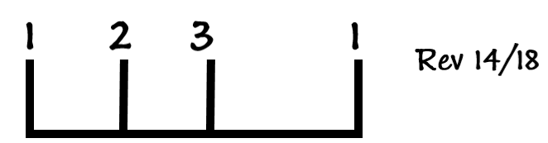

If you don’t understand the relationship between these two chapters, you won’t be able to make a correct application of the events at the end of the world.
Another structure that we use in our studies is structure from Daniel 11:40-45.
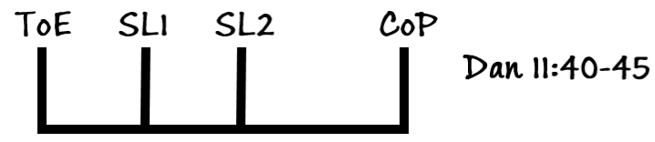
Here we understand that there is a time of the end (ToE), and we can see a progression of history in 3 steps. What is being taught here is that at the time of history which we mark as the ToE (“time of the end” is term used in verse 40), begins a period of testing. These verses bring to view the final events of Earth’s history, specifically, Sunday Laws that are going to hit this world, until we are going to hit the Close of Probation(CoP).
Another important structure is Mat 25. It teaches us many truths, but the 3 that we want to pick up is
- There is a gathering
- Midnight Cry
- Shut door
Another structure we use often is found in Rev 10:4. This is Seven Thunders. The seven thunders give us structure of the history between the 1st and the 2nd angel’s messages of Rev 14/18.
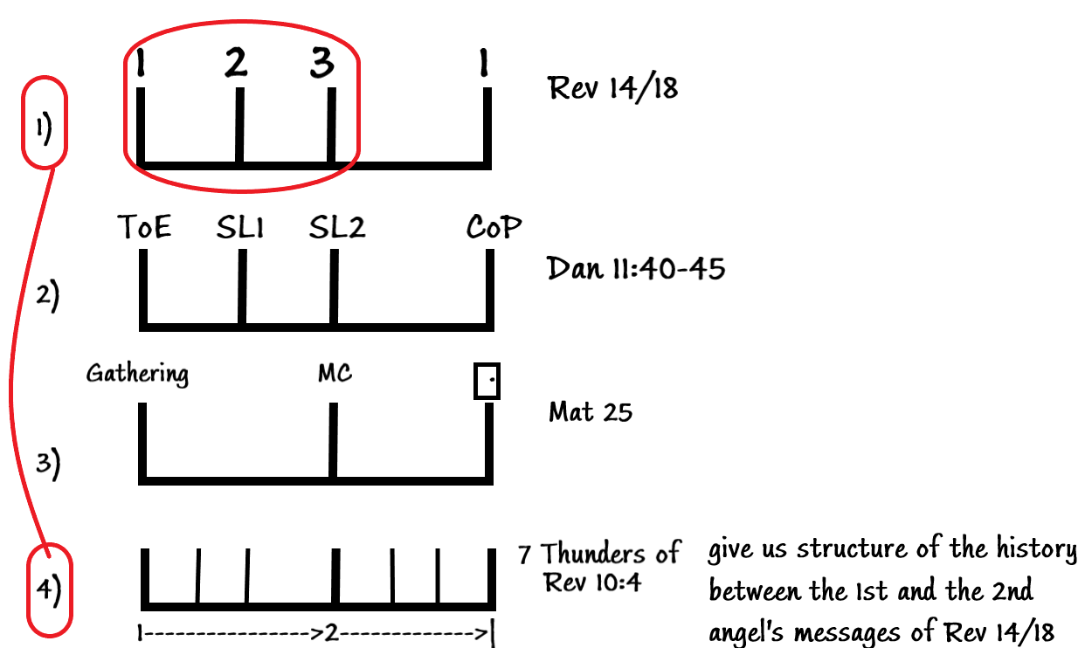

Another important structure that we need to consider is found in Ezra 7:9
Here we have two dates: 1d1mo, 1d5mo. You can infer from this chapter the 10d7mo. If you are new to this message, you need to be aware that we are picking up this models/structures from different chapters/stories. Without understanding this, you might think that we are plucking things up from the air. But, in fact, we are making detailed application from many of these structures. One of the things that challenges the SDAs here at the end of the world is the relationship between the literal things and symbolic things. I want to make it clear that when we present our studies, we follow rules of William Miller. One of the principles that use is that we should understand things figuratively/symbolically. For example, when we see the date 1d1mo in the book of Ezra in our calendar this would be the 1st of January, 1d5mo would be 1st of May, and 10d7mo would be 10th of July.
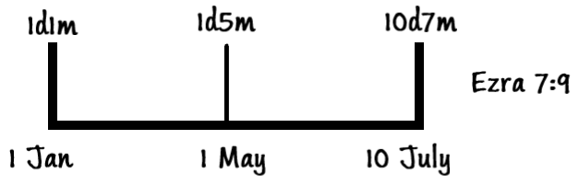
So, you can see that we are going to OT stories and picking the dates. Now, don’t be concerned, as we are not date setting or time setting. But we are using these dates as symbols. Once you begin to do that then you are able to use the WHOLE Bible as mentioned by Ellen White.
As soon as you take a name of a person or a place, or a time period, or date and turn that into a symbol and run that symbol line upon line through the Scriptures you will begin to see that the Scriptures open up to our understanding. In Daniel 8:13 there is a discussion between Gabriel and Christ brought to view. In that verse Christ is called “Palmoni, the Wonderful Numberer.” In the book of Esther, a prophetic structure is embedded. That structure is based upon the symbolic understanding of time.
The book of Esther is dealing with the history when God’s people are in the captivity. Ahasuerus is a Persian king. As Adventists we are familiar with this phraseology, because we teach Dan 2 frequently, and in Dan2 4 major empires are depicted. The second empire is the Medes and the Persians. In the book of Esther, we are in the time period of the second empire.
I want to show us the relationship of this book with other events that are occurring. One of the structures that we use is seven thunders of Rev 10:4. So we want to see relationship of book of Esther and the seven thunders of the Rev 10:4.
The 7 thunders, according to Ellen White in Manuscript 59, 1900, is the delineation of events that occur under the 1st and 2nd angel’s messages.
{The books of Daniel and the Revelation are one. One is a prophecy, the other a revelation; one a book sealed, the other a book opened. John heard the mysteries which the thunders uttered, but he was commanded not to write them. The special light given to John which was expressed in the seven thunders was a delineation of events which would transpire under the first and second angels’ messages. It was not best for the people to know these things, for their faith must necessarily be tested. In the order of God, most wonderful and advanced truths would be proclaimed. The first and second angels’ messages were to be proclaimed, but no further light was to be revealed before these messages had done their specific work. This is represented by the Angel standing with one foot on the sea, proclaiming with a most solemn oath that time should be no longer.}
We will take that principle:
And see the development of that history with other histories.
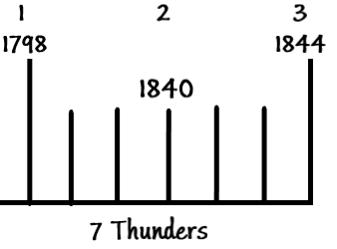
These dates have relationship to previous histories by prophetic time period.
How is 1844 connected to the previous histories? This history (1798-1844) is called 7 thunders in Revelation. I am going to show you that it is connected to the histories of 7 kings of Persia. The date 457BC is connected to the 1844 by 2300-day prophecy. As Adventists we are familiar with this. But the next thing that I am going to do is something quite advanced. We are not just looking at the 2300 days, but we are trying to see the connection between the two histories.
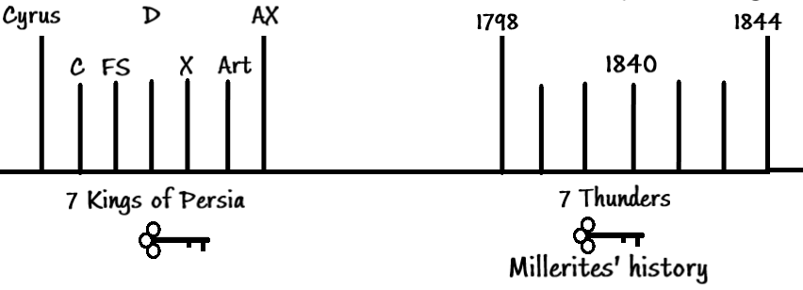
The way we are unlocking this connection is through a key. This key is 7 thunders, which is in this history is 7 kings of Persia. So, we are using this symbol which are the events between 1798-1844 and seeing that it was typified by the 7 kings of Persia. In the book of Ezra, Chronicles, and Nehemiah you will be aware that in this history (history of the 7 kings of Persia) there were 3 kings that did a work for God. We are going to label these kings as 1,2,3. So I connected the work of this 3rd king with the work of the 3rd message (1844). You can see a beautiful structure.
As Adventists we know about 2300-day prophecy, but when we approach our studies, when we teach people about 1844 and the cleansing of the sanctuary, we generally, don’t go back to Ezra, or Nehemiah to look for connection. And even if we do, we only look at 3 kings. Each of those kings gave a decree or a law. This law was to restore Jerusalem and the temple. This progressive restoration is complete by the 3rd decree. Through 2300-day it is connected to the arrival of the 3rd Angel’s message. The 3rd angel’s message is preceded by the message of the first two angels.
There is another time prophecy – 2520. We will see that the 7 kings of the previous history, 7 kings of Judah can also become a key. We are going to connect the 7 kings of Judah with the 7 kings of Persia. We are going to see that K (Jehoiakim) with Cyrus of Persia. Before that I want to connect these 3 histories together. The start of these 7 kings of Judah and end of the 7 thunders (1844) is connected by 2520. We have gone from the 1st king of Judah to the 5th king, and 5th king is connected to Cyrus, the 1st king of Persia, the 7th king will give the 3rd decree, which is connected to the 3rd angel’s arrival by 2300-day prophecy.
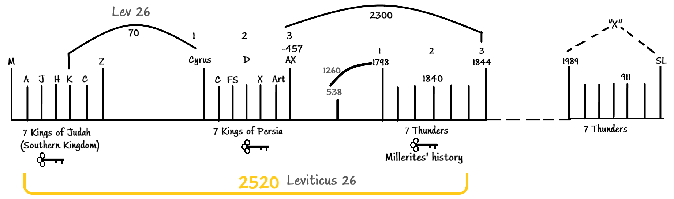
The 5th king (K for Jehoiakim) is connected to the 1st king of Persia (Cyrus) by the 70-year captivity, that is brought to view in the same chapter that the 2520 is brought to view. 2520 is found in Leviticus 26 and 70-year captivity is found also in this chapter. So, the punishment that is brought to view (2520) the 7 times of Lev 26 is connected to the 70 year prophecy in Leviticus 26.
1798 is also connected to 538 by 1260.
1260 prophecy is also connected with 70-year prophecy.
The names of the kings are designated as letters, but it is important that we know their names:
M = Manasseh, A = Amon, J = Josiah, H = Jehoahaz, K = Jehoiakim, C = Jehoiachin, Z = Zedekiah

Names of the Persian kings:
C= Cyrus, CII= Cambyses, FS= False Smerdis, D= Darius, X= Xerxes, Art= Artabanus, AX= Artaxerxes
You can see that there is connection between these kings and the 7 Thunders. There are many truths that we can connect with the relation to these sevens. We know that during the reign of Z the temple was destroyed. Between these 7 kings of Judah there is progressive destruction of the temple. But these 7 kings are connected to these 7 Thunders. In Millerite history there is a symbolic construction of the temple. So the history of the 7 kings of Judah is the story about the destruction of the temple, while in the 7 Thunders/Millerite history there is a symbolic construction of the temple. Seven kings of Judah = literal destruction, 7 kings of Persia = literal construction of the temple. I have not identified the time of Christ.
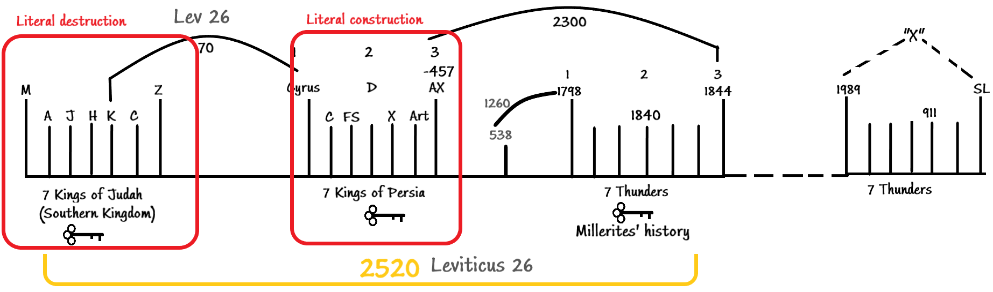
The history of Christ is connected to the 2300-day prophecy, and that is history of destruction of the temple as well. When we look at these histories prophetically, at one level, it is all about the construction and destruction of the temples. It is the story of the relationship between Christ and His people. In the book of Esther we are looking at the history of the 7 Persian kings. The seven Persian kings are:
- Cyrus
- Cambyses, Cyrus’ son
- False Smerdis
- Darius
- Xerxes
- Artabanus
- Artaxerxes
We will study the relationship between Cyrus and Jehoiakim (K), and between Artaxerxes and the 3rd angel’s message because we want to see how these 7 Persian kings, their histories, and their relationship to God’s people affects us at the end of the world. This is new light, the new way of understanding history, that we would look and the secular history and the Biblical history of these kings, and make the prophetic application of these things for us at the end of the world.
Let us focus on Xerxes, the 5th king of Persia. Xerxes is a secular, historical name. In the Bible Xerxes = Ahasuerus. He is the one mentioned in the book of Esther.
Esther is going to show us deep spiritual truths for us at the end of the world. Without placing these figures on the lines it very hard to understand how these little dot here (Xerxes) would affect what is going to happen here, at the end of the world. When we put our history, the seven thunders of our history on a line, we can see that all previous histories are all pointing to our line. This histories (7Kingsof Judah, 7Kings of Persia, 7Thunders) are all identifying our line. Our line starts with 1989, and end in SL.
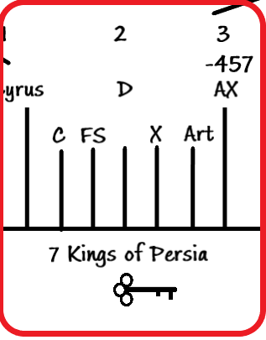This 7 is the symbol of this seven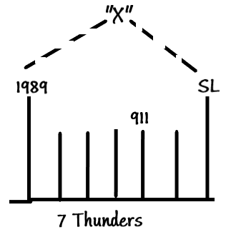
What I am doing, is this dot – Xerxes, his history, is discussed in our history, specifically 9/11. We will see that period from 911 to SL is going to be the focus of our attention.
In the history of 7Thunders, we will see that 1840 parallels 9/11. The way we zoom in and zoom out is based upon a mathematical principle of fractals. Fractals are repeating patterns. When you pattern repeating, you know that you have a fractal. And easiest place to see an example of a fractal in the Scriptures is Revelation 14:7. Verses 6-7 is the 1st angel’s message, and the when you the relationship between that message the other two messages you will see a repeating pattern:
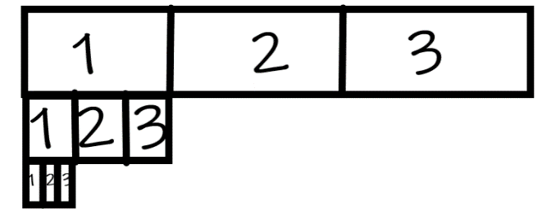
This is the principle that we use to zoom in and zoom out. The story of this king has an effect/bearing upon our history. Before we study the book of Esther let us see the historical placement of this book in the book of Daniel.

Dan 11:1 speaks about the king of Medo-Persia, Darius the Mede:
- Also, I in the first year of Darius the Mede, even I, stood to confirm and to strengthen him.
- And now will I shew thee the truth. Behold, there shall stand up yet three kings in Persia; and the fourth shall be far richer than they all: and by his strength through his riches he shall stir up all against the realm of Grecia
Note that Darius the Mede mentioned in Dan11 is NOT the Darius, the son of Hystaspes (a.k.a. Darius the Great) Darius the Mede is the one before Cyrus:
The book of Esther describes the events that happened under Xerxes/Ahasuerus, and the history of the previous kings (Cyrus, Cambyses II, False Smerdis, Darius the Great) has been dealt with in the book of Daniel. That is why when studying the book of Esther, you can’t escape but look at the book of Daniel. And Ellen White says that Daniel and Revelation are one book, one is the prophecy, and another one is revelation.
If we are discussing the book of Esther, it is referring us back to the book of Daniel, it means that we are investigating the book of Revelation. So, you can see that study of the book of Esther is a prophetic study. Considering this, I want you to know that we are using sound hermeneutical principles when studying the book of Esther. The story of these Kings is brought to view in the prophecy, in the book of Daniel.
And this prophecy is Daniel 11 is a repeat and enlargement of the prophecy in Daniel 8, 7, and 2.
The story of Darius the Mede is also brought to view in Dan 4, 5, and 6.
Dan 4 talks about the fall of Nebuchadnezzar and fall is referred in Dan 5.
In Dan 5, last verse mentions Darius the Mede. And Dan 6 talks about the beginning of the reign of Darius. And Dan 8, mentions the Darius the Mede again.
So, you can see that the history of these kings is brought to view in the book of Daniel. Why would you think that the book of Esther, which is dealing with the same time period, should not be looked at with the prophetic viewpoint? If we were doing a study on Dan 2, we would have no problem distinguishing between the morality and prophecy. So, when we talk about the Medes and the Persians (7 kings) in the book of Daniel, there is NO moral story in there. But Esther is tucked into Daniel 2, 4, 5, 6, 7, 8, 9, and specifically in Daniel 11. We have arrived at the book of Esther because of our understanding of Dan. But we are going to understand the book of Esther by using these structural patterns (fractals).
So in summary, we have started in Millerites history (7Thunders), connected it to the history of Persian kings, which are connected to the 7 kings od Judah. All four lines are connected to each other by 3 kings, 3 messages, 3 decrees.
