Book of Esther. Part 2 of 7
- Manasseh | Cyrus
- Amon | Cambyses II
- Josiah | False Smerdis
- Jehoahaz | Darius I, the Great
- Jehoiakim | Xerxes
- Jehoiachin | Artabanus
- Zedekiah | Artaxerxes I

Xerxes, according to secular historians reigned a long time, approximately 21 years. But in the book of Esther his reign is discussed in discreet periods 3rd year, 6-7 year, and 11-12th year. It doesn’t discuss what happens between these discreet periods:
This is because this story is a parable. As we know, parables can be true events and made up stories. In this case the true story = parable. And as such has an end time application. And the Lord gives us a story of specific periods that we need.
We will be looking at these symbols as figures.
Esther ch.1 and ch2 are dealing with different people.
Ch1 is dealing with Vashti. Ch2 is dealing with Esther. These chapters are dealing with 2 different women, their experiences with the king Ahasuerus. Now we have 3 people in the picture. And we need to understand the relationship between them. There are other 2 key people: Mordechai, and Aman. 5 characters. Who do they represent?
The king marries Vashti. Divorces her and marries Esther. Morally speaking everything is going wrong. So, we will not address the morality of these relationships.
The name “Ahasuerus” has various meanings, one of them is Lion king. It can also mean “prince”, “head or chief”. In Strong’s, as well as Brown Driver-Briggs it can also mean “I will be silent and poor”. He represents a lion king, and also someone who is silent and poor. We will discuss this later.
If we take the symbology of a lion king, we can see that this man represents Christ. He is marrying a woman, divorces her, then marries another woman. If you take symbology of Christ marrying people, that is clearly brought to view in the New testament, then Christ marries the church.
So, the overarching theme of the book of Esther is the story about Christ/Ahasuerus divorcing the church and marrying the church. Keep in mind that this is the story about the end of the world. If you start realizing the implications of what it means, you may become alarmed. The theme is that the church that exists at the end of the world is divorced by the Lord. He will divorce this church that represents Vashti, and He will replace her with another church Esther. This theme is also brought to view in many other books of the Bible, book of Esther is not the only one that tells this story (i.e. Revelation, Daniel, 4 Gospels etc.). It is also brought to view in Matthew 25 after describing the prophetic events in the history of the church in Matthew 24, Christ starts ch25 by saying “then…” The point He is trying to make is that after these events in Mat24 occur, then the kingdom of heaven will look like the following, which is the parable of the ten virgins. The thing that is so striking about that chapter that in the parable of the ten virgins is the perspective of there being two groups.
These two groups are brought to view over and over again in the Scriptures. When we speak about one church being bypassed and another church being married to Christ, this is not two separate churches, this is a singular church. The structure and components of this church has been identified by two groups in the book of Esther.
Vashti represents the church that is being separated from God, and He is going to marry another group from the same church represented by Esther.
When Christ came to Earth time that is exactly what happen then, He divorced the Jewish nation and married the Christian church. But the Jewish nation and the Christian church were not the two separate groups of people, - they were from the same group. The disciples who were seed of the first apostolic church were the remnant of Ancient Israel, the first church.
I want you to have a clarity that the Lord is in the process, in the book of Esther, of divorcing or separating from the Seventh Day Adventist structure. But within this structure He will enter into a relationship/covenant/marriage with a group not from another church but from within this church. That is the theme of the book of Esther.
Ch1 and Ch2 are giving us the sequence or the prophetic clues of when that is going to happen.
You can’t just go to the book of Esther at the beginning of a series of prophetic studies, without studying the background of the events as we need that to understand the symbology that is brought to view in this book.
The following sequence of events that we need to understand:
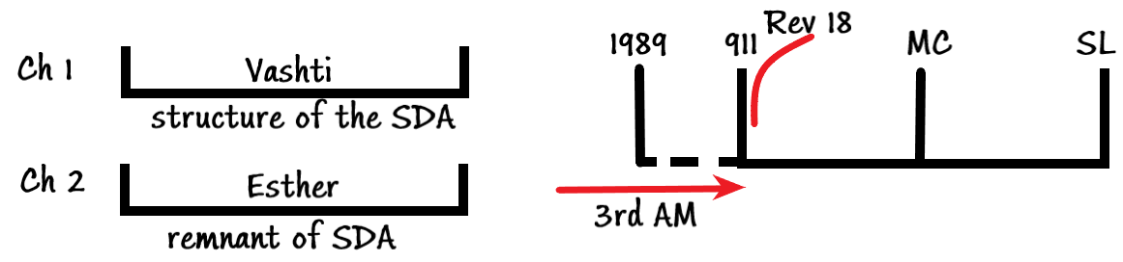
The third angel’s message that is running all throughout this history is going to be empowered. The angel of Rev 18 is going to come down at 911 and the test begins, the test of the 1st, 2nd and the 3rd Angels’ messages. By the Sunday Law, this 3rd angel that has been running since 1844 will complete his work for the church, and then the work will continue for the world. Esther teaches and confirms that this structure is correct.
Ahasuerus, that is represented by Christ is going to divorce the queen Vashti (SDA structure) and at 911 is going to be introduced a test. Upon this test he will divorce Vashti, and marry Esther, the remnant of the Adventism. This climactic event, this separation process between Vashti and Ahasuerus is going to be so sever, so shocking, that if you are standing and looking in from the outside, it would appear that the church falls, because this separation is so severe, that when it occurs it will look like there is no SDA church left anymore. But the church does not fall. The explanation of this famous EW quote is brought to view in this book Esther.
The separation of the SDA church is so severe that the king looks as though he is left without a bride, and in the story, he is. He hasn’t got a bride for several years.
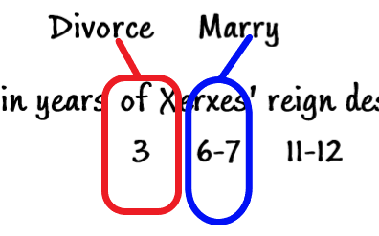
Divorce from Vashti is portrayed in this period (3) and marry in the (6-7) time period. So, for a portion of time, in a literal story the king is without a wife. We need to understand things symbolically, not literally. These things are happening concurrently, and not sequentially, as we will see from Ch1 and 2. This concept of repeat and enlargement or of paralleling events is one of the themes of prophetic studies that we need to be familiar with.
We have been incorrectly taught to read the book of Esther as one event occurring after another. We do that with all of our reading, and that is an incorrect way to study and understand prophecy.
In fact, periods 3, 6-7, 11-12 are running concurrently. Even though we have 3 discreet periods, prophetically we have only one history. So the history of the 3rd year is running concurrently with the 6-7th year history and 11-12th year. Even though we have 3 distinct periods, prophetically we only have 1 history.
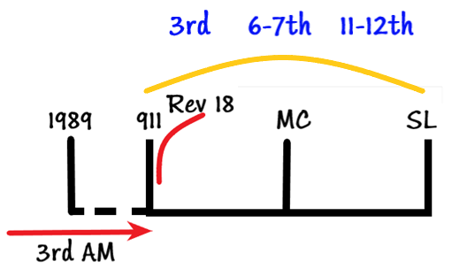
When we get these periods and bring it over to our history (1989-911-MC-SL) the period between the 911 and SL is the story of the 3rd year, 7th year, and the 12th year. All of these stories need to be applied this way. At the same time the structure is being divorced, the Lord is marrying, entering into covenant with the remnant that is taken from the same church. This is the theme of the book of Esther. It is in agreement with all the studies that have been presenting not only the D&R but many other stories in the Scriptures.
If it is not clear what I have said to you, and you get lost in the numbers, dates, people, and all merges into one thing and you become confused just take one thing with you:
We (the church and Christ) have already began the process of separation. Process of coming together has already began. This structure (SDA) is already being divorced by Christ but it is not complete. The progressive work has already begun from 911 onward. Ask yourselves, as friends, family, where do you stand? Who are you represented by in this story?
If you are new to this message you would have been taught by the church that the church of Adventism is going to go right through the struggle of the Sunday Law, unscathed, unharmed, but prophecy teaches otherwise. It teaches through the story of the 7 kings of Judah and with the 7 thunders of the Millerites history (thru 2520) that the structure is going to be destroyed.
If you are under any misconception that the structure of this church is going to be destroyed just read the story about the 7 kings: First the children are going to be destroyed, then at the reign of the last king, Zedekiah, the temple, the walls, the whole city of Jerusalem, the whole structure is destroyed. It is a progressive destruction that starts with Manasseh. But in that story (of destruction of Jerusalem) there is a story of Daniel, who is progressively lifted up before Babylon, and he becomes and ensample or example of this (“Esther”) group of people.
So, there is a relationship between Esther and Daniel. This is not the only place that you can see it, that the structure of this church which is symbolized by the temple in Jerusalem is going to be destroyed by Babylon. And this destruction begins a captivity of 70 years. This 70 years is not the same 70 years that we spoke about, but it is related. There are 2 70year-periods brought to view. We need to understand this because this event (occurring at the reign of Zedekiah) is a type of this event here (at the SL).
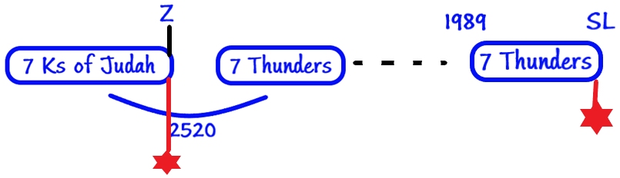
Therefore, this 70y of punishment is a type of the punishment that is going to come upon this church (at the SL) after the Lord separates from it. But in the midst of all this apostasy there are faithful people who are sighing and crying as Jeremiah, who are faithful in truth who represent Esther – remnant. But the time you get to this point (SL) you will get the church who is pure and true – the church triumphant. The story of Vashti is the story of the church militant and the story of Esther is the story of the remnant, the church triumphant. They are the same church (Esther and Vashti). The difference between the two is that in this church, Vashti, there are tares, mixed with the wheat but in this church, Esther, there are no tares. What happened to the tares? They have been harvested, bound into faggots, ready to be burned. Those faggots, which is the binding of the tares is the symbolic representation of the structure of this church and all the lay members are going to follow the leadership represented by Vashti. This is the overarching theme of the book of Esther.
We mentioned two other characters: Haman and Mordechai.
We are going to see that Haman who is an enemy of the God’s church is the symbol of the power at the end of the world who wants to destroy God’s people. Mordechai will have more than one representation. He is a symbol of more than one thing. In the story he is the protector of Esther, he is a symbol of someone who will protect the remnant at the end of the world – Holy Spirit. Mordechai symbolizes Holy Spirit at one level, but he also represents the remnant. You begin to see that there are levels of complexities in the study of any book because different people can be symbolizing the same thing.
In Revelation 10 there is an angel that comes down who has the book. He tells John to eat this book. Ellen White tells that this angel is Christ, but in the book of John at Capernaum (John 6) Christ tells the disciples tells to eat HIM (“eat my flesh and drink my blood”). In Revelation 10 when Christ tells John to eat the book in His hands, that book is the symbol of Christ. So, you have an angel AND the book represent Christ. But that book represents other things as well.
We follow the William Miller’s rules, one of his rules says that we need to understand figures figuratively, symbolically. But those figures and symbol can represent more than one thing. We have looked at these 5 characters and if you go away with nothing more from these studies ask yourselves, where do I stand, who am I represented by in the Scriptures: by Vashti or Esther? This structure that is going to be divorced or destroyed, or Esther, the remnant?
In the book of Esther, her history is the glorious one. You would go to other Bible passages that show you that the life and work of the remnant is not as straightforward as that. You know that Haman has the blood feud with Mordechai. If you want to be Esther, the remnant, God’s people, you will have powers that desire your death and your demise. Not only that. If you go to the gospels you will see that there was a struggle between the disciples (Esther) and the Sanhedrin (Vashti). Not only does the state (Haman – high official in the Persian empire) want to destroy you (if you want to be Esther), but the church does also. The Sanhedrin not only destroyed and killed the disciples, but when Lazarus is raised from the grave (the English say: “it was the last straw that broke the camel’s back”) it was all the Sanhedrin could take. Once Christ resurrects Lazarus, the Sanhedrin says, “enough is enough, now we have to kill them”. Lazarus is the symbol of the remnant (below is the slide from some other presentation about Lazarus): 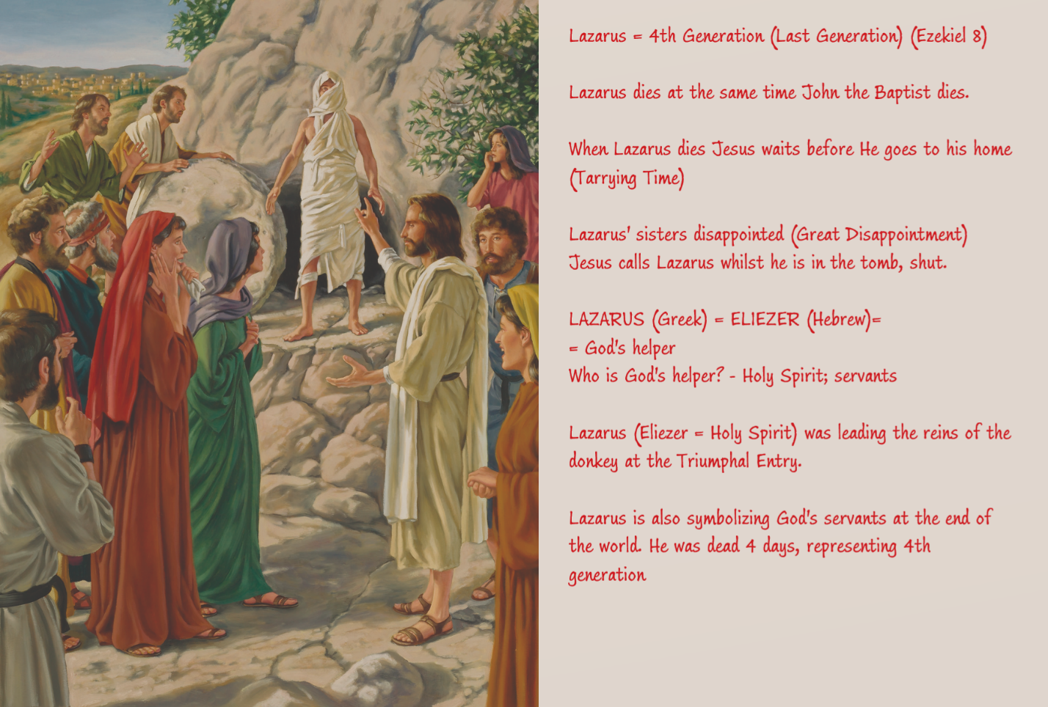
Lazarus is the story of Esther, Mordechai. If you want to be Esther you will received persecution not only from the state but also from the church. That opposition of the church is not brought to view in the book of Esther. Because the way the story is structured it is first separation (3rd year of Xerxes’ reign) then the marriage.
Esther Chapter I (Closer look)
The book of Esther needs to be laid over a line of our own history.
There are two distinct sections in the Esther ch1. Our purpose in this study of chapter I is to determine whether or not we can see symbology brought to view that verifies this truth. But you would have already realized, if you are new to this message that I assume that the significant events that are occurring in your life have already started 15 years ago (9/11 2001), and they are going to progress until we get to the Sunday Law. This is the assumption (as we have demonstrated in other prophetic studies). All the book of Esther will do for us is to confirm or deny if we are wrong. But it will confirm that the structure that we have developed is correct and will give us additional truths and the most important one is that the church structure is about to be separated from Christ. During that period, He is going to marry, enter into covenant with the remnant. If that is correct when we go to Dan 2 we should be able to the symbols that would line up with chapter 1. When it lines up with chapter I you will see that the 6-7th years and 11-12th years are lining up with the 3rd year.
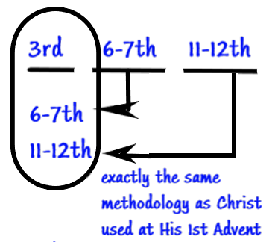
3 parallel histories lining up like this is exactly the same methodology that Christ used at His 1st Advent. But we have become so unfamiliar with His method of teaching, so blinded by the Sanhedrin of Adventism that today Christ’s method of teaching is something that is new to us, and we have to learn it afresh. We have to forget the traditions and customs which have got white hairs because they are so old and so establish that we respect them like we respect the elderly, but we need to become new vessels because when the new wine is brought in it cannot be introduced into the old bottles. These are not new things, these are old things that have been buried by the customs and traditions of apostate Protestantism that now have been carried away. This methodology is Parable Teaching. This methodology is placing things, juxtaposing things parallel to one another. The thing that we need to understand about the juxtaposition is that it is putting thing in parallel, the things which are not the same. The 3rd year is not the same as the 6-7th years, or the 11-12th year. Different things are happening: chapter I – divorce, chapter II – marriage. Juxtaposition is putting different things, which contradict each other, and joining them to develop a truth. This is what the Christ’s methodology is, and we are just following His principles that He used. But when you present these truths in the 21st century people say, “these are new things”. So new, that they brace themselves and resist and say “cannot be true”. They are following the footsteps of their fathers. Today the church is resisting against this truth, fulfilling their role as Vashti. As lay members we are not under the same restrictions as the leadership. You need decide for yourself whether or not you are bracing yourself or resisting yourself to this message, not accepting the methodology that Christ gave us. I am not suggesting that because you don’t understand that you are resisting, but I encourage you, that if these things are new, don’t take my word, don’t take the word of your pastor, or your elder, but study for yourself. Make the record of the verses and see if what I am presenting makes sense and correct. My interpretations of the Scriptures are correct. And If they are, you will see that this methodology is parable teaching and you will find in Mat 13 that the disciples who are Esther, they don’t understand prophecy, parables, but they seek the aid of the comforter. We are to do the same, we are to go to the Comforter, and He will open up the Scriptures to you. During the gospel period, the Comforter was Christ. John 16 He identifies Himself as the Comforter and says “I am going to go, and will send you ANOTHER Comforter, the Holy Spirit”. Our first work (as we study Esther chapter I) is to make sure that when I say it begins at 9/11 is this true or not. Do I have evidence to show you, that Esther I begins at 9/11? What I cannot do is to prove to you that the 9/11 is the significant event in your life as a Seventh Day Adventist (that is another study that is already done). I am suggesting that 9/11 is an established truth. At 9/11 the leadership of this church lost their jobs, they were bypassed, separated from their job function as the leaders of God’s people. At that moment God began to raise the new leader. In the gospel they are the 12 disciples. John the Baptist, speaking of the leaders calls them the “sons of Satan”. In Mat 23 they agree with this title even though they don’t admit to it. All of these is occurring at 9/11. Then begins collapse or separation and divorce of this church from Christ.
I want to encourage you to look at the book of 2 Chronicles and the book of Ezra, specifically 2Chr 29:16-17 and Ezra 7:9. These verses are the evidence that we will provide to know whether or not this structure is correct. The clue is this: In Ezra 7 we will see a structure of the 1d1mo, 1d5mo, and the 10d7mo. And we will see two periods, period of 120 and 70. An then in 2 Chronicles beginning at exactly the same period we will see that we will be at the 8d1mo, and the 16d1mo:
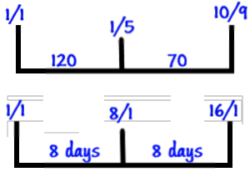
Please refresh in your minds that you can see the 1d1mo and 1d5mo brought to view in Ezra 7, and in 2Chronicles we can see the 1d1mo, 8d1mo, and 16d/1mo. And the structure in Esther 1 follow the same two step process, with 3 waymarks. The numbers might be different, but the symbols are all the same. This is the logic that we will provide to demonstrate that the separation begins at 9/11. But not only divorce from Vashti begins 9/11 but in many ways far more important events that are shaping the world today.

