In the last presentation we spoke about the structure of the book of Esther. I suggested to you to look in the book of Ezra 7:9 and 2nd Chronicles 29.
In 2 Chronicles 29 what I want us to see is that we get structure of two time spans:
1/1, 8/1, and 16/1 - This is the cleansing of the sanctuary (more in the series “Ezra 7:9”).
It is the time of Hezekiah. As soon as you know that this is the cleansing of the sanctuary you should know that there is connection to Dan 8.
We could see that there are two periods of 8 days.
We also see that the Priests are doing the work in the temple, whilst the Levites do a work in the courtyard.
Side note: We all know that the Passover is on the 14th day of the 1st month (14/1).
Now you can see that there is a problem: the temple is not ready on the 14/1, there is still 2 day until the completion of the cleansing. So, the king Hezekiah cannot have Passover, what does he do?
He goes back to the Lord and seeks His council. It turns out that in the writings of Moses that he has taken this things into consideration: there is a law that if you can’t keep the Passover of the 14/1, then you can wait a month and keep it on the 2nd month – 14/2. But there are strict rules about that. This is explained in the chapter 30.
These two Passovers (14/1 and 14/2) have a relationship to us. Passover is on the 14th day. Christ is crucified on the Friday the 14th. He rests the 15th and resurrected on the 16th.
16th is the day of the First fruit offerings. So, the 1st fruits offered on the 16th. That first fruit, in this framework, is the representation of Esther, or Daniel, or Priests and the Levites. At the Sunday Law the firstfruits or the harvest, who are the 144k are lifted up or raised to the Lord. According to the Rev 14 the sickle is laid to the Earth and the harvest is reaped.
So, if the firstfruits are the symbol of the 144k, and the 144k is the symbol of the remnant of the Adventism, and all that occurs at the SL, then you know that the 16th day when this first fruits are to be offered must be the symbol of the SL.
If you count back 3 steps then the 8/1 = 15th, and 1/1 = 14th. So this symbolic Passover (14/1) which is literal in the time of Hezekiah can be moved back to 1/1.
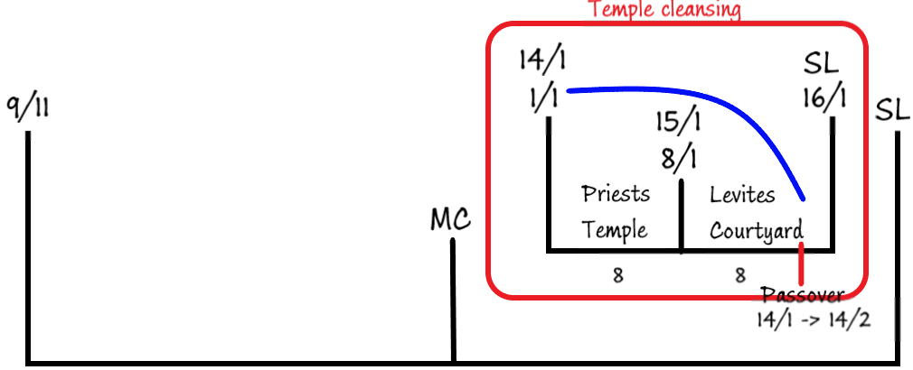
On Passover, what are you supposed to do? – eat some bread, drink some whine. Because this is the last supper. Last supper is the replacement for the Passover. Eating of the little book is the end time fulfillment of the John 6: “Eat my flesh, drink my blood” – which is the Passover/Last supper. And this is the symbol of 9/11. And this Passover which is literal in the 2nd Crhonicles (14/1) can be symbolically moved to this point (9/11 or 1/1, or 14/1) by considering these waymarks, three steps. This is important as 2 Chronicles 29 in connection with chapter 30, and the two Passovers is teaching us that at 9/11 we are supposed to be entering into Passover with our Lord. This is the Passover for Adventism (9/11-1/1-14/1). And there is another Passover. The rules that govern this Passover are for people that have defiled themselves. What is the definition of the 144k? – Virgins who have not defiled themselves.
The defilement is quite clear: those are the women who have gone into a relationship with a man (remember this is all symbolic). You can only go into the 2nd Passover not if you have been with a man, but if you have touched a dead body. All those people who are defiled can enter into this 2nd Passover, but no Adventist meets that criteria, Adventists have to be here at the first Passover (9/11-1/1-14/1).
When we begin to understand symbols which are literal dates in those stories, and how to make application of those symbols, the simple story of Hezekiah cleaning the temple can mean a lot to us.
What I want us to remember from this story is this: from 9/11 to the Sunday law we have 3 waymarks:
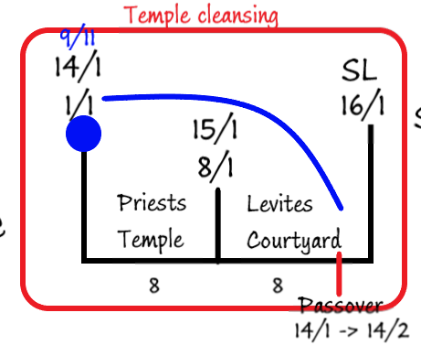
3 waymarks with 2 sections of 8 days (bigger chart 9/11 – MC – SL). Hopefully we can see that this big chart has exactly the same pattern as the one on the left, drawn from the 2nd Chronicles, and this structure can be seen in Esther Ch1.
Below is drawn the structure from Ezra 7:9
In Ezra 7:9 we have a call to come out of Babylon. This happens on the 1/1 where Ezra is going to come out of Babylon.
Ezra 7:9 is happening during the reign of Artaxerxes, the 7th Persian king.
Ezra has been given a scroll. On this scroll are the words of the king Artaxerxes. This is the 3rd decree to restore and rebuild Jerusalem.
On the 1/1 they come out of Babylon. It takes them 4 months to get to Jerusalem.
Once in Jerusalem it takes them time to prepare to put this decree into effect. In can be demonstrated that it occurs on the 10/7.
We can take these dates and use them as symbols and if you understand our calendar and the Hebrew calendar you can work out the time span of these dates. It turns out that from 1/1 to 1/5 there is 120 days, and between 1/5 and 10/7 there is 70 days.
These timespans (120, 70) can themselves be also symbols. The 1/10th – “12” and “7” or “7000” can also be symbols.
When you see these numbers in a particular story, you take that story and place it on this line. For example: it takes Noah 120 years to build the boat. The fact that it is 120, then you would place it here 9/11 to MC). It begins to be built at 1/1 and finishing at 1/5. You can show that calling the people at 1/5 is MC, and you can demonstrate that the shut door is at 10/7 – SL.
Just like we say that in the book of Esther the 1/1 is a symbol of 9/11, the 8/1 is a symbol of MC, and the 16/1 is a symbol of the SL you can do the same here. After the ark is built you know that the animals are coming two by two. Then you the seven days brought to view, and then the door is shut.
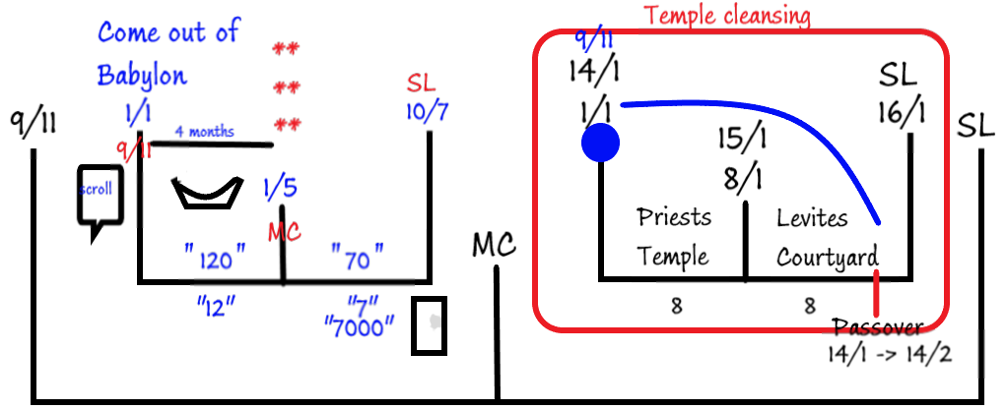
So, when Christ tell His disciples: “...as it was in the days of Noah...” He doesn’t mean that there is going to be high divorce rates at the end of the world, that people will eat a lot, and live luxurious life style (those things may be true), but He is trying to teach to go back to that story and look at the symbology carefully.
From Ezra 7:9 we can see 3 waymarks with symbols attached to them and 2 timespans which become symbols.
In the story of Elijah, he says that he is the only prophet in the land, but the Lord says, “you are not, but there are 7000 who haven’t bowed the knee to Baal”. Where would you place them 7000 at the end of the world? You can see that the structure teaches you that are coming into view in this (1/5 to 10/7) period.
If we compare this story with the story of the 2 Chronicles 29, this period corresponds to Levites. Hence the 7000 at the end of the world is the Levites and Elijah symbolizes priests.
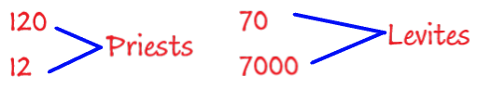
You can see how you can compare various lines of history and make a specific application at the end of the world.
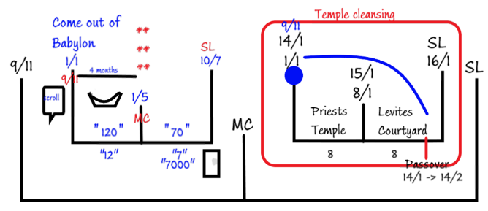
These two structures follow the same pattern. Therefore, the story of Vashti begins at 9/11 and by the SL she is fully divorced.

In Esther 1:1 the number 127 brought into view. Run the number 127 through the Scriptures and find the places where it is mentioned. It mentioned a couple of times in the book of Esther but also in Genesis 23:1. In Gen 23:1 Sarah, Abraham’s wife dies when she is 127 years old. What does the death of Abraham’s wife have anything to do with the book of Esther, or these 127 provinces? We will take 127 and make a symbolic application:
Sarah is woman married to Abraham, woman in the Bible prophecy is the church
Woman = Church
What is being identified at this waymark (pointing at 9/11) is the death of the church. This is one of the clues that at the beginning of this story the divorce of Vashti – we can identify the death of Vashti.
The death that if brought to view here is the death of the ministry. At this point (9/11) the ministers of God’s church (structure of the church) dies. They die because they have gone through the testing process prior to this (not addressed here). You can show that from 1989 to 911 the truth have been brought forward to this church, and the leadership rejected it and by 911 they were passed by. They no longer considered the priests and that title was given to another class of people, the laity of the church. That is what this 127 is identifying: the death of the ministry of the church all heading towards the final separation at the SL.
Esther 1:2. Shushan. The symbol of Shushan can be identified as being at 9/11. Shushan is identified in 2 other books (Dan 8:2 and Neh 1:1). 9/11 , attack on the U.S. by radical Islam was a fulfillment of prophecy of Dan 8, 9, 10, and 11, and the book of Revelation specifically 9 to 11 because the power that has been brought to view first begins in chapter 9 and ends in chapter 11. It is identified by the symbol of trumpet. That is not a coincidence. This trumpet power is the symbol of Islam. Radical Islam.
Shushan can mean a number of things: 1. Lily. Lily has the shape of a trumpet and also means trumpet 2. The locality of Shushan was such that it was a trading center for various civilizations. They used to trade horses there. It was a commercial center for trading horses. And horse is also a symbol for Islam. Both trumpet and horse are symbols of Islam.
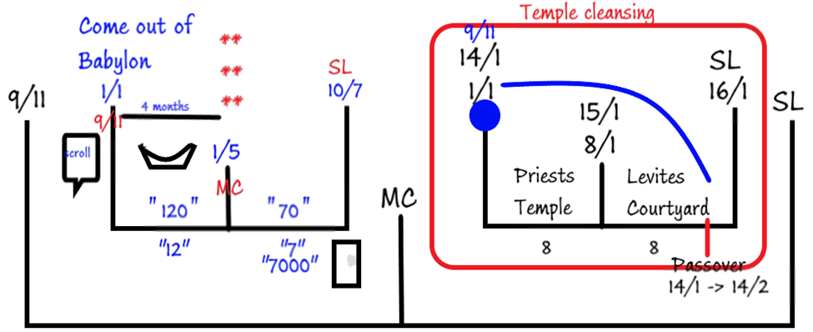
In Nehemiah 1:1 we are at the 9th month (Chislev) and the 20th year at Shushan. We are going to think about relationship of 9th month with Shushan.
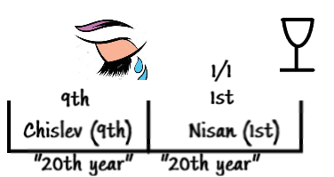
In Nehemiah 2:1 we are in the 1st month – Nisan. Chapter 1 and chapter 2 follow sequentially. First ch1 then ch2. In ch1 we are in the 9th month, in the ch2 we are at the 1st month. Which months occurs 1st in real life? – 1st month. 1, 2,3,4,5,6,7,8,9. Then the 1st month. Then the chapter 2 is the next year after the 1st chapter. In these chapters we have got 2 separate years. But in 1:1 it is the 20th year, and in 2:1 it is the same year. This seeming problem is caused by the merging of two calendars: Hebrew and Persian. This is important to understand for future studies. We are going to use these as symbols. 20th and the 20th. This 1st month in 2:1 doesn’t specify explicitly what day of the month this is, but in a number of passages it talks about 1st month, and in the context, you can identify that it was in the 1/1. You might think that I am guessing but there are other clues in this verse because here Nehemiah is giving the cup to his king. You can identify that the giving of the cup as occurring on the 1/1 (but the story would begin to expand if we went to prove this). We are using 20 as a symbol. I will juxtapose (bring two contrasting ideas parallel to one another).
Here he is giving a wine to the king and here he is crying because he has found out what has been happening in Israel. He is weeping or sighing and crying because of abominations happening in Israel.

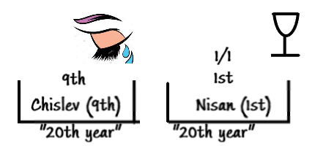
So, the 1/1 is a symbol of 9/11, and the 9th month is also a symbol of 9/11 (you might think that that is a stretch but in Jer 36:9 we are in the 9th month and what are they doing? – Proclaiming the fast. You can apply other Bible passages to this: not only on one level are we feasting on the blood of Christ, but we are also supposed to be fasting according to the book of Joel (sighing and crying). In vs 22 in the 9th month at the same time the king is in his winter house, by the fire. The book of Jeremiah has already been written and will be given to the king. Someone read the book to him and he gets a knife an cuts the book up and burns the pages. EGW says that the writing of Jeremiah (the Jeremiah in the Bible is not the words that Jehoiakim burnt, but it was a 2nd edition and it says he added more words to the original). EGW calls the writings of Jeremiah – “Testimonies to the Church”. So here Jehoiakim is destroying the Spirit of prophecy. The destruction of the Spirit of Prophecy is occurring in the 9th month. At 9/11, just a few weeks afterwards, in the year 2001 our church entered into spiritualism as they now require all their employees to take course of Spiritual Formation. It was a department in the General Conference whose purpose was to disseminate this information to the world church. This is another symbol that at the palace of Shushan Nehemiah was there at the 9th month and the 1st month in the same year of the king even though they are different in the Jewish calendar and in Persian.
The 1/1 is 9/11. We that it is 1d1mo because he is giving a cup of wine to the king. The 9th month is also the month when the SoP is rejected by the leaders of this church which happens at 9/11.
Ezra 10:9. We need to be familiar with the technique of going into a story and picking up symbols. In Ezra 10:9 we are in the 9th month and see the gathering of the tribes of Judah which represents the SDA church. This gathering is the gathering of the virgins in Mat 25. It is the same imagery. At the end of the verse there is a great rain. These tears of Jeremiah is the same symbol of the great rain (vs 13 – “… for the great rain…”).
They can’t complete the work quickly because of this great rain, and this is marked in the 9th month.
In vs 17 they are required to separate themselves from strange wives. Strange wives = strange doctrines, doctrines of other churches. There are many other clues that place Shushan at 9/11. The logic I use here is 1. Take the word “Shushan” as found in Dan and Nehemiah and go to 1:1 and 2:1, and we saw that chapter 1 = 9th month and chapter 2 = 1st month, but it is the same year due to mixing the calendars. The mixing of the calendars gives us the key that allows to juxtapose these two together. There is cup in one, and the rain(crying) in another. We can identify the cup as meaning the 1/1. Then we went to Ezra and Jeremiah and saw that all those things are occurring in the 9th month.
So, there is multiple symbols that give us a picture of the things that are occurring at 9/11.
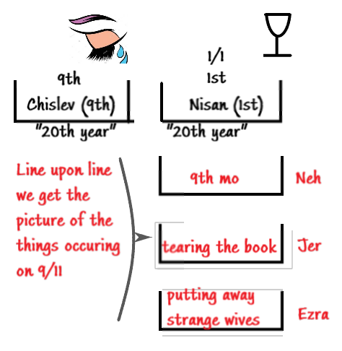
We can confidently say that Esther 1 is happening at 9/11.
Vs 3-4. In verse 4 the time period is 180 days. We will see that 180 days takes place between 9/11 and the MC.
These 180-day period in the Biblical time represents 6 months. Those 6 months Luke ch1 when Zacharia is ministering in the temple this begins 6mos period, because after the 6 months Elizabeth is going to meet Mary who is just impregnated with Christ. These two women come together and prophecy at this 6-mo. period.
This 6 months is divided into 2 segments: 5 months period and 1-month period. In the same chapter (Luke 1) Elizabeth went into hiding. The name Esther means hidden star. This 5 months of hiding is also seen in Dan 8:2. There it mentions palace in Shushan, in the province of Elam. Elam also means “hidden”.
180. 1 Kings 12:21 mention 180,000 soldiers. The story is about the struggle between Rehoboam and Jeroboam. It is discussion of war between 2 and 10 tribes. In vs 24 the Lord tells the soldiers of Rehoboam to return back to his house. That word “return” doesn’t’ just mean to return but it means to stay or abide. So in 1 Kings 12 that there shouldn’t fighting the between the 2 and the 10 tribes.
The symbols of 2 and 10. 10 = world, 2 = SDA church. Warfare understood symbolically is a destruction of the nations of the world. We know that at the end of the world we are not going to make war with them, but we do overcome the world by our words and our testimony, our life. This fight between these two tribes needs to be understood as the evangelism that we partake when we go and conquer the world. This fighting is a symbol of public evangelism.
We know that from 9/11 we are not to do public evangelism, and this is confirming this thought through the symbol of 180. In 1 Kings 12 it says “Thus saith the Lord, Ye shall not go up, nor fight against your brethren the children of Israel: return every man to his house; for this thing is from me. They hearkened therefore to the word of the Lord, and returned to depart, according to the word of the Lord.”
In the 2 Chronicles 17:13, 18, 19:
13 And he had much business in the cities of Judah: and the men of war, mighty men of valour, were in Jerusalem.
18 And next him was Jehozabad, and with him an hundred and fourscore thousand ready prepared for the war.
19 These waited on the king, beside those whom the king put in the fenced cities throughout all Judah.
This story is the story of Jehoshaphat. But here is the same number – 180. Again, in vs 19 these valiant men are stationed in Jerusalem. So, there is tarrying time that is brought to view in relation to 180.
So, 180 = tarrying time. Esther 1;3. In the 3rd year of his reign he makes a feast. This feast is for all the princes, all the servants, the nobles and the princes of the provinces. When it says all of them it is identifying that everybody is involved in this issue. This symbol of all provinces or all the power of the provinces is a representation of a world wide event.
In vs 3 we have a symbol of a worldwide event. It comes back to 9/11 and we can make an application of Revelation of 10:4 when the angel comes down in 1840 and 9/11 when the angel spans land and sea it is a symbol of a worldwide event. In vs 3 it talks about a feast that lasts 6 mos, it involves everybody in his empire (all the nobles princes and servants). It is highly unusual to have a feast to last 6 mos., and it involved all the leading people of the nation. This empire is not a singular country. It says it stretches from Indian to Ethiopia. If everybody was coming to this feast all the individual kings of this provinces (127 provinces) you would realize that there is no government structure in those countries for ½ a year. It would cause an instability in the empire.
The historical backdrop:
The day this king is reining: he reign for 21 years (from 485BC to 465/4 BC). If you check with the secular history this feast takes place in the 3rd year.
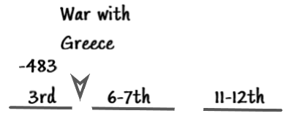
Feast.
Xerxes wants to expand his empire. And finish the work that his father Darius was unable to complete. When his father was on the throne, he wanted to increase his empire and tried to take Greece but was unsuccessful. Xerxes wanted to correct this mistake. He makes plans to destroy and subjugate Greece. But he won’t make the same mistakes. He will assemble the biggest army in the world (in that history it was unbelievably large) and it was a phenomenal task. He needs support of everybody in his empire. He will make this war in the year 480BC. His 3rd year (483) before he goes to war, he needs to get all the support that he needs. That is when he makes this feast of 180 days.
He goes to all these provinces and calls the rulers one by one (there are so many of them that it takes him 6 months to do it) and ask them what support that they are going to give him. So this is not a feast, but it is 6 months of war planning. This war planning is carried out by Ahasuerus in preparation for war against Greece. Soon afterwards in 480 he makes war with Greece but he is not successful. The medes and the Persians at the end of this fight lose this fight against Greece. He goes back home in shame, and when he returns back home in Esther ch. 2 he finds a new wife and marry Esther. This war planning is brought to view in another book – Daniel. In Dan 11:2 “… by his strength (127 provinces) through his riches (all the territory, the richest Persian king) he shall stir up all (127 provinces) against the realm of Grecia”. So, Daniel 11:2 is this story in the 3rd year of Ahasuerus, Esther 1 this 6 months war planning exercise he succeeds in amassing the biggest army the world has ever seen.
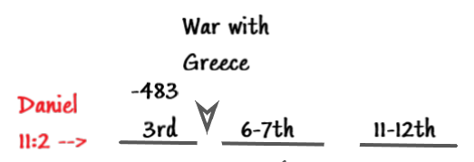
This battle is not a singular battle it is land and sea battle. It is one of the most famous battles in all of the military history. The famous movie about this battle called “300”. This is the battle of Thermopoli. These 300 Spartans blockade the Persian army, eventually die and lose the land battle, but win the naval battle, and Ahasuerus goes back home in shame.
So, there is more to this 180 day feast than just this structure presented here.
