So, we talked about the feast that lasted for 6 months. I explained the historical context and talked about the time of the end in chapter 10 of Daniel. We laid out the five kings: after Cyrus there would stand 3 kings and the 4th far richer than them all. Then we made application that emperor of MP was a symbol of the US. And began to look at the presidents of the US.
I mentioned about the possibility that Donald Trump being a next president and some become nervous about that. I want to show how difficult it is, how hard it is to make any kind of prediction.
If you look at the name Donald Trump the word Donald comes from an English name and means the ruler of the world.
Trump is a root word for trumpeter. You can see his name is represented by “the ruler of the world that blows the trumpet”.
The word Donald means the same thing as Xerxes – “one who rules”
We know that Donald trump is running against the Hillary Clinton. The last name Clinton comes from an English word “Glinton” and is made up of two words. The 1st part comes from the word glinde, and ton -comes from the word tun. Tun – means town, settlement, village which is on a hill. This is some kind of settlement on a hill:
The word glinde – is a settlement near a river which is enclosed, fenced in.
Glinde also has a number associated with it. This number is 6.
When you begin to see the meaning of these names (btw, Hillary means happy or laughter). You can derive from the name Clinton – the 6th city that has got a fence around it which is on a hill. It wouldn’t take much that this can have prophetic significance just as much as Donald Trump.
Turn to Dan 11:2
And now will I shew thee the truth. Behold, there shall stand up yet three kings in Persia; and the fourth shall be far richer than they all: and by his strength through his riches he shall stir up all against the realm of Grecia.
In this verse towards the end the word “against” you can derive from the Hebrew word that it doesn’t mean “against” it actually means “together”, “to come close to somebody. When the KJV translators chose the word Against this is what they thought: two people are going to come together, and because they knew it was the Persian and the Grecian empires, they knew historically it was to have a fight, so they used the word means “with, together with” and decided “against, contrary”. You can see the reasoning behind these words. But the words itself means together with. In the original context it would read like this: “by his strength through his riches he shall stir up all with/together with the realm of Grecia.” If you read it that way, this passage takes on a different context. Because now it is saying that the Persians and the Greeks are coming together. This “All” will be Everybody.
In Gen 16:12 And he will be a wild man; his hand will be against every man, and every man's hand against him; and he shall dwell in the presence of all his brethren.
It talks about radical Islam in its prophetic context. And it says every man will come against him, and there will be some kind of alliance, that everybody joins to come against Islam. As we study prophecy, we have to look at history, seeing how it is being repeated in our day and age, but we have to be careful how we use these words. You can develop an argument to show that this king of Medo-Persia represents the U.S. is going to have a struggle against Greece or the UN. An you can see that already happening in this person.
But when you read the words as they were given in the original, then the technical meaning of this verse would mean that Medes and Persians and the Greeks come together in an alliance and we know that also is a fulfillment of prophecy, because we know that there will be one world government. And if you take the name Clinton and part of her name means “6” we understand that the US is the 6th kingdom of Bible prophecy, when we consider Revelation 17. We are supposed to be students of Bible prophecy, we need to be careful to divide the word of God correctly. You can develop a strong argument to say that it may be Donald trump, but you can develop a strong argument to say that it could be Hillary Clinton. My counsel is that we shouldn’t just sit and wait to see what is going to happen, but we need to study for ourselves. Studying for ourselves is what will develop our character. We must not listen to presentation and somebody says it will be Donald Trump and we say, “that looks very good”. When he becomes president then we need to know we need to do something, may be move out of the cities. But if it is not Donald Trump, then “Oh, we made a mistake, we have got time, may be all these prophetic study is wrong”. Now the Lord is testing his people. We need to stand upon the word of God ourselves. I am showing you how you can develop an argument, which is still being developed at this time. I am trying to encourage you not to rely on people to do your won studying.
The logic behind all of these is sound and correct. The number 4 is well established in prophecy when it refers to the end of the kingdom.
The relationship between the MP and the US has been established, Cyrus is at the time of the end. We know that the ToE is at 1798 and it is also at 1989. And that is well established. When we coming to the time when we are rapidly approaching the midnight Cry, many people are under conviction that the presidential election that is currently approaching is of vital importance to us. Don’t think that everything is established. There are still more truth to be uncovered in the coming weeks and months. For those of you who are worried that it may not be DT, or what if it will be HC – and all of our methodology collapses, I want to encourage you to read the word of God carefully. There are so many intricacies in these verses that people have already missed. May be the Lord will give YOU some light that you can be used to further the light of this message. He can speak to every single one of us. Don’t think that you are too young, too old, not clever enough. We need to be studying for ourselves, as it is easy to make mistakes and miss important points.
If you have time it is well worth to listen to his presentations he has useful insight for us.
6-month feast.
Esther 1:4 And when these days were expired, the king made a feast unto all the people that were present in Shushan the palace, both unto great and small, seven days, in the court of the garden of the king's palace;
That palace in verse 2: … Shushan the palace…
The verse 5 mentions the court
You can see that in Esther ch1 it talks about the palace and the court, and in the vs 5 it says that when these days were finished then there was another feast that king has made. This feast for ALL the people:
And when these days were expired, the king made a feast unto all the people that were present in Shushan the palace, both unto great and small, seven days, in the court of the garden of the king's palace;
This is a different feast. It is for ALL the people who are in Shushan, it is in the courtyard, and it lasted for 7 days.
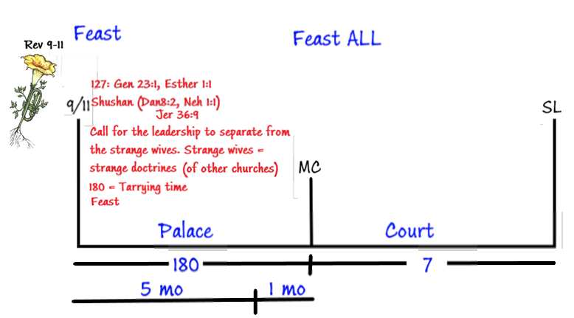
We spoke previously about Ezra 7 where 120 days and 70 days brought to view. I also overlaid the story of Noah who took 120 years to build a boat, animals come on, and then the 7 days brought to view. I mentioned the 7000 mentioned in the story of Elijah and the 70 disciples of Christ:
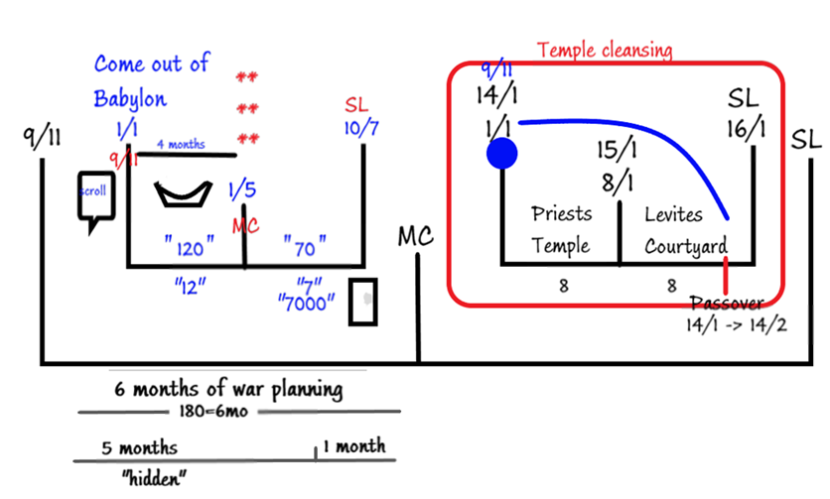
You can see that this 7 is following this structure and we have shown that Esther 1 is following this structure that we got from Ezra and 2 Chronicles: priests and Levites. Particularly in 2 Chronicles it talks about the priests that they are involved in temple building followed by the courtyard – the work of the Levites. And in the book of Esther you have the palace and the courtyard. Once you can see these structures you can see how this chapter that seems to have no prophetic significance suddenly you can put a structure on it. People have read these 180 days and 7 days for hundreds of years, but they never understood what they mean and why they were there.
We have become so familiar with these truths that they have lost their charm and their beauty. The truths that we are discussing are so new and startling, but after you heard them several time you begin to become complacent about them. I want us to think how many people in the history of the Earth from the very beginning up until now have understood the truths that we are talking about now. This is the greatest light that God has given to human beings, and often we say that looks OK let us move on.
So, you see this feast of 7 days that was made for everybody. But I want to show that not everybody that goes to that feast – it is ALL the MEN who are in Shushan:
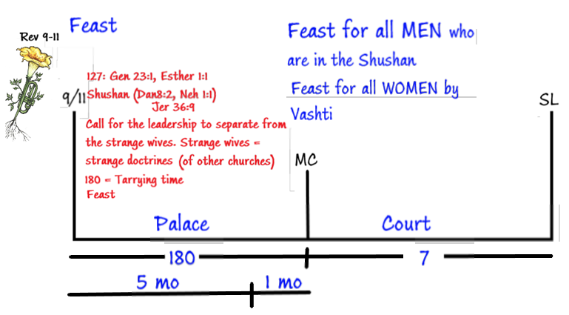
Prophetically those people who are in Shushan, people like Daniel, Nehemiah, are the ones who are to partake of this feast.
Vs 9. Also Vashti the queen made a feast for the women in the royal house which belonged to king Ahasuerus.
At the same time that king is having a feast for all men, Vashti the queen is having a feast for all women. You can se that there are 2 feasts. This doubling – a prophetic concept. This concept or principle of doubling is seen very often. We need to be familiar with these concepts because the book of Esther is confirming many of these truths that we all understand. We are all familiar with the beast of Bible prophecy and image of the beast. The IoB is a copy of the beast. A Beast in the context is Church + State.
Church+State is a representation of Woman and a man. That is what the beast is. When the church joins with the state, so the church has the power to force people to do what it wants so when your pastor is telling you to do something you don’t have to listen to them because they have no power, but if they joined with the government and pass the law to force to do what they wanted, they would have formed the beast.
This beast is a subject of Bible prophecy in the history of the 1260.
But there is going to be an IMAGE of THE BEAST (IoB). The IoB means the copy. This copy is of this (1260), and that beast was a Church+State, so the IoB is a copy of the church and the state. That is the definition of the IoB. It is when the church controlling the state tells you what to do. You know that when a woman and a man come together two people become one flesh. So the image brought to view here (the beast and the IoB) is one of marriage. It has all to do with the marriage. We spoke about the Clinton earlier, the 6th kingdom, on the 6th day of creation was brought to view the marriage of Adam and Eve. We know that this image of the beast which is connected to marriage, which is connected to the 6th day, which is Friday, which is the preparation day is the day of the Lord’s preparation before the day of the Lord, or the Lord’s day which is the 7th day. All this is happening ion the preparation day. You can demonstrate that from 9/11 till SL = 6 days, and the SL = 7th day:
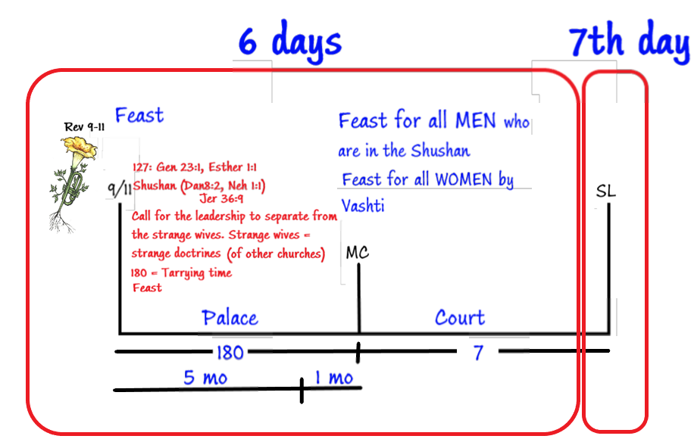
7th day is the Sabbath issue, you need time to prepare to that day, this what we call the PROBATIONARY TIME. We call Friday the preparation day, but it is really the day of probation, because come sunset on Friday, you will be tested whether or not you are ready for the Sabbath. If you are not able to get ready on Friday when sunset occurs and you start trying to sort things out in your life, you have failed the test because Friday is a test day. You have broken the Sabbath and in type you are lost. This weekly cycle God is trying to teach us the spiritual truths. Right here when this IoB, this marriage is being discussed in many different ways, when you get to this point (pointing at IoB = MC) the image of the beast will be built
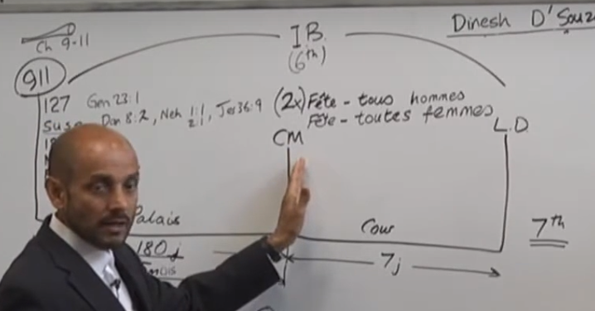
Think of Daniel 3. The image is built here (At MC). It has to have been finished before you are asked to bow to it (SL). This image in Dan 3 this is the representation of Nebuchadnezzar, it is a copy of Nebuchadnezzar, and you are required to bow down to it at SL. This statue or image is a representation of Church and State, which is a representation of marriage, two people coming together. What does God want us to understand in Esther 1? At the very time when everybody is joining together, God wants us to separate. Ahasuerus is a symbol of Christ and He wants to set up a feast system where men and women remain separate (This is NOT literal, MEN = State, Women = Church), Church and state should not be joining together. When you are able to see a symbol after symbol in these verses, like in vs 6:
Where were white, green, and blue, hangings, fastened with cords of fine linen and purple to silver rings and pillars of marble: the beds were of gold and silver, upon a pavement of red, and blue, and white, and black, marble.
We won’t discuss this verse in depth but I want to have a short discussion about fractals. In the early chapter of Ezekiel. He sees a vision “Wheels within wheels”. These wheels within wheels, I am not sure what exactly it looks like, but the way it is worded, you have identical elements – wheels which are inside bigger elements – bigger wheels:

The word picture in the book of Ezekiel is describing the idea of fractals. You know that you need 2 testimonies to defend something, the term “fractals” is used in spiritualism, and new age. People have objected to us using this word – fractal, it gives the impression that we are using the spiritualistic terms. But in vs 6 tucked into this words is a fractal: …Upon a pavement…
So, there is this pavement, it is red, blue, white, and black.
There is this multicolored floor. In Persian architecture they would use tiles to make pictures or patterns, many civilizations did this, mosaics of Romans, but the Persians would not have mosaic of a man, their mosaics were different. They would use patterns or geometric shapes.
You would have repeating patterns and each tile is the same shape, the technical name for this is tessellation. This term is when you get repeating geometric pattern. The definition of tessellation is the same as the fractal. In vs 6 embedded here you can see the concept of fractals, as we need this concept, to understand the message of the midnight cry. Without understanding fractals, this concept of wheels within wheels, you are unable to develop arguments and the logic to have this structure, the two steps (911 and MC). People who used to be in this message, the reason that they struggled to understand this two-step process, did not understand the concept of fractals or tessellation. Without understanding this concept, you cannot develop these arguments. It is found in the book of Ezekiel – wheels within wheels, it is found in the book of Esther – tessellation of the pavement of the feast that is occurring at the midnight cry.
Vs 10. We know that this feast lasts for 7 days and on the 7th day the king is happy and merry, butr in vs 11 he going to call the queen. So, mark Calling. This is king calling his bride or the church.
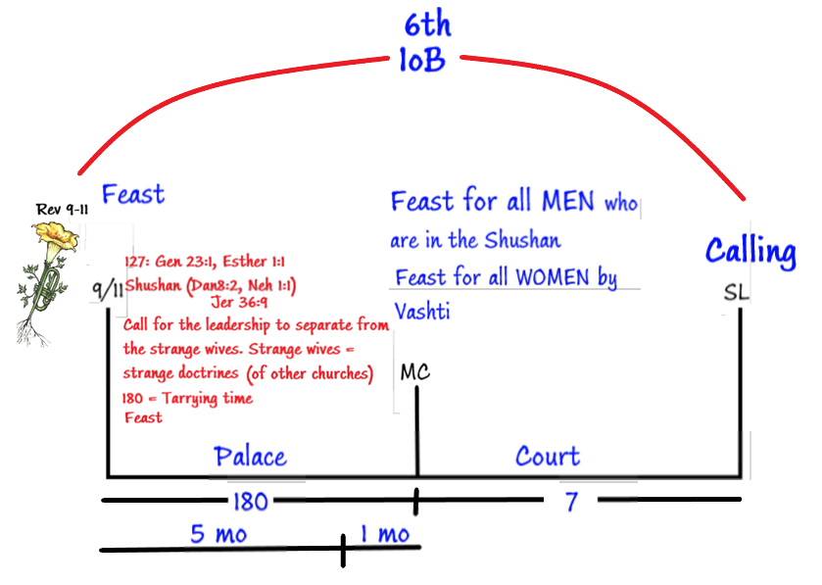
The purpose of this Calling is he wants everybody to see how beautiful she is. Here Christ wants to show the world how beautiful the Seventh Day Adventist Church is. But the church rejects the call and disobeys the king. Here at SL we see rejection by the church of a call that is made by Christ. There many other symbols there in Esther 1. We see 7 eunuchs, and 7 wisemen. When you do study of the role of these two groups
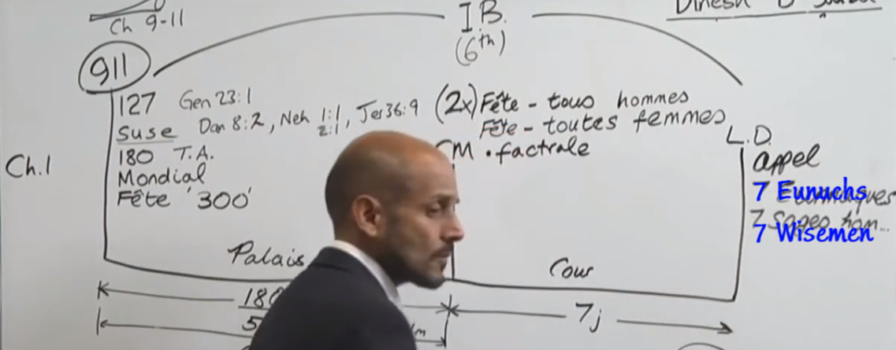
These 7 eunichs are the messages and messengers that Ahasuerus is going to use to call Vashti to himself, these 7 eunichs represent the messages that Christ is going to use to call the church so that everybody can see her at this time. She disobeys.
7 wisemen are the symbol of the judgement that going to come upon them. Because these wisemen are the ones that counsel Ahasuerus to separate and divorce from Vashti.
Ch1:
- We have identified that it is at 9/11
- There are two feasts, one is 180 days and the other 7 days.
- 1st one is in the palace and then in the courtyard.
- After this feast is expired there is a double feast is brought to view (doubling) where the concept of separation of church and state.
- You need to understand the concept of fractals because of the messages that Christ sends to the church to make that call, judgement is going to be brought to view.
- The judgement is that Christ and His church is going to separate and divorced.
Other components to consider:
9/11 is a worldwide message, and this separation, this judgement is also a worldwide phenomenon.
The separation will be complete between the SDA church and Christ (pointing at SL). When I say SDA church, I explained that it is the structure of this church. But at the very same time when this church is being divorced, we will see that he marries Esther.

Esther 2.
In Esther 2, we don’t see a story that goes up to to the SL, but the story goes up to MC.
We will see that there is a marriage at the MC. This marriage is between Esther and Ahasuerus. This is a representation that Christ will marry this remnant group that has come from Adventism at the very same time where the doubling feast if occurring and he is fully divorced here (at SL). Ch1 does not portray the concept of a progressive divorce, it does it in steps. But we have to understand the concept of progression.
The leadership are bypassed here at 9/11, this is the work of priests (9/11 to MC), then there is another work for the Levites to do. It shows you that there is progressive work. As you get the progressive work you can see the progressive destruction of the structure of the church.
You have to combine the two chapters together: separation and the coming together of Vashti and Esther. We will see that we are in this time period now: He has come back from his battles, misses his wife and now he wants to find a new wife.
2:1 After these things, when the wrath of king Ahasuerus was appeased, he remembered Vashti, and what she had done, and what was decreed against her.
2:2 Then said the king's servants that ministered unto him, Let there be fair young virgins sought for the king:
2:3 And let the king appoint officers in all the provinces of his kingdom, that they may gather together all the fair young virgins unto Shushan the palace, to the house of the women, unto the custody of Hege the king's chamberlain, keeper of the women; and let their things for purification be given them:
2:8 So it came to pass, when the king's commandment and his decree was heard, and when many maidens were gathered together unto Shushan the palace, to the custody of Hegai, that Esther was brought also unto the king's house, to the custody of Hegai, keeper of the women.
2:12 Now when every maid's turn was come to go in to king Ahasuerus, after that she had been twelve months, according to the manner of the women, (for so were the days of their purifications accomplished, to wit, six months with oil of myrrh, and six months with sweet odours, and with other things for the purifying of the women;)
We want to note the following words:
- Word “remember” – there is remembrance going on
- Virgins
- Gathering
- Purification
- Decree (in vs 4)
- Esther = means star, Hadassah = hidden
All these symbols are at the beginning of the chapter 2. They are all lining up at the beginning of this structure

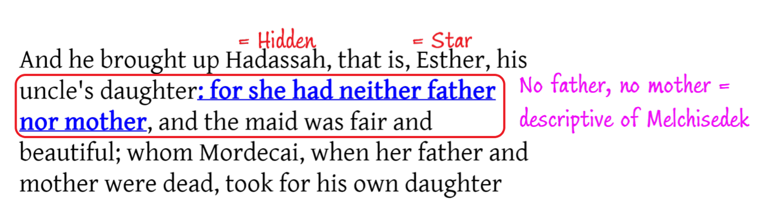
2:4 And let the maiden which pleaseth the king be queen instead of Vashti. And the thing pleased the king; and he did so.
2:7 And he brought up Hadassah, that is, Esther, his uncle's daughter: for she had neither father nor mother, and the maid was fair and beautiful; whom Mordecai, when her father and mother were dead, took for his own daughter
2:10 Esther had not shewed her people nor her kindred: for Mordecai had charged her that she should not shew it.
Her name is Esther and it means star, her Hebrew name is Hadassah, which means hidden. Her Uncle tells her. In vs 10 she had not shown herself to the king – she is in hiding. Same is brought to view in vs 20. Mordechai tells her not to show who she is. All of these symbols brought to view at the beginning on this verse.
Vs 16. So Esther was taken unto king Ahasuerus into his house royal in the tenth month, which is the month Tebeth, in the seventh year of his reign.
Tebeth is the 10th month. Esther was brought before the king into his house in the 10th month in the 7th year of his reign. = 10mo7y But previously you know that she is going to be purified for 12months. If you go 12 months before, it is 10mo6year
All of these events occurring in the 6th year of the 10th month. That is why we say 6-7th year, even though the verse is telling about the 7th only.
We have 12 mos. purification which lines up with number 12 of the structure in Ezra. All of these symbols are the representation of 9/11.
Remembrance brought to view line up with the number of stories/prophecies, ie, Jeremy 6:16:
“Remember the old path, the old ways, the old doctrines”
There is a call to be made here at 9/11 previous histories, previous methodologies, which is another ways of saying “line upon line”.
In Gen 41:9 we would see that the story of pharaoh, his butler, and Joseph. You have to understand that story well as there is also doubling: 7years of plenty and 7 years of famine. If you lay out that structure carefully, you can show that the 7 years of feasting is the period between 9/11 and MC
We can line up the Baptism of Christ with 9/11 and he was 30 y old when baptized. Joseph was 30 y.o. when butler remembers.
The virgins are sought (Matthew 25), Revelation 13 talks about the same virgins, it says, “let us find virgins” – this is the replacement of ministry of God’s church with the virgins, as now the virgins are being sought for.
Matt 25 talks about the gathering, where the trumpet of 9/11 is called there is an understanding that the bridegroom is about to come, and we need to come together and get ready. It is not enough to get ready, you need to be purified. This purification mentioned in 2 Chronicles 29 – this is the purification of the temple, and we saw it here (9/11) at the 1d1mo. Then we see that there is a decree written. The story of Esther besides being the story of Christ’s divorce and marriage, is also a story of laws and decrees.
Chapter 1 – there is a law and decree made here at SL, and one in ch2 we see law and decree at 9/11. Previously we have mentioned that at 9/11 there was a decree made Patriot Act. When we speak about Esther, we mentioned Esther means star, and symbol of a star is brought to view in Revelation ch9, where we see the beginning of the work of Islam. But the star that Esther represents is also this woman of Revelation 12, the woman who has 12 stars, she is hidden. The symbol of her being hidden can mean many things: we are hidden from the world and hidden in many ways from the church. If people understood the implications of this message you would have already been disfellowshipped from the church. The church doesn’t fully comprehend the significance of what is happening, because we are living in the time of safety and protection, or being hidden.
We see that this is on the 10th month. Yesterday we did study on the 9th month. We saw that it represented on 9/11.
The 10th month represents at least one thing: the siege of Jerusalem, the beginning of the destruction of Jerusalem, and prophecy of Egypt. The reason why this is interesting is because we can see in two places the 10th month.
The siege of Jerusalem is a significant symbol in Bible prophecy. We know, according mat 24, Luke 21, Mark 21, the sign of the dest5ruction of Jerusalem or the sign of its deliverance is the siege of Jerusalem. This siege of 10th month is the siege of Nebuchadnezzar where he besieges Jerusalem. When he does so, Egypt comes to help, and Babylonians withdraw the siege, deals with Egypt, come back, and destroy Jerusalem. You have heard that story before after the time of Christ in AD 66 and AD 70, that siege is not the 1st time it happened, it was an exact fulfillment of Nebuchadnezzar’s siege.
The symbol of the 10th month, siege, symbol of AD 66 or the beginning of the destruction of Jerusalem. AD 66, 1888 you can identify lining up at 9/11. This is a progressive work, as 10th month and 10th month line up. The same characteristics occurring here at 9/11 also occur here at MC as MC is also an empowerment of the 2nd angel, while 9/11 is the arrival of the 2nd angel. But also there is a prediction that Egypt is going to be destroyed. Egypt can represent the U.S., as well as the world, once this date happens (10mo6year, or 9/11) the sieging of Jerusalem begins it is the sign for us to flee Jerusalem, which does not mean separate from the church, it means separate from the strange wives, the false doctrines of Adventism before it is too late, when Christ will divorce the church. But it is also the prediction that from this point onward (from 9/11) the U.S. is going to fall, because national apostasy is followed by the national ruin. And when the U.S. -Egypt went into alliance with Papacy their end is sealed. This (9/11 to SL) is the period of the 6th kingdom and this is the period of the 7th (from SL onward):

