Esther Part 7
We have looked at the 6-7th year of Esther and then we looked at Esther ch 3, which was the 11th and 12thyear.What we have shown is how from ch3 to ch8 using the symbols that we have and structuring of the dates that it is following the same line as Ezra ch 7.
We have a line of decrees and we have a time span of 12 days and 70 days. Now let us turn to Esther 4. We will look at ch4 and ch5 together. This is where it gets a little bit complicated.
In Chapter 3 we read that there was this decree made on the 13/1. We also identified that Mordecai is in the gate at this time period (Esther ch 2: as soon as she becomes the queen Mordecai is in the gate). It is important to understand the relationship between the gate and the throne room. They are rooms that are next to each other. So, whenever something was happening to the king, Mordecai would know about it. Esther 4:1
When Mordecai perceived all that was done, Mordecai rent his clothes, and put on sackcloth with ashes, and went out into the midst of the city, and cried with a loud and a bitter cry;
Mordecai is at the gate, and when he realizes what is happening, he tears his clothes, puts sackcloth and ashes on and cries with a loud and bitter cry.
Let us turn to Matthew 25:6
And at midnight there was a cry made, Behold, the bridegroom cometh; go ye out to meet him
We can see that at midnight a cry is made. This where we get the term “midnight cry”. We want to identify this cry that Mordecai is making is occurring here (at the 13/1). The loud cry is made here because he realizes that there is a decree is made and that there is trouble. This is happening on the 13th day (need to keep that in our minds).
- And came even before the king's gate: for none might enter into the king's gate clothed with sackcloth.
- And in every province, whithersoever the king's commandment and his decree came, there was great mourning among the Jews, and fasting, and weeping, and wailing; and many lay in sackcloth and ashes.
- So Esther's maids and her chamberlains came and told it her. Then was the queen exceedingly grieved; and she sent raiment to clothe Mordecai, and to take away his sackcloth from him: but he received it not.
It says that even though he is supposed to be at the gate, he is not really allowed to be there because of his role. If you drop down to vs. 6:
6 So Hatach went forth to Mordecai unto the street of the city, which was before the king's gate.
So, he is not able to stay at the gate. Mordecai is a symbol of different things happening all at the same time. Him being at the gate is a symbol of judgement. And now he is in the street, with sackcloth and ashes, lamenting the situation. In vs. 4 we see the dialog happening between Esther and Mordecai. Esther’s maids find out that Mordecai has done this thing and the queen is grieved and send new clothes to Mordecai. Clothing is a representation of character and she wants to give him new clothes. When Esther is married, she receives her crown and her brides’ clothes. This change of clothing that we mark here at the MC is a reference to a change of character. This is referring to God’s people being sealed and a complete transformation of their character.
At the same waymark where Esther is receiving her new clothes, and you would expect Mordecai have a change of clothes as well. But his clothes have gone from good to bad. When Esther offers him a new clothing, he rejects that offer. We are going to try and explain why that is. In vs. 10:
Again, Esther spake unto Hatach, and gave him commandment unto Mordecai;
It says “again..” So there is the first interaction and there is the 2nd interaction in vs 10. They have a further discussion. In vs 15 is the 3rd interaction that Esther is having with Mordecai. These 3 interactions we are going to mark in the structure. This is the famous passage “and who knoweth whether thou art come to the kingdom for such a time as this?”
I suggested earlier on that Mordecai is a symbol of the Holy Spirit, because he instructs, guides, and protects Esther. But now in vs 10 and 17:
10 Again Esther spake unto Hatach, and gave him commandment unto Mordecai;
17 So Mordecai went his way, and did according to all that Esther had commanded him.
So the symbol of Mordecai here is not of Holy Spirit, but of the experience that God’s people are going through at this time of period. So now Mordecai is the representation of God’s people and not Esther.
16 Go, gather together all the Jews that are present in Shushan, and fast ye for me, and neither eat nor drink three days, night or day: I also and my maidens will fast likewise; and so, will I go in unto the king, which is not according to the law: and if I perish, I perish.
Mordecai instructed Esther to go to the king, and plead for her people and she replies back that she shouldn’t be doing this, then he goes back and says: “perhaps, this is why you have been called to be the queen, for such a time as this.” This is a famous verse, and many people have quoted it. But I would suggest that for the 1st time now we can understand the context of this verse. Because now we can place it in prophetic history. The time that Esther has been called for is not some general moral issue that you could apply at any time in a person’s life, the time that has been referred to is the time of the Midnight Cry. So, Esther is being called for the Midnight Cry. Here you are going to see her role is being fulfilled. But at the same time Mordecai is also representing God’s people. Showing you the different aspect of what is going on with him. What we will see is that Esther is a representation of the relationship between God’s people and Jesus.And Mordecai is representing the experience of God’s people as these events are coming and they are having to deal with them. In vs 16 is the instruction that Esther gives to Mordecai. In vs. 16:
She says “Go, gather together all the Jews that are present in Shushan, and fast ye for me, and neither eat nor drink three days, night or day: I also and my maidens will fast likewise; and so will I go in unto the king, which is not according to the law: and if I perish, I perish.” This doubling, this perishing is another marker that we are here at the MC.
Note the fast of 3 days, and 12 days + 70 days as these are also important to keep in mind.
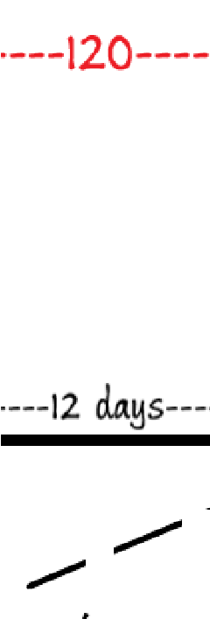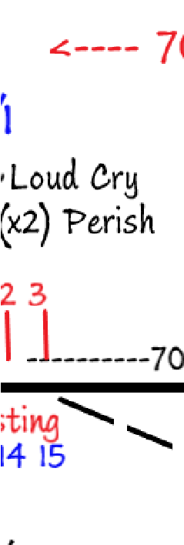

In vs 11 we have 30 days marked:
11 All the king's servants, and the people of the king's provinces, do know, that whosoever, whether man or women, shall come unto the king into the inner court, who is not called, there is one law of his to put him to death, except such to whom the king shall hold out the golden sceptre, that he may live: but I have not been called to come in unto the king these thirty days.
There is 3 days of fasting and we are on the 13th day. Then the 1st day of fasting = 13th, 2nd = 14, 3rd = 15th day:
We will look at these fasting days (13, 14, 15) in a little more detail.
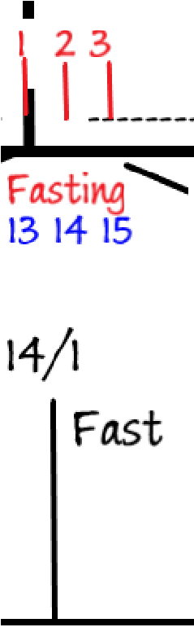

Now we will look at 30 days:
Here we are at the 13th day of the 1st month and she says “I haven’t been called for 30 days before this”. We have gone back 12 more days and if we go back 18 more days we are back at the 13th of the 12th month (13/12). From 13/12 to the 13/12 we are exactly 1 year long.
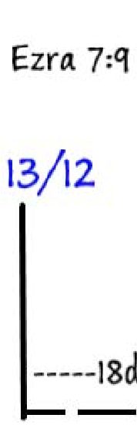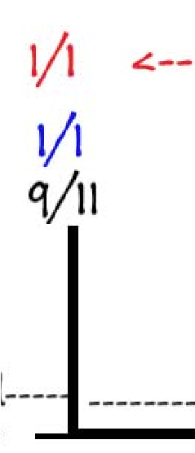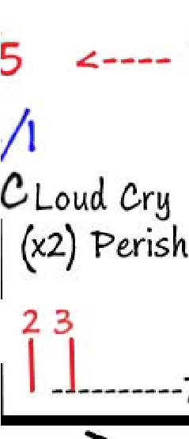

When we look closer what we end up seeing is the 13th day is not Midnight Cry but actually is the Midnight. And THEN there is going to be the three tests. In this story it is 3 days of fasting. This fasting is indication an experience that is not good. By the time when you come to the third day then you have arrived at the Midnight Cry. So, now, the 15th day is actually the Midnight Cry. If you were just to run this as you normally would, we have marked the 13th as the MC, and 23/3 as SL, then you would be looking at the pother waymark along the road. But what I am suggesting is happening when we get into chapter 4 and 5 that we are seeing the repeat and enlargements, and the clue is when he says that “you have been called for such a time as this”. “This” time is the Midnight Cry time. The Lord is directing as, focusing our attention on “this time”, which is what we are doing: we are looking at this one point here (MC) and opening it up. Hopefully we can see the relationship between the Midnight and the Midnight Cry. If you are new to this message I have explained it to you in the story you are familiar with, the story of Christ:
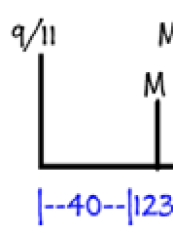
There are other stories that represent this. By the time you have come to the end – the 3rd step – you are at the Midnight Cry. The 15th day is lining up with the 13th, and the 13th becomes the Midnight. If you would step further back and back these lines would merge and look like one line: the 15th would be the 13th. The Lord is trying to teach us some truth about the Midnight and the Midnight Cry. Esther teaches us that there is fasting going on here at MC. There is the experience of bitterness and also of preparation to meet our Lord.
Esther ch5. Midnight Cry
Now it came to pass on the third day, that Esther put on her royal apparel, and stood in the inner court of the king's house, over against the king's house: and the king sat upon his royal throne in the royal house, over against the gate of the house.
In Dan 10 Daniel (Esther) meet Christ (Ahasuerus). He falls to the ground prostrate, and then he is touched 3 times. By the time you get to the 3rd touch, he is strengthened and rises to his feet helped by Gabriel. Here we are being shown the same thing: at the 3rd point (3rd day) Esther puts on her royal clothing (marking the Midnight Cry), pure clothing – the change of apparel and stands up. She arises, or is lifted up, again indicating what happens to the priests that she is the symbol of now being the firstfruit that is lifted up and offered to the Lord.
She goes before the king, and this is the 3rd and last step: They are in the inner court, she stand up in the inner court of the king’s house.
This inner court is the representation of the most holy place – it is the place where the king resides, which is in agreement with Daniel chapter 10, Isaiah 6, Revelation 11:19 – all of these are the symbols of the same thing – that at Midnight Cry we go into the Most Holy place and meet with Christ.
2 And it was so, when the king saw Esther the queen standing in the court, that she obtained favour in his sight: and the king held out to Esther the golden sceptre that was in his hand. So Esther drew near, and touched the top of the sceptre.
So, Esther goes and sees the king and instead of destroying her which he has a right to do, because she has not been called, instead he holds out the golden scepter to her, she touches the scepter and is accepted by him.
In Testimonies to the Church (1T 16.3):
I was much encouraged while listening to a discourse from the words [Ellen White was listening to a sermon about the book of Esther and it talks about going into the king and she quotes}, I will “go in unto the king,” “and if I perish, I perish.” In his remarks the speaker referred to those who [were not sure of their experience] were wavering between hope and fear, longing to be saved from their sins and receive the pardoning love of Christ, yet held in doubt and bondage by timidity and fear of failure. He counseled such ones to surrender themselves to God, and venture upon His mercy without delay. They would find a gracious Saviour ready to present to them the scepter of mercy, even as Ahasuerus offered to Esther the signal of his favor. All that was required of the sinner, trembling in the presence of his Lord, was to put forth the hand of faith and touch the scepter of His grace. That touch ensured pardon and peace.
They want to be saved but, they are scared they won’t be accepted. They are still held in bondage. Then this speaker counseled the congregation, that should gives themselves to God and they should trust His mercy, then she goes to say this: if these people would do this thing “they would find a gracious Saviourreado present to them the scepter of mercy, even as Ahasuerus offered to Esther the signal of his favor. All that was required of the sinner, trembling in the presence of his Lord, was to put forth the hand of faith and touch the scepter of His grace.
She then goes to say:
Those who were waiting to make themselves more worthy of divine favor before they venture to claim the promises of God, were making a fatal mistake. Jesus alone cleanses from sin; He only can forgive our transgressions. He has pledged Himself to listen to the petition and grant the prayer of those who come to Him in faith. Many had a vague idea that they must make some wonderful effort in order to gain the favor of God. But all self-dependence is vain. It is only by connecting with Jesus through faith that the sinner becomes a hopeful, believing child of God. These words comforted me and gave me a view of what I must do to be saved.
Here in Esther Ch 2. You have Esther putting out her hand and touching the golden scepter. She was afraid back here on the 13/1 to do anything. So, she goes through this 3-day fast and is putting her hand out to touch the scepter is the definition of her receiving favor or mercy from God. By the time you get to the MC Esther has her royal clothes on, she is pure and clean and found favor in the sight of God, because by going through this experience, she has faith to stand before the king. He accepts her and offers her mercy.
Vs 4:
And Esther answered, If it seem good unto the king, let the king and Haman come this day unto the banquet that I have prepared for him.
Now we have moved away from imagery of fast and now we are at the feast. She goes before the king and he says “what can I do for you”, she doesn’t answer straight away and we will see that she is going to go through a process:
She says “come to my house, and I will give you a feast, and then I will tell you what my request is. She says “come this day”. This day is the 15th. The 3rd day of the fast is also the 1st day of the feast. They go to this feast and in vs 15 the king and Haman go together, he asks her what does she want vs 7-8:
- Then answered Esther, and said, My petition and my request is;
- If I have found favour in the sight of the king, and if it please the king to grant my petition, and to perform my request, let the king and Haman come to the banquet that I shall prepare for them, and I will do to morrow as the king hath said.
Here she says I won’t give you an answer, but come tomorrow to another feast. So now we have four days marked in this chapter:
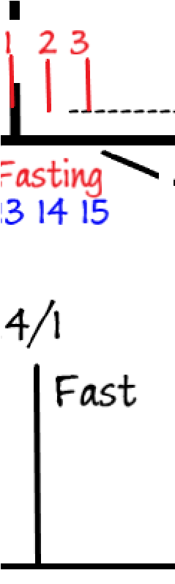

In Exodus 23:16:
16 And the feast of harvest, the firstfruits of thy labours, which thou hast sown in the field: and the feast of ingathering, which is in the end of the year, when thou hast gathered in thy labours out of the field.
Here you see that before you have the harvest you have to bring the first fruits. We have mentioned this symbology, many times before. The first fruits are the representation of the priests and the Levites who are lifted up before the world in the hand of Christ at the Sunday law. This is brought to view in the 2 Chronicles 29 where we have 1/1, 8/1, and 16/1. We can mark the 16th day, the day of the first fruits as the SL. This narrative here (13,14,15, and 16th days) from M/MC to SL a second feast is brought to view here. If you can understand this the rest of it is relatively straightforward.
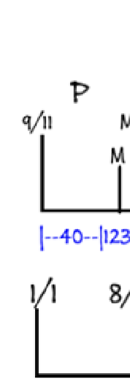
In ch 5 vs 8 it says “tomorrow we will have another feast”. So the 16/1 is lining up with the SL. On the scale of things Midnight and Midnight Cry are virtually the next to each other.
Vs 9.
- Then went Haman forth that day joyful and with a glad heart: but when Haman saw Mordecai in the king's gate, that he stood not up, nor moved for him, he was full of indignation against Mordecai.
Here it talks about Haman. He leaves the feast and goes home and it says “that day”. “That” day is the day of the first feast (15/1, or MC). So, here is Haman happy and he sees Mordecai at the gate. Mordecai is now symbolizes someone who brings judgement. He has changed his clothing back and now he is at the gate. If you were to do the study of Mordecai in the book of Esther you will see how his role changes back and forth. Haman is angry but vs 10 says he restrains himself, goes home and has a party:
- Nevertheless Haman refrained himself: and when he came home, he sent and called for his friends, and Zeresh his wife.
- And Haman told them of the glory of his riches, and the multitude of his children, and all the things wherein the king had promoted him, and how he had advanced him above the princes and servants of the king.
So, he explains all about his riches and his glory, and then vs 12 says “I have been invited to the feast tomorrow”
- Haman said moreover, Yea, Esther the queen did let no man come in with the king unto the banquet that she had prepared but myself; and to morrow am I invited unto her also with the king.
This “tomorrow” in vs 12 is the same ‘tomorrow” in vs 8. They are the same day.
- Yet all this availeth me nothing, so long as I see Mordecai the Jew sitting at the king's gate.
He says “all of these doesn’t bring me any happiness because Mordecai is still there, and if you think about it, what possible difference does Mordecai bring to this man’s life? His anger and hatred is more deeply seated than we realize. Because Mordecai hasn’t done anything to him. He is the most important man in the nation and his interaction with Mordecai is virtually zero.
- Then said Zeresh his wife and all his friends unto him, Let a gallows be made of fifty cubits high, and to morrow speak thou unto the king that Mordecai may be hanged thereon: then go thou in merrily with the king unto the banquet. And the thing pleased Haman; and he caused the gallows to be made.
Now Zeresh, his wife, begins to give him counsel, so you can see that right here at the MC husband and wife conversing one with another, and instead of the husband giving the wife instructions, you see the wife giving the husband instructions. So you see here a symbol of a woman or a wife, which is the church, taking control of the relationship with a man or a state. What is being brought to view here, is the image of the beast. Her counsel is to build the gallows as she says the gallows need to be 50 cubits high. We won’t study this 50 but it come up repeatedly.
Speaking,” of a nation, is action of its legislative and
The she says make the gallows, and then tomorrow, speak to the king. That “tomorrow” = 16th/1, which is SL where he should speak. Now remember that Haman is the symbol of the U.S. Here the U.S. is going to speak. Remember as Ellen White says that “
judicial authorities(
GC 442) when she is referring to the Revelation 13, when the U.S. speaks as
a dragon. So here at SL the U.S. is going to speak to have God’s people killed, but in this situation only Mordecai.

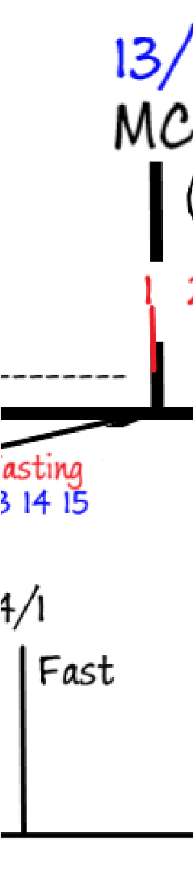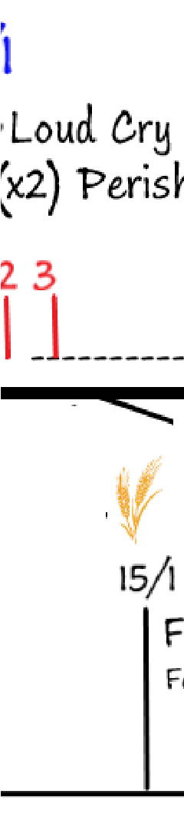

Ch 6
On that night could not the king sleep, and he commanded to bring the book of records of the chronicles; and they were read before the king.
That night is the night of the 15th. That night the king can’t sleep and the book of records, his subjects records is being reviewed. This si the representation of the investigative judgement. The name that comes up in vs 2 is Mordecai. What is being brought to view here is that the investigative judgement is now complete for Mordecai. His name has come up in remembrance and now his deeds are going to be reviewed. And you see that he is going to get his reward now. You see that Mordecai’s probation is closed here at MC (15/1)
This is one of the strongest evidences we have as
we mark the close
of probation
first for the Priests, then for the Levites, then the world happening
progressively: at MC it is the CoP for the Priests, at SL for the Levites and then for the world.
In this story we see that the deeds and the life of Mordecai is being investigated and his case is decided. And you know what his case is, it is favorable, and he is going to receive a reward.
It is discussed that he is going to discover these two people who are going to try to kill the king.
Vs3: 3 And the king said, What honour and dignity hath been done to Mordecai for this? Then said the king's servants that ministered unto him, there is nothing done for him.
So the question is asked what reward has he received, they said no reward was given. Because you cannot receive a reward until your case is being decided. All of this language is the language of the investigative judgement, the cleansing of the sanctuary, this is Daniel 8:13-14 all over again. It is the day of atonement. But we would expect the day of atonement to be further along down the line. What we are understanding is that where we thought the close of probation to be (here after the SL), then we realized that actually for the church it is actually back here (at SL) and for many years we have taught that the CoP for the church is at the SL, but once the truth of the Midnight Cry began to happen, and the key to open that up was fractals. Then we began to realize that there are two groups in Adventism (again brought to view in the book of Esther, because you have a king who has an insatiable appetite for women, and one woman is not enough he wants more as virgins is in the plural). We went to 2 Chronicles 29, we see these two groups: Priests and Levites. If you go back to the gospels you see two groups. All of these things begin to make sense when you place Bible stories on a line.
The methodology of line upon line study has opened up the Scriptures, so that you and I can have an opportunity of being saved before the overwhelming scourge comes at the SL. We speak about the overwhelming scourge occurring at the SL, that is correct, but with national apostasy, national ruin comes. And we now know that it is at the MC this apostasy begins. If you were thinking that at the MC we still have time to the SL, the world is about to collapse long before the SL. It is going to happen at the MC. Not just at the MC, because we have a relationship between the Midnight and the Midnight Cry, and this story is teaching that there is fasting and lamenting of the situation. Mordecai is refusing to put these clothes on. All of these is indicating that it is not just at MC, but it is at midnight.
The more we look at Scripture, the more we realize how little time we have left. We have just discussed Mordecai, and now he is going to receive his reward.
In the story Haman has taken the advice of his wife, they have built the gallows, and now he is going to go to the king (vs 4):
4 And the king said, Who is in the court? Now Haman was come into the outward court of the king's house, to speak unto the king to hang Mordecai on the gallows that he had prepared for him.
“That night” is the night of the 15th. Haman is so desperate to have this thing done, he goes as early as he can to see the king. The king says “who is outside?” and they say “it is Haman” and he calls Haman in, and has a discussion with him: what shall they do to the man who the Lord (Ahasuerus) wants to honour. Haman thinks it is him, Haman thinks that he is about to be lifted up and to be glorified, but he is about to be killed (Dan 11 when we looked at those kings). Here Haman says “I will tell you what to do, dress this man in the kings clothing and make him ride a horse”. The person who is going to be rewarded is going to have a new set of clothing. But they aren’t just special clothes, or nice clothes, these are the king’s clothes, showing the relationship between that man and the king. It is not just as we think in Revelation 3, where it says “I want you to wear white clothing” or the parable that talks about the wedding garment, where the king gives everybody a garment, this language is even stronger here we see him in the king’s clothes. He says “put him on your horse and ride around your city, giving this man great honor”.
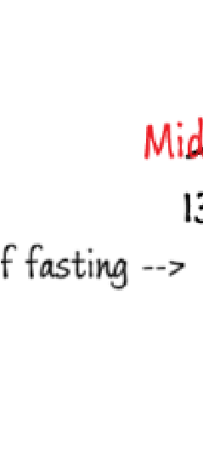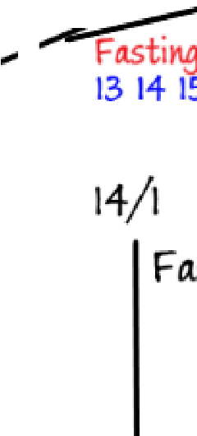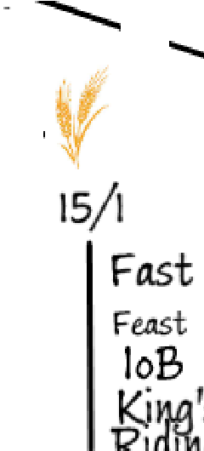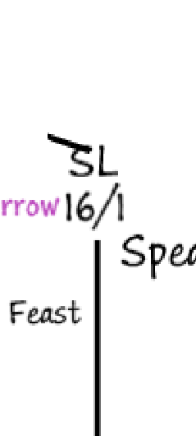

We know the symbol of the horse is the symbol of Islam, but it is also this person in royal clothing who is riding a horse is a symbol of Triumphal Entry that is brought to view in the gospels.
In the gospels we see multiple symbols occurring: we see Lazarus who was raised from the dead, who is the symbol of God’s people in this history. And he is leading this donkey, who Christ is riding upon, and that donkey was found by two disciples, who is the representation of the people in this (MC) history. This person in the gospels who is riding the donkey into Jerusalem, who is it? We think it is Christ, because in the gospels it is Christ, but according to this story who is that person? It is not the king. It is king’s servant. What does he look like? He looks like the king. If Haman wasn’t announcing this and you were a bystander looking on, remember, most people didn’t know what the king even looks like, we are talking about thousands of years ago, you see this man, riding his royal horse, wearing these clothes, who will you think it is? It is Mordechai. He is this person who represents God’s people. It might make you rethink, your concept of what you are reading in the gospels. Because we don’t think to understand the power, the responsibility that God’s people have at the end of the world. Most of Adventism, would stand horrified, if you tried to imply that the stone of Daniel 2 is not Christ, but His people. I contend, which version of the story is worse? If I said stone in Dan 2 is not Christ, or I said, go to the gospel and triumphal Entry, and that person is riding the donkey, isn’t even Jesus. He is another human being, who just looks like Jesus, how many people would accept that truth? But when you look at the book of Esther you can see all of these prophetic truths are revealed. It is easy to see once you have the key.
Ch6. Haman after taking Mordecai on this route around the city is so upset (the 16th day) he runs home sad.
Vs 13:
- And Haman told Zeresh his wife and all his friends everything that had befallen him. Then said his wise men and Zeresh his wife unto him, If Mordecai be of the seed of the Jews, before whom thou hast begun to fall, thou shalt not prevail against him, but shalt surely fall before him.
The prediction is made: Haman is going to fall, and even while their words are in their mouths, king’s chamberlains call Haman to the banquet.
- And while they were yet talking with him, came the king's chamberlains, and hasted to bring Haman unto the banquet that Esther had prepared.
Ch7 (16th day of the 2nd feast)
The king and Haman go to the banquet, they feast (2nd feast), then the king reminds her what do you want?
3 Then Esther the queen answered and said, If I have found favour in thy sight, O king, and if it please the king, let my life be given me at my petition, and my people at my request:
She explains that she wants her life and the life of her people. In vs 4 she says If you made us slaves I would never ask you anything, but someone wants to kill us, and when he wants to kill us, he is actually going to harm you, king,
5 Then the king Ahasuerus answered and said unto Esther the queen, Who is he, and where is he, that durst presume in his heart to do so?
In vs 6 Esther replies that it is Haman that wants to do this work. King arises. When you see the king arise, you know he is about to make judgement. When Stephen was being stoned, he looks to heaven and he says “I see Christ standing”, this standing is also brought to view in Daniel 7, when Christ moves from Holy to most Holy place. When he arises here he is going to bring judgement against Haman. And now everything unravels. The king leaves the room, Haman pleads for his life to Esther, and when the king comes back, he thinks that Haman is trying to attack his wife then:
9 And Harbonah, one of the chamberlains, said before the king, Behold also, the gallows fifty cubits high, which Haman had made for Mordecai, who spoken good for the king, standeth in the house of Haman. Then the king said, Hang him thereon.
Harbonah – one of the chamberlains, says to the king “you don’t know half of the things that are going on”, Haman has already built the gallows, to kill God’s people. If you look up the name the meaning of Harbonah – “his destruction or his sword” also means “donkey driver” or an ass driver. Harbonah is now bringing judgement to Haman (US) and now he is going to die. The gallows is built here (between MC and SL) this is the representation of the image of the beast. Now Haman is going to be killed on this gallows at the behest of Harbonah, the one who brings destruction, the sword, because he is an ass driver. You see the death of Haman brought to view here at the SL by ass or Islam.
After the death of Haman we are in this time period (23/3 to 13/12) and what we are going to see is the counter decree that Esther and Mordecai make happen.
Haman died here at the 16/1 and two months later (23/3) this law is being made, but prophetically these things are happening at the same time. Haman’s death is marked here at 23/3 prophetically, not literally. So at 23/3 is the counter decree is discussed. And in this time period (23/3-13/12) we can see the death or hanging of the 10 sons of Haman. 10 sons – in dan 2, 7, Rev 17, symbolizes 10 kings of Rev 17. Somebody asked, if God’s people were saved and happy, why is there such a bloodshed of the Persian? It seems unwarranted, and cruel. Many people make the same comments, this stone in Dan 2 going to destroy this image how many of you are concerned that this is genocide or wicked? Or Christ is going to come and there is going to be bloodshed and carnage? In these OT stories these are as much parables and symbols as other ones. This slaughter is the symbolic representation of the brining down of the glorious land at the end of the world. More than Medo-Persians, but the 10 who are the 7th kingdom or the UN, or the world.
The Lord is going to divorce the structure of the church and will go into covenant or remnant from this church. Why is that surprising? He takes a million people and allows them to die and enters into covenant with 2 men: Joshua and Caleb, this is the same story. A remnant only will be saved. The whole story is about the time “such as this” – the Midnight Cry. It is so important this complicated R&E that teaches so many truths about the experience of God’s people at this time. This portion is just about the priests. We know that their relationship with Christ is so close that if you didn’t know better, you could mistake him for Christ. Their character is so developed and perfected that they are dressed in the same cloth – character as He has. Islam is going to bring judgement at the SL, and the reward of the faithful priests is not way down here but you will be lifted up onto a horse right here (at the MC).
