Domestic policy

Moral
Economic
However economic turns into a moral issue

Foreign policy

Pro Israel domination
Anti Muslim with force
Pro Conservative moral gospel
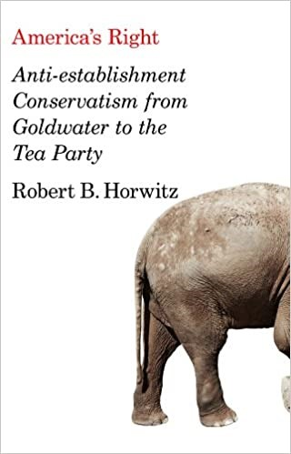
In contrast, American conservatism, born of classical liberalism’s focus on the individual, has usually gravitated toward theories of freedom and property. In this outlook, liberty and property are inescapably linked. Property makes it possible for a human being to develop in mind and spirit, that is, for an individual to be free. Property in effect underlies personhood: it provides an individual with perspective, privacy, responsibility, and a concrete place in society. A person has the natural right to the possession and use of his or her property; indeed, private property is among the most fundamental of natural rights. Without property, a person has no concrete free existence. He or she is inevitably dependent on others, especially government, and hence essentially unfree. Property, thus, is a sacred moral value, the key to individual freedom and the prerequisite of a free society. Against the modern liberal notion of equality, conservative thought declares human beings as essentially unequal in their natural gifts and abilities. Freedom can thus only consist in the ability of each person to develop without hindrance according to the law of his or her own personality. Hence of fundamental concern to conservatism is the power of the centralized state and its threat to liberty and property.
INTRODUCTION In the Western legal and political tradition, private property is often defended on the grounds that it promotes individual freedom.1 The nature of this relationship between property and freedom, however, remains contentious. Discussion of this subject often takes place as part of a debate over the legitimacy of government interference with private property, particularly in the contexts of regulatory takings and redistributive taxation. Pro-property, anti-interference advocates tend to suggest that there is a strong relationship between property and freedom.2 Those on the other side of the debate, however, tend to be more skeptical. 3 The political philosopher G.A. Cohen, for example, has asserted that “the familiar idea that private property and freedom are conceptually connected is an ideological illusion.”4 In a book on tax policy, Liam Murphy and Thomas Nagel similarly deny any relationship between “the right to speak one’s mind, to practice one’s religion, or to act on one’s sexual inclinations” on the one hand, and property rights on the other, on the grounds that interference with property rights “is just not the kind of interference with autonomy that centrally threatens people’s control over their lives.”5
Individualism stresses individual goals and the rights of the individual person. Collectivism focuses on group goals, what is best for the collective group, and personal relationships. An individualist is motivated by personal rewards and benefits.
an extreme laissez-faire political philosophy advocating only minimal state intervention in the lives of citizens.
But the Great Depression weakened faith in American business and its sundry ideological supports. The policies initiated under the Democratic presidency of Franklin Roosevelt – known as the New Deal – ushered in various forms of state intervention, some of which, pushed by a newly empowered labor movement, had a social democratic cast of mitigating inequality and of promoting basic public controls over markets. In the 1930s and 1940s, what we might call the “old right,” rooted in business and straddling the Democratic and Republican parties, set itself against the Roosevelt administration. The old right decried the New Deal as fostering economic collectivism and redistribution. For the conservatives of the 1930s and 1940s, like their predecessors in the “Gilded Age” from the late 1860s to the mid-1890s, the market was the democratic sphere of liberty. It was government that threatened freedom. Indeed, for conservatives the experience of the twentieth century was that in the name of equality and with the professed aim of improving life for the masses, the state alarmingly accrued power and weakened property rights. In so doing, the state undermined the fundamental condition of liberty that emanates from property, undercutting freedom writ large. The old right thus called for the “rollback” of the New Deal. Its critique of the state in many respects extended to foreign policy. In the period between the two world wars, American conservatives tended toward isolationism. They counseled avoidance of entangling political commitments – especially in European affairs, which, after the experience of World War I, conservatives saw as intractable. And because spending on armies and armaments required higher taxes and thus inevitably produced inflation, the old right was convinced that a militarized foreign policy would lead inevitably to the dreaded concentration of governmental power.
What bridged the differences between the two strains of conservatism was a shared loathing of the New Deal and of communism. In the fusion of traditionalism and libertarianism, the moral force of property was understood to guarantee individual freedom, the traditional family, and communal virtue. The Bible and the U.S. Constitution were understood as textual guides. Known at the time as “fusionism,” anti-establishment conservatism presented an ideologically charged version of customary conservative beliefs in laissez-faire capitalism and private property rights, limited government and low taxes, the defense of the traditional family, the original meaning of the Constitution, anti-communism, and stout national defense. Best articulated by William F. Buckley, Jr.’s National Review magazine, fusionism adopted a peculiarly anti-statist statism, allowing the movement to support interventionist anti-communist foreign policy and the massive military-industrial complex that served it, while
in the same breath condemning the growth of the federal government as a threat to individual liberty, personal responsibility, and self-reliance.6 Anti-establishment conservatism’s grassroots, located largely in the West and later in the South, were nurtured on this ideology while sustained materially by massive government spending on defense.
The Christian right and neoconservatism both also held that the United States was faltering in its leadership of the free world. They shared an unabashed belief in American exceptionalism: that is, in the conviction as to the beneficent, universal nature of the American values that necessarily accompany U.S. military ventures abroad; that war was the preferred means to defeat America’s external enemies and, in the case of the neoconservatives, the way to spread democracy to blighted parts of the globe. And they shared an appreciation of religion as providing the moral and cultural foundations for a wobbly, even endangered, liberal democracy. As leaders of the two groups began to interact, they increasingly came to share material networks and resources as well as ideas. They implored business to help spread the ideas, and business responded generously. The same foundations, corporations, millionaires, and CEOs began funding neoconservative and religious initiatives, think tanks, advocacy organizations, symposia, and publications; Christian right and neoconservative leaders began attending the same conferences; their writings appeared in each other’s newsletters and journals.
The second generation of neoconservatives ignored its forebears’ watchword of the dangers of social engineering and unintended consequences of public policy in favor of utopianism and the cleansing fire of violence in foreign affairs. This meant strong support for a confrontational policy legitimated by the belief in American exceptionalism. The idea that the United States is the embodiment of God’s gift of freedom and constitutes the greatest earthly force for good the world has known has always fused elements of nationalism and religion. Muscular versions of American exceptionalism distinguished the thinking of the Christian right and neoconservatism, and figured heavily in the Bush administration’s militaristic Middle East policy. Christian right support for the U.S. wars in the Middle East proceeded in some significant measure from the pre-millennialist belief in the Rapture and the “end-time,” in which the world’s destruction enables Christ’s return and a new, perfect world to emerge. During the Persian Gulf War of 1991, for example, the veteran prophecy writer Charles Taylor advised his followers that the war was preliminary to the Rapture.15 If not the Antichrist himself, suggested conservative evangelical organizations and preachers, Saddam Hussein could well be a forerunner of the Evil One. In many evangelical readings of the New Testament’s book of Revelation, the return of Jesus requires first that Jews return to the biblical boundaries of ancient Israel. War on Iraq would hasten this process. Thus many evangelicals regarded the invasion of Iraq as not simply an instance of a just war, but the realization of the prophesies of Revelation. Second-generation neoconservatism’s utopianism lay in an analogous apocalyptic belief in the United States’ ability to hasten universal democracy and a global free market through the creative application of violence.
Christian right and neoconservative brands of conservatism, influential since the late 1970s, became fully joined and embraced by the Bush administration in the wake of the fear and heightened perception of risk following September 11. President Bush himself said that he sensed a “Third [Great] Awakening” of religious devotion in the United States that coincided with the nation’s struggle with international terrorists, a war he depicted as “a confrontation between good and evil.”16 Fusing Christian right and neoconservative worldviews, Bush disclosed in a 2007 interview, “It’s more of a theological perspective. I do believe there is an Almighty, and I believe a gift of that Almighty to all is freedom. And I will tell you that is a principle that no one can convince me that doesn’t exist.”17 The parallel millennial beliefs of the Christian right, neoconservatism, and the Bush administration coincided in the disaster of Iraq.
I have referred to the Iraq War as a debacle a few times now. I am hardly alone in this judgment. Many prominent diplomats and scholars, including retired Army general William Odom, the preeminent conservative newspaper columnist George F. Will, and former Secretary of State Madeleine Albright, called Iraq the worst foreign policy disaster in U.S. history.18 The lineaments of this assessment are now well understood. The direct American combat role in the Iraq War proceeded for almost nine years, with nearly 4,500 American military and at least 100,000 Iraqi civilian casualties at an unknown cost (officially $750 billion but estimated at far higher – well beyond $3 trillion when long-term medical costs and replacement costs of troop and equipment are factored in), and the internal displacement of 2.7 million Iraqis and exile of another 2 million.19 The war siphoned off money, manpower, and attention from the military engagement in Afghanistan. The American military effort did remove the vile dictator Saddam Hussein from power. But as of this writing the viability of the Iraqi government remains in doubt, neighborhoods in major cities have been ethnically cleansed, infrastructure remains shattered, and basic services such as electricity are marginal at best. Indeed, the very “state-ness” of the country remains a question, given the strong tendencies of Shiite, Sunni, and Kurdish communities toward separation and perhaps partition. Contrary to the self-assured pronouncements of Bush administration policy-makers, there were no Iraqi weapons of mass destruction. And contrary to the hoary expectations of the backers of the war, a would-be democratic Iraq did not become a model for other Arab states. A severely weakened Iraq is no longer a regional counterweight to Iran; indeed, many analysts point to Iran’s heavy, if below-the-radar, influence on Iraq’s ruling parties. U.S. intelligence agencies concluded that the Iraq conflict was a prime source of recruitment for the global jihadist movement.20 In short, the Iraq War proved to be an utter fiasco, a dreadful monument to the law of unintended consequences abroad and at home.
Domestically, the Iraq War was perhaps the most far-reaching political event of recent years, for two interrelated reasons. First, when combined with the large tax cuts the Bush administration enacted in 2001 – which lowered tax rates across the board on income, dividends, and capital gains, and effectively eliminated the estate tax (and hence mostly reduced the taxes of America’s wealthy) – the huge expenditures on the Iraq War caused the federal budget deficit to balloon. Bush increased the budget deficit by $6.1 trillion, far more than any other administration in history. Thus when the housing collapse and financial crash ensued in 2008, the increased indebtedness meant that the U.S. government had far less room to maneuver than it otherwise would have had. The high deficit/debt made Keynesian remedies under the incoming Obama administration much more difficult to sell politically. Worries about the (war-inflated) debt and deficit constrained the size and effectiveness of Obama’s economic stimulus.21 And, of course, the effectiveness of a domestic stimulus package in an increasingly globalized economy already made its effectiveness less likely. The second far-reaching consequence was that the crisis intervention spending remedies that were put in place to deal with the near economic collapse mobilized a ferocious conservative populist political reaction in the form of the Tea Party movement, reanimating the anti-establishment conservative politics that had been temporarily discredited by the multiple failures of the Bush administration. As stated previously, it was the Tea Party that proved most capable of expressing the disgust of the class bias and unfairness of the government bailouts of the banks, insurance, and mortgage companies responsible for the financial collapse. The government was seen as aiding the elites. This view superficially is true inasmuch as the structural bias of the state causes it to engage in crisis management in ways that safeguard the financial infrastructure of a capitalist economy.
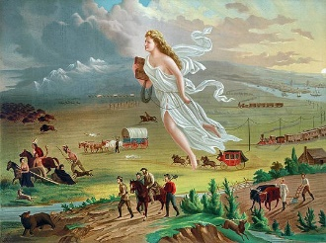
The Religious Origins of Manifest Destiny
Donald M. Scott
Professor of History
Queens College and the Graduate Center of the City University of New York
©National Humanities Center
In 1845, an unsigned article in a popular American journal, a long standing Jacksonian publication, the Democratic Review, issued an unmistakable call for American expansionism. Focusing mainly on bringing the Republic of Texas into the union, it declared that expansion represented “the fulfillment of our manifest destiny to overspread the continent allotted by Providence for the free development of our yearly multiplying millions.” Thus a powerful American slogan was born. “Manifest Destiny” became first and foremost a call and justification for an American form of imperialism, and neatly summarized the goals of the Mexican War. It claimed that America had a destiny, manifest, i.e., self-evident, from God to occupy the North American continent south of Canada (it also claimed the right to the Oregon territory including the Canadian portion). “Manifest Destiny” was also clearly a racial doctrine of white supremacy that granted no native American or nonwhite claims to any permanent possession of the lands on the North American continent and justified white American expropriation of Indian lands. (“Manifest Destiny” was also a key slogan deployed in the United States’ imperial ventures in the 1890s and early years of the twentieth century that led to U.S. possession or control of Hawaii and the Philippine Islands.)

But Manifest Destiny was not simply a cloak for American imperialism and a justification for America’s territorial ambitions. It also was firmly anchored in a long standing and deep sense of a special and unique American Destiny, the belief that in the words of historian Conrad Cherry, “America is a nation called to a special destiny by God.” The notion that there was some providential purpose to the European discovery and eventual conquest of the land masses “discovered” by Christopher Columbus was present from the beginning. Both the Spanish and the French monarchs authorized and financed exploration of the “New World” because, among other things, they considered it their divinely appointed mission to spread Christianity to the New World by converting the natives to Christianity. Coming later to the venture, the British and especially the New England Puritans carried with them a demanding sense of Providential purpose.

From <http://nationalhumanitiescenter.org/tserve/nineteen/nkeyinfo/mandestiny.htm>
The Great Depression

The Great Depression was the worst economic downturn in the history of the industrialized world, lasting from 1929 to 1939. It began after the stock market crash of October 1929, which sent Wall Street into a panic and wiped out millions of investors. Over the next several years, consumer spending and investment dropped, causing steep declines in industrial output and employment as failing companies laid off workers. By 1933, when the Great Depression reached its lowest point, some 15 million Americans were unemployed and nearly half the country’s banks had failed.

What Caused the Great Depression?

Throughout the 1920s, the U.S. economy expanded rapidly, and the nation’s total wealth more than doubled between 1920 and 1929, a period dubbed “the Roaring Twenties.”
The stock market, centered at the New York Stock Exchange on Wall Street in New York City, was the scene of reckless speculation, where everyone from millionaire tycoons to cooks and janitors poured their savings into stocks. As a result, the stock market underwent rapid expansion, reaching its peak in August 1929.
By then, production had already declined and unemployment had risen, leaving stock prices much higher than their actual value. Additionally, wages at that time were low, consumer debt was proliferating, the agricultural sector of the economy was struggling due to drought and falling food prices and banks had an excess of large loans that could not be liquidated.
The American economy entered a mild recession during the summer of 1929, as consumer spending slowed and unsold goods began to pile up, which in turn slowed factory production. Nonetheless, stock prices continued to rise, and by the fall of that year had reached stratospheric levels that could not be justified by expected future earnings.
Stock Market Crash of 1929

On October 24, 1929, as nervous investors began selling overpriced shares en masse, the stock market crash that some had feared happened at last. A record 12.9 million shares were traded that day, known as “Black Thursday.”
Five days later, on October 29 or “Black Tuesday,” some 16 million shares were traded after another wave of panic swept Wall Street. Millions of shares ended up worthless, and those investors who had bought stocks “on margin” (with borrowed money) were wiped out completely.
As consumer confidence vanished in the wake of the stock market crash, the downturn in spending and investment led factories and other businesses to slow down production and begin firing their workers. For those who were lucky enough to remain employed, wages fell and buying power decreased.
Many Americans forced to buy on credit fell into debt, and the number of foreclosures and repossessions climbed steadily. The global adherence to the gold standard, which joined countries around the world in a fixed currency exchange, helped spread economic woes from the United States throughout the world, especially Europe.
Bank Runs and the Hoover Administration

Despite assurances from President Herbert Hoover and other leaders that the crisis would run its course, matters continued to get worse over the next three years. By 1930, 4 million Americans looking for work could not find it; that number had risen to 6 million in 1931.
Meanwhile, the country’s industrial production had dropped by half. Bread lines, soup kitchens and rising numbers of homeless people became more and more common in America’s towns and cities. Farmers couldn’t afford to harvest their crops, and were forced to leave them rotting in the fields while people elsewhere starved. In 1930, severe droughts in the Southern Plains brought high winds and dust from Texas to Nebraska, killing people, livestock and crops. The “Dust Bowl” inspired a mass migration of people from farmland to cities in search of work.
In the fall of 1930, the first of four waves of banking panics began, as large numbers of investors lost confidence in the solvency of their banks and demanded deposits in cash, forcing banks to liquidate loans in order to supplement their insufficient cash reserves on hand.
Bank runs swept the United States again in the spring and fall of 1931 and the fall of 1932, and by early 1933 thousands of banks had closed their doors.
In the face of this dire situation, Hoover’s administration tried supporting failing banks and other institutions with government loans; the idea was that the banks in turn would loan to businesses, which would be able to hire back their employees.
Roosevelt Elected

Hoover, a Republican who had formerly served as U.S. secretary of commerce, believed that government should not directly intervene in the economy, and that it did not have the responsibility to create jobs or provide economic relief for its citizens.
In 1932, however, with the country mired in the depths of the Great Depression and some 15 million people (more than 20 percent of the U.S. population at the time) unemployed, Democrat Franklin D. Roosevelt won an overwhelming victory in the presidential election.
By Inauguration Day (March 4, 1933), every U.S. state had ordered all remaining banks to close at the end of the fourth wave of banking panics, and the U.S. Treasury didn’t have enough cash to pay all government workers. Nonetheless, FDR (as he was known) projected a calm energy and optimism, famously declaring "the only thing we have to fear is fear itself.”
Roosevelt took immediate action to address the country’s economic woes, first announcing a four-day “bank holiday” during which all banks would close so that Congress could pass reform legislation and reopen those banks determined to be sound. He also began addressing the public directly over the radio in a series of talks, and these so-called “fireside chats” went a long way towards restoring public confidence.
During Roosevelt’s first 100 days in office, his administration passed legislation that aimed to stabilize industrial and agricultural production, create jobs and stimulate recovery.
In addition, Roosevelt sought to reform the financial system, creating the Federal Deposit Insurance Corporation (FDIC) to protect depositors’ accounts and the Securities and Exchange Commission (SEC) to regulate the stock market and prevent abuses of the kind that led to the 1929 crash.
The New Deal: A Road to Recovery

Among the programs and institutions of the New Deal that aided in recovery from the Great Depression were the Tennessee Valley Authority (TVA), which built dams and hydroelectric projects to control flooding and provide electric power to the impoverished Tennessee Valley region, and the Works Progress Administration (WPA), a permanent jobs program that employed 8.5 million people from 1935 to 1943.
When the Great Depression began, the United States was the only industrialized country in the world without some form of unemployment insurance or social security. In 1935, Congress passed the Social Security Act, which for the first time provided Americans with unemployment, disability and pensions for old age.
After showing early signs of recovery beginning in the spring of 1933, the economy continued to improve throughout the next three years, during which real GDP (adjusted for inflation) grew at an average rate of 9 percent per year.
A sharp recession hit in 1937, caused in part by the Federal Reserve’s decision to increase its requirements for money in reserve. Though the economy began improving again in 1938, this second severe contraction reversed many of the gains in production and employment and prolonged the effects of the Great Depression through the end of the decade.
Depression-era hardships had fueled the rise of extremist political movements in various European countries, most notably that of Adolf Hitler’s Nazi regime in Germany. German aggression led war to break out in Europe in 1939, and the WPA turned its attention to strengthening the military infrastructure of the United States, even as the country maintained its neutrality.
African Americans in the Great Depression
One-fifth of all Americans receiving federal relief during the Great Depression were black, most in the rural South. But farm and domestic work, two major sectors in which blacks were employed, were not included in the 1935 Social Security Act, meaning there was no safety net in times of uncertainty. Rather than fire domestic help, private employers could simply pay them less without legal repercussions. And those relief programs for which blacks were eligible on paper were rife with discrimination in practice, since all relief programs were administered locally.
Despite these obstacles, Roosevelt’s “Black Cabinet,” led by Mary McLeod Bethune, ensured nearly every New Deal agency had a black advisor. The number of African-Americans working in government tripled.

Women in the Great Depression
There was one group of Americans who actually gained jobs during the Great Depression: Women. From 1930 to 1940, the number of employed women in the United States rose 24 percent from 10.5 million to 13 million Though they’d been steadily entering the workforce for decades, the financial pressures of the Great Depression drove women to seek employment in ever greater numbers as male breadwinners lost their jobs. The 22 percent decline in marriage rates between 1929 and 1939 also created an increase in single women in search of employment.
Women during the Great Depression had a strong advocate in First Lady Eleanor Roosevelt, who lobbied her husband for more women in office—like Secretary of Labor Frances Perkins, the first woman to ever hold a cabinet position.
Jobs available to women paid less, but were more stable during the banking crisis: nursing, teaching and domestic work. They were supplanted by an increase in secretarial roles in FDR’s rapidly-expanding government. But there was a catch: over 25 percent of the National Recovery Administration’s wage codes set lower wages for women, and jobs created under the WPA confined women to fields like sewing and nursing that paid less than roles reserved for men.
Married women faced an additional hurdle: By 1940, 26 states had placed restrictions known as marriage bars on their employment, as working wives were perceived as taking away jobs from able-bodied men – even if, in practice, they were occupying jobs men would not want and doing them for far less pay.
Great Depression Ends and World War II Begins

With Roosevelt’s decision to support Britain and France in the struggle against Germany and the other Axis Powers, defense manufacturing geared up, producing more and more private sector jobs.
The Japanese attack on Pearl Harbor in December 1941 led to America’s entry into World War II, and the nation’s factories went back in full production mode.
This expanding industrial production, as well as widespread conscription beginning in 1942, reduced the unemployment rate to below its pre-Depression level. The Great Depression had ended at last, and the United States turned its attention to the global conflict of World War II.
The 20th century[edit]
Following Theodore Roosevelt's loss to William Howard Taft in the 1912 Republican Party presidential primaries, Roosevelt and his followers broke off from the Republican party to form the Bull Moose Party.^{[1]} Wisconsin senator Robert M. La Follette also launched a presidential bid under the Progressive Party in 1924 after both the Republican Party and Democratic Party nominated conservative candidates.^{[2]} A period of realignment commenced following the onset of the Great Depression, as President Franklin D. Roosevelt constructed the successful New Deal coalition. Over the ensuing decades, Roosevelt's Democrats embraced several tenets of modern American liberalism, while the Republican Party tended to favor conservatism.

So we see the Characteristics of the Religious right and Republicanism as we know it toady, begin to develop here in this history.

Op-Ed: How Jimmy Carter championed civil rights &#8212; and Ronald Reagan didn’t
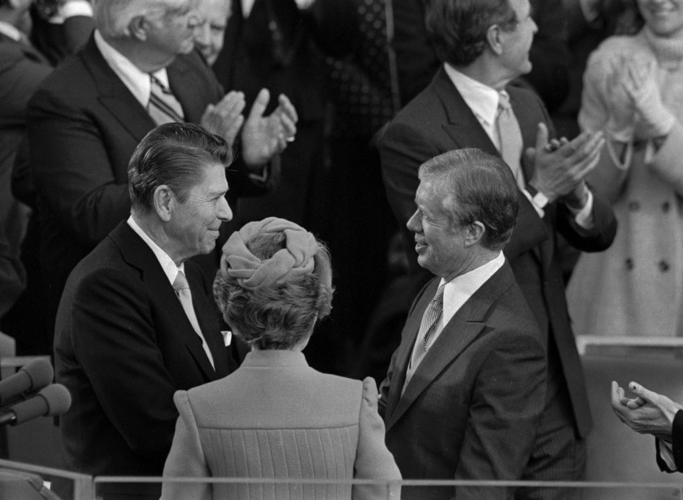
Ronald Reagan shakes hands with then-outgoing President Jimmy Carter on January 20, 1981 during Reagan’s swearing in ceremony at the captiol. Reagan’s wife Nancy is between them, back to camera.
(Associated Press)
By ARI BERMAN
SEP. 3, 2015
5 AM

In 1954, as segregationist organizations were springing up all over the South in response to Brown vs. Board of Education, the chief of police and a Baptist minister in Plains, Ga., visited a peanut farmer at his warehouse and urged him to join the local White Citizens’ Council. The farmer refused. The men returned a few days later and told the farmer he was the only white man in Plains who hadn’t signed up. That didn’t change his mind. The men returned a third time with some of the farmer’s customers, who threatened to boycott his business. If he couldn’t afford the $5 dues, they would lend it to him. “I’ve got $5,” the farmer responded. “And I’d flush it down the toilet before I’d give it to you.”
The farmer, in case you haven’t guessed, was Jimmy Carter.
The news that Carter has brain cancer has led many to consider his life’s work, as a controversial president and a dynamic former president. Carter is largely remembered as a feckless leader; even his own party tends to ignore his time in the White House. But he had a strong record on civil rights, and his work to advance the cause would have been far more consequential if his successor, Ronald Reagan, had not reversed course.
Few predicted that Carter would be an advocate for civil rights. When he ran for governor in 1970 as a little-known 46-year-old state senator, many thought he’d be just another second-rate George Wallace, like so many Southern governors before him. But in his inaugural address, Carter revealed his progressive views on race.
“I say to you quite frankly that the time for racial discrimination is over,” he told the people of Georgia.
Carter quickly became the poster child for the ascendant “New South.” Time magazine even put his face on the cover with the headline “Dixie Whistles a Different Tune.”
In his 1976 presidential campaign, Carter embraced the power of the 1965 Voting Rights Act, which enfranchised millions of African Americans and expanded protections for Latinos and language minority groups a decade later. Carter defeated Wallace — the symbol of the Old South — in the Democratic primary in part by appealing to black voters. His high-profile backers included Andrew Young and Barbara Jordan, the first black members of Congress from the South since Reconstruction. At the 1976 Democratic Convention in New York, Jordan gave the keynote speech, Young helped nominate Carter and Martin Luther King Sr. delivered the closing benediction.
While campaigning in black strongholds like Watts, Carter told audiences: “I could not stand here today as a candidate for president of the United States had it not been for Martin Luther King Jr.” The Voter Education Project, led by civil rights icon John Lewis, plastered thousands of posters across the South that read, “Hands that pick cotton ... now can pick our public officials.”
Carter owed his general election victory against Gerald Ford to black ballots. He carried every Southern state except Virginia by winning 95% of the black vote compared with 45% of the white vote. “The Voting Rights Act,” said Lewis, “created the climate for someone like Jimmy Carter to become the Democratic nominee and be elected president.”
Once in office, Carter pledged, “There will never be any attempt while I am president to weaken the great civil rights acts that have passed in the years gone by.” He appointed the first black division head at the Department of Justice, the first black female Cabinet member and the first black ambassador to the United Nations. Carter named more blacks, Latinos and women to the federal judiciary than all previous administrations combined.
But his Republican challenger in 1980, Reagan, took a very different position on civil rights, having opposed the Civil Rights Act of 1964, the Voting Rights Act and the Fair Housing Act of 1968. Reagan kicked off his general election campaign for president in Neshoba County, Miss., where civil rights activists James Chaney, Andrew Goodman and Michael Schwerner had been murdered in 1964. “I believe in states’ rights,” Reagan told the nearly all-white crowd at the county fair.
Carter responded to Reagan’s speech at Ebenezer Baptist Church in Atlanta, where King once preached. “You’ve seen in this campaign,” he said, “the stirrings of hate and the rebirth of code words like ‘states’ rights’ in a speech in Mississippi.” Again Carter attracted minority support, but that wasn’t enough to overcome Reagan’s commanding margin among whites.
When we look back on Reagan’s victory over Carter, we think of the end of the Iran hostage crisis and the beginning of “Morning in America.” Less well known is that Reagan’s triumph also ushered in a counterrevolution against the country’s civil rights laws.
Whereas Carter had appointed Drew Days III, a former lawyer with the NAACP Legal Defense Fund, to run the Justice Department’s Civil Rights Division, Reagan installed the conservative lawyer William Bradford Reynolds, who believed that “government-imposed discrimination” had created “a kind of racial spoils system in America,” favoring historically disadvantaged minorities over whites. The future leaders of the contemporary conservative legal movement, including Chief Justice John G. Roberts Jr., came of age in the Reagan Justice Department, where they aggressively tried to weaken the civil rights laws of the 1960s.
Now we live in the world Reagan created. The five conservative justices on the Supreme Court who gutted the Voting Rights Act in the 2013 decision Shelby County vs. Holder were all appointed by Reagan or served in his administration. Reagan’s ideological descendants, post-Shelby, have imposed strict voter-ID laws, cut early voting and eliminated same-day voter registration.
Of course, there’s also a growing movement to fight these restrictions and to make voting easier. In March, Oregon became the first state to adopt automatic voter registration for every eligible voter who requests a driver’s license or state ID card. California is considering a similar proposal, which would add 7 million voters to the rolls. Democratic presidential candidates Hillary Rodham Clinton and Bernie Sanders have highlighted this ambitious election reform in their policy platforms.
What nobody seems to mention is that Carter had the same idea 39 years ago. In 1976, while appearing with John Lewis, Carter proposed automatically registering every U.S. citizen 18 and older, which he said would “transform, in a beneficial way, the politics of our country.”
Ari Berman is a contributing writer for the Nation and the author of “Give Us the Ballot: The Modern Struggle for Voting Rights in America.”
Anita Bryant during Jimmy Carters Presidency

Bryant led several more campaigns around the country to repeal local anti-discrimination ordinances, including campaigns in St. Paul, Minnesota; Wichita, Kansas; and Eugene, Oregon. In 1978, her success led to the Briggs Initiative in California, which would have made pro-gay statements regarding homosexual people or homosexuality by any public school employee cause for dismissal.^{[19]} Grassroots liberal organizations, chiefly in Los Angeles and the San Francisco Bay Area, organized to defeat the initiative. Days before the election, the California Democratic Party opposed the proposed legislation. President Jimmy Carter, governor Jerry Brown, former president Gerald Ford, and former governor Ronald Reagan—then planning a run for the presidency—all voiced opposition to the initiative, and it ultimately suffered a massive defeat at the polls.^{[25]}

Before establishment[edit]
The origins of the Moral Majority can be traced to 1976 when Baptist minister Jerry Falwell Sr. embarked on a series of "I Love America" rallies across the country to raise awareness of social issues important to him.^{[2]} These rallies were an extension of Falwell's decision to go against the traditional Baptist principle of separating religion and politics, a change of heart Falwell says he had when he perceived what he described as the decay of the nation's morality.^{[3]} Through hosting these rallies, Falwell was able to gauge national support for a formal organization and also raise his profile as a leader. Having already been a part of a well-established network of ministers and ministries, within a few years Falwell was favorably positioned to launch the Moral Majority.
The impetus for the Moral Majority was the struggle for control of an American conservative Christian advocacy group known as Christian Voice during 1978. Robert Grant, Christian Voice's acting President, said in a news conference that the religious right was a "sham... controlled by three Catholics and a Jew." Following this, Paul Weyrich, Terry Dolan, Richard Viguerie (the Catholics) and Howard Phillips (the Jew) left Christian Voice.
During a 1979 meeting, they urged televangelist Jerry Falwell Sr. to found Moral Majority (a phrase coined by Weyrich^{[4]}). This was the period when the New Christian Right arose.^{[5][6]} Joining Falwell in the Moral Majority was Ed McAteer, who the same year, founded the Religious Roundtable in Memphis, Tennessee.^{[7]}
What explained this apparent sea change? While fundamentalist Christians had long stayed out of electoral politics, Falwell and many others were "extremely unhappy with the 'rights' movements that had sprung up in the '50s and '60s," says Didi Herman, author of The Antigay Agenda.
"First black people, then women, now gay people? The frustration had been mounting. Their actions were catching up with their view."
Falwell was plain enough about his views; in 1964, he told a local paper that the Civil Rights Act had been misnamed: "It should be considered civil wrongs rather than civil rights." His "Old Time Gospel Hour" TV program hosted prominent segregationists like Govs. Lester Maddox of Georgia and George Wallace of Alabama.

Fear Mongering to the Fore
While conservative Christians have led historic crusades against a number of "evils" in America — witchcraft, alcohol, communism, feminism, abortion — gay sex was never more than a minor concern until 1969, when protests in New York City launched the contemporary gay-rights movement.
In Where We Stand, Susan Fort Wiltshire recalls some early stirrings of a new crusade: "Around 1970, ambitious small-town preachers in the Northwest Texas Annual Conference of the United Methodist Church began to exploit 'the gay issue.' They saw that virulent anti-gay rhetoric could fill football stadiums for revivals in such tiny Panhandle towns as Tulia and Clarendon and Higgins and Perryton."
The crusade went national in 1977, courtesy of Anita Bryant. The perky spokesperson for Coca-Cola, Tupperware and Florida orange juice, Bryant had converted a runner-up finish in the 1959 Miss America pageant into a lucrative career singing "wholesome family music."
Bryant later said she knew next to nothing about gay people when she attended a 1977 revival at Miami's Northside Baptist Church. The preacher railed against a new ordinance in Dade County that protected gay people from discrimination, saying he'd "burn down his church before he would let homosexuals teach in its school."
Bryant was so impressed by the dangers of this new "homosexual agenda" that she launched an initiative to overturn the anti-discrimination ordinance, winning with a 70% vote.

Save Our Children's primary tactic was fear mongering. Gay people were "sick," "perverted," "twisted," and a threat to American families.
"Homosexuals cannot reproduce," Bryant often said, "so they must recruit. And to freshen their ranks they must recruit the youth of America."
Save Our Children distributed a press kit with a paper titled, "Why Certain Sexual Deviations Are Punishable By Death." Homosexuality was, of course, among those deviations. So was "racial mixing of human seed."
Save Our Children collapsed in 1979, after Bryant had a well-publicized divorce and breakdown, but not before her success in getting national publicity and large donations caught the eye of new-right strategists like Paul Weyrich and Richard Viguerie, the pioneer of right-wing direct-mail fundraising.

LaHaye, now famous for co-authoring the blockbuster Left Behind series of end-of-the-world thrillers, wrote that succumbing to the demands of the gay-rights movement would be a mistake of apocalyptic proportions — literally.
"The mercy and grace of God seem to reach their breaking point when homosexuality becomes normal," LaHaye said. "Put another way, when sodomy fills the national cup of man's abominations to overflowing, God earmarks that nation for destruction."

Cameron's brand of "science" echoed Nazi Germany. "These themes of disease and seduction are strongly reminiscent of older, anti-Semitic discourse," writes Didi Herman in The Antigay Agenda. "Jews historically were associated with disease, filth, urban degeneration, and child stealing."

ANTI-GAY MOVEMENT REACTS TO DECISION OVERTURNING ARREST OF TWO TEXAS MEN FOR HAVING SEX

From <https://www.splcenter.org/fighting-hate/intelligence-report/2005/anti-gay-movement-reacts-decision-overturning-arrest-two-texas-men-having-sex>
The Reagan administration practiced a policy of "constructive engagement" to gently push South Africa toward a moral racially sensitive regime. The policy had been developed by State Department official Chester Crocker as part of a larger policy of cooperation with South Africa to address regional turmoil.^{[21]} However, anger was growing in the United States, with leaders in both parties calling for sanctions to punish South Africa. Lawrence Eagleburger, Reagan's Under Secretary of State for Political Affairs, in June 1983 announced a clear shift in policy to an insistence upon fundamental change in Pretoria's racial policy, as the Reagan administration had to confront growing congressional and public support for sanctions.^{[22]} The new policy was inadequate to such anti-apartheid leaders as Archbishop Desmond Tutu. Weeks after it was announced that he had been awarded the Nobel Peace Prize he went to the United States and denounced the Reagan administration's policy as inherently immoral. On 4 December 1984, he told the U.S. House Subcommittee on Africa:
Apartheid is an evil as immoral and unchristian in my view as Nazism, and in my view the Reagan administration's support in collaboration with it is equally immoral, evil, and totally unchristian, without remainder.^{[23]}
However, on 7 December, Tutu met face-to-face with Reagan at the White House. They agreed that apartheid was repugnant and should be dismantled by peaceful means.^{[24]} Because efforts at constructive engagement had not succeeded in altering South Africa's policy of apartheid, Washington D.C. had to adapt this policy. In 1986, despite President Reagan's effort to veto it, the Comprehensive Anti-Apartheid Act of 1986 (CAAA) was enacted by United States Congress. This act was the first in this era that not only implemented economic sanctions, but also offered to aid to the victims living under apartheid rule.^{[25]} The Comprehensive Anti-Apartheid Act was the starting point for unified policy towards South Africa in United States politics. Under the Reagan, Clinton, and Bush administrations, there were continued efforts to try to end apartheid. By 1994, apartheid in South Africa had officially ended.^{[26]} Nelson Mandela was elected as the first president of this newly democratic nation.

From <https://en.m.wikipedia.org/wiki/South_Africa%E2%80%93United_States_relations>
So now we have the Conservative Evangelical and Republican Mindsets come together. During the time of the Moral Majority we can see what the domestic policy was when it came to rights and even economics.

No we are going to look at how they feel they lost the culture war in the United States and how they have gone to export their brand of government and religion to other vulnerable countries.

The Culture War That Isn't
by Jeremy Rabkin
Sunday, August 1, 1999
IS AMERICA IN THE GRIP of a bitter culture war? Quite a few people seem to think so. And for some of them, the events of the past year prove that conservatives are losing it, perhaps decisively and irretrievably.
Here, to cite the most prominent example, was the despairing reaction of Paul Weyrich, long-time conservative activist, after the Senate acquitted President Clinton on impeachment charges: "If there really were a moral majority out there, Bill Clinton would have been driven out of office months ago." From this premise, Weyrich proceeded to still more despairing reflections in a widely circulated letter to supporters last February: "I believe that we probably have lost the culture war. . . . in terms of society in general, we have lost." "Our culture," he went on to charge, "has decayed into something approaching barbarism"; as for the country, it "is very close to becoming a state totally dominated by an alien ideology, an ideology bitterly hostile to Western culture." The proper response, as Weyrich saw it, was a withdrawal from public campaigns — in effect, a kind of cultural secession: "we have to look at what we can do to separate ourselves from this hostile culture. . . . We need some sort of quarantine."
To be sure, many conservatives, while sharing Weyrich’s dismay at the public reaction to the Clinton scandals, shrink from pursuing his bitter logic to the same apocalyptic conclusions. At the same time, few have thought to quarrel with the premises on which those conclusions are based: that the past several decades have been characterized by a sweeping struggle pitting the forces of liberalism and progressivism, on one hand, against those of religious orthodoxy and tradition on the other; that this conflict, more than any other single force, has shaped the domestic politics of our time on every level; that we are, in short, in the throes of a "culture war," whether we choose to remain in the field or, following Weyrich and others, declare defeat and get out. To most conservatives, and indeed to many liberals, this way of interpreting our recent history now seems simply beyond argument.
It isn’t. As historical description, the notion of a "culture war" is a gross distortion. As a guide to contemporary strategists, it is a needless counsel of despair.
Anatomy of a metaphor
THE TERM "CULTURE WAR" itself, as applied to American politics, did not gain wide currency until the 1990s. What pushed it into circulation were the events of the preceding decade — in particular, the siege mentality generated by the disappointment of higher hopes in the Reagan years.
In the early 1980s, a lot of religious conservatives thought of themselves as the new winners in American politics, the leaders of a newly mobilized majority. A few years earlier, Weyrich himself had approached television evangelist Jerry Falwell with an idea for a new organization that would mobilize evangelical Christians, unite them with conservative Catholics and Jews, and establish a powerful new voice in American politics. Weyrich, raised a Catholic, was the person who suggested the name "Moral Majority" as a way of bridging sectarian divisions and emphasizing the common moral principles that seemed so much under attack in the 1960s and ’70s. Falwell, for his part, had little experience in politics. But like Weyrich, he had seen the potential for political mobilization of his audience. Harnessing this latent constituency and broadening its appeal seemed to be a plausible way of changing the direction of national politics.
The new organization chose its targets strategically. The Moral Majority called for the restoration of prayer in public schools — a venture with overwhelming popular approval, at least according to opinion polls. It called for the renewal of restraints on pornography — another winner, according to polls. And it also emphasized the need for restraints on abortion, picking up on a concern long championed by the Catholic Church but one in which evangelical Protestants had not previously been very active. On all of these issues, the Moral Majority could cast itself as the voice of a latent majority, resisting policies imposed by judicial edict at the behest of liberal elites.

From <https://www.hoover.org/research/culture-war-isnt>
But not all missionaries in Africa are as understanding as Shelvis and Nancy – something made clear when considering how belief and homosexuality collide across the continent.
Africa is by and large conservative, and many poor countries are susceptible to charity with a socially conservative agenda. It’s within this context that many US evangelical churches go to Africa to win the battles that are being lost at home. Many of them subscribe to the dominionist movement, which supports turning secular governments into Christian theocracies. They pressure NGOs not to accept Christians in same-sex marriages. Missionaries have traversed the length and breadth of Africa for centuries, so this 21st century American campaign is just the latest in a long line of foreign influence.

From gay marriage to abortion rights and birth control, the last decades have seen huge strides in the west towards minimising discrimination and encouraging equality. Hatred still exists, but public opinion has experienced a sea change towards accepting difference.
The Rev Jackson George Gabriel, the curate of the Episcopal Church of South Sudan and Sudan, tells me that he welcomes outside encouragement, confirming that the American branch of his church “are telling us to stand firm against homosexuality”. In a country where President Salva Kiir has said that homosexuality will “always be condemned by everybody”, and where the public shaming of gay South Sudanese by local tabloid media is growing, his stance enjoys a lot of support.

Gabriel fears western influence is fundamentally changing African societies for the worse. “Western society is trying to destroy us,” he says. “Behaviours such as fornication, spirit of independence, gay rights, no respect for elders, abortion and birth control are being imported. African leaders must maintain our culture.” He says the archbishop of the local Episcopal church is currently directing his ministries to investigate if they receive any funds from foreign churches that back homosexual rights. “If so, they must cut all ties,” Gabriel says.

These attitudes mirror the social agenda of many US evangelicals organisations which have both charitable and ideological agendas.

Samaritan’s Purse, run by Franklin Graham, son of the Christian evangelist Billy Graham, has a large presence in Africa and been active in Sudan since 1993. Along with providing food, fishing kits, water, shelter, training, hygiene and medical supplies, the group proselytises, screens the evangelical Jesus Film to thousands of people and rebuilds churches (“People are open to the Gospel here,” says country director Brock Kreitzburg). As a global enterprise, it has also been accused of blurring the line between church and state during its emergency relief work in developing countries.

Graham is a powerful figure, having met Kiir and Sudan’s President Omar al-Bashir many times to advocate for the country’s Christians. He visited South Sudan in March, prayed with Kiir and the rebel leader Riek Machar, and inaugurated an airport hangar in Kenya. Graham is also anti-gay, backing Russia’s draconian laws against sexual minorities. He told delegates at a recent Oklahoma State Evangelism Conference to “get involved in politics. [The] gays and lesbians are in politics [and] all the anti-God people are.”

Despite repeated requests, the group refused to provide details on the amount of money it currently spends in South Sudan, though its 2013 financial report said that in 2012 it had more than $2m of expenses in the nation and raised more than $376m worldwide.
•••

Part of the agenda of US evangelical churches is explored in a 2014 report by the Rev Kapya Kaoma called American Culture Warriors in Africa: A Guide to the Exporters of Homophobia and Sexism, which is endorsed by Desmond Tutu. Kaoma is an Anglican priest from Zambia now living and working in the US with the Episcopal Diocese of Massachusetts due to threats against his life. His work paints a picture of the myriad of US groups and their African allies who, he says, are “seeking to impose their intolerant – and even theocratic – interpretations of Christianity on the rest of the world”.

This includes the American Centre for Law and Justice (ACLJ), whose founders are televangelist Pat Robertson and lawyer Jay Sekulow. The organisation has visited South Sudan’s leadership with aims to influence its political agenda. The organisation has pushed for the criminalising of abortion and homosexuality across Africa and operates in Russia, Israel and Europe. The Republican presidential hopeful Jeb Bush recently appointed Sekulow’s son, Jordan, to be his “liaison” with religious conservatives.
Human Life International, a far-right American Catholic group working in Nigeria and Tanzania, opposes abortion and contraception. Stephen Phelan, its director of mission communications, tells me that the problem lies with secular aid groups, not evangelicals. He condemns “wealthy governments and enormous NGOs spending billions each year to impose their culture on Africa, including values that are literally foreign to African families … At times these funds actually go to aid Africans who live in less developed parts of the continent, but a great deal more is spent on population control than on wells, roads and medicine combined.”

In Uganda, American evangelicals have partnered, and sometimes trained, local pastors and church leaders to push extreme, anti-gay legislation. Leading newspapers outed people as “top homosexuals”, such as Frank Mugisha, and gay men and women face discrimination and violence.

The documentary God Loves Uganda documents this political evolution by focusing on the American missionary organisation International House of Prayer (IHOP) and its work in Uganda. Spokesman Jono Hall, who appears in the film, tells me that the group does “not have any organisational presence in Uganda or any other part of east Africa, and we do not have any intention to”.

The film’s director Roger Ross Williams explains to the Guardian that the “only response from IHOP has been denial, denial, denial … I screened in Kansas City a number of times, and IHOP folks came and someone even stood up and said they were ashamed of their church. We also flew IHOP leaders to New York to screen the film and had a three-hour conversation with them afterwards. They said it made them think about how they spread the word. But then they continued to spread hate and even invited anti-gay pastors from Africa to Kansas City.” Williams warns that growing numbers of American churches are operating in Rwanda, Ghana, Cameroon and Malawi.

In Uganda, a key supporter of the movement to stigmatise gay citizens is the US lawyer and activist Scott Lively (who recently wrote that Obama “orchestrated a coup” in Ukraine to support the LGBT agenda). During multiple visits to Uganda since 2002, Lively has spoken of Africans resisting the “disease” of homosexuality.

Lively justifies his opinions in a way similar to Phelan. When I probed him on this, he explained that he doesn’t “want Africans to experience the same collapse of their family-centred Christian infrastructure that is still unfolding in America and Europe. I went to Uganda to warn Africans of the goals and tactics of the homosexual political movement.”
He tells me that his mission in Uganda was “to focus on prevention and rehabilitation of homosexuality. The western media know this but deliberately portray me falsely as an architect of the overly harsh and punitive law the Ugandan government eventually passed.” Lively says he currently has no plans to return to Africa but still supports a Bible school in Kenya. He believes evidence shows that Obama is gay.

His advocacy in Uganda was challenged by a lawsuit brought by the New York-based Center for Constitutional Rights (CCR) on behalf of the group Sexual Minorities Uganda; they argued that Lively’s ministries constituted persecution. CCR’s lead counsel on the case, Pamela Spees, tells me that although proceedings remain in the discovery phase and the next major court date will likely be 2016, the “campaign to export discriminatory, anti-gay policies into Uganda and Africa more broadly has been remarkably successful”.
However, Spees says that the significance of the court case “cannot be overstated. For Ugandans who have been able to come to the United States for court hearings and meet activists in Massachusetts, who are also working to raise awareness about Lively’s efforts abroad, it’s an example of forging human connections, solidarity and of bringing awareness – and in some ways is its own form of accountability.”

Despite the huge challenges and growing homophobic campaigns across Africa, Kaoma is optimistic. “I can prayerfully say every tear and drop of blood of African sexual minorities is the step towards total liberation,” he says. He cites a resolution tabled in Angola in 2014 by the African Commission on Human and Peoples’ Rights that condemned “acts of violence, discrimination and other human rights violations” against sexual minorities.
Bishop Senyonjo of Uganda, a rare voice in his country advocating for LGBT rights, also hopes that churches will change their ways. “Evangelicals, wherever they come from the US and elsewhere, should bring good news of inclusion and love of God rather than sowing seeds of discrimination and hate,” he tells me before adding: “The Gospel is supposed to be liberating to marginalised people.”

From <https://www.theguardian.com/world/2015/mar/18/us-evangelicals-africa-charity-missionaries-homosexuality>
The Evangelical Roots of US Africa Policy

Asteris Huliaras

Until the late 1970s, evangelicals tended not to take part in US politics. A large proportion of them did not even vote in presidential elections. However, through a process of gradual politicisation initiated mainly by their strong interest in contested domestic issues such as abortion and gay marriage, and strengthened by Republican officials looking for new constituencies,4 the evangelical presence in US political life increased spectacularly.5 By the late 1990s, evangelicals had become a recognised voting bloc, mobilised most effectively by George W. Bush in the 2000 presidential election.6 More recently, the evangelical lobby has been a major driving force in placing African issues on the US government agenda

Saving the Third World It is no coincidence that US evangelicals have become increasingly interested in the Third World. Evangelical Christianity has grown tremendously in the global South, to the point where Third World Christians greatly outnumber their counterparts in the North. In 1900 only 7% of the world’s evangelicals lived in the Third World. By 1985 this share had shifted to 66%.7 In 2002 evangelicalism had nearly 800 million adherents worldwide, of whom some 500m resided in the global South.8 And it is in Africa where evangelicalism (especially its Pentecostal and charismatic variants) is growing most spectacularly.9 Still, demographic changes do not fully account for the relatively sudden interest of US evangelical Christians in the Third World. Also of importance are the missionary activities that have brought increasing numbers of evangelicals into direct contact with the people of Africa and other developing areas. Until the early 1950s, the majority of US Protestant missions in the Third World were drawn from mainline denominations.10 By the late 1980s, however, 90% were evangelical.11 A combination of growing self-confidence and impressive economic resources (more than $2 billion annually) explain this shift. Evangelical missions have become a particularly big industry in Africa. In the early 1990s there were at least 1,300 American protestant missionaries in Kenya alone.12 In the second half of the 1990s, the number of US evangelicals fanning out across the globe on proselytising missions reached record levels. According to some estimates, nearly 350,000 Americans undertook such missions in 2001, eight times as many as in 1996.13 In 2002, the Southern Baptist Convention, one of the most important US evangelical denominations, spent $290m abroad, mainly in Asia and Africa, establishing more than 8,000 churches and baptising more than 421,000 converts.14 In 2005, the BBC’s Focus on Africa reported:

Africa is being colonised and Christianised all over again. The colonisers this time are Americans, not Europeans, and the brand of belief they are bringing to Africa is Evangelical Christianity.15

Evangelical missionaries returning to the United States were acutely aware of the poverty and oppression they had encountered in the less-developed
The Evangelical Roots of US Africa Policy | 163
countries they had visited. Above all, they were concerned with the persecution of Christians in countries such as Myanmar and Sudan. They played a crucial role in persuading their organisations to mobilise in support of their persecuted co-believers. As a result of their interest in the ‘suffering church’ in Third World countries, evangelical groups attempted to re-direct American foreign policy in defence of Christian minorities worldwide. In 1996 the National Association of Evangelicals embarked upon a highly coordinated campaign that included public gatherings, strong media coverage and private meetings with officials in Washington aimed at changing US foreign policy towards countries that were seen as persecuting Christians.16 The association finally persuaded a reluctant Clinton administration to introduce the International Religious Freedom Act in 1998. Although government officials initially tried to underplay its importance, the act created three significant government bodies to monitor and respond to violations of religious freedom: the State Department Office of International Religious Freedom, the Commission on International Religious Freedom and the Special Advisor on International Religious Freedom within the National Security Council.17 Another factor that played a crucial role in increasing evangelical interest in foreign affairs was the violence of 11 September 2001. In the three presidential elections prior to 2004, fewer than 2% of evangelicals mentioned foreign policy as ‘the most important issue’ that the United States was facing. However, after 11 September attitudes changed markedly: by 2004 about a third of evangelical Christians named foreign policy as the most important issue on the country’s agenda.18 But the events of 11 September not only changed the views of the evangelical community, they changed those of the US administration. America was now at war. And it was not just a war of revenge but a war of ideals, including the spread of democracy worldwide. As liberal evangelical Jim Wallis observed, the terrorist attacks transformed Bush from a ‘self-help Methodist’ to a ‘messianic Calvinist’.19 If the United States had decided to become the world’s ‘moral leader’, a ‘force of good’ in global politics aiming to ‘export democracy and freedom’ in an unruly world, then evangelicals clearly had a role to play.

The content of the US programme on AIDS, for example, was heavily influenced by the president’s evangelical backers. It has been reported that when Bush spoke to his evangelical speech-writer Michael Gerson about the feasibility of a plan to spend $15bn fighting AIDS, Gerson told him, ‘if this is possible, and we don’t do it, we will never be forgiven’.35 In 2003, under pressure from evangelical lobby groups like Focus on the Family, the US administration decided to introduce a three-pronged strategy to fight AIDS, based on promoting abstinence, monogamy and, under certain limited circumstances, the use of condoms.36 The programme has faced heavy criticism from many activists and health experts: the UN secretary-general’s special envoy for HIV/AIDS in Africa has argued that its emphasis on abstinence has contributed to a shortage of condoms in some African countries.37 ‘To impose a dogma-driven policy that is fundamentally flawed is doing damage to Africa’, said the UN official. The influence of evangelicals was also evident in US development assistance programes that did not focus on AIDS. For decades, US policy avoided intermingling aid programmes and religious proselytising. However, in December 2001 Bush created a new Center for Faith-Based and Community Initiatives within the United States Agency for International Development (USAID).38 Gradually, the percentage of US aid going to faith-based organisations doubled and, according to many observers, the separation between religious services and donor activities became increasingly blurred.39 Some restrictions imposed at the request of Congress in order to separate USAID-funded programmes from religious activities seemed to lose their effectiveness as many religious organisations could easily argue that they were using private and not public money for proselytising. In 2006, the US Government Accountability Office examined 13 federally financed faith-based organisations and concluded that four of them ‘did not appear to understand the requirements to separate these activities in time or location from their program services’.40 ‘By the early years of the new millennium’, concluded development scholar Gerard Clarke, ‘an effective nexus between the Bush administration and the US Christian right had become an important feature of US policy in international development.’41

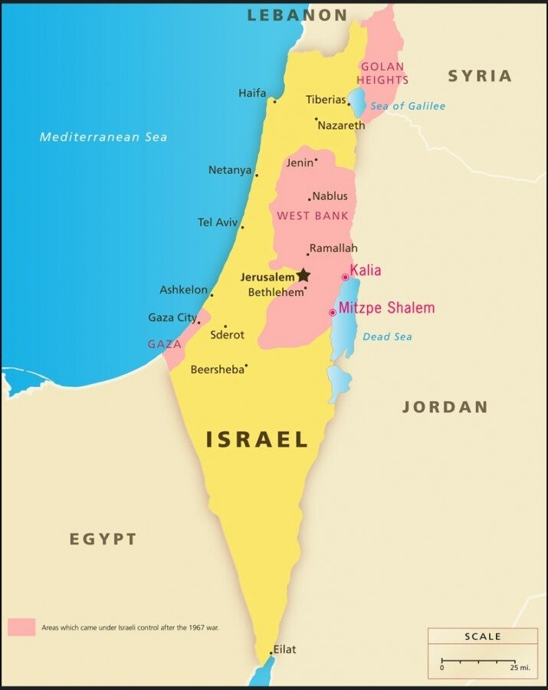
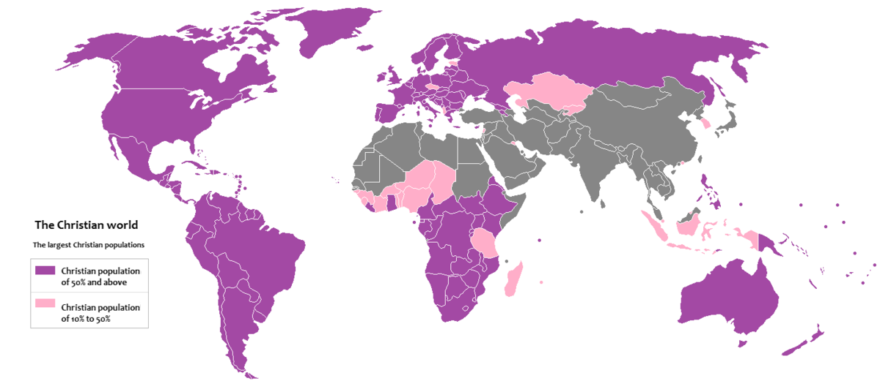
The Spread of the Gospel HD

From <https://www.youtube.com/watch?v=9Gp-_ZsUagc>

