False Freedom - A Prophetic Pattern (Part 1)

Dear father in Heaven, Thank you Lord for our blessings. You know Lord what this movement has been raised up to do and you know the attacks that this movement as a unit is facing as we endeavor to prepare for this so important work. Lord you have entrusted to this movement the job function of reaching the final generation of the world with the gospel to save as many as are willing, and we see that Satan wishes to destroy this work. We have seen that through the attacks of the last dispensation and we see it through the wilderness time period. I pray Lord that you prepare us to stand for the truth, Father, that everyone who is wavering, who is becoming weakened by the falsehoods and deceptions that do exist, that they will be removed from this influence. That they might take back hold of those cords and not let them go. I pray Lord as you direct us, as you lay out the warnings that you have given us that we’ll pay heed to these warnings that all who can be saved will be saved. I pray this in Jesus' name Amen.

Good morning everyone. For the last months we have been laying out over and over again where we stand on the reform lines, where we stand on the lines God has given us, and we have labored those points over and over again because of the satanic attacks this movement has faced through its Sunday Law history, through its Jacobs time of trouble.

So the purpose of this presentation is to do that, hopefully with a greater deal of clarity and with some further explanations that I think many, if not most people in this movement do not currently understand as completely as they need to be safe. So what I want to do is revisit the history of the last dispensation. The history that is typified by the end of ancient Israel, the experience from the upper room from Gethsemane to the cross. I will not for time repeat all of those lines and logic. They have been developed and presented time and time again in a fashion that makes them irrefutable. I will not be repeating those arguments. If people are not familiar with those studies, there are many presentations done by myself and by others that lay out the end of ancient Israel in its two relevant reform lines. I will spend the first moments of this study reminding us of the compare and contrast of those two reform lines, Gethsemane and the wilderness.
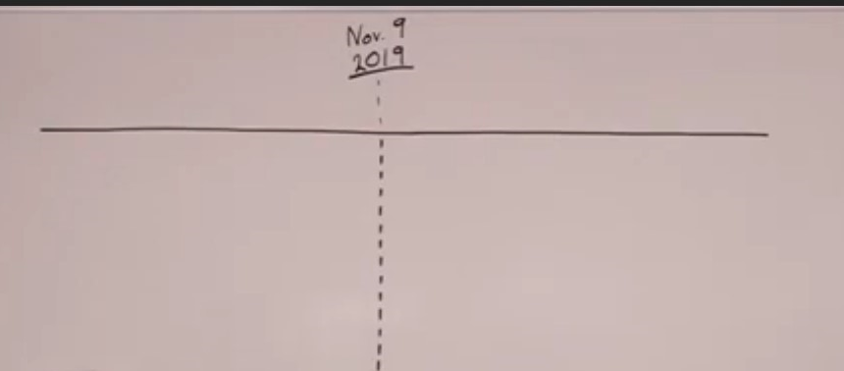
So I’ve drawn a line here. I’m going to call this point November 9, 2019.
This was the shut door, the close of probation for the priests. We have this waymark at the end of ancient Israel typified by the cross. I want to read from Desire of Ages. These are not new quotes I’m referring to. These are old quotes. They have been taught before but I want to remind us of this point.

Jesus had been earnestly conversing with his disciples and instructing them. This is Desire of Ages 685.2. I’m going to read through some portions of this. At least this and the next paragraph, portions of these paragraphs. Jesus had been earnestly conversing with his disciples and instructing them. But as he neared Gethsemane, he became strangely silent. He had often visited this spot for meditation and prayer but never with a heart so full of sorrow as upon this last night of agony. Throughout his life on earth he had walked in the light of God’s presence. When in conflict with the men who were inspired by the very spirit of Satan, he could say “He that sent me is with me. The Father hath not left me alone for I do always those things that please him”. But now he seemed to be shut out from the light of God’s sustaining presence. Now he was numbered with the transgressors. The guilt of fallen humanity he must bear. Upon him who knew no sin must be laid the iniquity of us all. So dreadful does sin appear to him, so great is the weight of guilt which he must bear, that he’s tempted to fear it will shut him out forever from his father’s love. Feeling how terrible is the wrath of God against transgression he exclaimed, “My soul is exceedingly sorrowful even unto death”. As they approached the garden, the disciples had marked the change that came over their master. Never before had they seen him so utterly silent and sad. As he proceeded this strange sadness deepened.

So I just want to compare and contrast this experience with what Ellen White describes in 2 RED 34.3 and 35.1. Now she’s describing the wilderness. Christ had entered the world as Satan’s destroyer, and the redeemer of the captives bound by Satan’s power. He would leave an example in his own victorious life for man to follow and thus overcome the temptations of Satan. As soon as Christ entered the wilderness of temptation, his visage changed. So there were accusations made that I was misusing the wilderness time period by saying that that period of trouble and temptation occurred through the whole of the wilderness experience. People were arguing no, that temptation only exists at the end of the wilderness. But Ellen White said, “Christ’s visage changed the moment he entered the wilderness”. The glory and splendor which were reflected from the throne of God in his countenance when the heaven’s opened before him, and the father’s voice acknowledged him as his son in whom he was well pleased were now gone. Why?

So Christ entered the wilderness and he entered Gethsemane. At both times he made a marked change. A change in Gethsemane from conversing with his disciples, instructing them to this silence, to this deep sadness. He goes into the wilderness. His visage changed. The glory appears to be gone. He is sad and silent. Why? In Gethsemane the weight of the sin of the world is placed upon his shoulders. Upon him who knew no sin must be laid the iniquity of us all.

Back to the quote in 2 RED. The wilderness, the weight of the sins of the world was pressing his soul. Why did Christ’s visage change when he entered the wilderness? The weight of the sins of the world was pressing his soul and his countenance expressed unutterable sorrow. A depth of anguish that fallen man had never realized. He felt the overwhelming tide of woe that deluged the world. He realized the strength of indulged appetite and unholy passion which controlled the world and had brought upon man inexpressible suffering. The indulgence of appetite had been increasing and strengthening with every successive generation since Adam’s transgression, until the race was so feeble and moral power that they could not overcome in their own strength. Christ on behalf of the human race was to overcome appetite by standing the most powerful test upon this point. He must tread the path of temptation alone and there must be none to help him. None to comfort, none to uphold. Alone he was to wrestle with the powers of darkness.

So you have a compare and contrast with Gethsemane and the wilderness. Prior to Gethsemane you have the triumphal entry, you have the upper room. Prior to the wilderness you have the baptism, the pouring out of the Holy Spirit, and then his visage changes. He enters the garden, he enters the wilderness, and he becomes silent and sad. He becomes weighed down with the sin of the world. He must confront Satan alone and have victory. Upon his success in both tests hung the destiny of the human race. We find that in Desire of Ages 686.5. She discusses both histories. In the wilderness of temptation the destiny of the human race had been at stake. Christ was then conqueror. Now the tempter had come for the last fearful struggle. Then she says “Everything was at stake in Gethsemane”. So everything is at stake in Gethsemane, and everything is at stake in the wilderness.

Through those quotes I’m not attempting to draw them out. I’m hoping we can see it in the quotes themselves. I won’t draw it for time but there’s the perfect compare and contrast of these two painful time periods that Christ must experience and in them find victory. The purpose of this study is not to repeat what has already been laid out regarding the wilderness time period. I want to put it in a prophetic framework, comparing and contrasting Gethsemane and the wilderness.

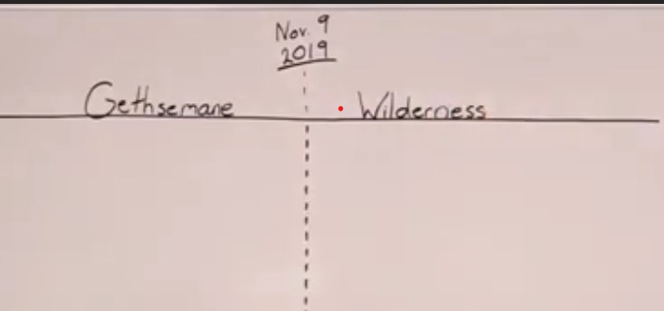
We understand this to be Gethsemane from the reform line of the disciples as the first of 3 groups are called. As Christ represents the priesthood, we understand this to be the wilderness.

So the experience of Christ in the wilderness has already been repeated in Uganda particularly and in the Brazilian camp meeting, the Ugandan school and two camp meetings and the camp meeting held in Brazil earlier this year. I will not be repeating that prophetic explanation but I want to make one point. In the wilderness what does Christ not have? There is no bread. In Gethsemane he had previously eaten, but there is no bread. In the wilderness time period which we have been in from Nov 9 through to Concord there is no bread. There is no new message. I want to emphasize there is no new message. If we were to turn to Spiritual Gifts vol. 2 30.2, Ellen White is describing her first vision. She had this just after October 22, 1844 and it was written and published in 1846. In describing her vision remember this is post October 22. Its post this waymark here, and what does Ellen White say? As she went into this vision she raised her eyes and saw a straight and narrow path cast up high above the world. On this path the Advent people were traveling to the city which was at the further end of the path. So the Advent people post October 22, they are on this path that will take them all the way to the Second Advent. They had a bright light set up behind them at the first end of the path, which the angel told me was the Midnight Cry. This shone all along the path and gave light for their feet that they might not stumble.

Back here you have the Midnight Cry and how far does the Midnight Cry light extend? Does it extend to the close of probation? Did the Midnight Cry of Millerite history extend only to October 22? No, the light of that Midnight Cry was to extend all the way to the Second Advent, all the way to 1863.

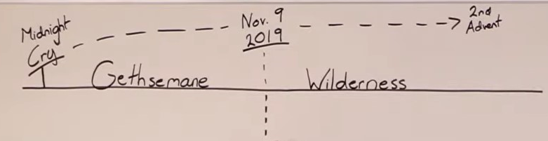

She wrote this in 1846. She had this post October 22, 1844. She’s describing the same Midnight Cry and she says that bright light shone all along the path, all along to the New Jerusalem. Over all along to the second advent that in following it their feet might not stumble. This is the path. The path leads us through Gethsemane. It leads us through the wilderness but the light of the Midnight Cry 2018 will extend all the way to the second advent of Christ.

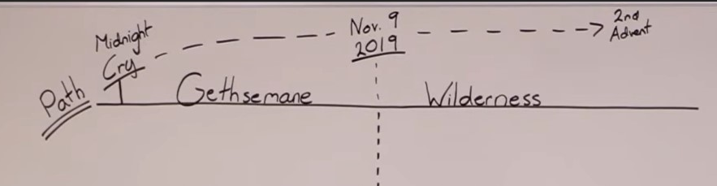

This shone all along the path and gave light for their feet that they might not stumble. Some rashly denied this light behind them and said that it was not God that had led them out so far. The light behind them went out leaving their feet in perfect darkness. What happens if you reject the light of the Midnight Cry? The light goes out and what happens? They fall off the path. They are left in perfect darkness. So while there is no bread in the wilderness the light of the Midnight Cry has not stopped shining. This is the 40 day experience.

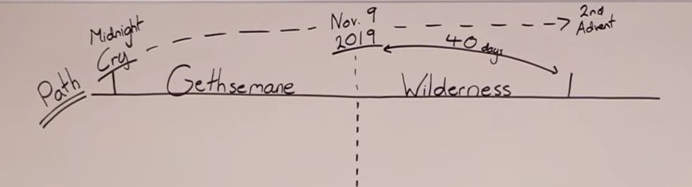

In that 40 day experience after the cross, what was Chris explaining to the disciples? The light of the Midnight Cry. He was repeating the exact same message. So there is no new message but the light of the Midnight Cry that Christ had already taught he teaches to them again.

I want us to consider what occurred in our history of Gethsemane, in what we experienced from September 2018 to September 2019, that 12 month time period when that message was spread. What happened in that time period from September 2018 was a growing rift inside this movement, a fight between 2 definitions of the nature of the kingdom. I’ll put it up here.

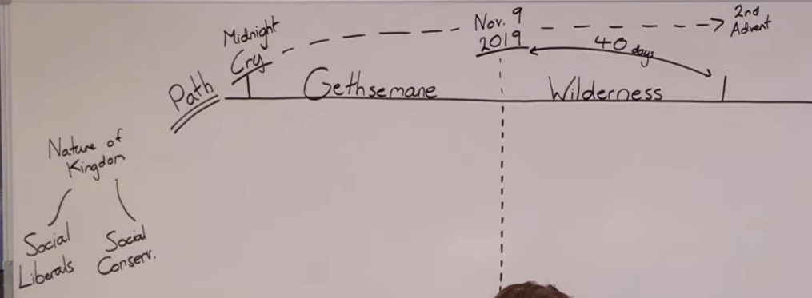

Two definitions, and what did one definition say? One definition said we are social liberals and one definition said we are social conservatives.

The Midnight Cry message, when it was first presented right back in 2018 started to create a rift between 2 different definitions of the nature of the kingdom of God. The socially conservative worldview was built up on what type of methodology? This is conspiracy theories. The socially liberal worldview was through parable teaching.

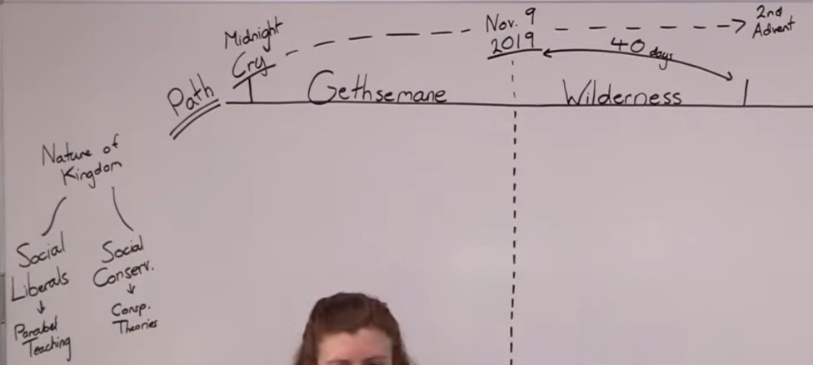

As that message began to spread, we began to experience a growing divide, schism within this movement. Elder Jeff led the opposition to the Midnight Cry message which was producing a shaking in the movement. It began from the very beginning but was not visible to very many people. From the moment the message was shared in Arkansas September to October 2018 he began to fight against it and what I want us to do is see the steps Elder Jeff took in fighting against and attacking the Midnight Cry message. There were 4 specific steps that he took. His very first reaction when that message was presented was to start to redefine it in his own terms.

What he did was as soon as I left Arkansas, there was a camp meeting there and he presented his version of what the Midnight Cry message looked like. What he said in this first attack was that the Midnight Cry was a combination of messages from different people, different people, different messages all coming into union, all combining to form the Midnight Cry. So he said “This is multiple people independent of each other”. He particularly highlighted 3. There were 3 that he saw that were combining to form the Midnight Cry. The first was one was myself with Acts 27 and the studies that developed from Acts 27. The 2nd that he claimed was a component of the Midnight Cry was Theodore. The 3rd that he said was a component of the Midnight Cry was some studies that came out of Africa. I won’t yet get specific with locations or names. I’ll keep it broad for now, but he said that these 3, that the Midnight Cry message through Acts 27 combined with Theodore, which was situated, centered in the United States, plus individuals in Africa and the studies and thoughts they developed, he said all of these 3 combined to form the Midnight Cry. People on different continents independently to each other. So the claim that he made was because these were different people independent to each other, it was evidence that the Holy Spirit was working with a variety of people and a variety of messages to bring them to one common conclusion. His argument was that this is evidence that the Holy Spirit was working throughout the movement worldwide.

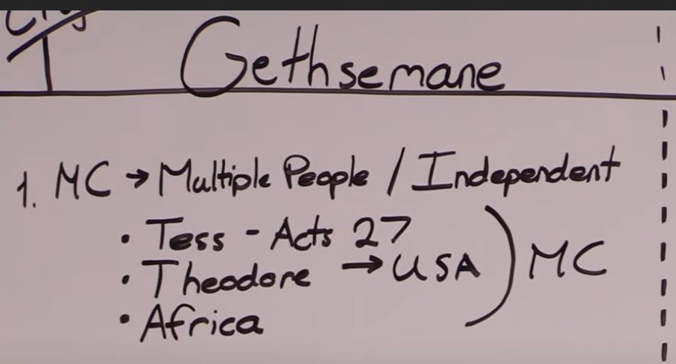

How did Elder Parminder and I respond to that definition of the Midnight Cry? How much light did we see in that? Elder Parminder responded in Kenya December 2018 with an explanation of the charts of Millerite history and how Ellen White described the chart making business, there was one chart people were to follow, not a mixture of charts being done by multiple people.

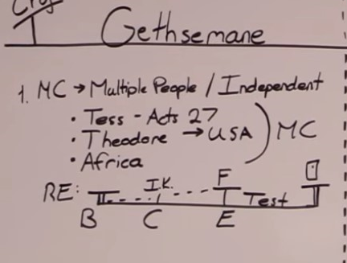
I responded to this definition of the Midnight Cry in December of 2018 in Australia with a study of Boston, Concord and Exeter. So the response was essentially, the lines give us a prophetic pattern. You have a waymark associated with the Time of the End or opening up of a message at Boston. There is an increase of knowledge. You can call that Concord. It’s formalized at Exeter. Then there is a test. Then there is a shut door.

So by laying out the structure of how light is given to this movement, it was a direct response to Elder Jeff’s definition of the Midnight Cry. He had been very deliberate about the way he had done this. When Elder Jeff says that the Midnight Cry is a combination of all these at least 3, what was he doing? His intent and purpose was to water down the Midnight Cry message. To see that in what I had presented he could take what he wanted and discard the rest because there were parts of that message that he did not like, that he did not agree with, particularly the message of 2 streams of information, Social Liberalism - Social Conservatism. In combining these messages he was making a deliberate attempt to water down and cut up the Midnight Cry message.

So we responded with evidence from the lines. The Midnight Cry message is not a combination of the United States and the studies that were done in Africa in combination with Acts 27. If you were to go back and look at those other 2 points, other two studies that Elder Jeff was trying to tie to the Midnight Cry message, you would see that they both were failed, failed prophecies. Time has given evidence for that but people had to see that then not on July 18th. Through those weeks after presenting and after I presented the message built upon acts 27, Elder Jeff’s response was to combine these messages, call that the evidence of the working of the Holy Spirit, and then as he battled with what I had presented, as he tried to remake what I had presented in his own world view, he did not see the need to have any communication with me. I want to make that point, not because it was about me but because it was a repeating pattern. The only contact I had with Elder Jeff in that whole 12 month time period was a message that he sent me asking for me to join the bible study forum so that people could ask questions and discuss with me directly on WhatsApp forums.

As respectfully and politely as I could I responded and said I would not. I'm hoping that people start to understand the position that I have on WhatsApp forums. Externally, when you look at what's happening in the world, why is the world In such a mess? Because they go to social media to understand and find out news. They no longer go to the Guardian or the Washington Post or the New York Times. They go to Facebook and WhatsApp and Twitter to understand news and social media is not a platform to understand news internally to understand light. WhatsApp is not a platform by which the true light of this movement is properly shared, not in the spirit or in the content. So I politely refused and did not join the Bible study forum. I still have not and will not. But I wanted to make the point that as he battled with what had been presented, as he tried to both water it down and cut it up, we did not have contact. He did not feel comfortable speaking to me.

So once he had done this, we had responded. People began to understand what we believed, what the position of Elder Parminder and myself was. This attempt to make the message a combination of these three started to go a little bit more silent. Elder Jeff then launched his second attack. I'm not saying that these were deliberate attacks. I'm sure that in some ways they were not, but this is the way that he was led down. So the second attack began early last year, primarily through January February and March, the three months that Elder Parminder and myself we're teaching in the school in Brazil. When it couldn't be watered down and it couldn't be cut up between this worldwide so-called working of the Holy Spirit he chose a different tactic.

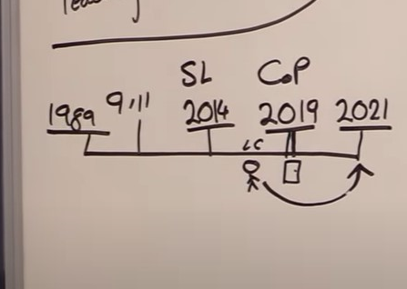
Again I don't think this is deliberate. I think he was led and he doesn't, unfortunately never realized it. But he then condensed the message that had been presented on Act 27. And the essence of his point was, the point of that message is November 9 2019. Theodore gave a secondary witness, apparently. Therefore we’ve passed that message and can look into the future. So he started directing people away from the Midnight Cry Message, away from the Sunday law test to a future dispensation, Panium. And what he started to do In conjunction with others Is that where we are on a reform line, if we were to see where we are on a reform line 1989, 911, 2014, 2019, 2021 and Sunday law, loud cry, close of probation. We were standing in the midst of the Sunday law test. And what Elder Jeff just did was to direct us to the second Advent, and he started putting together studies that were designed to explain the external events of Panium.

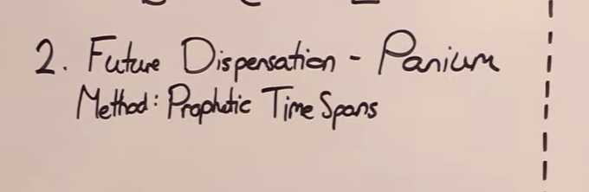
And he believed we could do that because the fact he'd accepted November 9 was seen as the passing of the Sunday law test. As if that itself, the date itself was the test. And what methodology did he use to do that? He used the same methodology that had been used to create November 9th. He used prophetic time spans.

So for the Midnight Cry message, what we were able to do is use some of these prophetic time spans. For example the 151. 1868 first presidential impeachment - 151 years - 2019 third presidential impeachment. We were able to use the 220. 1799 - An opening up of the understanding of the language of the King of the South - 220 - 2019. An opening up of understanding of the nature of the king of the south. State over Church equality. 490. Going back to the restraint of Islam at the Siege of Vienna, 2019 the restraint of Islam - the overthrow of the Isis caliphate the - death of Baghdadi. We used prophetic time spans to build up our understanding of the close of probation. November 9th 2019, the year of 2019 itself. What Elder Jeff did was he took us not to our shut door but to the test of a future dispensation. And he saw fit when doing that in his own mind to use the same methodology that he had seen me present in Arkansas. But he used, if I can put it this way, a perversion of that methodology. He did not use that methodology correctly. He took it, attempted to repeat it and in repeating it he twisted it / broke it. He started seeing the 151 years and cutting them up into years with half years, cutting up the 81 years. Going back into China, seeing things happen In China, started saying that slavery would return with a three-fold union at Panium. That the Adventist Church was about to go into a league with the dragon, the beast and the false prophet. All of these strange arguments he built up with a perverted use of the Midnight Cry methodology.

I wanted to be absolutely clear with what I'm saying. He made two mistakes. First of all, he tried to direct us to the test of a future dispensation. You can't do that. God is opening up the test of the current dispensation. Elder Jeff at that point in time, many people were with him, and were failing the Midnight Cry message. God is not about to give them increased light on the Second Advent when people were about to fail the close of probation. Understanding the Second Advent is of no use to them. So first mistake, directing people to a future dispensation. Elder Parminder and I had already taught you can’t do that. The second mistake he made was using prophetic time spans incorrectly, a perversion of the Midnight Cry methodology, and people who did not understand the methodology of parable teaching were deceived by that attempt. So Elder Parminder and I again responded both privately and publicly. We responded with studies about how God opens up light. He opens light that is suitable for the dispensation that we were in, and privately we tried to explain to those teaching this false message how that methodology was being misused.

That went quiet. People went quiet about Panium. So first attack, multiple people independently to each other seen as evidence of the working of the Holy Spirit. It’s going to redefine the Midnight Cry message. Second attack, direct people to a future dispensation, distracting them from the test they are currently in using a perversion of the Midnight Cry methodology to do that. Third attack, when we responded publicly to Elder Jeff on attack one and attack two, towards around the time of March, he responded with the third. The third attack was another camp meeting in Arkansas where he presented the message of half right - half wrong.

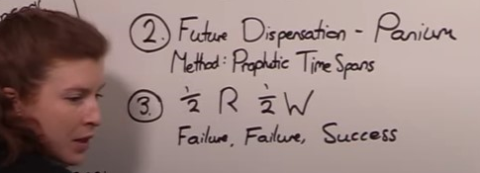

He said Miller - Half right half wrong. Snow - Half right half wrong. Butler - Half right half wrong. Wagonner - Half right half wrong. Now we felt the need to be much more open about the fact that we disagreed with what Elder Jeff was doing. We felt the need for people to be aware that what he was teaching was, deliberately or not, a direct attack on the Midnight Cry message, and if followed would cause people to fail the Sunday Law test. So I responded much more clearly in Guadalupe last year with a study of failure, 3 histories, failure, failure, success. You can’t take Snow and Waggonner and apply it to Elder Parminder. The same way you can’t take the failure in Egypt, and the failure in Babylon to say Christ fails in this history. It’s complete and total success.

So this was done in a way that now began to name Elder Jeff, where people knew who we were talking about when we were responding to these sequential attacks on the integrity of the Midnight Cry message. All of these 3 attacks happened between October of 2018 and March of 2019. After the subject of half right and half wrong, Elder Jeff then went silent. So what we experienced after this was silence. In this silence, another concern began to develop.

Once I had publicly stated in Guadalupe that Elder Jeff was wrong in his application of Millerite and 1888 history, Elder Jeff was quite open and frank in saying he was now going to be quiet. He wasn’t going to teach anymore. And in that silence, Elder Parminder and myself began to face different accusations. The attacks began. This isn’t a prophetic difference. This isn’t about the Midnight Cry message. All of this is happening because you Tess and you Elder Parminder are just not nice. Then it became a moral issue. People said, how can you disrespect this elderly man God raised up to be John the Baptist, to be the first angel. You are not showing him proper respect. You people just aren’t nice. You’re not being reasonable. You are not allowing other people to come in and contribute to the Midnight Cry message. What’s so bad about incorporating Theodore into this Midnight Cry message? What is so wrong about different people coming in with their own perspectives and building upon the Midnight Cry message? We were seen as being in the words of one leader who spoke to me, overly protective of the Midnight Cry message. He said that I was overly protective, and in my protectionism, I was not suitably allowing him to add to that message.

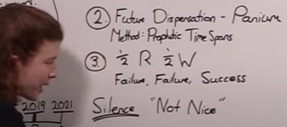
Behind all of this was increasingly personal attacks. And the thought was presented to many people, that this growing rift that people could now see, would not happen if Elder Parminder and myself just met with Elder Jeff, if we were just nicer to him, if we just let him teach his perspective, if we gave some credence to his views. I hope that everyone still in the movement can see that we could not do this. Was this an issue about whether or not we were nice? No. The only reason that people were called not nice was because we were not tolerating the misuse of the Midnight Cry message. We were defending the message God gave to this movement. People who could not see the prophetic fulfillment started to make this personal. This was a dangerous deception. It started to close people’s minds to seeing the prophetic steps of what was taking place. The people that made it personal because they felt sorry for Elder Jeff, they felt sorry for those who were following him and were not prepared for the split and the shaking. It poisoned the minds of the people.

And I want to repeat myself, I was open to speaking to Elder Jeff but where I am not wanted I do not push. If I know that people don’t want to speak to me about their questions and their problems, I do not push myself on them, but if it’s going to be something that is public, that's going to endanger other souls, then it requires a prophetic response as was given in Guadalupe.

Silence, allegations of personal mistreatment, people being blinded to the prophetic nature
of the rift that was developing. Silence up until September. And now it's open rebellion,
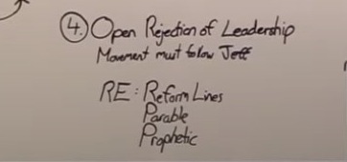
open rejection of the leadership of the movement. I'll write rejection. Open rejection of leadership. Did Elder Jeff ever claim to leave this movement? No. He said that Elder Palminder and myself had led this movement astray and people must follow him instead of us. What he saw was that he did not leave this movement. All he said is I am going to force this movement to follow, to turn from the trajectory it was under Elder Parminder and myself. He was going to force it to turn around and follow his direction, his definition of the nature of the kingdom.

We saw this coming. We saw that his position was being made more public. That he was about to engage in an open attack and so we responded first at the German conference not with conspiracy theories, not with saying Elder Jeff is not a nice person, not with private lies, not with twisting private emails and private conversations, not with calling him a Jesuit, not with saying he's not a nice person but with prophetic explanations with the omega of ancient Israel. He says the movement must follow him and we respond with reform lines, with parable methodology, with prophetic explanations, not personal accusations. This was the Gethsemane experience. it was not a fight between two groups of people where they just couldn't get along or couldn't be nice to each other.

What happened to this movement was that a prophetic message came and it did the work of the everlasting gospel. It divided two classes of people. Two definitions of the nature of the kingdom of God. This was the experience of Gethsemane. The pain that many people in this movement experienced as they saw a division from people that they loved.

Now I want to speak about the wilderness. We've laid out four steps that were taken. The first, the Midnight Cry message is multiple people independently to each other worldwide being led by the power of the Holy Spirit to come together and add select parts to this Midnight Cry message and he focused on a message from Africa, from messages from Theodore and from what I had presented based on Acts 27 and he combined them all. What he did was water down and cut up the Midnight Cry message because he was, because it conflicted with his worldview. This all happened in the first few months. Now it wasn't just Elder Jeff that was doing this. This was Elder Jeff and also those that followed him and also those that had imbibed his methodology and had not been able to learn the parable methodology of the second angel.

Sometime around when this attack was still being made a brother went to Brazil and what did he present? He presented supposedly in his view the Midnight Cry message. The Midnight Cry message centers around Donald Trump as being what person in history? Hitler. Trump is Hitler. Who is Stalin? Putin. So you have Hitler as Trump. Stalin as Putin. You have the Republican Party in all of its prophetic wickedness and you have the king of the south Russia under Vladimir Putin. We explain 2014, 2016 election and where does Hillary Clinton fit into all of that. Just where Barack Obama does. She becomes in world war II France, Britain. Those forces that were fighting against Nazism Fascism. What did brother T present in Brazil? Hitler is Trump. Stalin is Cinton. What had he done to the Midnight Cry message? He'd taken it, supposedly taught the same message but twisted it to fit his own world view.

So when I responded in Brazil to Elder Jeff's attacks on the Midnight Cry Message I also responded to brother T and I called him out by name and why did I do that? Because he needed to wake up to the danger that he was in. When you take the Midnight Cry Message and you try and break it and mold it to fit your personal worldview, you damage the message and I think that today perhaps more than in February of last year you can see the danger, the error of labor labeling Hillary Clinton as communist as the application of Stalin. There is no prophetic line, no prophetic pretext to make Hillary Clinton Stalin. I tried to warn my brother against handling the message in that kind of way. When that went silent because the prophetic logic was too strong, he couldn't respond so he changed tactics. Just distract them from the Midnight Cry Message, use a perverted form of the methodology, and use prophetic time spans to distract people to the test of a future dispensation. We responded to that publicly and privately.

When they had to go quiet about Panium because the prophetic explanation was too strong he launched the third attack: half right half wrong. Histories of failure and success was our response in Guadeloupe. Then came silence and the accusations that this movement is just not tolerant, that we're just not kind, to, not respectful. That there could be unity if only people would be nice to one another. Then came the fourth attack, open rejection of leadership, the movement must follow Elder Jeff, and we say we did not leave him; he left this movement. We responded to that not with personal accusations but with reform lines, parable teaching and prophecy. That was Gethsemane. As you compare and contrast Christ's experience in both histories, so you can compare and contrast the experience of this movement in both histories.

Soon after November 9, a second rebellion began and it followed as you would expect
the exact same model. This one was quieter. It was handled more on social media on WhatsApp groups in private conversations. No one had the platform and the influence of Elder Jeff. So there was no Elder Jeff on a platform showing publicly this growing division. This one began more quietly, more on social media, more through sowing the seeds of doubt than through public camp meeting presentations, but it had the exact same if not worse effect.

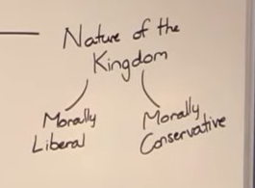
And we came to another conflict about the nature of the kingdom and now it wasn't about socially conservative and socially moral. What some people started to do in the late months of last year is take the Midnight Cry message, and they were going to investigate, build upon it. I was concerned very early on with the way that they were approaching this subject. What they did is they took the word Conservativism. What does conservatism mean? It means to conserve and what they started to see is that there were still things that this movement was conserving and if we are not to be conservative why are we conserving all of these other things? So there began to be this from late last year. This further second split occurred through the movement. It’s still about conservatism and liberalism. It's still about correctly defining conservatism and liberalism, correctly defining the nature of the kingdom, but it's particularly about reforms and I just summarize it simply by saying morally liberal, morally conservative. All I mean when I say moral is not to say this isn't prophetic, but its reforms, all of the other elements of what this movement teaches.

Some in the movement began to focus their message on developing study after study after study against conservatism and as they did that they redefined conservativism from what
the Midnight Cry message had used that term to mean. So with twisting the issues the Midnight Cry message was meant to shine a torchlight on from social issues towards the reforms. They began a train of thought that led them to believe that this movement is conserving things that it still should discard but won't discard and this is evidence of our failure to learn the lessons of freedom. These thoughts being sewed on social media quickly began to reap a harvest. Those who followed in their steps started to see all of these vast arrays of things that this movement conserves. We are conserving the Sabbath, we are conserving the charts, we are conserving baptism, we are conserving our position on going to the theater, ongoing to watch movies, in listening to rock music, in our positions on dress reform and jewelry and we were seen as, that the term conservative was taken from its context in the Midnight Cry message which shone a light on social issues and was transformed to mean any type of conservation.

And why did they believe that this message on social, on moral liberalism was led by God? The very first logic they used to defend that their understanding of the same Midnight Cry message was led by God was to say that there were multiple people working independently to each other. This independence was not real. This is happening under the encouragement of Elder Jeff.

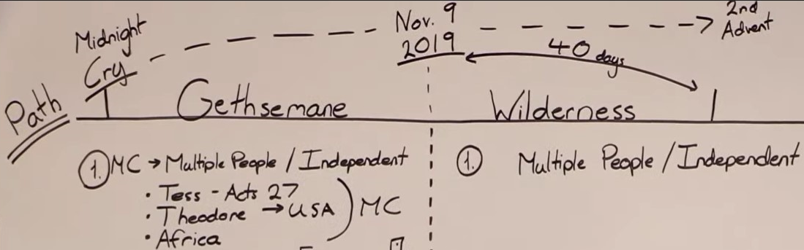

Even if he's only seeing the later development of those studies by Theodore or what was done in some parts of Africa, this was done using his methodology with his approval.

It was not entirely independent nor is it here. Multiple people supposedly independently
throughout the movement, but because of what is the doubts and questions being sown
through social media were coming to similar conclusions about the nature of conservatism
and liberalism, and it was said if we properly want to understand what equality means,
we have to take the message that Tess gave that was equality, we have to combine it with all of these other studies coming from multiple people independent, and this is being called the leading of the Holy Spirit purely because it's multiple people, and again it was a train of thought that was centered in the USA particularly by a brother and sister in Arkansas, and again there were some select portions a few people in Africa that had come up with similar thoughts,
particularly through what is being shared on WhatsApp forums and how those thoughts developed. This is being seen as evidence of the working of the Holy Spirit, that the message of the Midnight Cry can be molded, reformed by combining it with brother Theodore’s and by some studies that came out of Africa, there is the belief that the Midnight Cry message of equality can be reformed, redefined by combining it with messages and thoughts coming out of Arkansas, the United States and some thoughts coming out of Africa, and it's believed that this is evidence that the Holy Spirit is working, and only when you have this redefining of conservatism and liberalism. Can the message of the Midnight Cry still shining be truly understood? Because if we are conserving, if we are still conservative, if this movement is so intolerant, if this movement doesn't

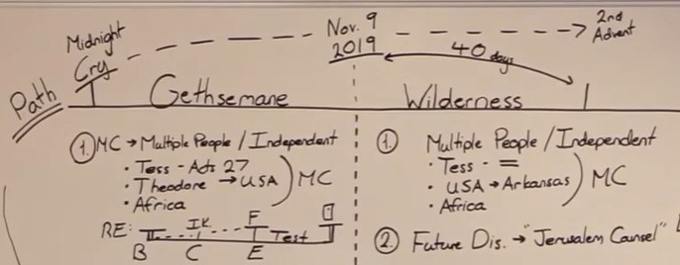

understand freedom then what's the problem?

We need to combine it with those who claim that they do. This is not evidence of the working of the Holy Spirit. This is not evidence of the working of the Holy Spirit. If anything its evidence on the danger of social media platforms. We see that externally we see that internally. Elder Parminder and myself did not see that these arguments that they were making were prophetically sound no more than we saw the arguments of Elder Jeff. When we refused to acknowledge their claims on this point a second attack was made. Again, I used attack because it's a prophetic subject, because this is the wilderness experience, not because it was people's intention. When we fail to listen to this argument that this is evidence of the working of the Holy Spirit, to correctly understand the Midnight Cry, a couple of people in this movement who led out in this effort then led out in a study. They wrote together a study on the Jerusalem Council.

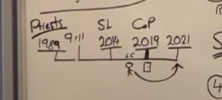
Elder Jeff took people to a future dispensation. This was a study on the Jerusalem Council. In the book of Acts, Question: on a reform line where are we? In the history of the Midnight Cry prior to the shut door, we’re in the history of the Sunday Law. Elder Jeff could not take us to Panium to a future test. But the second argument they make against the position of this movement is the following: This is the line of the priests.

I want to take us to the line of 144,000.
Where are we on the line of the hundred
and forty four thousand? 1989, 911, Sunday Law, close of probation, Second Advent. Again, in every dispensation there is a Boston, Concord and Exeter. We are here. We are between Raphia and Panium and what does this study do? It takes you from the test of your current dispensation, not just the dispensation of the priests, Jacob's time of trouble. It takes you from the early reign of
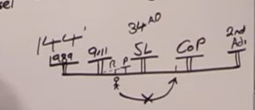
the 144,000 to the Jerusalem council which on a line is where? If Sunday Law is 34 A.D., where does it take you? You can't do that. You can't do it here.

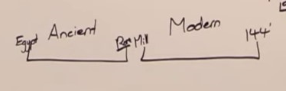
You can't do it here. Depending on which reform line you view, it's taking you one or two dispensations in the future to the prophetic test of a future dispensation. They repeated the same mistake Elder Jeff made and again there was in this one mistake, they made two errors. The first is taking and building a study based on a future dispensation. Elder Jeff built a study based on a future dispensation. Second mistake: the claims made. If this is ancient Israel. I'll put it in the middle and then erase it for time for space, sorry. If this is ancient Israel, if this is modern Israel, this is the Millerites, this is the 144,000. This is the time when they're in Egypt. This is the time they're in Rome. So with the Jerusalem council.

What problem are they facing? God instituted things here for the Jewish nation and what are the Jews trying to do over here? They've gone to the Gentiles and they're trying to give to the Gentiles the Mosaic Law, the laws and instructions given by God through Moses of how the nation of Israel should operate. So what was given in that experience after they left Egypt, those traditions and instructions of Moses. The Jews down in this time period at the end of ancient Israel were trying to force these views upon the Gentiles, so when you come to modern Israel, the study of the Jerusalem council is making the following argument: All of these things, all of these conservative ideas, all of these things that this movement is conserving, we are making a mistake in practicing them ourselves, and we will make a mistake when we try to force these views upon the world come Sunday Law. We need to discard them now and what type of thoughts are being shared through social media, through private conversations about what this movement conserves?

Diet reform, baptism, jewelry, the Sabbath, the charts. Elder Jeff made two mistakes in that attack. First mistake, he tried to explain the test of a dispensation we were not even in.
First mistake they try to explain the test of a dispensation we are not even in. Second mistake, what methodology does he use to do that? Prophetic time spans? Does he use that methodology correctly? No. He uses a perverted form of the Midnight Cry methodology.

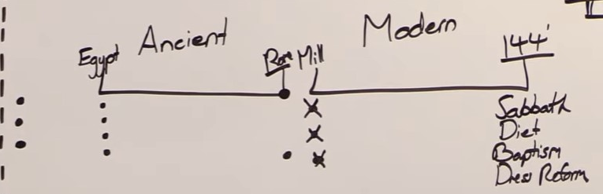

Problem: If you're going to say that this is things such as the Sabbath, the way we keep the Sabbath, if it's things such as diet, if it's baptism, if it's dress reform, when was the Sabbath given to God's people? Here, not here. When was diet reform given to God's people? Eden. It began to be through six thousand years reinstituted. When was baptism given to God's people? Here. When have God's people always been expected to dress differently to keep a different standard? God dressed Adam and Eve. They weren't allowed to dress themselves.

So the methodology itself, Elder Jeff went to prophetic time spans. He twisted that methodology and made serious mistakes. This study tries to use dispensationalism. Dispensation of rules given by Moses to the Jewish nation in their alpha history, and how that applies when they're in their omega. None of these moral reforms were given to the Millerites in our alpha history. These things are long-term permanent expectations that God has placed upon his people.

When it comes to trousers they are not a subject of freedom or dressing how we like or trying to fit in more with the world. That is a subject that has entirely to do with equality. So to repeat myself: Two mistakes: In the second attack on the midnight cry message.

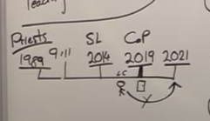
Take it to a future dispensation and try to unlock it,

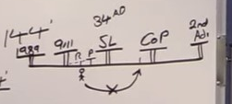
take it to a future dispensation and try to unlock it.

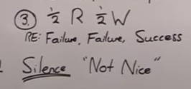

Use prophetic time spans in a perverted fashion.

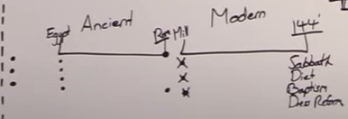

Use dispensationalism in a perverted fashion.

By this point in time Elder Parminder and myself were in Uganda. We saw the danger of what was happening more and more visibly, more and more clearly. So we responded. We responded with the opening up of an explanation of the wilderness time period. How Christ faced two temptations that on our reform lines can be placed back to back. Two tests about how people are going to handle the Midnight Cry message that they were given.

So in Uganda I began to publicly reject this type of understanding of liberalism. This false liberalism, this false equality, this false freedom. When I did that, a brother from Zimbabwe responded by sowing what seed on social media? What response came? He made the argument that of course Tess does not accept this opening up of the Holy Spirit of liberalism and conservatism. Of course Tess doesn't understand the nature of the kingdom. Because Elder Jeff is the first angel he says and he was half right and half wrong. Then you have Elder Parminder. And then have Elder Tess and what was the argument that he made?

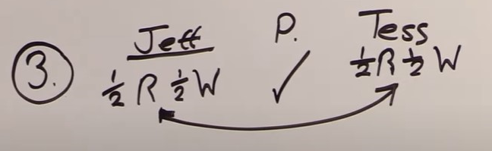

Let's do a chiasm. Elder Jeff is half right and half wrong, so Elder Tess must be half right and half wrong. Elder Jeff couldn't understand the Midnight Cry Message, so Elder Tess
can't understand the Midnight Cry message. And he's making through that chiasm, he's forced to whether he says it or not forced to make the application. Does Elder Parminder understand the nature of the kingdom? This is a real chiasm. If you want a pattern, Elder Parminder has to understand the nature of the kingdom.

So when I started to publicly reject the message they were creating, this was the response to the studies in Uganda. Of course Tess won't agree with us. She's half right and she's half wrong.

The problem they have, separate to failure, failure success, the problem that they have is that Elder Parminder and myself have the exact same views on the nature of the kingdom so the math’s don't add up. Either Elder Parmnder and myself are both right or we're both wrong but you can't say he's right and I'm wrong because we have the same views. We have the same position and if we do that we break his chiasm. So Elder Jeff, when I rejected his study we rejected his study on Panium. His next attack was half right and half wrong. When I rejected the study on the Jerusalem Council, the next attack is she's half right and she's half wrong.

I didn't respond in great detail to this. I warned the brother directly once he contacted me
of what he was doing and he saw that as a personal attack, unfortunately, instead of a warning to try and save him from the path he was on. One of the reasons that it has been difficult to respond to the steps that these brothers and sisters have taken is not because Elder Parmnder and myself don't have a response. But it's because we've already given it. We already responded last year. We responded with Boston, Concord, and Exeter. With an understanding of the opening up of light in a current dispensation, with trying to re-teach how prophetic time spans are supposed to be used, with understanding failure, failure success, all of the evidence to show that this position that some brothers and sisters in the movement have gone down
is 100 percent error. it is not the work of God. It is a secondary attack on the clear message of the Midnight Cry.
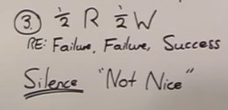
So after this came silence, comparative silence, at least as much as people were willing or open to speak to myself. But now the attacks began similarly to how they did here.

The attacks that began were not primarily directed at myself. People were not. I don't know what gets said on social media. Some have said it, but primarily the attack was not directly at myself. It wasn't me that was being said she's not nice.

Much, I know it has happened somewhat. Back here the supporters of Elder Jeff, what do they say? We're not nice. Why? The only thing that we did to Elder Jeff was disagree with his proof with the stand that he had taken on the Midnight Cry message. That's the only thing that we did to Elder Jeff, but because of that is it's seen as disrespectful, as not nice.
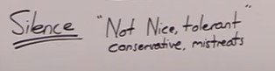
So after Uganda, the accusations begin to come thicker and faster that this movement is not nice, not tolerant, that it's conservative, that it mistreats people, and the accusation wasn't leveled particularly at Elder Parminder and myself but at their own local fellowship in Arkansas, and it has been poisoning the minds of people worldwide on a fellowship in this movement, as well as other issues in other areas but particularly set and centered in Arkansas itself.

They say there's a conservative culture in this movement. I agree. There's a conservative culture that conserves the Sabbath that conserves baptism that conserves reforms. You only have to look at the vows of baptism this movement has to know that we conserve things. We conserve the charts. That's why they're displayed. We conserve our understanding of the 2300 of Millerite history.

This is not an argument about whether or not a sister in this movement can wear earrings. It's been represented as such because when it's represented as such it looks like someone trying to practice their freedom and the leadership of this movement both local and worldwide, local national and worldwide are intolerant because we simply don't agree with Elder Jeff. All we did is not agree with him.

Now these attacks of mistreatment have absolutely no foundation. All they are is a response to a group of people, to a group of leadership that say we do not accept, we do not agree with the nature of the kingdom that you are trying to represent through studies that are supposedly coming worldwide, supposedly led by the Holy Spirit that are being evidenced in a study of the Jerusalem Council that are being defended by an understanding of half right and half wrong and the leadership of the movement today. These accusations that there is a conservative unkind intolerant culture in this movement are completely unfounded.

I didn't go to South Sudan and not witness sexism and not say that there weren't changes that need to be made. I see that in every country I go to but to suggest there is this culture coming from the message itself, coming from the leadership themselves that is intolerant, is completely and utterly unfounded. It is a repeat of the same issue that we experienced in the last dispensation where people had their minds poisoned, where they could not see the prophetic events that were transpiring, the prophetic shaking that we were entering into where they believed if Elder Parminder and myself and those who believed as we did were just nice enough, this split would not take place. It was not true for Gethsemane. It is not true for the wilderness. We faced those accusations. All we do, all we have done is simply not agree.

After a period of silence we are already in step number four and that is why I am publicly presenting this video. When we reached step number four in Gethsemane it became
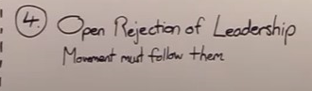
necessary that people identified what was occurring in the movement, and it becomes necessary now that people have that visibility. This is open rejection of leadership. This is saying if we truly have freedom, we do not have organization, we do not have leadership. Different factions following this same definition of the nature of the kingdom have taken this to different extents in different areas.

A former bible worker from Kenya, brother R, he has taken this to the ultimate extreme, he and those who have associated with him. And they are pushing this thought publicly through Africa and as they influence worldwide. Others in different areas would perhaps not say it so bluntly but the exact same sentiments are there: A rejection of organization and leadership of this movement. Do they say that they leave this movement? No. Did Elder Jeff say that he was leaving this movement? No. What they're doing is saying that this movement is following the wrong leadership, that Elder Parminder and myself had led this movement astray, and that we needed to turn and follow him. We needed to turn and follow them because the current leadership has led it astray. They are not saying that they're leaving this movement. People who have had their minds poisoned by these errors have, and I still hold out hope for them.

We have addressed this shaking in three specific ways through this time period. We've tried to go back and explain what this Midnight Cry message was.
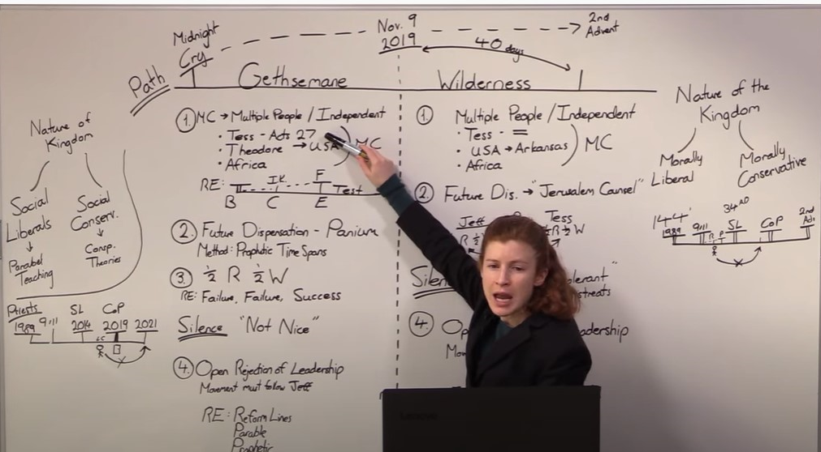

It stood firm through this shaking. We’re a history of success. It stood firm through this shaking. We’re a history of success. It will stand firm through this one. But for the sake of those wavering we have tried to explain more clearly what the Midnight Cry message is designed to teach. The Midnight Cry message teaches how people should be treated regardless of whether they are male or female, whether they are an immigrant or a refugee or a white long-term male citizen of the United States. That all have the same inherent value. All deserve respect. This is what divides Republicans from Democrats. Republicans and Democrats do not keep Sabbath and Sunday, do not have a difference in the days of worship or in how they keep the Sabbath. Republicans and Democrats do not disagree on baptism. They don't disagree on makeup. They don't disagree on jewelry. They don't disagree on the twenty three hundred days. This is not what divides a Republican from a Democrat. What divides a Republican from a Democrat is understanding the inherent value of a human being. This is the equality that this movement Is raised up to represent.
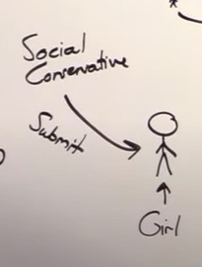
If you're a young girl in this movement, let's say you're 14, 12, 13, 14, or 15. Let's say you're not in this movement. Let's say you're just in the world. You're just someone in the world and you are going through those early teen years. Everyone knows they're difficult. What attacks happen on a young girl in her early teens to destroy her confidence, her understanding of her own value? I’m not going to draw a dress so you're just going to have to understand. This is a girl. She's in trousers. What happens to her to destroy her confidence? Two different attacks can come. One is social conservatism. This attacks her. This says your role in life is to get married and have babies. Your value is attached to how many babies you can give the motherland, you can give god's church. It's all about her ability to reproduce. Her value is based upon whether or not she can cook nice food for her family because she must have a family. She's told that she must marry, have children and submit. Submit both in an organizational sense in her role in god's church and submit in her home life to her husband. So this is submission.

Those things come upon a young girl and can destroy, do destroy their confidence and their value. I'm not making this even Adventism; you can make this, you can see this outside of religion. There's plenty of atheists who believe that women have evolved to fit that job function and they are best in that job function. Plenty of atheists believe that this is an attack that can be outside of religion itself. What second attack comes against a young girl? Its value in appearance. This is Hollywood. The whole world knows that. This is why they take down advertising campaigns. When they start trying to objectify young girls, when they start showing young girls pictures of fashion models who are skinny, when they start seeing movie stars who are skin and bones, when they start seeing popular pop stars, female pop stars almost naked, in front of 12 year olds dancing. The whole world recognizes externally that this focusing on the value in appearance of a young girl destroys their self-confidence because they start to see that society values them based on the way that they look. Hollywood, someone inside Hollywood recently said Hollywood is fake liberal. It is so deeply conservative. You see that just in the roles they give people. You see that when you see the popular movies. The way that they represent women, the way, the way older women in their 40s can't get certain roles in Hollywood. You see that when the time comes around for their award ceremonies and black actors say we're boycotting, we're not going because we are not treated with equality in this industry.
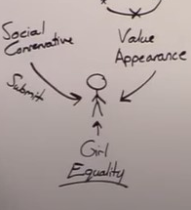
Whether it's the music industry, whether it's the television and movie industry. Those industries objectify women by turning their idea of value into a direction that causes them to focus or see value in their appearance. Both of these are attacks on what is true equality, and many people in those industries recognize it. However many of us are aware of Taylor Swift, she said recently the way that she has to expose herself, her body, her personal life, the way she has to reinvent herself every six months to stay relevant to keep people's attention to where she can be successful in her industry is so degrading as a woman, and no male in that industry has to do that. She sees the sexism in her own industry. This isn't something that some conservative Adventist is saying.

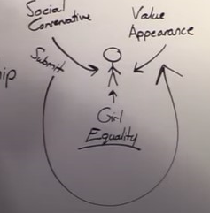
They see it themselves and when I go to Uganda and I greet a sister there and she greets me in what is traditional in her area, which is to fall on her knees look at the ground and extend her arm to me because she cannot look me in the eye, she cannot stand before me. The equality I want to see represented is not to start telling her to start thinking about the freedom she can have now to wear earrings and makeup and listen to rock music. The deliverance that they were given was that she has inherent value in who she is as a human being, in her ability to lead, to teach, in her ability to stand as her husband's equal, in her ability to be an Elder of the movement. Paminder and I when we were there and the sisters did that, we got on our knees with them and we said we will sit when you sit. We will stand when you stand because that's the equality that they needed to see.

This taking them from this, to this will not give them freedom. It will not free them from that slavery and all you have to do is look to a liberal, liberally grown up 14 year old girl following Hollywood and movie stars and that whole worldly image to understand how it destroys them. So we said before, the world can recognize the dangers of social conservatism and turn from it. The world can also understand the dangers of this form of liberalism, however badly they do both, but either issue can only be truly understood through the movement.

So we responded to these, this four-step attack as explaining the true intent of the Midnight Cry message, the true use of the terms liberalism and conservatism. We responded to it by going back to the line of the Nethanims showing how this movement takes over leadership. They learn from us, we don't learn from them. We don't take that stone and make it bread. We don't throw ourselves at the stones and come away unhurt. Most importantly we used this parable methodology to understand the experience we were currently both going through.

What I want us to see is that this is one test. It's one test from beginning through the end. It's the test of the Midnight Cry, but it comes under two distinct attacks, and in either history people accept or reject the Midnight Cry message. Both rejections of the Midnight Cry message follow the same pattern, follow the same structure. They use the same methodology and it is not the methodology of the Midnight Cry. From 2014 we need to remember that Elder Jeff was not the leader of this movement. His methodology like John the Baptist was not fit for purpose in that dispensation. Those who designed and followed this false message used Elder Jeff's methodology. They were not able to unlearn it. They were not able to follow the second messenger, the second angel and parable teaching. That's the danger they found themselves in. There are many more comparisons and contrasts. I want to make a couple more.

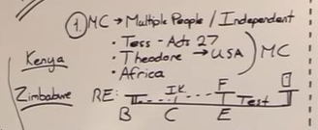
As soon as I presented this message Africa itself was divided. Now I don't want to make this about two countries in some type of whole comprehensive fashion. There are many bible workers in Zimbabwe who have my complete support, my complete affection, trust and support, particularly the sisters there who are doing a wonderful work. There is also a brother in Kenya who has played a major part in developing this fanaticism and this attack on the Midnight Cry message. So I understand that there are people in different countries both in Zimbabwe and in Kenya who have in Zimbabwe supporting the Midnight Cry and in Kenya attacking it in this fashion, but I also want to identify another prophetic parallel. Back in this history, particularly the early days there was a divide between two African countries, Kenya and Zimbabwe. Kenya overall followed the Midnight Cry message, particularly because they had a school there December 2018 and the bible workers became strong in the Midnight Cry
message. They were united, they saw the truth of it and they were ready to defend it, and they did defend it, and there's a faction inside Zimbabwe, and what does Zimbabwe say? We're going with Elder Jeff's model. Kenya says we're going with Elder Parminder and Elder Tess's model.

This is the midnight cry. Zimbabwe says we're going after Elder Jeff's model. It's a combination of then but not only is it then we're going to continue to develop and add to that message
using Elder Jeff's methodology. Kenya says you can't. Zimbabwe says you're bigots of the
leadership. Again I'm being general. There's some people here who have my utter respect
and support but this model still fitted. What happened down here? What happens when you have, again Kenya other than our ex-bible worker who has removed himself from the Midnight Cry message, rejected it. Kenya says we're rejecting this false liberalism. There are elements inside Zimbabwe and what is their response? You're following Elder Tess and Elder Parminder. That's bigotry. You're following man. We want to do this, nationally we want to do this as a country. We want to have our own studies, our own independence, our own contribution. The exact same thing occurred here (Kenya) and anyone in Kenya or Zimbabwe who are shown to support the understanding of the nature of the kingdom given by the Midnight Cry message. What was the word used? Bigots.

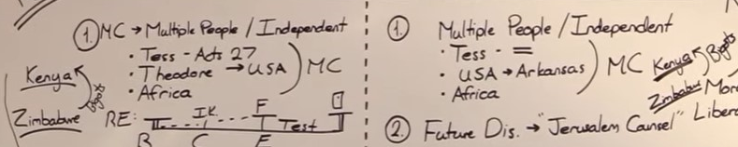
We need to have our alarm bells, when we see such language used because it is a repeating pattern. It was an issue here and it's an issue now. Why is it an issue in both? Because they're the same test. It's the same in many ways.
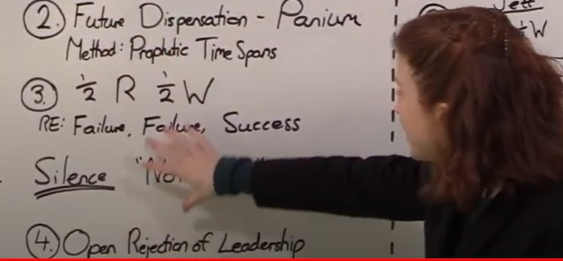
When I faced this fight, when people were attacking the Midnight Cry message in this history,

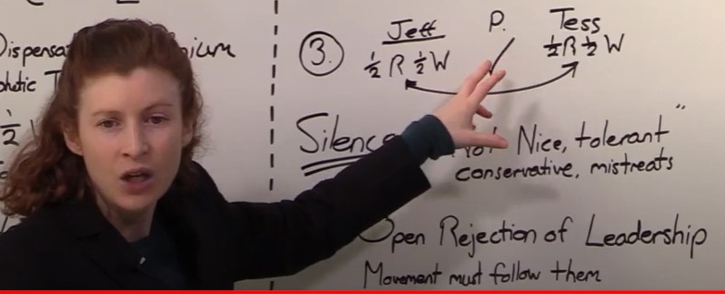

they are in many ways the same people attacking the Midnight Cry message in this history. While they might have sided with us in September of last year they didn't do so because they understood either the prophetic understanding of the Midnight Cry message and or they didn't understand the test of leadership. I can't put in a presentation just how complete the compare and contrast is.

When I stand in Brazil and say brother T from Arkansas do not take the Midnight Cry message and twist it using Jeff's methodology to fit your own world view.

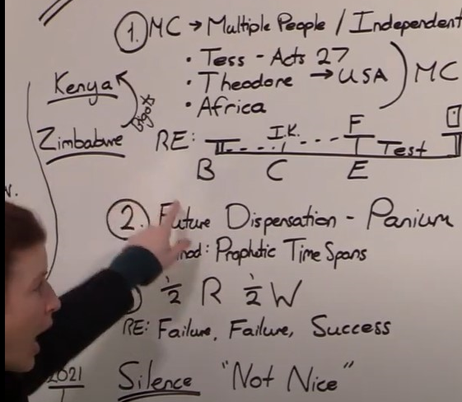

When I have to do that here,

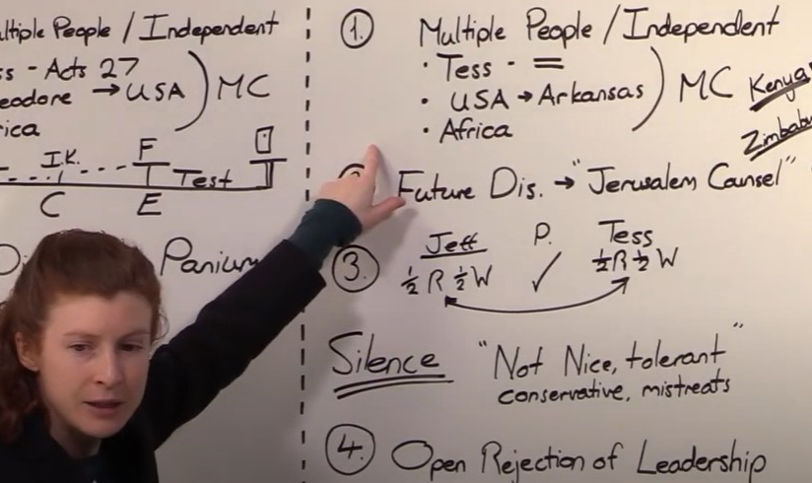

I have to do that here.

It's the same test that was not passed. The people that failed to understand and accept the Midnight Cry message now over this issue never passed this test either. It's one test. It's one Midnight Cry message, its one test to accept or reject it. It's one test of leadership. We might have a short break and then we will continue if that's okay. So I'm going to close in prayer and we probably have about another 45 minutes to go. If you'll kneel with me.

Dear Father in heaven, thank you for our blessings. Lord you have held this movement sound
through many attacks. You have through all of the different issues that have come in. Through all the attacks of Satan your truth has not stopped shining. It is a light that cannot be extinguished. But Lord, we see people having their minds poisoned. We see people being deceived. We see people leaving this movement, rejecting leadership, rejecting the Midnight Cry in two steps but failing the same test and we do not wish to see them lost. We did not wish to see Elder Jeff leave the movement. We don't wish to see anyone leave today, but we cannot compromise the truth. To compromise the truth lord it would be to lose the fight for the destiny of the whole of the human race. We do not have that freedom. I pray for all watching Lord, that they will hold onto those chords that you have laid out so clearly what the truth is. Not just in the last dispensation but in the one we are currently in. I pray this in Jesus name amen

