Overview of what was covered previously:
Previously, Ancient and Modern Israel have been compared. Key points:
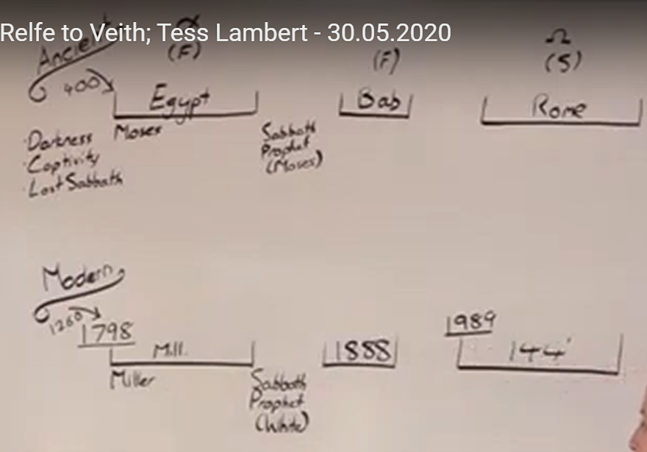
Ancient Israel | Modern Israel
End of 400-year prophecy | End of 1260 y prophecy
During the darkness and captivity Sabbath truth lost | During the darkness and captivity Sabbath truth lost
God raised up a deliverer – Moses. He is going to draw out the people out of the pagan nations that surround them. | God raised up a deliverer – William Miller who is going to draw out a people out of apostate Protestantism.
Sabbath reintroduced. | Sabbath reintroduced.
Prophet that they looked at was Moses, books of the decalogue. | We looked at Ellen White, she is the prophet for Adventism.
The same person who drew God’s people out wrote the books | Distinction between Miller who draws out God’s people and White who writes the books.
In Alpha history people fail to be fit to do the work. The work should have been completed quickly. They could have conquered the Canaan quickly and get fit soon after entering the Canaan. But they continued to go into apostasy (Idolatry). Held onto parts of Egypt. | Same thing for Millerites. They should have been preparing the way for the 2nd advent and find it completed in the 1860s history (a quote from 1868 made it clear). They didn’t, because they were not fit to do that work. They had also held onto tenets of Protestantism, which is the Laodicean condition. It is the protestant idea of millennium that they held onto – to make oneself comfortable here on Earth, because we don’t know when Christ will come back, we know that it will be far in the future.

The Adventists in the 1850s history held onto the same ideas of millennium as did Protestantism: since it took so long from the 1st Advent to the 1798 they did not expect His coming to be that soon. So, it is the same mindset of making oneself comfortable here on Earth, cause we don’t know how long it will be till Christ returns. This was the Laodicean condition, it was failure in both cases.
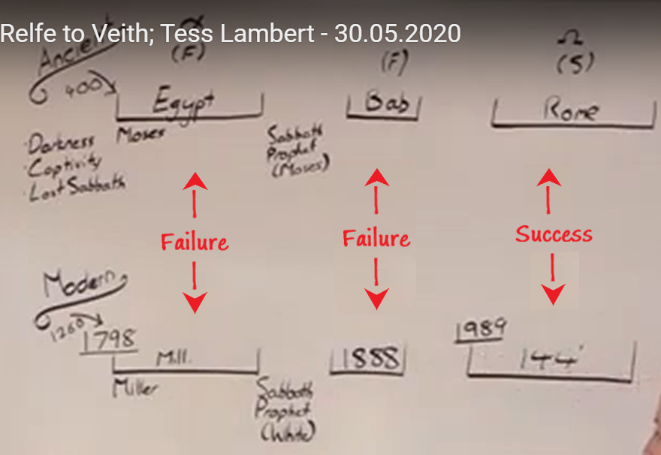
Previously, we described how the idolatry of Ancient Israel is the idolatry of Egypt – the Apis bull, as it relates to the king, characteristics of the king. That is what they wanted in their God and also in their visible leadership. When They asked for a king, they were given Saul. Saul has all the characteristics of this Apis bull: he is tall, respectable, powerful, he can lead them in battle. They desired the characteristics of Saul. This Apis bull, they were not saying that they were bowing before another God, they were saying this is the characteristics of our true God, Jehovah. That is how they justified their idolatry. They have taken Jehovah, the true God and ascribed to Him the characteristics of the pagan deity. And when they are bowing before this golden calf, they are saying they are worshipping Jehovah, but these are His characteristics and they want to be able to see Him.
When they come out of the Babylon, they let go of the image, they no longer need to see Him, but they hold on to their characteristics and that is the problem when the Christ comes: They are looking for the Apis bull, but when Christ comes, they are not able to recognize Him.
When Christ comes, He is going to re-educate them through parable teaching. The parable teaching is use literal to build a spiritual application. In literal, the shepherd is God and the sheep is you, so it is taking literal story, or picture, or history, or culture to make a spiritual application. That is his cure to their misunderstanding about the nature of their king.
I want to pick up a couple of thoughts from DA 211.3, DA 212.4, DA 213.2. This is where Jesus is dragged before the Sanhedrin on the charge of Sabbath breaking:
“The time, the place, the occasion, the intensity of feeling that pervaded the assembly, all combined to make the words of Jesus before the Sanhedrin the more impressive. The highest religious authorities of the nation were seeking the life of Him who declared Himself the restorer of Israel. The Lord of the Sabbath was arraigned before an earthly tribunal to answer the charge of breaking the Sabbath law. When He so fearlessly declared His mission, His judges looked upon Him with astonishment and rage; but His words were unanswerable. They could not condemn Him. He denied the right of the priests and rabbis to question Him, or to interfere with His work. They were invested with no such authority. Their claims were based upon their own pride and arrogance. He refused to plead guilty of their charges, or to be catechized by them.”
So, in this history, the Omega history, what are the pharisees holding to? – The Sabbath. That is what makes them particularly a peculiar people. In this history they don’t see themselves as having anything in common with Egypt, or Babylon, or Rome. They are the special people. The people drawn out and separated from these nations. After coming out of Babylon, they built walls between themselves and other nations. They saw themselves as peculiar covenant people, and the major part of that was that they had the Sabbath truth. The Sabbath was given to them to honor and protect. So when you come down to Omega history, is Sabbath a testing question? – No, it is not the testing question. Was there any danger of the Jews breaking the Sabbath? – No, it wasn’t the threat in this history. Egypt? – Definitely. Babylon? – There was a risk of not keeping Sabbath, but not this history, not Omega history. In fact, the person who was to prepare them to give the message to gentiles which we line up by the way with the Sunday law, has that got anything to do with the Sabbath? – No. Because of his (I assume here she is speaking about Jesus) mission, what is he charged with? – There’re three specific things that Christ is accused of the first one is Sabbath breaking – they're saying he does not honor the Sabbath.
The second one is that he is accused of dishonoring the prophet – Moses.
The third one is sedition. What is the charge of sedition? – Sedition is the accusation of making a political movement that is opposed to certain political government, being a political movement that is opposed to the government of the glorious land. I want us to be aware of these 3 accusations that come against Christ in this history, when Sabbath is not their danger, and not their test. When they go to the gentiles, does the Sabbath stop being a pre-requisite to baptism? – No. In 34 AD when they go to the gentiles, if one of these gentiles is being baptized, he is required to accept and Sabbath. There is no change in the position, but He still faces the accusation of breaking the Sabbath.
“They would receive the false teacher because he flattered their pride by sanctioning their cherished opinions and traditions. But the teaching of Christ did not coincide with their ideas. It was spiritual, and demanded the sacrifice of self; therefore, they would not receive it. They were not acquainted with God, and to them His voice through Christ was the voice of a stranger.”
Because Christ would not bring a message that agreed with their cherished opinions and traditions then they have rejected him. At the same time, they would accept a false teacher who sanctioned their cherished opinions and traditions. Because they are not acquainted with God, they cannot recognize Christ.
They don’t understand the kingdom, they have cherished opinions and traditions about the kingdom, so they cannot recognize the King. Christ says: “Had ye believed Moses,” said Jesus, “ye would have believed Me: for he wrote of Me. But if ye believe not his writings, how shall ye believe My words?” It was Christ who had spoken to Israel through Moses. If they had listened to the divine voice that spoke through their great leader, they would have recognized it in the teachings of Christ. Had they believed Moses, they would have believed Him of whom Moses wrote.”
So eve though they cherished their prophet, (they are descendants of Abraham, Moses, these are their fathers), and lift them up, it was Christ who spoke to Israel through Moses, if they had listened to the divine voice that spoke through their leader. They would have recognized the teachings of Christ. Had they believed Moses, they would have believed him of whom Moses wrote.
We have talked about it before, where in the writings of Ellen White do you find about the dangers of vaccines, and the danger of Iluminati, the danger of secret societies that are united behind every earthly government? – You don’t find them. They don’t exist. These ideas we do not find them in the writings of our prophet, just the same as the ideas of the pharisees, what they held onto, you cannot find in the writings of Moses. These are their cherished opinions and traditions. That have been accepted as a part of our faith, as if they were writings of our prophet, but they are not there. And because he does not re-enforce or sanction their cherished opinions and traditions, he is accused of dishonoring the prophet, breaking the Sabbath, and being a political movement opposed to the government of the glorious land.
I am making the direct compare and contrast, and you know this movement is being accused of being against the Sabbath, not because we don’t require it for baptism, not because we won’t insist on keeping the Sabbath, but because we don’t see it as a great test of our history, of the 144k, just as it wasn’t [the test] at the end of the Ancient Israel, it is not at the end of the modern Israel.
We are accused of dishonoring the prophet because of how we read and understand her writings, the same way Christ was accused of dishonoring Moses, and being a political movement opposed to the government of the glorious land.
They misunderstand the nature of the kingdom, therefore, they misunderstand the nature of the king, therefore, they don’t find themselves prepared for the test. The exact same history is being repeated with the Modern Israel.
1888 1687.1:
“With many there is an apparent desire to be much in prayer with God, and yet when the word comes from the Lord, they are startled into resistance, and they exclaim against it and the messenger as did the Jews, saying, “He is tearing away the very pillars of our faith.” In their blindness they do not comprehend what constitute the pillars of <genuine> faith.”
So, this is the 1888 history. In this history Ellen White is facing the accusation that she is dishonoring Sabbath. The reason is because of the doctrine of righteousness by faith. 1888, externally, is all about Sunday laws, blue laws in the U.S. and everyone knows and being told,- Ellen White is telling them – “We are under the cry of the Third angel.” So, she is speaking in the same time period about people who believe that they are safe in the 1888 history, history of the Sunday laws. They think they are safe because they have the Sabbath, and she says they are dividing up the third angel’s message.
Is the third angel’s message – the Sabbath truth? – Yes. But not only. The third angel’s message constituted of multiple truths, and when they accepted the Sabbath and rejected other elements of the third angel’s message they are in a false sense of security. She said they will fall. So, even in the history of Sunday laws, there is more than Sabbath truth and that brings against those bringing the other truths the accusations of dishonoring the Sabbath and tearing away the pillars of our faith. And her point is: those making that accusation in their blindness do not comprehend what constitutes the pillars of our faith. The answer to all of this {once we get to our history} is parable teaching – to take the literal and explain the spiritual and that is exactly what we are doing now – taking the ancient Israel, the literal, to give us more understanding of the spiritual. So we are doing this literal – spiritual. But we are doing something else – we are doing a compare and contrast with our alpha history to our Omega history. So, literal – spiritual, but also literal alpha, the beginning explains the end – Omega.
So, we also need to learn from our alpha history. From September last year I have spent much time on the end of ancient Israel and explaining the fractals within that history, the two calls for the church and then the call for the world. The whole gospel into the book of Acts explaining the history before they go to the gentiles, in the spiritual, explaining the history that leads up to the Sunday law, when we go to the world. That has been labored. What we are doing now more and more is focusing of this history – our Alpha, our beginning as it explains the end. So, just as ancient Israel we have failure, failure, success. In the alpha history they went into Laodicean condition and it resulted in failure, 1888 also resulted inf ailure and gave a good deal of pharisaism in the Adventist church setting up walls between us and not just those other protestant religions who want to bring a Sunday law, but alos we built these brick walls between the good, holy Adventists who keep our garments to show our morality. Essentially, it is the same ideas of pharisaism. They didn’t just separate themselves from pagan nations, they saw themselves as holy compared to all those unholy Jews, who were as moral as they were. You can see conservative Adventism, you can see it line upon line, it fits, have gone down the same road.
Coming back to the 1798. We want to see what happened here ther was this split within Protestantism. It really rose up in the first great awakening in the early 1700s, but it is all these external events such as American Revolution, French Revolution, declaration of Independence, the U.S. Constitution, the forming of the United States. In all of these massive, momentous external events you have those political changes impacting Protestantism. IF you have free thought, inherent rights and freedom within the states throught he government what about in our church and your freedom of thought within the church? So, this begins to divide Protestantism into these factions. Everyone is aware of these momentous events. So, prior ti it you have the beginning of the second great awakening, and this is a second great religious revival within Protestantism and this revival isn’t going to stay purely religious. It is going to also show not just two religious camps but two political camps. And they are best summarized in the 1800 election. 1798 being the lead up to that election between John Adams and Thomas Jefferson.
So, in 1800 you have G. Washington as president, John Adams for one term, and now John Adams is running for his second term as president but he has a rival – Thomas Jefferson.
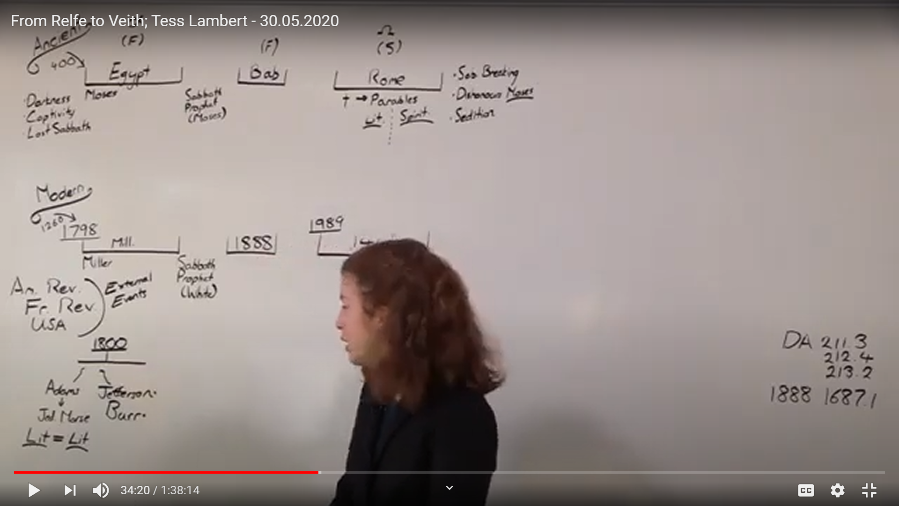
We showed how these also show the division within the Protestantism. The old conservative guard supporting Adams, because he was a strong religious, not just personally religious man, but also defending it through the state. We read quotes by Jedediah Morse, explaining how the united states was as Israel, came out of Egypt, found freedom, so was United States found freedom from Great Britain.
So, they saw themselves as being in that dangerous period just after finding freedom: Israel – from Egypt, and United States – from Great Britain.
What were doing, they are taking the literal story and making a literal story. Because if you have Israel come out of Egypt, then what does the success of Israel depend on? It depends entirely on their keeping the moral code, that they have to keep the Saturday Sabbath, if they don’t keep the Saturday Sabbath what is going to happen to the nation? – they will be destroyed.
So, if the United States, individually don’t keep the Sunday Sabbath and demonstrate that from the highest levels of government what is going to happen? – They are going to be destroyed as a nation.
This is the thinking that is going to lead us to the 1888, and blue laws. John Adams is not doing well as a president. One fellow from Youtube, John Green, Crash Course U.S. History, he describes John Adams, as the greatest thing about John Adams as president was to hand over power. He is not looked that kindly on in history. And part of it was he had this very monarchical view of the role of a U.S. president.
Alexander Hamilton, he is on the U.S. 10-dollar bill. Obama wanted to remove him from the bill, but they scrapped those plans and kept him on the bill. Alexander Hamilton was one who formed the federalist Party. So, John Adams is from the Federalist party, Thomas Jefferson is the democrat-republican party.
This 1800 election is the 1st election in the U.S. when you have two formed political parties running candidates.
So, the very 1st time you see the same dynamic as you would expect to have today.
So, you have John Adams and Thomas Jefferson. Behind John Adams you have this fellow, Alexander Hamilton who has becomes quite famous. And Alexander Hamilton so surely viewd the success of the U.S. as needing a very strong presidential power he wrote most of the federalist papers.
It is an interesting bit of history. What happened in this election John Adams was so unpopular because of what he did in 1798, - the Alien and Sedition Acts.
These two sides: the federalist side (Adams) opposed to the democratic Republicans. One of the things that divides them is allegiance to foreign powers. The Federalists supported Great Britain, the democrat-republicans supported France. So you have the support of Britain and the support of France. They want to support Britain because they want trade, political connections etc.
Thomas Jefferson side supported France because of the French revolution and the ideals of freedom. So there is this division between supporting Britain, and supporting France. They are divided by the number of these dynamics.
So, as Alexander Hamilton is supporting John Adams knowing he is not going to do well in this election, and there is many French immigrants coming to the U.S. SO, what do you want to do when you have an immigrant French population who isn’t going to vote for you? You want to start to curtail the rights of the immigrants to vote. That is partly what is behind these 1798 Alien and Sedition Acts, the alien – being the immigrants to the United States, particularly targeting French immigrants.
So, John Adams wants to prevent those immigrants to be able to vote in the next election, because those immigrantrs are largely French and they are going to support Jefferson who is allied to French interests as opposed to Adams, who is allied to the interests of Great Britain.
So, in 1798 he wants to start taking or restricting the rights of immigrants into the U.S. He makes it 5 years, before, an immigrant is allowed to become a citizen and vote. He extends to 14 years, and then there is also sedition act. Multiple people who spoke against his government or said mean words about him in newspapers or there was a drunk man who shouted something offensive to one of his politicians in his administration, they were imprisoned, they received extensive fines, and there was quite a number that were imprisoned under those sedition acts. You were not allowed to speak against the government that also was very unpopular.
So, Hamilton supporting John Adams, Thomas Jefferson is running for this election in 1800 and running with another fellow – Burr. But the elction system in the U.S. hadn’t been very well refined. There were many problems with that election system. When this side (the democrat-republicans) wins and Federalists lose there is a split in the electoral college vote. There is equal number go to Burr, and equal number go to Jefferson. So that either one of them could become president. This is because they haven’t refined their system and it still wasn;t clear who would be president and who would be a vice president. So, Jefferson and Burr vote is split and no one knows how to solve it. So Alexander Hamilton who was on this side equation, now that his party has lost the elction, he throws his support behind Jefferson and says mean things about Burr. Which leads to 1804 when Burr has had enough of A. Hamilton and challenges him to a duel and Burr kills Hamilton. And it is because of his treatment of Burr in this 1800 election.
So, there is a split between the Federalist party – John Adams and democrat-republican party -Thomas Jefferson.
We showed how this also show the split within Protestantism (Jedediah Morse supporting the literal-to literal view, - they see Jefferson as anti-God atheistic power. That is essentially satanic and they subscribe to him the conspiracy theory of the Illuminati. That he is part of Illumanti and because Hamilton was being quite mean to John Adams, they also say that Hamilton’s part of the Illuminati. So, you can see how they have created this deep state. He is saying “it doesn’t matter what political party you belong to. Hamilton is part of Illuminati, Jeffersone is part of Illuminati. That is why he says the Illuminati is based in the home state of Hamilton, and the home state of Thomas Jefferson. It is essentially idea of a deep state. There aren’t these two political parties, instead you have this entrenched deep state behind them whish is essentially satanic power, it is against the government and the will of God, and our only hope is John Adams. It just becomes interesting when you bring that to our day and you start seeing this idea of a deep state, this satanic union that crosses political parties.
This literal to literal interpretation leads Jedediah Morse to make the astounding claim that the success of the nation depends on enforcement of Sunday keeping in the U.S.
They are also using conspiracy theories, this idea of deep state that is intentionally behind the scenes.
This division of the Protestantism didn’t go away, it extended down into the history of the 1850s when there is discussion about slavery starts reaching a dangerous pitch inside America.
The end of the studies in Portugal we discussed the 1844 election and Henry Clay stated that the church divisions, division within Protestantism was the greatest source of danger to the U.S.
What this senator is saying is that the greatest threat that the U.S. currently faced with was the split within Protestantism over the issue of slavery. The great external threat of this history split Protestantism.
Before 1888 the Methodist church was the largest organization in the U.S. outside of the Federal government. It split officially in 1844. A strong cord tying North and South was cut. 94% of Southern churches belonged to one of the 3 major bodies that were torn apart suddenly in a religious sense. The South was set adrift from the Union. So, the churches split between North and South, before the states split between North and South. Civil War times illustrated explains that the church divisions helped crack America’s delicate Union in two by severing the religious ties between North and South the schism bolstered the South’s strong inclination towards secession from the union. It helped bring about a breakup in the national political parties which splinted into factions and the shattering of the parties led to the breakup of the Union itself. The divided churches also reshaped American Christianity. Important new denominations such as Southern Baptist Convention formed and Christianity in the South and its counterpart in the North headed in different directions. Southern believers who are drawn on the literal words of the Bible to defend slavery increasingly promoted the close literal reading of Scripture.”
So what is the South doing? – They are using the same methodology as used by Jedediah Morse, it is literal to literal reading of Scripture. Israel comes out of Egypt – you have to enforce morality. John Adams was a candidate who they had hope in doing that. He didn’t succeed to do that. Israel goes into promised land. It is instructed by God to practice slavery. Literal to literal interpretation. This article is recent, it says only 9 years ago the Southern and Northern Presbyterians reunited. So it is only in our lifetime that Presbyterians reunited, about 125 years after the end of the Civil war.
Few observers expect reunion between Northern and Southern Baptists American Christiantiy began to feel the aftershocks of a war that ended 125 years ago. It is over this interpretation of the Bible, this side saying we must read literal to literal, and therefore as the United States as Israel we have to practice slavery, segregation, and all of the things practiced by Ancient Israel.
I want to quote Samuel Morse (Jedediah Morse’s son and co-inventor of the telegraph system, the Morse code):
“In the 1850s, Morse became well known as a defender of slavery, considering it to be sanctioned by God. This was a position held by many Southerners and others. In his treatise "An Argument on the Ethical Position of Slavery," he wrote:
My creed on the subject of slavery is short. Slavery per se is not sin. It is a social condition ordained from the beginning of the world for the wisest purposes, benevolent and disciplinary, by Divine Wisdom. The mere holding of slaves, therefore, is a condition having per se nothing of moral character in it, any more than the being a parent, or employer, or ruler.”
So, Jedediah’s son, Samuel Morse continues the same exact methodology as he becomes a defender of slavery in 1850s. And his explanation of it is:
- It was designed by God’s divine wisdom all the way back at the beginning of the world heading down to ancient Israel to the time of Noah. This is the thinking of the South. It is the literal to literal interpreatation of Scripture.
And we understand that ellen White, and not only her, but also our pioneers, a whole branch of Protestantism disagreed with that literal to literal interpretation, and stood on the right side of the slavery question.

