Germany #13 Tess Lambert, Church & State Part 1

Recap of presentation #12 on World War I.
Tess starts out by explaining what she talked about in the last presentation. Here she wants to just go over the main points of what she covered regarding World War I.
In the last few studies we have gone through the history of the third Diadochi War and World War I. There are a lot of details; WWI is not a simple subject. It is not a simple war. So, we have moved quite quickly. I want to take the time to just cover the main points before we move on. So, we are not going to go through everything again, but just those punchlines that we want to take away with us. I have already explained why we need to look at WWI, we have explained its connection to Modern Babylon, the triple application of Prophecy, and its connection to the third Diadochi War. So, we first looked at the third Diadochi war, we traced the history of Antigonus and his dictatorship.
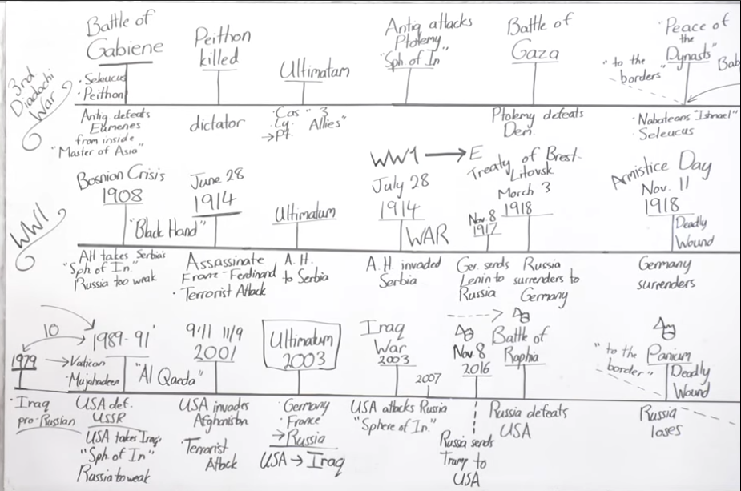
Fig 1. Screen Capture of Tess's Boardwork

Boardwork: 3rd Diadochi War, WWI, Present
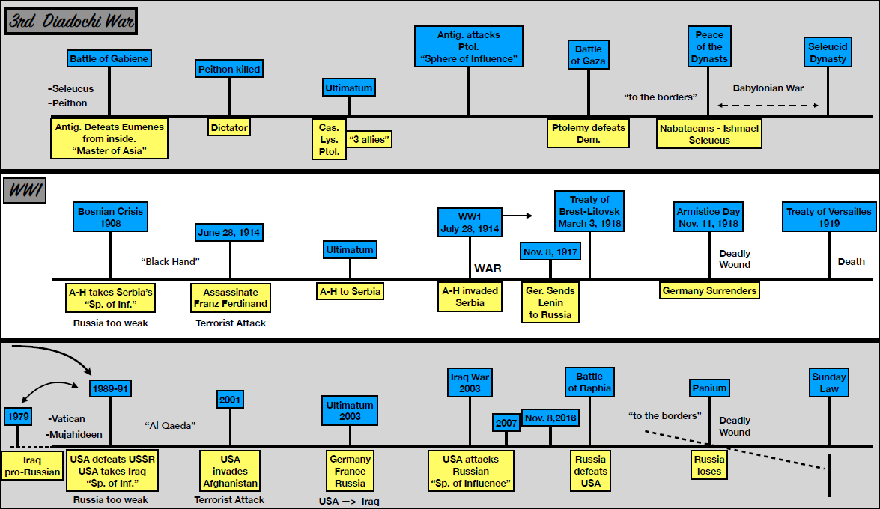
Russia surrenders to Germany
Russia sends Trump to USA
Fig 2. Tess's Boardword of WWI, from Brother Jonathon

WWII Leaves Big Gaps in our Present Line
From our understanding of World War II, when we built that reform line, we understood 1989 and then we have this big space, a 25-year gap. We come to 2014 and we see that there is an alliance. We come to 2016 and there was a war on the Western Front.
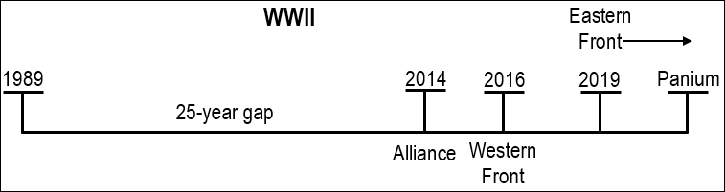
Fig 3. Present time line with waymark gaps after WWII additions.

WWI Fills in The Gaps of our Present Line
If we're going to talk about the Eastern Front, you wouldn't mark the Eastern front until 2019. And for World War II you would see the Eastern Front begin at 2019 and it's going to extend until Panium. For our study of World War II, you see the end of the Cold War in 1989, then this long period of 25 years, then an alliance in 2014, then in 2019 you have a war on the Eastern Front. We defined that war as an Information War fighting over spheres of influence. What we are left with is this huge period of 25 years. And we know that all through this history, particularly since the rising of Vladimir Putin in 1999, there has been an Information War over spheres of influence. And all of that is missing from the model of World War II. But because of these other characteristics of World War III, World War III must begin before Raphia. We understand first Angels message and second Angels message, and Millerite history separated. In our history there's a combination. Essentially what we’ve placed is the second Angels message, without taking into account the first. If we take into account the first, or World War I, you can see that it begins in 2003, with the war in Iraq. And for World War I, it begins at 911. It doesn't start in 2019 at Raffia, it ends in 2019. For World War I the Eastern Front begins in 2003 with the Iraq War which is where Vladimir Putin turns against the West, and it ends at Raphia. For the World War II model this history of War is actually a period of friendship. We need both models World War I and World War II. Right now, Vladimir Putin and Donald Trump are friends, allies, at the same time, they're still fighting in Venezuela. You have war and peace at the same time. Enemies fighting at the same time they're in an alliance. They are seemingly contradictory, but in reality, they are not contradictory because the reality it is more complicated than saying that it is just war or peace. There might be an alliance in 2014, but 2014 Russia and the United States are fighting over Ukraine; they are engaging in an Information War, the spheres of influence. World War I fills in a major gap in our reform line, this whole missing space. Someone asked me, what about the Arab Spring and all of those revolutions; how do they fit into the World War models? They don't fit into World War II, but they become part of the Eastern front of World War I.
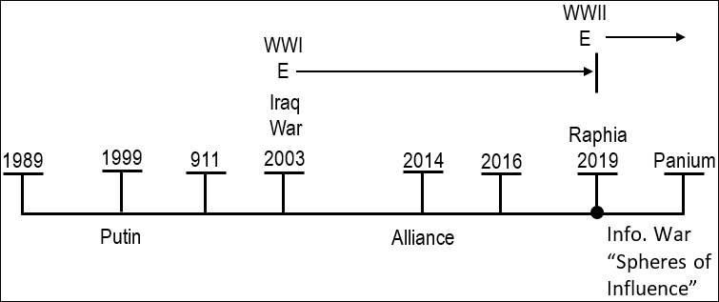
Fig 4. Present time line with waymark gaps filled in from WWI additions.
So, we have to wonder what Raphia looks like; because we went to World War I and we saw this conflict, Kuwait/Iraq or Serbia/Bosnia, terrorist attack, ultimatum, invasion of sphere of influence, which lines up with Iraq, then you see Germany get clever, they are going to invade from the inside, and they send Lenin to Russia. It's a history of failure. Once you get to battles, like World War II, you switch it, because at some point you know that in the history of failure the King of the North has to begin to lose. So, when you get into battles you need to switch that victor. Lenin or Trump do just what they have been sent to do, conducting an internal revolution, overthrow the establishment, and begin a dictatorship. And then they make peace, the Treaty of Brest-Litovsk, Russia surrenders to Germany. [Boardwork: refer to fig 1 on page 1 or fig 2 on page 2]
So, this waymark of Raphia, depending on what perspective or layer you are looking at, it is either the end of the war or the beginning of a war; it is either a battle or a peace treaty. They are seemingly contradictory, but I would suggest that they are not. Speaking hypothetically, if Donald Trump was to say, as he's been saying this week, Vladimir Putin is my friend and you are all treating him badly. Obama was mean to him; he should be back in the G8. And then, he keeps forming these plans, pulling out these troops out of Syria. On one level that is a peace treaty; he is gone to the King of the South and they have made peace. At the same time that is a peace treaty from America, that is a defeat; it is a loss of power and a humiliation. They look at it from different perspectives but they are all accurate.
I want to make a couple more points, what else we can learn from this? Just like 1989 they go to the borders; it is just another witness for what we have been teaching. We have been teaching against this hot war concept, that a kingdom is not defeated unless the actual nation is destroyed, or its government taken over. We know that with Seleucus and Ptolemy, through six Syrian Wars, Egypt was never finally taking over by Seleucus. It wasn't necessary for defeat; they go to the border. But when Germany surrenders, just like 1989, that was a surrender, but they did not know the implications of that step, exactly how devastating that was.
We talked about the role of Seleucus, that we can see Seleucus, who we identify as also the King of the North, the papacy, and his role in the affairs after 1989, the way he turns on the United States.

The Two Streams and Parable Teaching
The last point I want to address is to certain people in our audience, I want to make a point, we understand the concept of two streams of information, we understand the Ulai and the Hiddekel. We understand that it is internal and external; it applies to the Priest, Levites, and Nethinims. If we accept the Ulai and the Hiddekel model and every reform line, then we understand that you cannot drink from both. We can go through that argument quite easily, build strong logic that demonstrates there is a right and a wrong stream inside Adventism and at certain points inside this movement. One leads to the Sea of Glass and one leads to the Lake of Fire. I don't think anyone would suggest you want a little of the Sea of Glass and a little of the Lake of Fire; I don't think anyone would choose that, not intelligently. The theory is easy enough to see, but we have a problem with practicing that. When we come to practicing that and it can be identified, what exactly is the Hiddekel, the wrong stream of information, when it impacts our preconceived ideas, from Apostate Protestantism that have been taken on by Conservative Adventism and you identify the false stream of information is Walter Veith conspiracy theories. You can see that just based on structure; but I still have brothers in this audience still not accepting that structure, because they do not accept the methodology of parable teaching. So, I want to address it from this line of World War I; the assassination a Franz Ferdinand, who does that? Does Austria-Hungary pretend to be a terrorist organization and kill their own Prince to bring about a war? No.
So, if you will not accept parable teaching, I'm just going to add one more and hope it gets through. In World War I, it is a terrorist organization that kills the Archduke and yes, Austria-Hungary see that and use it as the excuse they always wanted; but they did not go behind the scenes and orchestrate that terrorist attack. So, if it makes a difference, one more witness, our conspiracy theories never agree with prophecy and if we continue to hold on to them or spread them, we are going to continually find ourselves on the wrong side of Prophecy. That is all I wanted to say in the review of World War I. I am sure there is much more to study in that history and I would encourage you to look at it and study it for yourself. But for the purposes of this camp meeting we must move on.

Kaiser Wilhelm & Donald Trump
One last revision, on the characteristics of Kaiser Wilhelm II. His characteristics of how he took over and how he ruled, line up accurately with Donald Trump. You can place the 126 from 1890 to 2016. His characteristics, there are quite a few that line up with Donald Trump, if you combine them with Hitler it forms quite a complete picture. But I particularly want us to remember, what for me was his most significant blunders. His number one characteristic was that he thought he could rule based on his personal relationships. That is what people have been complaining that Trump does since before his presidency, and of itself is quite unusual, where with Bismarck you see how Obama ruled through alliances. I'm leaving World War I for now.

Applying the Millerite & Civil War Lines to Ours

2014, “The 2520 Revealed”, and 126/151
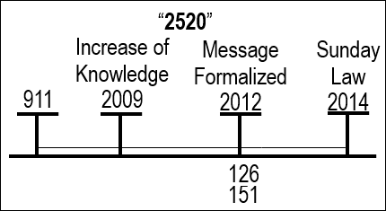
I want to look at a study that has been done in a few places, many of you are probably familiar with it, or you have taught it, but I think it needs to be put properly in the record, and be revised so we can build upon it. There is no use building upon it if not everyone understands the subject and I would rather we moved together. It begins with understanding 2014. When 2014 is predicted, which is in 2012, it is predicted based on an understanding that has developed on the 2520. We understand that in this dispensation, from 911 to 2014, the subject that is being opened up is the 2520. And the messenger that is giving this increasing light, Elder Parminder, lays out the 2520 in 2009 in a series called “The 2520 Revealed” [Links to YouTube Playlist on FIN]. This is an increase of knowledge. The subject for this dispensation can be summed up by saying the 2520, but the 2520 gives us a lot of information; it gives us time setting, the understanding of the 126 and the 151. And it is time setting in 2012 that is laid out before the movement, formalizing this message. It is an understanding of the 126 and the 151.
Fig 5. The 2520.
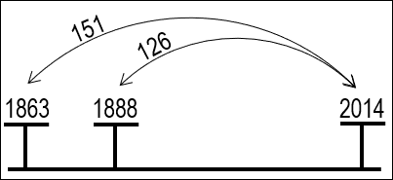
When the 126 and 151 is understood in 2012, they start looking at past waymarks, they identify that there is a 126 that takes you to 2014, from 1863, so 1888. In other words, a 126 from 1888 to 2014, and a 151 from 1863 to 2014. I know those studies were more detailed, but this is all we need to remember for the purpose of this study. The understanding of the 2520 that has developed, shows us that the 126 and the 151 allow us to bring 1863 and 1888 and apply their characteristics to 2014. Based on these two previous waymarks particularly, 2014 is identified as being the Sunday Law. 2014 becomes the Sunday Law through these numbers identifying one point, the 126 and the 151, connected to the 2520; particularly the 126 shares its similar characteristics.
SL
Fig 6. The 126/151 to 2014.
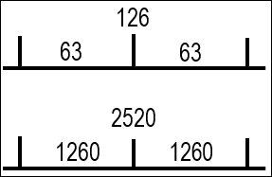
And when you take the 2520 you can divide it into two periods of 1260. When we are using the 126 in the same fashion, you can divide it into two periods of 63 years. So, we have another number to add to this mix the 126, the 151, and the 63. This is all old revision or review, and all of this was covered in more detail in previous presentations in the record. It is the 151 and the 63 that we are going to focus on.
Fig 7. The 126 & 2520 divided.

Our Reform Line Overlaid with the Millerite Reform Line
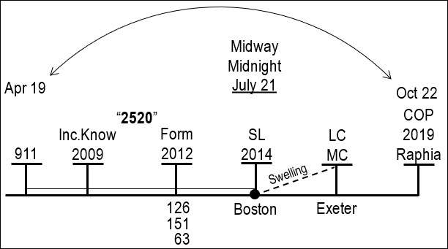
When we look at our reform line and we overlay it with the Millerite reform line, we can characterize 911 as April 19, 1844. 2014 is Sunday Law; Sunday Law is the beginning of a cry, that is going to swell. All of which is warning them of the Close of Probation. Sunday Law, Loud Cry, Close of Probation, 2014, Midnight Cry, Raphia/2019. But if we take this to the Millerite line the beginning of that cry is at a camp meeting in Boston, it is July 21, 1844; that cry begins to swell, and for the Millerites, when they are looking at their history, they identify that they're fulfilling the parable of the Ten Virgins. So, they understand that at this point in Boston a cry begins, they connect that to the parable of the Ten Virgins, and the cry that begins at midnight. So, you can identify July 21 as midnight, a cry is raised, and that cry says, “the bridegroom is coming, go out to meet him”. It swells to Exeter, all of which takes them to October 22, 1844. So, they identified midnight, we see July 21, but it is also identified, which midnight relates to, as Midway; it is a Midway point between April 19 and October 22.
Fig 8. Our reform line overlaid with Millerite reform line.
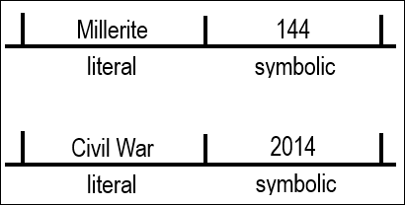
When we go to Millerite history, if we take Millerite history and apply it to our history, I want us to see we are taking the literal and we are applying it to the symbolic. So, the Millerite history is literal and Our 144,000 history is symbolic. What is literally in the Millerite history becomes a symbol in our history of the 144,000. In their history, July 21 lines up with the Waymark of Sunday Law, which is 2014; it has these characteristics of Midway and Midnight, and they become symbols. Millerite history, July 21 is exactly midway between April and October. This July 21 Waymark is literally Midway in their history. In our history it is a symbol, symbolically midnight and midway between 911 and 2019. We have to consider why we need that symbol; it must be to teach us something. Because the fact that July 21 is Midway in their history, it fits neatly and they know that the cry was raised. It must need to teach us something. When we go back to these dates, we can look at other ones; we can do the 490 and the 220, but like I said we are going to focus on the 151 and the 63. If we do that it takes us to another history.
Fig 9. Literal and Symbolic.
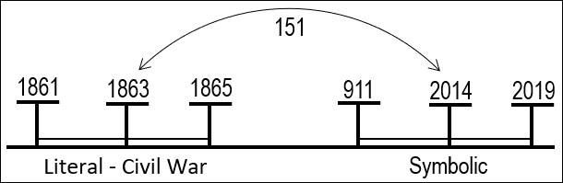
If we were to go back 151 years, from 2014 to 1863, we know that 2014 is symbolically Midway between two points, 911 and 2019, April and October, but it is symbolic. When we go back to the Millerite history it is literal. If we go back 151 years, we are going to another history that we want to make application of and bring into our own. We are going to overlay 1863 with 2014. This history of 1863, I'm going to call it the Civil War, it now becomes the literal that we are applying to our history which is the symbolic. Back in the history of the Civil War if we want to overlay this history as a parable, it must be Midway. If 2014 is the symbolic than 1863 must be the literal, and it is. It is going to take us through the Civil War from 1861 to 1865. Now we have not one date, not one number, but a whole history to treat as a parable. From 1861 to 1865 is a civil war and from 911 to 2019 is a civil war.
Fig 10. Literal Civil War in 1863 to Symbolic Civil War in 2014.
I want us to remember that war on the Western Front of World War I, that all escalates because of the assassination of Archduke Franz Ferdinand. At this point a division is made between the Western Front and Germany where they begin to argue. And then in 2003 it's all that war, so we are marking war on the Western Front from 2003, and our whole issue begins because of the terrorist attack in 911. And we understand that the war on the Western Front in World War II and then in World War I, and therefore World War 1, is a war within the United States itself, and amongst their allies. So, we have another witness with World War I, to identify from 911 internal conflict between two different ideologies. [Boardwork: refer to fig 1 on page 1 or fig 2 on page 2]
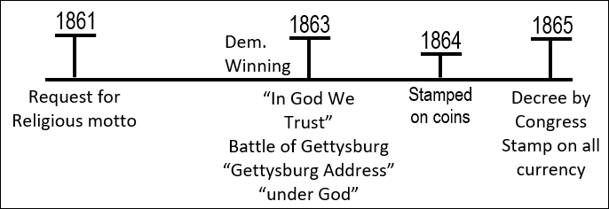
For our study I want us to go back to the Civil War and understand it, and make application to our day. So, this is the history of the Civil War, 1863 is Midway or the Midway point, it all begins in 1861 and it ends in 1865. We see that 1861, the beginning of the Civil War, is in national crisis. 1861 when that Civil War begins neither side knows whether or not they're going to win in that war. The North is not so confident, so they are going to ask that they can make some type of statement, particularly the northern churches of the United States. One Pastor writes to the treasury and ask for the introduction of a religious phrase. This has been asked for before, that some type of religious motto would be introduced, that could be propagated by the government, and that made some type of statement that their nation was allied to God. This idea only gains traction after the beginning of the Civil War, because of the crisis. In 1863 they decide on that motto, “In God We Trust”. In 1864 they begin to stamp it on their coins. In 1865, by a decree by Congress, it is to be stamped on all currency that is to bare the inscription. In 1861 the request is made in a national crisis, and then in 1863 Congress says yes and chooses a phrase, then in 1864 it begins to be stamped, and in 1865 there's another decree by Congress ordering its placement on all currency that is large enough to contain it. At the beginning of the Civil War the victor is uncertain, so they want to make this statement, there are two sides and God is on our side.
Fig 11. Religious motto from Congress
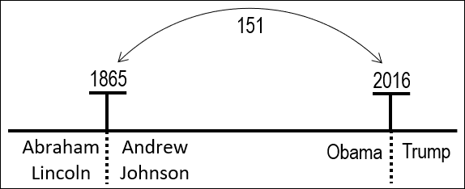
Before progressing further, I just want to identify one characteristic of this history. If we were to look at the Civil War or any part of this history, from the election of Abraham Lincoln, it has a jewel significance. There are two issues in this history. You can look at it from two different perspectives. The first issue is slavery, there is this issue with slavery. There's a second issue, with church and state. Now we have spoken before about parables, the fact that they can teach more than one lesson depending upon your perspective. We discussed Agriculture and The Pearl, both scenes can create more than one parable. I want to make the claim now, to hopefully prevent this from being a confusion, that there are two layers to this history. Those two different layers or two separate parables are 1. Slavery and 2. Church and State. If you are dealing with slavery, it is the North, and is Abraham Lincoln the good guy or the bad guy? He is the good guy; he ends slavery. So, if we are going to understand the issue of slavery, Abraham Lincoln becomes the good guy. We see in 1865, Abraham Lincoln is assassinated. Prior to 1865, you have a president who was anti-slavery on this issue he is good. So, you have a president who is anti-slavery before 1865, Abraham Lincoln is assassinated, and to replace him is who? Andrew Johnson. How did Andrew Johnson stand on the slavery issue? He sympathized with the South. So, you go from a good president who was anti-slavery, to a bad president who is pro-slavery. The 151 takes you to when? 2016, and what do you have? Obama. Obama is good, he is anti-slavery. 2016 he is assassinated in a political death and instead we have Trump who is pro-slavery. So, depending on the issue, if it is the issue of race, racism and slavery, Abraham Lincoln is good, and Andrew Johnson is bad.
Fig 12. Lincoln and Obama; Johnson and Trump.
- Slavery Lincoln X
- Church & State Lincoln
But we are not dealing with this first issue yet, we will come back to it; our parable is church and state. If our parable is church and state, how is Abraham Lincoln on that issue? Bad. He is known even now, and Trump supporters quote him, the statements he makes during the Civil War, particularly 1863, calling the nation back to God. So, they are two parables, we are starting on the parable of Church and State; we will complete that study. And then we are going to deal with slavery and bring that into the subject. In this history it is the North that is bringing together church and state. It all begins because of the Civil War; they want to say that God is on our side or the Republican side. Just prior to 1863 the Republicans are losing and the Democrats are winning. The Democrats are the South in that story. The Democrat South is winning in the Civil War. In 1863 the Battle of Gettysburg is the turning point, in the Civil War, where the North starts to win and the South starts to lose. And from this point the North wins. In 1863 Abraham Lincoln makes his Gettysburg Address, and in that Gettysburg Address he pledges Allegiance to the United States and he makes the statement that this is a nation under God. The two phrases that we are particularly tracing through this Civil War history are “In God We Trust” and “Under God”.

