Germany #16 Tess Lambert, Church & State Part 3

Recap of Presentation #14

Millerite History & The Midway Point
Some revision or review of yesterday. We understood Millerite history, April 19 to October 22, where July 21, the Boston camp meeting, is recognized as Midnight and Midway. We have taken that principle of the Midway point, and all we have done is created a study based on line upon line; it is nothing new. We have line upon line and we are particularly focusing in on two histories with a similar theme, one is based on the 151 and one is based on the 63.
2014 carries with it this characteristic of being a Midway point. We have gone back into history seeing two time periods that for different reasons fit with our own. And we have cut our line and we are doing a study of line upon line. We can see line upon line, but I want us to remember that we have two methods, we have to choose intelligently when we use each one, line upon line and progression. We can cut our line and make application of these histories, but we also need to understand the concept of progression. I would like us to challenge our thinking and try to remember that the issues that America faced at its very inception and its very birth as a nation, are the same issues that it is facing today.

Review of the Civil War, The Midway Study, & The 151 Study
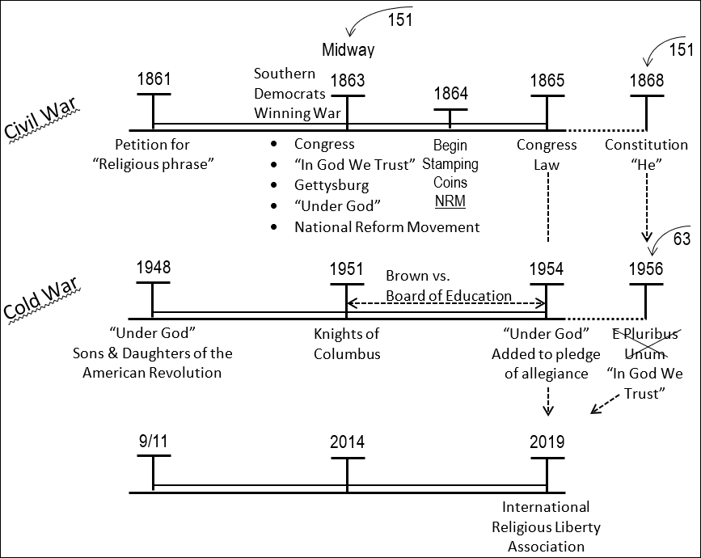
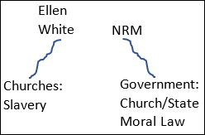
We will review the Civil War history. There is a national crisis; in 1861 the Civil War begins. The churches come together, and they say, ‘we are under the Judgment of God. We need to appease God's anger. He is angry because Church has been separated from State, and the country is not moral.’ In this history Adventism is active and they have a voice. Ellen White and others are saying clearly, ‘the nation is under the judgment of God’, which is basically the same as what the churches are saying. Both sides, the Evangelical churches and Adventism, say this is the Judgment of God, but they have completely opposite reasons for that judgment. One side says, ‘it is because of Church and State and immorality’; Ellen White says, ‘God is angry at the churches and the reason he is angry, at the nation but particularly at the churches, is because of slavery. And God is going to do whatever he has to do to make sure that slavery is abolished.’ So, they have two different messages.
In 1861 the evangelical leaders call for a religious phrase and Congress decides that the phrase will be “In God We Trust”. That is the introduction of that phrase into American life. Democrats (the South) are winning the war. Gettysburg is a turning point and Republicans (the North) begin to win, “Under God”. In the Gettysburg Address, Abraham Lincoln introduces the concept of a deity as being the authority of the Nation. And there is the beginning of the National Reform Movement (NRM). The Evangelical leaders, afraid of this judgment, determine to bring together Church and State and enforce morality. In 1864 the phrase, “In God We Trust”, begins to be stamped on their coins and the NRM organizes. In 1865 Congress passes a law that “In God We Trust” must be stamped on all currency that has room for the inscription. This is our Midway study.
This Civil War history that we want to use to understand our history, from a national crisis in 2001 to the establishment of dictatorship in 2019. We come to the 1868 through the 151 where they introduce male pronouns into the Constitution in the Fourteenth and Fifteenth Amendments when they give black men the vote. They want to make it clear that it is only for black men. That is the 151 study.

Evangelicals & The Stones Crying Out
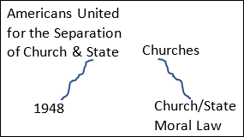
We come to 1948, people are waking up to the fact that there is another war different to what has been fought before. In this history of national crisis, you again have the Evangelical leaders coming together, pushing for Church and State to unite and enforce morality, because they are afraid that the United States is under the judgment of God. In 1948 is the introduction of “Under God” to the “Pledge of Allegiance" and “In God We Trust” is the National Motto. That is only two issues. If you study this history, it is so full of the Evangelical churches pushing their way into politics. This is when Billy Graham is doing his work, having National Prayer Breakfast and opening political meetings with prayer and bible study; that is the history of the 1950s, and it is a direct result of the Cold War. In this history of 1948 and our own, Adventism is silent; they are dead. So, there are no Pioneers protesting and when there is no one of God's people who will cry, the stones have to do it. And if you want to understand what's happening now, we talk about 1996, two streams of information, why does there even need to be an external stream that is giving the message that they're giving, regarding what is happening in the United States? That true stream are the stones crying out. Because God's people are in no condition to give a message. A new message is formed, a new organization, right on time in 1948, they are called the “Americans United for the Separation of Church and State.” This group is the front line today, protesting what is happening between Donald Trump and the Evangelical churches. I want to apply these. I want us to see that there are two issues, one is Church and State and the second issue is an issue of discrimination. Ellen White said, to paraphrase, ‘The same spirit that held the black people in slavery, is not dead but alive. So, the spirit is there even though this slavery is abolished. The same spirit of oppression it's still cherished in many minds. They're just waiting for another opportunity to oppress. And in the 1890s they found that opportunity, with the doctrine ‘equal but separate’. With this doctrine they're saying that black and white are equal but separate. And they don't really mean equal, the minute they introduce a but, they lose any excuse to say equal. I want us to be aware they say ‘equal but separate’, that is how we excuse headship today, male and female submission. We would say a man and a woman, a husband and wife are equal but separate. It is this exact same thinking and I just want us to identify that now. So, that is what comes in in the 1890s
From 1951 to 1954 is the court case “Brown versus Board of Education”, and they're fighting this doctrine of equal but separate. In 1954 they win that court case. That fits exactly within our dispensation. So, you already know why you have the Christian right active today and what the issues are.
Going back to progression, there is a mindset behind slavery. Those behind slavery, that are extremely religious, are going to defend it with Bible arguments. They're forced to stop, but the mindset does not change, it exhibits itself in segregation. They're forced to stop, but the mindset does not change. It comes into the Evangelical leaders, Jerry Falwell being the chief, and exhibits itself in the Moral Majority. The Moral Majority died a death, but the mindset doesn't change. Jerry Falwell Jr endorses Donald Trump, with 81% of the Evangelical vote. This isn't to say that everyone who supported Donald Trump is a racist, but it is either racism or ignorance. And ignorance is excusable, but we have to be educated to see why they are supporting Trump. What is it particularly about Trump that appeals to 81% of the Evangelicals?

To Bring This Into Our History
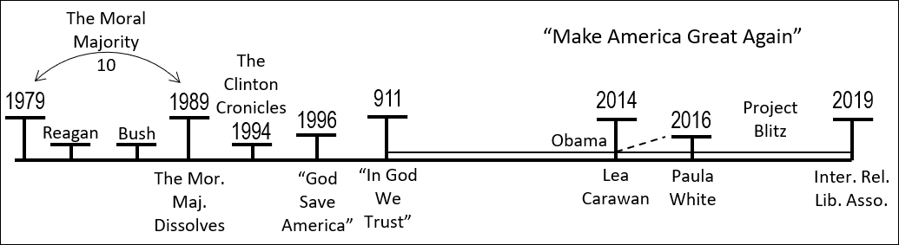
To bring this into our history, I want to go back to 1979 where we construct our reform line; we construct this 10-years, from 1979 to 1989. You can do that with Information War, Afghanistan, Iran and Iraq, at many different levels, our parable is Church and State. This is the Moral Majority formed 1979, Jerry Falwell is leader. We quoted him when he spoke about segregation. He spoke about Brown versus the Board of Education, and he said, ‘the Supreme Court would never have ended segregation if they understood Bible quotes.’ Understand from the beginning the argument that he is saying, ‘if the Supreme Court understood “my thus saith the Lord”, they would not have ended segregation and I've gone against the will of God’. He is preaching this from a pulpit, in a church, from the Bible. I have a “thus saith the Lord”, God has drawn a line of distinction between races that we should not attempt to cross. He says, ‘that if we break down that line of distinction, the white race will be destroyed. He is protecting the Jewish Christian West, and he decides that we need to go into a culture war. It is the exact same mindset and language, and everything, behind Steve Bannon, Donald Trump, and the Christian right. He attacked Martin Luther King, as a left-wing socialist. He says, ‘he's going to bring destruction and violence on our land. Then he goes into conspiracy theories and says, ‘that Martin Luther King Jr is a communist spy’. They are opposing segregation so much they create private Christian universities, so they can bypass the government and segregate their children. In 1971 the Supreme Court rules that if a private school is going to segregate, they cannot be tax exempt. Jerry Fowler was so angry he said, ‘that in some states it is easier to open a massage parlor (and he doesn't mean remedial massage) than a Christian School’.
You have to be careful today when you read their version of this history, they will say that it was all about abortion, ‘Roe versus Wade’, which was a Supreme Court case of legalized abortion. They have tried to rewrite their whole history, but some of those evangelicals that were there in that history have said that in any of those meetings that formed the Moral Majority, abortion was not mentioned once. Paul Wyrick said, I tried to get people interested in abortion, but none of the Evangelical leaders cared. Their Culture War began with the end of segregation, not with beginning of abortion. Jerry Falwell says ‘we are fighting a holy war, we are going to take over the government, and establish the Christian right, so we can have our way in the government of the United States. In 1979 they form the Moral Majority; those Evangelical leaders began a political campaign. Their first victory is getting Reagan elected and their second is George Bush's election. In 1989 Jerry Falwell says ‘we have accomplished our mission; the Christian right is firmly in place and it is here to stay.’ They dissolve the Moral Majority. In 1994 it is his influence and Liberty University that we're behind “The Clinton Chronicles.” In 1996 he conducts a “God Save America” Campaign.

Making Application In Our History.
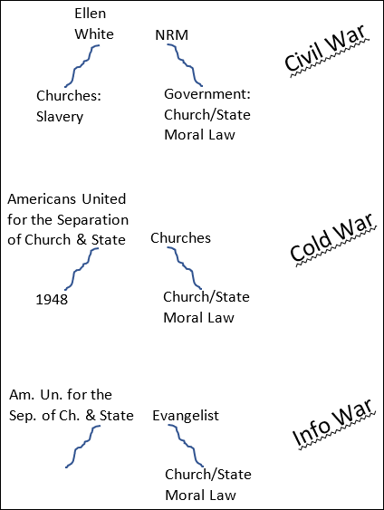
Making application in our history, in 9/11 you have a national crisis and we went to World War I to also identify the war on the Western Front beginning of this history. It is a time of national crisis, God's people are too dead to protest, so again it's this “Americans United For The Separation of Church And State” organization, formed in 1948, that release a paper and say ‘I know it's a national crisis, but please don't use that crisis as an excuse to introduce Church and State. They already know what is about to happen and they were correct.
It is the same in Evangelical leaders, now it is Jerry Falwell still, but his son Jerry Falwell Jr is becoming involved and now it is Billy Graham's children. But it is that same network of Evangelical leaders. Here is a quote from Billy Graham's daughter, Ann Graham Lotz, “We abandoned God as a nation, so God abandoned us, He takes his blessings away. So, God allowed 9/11 to happen, to show us that we need Him.” She says, “God has forsaken the United States because of Transgender people, the teaching of evolution, and homosexuality. The United States is shaking its fist in God's face, telling Him to remove Himself from our politics.” Does God have any place in American politics? No. She says, ‘We are telling God to get out of our schools’. Does God have any place in the public school? According to our pioneers, no, that is Church and State. Get out of our businesses; must God be in Wall Street? No. All of these reasons that she is giving, for the 9/11 attack, the exact same reasons the Evangelical side was making in the Civil War. We've told God to get out of our government and we have too many gay people. Her brother is a little bit more pointed and he will just say, “It is the gay people, the abortionist, the feminist, and our secular society’. Jerry Falwell says, ‘It is the judgment of God, we deserved 9/11.’ He says, ‘I will point my finger in your face, in the face of a lesbian, or a feminist, or a pagan (an atheist)’, and say “It is your fault.” Pat Robinson agrees with him. So, that narrative has already been created. And there are many like Steve Bannon that see this as war now. It is a culture war and if they don't win it, they are going to lose the Jewish Christian West.
This is the same mindset of the judgment of God, backed up by the conspiracy theories. We talked about the hurricanes, but they said we're because of Gay Pride marches. I have heard that thought shared in this movement. So, you know what danger we are in. With the Ulai and the Hiddekel, we cannot drink from both. The most recent one, shared through Fox News, which should know to separate Church and State, but won’t, they're sharing the thoughts, ‘Gun violence is not because of guns, it is because we have removed God from society, secularism’. They say ‘if people just knew God, and what God says about how we treat each other, they would know not to hurt each other’. And those left-wing atheists, what is their response? You used your God, your “Thus saith the Lord's”, your idea what God wants, to fight against the Civil Rights movement. So, don't tell us what God wants. And they are right.
Fox News also made the argument, it was more subtle, but it is because of the destruction in the home, and they are particularly discussing male and female roles.
“In God We Trust” all begins in 1861 and “Under God” begins in 1948, and in 9/11 it all begins again. Just before 9/11, but then particularly escalating because of 9/11 is a movement that introduces this phrase, “In God We Trust”, into schools. State-by-state has passed laws, it all began in Mississippi in 2001, that in almost every room in every school must display the words “In God We Trust”. The politician that brought this law into effect said as an excuse, this nation was founded as a Christian Nation. And I hope we all know where we stand on that thought. His second excuse is we already put it on our currency. Again, there is a push by the Evangelical leaders through the government to bring together Church and State, that happens in this history of 9/11 just prior to 2014. Here the Democrats are winning, Obama. Remember we discussed two parables in one story, Abraham Lincoln is good when it comes to slavery, but bad when it comes to Church and State. We are discussing Church and State, so in that context, it is better to be a Democrat, Obama.
I want to quote Steve Bannon, a statement he made in 2014, “We are in an outright War against Islam, but also socialism and Atheism.” Why would they fight a war against atheism? And he calls this a war, says “We need to form the Church Militant, fight in this war for our beliefs or we are going to see the destruction of the Jewish Christian West.” In 2014 through other studies done this year you could see the movement that began from 2014 forward, to the election of Donald Trump in 2016.
Obama, how did he stand on these phrases? On the 150th year anniversary of the Gettysburg Address, Obama recites that speech, and intentionally leaves out the words “Under God”. He will not say it. Then he quotes the motto of the United States, and he does not say, “In God We Trust”, he says, “Out of Many, One”. And piece by piece Obama was dismantling the last 150 years of Church and State. For someone like Steve Bannon and Jerry Falwell Jr this is a worst nightmare. You have a black president dismantling 150 years of progress towards Church and State.
We're not going to go through the evidence of 2014 here and what happened with Steve Bannon in 2014, Cambridge Analytica, and the Evangelical leaders. But quoting Lea Carawan, head of the Congressional Prayer Caucus, she says, ‘the separation of Church and State is its liberal plan to destroy America’. In 2016 it is accomplished; Donald Trump is elected. When he wins that election, his spiritual advisor is Paula White. All those evangelicals are in the back room praying. And she says she's never seeing the evangelicals unite to such an extent since 9/11. 2014 was the beginning of a movement, it is also the beginning of a message. Internally there is a message, a cry, that begins in 2014. At the beginning it is in obscurity, but as it begins to swell more and more people begin to notice it, hear it, and add their voices. Externally, there's beginning of a cry. You could say that cry is to “Make America Great Again”. To make America great again is the same message as saying a national reform movement. To say “Make America Great Again”, is to say that America needs reforming. It is Nationalistic, it is a movement, and it is all about reformation. To say to reform, means to take something formed and you're going to mold it back to an original shape. In 1951 is the beginning of a movement but they are not organized yet. In 2014 is also the beginning of a movement and they also take time to swell the cry. Internally and externally there is a message; by 2016 you can identify them. They've had their increase of knowledge.
There is something under way currently, it is called project Blitz. Every one of us, if we are not already should be researching this organization. They formed about 2015-16. They're saying, “we have wanted this for a long time and right now we have a more receptive administration in the US government than any in the last 30 years. We are just beginning; this is a powerful momentum.” I'm quoting the director of project Blitz, that person is Lea Carawan, who has also made it very clear that any separation between Church and State must be dismantled. And she has added her voice to this 3-step plan. Project Blitz, where does Blitz come from? What does that remind you of? It's a Blitzkrieg; it is a German fighting technique. It means to attack suddenly with extreme force, take your enemy by surprise, and overwhelmed them. Which is exactly what they have planned in this history of 2016. Step one is to introduce “In God We Trust”, into every classroom, but not just in schools, throughout the Nation with it. Step one is “In God We Trust”. Step two, going to schools and start reforming our notion of what America is. Bring in Bible teaching. Teach children that we are a Christian Nation, and we were formed that way. Step 3, they are called the Mississippi Missile, 9/11 started with Mississippi, I don't know why but is ending with Mississippi. In 9/11 in Mississippi is where they introduced “In God We Trust”. They have named this the Mississippi Missile and their concept is they're going to petition the government, conservative Republicans, to start making changes to state laws regarding rights for minorities. That is their last step. They've already accomplished step one very well. The same law in 9/11, 2001, it wasn't literally in September, this “In God We Trust” law, in Mississippi, is passed in Arkansas in 2017. It was Act 9/11. Donald Trump heard about this introduction of Bible teaching into public schools, that in one state it had begun. And he made the comment, “Starting to make a turn back. Great.” So, what does Donald Trump mean when he says, “Make America Great Again”? What history is he wanting to go back to? What is their idea of what America is? I would suggest it is a combination of Church and State, the same push in the 1950s and during the Civil War. Because he sees that when schools are beginning to teach Christianity that is fulfilling his promise to bring America back to a greater time.
I want to see Donald Trump's role in this. We haven't done reform lines and detail here. We know that in every dispensation there is an Increase of Knowledge, Formalization of the message, and a Test. In our history Increase of Knowledge, Formalization, and Test. It all happens in this context. It happens in the context where you have a black president, rejected, a potential woman president, rejected, and then the introduction of a white male Evangelical conservative, with an Evangelical base. Take Donald Trump back to the beginning of our reform line; in 1979 he is in his early thirties I believe, he is young, and the first proper journalistic studies into his business practices have just been conducted. We could talk about how he tries to bribe and threaten the journalist; that hasn't changed. But I want to detail what they uncovered. There are two large editorials written in 1979, written about this young developer. And they bring to him two charges, the first he has all these hotels and apartments, it is very hard to get a place in them, if you are not white. They detailed the evidence for racism in his business practices. And then they say, the second issue, if a family wants to move in, they will only consider them based on the job and income of the male. Sexism. In 1979 he is already being exposed for racism and sexism. In 1988 he makes the first indications that he wants to be president of America. He goes bankrupt and the plan is delayed. But we could have had Trump in 1989, and we would have had a much shorter reform line. But January of 1989 he is on the front cover of Time Magazine, another editorial, holding his trump card. I'm just identifying you can place him at the beginning of our reform line, and the issues are the same. So, we come to our dispensation of 2014 to 2019, and the external events give us an indication of what type of test we are facing, because many in this movement and much of Adventism and the organization that Adventism had formed protest Church and State are all now on the NRM side of the issue, supportive of Donald Trump. They are seeing logic in his arguments and unable to identify the racism and sexism. The problem is the prophecy tells us exactly who he is, exactly what he is going to do, why is going to do it, and also tells us that these two explanations for judgement are in direct opposition to each other. When we come to our history and Adventism is saying that there are hurricanes because of gay pride marches, there is no point of coming to a Sunday law test; we have already failed. The issues in our dispensation, you can see in so many ways, are the issues of conspiracy theories, racism, and sexism. Because if it isn't ignorance, and I mean that gently, if it isn't ignorance, that is the core reason why people like what Donald Trump says.

