Glorify God, Not Man
My soul shall make her boast in the Lord: the humble shall hear thereof, and be glad.
Psalm 34:2. {UL 128.1}

I was about to write some words of encouragement to one who had helped in the work ... at a time when it was going very hard. A hand was placed upon the paper, forbidding me to write, and a voice said, “These words of commendation will do harm to the one you are addressing. God is the Master Worker. Glorify Him, not man.” ... {UL 128.2}

Let us be very careful not to praise or flatter any human being. Do not place before the Lord’s servants the temptation of human praise. It is God who enables men and women to accomplish good. He is behind every worker. Without His power, man is helpless.... {UL 128.3}
There are those who by self-denial and self-sacrifice have prepared the way for a good work, yet who have not the capabilities that enable them to carry this work forward successfully when it has reached a certain stage of advancement.... {UL 128.4}

Brother S_____ has been greatly blessed by God. The Lord used him to start the work at H_____. But he is not to think, because of this, that he is fitted to carry the schoolwork forward on the broad, elevated place on which it must be carried. Others, whose education, and training fit them for it, must take up the work in its advanced stages, and carry it onward and upward. But the Lord does not value the less those who in self-sacrifice and self-denial prepared the way for the work to advance. {UL 128.5}

The Lord’s workers must not think that they must be their own judges of the position they should fill. Let all remember that there are many different lines of work, and that all these lines of work are necessary. The hewers of wood and drawers of water do acceptable service and make a success where others would certainly make a failure.... {UL 128.6}
Look to Jesus. Do not spoil your record by giving way to despondency and distrust. Make straight paths for your feet, lest the lame be turned out of the way.... The man who is nearest the Lord is the man who waits for Him as one who waits for the morning, the man who has the least confidence in self and the strongest confidence in God as the One who can save to the uttermost all who come to Him.... {UL 128.7}

The Lord has an interest in all the work you are trying to do for Him. Do not worry. The day of trust is in our hands. The day of reckoning will bear the faithful witness as to how we have done our work. Let us do our best. If the Lord is with us, we shall be prospered.—Letter 64, April 24, 1902, to J. E. White, who was working among the blacks in the South. {UL 128.
Come Thou Fount of Every Blessing

Come, Thou Fount of every blessing
Tune my heart to sing Thy grace
Streams of mercy, never ceasing
Call for songs of loudest praise
Teach me some melodious sonnet
Sung by flaming tongues above
Praise the mount, I'm fixed upon it
Mount of Thy redeeming love
Here I raise my Ebenezer
Here there by Thy great help I've come
And I hope, by Thy good pleasure
Safely to arrive at home
Jesus sought me when a stranger
Wandering from the fold of God
He, to rescue me from danger
Interposed His precious blood
Oh, that day when freed from sinning
I shall see Thy lovely face
Clothed then in the blood washed linen
How I'll sing Thy wondrous grace
Come, my Lord, no longer tarry
Take my ransomed soul away
Send Thine angels now to carry
Me to realms of endless day
Oh, to grace how great a debtor
Daily I'm constrained to be
Let that goodness like a fetter
Bind my wandering heart to Thee
Prone to wander, Lord, I feel it
Prone to leave the God I love
Here's my heart, oh, take and seal it
Seal it for Thy courts above
Here's my heart, oh, take and seal it
Seal it for Thy courts above

OPENING PRAYER
Let us be very careful not to praise or flatter any human being. Do not place before the Lord’s servants the temptation of human praise. It is God who enables men and women to accomplish good. He is behind every worker. Without His power, man is helpless.... In Jesus name, let this be our prayer, Amen
HEALTH MESSAGE

6 Super Healthy Seeds You Should Eat
Seeds contain all the starting materials necessary to develop into complex plants. Because of this, they are extremely nutritious.
Seeds are great sources of fiber. They also contain healthy monounsaturated fats, polyunsaturated fats and many important vitamins, minerals, and antioxidants.
When consumed as part of a healthy diet, seeds can help reduce blood sugar, cholesterol, and blood pressure.
This article will describe the nutritional content and health benefits of six of the healthiest seeds you can eat.
1. Flaxseeds
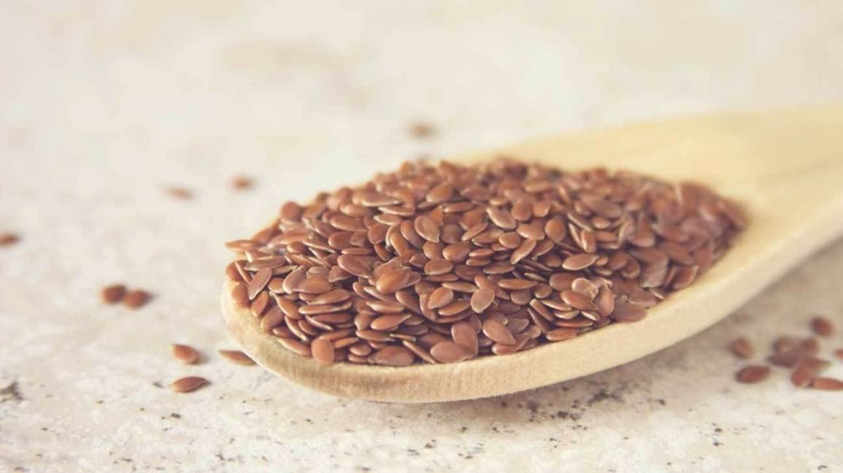Share on Pinterest
Flaxseeds, also known as linseeds, are a great source of fiber and omega-3 fats, particularly alpha-linolenic acid (ALA).
However, the omega-3 fats are contained within the fibrous outer shell of the seed, which humans can't digest easily.
Therefore, if you want to increase your omega-3 levels, it’s best to eat flaxseeds that have been ground.
A 1-ounce (28-gram) serving of flaxseeds contains a wide mix of nutrients:
- Calories: 152
- Fiber: 7.8 grams
- Protein: 5.2 grams
- Monounsaturated fat: 2.1 grams
- Omega-3 fats: 6.5 grams
- Omega-6 fats: 1.7 grams
- Manganese: 35% of the RDI
- Thiamine (vitamin B1): 31% of the RDI
- Magnesium: 28% of the RDI
Flaxseeds also contain several different polyphenols, especially lignans, which act as important antioxidants in the body.
Lignans, as well as the fiber and omega-3 fats in flaxseeds, can all help reduce cholesterol and other risk factors for heart disease.
One large study combined the results of 28 others, finding that consuming flaxseeds reduced levels of “bad” LDL cholesterol by an average of 10 mmol/l.
Flaxseeds may also help reduce blood pressure. An analysis of 11 studies found that flaxseeds could reduce blood pressure especially when eaten whole every day for more than 12 weeks.
A couple of studies have shown that eating flaxseeds may reduce markers of tumor growth in women with breast cancer, and may also reduce cancer risk.
This may be due to the lignans in flaxseeds. Lignans are phytoestrogens and are similar to the female sex hormone estrogen.
What’s more, similar benefits have been shown regarding prostate cancer in men.
In addition to reducing the risk of heart disease and cancer, flaxseeds may also help reduce blood sugar, which may help lower the risk of diabetes.
SUMMARY: Flaxseeds are an excellent source of fiber, omega-3 fats, lignans and other nutrients. A lot of evidence has shown they may reduce cholesterol, blood pressure and even the risk of cancer.

2. Chia Seeds
Chia seeds are very similar to flaxseeds because they are also good sources of fiber and omega-3 fats, along with a number of other nutrients.
A 1-ounce (28-gram) serving of chia seeds contains:
- Calories: 137
- Fiber: 10.6 grams
- Protein: 4.4 grams
- Monounsaturated fat: 0.6 grams
- Omega-3 fats: 4.9 grams
- Omega-6 fats: 1.6 grams
- Thiamine (vitamin B1): 15% of the RDI
- Magnesium: 30% of the RDI
- Manganese: 30% of the RDI
Like flaxseeds, chia seeds also contain several important antioxidant polyphenols.
Interestingly, several studies have shown that eating chia seeds can increase ALA in the blood. ALA is an important omega-3 fatty acid that can help reduce inflammation.
Your body can convert ALA into other omega-3 fats, such as eicosatetraenoic acid (EPA) and docosahexaenoic acid (DHA), which are the omega-3 fats found in oily fish. However, this conversion process in the body is usually quite inefficient.
One study has shown that chia seeds may be able to increase levels of EPA in the blood.
Chia seeds may also help reduce blood sugar. A couple of studies have shown that whole and ground chia seeds are equally effective for reducing blood sugar immediately after a meal.
Another study found that, as well as reducing blood sugar, chia seeds may reduce appetite.
Chia seeds may also reduce risk factors of heart disease.
A study of 20 people with type 2 diabetes found that eating 37 grams of chia seeds per day for 12 weeks reduced blood pressure and levels of several inflammatory chemicals, including C-reactive protein (CRP).
SUMMARY: Chia seeds are a good source of omega-3 fats and are effective at lowering blood sugar and reducing risk factors for heart disease.

2. Hemp Seeds
Hemp seeds are an excellent source of vegetarian protein. In fact, they contain more than 30% protein, as well as many other essential nutrients.
Hemp seeds are one of the few plants that are complete protein sources, meaning they contain all the essential amino acids that your body cannot make.
Studies have also shown that the protein quality of hemp seeds is better than most other plant protein sources.
A 1-ounce (28-gram) serving of hemp seeds contains.
- Calories: 155
- Fiber: 1.1 grams
- Protein: 8.8 grams
- Monounsaturated fat: 0.6 grams
- Polyunsaturated fat: 10.7 grams
- Magnesium: 45% of the RDI
- Thiamine (vitamin B1): 31% of the RDI
- Zinc: 21% of the RDI
The proportion of omega-6 to omega-3 fats in hemp seed oil is roughly 3:1, which is considered a good ratio. Hemp seeds also contain gamma-linolenic acid, an important anti-inflammatory fatty acid.
For this reason, many people take hemp seed oil supplements.
Hemp seed oil may have a beneficial effect on heart health by increasing the amount of omega-3 fatty acids in the blood.
The anti-inflammatory action of the omega-3 fatty acids may also help improve symptoms of eczema.
One study found that people with eczema experienced less skin dryness and itchiness after taking hemp seed oil supplements for 20 weeks. They also used skin medication less, on average.
SUMMARY: Hemp seeds are a great source of protein and contain all the essential amino acids. Hemp seed oil may help reduce symptoms of eczema and other chronic inflammatory conditions.
4. Sesame Seeds
Sesame seeds are commonly consumed in Asia, and in Western countries as part of a paste called tahini.
Similar to other seeds, they contain a wide nutrient profile. One ounce (28 grams) of sesame seeds contains.
- Calories: 160
- Fiber: 3.3 grams
- Protein: 5 grams
- Monounsaturated fat: 5.3 grams
- Omega-6 fats: 6 grams
- Copper: 57% of the RDI
- Manganese: 34% of the RDI
- Magnesium: 25% of the RDI
Like flaxseeds, sesame seeds contain a lot of lignans, particularly one called sesame. In fact, sesame seeds are the best-known dietary source of lignans.
A couple of interesting studies have shown that sesame from sesame seeds may get converted by your gut bacteria into another type of lignan called enterolactone.
Enterolactone can act like the sex hormone estrogen, and lower-than-normal levels of this lignan in the body have been associated with heart disease and breast cancer.
Another study found that postmenopausal women who ate 50 grams of sesame seed powder daily for five weeks had significantly lower blood cholesterol and improved sex hormone status.
Sesame seeds may also help reduce inflammation and oxidative stress, which can worsen symptoms of many disorders, including arthritis.
One study showed that people with knee osteoarthritis had significantly fewer inflammatory chemicals in their blood after eating about 40 grams of sesame seed powder every day for two months.
Another recent study found that after eating about 40 grams of sesame seed powder per day for 28 days, semi-professional athletes had significantly reduced muscle damage and oxidative stress, as well as increased aerobic capacity.
SUMMARY: Sesame seeds are a great source of lignans, which may help improve sex hormone status for estrogen. Sesame seeds may also help reduce inflammation and oxidative stress.

5. Pumpkin seeds
Pumpkin seeds are one of the most consumed types of seeds, and are good sources of phosphorus, monounsaturated fats, and omega-6 fats.
A 1-ounce (28-gram) serving of pumpkin seeds contains:
- Calories: 151
- Fiber: 1.7 grams
- Protein: 7 grams
- Monounsaturated fat: 4 grams
- Omega-6 fats: 6 grams
- Manganese: 42% of the RDI
- Magnesium: 37% of the RDI
- Phosphorus: 33% of the RDI
Pumpkin seeds are also good sources of phytosterols, which are plant compounds that may help lower blood cholesterol.
These seeds have been reported to have several health benefits, likely due to their wide range of nutrients.
One observational study of more than 8,000 people found that those who had a higher intake of pumpkin and sunflower seeds had a significantly reduced risk of breast cancer.
Another study in children found that pumpkin seeds may help lower the risk of bladder stones by reducing the amount of calcium in urine.
Bladder stones are similar to kidney stones. They are formed when certain minerals crystalize inside the bladder, which leads to abdominal discomfort.
A couple of studies have shown that pumpkin seed oil can improve symptoms of prostate and urinary disorders.
These studies also showed that pumpkin seed oil may reduce symptoms of overactive bladder and improve quality of life for men with enlarged prostates.
A study of postmenopausal women also found that pumpkin seed oil may help reduce blood pressure, increase “good” HDL cholesterol, and improve menopause symptoms.
SUMMARY: Pumpkin seeds and pumpkin seed oil are good sources of monounsaturated and omega-6 fats and may help improve heart health and symptoms of urinary disorders.

6. Sunflower Seeds
Sunflower seeds contain a good amount of protein, monounsaturated fats and vitamin E. One ounce (28 grams) of sunflower seeds contains.

- Calories: 164
- Fiber: 2.4 grams
- Protein: 5.8 grams
- Monounsaturated fat: 5.2 grams
- Omega-6 fats: 6.4 grams
- Vitamin E: 47% of the RDI
- Manganese: 27% of the RDI
- Magnesium: 23% of the RDI
Sunflower seeds may be associated with reduced inflammation in middle-aged and older people, which may help reduce the risk of heart disease.
An observational study of more than 6,000 adults found that a high intake of nuts and seeds was associated with reduced inflammation.
Consuming sunflower seeds more than five times per week was associated with reduced levels of C-reactive protein (CRP), a key chemical involved in inflammation.
Another study examined whether eating nuts and seeds affected blood cholesterol levels in postmenopausal women with type 2 diabetes.
The women consumed 30 grams of sunflower seeds or almonds as part of a healthy diet every day for three weeks.
By the end of the study, both the almond and sunflower seed groups had experienced reduced total cholesterol and LDL cholesterol. The sunflower seed diet reduced triglycerides in the blood more than the almond diet, though.
However, “good” HDL cholesterol was also reduced, suggesting that sunflower seeds may reduce both good and bad types of cholesterol.
SUMMARY: Sunflower seeds contain high levels of both monounsaturated and omega-6 fats and may help reduce inflammation and cholesterol levels.
Seeds are great sources of healthy fats, vegetarian protein, fiber, and antioxidant polyphenols.
Furthermore, they can help reduce the risk of certain diseases. In particular, the lignans in certain seeds may help lower cholesterol and the risk of cancer.
Seeds are extremely easy to add to salads, yogurt, oatmeal, and smoothies, and can be an easy way to add healthy nutrients to your diet.

CLOSING THOUGHTS
The Lord has an interest in all the work you are trying to do for Him. Do not worry. The day of trust is in our hands. The day of reckoning will bear the faithful witness as to how we have done our work. Let us do our best. If the Lord is with us, we shall be prospered.

CLOSING PRARER
Look to Jesus. Do not spoil your record by giving way to despondency and distrust. Make straight paths for your feet, lest the lame be turned out of the way.... The man who is nearest the Lord is the man who waits for Him as one who waits for the morning, the man who has the least confidence in self and the strongest confidence in God as the One who can save to the uttermost all who come to Him....Lord let this be our prayer, In Jesus name we pray, Amen

