God Calls for Workers
Verily my sabbaths ye shall keep for it is a sign between me and you throughout your generations; that ye may know that I am the Lord that doth sanctify you. Exodus 31:13. {UL 76.1}

The Lord speaks to those who turn away their feet from [trampling on] the Sabbath. This is the Sabbath spoken of in the thirty-first chapter of Exodus, which God declares is a sign between Him and His people. By keeping this day holy, we show to the world that we recognize God as the One who created the world in six days and rested on the seventh. Earnestly and untiringly we are to bear the message given us, lest time shall pass, and people be left unwarned. {UL 76.2}

My heart aches almost to breaking as I see so much left undone that ought to be done. God’s ambassadors are to maintain a living connection with Him. They are to enlarge their borders and extend their labors. Their lives are to be made pure, holy, ready for the great day soon to come upon the world. When they are imbued with the Spirit of the Master, they will see all around them souls ... perishing in sin, and they will make every effort to save those nigh—even in their own households—and those afar off. Earnest, consecrated effort for those who are out of the fold leaves no time for criticism or questioning. {UL 76.3}

There must be no compromise with selfishness, for selfishness leads to idolatry. Minds that are in the darkness of ignorance, regarding the truth of the Word of God must be enlightened. A breach has been made in the law of God by the transgression of the fourth commandment. The Sabbath command is to be given its rightful position in the law of God, and by those who see and realize its importance, it is to be presented to the world. Those who work unitedly, who act faithfully their part in raising the foundation of many generations with patient, persevering effort, will be called, Repairers of the breach, Restorers of paths to dwell in. {UL 76.4}

There is no excuse for those who have the light of present truth, and yet fail to impart this light to others. God calls for workers. We have a great work to do in cooperating with Him as His helping hand and helping voice. Satan is casting his hellish shadow across the pathway of every soul, seeking to eclipse the testing truth for these last days. We are to sound the message of warning to a guilty race. We are to present to men the binding claims of God’s law, so that when Christ comes, they will not be found in disloyalty, on the side of the Apostate. We must now prepare the way of the Lord. We must make plain in the desert a highway for our God. —Manuscript 22, March 3, 1901, “Diary.” {UL 76.5}
SONG SERVICE:

Rock of Ages

Rock of ages, cleft for me
Let me hide myself in Thee
Rock of ages, cleft for me
Let me hide myself in Thee
Let the water and the blood
From Thy riven side which flowed
Be of sin the double cure
Cleanse me from its guilt and pow'r
Nothing in my hand I bring
Simply to Thy cross I cling
Nothing in my hand I bring
Simply to Thy cross I cling
Naked, come to Thee for dress
Helpless, look to Thee for grace
Vile, I to the fountain fly
Wash me, savior, or I die
Rock of ages, cleft for me
Let me hide myself in Thee
Rock of ages, cleft for me
Let me hide myself in Thee

OPENING PRAYER;

Heavenly Father, my God, we come before you with a desire to know of you more and more every day. We pray Father for your Holy spirit to dwell within. Lead us Lord where you want us to go. It’s almost over Lord, our redemption draws nigh. Our prayer is that you do all you can to keep us from losing our way, whatever it takes Lord. We’ve have come so far. To lose you is unimaginable, so please may we stand fast to the test and trials you will set before us. We ask this pray in Jesus lovely name, Amen.

8 Houseplants to Grow That Can Dramatically Improve Your Health

1. Spider Plant
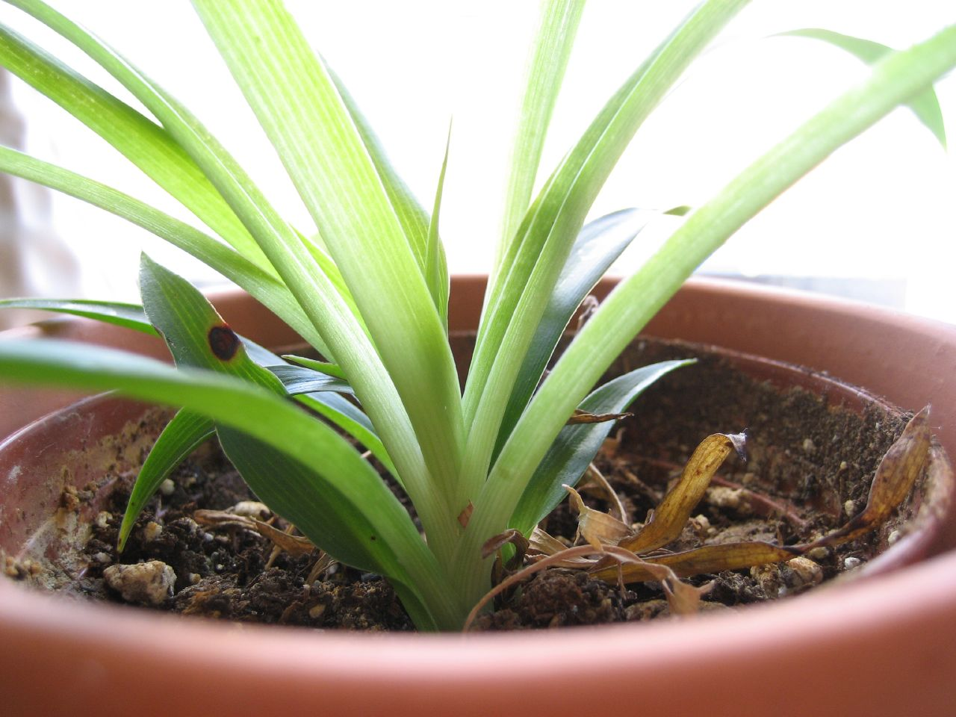
Spider plants are great for removing formaldehyde from the air in your home. This is the stuff that comes from all sorts of things you bring into your home including paper bags, waxed papers, facial tissues, paper towels, napkins, particle board, plywood paneling and synthetic fabrics. In addition to formaldehyde, snake plants target carbon monoxide and other toxic air impurities as well.
If you have poor indoor air quality and not much of a green thumb, a spider plant may be exactly what you need. It’s one of the easiest plants to care for and can be kept in less sunny places in your home since it typically doesn’t like to be placed under direct sunlight.
A spider plant can grow in any type of soil and only needs to be watered occasionally. If you can remember to water it often enough that its soil stays moist, then that’s all you really need to keep this plant alive and thriving.

2. Aloe Vera
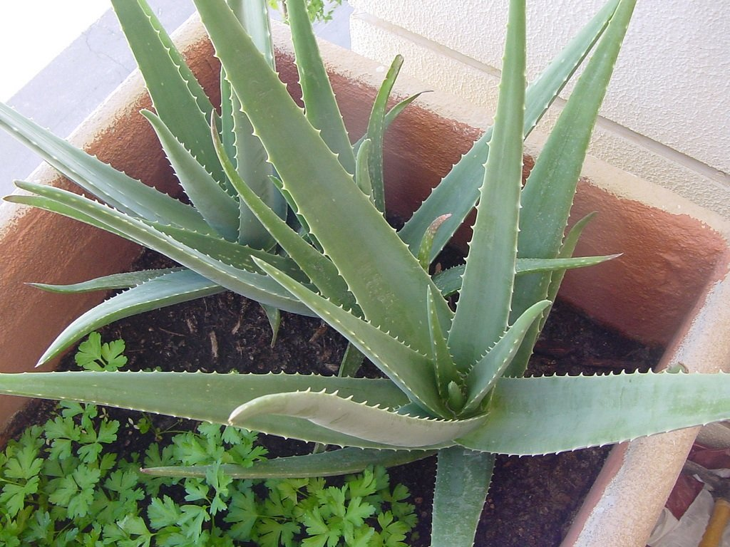

Chances are you’ve probably heard of or used commercially sold medicinal creams or ointments that say they contain aloe vera on their labels. Despite a lack of scientific evidence that aloe vera has any substantial healing properties, it’s been used for thousands of years as a common natural remedy to soothe irritated skin.
The clear, gel-like substance found in the inner part of the leaf can be applied directly to the skin. According to WebMD, people typically use it to help treat burns, sunburn, frostbite, psoriasis and cold sores. Make sure you speak to your doctor first in case you have any allergies.
Aloe vera plants need to be deeply watered and their soil left to dry just slightly (about 1 to 2 inches deep) between watering. They do very well with lots of sun but can turn brown if they get too much of it, so keeping your aloe vera plant under indirect sunlight is best.

3. Lavender
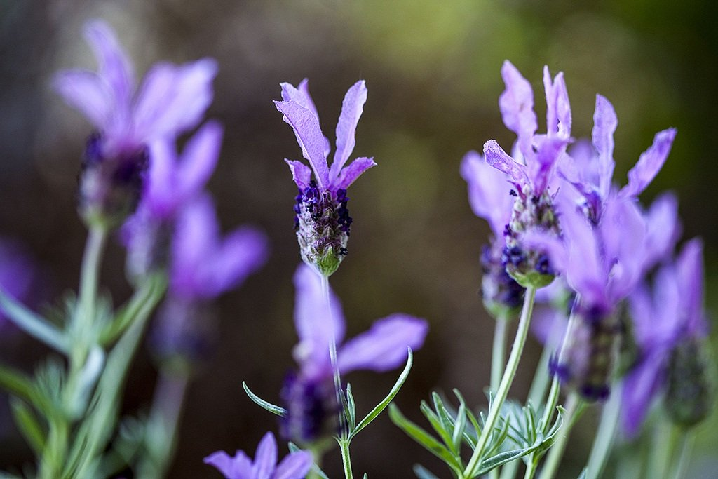

Lavender is a flowering plant that has a very gentle and pleasant aroma. Best known for its stress-relieving mental benefits, the scent of lavender is often used in spa products like bath salts, skincare creams, soaps and candles.

4. English Ivy

Nobody ever wants to think about the possibility of mold thriving in their home. If you’re worried about it, bringing an English ivy plant into your home can help you rest easy since it’s well-known to purify up to 94 percent of airborne mold particles that can trigger allergies.
Like the aloe vera plant, English ivy is another great plant to put in your bedroom. If you have asthma or difficulty breathing at night, it can help you breathe easier and get a restful night’s sleep.
Be aware that English ivy is poisonous, so it should be kept well out of reach from children and pets. The plant thrives under fluorescent light but not direct sun, so it’s the perfect houseplant for darker than normal bedrooms with artificial light. Soil should always be kept moist, but not soggy.

5. Snake Plant
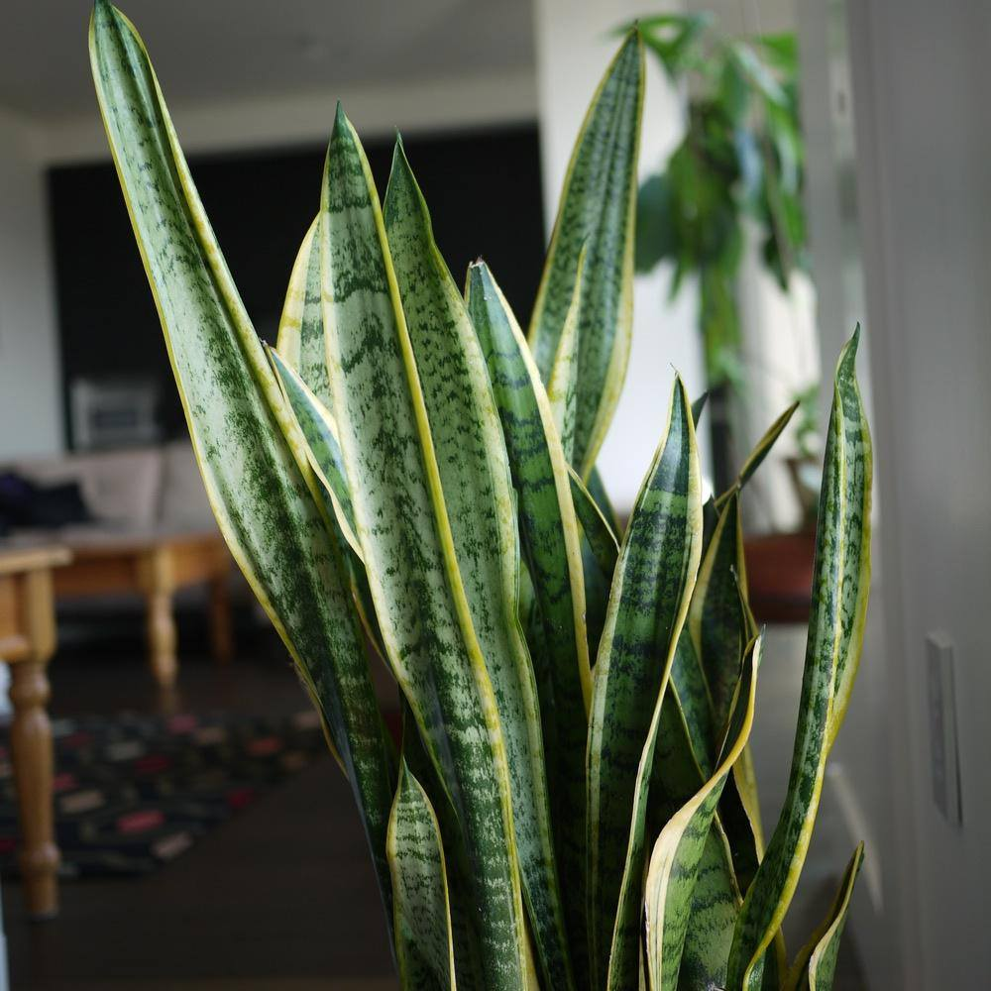

Another great houseplant for the bedroom, the snake plant (also known as the “Mother-in-Law’s Tongue”) is among one of the most popular choices for improving indoor air quality. It actually gets most of its job done at night, converting carbon dioxide into oxygen as you sleep.
Snake plants also remove all sorts of toxins from the air including trichloroethylene, formaldehyde, toluene, benzene and xylene. To optimize its air purifying power throughout your entire home, you’ll likely need more than one plant. Plan to get anywhere from 6 to 8 snake plants that are of waist-high height for optimal air purification.
Considered to be one of the easiest plants to care for, snake plants do great when placed under indirect sunlight. You really don’t have to water them much at all, and they’ll actually grow better if you let them dry out quite a bit between watering.

6. Rosemary
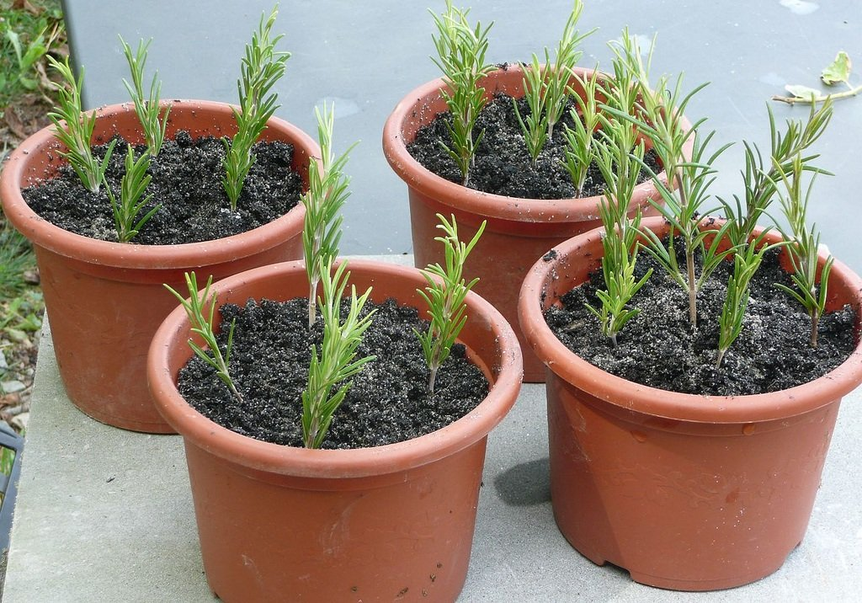

Rosemary is an herb that’s been used in folk medicine for centuries to help improve concentration and memory. It turns out that there may be some merit to this claim since a study conducted by Northumbria University found that people who were exposed to the scent of rosemary essential oil performed better on questionnaires compared to people who were exposed to no scent at all.

Use essential oil with a diffuser in your home, it doesn’t hurt to keep a rosemary plant nearby in places like your home office or any other room where you could use a mental boost.
Rosemary can be planted in a pot and put in any spot where it has access to bright sunlight. It should be watered evenly throughout the growing season but will need less water in the winter. Avoid over-watering and remember to trim your rosemary plant after it flowers.

7. Peace Lily
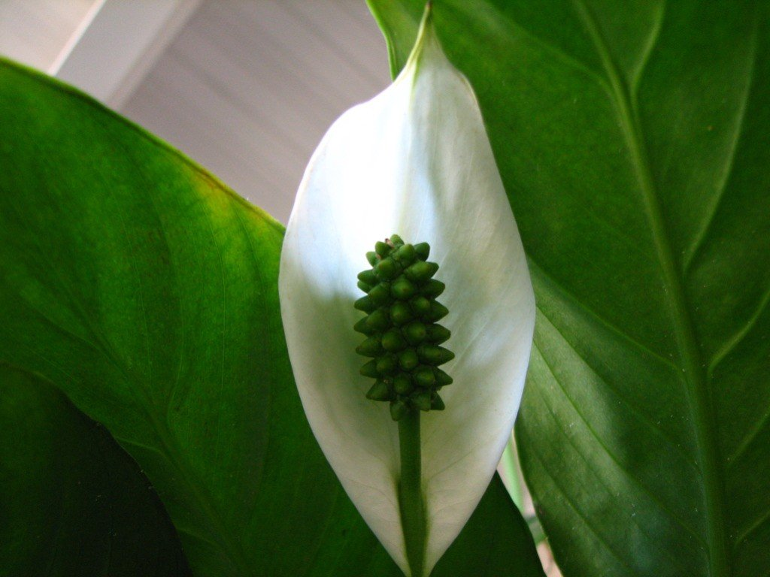

Peace lilies will really compliment your home decor in the summer when their beautiful white flowers are in full bloom, but that’s not all that they can do. This pretty and powerful houseplant is a master of air pollutant removal – working hard to absorb ammonia, benzene, xylene, formaldehyde and trichloroethylene throughout your home.
Since this is a flowering houseplant, it will produce some pollen and a floral scent, which isn’t always suitable for people with plant and pollen-related allergies. With that in mind, peace lilies can make a gorgeous addition to any dining table, side table or entryway table.
Peace lilies should be planted in a pot with all-purpose soil and kept slightly most throughout the entire year (without overwatering). They can thrive in both low and bright light but do best in shaded areas.

8. Boston Fern
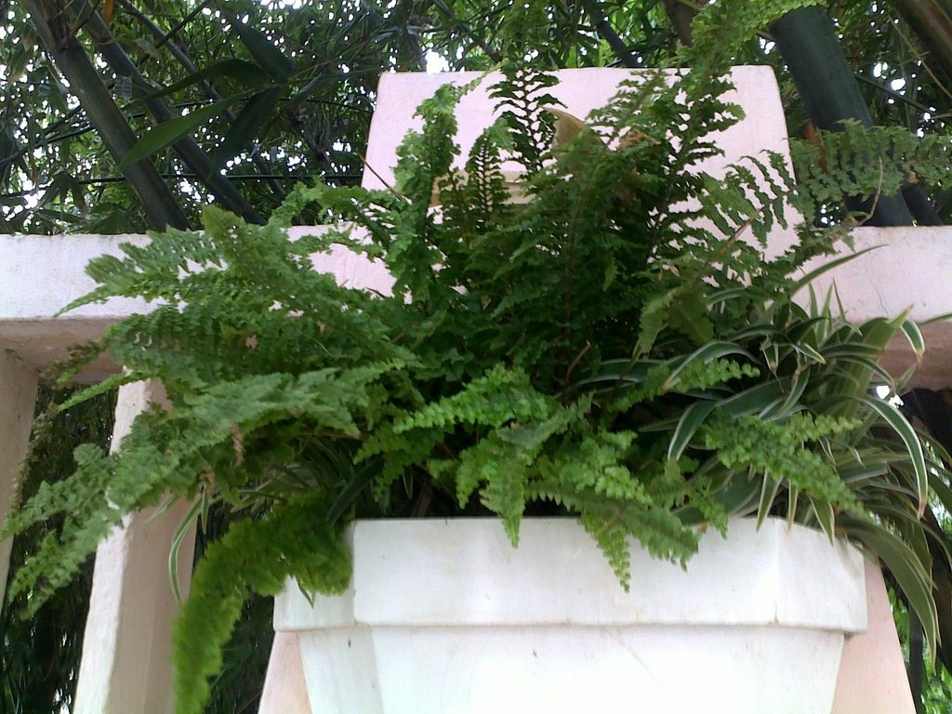

If you live in a location where humidity tends to be a problem, the Boston fern may be the most ideal houseplant to bring into your home. Said to be a natural humidifier, Boston ferns are among the best air purifying plants that also combat formaldehyde, xylene and other unwanted toxins.
Place this type of fern in any air-conditioned room of your home. It may also indirectly benefit any dry skin you may suffer from, which can often be a side effect of highly air-conditioned indoor spaces.
Boston ferns are easy to grow and prefer indirect sunlight, but you should check the soil daily to make sure that it’s kept moist. They’re most efficient in rooms kept at a cool temperature with a humidity level of 50 to 80 percent.
Never discount the power of what a simple and innocent looking houseplant can do for your health. It’s worth doing some further research on the type of plant you choose and how to care for it if it means it will make a difference in how you feel.

CLOSING THOUGHTS:
There must be no compromise with selfishness, for selfishness leads to idolatry. Minds that are in the darkness of ignorance, regarding the truth of the Word of God must be enlightened. A breach has been made in the law of God by the transgression of the fourth commandment. The Sabbath command is to be given its rightful position in the law of God, and by those who see and realize its importance, it is to be presented to the world. Those who work unitedly, who act faithfully their part in raising the foundation of many generations with patient, persevering effort, will be called, Repairers of the breach, Restorers of paths to dwell in. {UL 76.4}

CLOSING PRAYER:

Heavenly Father, we want to thank you for being in our heart and in our life. We know you are with us, doing all you can, for the perfecting of our soul. With fear and trembling we are at your feet. With songs of praise, with love so deep, we are in your dept. Thank you Father for your Son, thank you for seeing in us what we cannot see for ourselves. We love you. In Jesus most precious name, Amen and Amen.

