7. Half Right, Half Wrong - Is Still Wrong

Tess Lambert

Australian Prophecy School

November 5, 2019

Introduction
We finished our last presentation by talking about the message given in October [2019]. It began with a message on Fatima and it ended with a message on the counterfeit; so, we know that part of this message is designed to give us an understanding of what is happening within the papacy. So, it isn't my intention for the sake of time to go into a very in-depth discussion of this subject, or to lay out all the logic that's been previously presented. I suppose the key obstacle to that being time. But I want to just quickly revise [review] the study of the counterfeit. If you have questions about that we can point you in the direction of other presentations that may go into this subject with some more detail. But just as a way of introduction, we understand that there was a war in heaven, that this war was between Christ and Satan, that war spilled out onto this earth, and since that point in time, what type of war has this been? It's been a proxy war; and a proxy war is when two parties fight, but they fight through other agents.

Proxy War
So, the United States is fighting Russia, but they're not fighting; you have troops in Syria fighting and you have Assad’s troops fighting against rebels. So, you have USA and Russia (see Boardwork 2:19-3:36); and the United States is arming rebels and Russia is arming Assad or the government. And it's the rebels and Assad that are fighting. [Bashar al-Assad is] the president of Syria. (I’ll cross off Assad [on Boardwork] and I’ll just write Syria.) So, the government of Syria is fighting an internal civil war against these rebels; they're fighting each other, but behind the Syrian government is Russia, that's arming them, supporting them. This war would have ended many years ago if they didn't have Russia continually resupplying them. Same for the rebels; the United States has propped them up, and you've had this ongoing war since 2011 between the rebels and the Syrian government. But this war is just a proxy war between two global superpowers.
Boardwork 2:19-3:36
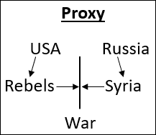
So, you have this war in heaven and it's between Christ and Satan (see Boardwork 3:44-6:54). And what that war begins to look like once it spills out onto this earth is they're not engaging in hand-to-hand combat. Christ has a people, a Church, and Satan has a Church; and then it's these two churches that are engaged in conflict. And Christ can supply us with our armor, with our shield, with our sword; he gives us all of the weapons we need, all of the protection we need, but he fights through his Church. So, this is the definition of a proxy war and how it spilled out of heaven and has been that type of war since Eden.
Boardwork 3:44-6:54
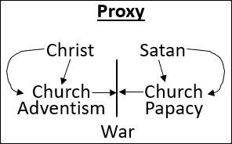
So, when we see this structure, we know that Christ has a church and Satan has a church. How many churches has Christ had since Eden? One church. One church from the very beginning all the way through. How many churches has Satan had? One church. It may appear to change; the church may appear to fall, but it does not fall. It's the one church all through history.
So, it's these two churches that I now want to ‘Compare and Contrast.’ Those churches in our history and our dispensation, Satan’s Church most directly; what would you call it? The papacy. And Christ’s Church? Adventism. So, you have these two separate churches, both at war. So, you now know that we can ‘Compare and Contrast’ Christ’s Church with Satan’s Church. And you know that there are these similarities. Satan’s Church or Satan, he can be represented as being the King of the North (KoN). He wants to live in the side of the North; why? Because that's where Christ’s throne is. So, you start to see that Satan wants the same things that Christ has, and that he works by observing what Christ does and then counterfeiting it.
So, one church is going to keep a Sabbath Day on Saturday and the other church is going to keep a Sabbath Day on Sunday; so, they both are worshiping on specific days. Satan doesn't decide that they're just not going to worship on a specific day; if Christ has a day his people worship, then Satan’s going to have a day his people worship. It's a counterfeit. So, what we began to understand through Fatima is that the way Satan is interacting with his church is in the same fashion or a counterfeit of the way that Christ has interacted with his church.

History of the ‘True’
So, I want to first give a quick overview of how we have seen Christ work with his church over the last centuries. We know we can mark what happens to Christ’s Church in 538 AD (see Boardwork 8:02). You can see it go into captivity; you can see in this history of ‘Scattering’ time. And how long does that last for? 1260 days or years, depending on how you're wording that prophecy, 538-1798 AD. 1260 years of persecution and ‘Scattering.’
Boardwork 8:02
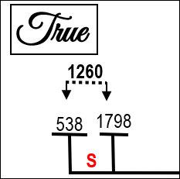
In 1798 what does God begin to do to his church? God is going to raise up a messenger who is going to give a message. So, first thing he has to do is raise up a messenger who can give that message; and he's going to use that message to gather his scattered people. We find this history (see Boardwork 10:33-11:02), from 1798 through these 46 years, is the raising up of William Miller. He has an ‘Increase of Knowledge’ (IoK) until 1818, it's formalized in 1833. And what is he saying? Christ is going to come around the time, he first said 1843, but we know it was October 22, 1844. And what was October 1844 for the for the Millerites? It was a disappointment, the failure of their hopes. 1798 God raises up a messenger, that messenger in 1798, William Miller, is only a teenage boy at that time. He doesn't know his calling; he begins to study around 1816. In 1818 he has his message; and he says in 1818, in about 25 years Christ will come back. In 1833 he is given his credentials as a minister and he is traveling and teaching; and the message continues to spread, and we know there are other events after 1833.
Boardwork 10:33-11:02
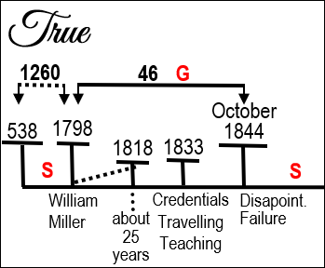
In 1844 this message from this history (see Boardwork 10:33-11:02) all leads to disappointment and failure. The Millerite Movement is decimated, their hopes are destroyed, and many of them are scattered. At this point they go into a time of ‘Scattering’; so, they're scattered here from 538 to 1798 AD. They are gathered for these 46 years [from 1798 to 1844]; after October 22, 1844 they are again scattered.
I want to quote from Ellen White in 1850. She writes in 1850, “The Lord showed me that he had stretched out his hand the second time to recover the remnant of his people.” {Review and Herald, November 1, 1850 par. 9} So, she's being told that God is going to make a second attempt to gather his people. When was the first attempt? 1798-1844. They've been scattered and now God is going to make a second attempt to gather them. She says, “In the ‘Scattering’ time [after October 22] Israel was smitten and torn; but now in the ‘Gathering’ time God will heal and bind up his people. In the ‘Scattering’ [1844-1850], efforts made to spread the truth had but little effect, accomplished but little or nothing; but in the ‘Gathering’ when God has set his hand to gather his people, efforts to spread the truth will have their designed effect.” {RH, November 1, 1850 par. 9}
So, she says in this paragraph we've been gathered in these 46 years, then we were scattered, and God is going to make a second attempt to gather the remnant of his people. In the next paragraph she says this (in our movement) famous passage. “The Lord showed me that the 1843 chart was directed by his hand, and that no part of it should be altered;” {RH, November 1, 1850 par. 10} So, on this same day [in 1850], the next paragraph (see Boardwork 14:18), she states that that 1843 chart (laying out those prophecies) was directed by the hand of God.
Boardwork 14:18
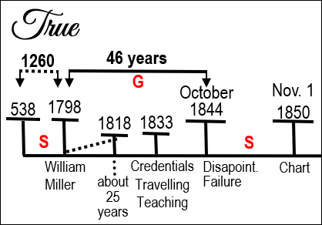
Manuscript Releases Volume 5 202.4 This was written on the same day; it's a letter to Brother and Sister Loveland November 1, 1850. Written on the same day. “God showed me the necessity of getting out a chart. I saw it was needed and that the truth made plain upon tables would affect much and would cause souls to come to the knowledge of the truth.” {5MR 202.4}
So, all of these quotes are from the same day. She gives her seal of approval to the 1843 chart; she writes that she has been told that they were to put out the 1850 chart. She says this all in the context of God making a second attempt to gather up his people. So, what she's doing here is pointing them back to those messages of William Miller, back to the 1843 chart; and then says, based on that same message that's going to be placed in the 1850 chart, there will be a second attempt at ‘Gathering.’ But we all know that this ended in failure.
In 1863 what happened to Adventism? Two different things happened in 1863 I want to want us to remember (see Boardwork 16:02). First of all was the organization of the church. Was this good or bad? Good. Organization is a good thing; we should be organized. So, they were organized, that's a good thing. But then they rejected the message; they rejected the 2520. Good thing or bad thing? Bad. So, they organize which is a good thing in our history, but they reject the message which is a bad thing. So, we recognize that from 1863 we go back into a time of ‘Scattering.’ And how long does that ‘Scattering’ last for? 126 years. That's a 1260 [from 538 to 1798]; this is a 126 [from 1863 to 1989] or a 10th, taking us to 1989.
Boardwork 16:02
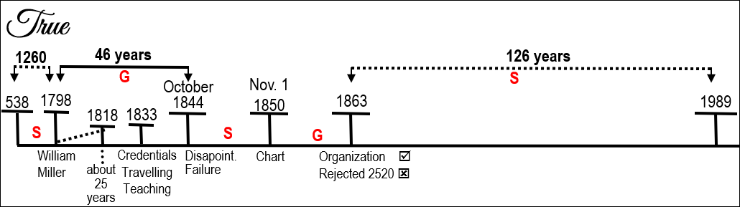
So, in this history of ‘Scattering’ between 1863 and 1989 does God make another attempt to finish the work? Yes. This is the history of Jones and Wagner in 1888. So, in 1888 you have the message of ‘Righteousness by Faith,’ the message of Jones and Wagner. And there's an issue within the church; how does the church leadership respond to the message of Wagner? They reject it. You find that there's a division, a split within the church, where you find on one side Elder Butler and on the other side Wagner. And we can talk about A. T. Jones and other history, but to keep it simple, I just want us to see Elder Butler and his opposition to the work of Wagner. In 1886, two years prior to 1888, Elder Butler writes a pamphlet as a direct attack against the message of ‘Righteousness by Faith,’ and it's called “The Law in the Book of Galatians.” The Pamphlet on Galatians and he's fighting against the message of ‘Righteousness by Faith.’ So, there's a book written by Butler opposing the work of Wagner in 1888; we all know how that eventuates. And did that finish the work? No.
The 126 is completed; we come to 1989. And now what's going to happen? This [Millerite history] is the Alpha of ‘Modern Israel’ and this [Our history] is the Omega of ‘Modern Israel.’ Now God gathers his people. And what does God first have to do? Raise up a messenger. We find Elder Jeff raised up in 1989, the arrival of the First Angel and First Angels Message. So, in a very brief quick overview, this is our history from 538, but particularly from 1798, and this is the history of ‘Modern Israel.’
Who else does God raise up in this time? You have William Miller giving that message, but there's another prophet. I’m not going into the history of Snow and that further development; we're just looking at the development of the prediction. I want us to see that there are two types of prophets; you have a prophet who sees things through study, and then you have the prophet who has divine revelation, and that is Ellen White (see Boardwork 19:42). She's also raised up in that history, converted just prior to October 22, and does her work. So, this is the history of the ‘True.’
Boardwork 19:42
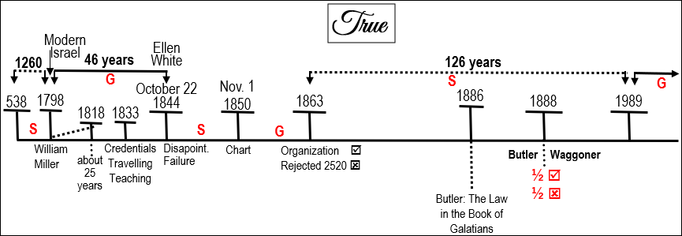

History of the ‘Counterfeit’
Now I want us to see or be reminded of how this parallels with the history of the counterfeit. Why are God's people scattered? What causes God's people to be scattered? And let's change the word ‘Scattering’ to ‘Captivity.’ Why do God's people go into captivity? They reject the message, another word for that would be rebellion. So, God's people go into ‘Captivity,’ because they rebel against their boss. And who takes them into captivity? The King of the North. So, God's people go into captivity because of their rebellion against their master; and they are enslaved by the King of the North. So, in 1798 what happens to Satan’s church? In 1798 what happens to the papacy? They go into captivity. If they go into captivity, why do they go into captivity? Rebellion. Rebellion against who? Their boss. You have to ‘Compare and Contrast’ the two situations. God's people go into captivity because they're rebelling against their boss, God; and they're enslaved by the King of the North. Satan’s people go into captivity because they're rebelling against their boss. And who enslaved them? The King of the South. So, when we look at it that way, we have to understand 1798 from this perspective, that once you have conducted a ‘Compare and Contrast,’ that the reason the papacy went into captivity has to be because they rebelled against their boss.
If you were to go to the Great Controversy 439.2, I just want to highlight one point [with a quote from Ellen White]. “This period, as stated in preceding chapters, began with the establishment of the papacy, A. D. 538, and terminated in 1798. At that time [in 1798], when the papacy was abolished and the pope made captive by the French army, the papal power received its deadly wound, and the prediction was fulfilled, “He that leadeth into captivity shall go into captivity.” {GC88 439.2} So she says, in 1798 the papacy is abolished, the pope is made a captive.
Great Controversy 306.1. “The 1260 days, or years, terminated in 1798. A quarter of a century earlier [25 years before 1798], persecution had almost wholly ceased.” {GC 306.1} Why did persecution cease in 1773, 25 years before 1798? Because the pope abolished the Jesuit order. What was the job function of the Jesuit order? They are to control the kings of Europe and persecute God's people. And what does the papacy do in 1773 when they abolish the Jesuit order? They stop fulfilling the job function given to them by their boss; they stop persecuting God's people; they stop controlling the kings of Europe. So, in 1773 they have gone into rebellion against their boss; they're no longer persecuting God's people; they're no longer controlling the kings of Europe. 25 years after their rebellion they go into captivity. So, from 1798 the papacy was abolished; the pope went into captivity; and you could call this a ‘Scattering.’ And we briefly touched on this when we looked through our histories and we touched on Fatima.
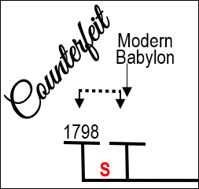
What gathers God's people? A message. In how many parts? It's a three-part message; a three-step prophetic testing message. So, what needs to happen to bring the papacy out of a ‘Scattering’ time? A three-step prophetic testing message. Now what we're doing is we're taking the ‘True’ of ‘Modern Israel’ and we're ‘Comparing and Contrasting’ it with a ‘Counterfeit’ of ‘Modern Babylon.’ How many histories do you find of ‘Modern Israel?’ An Alpha and Omega; Millerites and 144 000. Two different histories, a beginning and an end. So, for ‘Modern Babylon’ how many histories must there be? Two. An Alpha and an Omega history, a beginning and an end. So, you know that there has to be a history prior to our own, because we know that we're in the final events of world history. There must be history prior to our own, but past 1798 where you see ‘Modern Babylon’ resurrect and attempt to finish the work.

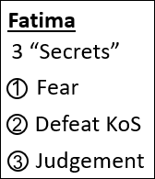
What resurrects God's church is a three-step prophetic testing message. What resurrects Satan’s must be a three-step prophetic testing message; and we discussed the history of Fatima, that they are given three secrets, as they are known. The first one is a vision of hell; it's a message of fear. The second one is to defeat the Soviet Union; defeat the King of the South. The third one a vision of judgment; if you find yourself failing the second. The first one a message of fear, the second one your job function, the third one the consequences of failing your job function. They were given a counterfeit three angels message. They’re given that counterfeit three angels message in 1917. So, you know in 1917 when they have that counterfeit three angels’ message, you know that they must be in a history where Satan is doing a work of restoring his people.

When God deals with his church, we said before there's one church, one church from the beginning all the way through to the end, what happens when the leadership is rebellious? The leadership is bypassed. In one sense you can see it a couple of different ways. I want to argue that the church remains; the leadership comes up within the church, and they are the new leadership. So, when you see the history of God's church, the leadership must come up from within it, and take over as God's church. But the church remains the same. The leadership are bypassed and a new leadership emerges. You find that in the history of Christ. You find that the Jewish leaders are bypassed, and so these other leaders, these disciples, are raised up from within the Jewish nation bypassing that Jewish leadership; and they're going to do the work that the Jewish leadership should have done at the beginning. But they come up from within.
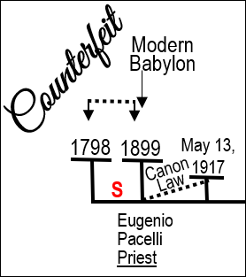
So, what we're looking for is not just a message, but the rising up of a new leadership from within the papacy that's going to restructure it and do a work. And as it's been evidenced in other presentations (but I want to skip through) most clearly that is 1899 and a man known as Eugenio Pacelli. They were famous; they were back then a famous family of Vatican lawyers. There was a grandfather Pacelli, who had worked as the pope's personal lawyer decades before around the 1850s, 1860s, and he had two grandsons. A famous cardinal of that time was a man known as Cardinal Gasparri; and Cardinal Gasparri took these two grandsons under his wing. One grandson, Eugenio’s brother, was Francisco Pacelli, and he was a Vatican lawyer. And what did he draft and introduce? He drafted and introduced the Lateran Treaty [in 1929] with Mussolini. Eugenio Pacelli, his brother, also working with Cardinal Gasparri, worked on another document the, Code of Canon Law.

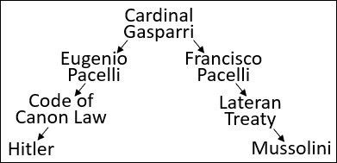
What he began to do was restructure the Catholic Church from the inside; and he introduced that Code of Canon Law in the most rebellious Catholic country there was. The most rebellious Catholic country that he needed to force back under the control of the papacy was Germany. And he signed that Code of Canon Law with Adolf Hitler. So, one brother negotiates a document with Mussolini and one with Hitler; and between them they are able to restructure the Catholic Church, bring back their papal states, and bring back all of those independent pockets of Catholicism under one pyramid structure with the pope at the very head.
So, we're going to discuss Fatima, but it's not just the message of Fatima; there's a leadership being raised up from within. In 1899 Eugenio Pacelli is made a priest, and he begins to study Code of Canon Law. Canon law being the laws of the Catholic Church. He begins that study in 1899; he continues it under Cardinal Gasparri, and they rewrite church law for the entirety of the Catholic Church. He begins to have an agenda. As you see World War I/World War II, he has quite a papal agenda. And you find that in May of 1917, after years of work, in May of 1917 they finished rewriting the Code of Canon Law. Once they're finished rewriting the Code of Canon Law in May of 1917, Pacelli is made a bishop. And the reason that he's made a bishop is that they want to send him to that rebellious country of Germany to bring the Catholic Church back into the control of the papacy, because they were quite rebellious. So, you're noticing a ‘Compare and Contrast.’
Before God's church can do a work, he has to sort out his own people because they are not fit for purpose. Before Satan’s church can do a work, who does he have to sort out? His own church, because the papacy is not fit for purpose, not for Satan’s purpose. So, he rises up a leadership from the inside. It's May 13, 1917 that Pacelli is made a bishop.
I’m quoting here from the book Hitler’s Pope. “Those with a mind to read significance into Marian dates would later note that Pacelli was made a bishop on the very day, Sunday, May 13, 1917, when three children were said to have witnessed a Lady all of dazzling light at a place called Fatima in Portugal.” This is the first Fatima vision. “Forty years later, as Pope, Pacelli himself witnessed in the Vatican gardens what he thought to be the phenomenon of the spinning sun.” [The spinning sun] was the miracle that was supposed to have occurred at Fatima. So, on the same day as Fatima, Pacelli was made a bishop; and he personally connected himself to Fatima, to those events.
A Marian date is a date associated with Mary.
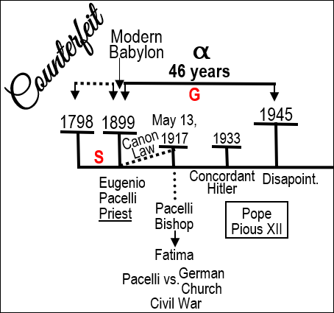
May 18, a few days later, he sets off for Germany to rewrite church law within Germany and bring them back under the control of the papacy. He's working on that church law within Germany for a long time; because of the conflict in the country, it takes a long time to bring that law into practice. And one of the reasons it's so hard is that within the papacy, he's not just fighting the German government, he's also fighting with the German church itself. So, it's Pacelli versus the German Catholic Church. What you find, there's civil war within the church, because they don't want to come under the dictatorship of the Vatican. But he finally has that signed in 1933; and he has a quid pro quo with Hitler, where Hitler allows him to introduce this church law as long as Pacelli dissolves the last democratic political party in the German government. It's this introduction of this law that also places Hitler as a complete dictator that they sign a concordant. And you would think that he has Germany under control and the Catholic Church restructured, but soon after this he becomes Pope Pius XII in 1939. So, this is the history of Pope Pius XII, Eugenio Pacelli.

And he has a plan that out of the chaos of World War II (either by supporting Hitler and defeating the Soviet Union, or being neutral and acting as some type of mediator), that he's going to be able to really revive the Catholic Church as a political power over Europe. And he's hoping to do that through the history of World War II so much so that ambassadors to the Vatican (particularly from Britain) are disgusted with him, because they can see his attempts. And because he wants to be neutral or support Hitler, he is refusing to condemn the Holocaust or help the Jews within Rome. So, he made quite some enemies in that history. His hopes in 1945 were dashed when Germany was defeated and communism swept across eastern Europe all the way up to the very doorstep of Italy and almost took over Italy itself. There was a great disappointment.
From Fatima forward it was recognized by Franco in Spain as well as these other dictators, Mussolini and Hitler, that their fight against communism really was under the cult of Mary. It was Mary in this second secret that said to defeat the King of the South. So, they use Mary throughout this history as a rallying call against communism.
I’m just going to quote from Hitler’s Pope, “Pacelli’s remarkable agenda was impelled, as we have seen, by an almost messianic conviction through three generations of the Pacelli family, that the Church could survive and remain united in the modern world only by strengthening papal authority through the application of law.” And that's what he put into effect from 1899 all the way through to his election as pope, and then attempted to capitalize off. 1945 resulted in the disappointment of those hopes. And again, we find a ‘Scattering’ time; in this history all they're trying to do is everything in their power to make sure that Italy doesn't fall under communism and that the Catholic Church doesn't lose the small amount of power it had gained.
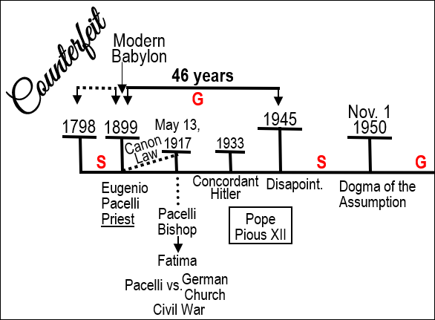
In 1850 Pope Pius XII, Eugenio Pacelli, makes a second attempt using the message of Fatima and the cult of Mary; and in 1950 he steps out onto the loggia above St. Peter's Square and he announces to the thunderous applause of a crowd of a million people that Mary, when the course of her life was run, was assumed in body and soul to heaven. This is the formal definition of the dogma of the Assumption, that Mary was assumed body and soul to heaven after her course in life was run. Quoting from Hitler’s Pope, “But there was a sense of militancy and defiance about the timing of this [Pope Pius XII] dogmatic formulation.” “Pacelli’s Marian fervor was confined and intensified at the time” by, this is when he claims to have his “mystical” experience. And the reason that he's reviving the message of Mary and of Fatima is because he was using it as a rallying cry again against communism. The day he steps out to that million strong crowd and announces the dogma of the Assumption was November 1, 1950, but this came to no fruition. He later died. The ‘Gathering’ he began and hoped for ended in failure.
A new pope arrived and how did that pope handle the message of Fatima? He didn't. In 1962 you are in the history of the second Vatican council; and what are they doing? It's a work of reorganization of the Catholic Church.
Question: If this organization was good for God's Church, for their mission, was this reorganization good for Satan’s Church and for their mission at the end of the world? Yes. But what else do they do at the second Vatican council? They reject the message of Fatima. And how they do that is by not publicly rejecting it, but they go into a secret deal with the Soviet Union. And if the Soviet Union allows the Orthodox Russian Church to send representatives to the second Vatican council, Pius XII promises that they're not going to make any condemnation of communism or of the Soviet Union at this Vatican council. And you remember what their instructions were; it's [this agreement] a rejection of that their prophetic message [of Fatima]. By this stage he's died [Pius XII]; this is a new leadership, Pope John XXIII. You have a series of popes after this date [from when Pius XII dies in 1958] until you come to John Paul II [in 1978]. So, I would suggest that from 1962 they've gone back into history of ‘Scattering.’
Now we know from our message, we know that we are in the final scenes of this earth's history, and closer than perhaps we are aware to the Sunday Law. So, do you think that after 30 years of God working with his church and building us up, that Satan hasn't already begun to prepare his own church for that same crisis? You know that he has already begun that work; the only question is when did he step up and start counterfeiting and preparing the papacy for the end of world history, for the final conflict. I’ll discuss that date in a minute.

Half Right, Half Wrong
What I want us to see is that between 1962 and this final preparation within the Catholic Church you have another attempt, the history of 1989. And in this history, you have another Pope, John Paul II. You have Pope John Paul II and he's the leadership of the Catholic Church. Now in the history of Butler and Wagner, who's right and who's wrong? According to Ellen White's comments of that history, she says, neither of them have all the light on the issue. If neither of them have all the light, what does that mean they have? Some of the light. So, you could say that Butler has some light and Wagner has some light. She says neither of them have all the light on the issue; this is where we start entering into the topic of ‘Half Right, Half Wrong.’
So, in this history of 1989 (see Boardwork 47:07), John Paul II is trying to do a good work for their church; and what is that good work? He wants to defeat the King of the South; he wants to defeat the Soviet Union. But within the Catholic Church what do you have? Civil War. Because who is fighting against him? Who is he ideologically opposed to? The Jesuits. This is a history, this 1989 history, is a history of civil war within the Catholic Church to a scale that I don't think we're fully aware of. It was John Paul II against the Jesuits. And they were strongly opposed to each other, so much so that in the history of 1987 a close associate of John Paul II, a man known as Malachi Martin, wrote a book defending John Paul II titled The Jesuits: The Society of Jesus & the Betrayal of the Roman Catholic Church. And you find that there's this split and this civil war between them. So, John Paul II, he's trying to do the right work in defeating the Soviet Union, but he's a fighting against the Jesuits. And I would suggest that he's half right, he's trying to defeat the Soviet Union. But it's the Jesuits who were right on the second Vatican council and the changes that needed to happen within the Catholic Church.
Boardwork 47:07
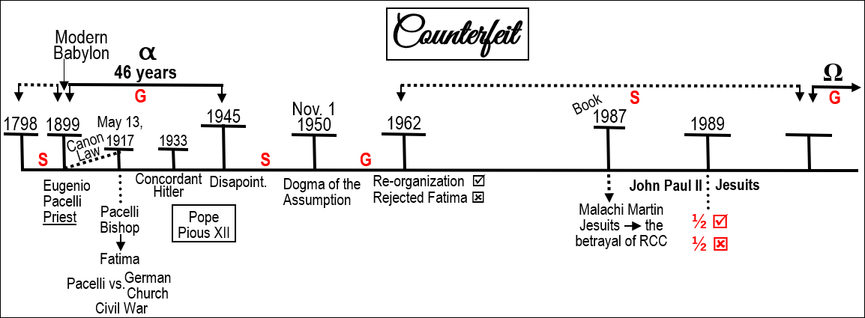
So, we've flown through this history. We've seen that there is a history of an Alpha and an Omega, this [46 years during Eugenio Pacelli] being the Alpha, this [time at the end] being the Omega. We can ‘Compare and Contrast’ the ‘True’ and the ‘Counterfeit.’ God's people go into apostasy and they're scattered. God attempts to re-gather them through a three-step prophetic testing message, But He's going to raise up a messenger, William Miller, who's going to have an ‘Increase of Knowledge’ on that message. The message in its capsule form is known in 1818, it's formalized in 1833, but it all leads to a disappointment and a failure on October 22, 1844. In that history he's also raising up a prophetess who has visions; she's instructed by God, not through just a study of the word, but directly.
The counterfeit, they go into apostasy in 1773, they abolish the Jesuit order, soon after they're scattered. Satan needs to regather his church; he's going to do that through a three-step prophetic testing message. He needs to raise up a new leadership within that church who are going to listen to his voice. He begins that with Eugenio Pacelli who's made a priest in 1899, begins to study the Code of Canon Law, and May of 1917 completes his church law that's going to restructure the Catholic Church under the leadership of Rome.

Boardwork 49:01
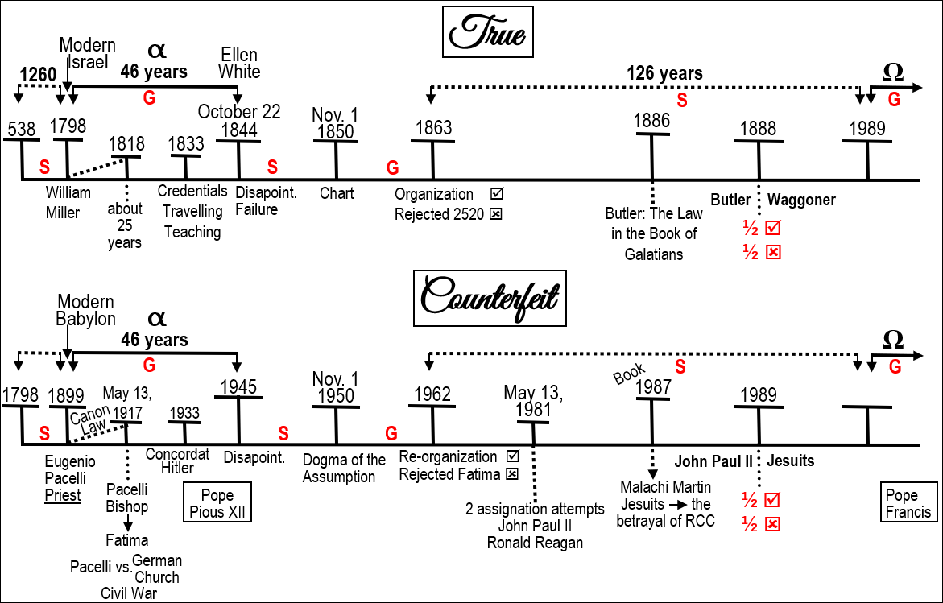
This [True (T) line: three-step testing message] causes civil war within Protestantism that leads to a new leadership. The church doesn't change. This [Counterfeit © line: three-step testing message] leads to a civil war within the papacy. A new leadership emerges but the church essentially doesn't change. In 1933 it's formalized; he becomes Pope Pius XII. 1945, disappointment and failure. You have [comparing the dates from both lines] 1798 [T], 1899 [C], 1818 [T], 1917[C], 1833 [T], 1933[C], 1844 [T], 1945[C] (see Boardwork 49:01). Like any counterfeit trying to be perfect, not succeeding to be perfect. Again, they're scattered; now it's just a struggle to keep communism from your doorstep. November 1, 1850 Ellen White announces that there is a new ‘Gathering’ and she reminds them of the message in this [46 year] history, the 1843 chart. November 1, 1950 Pius XII attempts a new ‘Gathering’ and is reminding them of the message of Mary, of Fatima, the dogma of the Assumption. This attempt of a ‘Gathering’ by bringing them back to the old paths is a failure. And in 1863 Adventism organizes, rejects the prophetic message. 1962 the Catholic Church reorganizes, rejects their prophetic message.

Boardwork 49:01
You have this second attempt to finish the work. In 1888 you have Butler and Wagner; again, there's a civil war within the church just like there is back here [Miller and Snow]. With Butler and Wagner neither had all the light on the issue; they're unable to complete the work. In 1989 it's John Paul II versus the Jesuits. John Paul II does defeat the Soviet Union but he does not take over eastern Europe and make it the Catholic stronghold that he wanted it to be. He also does not continue to have influence within the American government, even on that level he fails. So, you see that this [John Paul II] history failed, just as did this [Pious XII] history.
So, again from 1989 God is working to raise up a leadership within Adventism that's going to be prepared for the final events of world history and finish the work. Satan isn't going to give God much of a head start, it's been 30 years. So, you know that the Catholic Church today, it is in a state of civil war. It's in a state of civil war because there's a new leadership that's overthrowing the old order and is preparing them for the final scenes of world history.
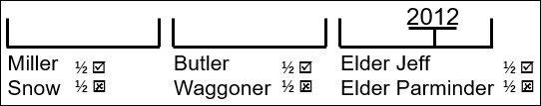
This is where it was left until Elder Jeff began his study of ‘Half Right, Half Wrong.’ And what he taught was, he took these two histories [Miller/Snow and Butler/Waggoner], he took the history of William Miller and Samuel Snow, and he said that Miller and Snow were half right and half wrong. Miller was half right and Snow was half right; they both had truth in their messages. But they were opposed to each other, because they were also half wrong. Samuel Snow predicted that October 22 would be the second advent, and it wasn't. So, Samuel Snow was half right and half wrong. You come to this history [1888] and Butler and Wagner are half right and half wrong. And what he did with this was he said that you have these two other histories, it is Miller and Snow, and it is Butler and Wagner, and he lined that up with himself and Elder Parminder in the history of 2012 and the rejection of time. He said that Miller and Snow were half right and half wrong, Butler and Snow were half right half wrong, and therefore in this dispensation he was half right and half wrong and Elder Parminder was half right and half wrong.
We talked about our four dispensations. We have four dispensations within our reform line, this is the dispensation of 9/11 [2001] to 2014 (see Boardwork 56:05). In 2012 Elder Parminder introduced time setting into the movement and predicted 2014; when that prediction was made Elder Jeff rejected the message of time setting, he rejected the testing message for this dispensation. We have said from this movement for many years, if you reject the first angel’s message, can you be benefited by the second? Continue that logic, if you reject the second angel's message can you be benefited by the third? Did Elder Jeff accept the second angel's message? No.
Boardwork 56:05
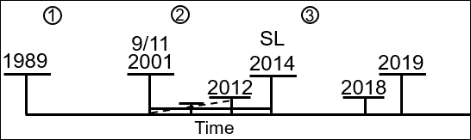
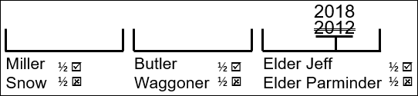
So, is it a coincidence or is it prophetic that when the ‘Midnight Cry’ message came he could not study it, he could not teach it, and he has publicly admitted to not even being willing to watch it? If you reject the first angel, you cannot be benefited by the second; but the mistake made by Elder Jeff and others within this movement, if you reject the second, you can't be benefited by the third. In 2012 there was a rejection of the message of time. And what was taught earlier in this year in April [2019] is that he was justified to reject time in his history because Elder Parminder predicted 2014 to be Sunday Law. And it's Sunday Law on fractal, but it's still Sunday Law. So, he has a logic to try and say that it's half wrong because it's a fractal Sunday Law not the Sunday Law of Daniel 11:41 that's his logic. And his excuse for making that claim is that Miller and Snow were half right and half wrong and Butler and Wagner were half right and half wrong. And he's saying that there's these three histories. The problem is, that if you do that, the message of Snow was meant to be the Midnight Cry that finished the work, Wagner, that was meant to be the Loud Cry that finished the work. So, he shouldn't be making this 2012, he should be making this 2018. And now you know why he has no problem saying that the Midnight Cry of 2018 was half right and half wrong.
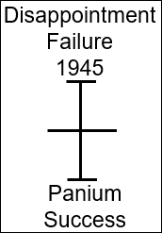
The problem identified with this logic (in the last 30 seconds we have), is what two histories is he using? The problem is that 1945 for the papacy was a history of disappointment and failure. But when you cut and overlay your lines what is 1945? What is 1945 in the Omega of ‘Modern Babylon,’ not in the Alpha history? 1945 lines up with Panium; 1945 is disappointment and failure, because Pope Pius XII had mistakes in his message. Panium for the papacy, the defeat of the King of the South, is that disappointment and failure for the King of the North? No. So, the problem identified with this is that he's using these two histories, the history of Miller and Snow, the history of Butler and Wagner; and the issue that he's facing is he's using two histories of failure. If this work had come to completion, would you have any history today with an Elder Jeff and an Elder Parminder? No. It wouldn't exist, because the only reason you have an Omega history is the fact that the Alpha history ended in failure. You can't take a history of failure, connect it with a history of failure, and make application in a history of success. And we are not in a history of failure.
If you were to go to the history of Ancient Israel, they came out of Egypt under Moses, they came out of Babylon (see Boardwork 58:40-1:00:00). First the captivity to Egypt, that God brought them out of, then the captivity to Babylon, that God brought them out of, and at the end (this [Egypt/Moses] is the Alpha, this [Rome/Christ] is the Omega) they're in captivity to Rome, and God has to bring them out of captivity to Rome. Alpha and Omega; beginning and the end. But in this history, in the history of Moses, in our Alpha history, did they complete the work? No, they failed. There was failure here on the part of the Israelites; they came out of Babylon and they just became pharisees. They didn't complete the work. When God brought them out of captivity to Rome (which looked different to what they expected), it was a history of success.
Boardwork 58:40-1:00:00
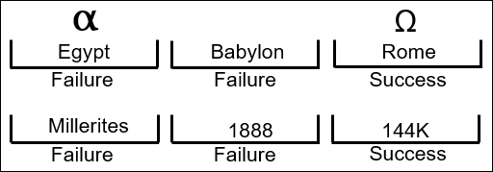
When you come down to our history, and you see the history of the Millerites, and you see the history of 1888, you're dealing with two histories that ended in failure. And we know the Omega history of the 144,000 ends in success. 1945 teaches us that when you line it up with Panium, you can't say there's going to be a defeat of the King of the North here [1945]. In 1945 the King of the North, Germany, was defeated. Panium, the King of the North is not defeated. What is failure for the King of the North here [in 1945], is success for the King of the North here [Panium]. Failure in an Alpha history is success in an Omega history. Failure in the history of Moses, you bring that to the history of Christ; and was the message of Christ to the disciples half right and half wrong? No. It was perfect, because the history of Christ was a history of success.
That's a quick overview of ‘Half Right and Half Wrong, understanding failure and success. The history of Pyrrhus gives us a whole second witness to show how there are histories of failure and histories of success. And you cannot use the mistake of a failure and project that into a history of success. What did happen was the rejection of the second angel (see Boardwork 1:01:17); and if you reject the second, you will not be able to receive the third.
Boardwork 1:01:17
We're over time. This is the counterfeit laid out fairly quickly. When we come back tomorrow the purpose of our studies (really what I want to bring us to) is to discuss this movement within the Catholic Church, our current counterfeit movement. Right now within Adventism there's a movement coming up, this Movement, the leadership of Adventism has been passed by. This movement becomes the leaders of Adventism. The same church remains; God's Church never changes, but the leadership is passed by. And you find that people have to make a choice, and it can look like a split or civil war.
So, when you look at the Catholic Church, we're preparing for the final events, they're preparing for the final events. And as they prepare for the final events, Satan’s going to counterfeit the same work, a movement within the Catholic Church that replaces the leadership and prepares them for the final events of world history. And I’m stating that that leader is Francis. And the work that he is doing is to restructure the Catholic Church. There are differences between the ‘True’ and the ‘Counterfeit.’ Here [on the ‘True’ line] you have William Miller, Samuel Snow, other leaders. In this history [on the ‘Counterfeit’ line], it's just Pacelli; you just have one all the way through. The counterfeit is close, but it's not perfect. Pacelli was the only leader that overthrew the leadership in this history and became the pope, the same with Francis; he's the last pope for the Catholic Church, and you can demonstrate that. And he will finish the work. So, we want to come back tomorrow and have a bit of an observation of what this civil war within the papacy looks like.

Closing Prayer
If you kneel with me, we'll close in prayer. Dear Father in heaven, thank you for this day, for this camp meeting. I pray Lord that you will bless our day, our fellowship, and the studies that come after. Lord we know that you are preparing and training us for the final events and that they are coming quickly. I pray Lord that you'll help us to see your love for us, your value in us that you would want to even work with us Lord to do your work. I pray you'll fit us up for that purpose. I pray in Jesus’ name, Amen.
