Overview of Chapters 1,2, and 3

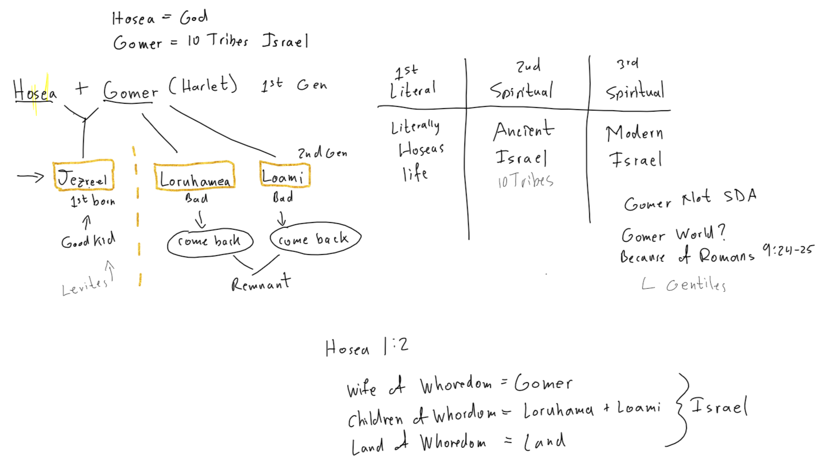

Chapter 1

1 The word of the LORD that came unto Hosea,(H1954 deliverer) the son of Beeri,(H882 fountained) in the days of Uzziah, (H5818 strength of Jah) Jotham,(H3147 Jehovah is perfect),Ahaz,(H271 possesor)and Hezekiah,(H3169 strengthened of Jah)kings of Judah,(H3063 celebrated) and in the days of Jeroboam (H3379 people will contend)the son of Joash,(H3101 from H3060 Jehovah fired)king of Israel.
2 The beginning of the word of the LORD by Hosea. And the LORD said to Hosea, Go, take unto thee a wife of whoredoms and children of whoredoms: for the land hath committed great whoredom, departing from the LORD.
3 So he went and took Gomer ( H1586 completion) the daughter of Diblaim; ( H1691 two cakes) which conceived, and bare him a son.
4 And the LORD said unto him, Call his name Jezreel;(H3157 God will sow)for yet a little while, and I will avenge the blood of Jezreel upon the house of Jehu,(H3058 Jehovehis He) and will cause to cease the kingdom of the house of Israel.
5 And it shall come to pass at that day, that I will break the bow of Israel in the valley of Jezreel.
6 And she conceived again, and bare a daughter. And God said unto him, Call her name Loruhamah(H3819 not pitied)for I will no more have mercy upon the house of Israel; but I will utterly take them away.
7 But I will have mercy upon the house of Judah, and will save them by the LORD their God, and will not save them by bow, nor by sword, nor by battle, by horses, nor by horsemen.
8 ¶ Now when she had weaned Loruhamah, she conceived, and bare a son.
9 Then said God, Call his name Loammi(H3818 not my people) for ye are not my people, and I will not be your God.
10 Yet the number of the children of Israel shall be as the sand of the sea, which cannot be measured nor numbered; and it shall come to pass, that in the place where it was said unto them, Ye are not my people, there it shall be said unto them, Ye are the sons of the living God.
11 Then shall the children of Judah and the children of Israel be gathered together, and appoint themselves one head, and they shall come up out of the land: for great shall be the day of Jezreel.

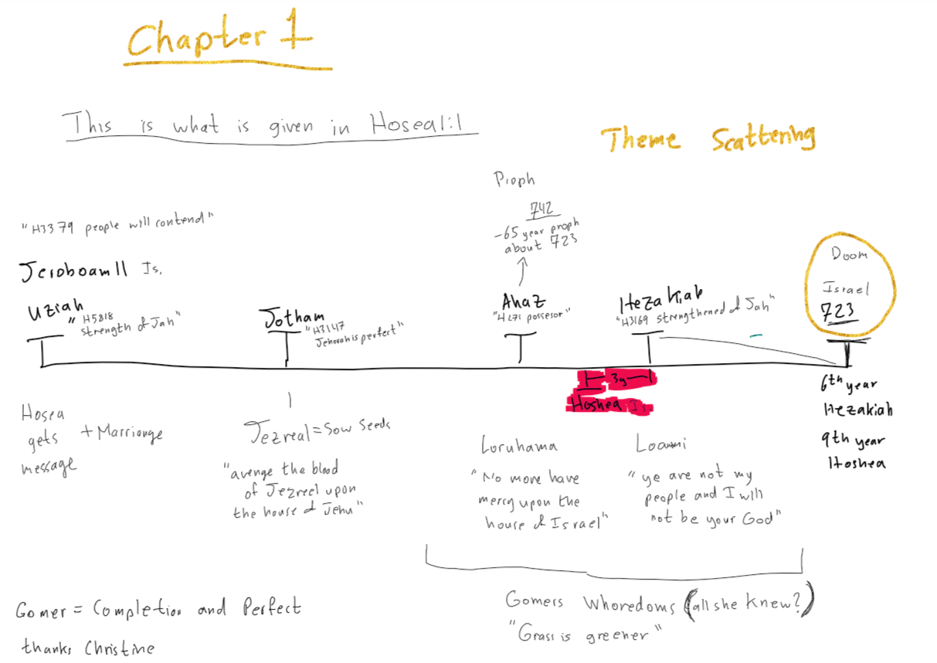

CHAPTER 2
1Say ye unto your brethren, Ammi;(H5971 a people, troops or attendants) and to your sisters, Ruhamah.(H7355 to fondle, to love, have compassion)
2 Plead with your mother, plead: for she is not my wife, neither am I her husband: let her therefore put away her whoredoms out of her sight, and her adulteries from between her breasts;
3 Lest I strip her naked, and set her as in the day that she was born, and make her as a wilderness, and set her like a dry land, and slay her with thirst.
4 And I will not have mercy upon her children; for they be the children of whoredoms.
5 For their mother hath played the harlot: she that conceived them hath done shamefully: for she said, I will go after my lovers, that give me my bread (food) and my water, my wool (to be shaggy) and my flax,(linen) mine oil (richness, anointing)and my drink (moisture, refreshment)
6 ¶ Therefore, behold, I will hedge up (shut in,entwine,fence) thy way with thorns, and make a wall,(towall in all around) that she shall not find (to come forth, to appear, to exist) her paths.
7 And she shall follow after her lovers, but she shall not overtake them; and she shall seek them, but shall not find them: then shall she say, I will go and return to my first husband; for then was it better with me than now.
8 For she did not know that I gave her corn, and wine, and oil, and multiplied her silver and gold, which they prepared for Baal(Phoenician diety).
9 Therefore will I return, and take away my corn (property increase)in the time thereof, and my wine in the season (fixed time) thereof, and will recover (snatch away)my wool and my flax given to cover (fill up hollows, clothe, conceal, cover) her nakedness(properly disgrace)
10 And now will I discover her lewdness in the sight of her lovers, and none shall deliver her out of mine hand.
11 I will also cause all her mirth(delight, joy) to cease, her feast days, her new moons, and her sabbaths, and all her solemn feasts.
12 And I will destroy her vines and her fig trees, whereof she hath said, These are my rewards that my lovers have given me: and I will make them a forest, and the beasts of the field shall eat them.
13 And I will visit upon her the days of Baalim, wherein she burned incense to them, and she decked herself with her earrings and her jewels, and she went after her lovers, and forgat me, saith the LORD.
14 ¶ Therefore, behold, I will allure her, and bring her into the wilderness,(desert, no pasture) and speak comfortably unto her.
15 And I will give her her vineyards from thence, and the valley of Achor (troubled) for a door of hope: and she shall sing there, as in the days of her youth, and as in the day when she came up out of the land of Egypt.
16 And it shall be at that day, saith the LORD, that thou shalt call me Ishi;( H582 husband, man, fellow, he, him check H802) and shalt call me no more Baali.
17 For I will take away the names of Baalim out of her mouth, and they shall no more be remembered by their name.
18 And in that day will I make a covenant for them with the beasts of the field, and with the fowls of heaven, and with the creeping things of the ground: and I will break the bow and the sword and the battle out of the earth, and will make them to lie down safely.
19 And I will betroth (ehgage for matrimony) thee unto me forever; yea, I will betroth thee unto me in righteousness, and in judgment, and in lovingkindness, and in mercies.
20 I will even betroth thee unto me in faithfulness: and thou shalt know the LORD.
21 And it shall come to pass in that day, I will hear, saith the LORD, I will hear the heavens, and they shall hear the earth;
22 And the earth shall hear the corn, and the wine, and the oil; and they shall hear Jezreel.
23 And I will sow her unto me in the earth; and I will have mercy upon her that had not obtained mercy; and I will say to them which were not my people, Thou art my people; and they shall say, Thou art my God.

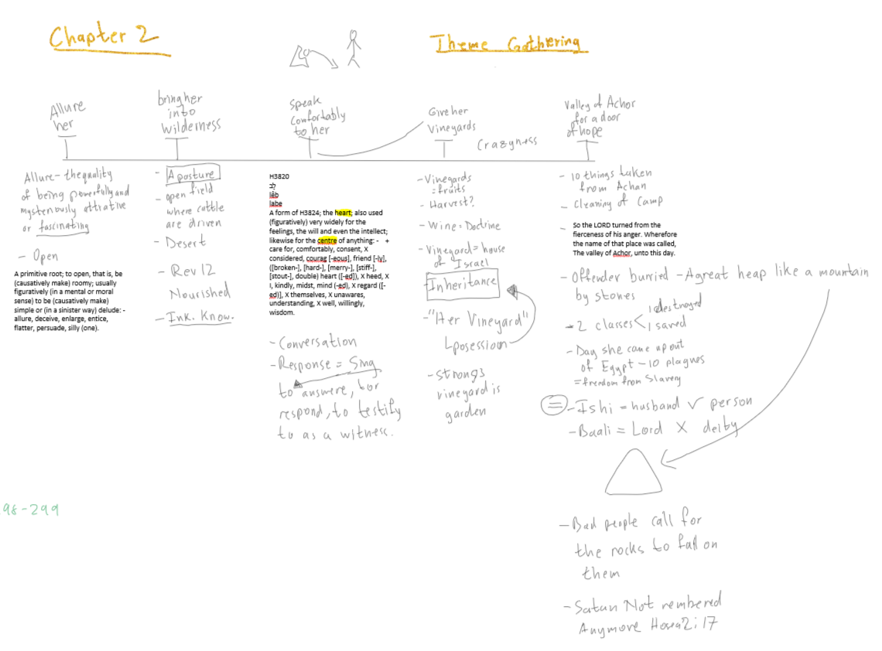

CHAPTER 3

1 ¶ Then said the LORD unto me, Go yet, love a woman beloved of her friend, yet an adulteress, according to the love of the LORD toward the children of Israel, who look to other gods, and love flagons (something pressed together like cake of figs) of wine. Lev. 27:16 1 homer = 50 shekels
2 So I bought her to me for fifteen pieces of silver, and for an homer of barley, and an half homer of barley: 15 + 50 + 25
3 And I said unto her, Thou shalt abide for me many days; thou shalt not play the harlot, and thou shalt not be for another man: so will I also be for thee.
4 For the children of Israel shall abide many days without a king, and without a prince,(H8269 a head person, captain, general, governor) and without a sacrifice,(H2077 properly a slaughter, the flesh of an animal, a sacrifice, victim) and without an image,(H4646 something stationed, a column or memorial stone, a pillar) and without an ephod,(H646 girdle or the shoulder piece of the high priestand without teraphim(H8655 a healer):
5 Afterward shall the children of Israel return, and seek the LORD their God, and David their king; and shall fear theLORD and his goodness in the latter days.

WHO IS JEHU AND WHAT IS THE STORY OF THE VALLEY OF Jezreel?

The valley of Jezreel comes from 1Kings 19 to 2Kings 10.
It is the story of Ahab and Jezebel. It starts with Elijah on Mt. Carmel, when he killed the prophets of Baal, 450 and the prophets of the groves or the prophets of Ashtaroth, 400. This was done to restore to Israel the true worship of God . God miraculously saves Ahab and Israel twice from the hand of Ben-Hadad, the king of Syria.
“And it came to pass after these things that Naboth theJezreelite had a vineyard, which was in Jezreel, hard by the palace of Ahab, king of Samaria.” 1Kings 21:1
So Ahab was living in Jezreel, there was his palace; we can say Jezreel was the capital of Samaria in that time. Ahab wants to buy the vineyard ofNaboth, he tells him that he can’t give him the inheritance of his fathers. Ahab is very sad about it, then Jezebel takes the matter in her hands, kills Naboth by having two men of Belial witness against him and Naboth and his sons are killed with stones. That way Ahab gets to possess the field. God saw all this and the decree/decision was taken, not only for killing Naboth but for all the sins that Ahab and Jezebel brought over Israel, all the prophets and the men of God that Jezebel killed,so the decision is for Ahab and Jezebel and their house to be killed just like Naboth died. 2Kings 9:7
1Kings 21:7 Jezebel says…”Dost thou now govern the kingdom of Israel?” meaning, you are the king you can do whatever you want, kill who you want. Reminds me of Trump that takes decisions trampling on the constitution because he is “the king”.
Ahab somewhat humbled himself and God said all this is going to happen to his children. Ahab dies in a war with Syria, hit by an arrow.
Few generations later, Jehu is anointed king and God tells him to revenge the Lord’s priests that were killed by Jezebel. The king of Israel was Joram, he was in Jezreel to get healed from wounds that he received warring with Hazael king of Syria. Ahazaia, king of Judah came down to visit him, they were related, Ahaziah married Ahab’s daughter. Right at this time, Elisha sends a prophet to anoint Jehu and Jehu killed both kings, king Joram was killed in the field of Naboth, then he killed Ahab’s sons, 70 people, then he killed the brothers and the children of Ahaziah, 42 people. He cunningly made a feast and invited Baal’s worshipers only where he killed all of them, destroyed the idols and burned their Temple, thus ending the worship of Jezebel in Samaria. But the Bible says that the two calves at Dan and Bethel were left.
2Kings 10:28 “Thus Jehu destroyed Baal out of Israel”
Jezebel as we know was thrown down the window and the dogs ate her as is was prophesied by Elijah, only the scull, the hands and the feet were left.
2Kings 10:31 “But Jehu took no heed to walk in the law of the Lord God of Israel with all his heart: for he departed not from the sins of Jeroboam, which made Israel sin.”

ISRAEL / JUDAH
JEHU 28 /
JEHOAHAZ 1 17 / AZARIAH OR UZZIAH
JEHOASH 2 16 / he had leper so his son
JEROBOAM 3 41 27thof uziah / reigned conjointly
ZACHARIAH 4 killed 6mo / JOTHAM
SHALLUM 1 mo /
MENAHEM /
PEKAHAIAH 2 /
PEKAH 20 / 2ND Y of Pekah, Uzziah
In his time Tiglat-pileser of Assyria / died,JOTHAM starts to reign
Took lots of cities captive / alone for 16 y
HOSHEA / IN HIS DAYS Rezin of Syria
In the 7th year Samaria carried / made Judah pay tribute
Captive in Assyria and replaced /AHAZ 16 y evil
With Chaldeans. / made his sons pass through
2Kings 17:18 “there was none left / fire
But the tribe of Judah only.” /in the 3rd y of Hoshea
HEZEKIAH
In the 4th y of Hezekiah and 7th y of Hoshea, ISRAEL taken captive.
JUDAH only
In the 14th y of Hezekiah came Sennacherib King of Assyria and took the fenced cities of Judah, Hezekiah paid tribute. They cut the gold from the doors and pillars of the Temple.
Then came Rab-Shakeh and defied God. The city was under siege, terrible famine. ISAIAH the prophet tells them not to be afraid.The Angel of God killed 185,000 in the Assyrian camp.
2Kings 19:31,32 “For out of Jerusalem shall go forth a remnant, and they that escape out of mount Zion; the zeal of the Lord of hosts shall do this.”
Hezekiah falls sick, God heals him, gives him 15 more years, time in which Manasseh is born. Ambassadors from Babylon saw the sign and came to bring him presents, he is showing them everything. Isaiah gives him the bad message.
MANASSEH 12 Y old and reigns for 55 y he was evil
AMON reigns for 2 y killed by his servants
JOSIAH 8 y old and reigns for 31 y
He found the Book of the Law did reform in Judah but not enough. Because of Manasseh the decision was taken in heaven. 2Kings 23:26
Josiah died in the war between Egypt and Assyria.
JEHOAHAZ 3 mo evil, taken by Pharaoh-nechoh, put in bands, died in Egypt.
ELIAKIM (son) made king by Pharaoh name changed toJEHOIAKIM
In his days came Nebuchadnezzar.
2Kings 24:3 “Surely at the commandment of the LORD came this upon Judah, to remove them out of his sight, for the sins of Manasseh, according to all that he did; And also for the innocent blood that he shed; for he filled Jerusalem with innocent blood; which the LORD would not pardon.”
JEHOIACHIN 3 mo 8th y of Nebuchadnezzar taken captive to Babylon. The treasures from the Temple taken

MATTANIAH (his father’s brother) made king by Nebuchadnezzar and changed his name to ZEDEKIAH.
He rebelled against the King of Babylon. After 2 years of besieging Jerusalem, it was taken, Zedekiah’s sons killed in front of him and his eyes plucked out and put in fetters.
In the 19th year of Nebuchadnezzar Jerusalem is destroyed and burned.
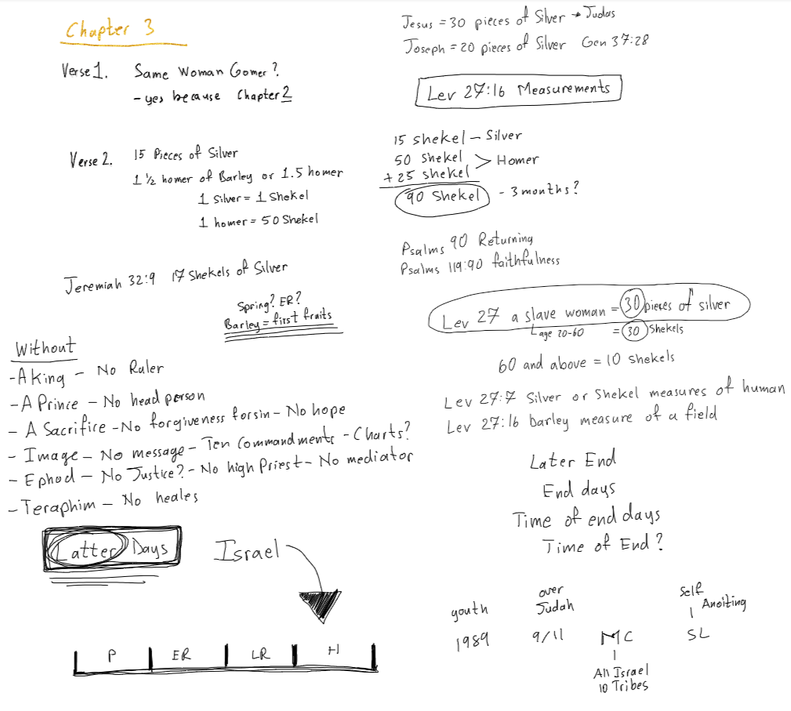
T H E E N D

“ With the severest reproofs, God sought to arouse the impenitent nation to a realization of its imminent danger of utter destruction. Through Hosea and Amos He sent the ten tribes message after message, urging full and complete repentance, and threatening disaster as the result of continued transgression. "Ye have plowed wickedness," declared Hosea, "ye have reaped iniquity; ye have eaten the fruit of lies: because thou didst trust in thy way, in the multitude of thy mighty men. Therefore shall a tumult arise among thy people, and all thy fortresses shall be spoiled. . . . In a morning shall the king of Israel utterly be cut off." Hosea 10:13-15. {PK 279.2}
“Through the man of God that had appeared before the altar at Bethel, through Elijah and Elisha, through Amos and Hosea, the Lord had repeatedly set before the ten tribes the evils of disobedience. But notwithstanding reproof and entreaty, Israel had sunk lower and still lower in apostasy. "Israel slideth back as a backsliding heifer," the Lord declared; "My people are bent to backsliding from Me." Hosea 4:16; 11:7. {PK 281.1}
“The time preceding the captivity of the ten tribes of Israel was one of similar disobedience and of similar wickedness. God's law was counted as a thing of nought, and this opened the floodgates of iniquity upon Israel. "The Lord hath a controversy with the inhabitants of the land," Hosea declared, "because there is no truth, nor mercy, nor knowledge of God in the land. By swearing, and lying, and killing, and stealing, and committing adultery, they break out, and blood toucheth blood." Hosea 4:1, 2. {PK 297.3}
“ The prophecies of judgment delivered by Amos and Hosea were accompanied by predictions of future glory. To the ten tribes, long rebellious and impenitent, was given no promise of complete restoration to their former power in Palestine. Until the end of time, they were to be "wanderers among the nations." But through Hosea was given a prophecy that set before them the privilege of having a part in the final restoration that is to be made to the people of God at the close of earth's history, when Christ shall appear as King of kings and Lord of lords. "Many days," the prophet declared, the ten tribes were to abide "without a king, and without a prince, and without a sacrifice, and without an image, and without an ephod, and without teraphim." "Afterward," the prophet continued, "shall the children of Israel return, and seek the Lord their God, and David their king; and shall fear the Lord and His goodness in the latter days." Hosea 3:4, 5. {PK 298.1}
“In symbolic language Hosea set before the ten tribes God's plan of restoring to every penitent soul who would unite with His church on earth, the blessings granted Israel in the days of their loyalty to Him in the Promised Land. Referring to Israel as one to whom He longed to show mercy, the Lord declared, "I will allure her, and bring her into the wilderness, and speak comfortably unto her. And I will give her her vineyards from thence, and the valley of Achor for a door of hope: and she shall sing there, as in the days of her youth, and as in the day when she came up out of the land of Egypt. And it shall be at that day, saith the Lord, that thou shalt call Me Ishi ["My husband," margin]; and shalt call Me no more Baali ["My lord," margin]. For I will take away the names of Baalim out of her mouth, and they shall no more be remembered by their name." Hosea 2:14-17. {PK 298.2}
“In the last days of this earth's history, God's covenant with Hiscommandment-keeping people is to be renewed. "In that day will I make a covenant for them with the beasts of the field, and with the fowls of heaven, and with the creeping things of the ground: and I will break the bow and the sword and the battle out of the earth, and will make them to lie down safely. And I will betroth thee unto Me forever; yea, I will betroth thee unto Me in righteousness, and in judgment, and in loving-kindness, and in mercies. I will even betroth thee unto Me in faithfulness: and thou shalt know the Lord. {PK 299.1}
"And it shall come to pass in that day, I will hear, saith the Lord, I will hear the heavens, and they shall hear the earth; and the earth shall hear the corn, and the wine, and the oil; and they shall hear Jezreel. And I will sow her unto Me in the earth; and I will have mercy upon her that had not obtained mercy; and I will say to them which were not My people, Thou art My people; and they shall say, Thou art my God." Verses 18-23. {PK 299.2}
"In that day" "the remnant of Israel, and such as are escaped of the house of Jacob, . . . shall stay upon the Lord, the Holy One of Israel, in truth." Isaiah 10:20. From "every nation, and kindred, and tongue, and people" there will be some who will gladly respond to the message, "Fear God, and give glory to Him; for the hour of His judgment is come." They will turn from every idol that binds them to earth, and will "worship Him that made heaven, and earth, and the sea, and the fountains of waters." They will free themselves from every entanglement and will stand before the world as monuments of God's mercy. Obedient to the divine requirements, they will be recognized by angels and by men as those that have kept "the commandments of God, and the faith of Jesus." Revelation 14:6, 7, 12. {PK 299.3}
"Behold, the days come, saith the Lord, that the plowman shall overtake the reaper, and the treader of grapes him that soweth seed; and the mountains shall drop sweet wine, and all the hills shall melt. And I will bring again the captivity of My people of Israel, and they shall build the waste cities, and inhabit them; and they shall plant vineyards, and drink the wine thereof; they shall also make gardens, and eat the fruit of them. And I will plant them upon their land, and they shall no more be pulled up out of their land which I have given them, saith the Lord thy God." Amos 9:13-15. {PK 300.1}
“ The prophecies of judgment delivered by Amos and Hosea were accompanied by predictions of future glory. To the ten tribes, long rebellious and impenitent, was given no promise of complete restoration to their former power in Palestine. Until the end of time, they were to be "wanderers among the nations." But through Hosea was given a prophecy that set before them the privilege of having a part in the final restoration that is to be made to the people of God at the close of earth's history, when Christ shall appear as King of kings and Lord of lords. "Many days," the prophet declared, the ten tribes were to abide "without a king, and without a prince, and without a sacrifice, and without an image, and without an ephod, and without teraphim." "Afterward," the prophet continued, "shall the children of Israel return, and seek the Lord their God, and David their king; and shall fear the Lord and His goodness in the latter days." Hosea 3:4, 5. {PK 298.1}
“In symbolic language Hosea set before the ten tribes God's plan of restoring to every penitent soul who would unite with His church on earth, the blessings granted Israel in the days of their loyalty to Him in the Promised Land. Referring to Israel whom He longed to show mercy, the Lord declared, "I will allure her, and bring her into the wilderness, and speak comfortably unto her. And I will give her her vineyards from thence, and the valley of Achor for a door of hope: and she shall sing there, as in the days of her youth, and as in the day when she came up out of the land of Egypt. And it shall be at that day, saith the Lord, that thou shalt call Me Ishi ["My husband," margin]; and shalt call Me no more Baali ["My lord," margin]. For I will take away the names of Baalim out of her mouth, and they shall no more be remembered by their name." Hosea 2:14-17. {PK 298.2}
“ In the last days of this earth's history, God's covenant with His commandment-keeping people is to be renewed. "In that day will I make a covenant for them with the beasts of the field, and with the fowls of heaven, and with the creeping things of the ground: and I will break the bow and the sword and the battle out of the earth, and will make them to lie down safely. And I will betroth thee unto Me forever; yea, I will betroth thee unto Me in righteousness, and in judgment, and in loving-kindness, and in mercies. I will even betroth thee unto Me in faithfulness: and thou shalt know the Lord. {PK 299.1}
"And it shall come to pass in that day, I will hear, saith the Lord, I will hear the heavens, and they shall hear the earth; and the earth shall hear the corn, and the wine, and the oil; and they shall hear Jezreel. And I will sow her unto Me in the earth; and I will have mercy upon her that had not obtained mercy; and I will say to them which were not My people, Thou art My people; and they shall say, Thou art my God." Verses 18-23. {PK 299.2}
“The Lord had rebuked Israel for their evil doing and had pleaded with them to mend their ways. "I have also spoken by the prophets," he said, "and I have multiplied visions, and used similitudes, by the ministry of the prophets." Hosea 12:10. Through the prophet that appeared to Jeroboam before the altar at Bethel, through Elijah and Elisha, through Amos and Hosea, God had repeatedly set before Israel the sure result of disobedience. But notwithstanding reproof and entreaty, Israel sank lower and lower in apostasy. "Israel slideth back as a backsliding heifer," the Lord declared. Hosea 4:16. "My people are bent to backsliding from me." Hosea 11:7. {RH, January 29, 1914 par. 6}
“After he had been proclaimed king by the army, Jehu hastened to Jezreel, where he began his work of execution on those who had deliberately chosen to continue in sin and to lead others into sin. Jehoram of Israel, Ahaziah of Judah, and Jezebel the queen mother, with "all that remained of the house of Ahab in Jezreel, and all his great men, and his kinsfolks, and his priests," were slain. "All the prophets of Baal, all his servants, and all his priests" dwelling at the center of Baal worship near Samaria, were put to the sword. The idolatrous images were broken down and burned, and the temple of Baal was laid in ruins. "Thus Jehu destroyed Baal out of Israel." 2 Kings 10:11, 19, 28. {PK 215.1}

The Valley of Achor Hosea 2:15, 2 Chronicles 2:7 “trouble” Joshua ch 6 and 7:26, Where God’s anger turned away ( a door of hope)
“After Israel's apostasy and bitter retribution, God's message of grace for the repentant people was: "Behold, I will allure her, and bring her into the wilderness, and speak comfortably unto her. And I will give her her vineyards from thence, and the valley of Achor for a door of hope: and she shall sing there, as in the days of her youth, and as in the day when she came up out of the land of Egypt." Hosea 2:14, 15.
The Valley of Achor is after Jericho.

From <https://d.docs.live.net/deb71ba2deb8a26f/Desktop/Sac%20Fel/BIBLE%20STUDIES/SABBATH/2020/February/2-15-2020/HOSEA%20%20Parables%20Feb.%2015%5eJ%202020.docx>

