Let the Holy Spirit Control
But the fruit of the Spirit is love, joy, peace, longsuffering, gentleness, goodness, faith, meekness, temperance: against such there is no law. Galatians 5:22, 23. {UL 227.1}

The question of religious liberty needs to be clearly comprehended by our people in more ways than one. With outstretched arms men are seeking to steady the ark, and the anger of the Lord is kindled against them because they think that their position entitles them to say what the Lord’s servants shall do and what they shall not do.... {UL 227.2}

Moses was specially chosen to be the visible leader of the children of Israel. Through long years of discipline, he learned the lesson of humility, and he became a man whom God could teach and guide. He endured as seeing Him who is invisible. God trusted him—a daily learner in the school of Christ—with the leadership of the host of Israel. God talked with him face to face, as a man talketh with his friend. He was the meekest of all men. He did not seek to control the Holy Spirit, but was himself controlled by the Spirit.... {UL 227.3}

Every man has an individuality of his own, which is not to be submerged in any other human being. The life of each one must be hid with Christ in God. Men are under God’s control, not under the control of weak, erring human beings. They are to be left free to be guided by the Holy Spirit, not by the fitful, perverse spirit of unsanctified men.... {UL 227.4}

Let God be recognized as the supreme Ruler of His heritage. Let every man place himself under His control. Let Him be recognized in all our assemblies, in every business meeting, every council, every committee. He sees all that is done and hears all that is said. {UL 227.5}

“Thou God seest me” (Genesis 16:13). Let these words be kept ever in mind. They will be a safeguard against imprudent, passionate speeches, against all desire to domineer. They will repress words that should never be spoken, and resolutions that men have no right to make—resolutions that restrict the liberty of human beings.... {UL 227.6}

God calls upon men to act under His supervision, to accept His standard, to take all their decisions and plans to Him for approval. His holiness, His justice, is to keep them from unprincipled actions.... {UL 227.7}

“Happy is he that hath the God of Jacob for his help, whose hope is in the Lord his God: which made heaven, and earth, the sea, and all that therein is which keepeth truth forever: which executeth judgment for the oppressed: which giveth food to the hungry.... The Lord shall reign forever, even thy God, O Zion, unto all generations. Praise ye the Lord” (Psalm 146:5-10). —Manuscript 51, August 1, 1895, “God to Control His Heritage.” {UL 227.8}

ALL THINGS BRIGHT AND BEAUTUFUL
Refrain: All things bright and beautiful,
All creatures great and small,
All things wise and wonderful,
'Twas God that made them all.
Each little flower that opens,
Each little bird that sings,
He made their glowing color,
He made their tiny wings.
Refrain:
The purple headed mountains,
The river running by,
The sunset and the morning
That brightens up the sky.
Refrain:
The cold wind in the winter,
The pleasant summer sun,
The ripe fruits in the garden,
He made them every one.
Refrain:
He gave us eyes to see them,
And lips hat we might tell,
How great is the Almighty,
Who has made all things well.

OPENING PRAYER
God calls upon men to act under His supervision, to accept His standard, to take all their decisions and plans to Him for approval. His holiness, His justice, is to keep them from unprincipled actions. Lord may this be our prayer. Amen.

How to use cumin for weight loss
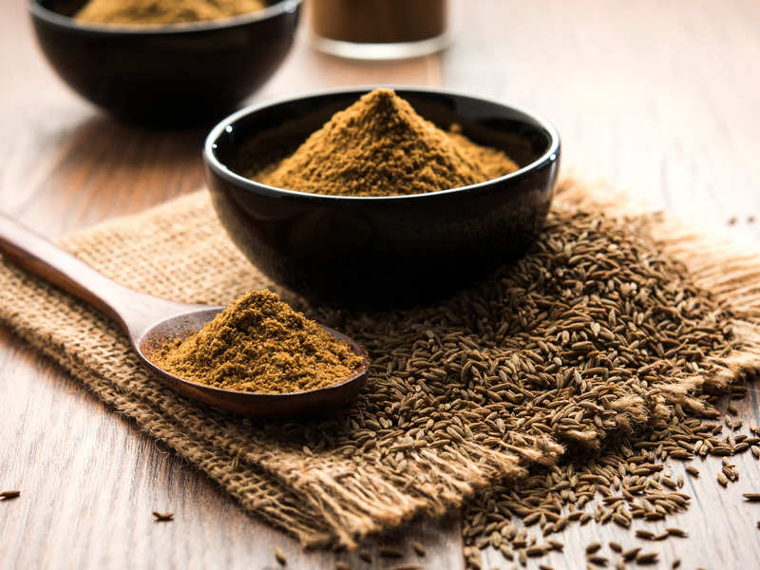
Cumin, also known as jeera, is a spice which is used in our dishes to enhance the taste. It has an earthy and warm flavor. But do you know that it can also help you with weight loss? It’s true! Cumin has the ability to speed up your weight loss process. Along with that it also has many other health benefits, which is why it has been used in traditional medicines for so many years. Studies show that consumption of cumin regularly has various types of benefits for the health.

HEALTH BENEFITS OF CUMIN
- Cumin can aid your digestion by increasing the activity of the digestive enzymes in your gut.
- Cumin seeds are rich in iron and one teaspoon of it can contain about 1.4 mg of iron.
- Cumin can help you in managing your diabetes.
- Cumin can be used to remove the bad cholesterols from the body.
- Eating cumin seeds can help in reducing inflammation in the body.
- Lastly, cumin seeds are beneficial for fat reduction and weight loss.

CUMIN AND WEIGHT LOSS
Cumin can be used for weight loss as it is an effective weight loss remedy. You can lose fat from your belly as well as your whole body within just 15-20 days by eating cumin seeds or drinking cumin water daily. Previously, a study was held in which 80 obese women were divided into two groups: 'cumin group' and 'diet control group'. The cumin group were asked to consume cumin on a daily basis and the other group was asked to control their diet. In the end, it was found out that women who had cumin had lost a significant amount of weight as compared to others.
Cumin can help in burning calories faster by increasing the speed of metabolism and improving digestion. When you have a healthy digestive system and a faster metabolism, you will automatically lose weight.

HOW TO USE CUMIN FOR WEIGHT LOSS
There are many ways in which you can use cumin for weight loss.
1. Cumin seeds
Soak 2 tablespoons of cumin seeds in water for 5-6 hours or overnight. Then, boil the seeds in the morning and filter the drink. Now, add lemon juice to it and drink it on an empty stomach for 2 weeks.
2. Cumin powder and yoghurt
Mix one teaspoon of cumin powder with one teaspoon of yoghurt and have it after your meals for 15 days.
3. Cumin powder
Boil one cup of water and add cumin powder in it. You can also add a little salt to make the drink taste better. Drink this after your meals every day for 20 days.

CLOSING THOUGHTS
Every man has an individuality of his own, which is not to be submerged in any other human being. The life of each one must be hid with Christ in God. Men are under God’s control, not under the control of weak, erring human beings. They are to be left free to be guided by the Holy Spirit, not by the fitful, perverse spirit of unsanctified men.
Let God be recognized as the supreme Ruler of His heritage. Let every man place himself under His control. Let Him be recognized in all our assemblies, in every business meeting, every council, every committee. He sees all that is done and hears all that is said.

CLOSING PRAYER
“Happy is he that hath the God of Jacob for his help, whose hope is in the Lord his God: which made heaven, and earth, the sea, and all that therein is which keepeth truth forever: which executeth judgment for the oppressed: which giveth food to the hungry…The Lord shall reign forever, even thy God, O Zion, unto all generations. Praise ye the Lord” Father let this be our duty and our prayer. In Jesus name we pray. Amen.

