Parables
Sunday, June 30, 2019
2:40 PM
- Compare/Contrast
- Juxtaposition
- Chiasm/Mirror
- Natural vs. Spiritual
- Repeat and enlarge
- End from the Beginning/Parabolic Curve
- Rule of First mention
- Rule of First and Last mention
- Jesus
- Us
Compare and Contrast
- Comparing you show similarities
- Contrasting you show differences
Juxtaposition
- To compare and contrast by joining two or more things together.
- To yoke or join two or more items together to produce and interesting effect.

JUXTAPOSITION, n. [L. juxta, near, and position.]
A placing or being placed in nearness or contiguity; as the parts of a substance or of a composition. The connection of words is sometimes to be ascertained by juxtaposition.

Chiasm
Chiastic structure, or chiastic pattern, is a literary technique in narrative motifs and other textual passages. An example of chiastic structure would be two ideas, A and B, together with variants A' and B', being presented as A,B,B',A'.
Natural vs. Spiritual
- Shepheard and flock to Christ and his followers
- Taking a real life event or example and combining it with a
Spiritual motif of the bible to better explain the spiritual idea in more simple
And easy to understand terms.
Repeat and Enlarge
- A repetition of the initial phrase with additional information. Sometime the added information can be a direct definition of the prior phrase.
End from the Beginning/Parabolic curve
- Showing the ending of a subject from the beginning
- Insinuates that there is a specific pattern repeating.
- Parabolic Curve
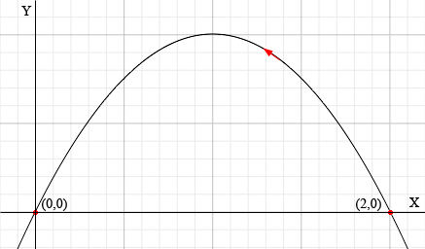

If you throw a ball in the air it will come back down to the earth. Its trajectory will create a parabolic curve. This is a mathematical principle. The ball will begin at the earth and will end at the earth. The ball will also come back down to the earth with the same speed that it left.
This is an example of End from beginning in a chiastic structure model.

Gen 1:1 And in the beginning God created the heaven and the earth.
Rev 21:1 And I saw a new heaven and a new earth.

This is our chiasm that we know. But if we look at it like a parabolic curve…

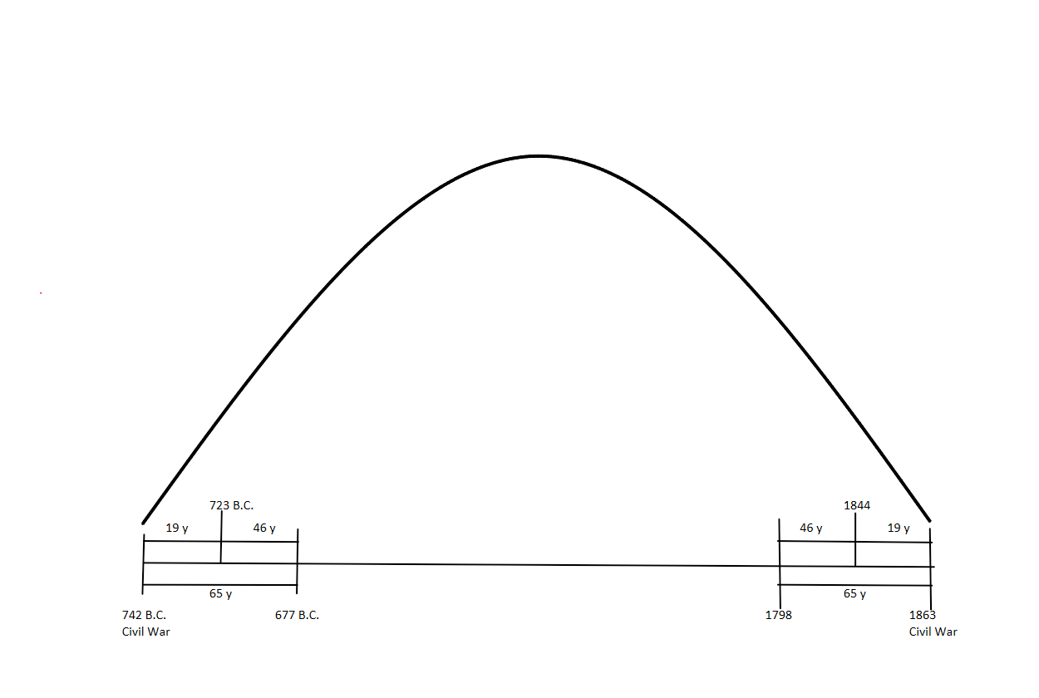
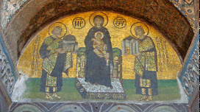

The subject presents a group of two Emperors on either side of the Virgin enthroned with the Infant Savior. The figures are inscribed with their name and titles. In the center the Virgin with her appellation of Mother of God. To our right, Constantine the Great as a saint; to our left, Justinian the First; both emperors are nimbate with halos. The Virgin holds the Infant in her lap. Constantine carries the City that bares his name. Justinian supports in his hands the Church of St. Sophia. The green ground beneath the figures is presented in four horizontal layers which grow darker as they recede. The background is bright gold mosaic which vibrates with every pulse of light and creating an air of celestial brilliance around the amethyst-blue figures. The mosaic is ragged along its edges; originally it was surrounded by a border of red tessellate, of which parts remain; at the base of the picture no less than eleven rows are missing.

The western Empire spoke Latin and was Roman Catholic. The eastern Empire spoke Greek and worshipped under the Eastern Orthodox branch of the Christian church. Over time, the east thrived, while the west declined. In fact, after the western part of the Roman Empire fell, the eastern half continued to exist as the Byzantine Empire for hundreds of years. Therefore, the "fall of Rome" really refers only to the fall of the western half of the Empire.

From <http://www.ushistory.org/civ/6f.asp>

Rule of First Mention + Rule of First and Last Mention
- The first and last time something is mentioned in the bible will give you all the information you need to understand that subject.
Rev 12:16 Gen 4:11
Jesus is Alpha and Omega. This is mentioned twice at the beginning of Revelation and Twice at the end.
Jesus
- He spoke Parables
- He was the Word
- He was Divinity combined with humanity. Two opposite things split by sin brought back together
- Jesus was the example of what to do. He showed us how to act compared to how everyone else around him acted in contrast So Jesus is Himself a Parable.

Us
- If we are to emulate Christ to this world and we are to have his heart in us and show his character to the world through our actions compared to the actions of the fallen world around us the we too are to be Parables. If we are to be parables we have to understand and speak In parables.
Noise
- We have to understand how to separate Noise from our understanding of Parables. Noise is irrelevant information. However we also know that each word must have its proper baring. So how do we reconcile this? We have to look at what the model is trying to teach us. The model of the Shepheard and the Sheep is a structure depicting who is the leader and who are the followers. It also shows how the leader leads and how the followers are to follow. It is not trying to show how sheep eat grass or how the Shepheard walks on two legs while the sheep walk on four. This is how we can distinguish noise.
E.G.W.
- Gods Prophet also writes in Parables. Conflict of the ages series starts with "God is love" and ends with "God is Love".
- She did not spend hours doing this on purpose. The same God that authored the Bible also authored her writings.

Psalm
Chapter 1

1:1 Blessed [is] the man that walketh not in the counsel of the ungodly,

nor standeth in the way of sinners,

nor sitteth in the seat of the scornful.

1:2 But his delight [is] in the law of the LORD;

and in his law doth he meditate day and night.

1:3 And he shall be like a tree planted by the rivers of water,

that bringeth forth his fruit in his season;

his leaf also shall not wither;

and whatsoever he doeth shall prosper.

1:4 The ungodly [are] not so: but [are] like the chaff which the wind driveth

away.

1:5 Therefore the ungodly shall not stand in the judgment,

nor sinners in the congregation of the righteous.

1:6 For the LORD knoweth the way of the righteous:

but the way of the ungodly shall perish.

Numbers
Chapter 23

23:1 And Balaam said unto Balak, Build me here seven altars, and prepare me here seven oxen and seven rams.

23:2 And Balak did as Balaam had spoken; and Balak and Balaam offered on [every] altar a bullock and a ram.

23:3 And Balaam said unto Balak, Stand by thy burnt offering, and I will go: peradventure the LORD will come to meet me: and whatsoever he showeth me I will tell thee. And he went to an high place.

23:4 And God met Balaam: and he said unto him, I have prepared seven altars, and I have offered upon [every] altar a bullock and a ram.

23:5 And the LORD put a word in Balaam's mouth, and said, Return unto Balak, and thus thou shalt speak.

23:6 And he returned unto him, and, lo, he stood by his burnt sacrifice, he, and all the princes of Moab.

23:7 And he took up his parable, and said, Balak the king of Moab hath

brought me from Aram, out of the mountains of the east, [saying], Come, curse

me Jacob, and come, defy Israel.

23:8 How shall I curse, whom God hath not cursed? or how shall I defy,

[whom] the LORD hath not defied?

23:9 For from the top of the rocks I see him, and from the hills I behold him:

lo, the people shall dwell alone, and shall not be reckoned among the nations.

23:10 Who can count the dust of Jacob, and the number of the fourth [part]

of Israel? Let me die the death of the righteous, and let my last end be like his!

23:11 And Balak said unto Balaam, What hast thou done unto me? I took thee to curse mine enemies, and, behold, thou hast blessed [them] altogether.

23:12 And he answered and said, Must I not take heed to speak that which the LORD hath put in my mouth?

23:13 And Balak said unto him, Come, I pray thee, with me unto another place, from whence thou mayest see them: thou shalt see but the utmost part of them, and shalt not see them all: and curse me them from thence.

23:14 And he brought him into the field of Zophim, to the top of Pisgah, and built seven altars, and offered a bullock and a ram on [every] altar.

23:15 And he said unto Balak, Stand here by thy burnt offering, while I meet [the LORD] yonder.

23:16 And the LORD met Balaam, and put a word in his mouth, and said, Go again unto Balak, and say thus.

23:17 And when he came to him, behold, he stood by his burnt offering, and the princes of Moab with him. And Balak said unto him, What hath the LORD spoken?

23:18 And he took up his parable, and said, Rise up, Balak, and hear; hearken

unto me, thou son of Zippor:

23:19 God [is] not a man, that he should lie; neither the son of man, that he

should repent: hath he said, and shall he not do [it]? or hath he spoken, and shall

he not make it good?

23:20 Behold, I have received [commandment] to bless: and he hath blessed;

and I cannot reverse it.

23:22 God brought them out of Egypt; he hath as it were the strength of an

unicorn.

23:23 Surely [there is] no enchantment against Jacob, neither [is there] any

divination against Israel: according to this time it shall be said of Jacob and of

Israel, What hath God wrought!

23:24 Behold, the people shall rise up as a great lion, and lift up himself as a

young lion: he shall not lie down until he eat [of] the prey, and drink the blood of

the slain.

23:25 And Balak said unto Balaam, Neither curse them at all, nor bless them at all.

23:26 But Balaam answered and said unto Balak, Told not I thee, saying, All that the LORD speaketh, that I must do?

23:27 And Balak said unto Balaam, Come, I pray thee, I will bring thee unto another place; peradventure it will please God that thou mayest curse me them from thence.

23:28 And Balak brought Balaam unto the top of Peor, that looketh toward Jeshimon.

23:29 And Balaam said unto Balak, Build me here seven altars, and prepare me here seven bullocks and seven rams.

23:30 And Balak did as Balaam had said, and offered a bullock and a ram on [every] altar.

Chapter 24

24:1 And when Balaam saw that it pleased the LORD to bless Israel, he went not, as at other times, to seek for enchantments, but he set his face toward the wilderness.

24:2 And Balaam lifted up his eyes, and he saw Israel abiding [in his tents] according to their tribes; and the spirit of God came upon him.

24:3 And he took up his parable, and said, Balaam the son of Beor hath said,

and the man whose eyes are open hath said:

24:4 He hath said, which heard the words of God, which saw the vision of the

Almighty, falling [into a trance], but having his eyes open:

24:5 How goodly are thy tents, O Jacob, [and] thy tabernacles, O Israel!

24:6 As the valleys are they spread forth, as gardens by the river's side, as the

trees of lign aloes which the LORD hath planted, [and] as cedar trees beside the waters.

24:7 He shall pour the water out of his buckets, and his seed [shall be] in

many waters, and his king shall be higher than Agag, and his kingdom shall be

exalted.

24:8 God brought him forth out of Egypt; he hath as it were the strength of

an unicorn: he shall eat up the nations his enemies, and shall break their bones,

and pierce [them] through with his arrows.

24:9 He couched, he lay down as a lion, and as a great lion: who shall stir him

up? Blessed [is] he that blesseth thee, and cursed [is] he that curseth thee.

24:10 And Balak's anger was kindled against Balaam, and he smote his hands together: and Balak said unto Balaam, I called thee to curse mine enemies, and, behold, thou hast altogether blessed [them] these three times.

24:11 Therefore now flee thou to thy place: I thought to promote thee unto great honour; but, lo, the LORD hath kept thee back from honour.

24:12 And Balaam said unto Balak, Spake I not also to thy messengers which thou sentest unto me, saying,

24:13 If Balak would give me his house full of silver and gold, I cannot go beyond the commandment of the LORD, to do [either] good or bad of mine own mind; [but] what the LORD saith, that will I speak?

24:14 And now, behold, I go unto my people: come [therefore, and] I will advertise thee what this people shall do to thy people in the latter days.

24:15 And he took up his parable, and said, Balaam the son of Beor hath

said, and the man whose eyes are open hath said:

24:16 He hath said, which heard the words of God, and knew the knowledge

of the most High, [which] saw the vision of the Almighty, falling [into a trance],

but having his eyes open:

24:17 I shall see him, but not now: I shall behold him, but not nigh: there shall

come a Star out of Jacob, and a Sceptre shall rise out of Israel, and shall smite the

corners of Moab, and destroy all the children of Sheth.

24:18 And Edom shall be a possession, Seir also shall be a possession for his

enemies; and Israel shall do valiantly.

24:19 Out of Jacob shall come he that shall have dominion, and shall destroy

him that remaineth of the city.

24:20 And when he looked on Amalek, he took up his parable, and said,

Amalek [was] the first of the nations; but his latter end [shall be] that he perish

for ever.

24:21 And he looked on the Kenites, and took up his parable, and said, Strong

is thy dwellingplace, and thou puttest thy nest in a rock.

24:22 Nevertheless the Kenite shall be wasted, until Asshur shall carry thee

away captive.

24:23 And he took up his parable, and said, Alas, who shall live when God

doeth this!

24:24 And ships [shall come] from the coast of Chittim, and shall afflict

Asshur, and shall afflict Eber, and he also shall perish for ever.

24:25 And Balaam rose up, and went and returned to his place: and Balak also went his way.

