Date | Name | Testimonial Reports
12/03/2019 | Sister Antoinette | Shares that her friend Dovie has officially moved in with her family, living specifically with her niece, who is caring for her. Dovie is doing very well and is happy with her new home and placement. Praise God! What an answer to prayer!
12/03/2019 | Sister Victoria | Praises the Lord for Life and the opportunity to have it more abundantly! Sister Victoria wants to take the time to thank the Lord for the life of the brethren. She cherishes the life of all the brethren who stand for truth and live to be a blessing. For all the December babies (those born in December), happy birthday! May God continue to bless you as you continue to choose to live for Him with the sole purpose to honor Him with your life and be the blessing He has raised you up to be for such a time as this. Amen.
12/03/2019 | Sister Victoria | Shares a word of encouragement through a poem by Laura Lush, entitled, “The First Day of Winter:  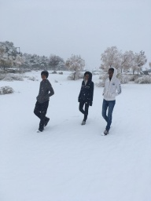  "On the first day of winter,  the earth awakens to the cold touch of itself.  Snow knows no other recourse except  this falling, this sudden letting go  over the small gnomed bushes, all the emptying trees.  Snow puts beauty back into the withered and malnourished,  into the death-wish of nature and the deliberate way  winter insists on nothing less than deference.  Waiting all its life, snow says, "Let me cover you."  The Flucas Kids  May all be blessed this winter season!

