Date | Name | Testimonial Reports
07/30/2020 | Members of Sac Fellowship | Praises the Lord for a wonderful turn out in the monthly Zoom meeting! The mini Zoom camp meeting hosted by the Sacramento Fellowship for the month of July was a great blessing! The messages presented by each speaker were both timely and empowering. There were little to no internet interruptions or difficulties. The fellowship was sweet and the presence of the Lord was surely among us! Praise be to God! Our prayer for a blessed outcome was heard and honored. Amen!
07/30/2020 | Select Members of Sac Fellowship | We praise the Lord for our dear Sister Lana, who personally shared a heartfelt and powerful testimony about relationships, specifically what God taught her through her sweet cat named Whiskey. What a blessing it was! You can read Sister Lana’s testimony on the Sacramento Fellowship website on the prayer and devotional page linked to 6/11/2020 praise report.
07/30/2020 | Sister Lana | Shares a word of praise to the Lord. Be blessed:  “Hello Church,  Here is something I wanted to share with you. My father is an alcoholic and a heavy smoker. He drinks vodka every day, and also as a part of the culture (in former Soviet Union countries alcoholism is very widespread and one is required to drink for all holiday celebration). I have been telling him all the time how bad it is from a perspective of a biochemist. And he doesn’t usually listen to me. But with this coronavirus disaster that is happening, his company invited pulmonology doctors with equipment to test the employees for the lung capacity. Upon completion of the test, he was told that 25% of his lungs are damaged. It was very sobering to him. So just wanted to praise the Lord that He is trying to help my alcoholic father and arranged so that that kind of test is provided to employees. Many people back home smoke and drink. I pray for all the alcoholics and smokers as often they are the nicest people who couldn’t cope with pressure. “Amen.
07/30/2020 | Sister LoGina | Praises the Lord for the beautiful bundle of joy—their 10 day old granddaughter!!! Baby Adelaide Amaris is Sister LoGina’s and Brother Fel’s sixth grandchild and fourth granddaughter. Their son, Ty and daughter in law, Jef are newly parents. So, Sister LoGina has stepped in to help them get adjusted to their new role as parents. Sister LoGina has willingly and readily taken on the 4am shift in caring for Baby Adelaide, so please remember to keep her in prayer, as she has experience some sleep deprivation. Nevertheless, she enjoys every precious moment she has with her grandbaby and couldn’t be happier doing anything else at this time. And the birth Baby Adelaide couldn’t be more timelier as she has brought much joy and comfort in the mist of loss and sorrow. The Lord is so good! Oh, how He knows! To every thing there is a season, and a time to every purpose under the heaven: A time to be born, and a time to die. ~ ECC 3:1  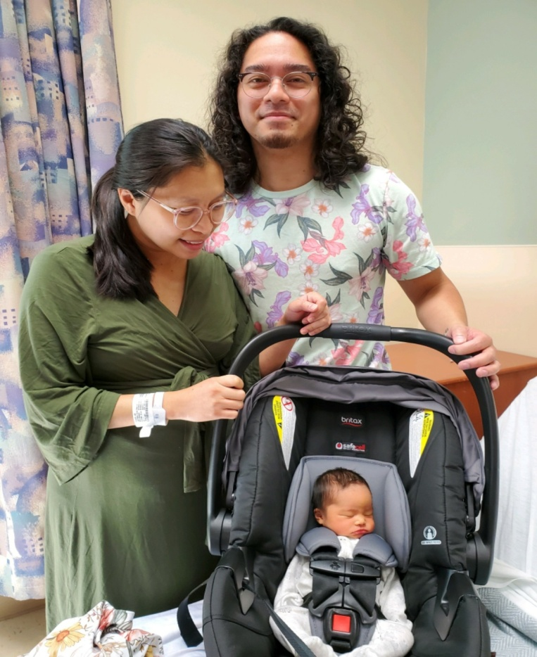  From all of us at Sacramento Fellowship: CONGRATUALATIONS Sister LoGina and Brother Fel!!!

