Date | Name | Testimonial Reports
08/20/2020 | Sister Linda | Praises the Lord for more great news!!! Sister Linda had previously shared with us an update on her coworker Suchi and her husband’s situation. The Lord had begun to move mightily in their lives when word spread of their need of prayer. Long story short, due to a law Donald Trump signed, Suchi’s husband was soon to be out of a job and that meant the family would possibly have to move back to India if Suchi’s husband could not find work to help support their residency in the US. Sister Linda could only jump for joy when she received news from Suchi that doors appeared to be opening up for them and that their hope had been revived to believe things may just work out for them to stay. And can we say, “amen” and “praise God!” for the news we received next from Sister Linda: “The prayers have been answered for my coworker Suchi—at least for the time being her husband is going to work remotely from Illinois for the NIH with Dr. Fauci until the Trump administration manages to stop the process. It’s a possible 5 year contract. The possibility of working in Ohio did not happen. The fact that they get to stay in Illinois is even more amazing. She can continue helping the rest of us older ladies care for the kids as has been happening all along. So praise the Lord and thank you all once again for the prayers on their behalf.” Hallelujah! Let the Lord God be magnified for He is merciful and His mercy endureth forever!  All praise be to Him! Sister Linda also shares much thanks from her coworker Suchi, “Suchi thanks you all so much. We never thought for a minute that they would get to stay where they are and still work at NIH but that’s the beauty of working with modern technology.” Sister Linda further expressed, “She began asking how I became connected with you all and our health message and intermittent fasting. God’s footprint is absolutely on this quick answer to prayer.” Amen. Praise God indeed! Let us continue to keep Suchi and her husband in prayer. Thank you.
08/20/2020 | Select Members of Sac Fellowship | Praises the Lord for green thumbs and beautiful gardens! Sisters Elaine and Toni have been amazingly excited over how their garden has blossomed. They are so full of praise to the Lord in how He has blessed their gardens to prosper and multiply. They have done their part: planted the seeds, watered, and cultivated their vegetation and happily share the fruit of their labor, so to speak with us all! May we all rejoice with them!  Sister Elaine:  “First try at potatoes. And blossoms began to explode again on my watermelon plant. I have two that seem to have been pollinated. I pray they have time in the season to mature. Also, I have seven honeydews. The first one I picked too soon. The rest were awesome. I have 8 more a little over halfway grown. I praise God as He has blessed this garden. I had (and still producing) tons of zucchini. Lots of tomatoes. If I may yet get some fall lettuce planted.”  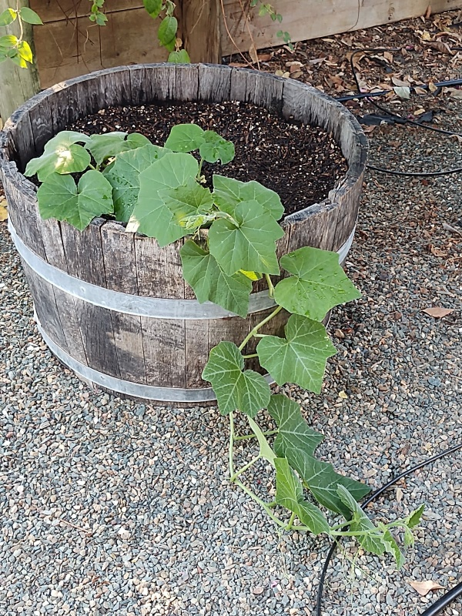  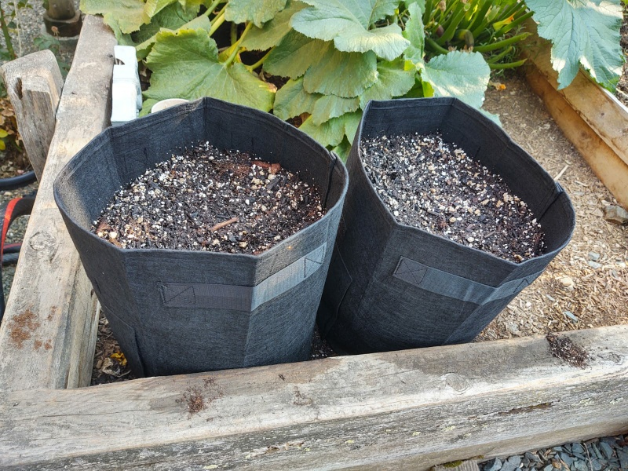  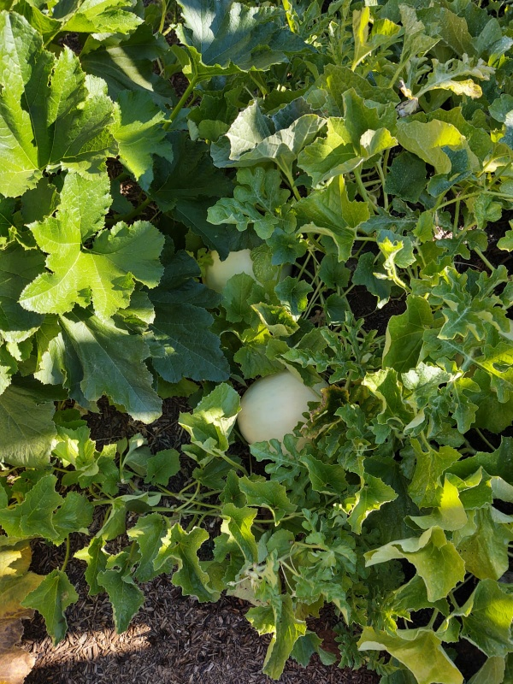  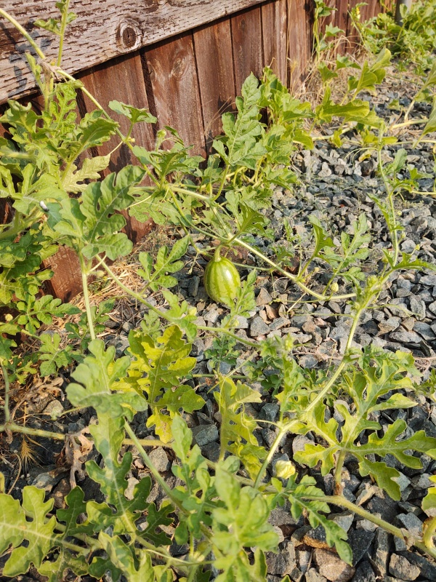  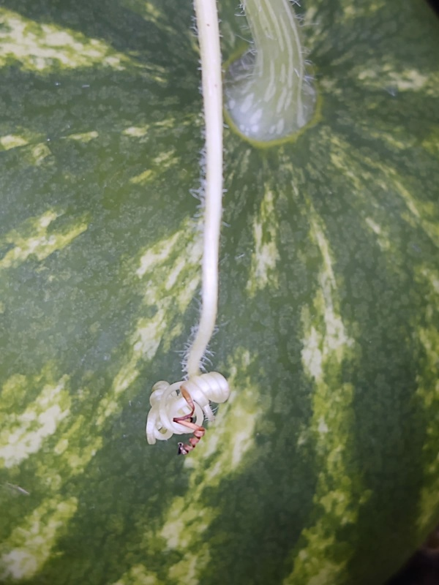  Sister Toni:  “I just thought I’d share this morning bounty. The Lord supplies.”  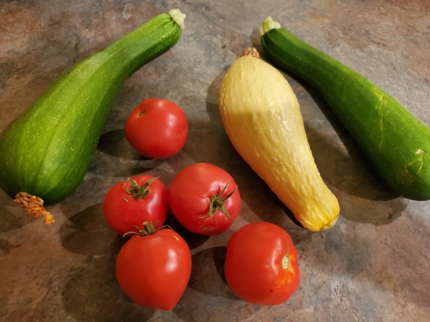  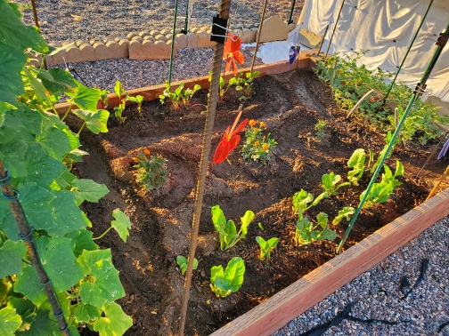  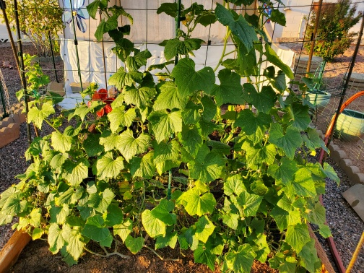
08/20/2020 | Sister Elaine | Shares a word of encouragement from SOP written by Ellen G. White:  “God Needs Human Agencies.--We are to put into practice the precepts of the law, and thus have righteousness before us; the rereward will be God's glory. The light of the righteousness of Christ will be our front guard, and the glory of the Lord will be our rereward. Let us thank the Lord for this assurance. Let us constantly stand in a position where the Lord God of heaven can favor us. Let us consider that it is our high privilege to be in connection with God--to be His helping hand. {4BC 1151.3}  In God's great plan for the redemption of a lost race, He has placed Himself under the necessity of using human agencies as His helping hand. He must have a helping hand, in order to reach humanity. He must have the cooperation of those who will be active, quick to see opportunities, quick to discern what must be done for their fellow men.” (NL No. 23, p. 1). {4BC 1151.4}
08/20/2020 | Sister Suzan | Shares a morning read she had with us from one of the pioneer’s writings entitled The Third Angel’s Message by AT Jones:  “So then we are to learn the truth only--no difference who speaks it. The Lord will speak it, of course, no difference by whom it is spoken or the way it comes. If we knew it before, thank God somebody else knows it now. If we did not know it before, then thank the Lord we now know it. The only thing to ask is, Is it true? You all know those verses in 2 Thess. 2:9, 10: "Even him, whose coming is after the working of Satan with all power and signs and lying wonders, and with all deceivableness of unrighteousness in them that perish; because they received not the love of the truth. Any one who loves the truth and will receive the love of the truth, Satan will never have any chance to work in with all signs and lying wonders and all deceivableness of unrighteousness. No sir. Because Jesus has said it (John 8:32): "Ye shall know the truth, and the truth shall make you free." Then every one who receives the love of the truth, this will make them free. Then the one in whom Satan is to work all signs and lying wonders, is he free? No, he is a fearful slave. As long as we have it settled in our minds that the only thing we shall ever seek or expect is the truth, and love it because it is the truth, and take it because it is the truth, then we need not be uneasy about whether Satan is going to deceive us or not.” {January 27, 1893 ATJ, GCDB 7.5}

