Date | Name | Testimonial Reports
09/03/2020 | Brother Jonathon | Shares a wonderful testimony of the power of prayer:  “I’m pretty shy about sharing my personal life on a public forum, but I need to share a miracle that just happened because I know it will encourage many of you. Sorry if it is a bit long.  In March, I lost my first grandmother (my mom’s mom) to dementia. It was difficult to see her go but I’m glad she isn’t suffering anymore … She was a woman of faith so her fate is in the Lord’s hands. A few weeks ago, my second grandmother (my dad’s mom) passed away, and she also was a woman of faith, so again I am content with it. This morning my aunt (my dad’s sister) passed away. She had been fighting cancer for several years. I was raised with absolutely zero religion and zero understanding of God (from a religious perspective). I have never really known where my parents stand in their beliefs because it has almost always been a completely avoided subject. Every impression I ever had growing up was that religion was not for them. I didn’t know who God or Jesus was for most of my life, and I personally was only converted 5-6 years ago. Since then, I have prayed so much for my parents. I prayed for them to ask questions, I prayed for them to learn about Jesus, to have a desire to learn about prophecy, you name it … I have prayed for something … for anything. My parents were fairly accepting of me when I was converted but for the past 5-6 years they avoided almost all conversation about my faith.  Today when my parents called to give me the news about my dad’s sister’s passing, the three of us talked about a lot of things. At one point, we talked about 2020, and all that is going on in the world. Out of nowhere, my dad says, “These things that are happening in the world, they were written about in the Bible, they just aren’t happening exactly the way people always thought they would.” Then he said, “Those folks that wrote the Bible so long ago must have gotten their insight from somewhere”!!!  This is the most unexpected thing I have ever heard my dad say … EVER!  For those who have loved ones that do not believe in God, keep praying. I never thought I would hear those words come out of my dad’s mouth. If you knew my dad the way I do, you’d think the same. It opened up the conversation a bit about what’s going on with Trump, and the pandemic, the entire world etc … It’s a start, and I don’t know how or where it came from but I know my prayers for the last 5-6 years have made it into the Most Holy Place, and however God does it … whatever He instructs the angels to do, however the Holy Spirit works … I don’t know. What I do know is that they are always working on behalf of humanity, and that prayers ARE heard in the courts of heaven. Keep the faith. Please pray for my parents and loved ones, and I will pray for yours also.  Another part that I want to give glory to God for is that my upbringing could by no stretch be defined as 100% worldly. Interestingly enough my parents have always been pretty fairly liberal socially, and they have been may be more middle ground morally. I lived a pretty liberal lifestyle for my younger years, and became more and more conservative in the years leading up to my conversion (conspiracy theories played a big role in that). When I became a Christian, I was definitely conservative leaning in most things (but still had some liberal qualities in tact). Anyway, my political conversations with my parents were virtually a no-go zone for several years because we were opposites. Over the past year I haven’t known how to restart some of those conversations with them. But over time they have noticed a difference, and today I was able to share with them why my views have changed. I was able to share with them that not all Christians have the same viewpoint on things and that it all boiled down to how one reads the Bible. I am ecstatic that I am having these conversations with my parents, and God deserves all the glory, and these lines … If I ever get a grasp on them enough to teach them, may one day be acceptable to both of my parents. That is my prayer now. I hope the same for everyone else who wonders if they will ever see a miracle in their loved ones’ lives. Even if it is small like this at first, it gives you hope for them and it certainly helps to resuscitate your own spirits and restores hope in why we are doing this.  For those who have read this, whatever the circumstance is, don’t stop praying for your loved ones. Don’t stop praying for the world. Don’t stop praying for the church. And don’t stop praying for our loved ones in this Movement who have for whatever reason decided to step away from the path. And don’t stop praying for our leaders! Don’t stop praying, they are all heard by Divine ears.  God Bless.”
09/03/2020 | Sister Adriana | Praises the Lord for quick response to prayer for a friend in trouble. Sister Adriana had asked for prayer for a friend named James. His girl, Kim had just given birth to their newborn and soon after things took a turn for the worst. The medical team immediately went to resuscitation on their son and Kim was bleeding badly. They were told that their son had to go to NICU. But God! He heard the cry of all on the behalf of the family and began working mightily in flipping the odds for a positive outcome. Prayers continued to be lifted up for the family. As things began to look better, they were still in need of prayer as their son needed strength enough to breathe without oxygen. And the Lord, faithful as always, turned a nightmare of a situation into a dream come true ending. Sister Adriana shared the wonderful news, “The family is able to head home…Everything seems to be good.” Praise be to God! Let’s all welcome baby Achilles. Congratulations to the family! God is so good!  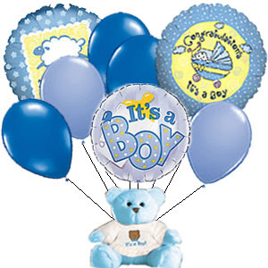  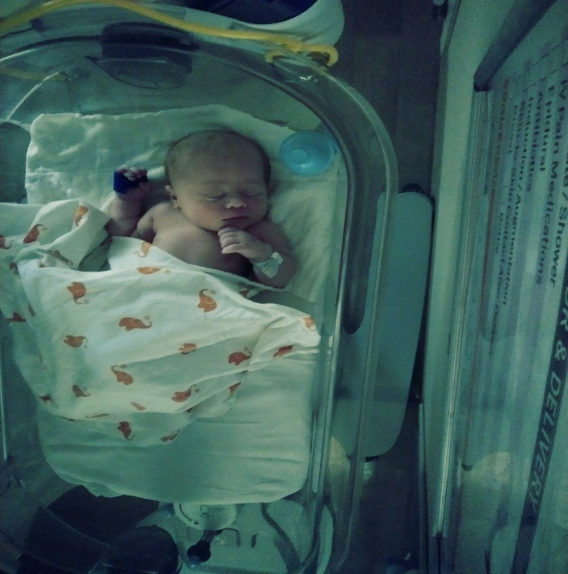
09/03/2020 | Sister Victoria | Praises the Lord for Life and the opportunity to have it more abundantly! Sister Victoria wants to take the time to thank the Lord for the life of the brethren. She cherishes the life of all the sisters and brothers who stand for truth and live to be a blessing. For all the September babies (those born in September), happy birthday! May God continue to bless you as you continue to choose to live for Him with the sole purpose to honor Him with your life and be the blessing He has raised you up to be for such a time as this. Amen.  