Name | Your Prayer Requests | Date
Select Members of Sac Fellowship | Asks that we keep Brother Larry in prayer. Specifically, that the Lord blesses him to have good internet service so he could join us in fellowship and for other uses that would be of benefit for him. Thank you. | 09/03/2020
Sisters Toni and Elaine | Asks that we keep in prayer Brother Fel and Sister LoGina as the CA fires are spreading closer to the area in which they reside. They may soon have to evacuate. Also, Sister Toni asks for prayer for a friend named Kenny who has to evacuate his home and property because of the fires, as well as, a dear friend of the family named Jeff DeMarco who had already evacuated his home. He may lose his cabin. Also Sister Elaine adds that we keep brother Victor and his family in prayer too. A new fire sparked into flame by their house. They may have to evacuate soon. The fire is really close.  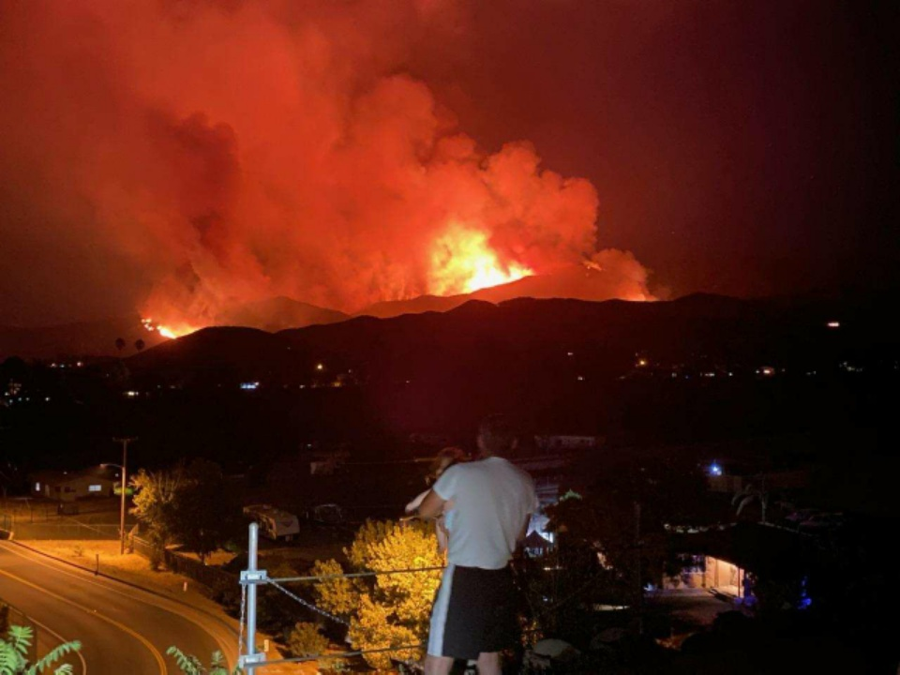 | 09/03/2020
Sister Lana | Asks for prayer, specifically asking that we keep her in prayer as she desires to have it completed by Sunday (09/06/2020). Pray that it be her best work and that the Lord would bless her thesis be remarkable paper deserving of an excellent grade. Thank you. | 09/03/2020
Sister Lana | Asks for special prayer for all the single people in the Movement. Pray that those desiring to be in a relationship find their counterpart. As it is a small group and some are positioned on different parts of the globe. Pray the Lord bring them together and no longer have to be alone. Thank you. | 09/03/2020
Sister Victoria | Asks for prayer on the behalf of her mom. A family member is soon to leave for college. He is 18 years old. He is very anxious about leaving home to college as it will be his first time being away from home and living alone. Also pray for his safety and health as we are still in a pandemic. Thank you. | 09/03/2020
Sister Victoria | Asks that we keep Sister Ali and Brother Henry in prayer as they are to travel to BC sometime this month. Pray for safe travel and protection and that their trip be a blessed one. Thank you. | 09/03/2020
Select Members of Sac Fellowship | Asks that we remember our family and friends in prayer. And to continue to keep the members and leaders of the Movement in prayer. Thank you. | 09/03/2020
Members of Sac Fellowship | A year ago Elder Parminder was warned by FFA that the leaders of the Movement would be cursed for rejecting their message on Islam (their July 18th Nashville prophecy) and declaring to the followers to decide who has the true message on Islam. Is Islam rising or coming down this year? FFA believes Islam is rising up. The Movement believes Islam will be restrained. The Movement believes this because Islam is tied to Russia. Islam becomes restrained as Russia loses its influence. So, Elder Parminder is asking us to pray—next hours, days, and weeks for God to give us an increase of knowledge on Islam. July 18, 2020 is not that far away. Elder Parminder says, “If we don’t pray, don’t confess our sins, what hope will we have in the Lord giving us more light on Islam.” Let us pray fervently and incessantly. Thank you. | 09/03/2020
Members of Sac Fellowship | Asks that we keep in prayer all affected by the coronavirus pandemic outbreak. It is still spreading, though in some places the severity has lessened a little, but is still at risk for a sudden spike in cases (and possible 2nd wave). As people continue to adjust to the new normal, please pray for protection for those unknowingly exposed and for those who are stuck in places where the virus is hit very strong. Thank you. | 09/03/2020
Select Members of Sac Fellowship | Asks that we keep the upcoming Gold Country camp meeting hosted by Sacramento Fellowship and IPR. The camp meeting will be hosted via Zoom. Meetings begin Wednesday, September 23rd 2020 thru Saturday, September 26th 2020. Presenters will be Sister Tamina and Elder Parminder. Pray for the internet service to run smoothly and if there be any glitches or difficulties that the Lord will help the meeting go forward successfully. We ask prayers for the speakers as they prepare to present and for all in attendance to be open and receptive of the present truth taught. That all be blessed by the message of the hour. | 09/03/2020
Members of Sac Fellowship | Ask that we keep in prayer the leader to be raised up to teach on the subject of the Nature of Man part 2 and the LGBQT. When the test is placed in front of each one of us, may we be found faithful and standing on the side of right as victors. Also pray the Lord gives the women of the Movement courage and strength to teach and finish the work. | 09/03/2020

