Name | Your Prayer Requests | Date
Sister Anna | Asks for continued prayer. Prayer was requested for Sister Anna who has been sick for a few weeks. She got her test results back and was found positive for COVID-19. Sister Anna says, “I’m feeling pretty awful. It’s exactly like a really bad head cold. The worst I’ve ever had. If it goes into my lungs, I will be calling 911. So far I’m not going anywhere… I really need to get better soon so I can get back to work.” “Thank you all for your prayers [and] concern. Please continue [to pray]. Love to all”, Sister Anna states furthermore. Thank you. | 12/30/2020
Select Members of Sac Fellowship | Please keep in prayer the Hold the Rope, FIN German International Camp Meeting, which began December 30th thru January 3rd. Speakers are Elders Tess and Parminder. May the Lord bless the speakers and anoint their mouths with the truth to be spoken and may all be open to receiving and accepting present truth shared. Thank you.  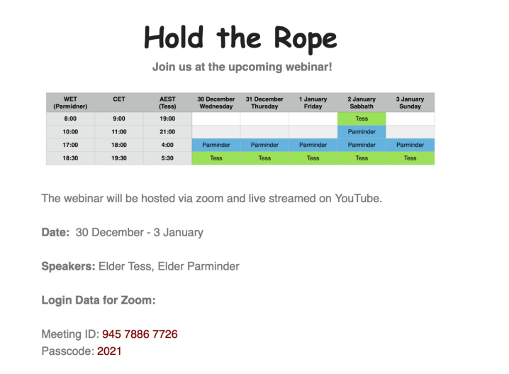 | 12/30/2020
Select Members of Sac Fellowship | Asks that we keep in prayer the Sacramento Fellowship publishing project. The goal is to have the entire 15 chapters of the Guadeloupe 2019 Midnight Cry studies published into a book. They continue to seek volunteers for the continued editing process. Please pray for a special blessing for each individual who participate in the editing and proof-reading. That the Lord would guide their eyes to see any and all errors and mistakes that need polishing and correcting. And, for the Lord to guide and bless the Sacramento Fellowship ministry on which future publishing projects to take on next. Thank you. | 12/30/2020
Select Members of Sac Fellowship | Asks that we remember each other in prayer, specifically that we be united in our message and methodology. Pray that we set aside our differences and truly seek and come to understand the message of equality and be fit to teach. Thank you. | 12/30/2020
Select Members of Sac Fellowship | Asks that we keep all individuals in the Movement in prayer. That they would use the best of their time to study and understand the message we are to give. The salvation of others depends on our effort to learn and teach present truth. May the Lord bless us all with better time management skills in however that looks for each individual’s situation. Thank you. | 12/30/2020
Members of Sac Fellowship | Asks that we remember our family and friends in prayer. And to continue to keep the members and leaders of the Movement in prayer. Thank you. | 12/30/2020
Members of Sac Fellowship | A year ago Elder Parminder was warned by FFA that the leaders of the Movement would be cursed for rejecting their message on Islam (their July 18th Nashville prophecy) and declaring to the followers to decide who has the true message on Islam. Is Islam rising or coming down this year? FFA believes Islam is rising up. The Movement believes Islam will be restrained. The Movement believes this because Islam is tied to Russia. Islam becomes restrained as Russia loses its influence. So, Elder Parminder is asking us to pray—next hours, days, and weeks for God to give us an increase of knowledge on Islam. July 18, 2020 is not that far away. Elder Parminder says, “If we don’t pray, don’t confess our sins, what hope will we have in the Lord giving us increased light on Islam.” Let us pray fervently and incessantly. Thank you. | 12/30/2020
Members of Sac Fellowship | Asks that we keep in prayer all affected by the coronavirus pandemic outbreak. It is still spreading, though in some places the severity has lessened a little, but is still at risk for a sudden spike in cases (and possible 2nd wave). As people continue to adjust to the new normal, please pray for protection for those unknowingly exposed and for those who are stuck in places where the virus is hit very strong. Thank you. | 12/30/2020

