Put on the Armor of Christ
Let your light so shine before men, that they may see your good works, and glorify your Father which is in heaven. Matthew 5:16. {UL 71.1}
The light of truth must shine forth to the world. Those who love God and keep His commandments are called to aggressive warfare, not against one another, but against the armies of the invisible foe. There is to be no such thing as laying off the armor. At no time are those who claim to be Christ’s disciples to feel at ease in their church capacity, content to do nothing to rescue fallen human beings, and bring them back to their loyalty. {UL 71.2}
Heavenly angels are constantly ascending and descending between heaven and earth, engaged in unselfish service for the building up of the kingdom of Christ. Where are the men and women who will unite with these heavenly messengers? Where are those who will use their abilities in cooperation with divine power? {UL 71.3} Think of what God has done for you. When you were perishing out of Christ, did not the warning message come to you, convincing you of sin and arousing you to repentance? Did not Christ reveal Himself to you as a sin pardoning Saviour? And in the light and glory of your first love, were you not full of unselfish love to impart to others the grace which gave you newness of life in Christ? {UL 71.4}
Do not allow your zeal for Christ to decrease. Now that you have become the helping hand of Christ, you are to work earnestly for those whom, before your conversion, you looked upon with indifference. Remember that they are in as favorable a condition as you were ... [when you were] brought to repentance, and that their salvation may be of higher value to the church than yours was. Grudge not earnest, tender words and kindly deeds. Draw those around you to the cross of Calvary. Be so greatly in love with the truth that you will daily receive fresh grace to impart. Open the windows of the soul heavenward, that the bright beams of the Sun of Righteousness may shine into your hearts. “Let your light so shine before men, that they may see your good works, and glorify your Father which is in heaven” (Matthew 5:16). {UL 71.5}
Truth, precious, essential truth, will open before all who will keep their souls in the love of God. Duty and sacrifice will be precious to them, because of their love for the purchase of the blood of Christ. Human beings upon whom they would once scarcely look now assume a preciousness in their eyes. Once they had no interest in them; now they are united with Christ, and they are bound up in love with His heritage. The heart once frozen by icy selfishness is now melted by the influence of the Spirit.—Manuscript 17, February 26, 1901, “Neglected Duties.” {UL 71.6}
SONG SERVICE:

Here I Am, Lord, SEND ME!

I the lord of sea and sky
I have heard my people cry
All who dwell in dark and sin
My hand will save
I have made the stars of night
I will make their darkness bright
Who will bear my light to them?
Whom shall i send?
Here I am Lord
Is it I Lord?
I have heard You calling in the night
I will go Lord
If You lead me
I will hold Your people in my heart
I the lord of wind and flame
I will tend the poor and lame
I will set a feast for them
My hand will save
Finest bread I will provide
Till their hearts be satisfied
I will give my life to them
Whom shall I send?

OPENING PRAYER:
Heavenly Father, Thank you! You have shown us what true love is. Because you loved us first and seen in us what we could not see in ourselves, we have been given the most precious gift ever; the gift to love others more than we love ourselves. We pray Father for your presence always, for your light to shine within forever, for your guidance and your Holy Spirit to dwell and convict us daily. Without you Lord, we are but filthy rage, but along side you, we are your children, your messengers, your warriors; we are more than conquerors. We give praise and thanksgiving for always hearing and answering our prayers. In Jesus most precious name, Amen.

EIGHT HEALTHY FOODS FOR A HEALTHIER LIFE

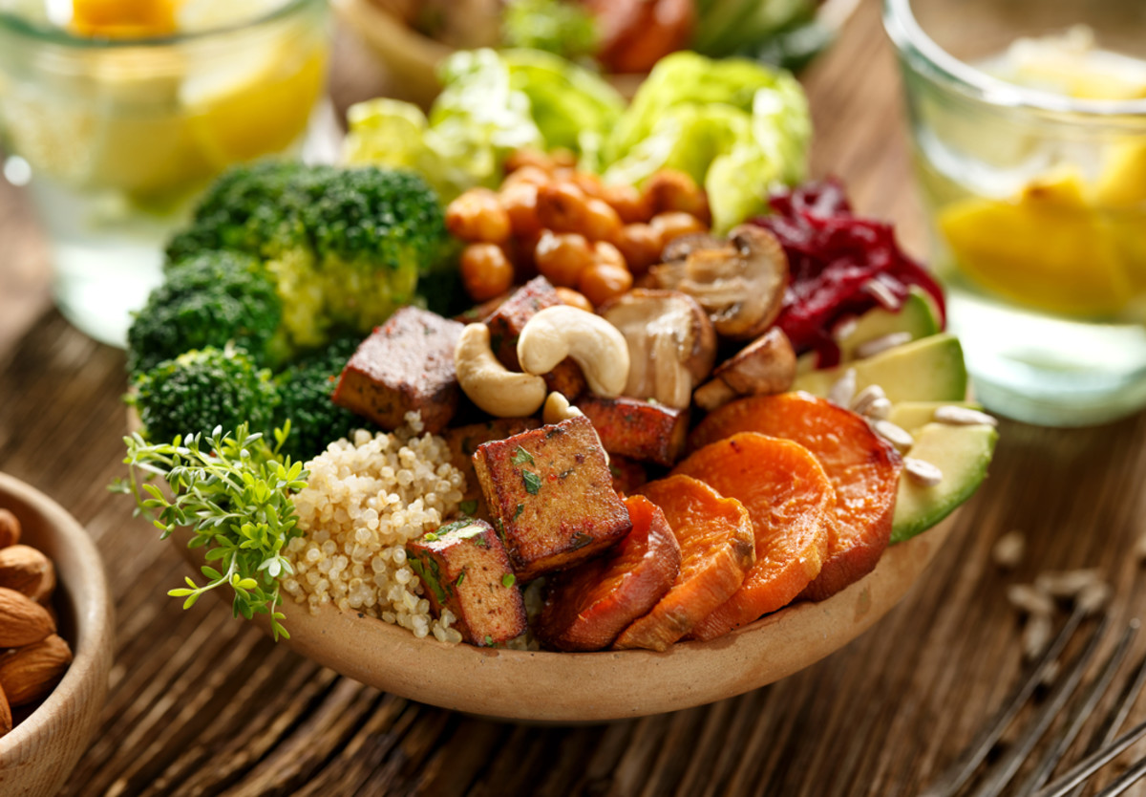

There is a world of reasons to go meatless, from heart health to animal welfare. But nutritionally, there's one tricky trade-off. You drastically shrink your body's supply of six vital nutrients: protein and iron—which can be the toughest to get in adequate quantities—plus calcium, zinc, vitamin B12 and vitamin D.
EIGHT GREAT FOODS ALL ARE LOADED WITH ONE OR MORE OF THESE
HARD-TO-GET NUTRIENTS

1. Tofu
Why it's great: Plain tofu has a lot going for it. It's a terrific source of protein, zinc, iron, and it even contains some cholesterol-lowering omega-3 fatty acids. It also gives you more than 100 milligrams (mg) of calcium in a half cup. But the same amount of calcium-enriched tofu gives you up to 350 mg (about one-third of your daily needs) plus roughly 30 percent of your daily vitamin D, which helps your body absorb the calcium—an extra bone-building punch that many people need. Look for enriched soymilk, too, which is also fortified with calcium and vitamin D.
Tip: "Tofu can be substituted for the same amount of meat, poultry or fish in almost any recipe," Firm tofu works best because it holds its shape when you sauté it or grill it.

2. Lentils
Why they're great: Lentils, like beans, are part of the legume family, and like beans, they're an excellent source of protein and soluble fiber. But lentils have an edge over most beans: They contain about twice as much iron. They're also higher in most B vitamins and folate, which is especially important for women of childbearing age as folate reduces the risk for some birth defects. For new vegetarians, lentils are also the perfect way to start eating more legumes because they tend to be less gassy.
Tip: Lentil soup is just the beginning. Add lentils to vegetable stews, chilis or casseroles. Toss them with red onions and vinaigrette. Stir them into curries; cook them with carrots. Experiment with different varieties—red lentils (right) cook up very fast and can be turned into bright purées.

3. Beans
Why they're great: A cup a day gives you about one-third of your iron and protein and roughly half your fiber. Even better, most of that is soluble fiber, which helps lower cholesterol. One cup also provides a good amount of potassium, zinc and many B vitamins, and some calcium too. Just one alert: Rinse canned beans well—they can be soaked in salt.
Tip: It was once thought that to get a complete protein, you needed to combine beans with grains (rice, pasta, bread) at the same meal. "Now we know you just have to eat them during the same day," Toss beans and vegetables with whole wheat pasta; make soups and chilis with several varieties; add a sprinkling to grain salads. And for a different taste treat, look for canned heirloom varieties.

4. Nuts
Why they're great: They're a nifty source of quick, totally palatable protein. In addition, walnuts, peanuts, almonds, cashews, pecans, macadamias and Brazil nuts are rich in zinc, vitamin E and omega-3 fatty acids. Some, like almonds, even provide a decent amount of calcium (about 175 mg in a half cup). There's also some great nut news: "Recent studies show that even though nuts are high in calories, eating them does not lead to weight gain,". In fact, people who eat nut-rich diets tend to weigh less than those who don't, say researchers at Loma Linda University and Purdue University. Peanuts may even help weight loss. Why nuts don’t make you fat—and may even help you lose weight—isn't clear. "It's possible that nuts make you feel so full that you're less likely to overeat other foods,". Other experts suspect that the labor-intense job of digesting nuts burns off calories. There are also hints that nuts increase the amount of fat that passes through the digestive tract, which might explain nut-linked weight loss. More research is obviously needed!
Tip: Different nuts give you different nutrients. For example, a half cup of almonds provides about four times as much fiber as the same number of cashews. Cashews, however, contain about twice as much iron and zinc as almost any other nut. Pecans and walnuts tend to land right in the middle for most nut nutrients—potassium, magnesium, zinc and calcium. Sprinkle them in salads or keep a bag of mixed nuts in your desk or backpack. Garnish smooth soups with crunchy whole nuts, stir chopped nuts into muffins and add crushed nuts to pie crust.

5. Grains
Why they're great: Some enriched whole-grain cereals are fortified with hard-to-get vitamin B12—some even offer 100 percent of a day's requirement in one serving—as well as iron, calcium and many other nutrients. Keep in mind that if you don't eat eggs or dairy, you'll have to take a B12 supplement to make sure you're getting enough. As a group, cereals and other whole-grain foods (whole wheat breads and pastas, brown rice, etc.) are also high in other B vitamins, zinc and, of course, insoluble fiber, which not only helps whisk cholesterol out of your system but may reduce your risk of colon cancer and other digestive disorders.
Tip: Because different grains provide different nutrients, vary the types you eat. "It's easy to get into a rut of, say, just making brown rice all the time. It's better to mix up the grains you eat, including oatmeal, bulgur, wild rice, whole rye and pumpernickel breads," says Sass. Also try some of the ancient grains—spelt, faro, kamut—which are now sold at most whole foods markets.

6. Leafy Greens
Why they're great: Unlike most vegetables, dark leafy greens such as spinach, broccoli, kale, Swiss chard and collards contain healthful amounts of iron—especially spinach, which has about 6 grams or about one-third of a day's supply. They're also a great source of cancer-fighting antioxidants; are high in folic acid and vitamin A; and they even contain calcium, but in a form that's not easily absorbed. Cooking greens and/or sprinkling them with a little lemon juice or vinegar makes the calcium more available to your body.
Tip: Always try to eat iron-rich foods with foods that are high in vitamin C because the C helps your body absorb the iron. With dark leafy greens, this comes naturally—just toss them into salads with yellow and red peppers, tomatoes, carrots, mandarin oranges or any citrus. Or if you prefer your veggies cooked, sauté a couple of cups of greens in some seasoned olive oil with sweet peppers, garlic and onion.
I do not recommend cooking in oil or mixing fruit and vegetables together.

7. Seaweeds
Why they're great: Besides being a terrific source of iron and phytochemicals, many seaweeds—such as alaria, dulse, kelp, nori, spirulina and agar—are good sources of minerals, including magnesium, calcium, iodine, iron and chromium, as well as vitamins A, C, E and many of the Bs. Talk about superfoods!
Tip: Add chopped dulse to salads or sandwiches, sauté it with other vegetables or use it in soups. Use nori sheets as the wrappers for vegetarian sushi. Toast kelp, and crumble it on pasta or rice, or add it to noodle soups. Browse through Japanese or Korean markets to find seaweeds to sample.

8. Dried Fruits
Why they're great: They're good, super-convenient sources of iron—and if you combine them with some mixed nuts, you've got a packet of iron and protein you can take anywhere easily. In addition, dried fruits—think apricots, raisins, prunes, mangos, pineapple, figs, dates, cherries and cranberries—provide a wide array of minerals and vitamins as well as some fiber. And even kids love to snack on them.
Tip: Sprinkle them on salads, use in chutneys, stir into puréed squash and sweet potatoes, or blend with nuts and seeds to make your own favorite snack mix. Chopped up, dried fruits make healthful additions to puddings, fruit-based pie fillings, oat bars, cookies, hot and cold cereals—you name it.
Nuts. Why they're great: They're a nifty source of quick, totally palatable protein. In addition, walnuts, peanuts, almonds, cashews, pecans, macadamias and Brazil nuts are rich in zinc, vitamin E and omega-3 fatty acids. Some, like almonds, even provide a decent amount of calcium (about 175 mg in a half cup). A palm full of nuts a day, but for Brazil nuts only 3 a day.

CLOSING THOUGHT:
Truth, precious, essential truth, will open before all who will keep their souls in the love of God. Duty and sacrifice will be precious to them, because of their love for the purchase of the blood of Christ. Human beings upon whom they would once scarcely look now assume a preciousness in their eyes. Once they had no interest in them; now they are united with Christ, and they are bound up in love with His heritage. The heart once frozen by icy selfishness is now melted by the influence of the Spirit.

