Pyrrhic Victory

When Pyrrhus invaded Apulia (279 BC), the two armies met in the Battle of Asculum, where Pyrrhus won a costly victory.^{[10]} The consul Publius Decius Mus was the Roman commander, and while his able force was ultimately defeated, they managed to almost break the back of Pyrrhus' Epirot army, which guaranteed the security of the city itself. In the end, the Romans had lost 6,000 men and Pyrrhus 3,500 including many officers.^{[4]} Pyrrhus later famously commented on his victory at Asculum, stating, "If we are victorious in one more battle with the Romans, we shall be utterly ruined".^{[13]} It is from reports of this semi-legendary event that the term Pyrrhic victory originates.

From <https://en.wikipedia.org/wiki/Pyrrhus_of_Epirus>

Reichstag is a German word generally meaning parliament, more directly translated as Diet of the Realm or National diet, or more loosely as Imperial Diet.

From <https://www.google.com/search?q=reichstag&oq=reichstag&aqs=chrome..69i57j0l5.2839j1j7&sourceid=chrome&ie=UTF-8>
di·et²
/ˈdīət/
noun
noun: diet; plural noun: diets
- a legislative assembly in certain countries.
synonyms: | legislative assembly, legislature, parliament, congress, senate, synod, council; More
- HISTORICAL
a regular meeting of the states of a confederation.
- SCOTS LAW
a meeting or session of a court.

From <https://www.google.com/search?ei=Ky3sXIeYLYrB-wTo6ImADQ&q=diet+definition&oq=Diet+def&gs_l=psy-ab.1.0.0i20i263i70i249j0j0i20i263j0l7.2992.4524..6294...0.0..0.80.312.4......0....1..gws-wiz.......0i71j0i67j0i67i70i249.d9oLRMj91P0>
Fascism
From Wikipedia, the free encyclopedia
Jump to navigationJump to search
For other uses, see Fascism (disambiguation).
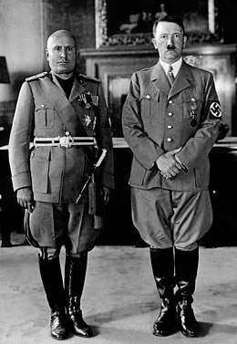
Benito Mussolini (left) and Adolf Hitler(right), the fascist leaders of Italy and Nazi Germany, respectively
Part of a series on
Fascism (/ˈfæʃɪzəm/) is a form of radical, right-wing, authoritarian ultranationalism,^{[1][2][3][4]} characterized by dictatorial power, forcible suppression of opposition, and strong regimentation of society and of the economy,^{[5]} which came to prominence in early 20th-century Europe.^{[6]} The first fascist movements emerged in Italyduring World War I before it spread to other European countries.^{[6]} Opposed to liberalism, Marxism, and anarchism, fascism is placed on the far-right within the traditional left–right spectrum.^{[6][7][8][9][10][11]}

From <https://en.wikipedia.org/wiki/Fascism>
Communism

From Wikipedia, the free encyclopedia
Jump to navigationJump to search
For other uses, see Communism (disambiguation).
Not to be confused with Communitarianism or Communalism.
"Full Communism" redirects here. For the album by Downtown Boys, see Full Communism (album).

In political and social sciences, communism (from Latin communis, "common, universal")^{[1][2]} is the philosophical, social, political, and economic ideology and movement whose ultimate goal is the establishment of the communist society, which is a socioeconomic order structured upon the common ownership of the means of production and the absence of social classes, money,^{[3][4]} and the state.^{[5][6]}
Communism includes a variety of schools of thought, which broadly include Marxism and anarchism (anarcho-communism), as well as the political ideologies grouped around both. All of these share the analysis that the current order of society stems from its economic system, capitalism; that in this system there are two major social classes; that conflict between these two classes is the root of all problems in society;^{[citation needed]} and that this situation will ultimately be resolved through a social revolution. The two classes are the working class—who must work to survive and who make up the majority within society—and the capitalist class—a minority who derives profit from employing the working class through private ownership of the means of production. The revolution will put the working class in power and in turn establish social ownership of the means of production, which according to this analysis is the primary element in the transformation of society towards communism. Critics of communism can be roughly divided into those concerning themselves with the practical aspects of 20th century communist states^{[7]}and those concerning themselves with communist principles and theory.^{[8]}
Marxism-Leninism and democratic socialism were the two dominant forms of socialism in the 20th century; democratic socialism advocates economic reform through gradual democratic legislative action rather than through revolution.

From <https://en.wikipedia.org/wiki/Communism>
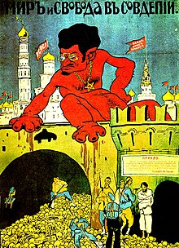
Pogrom
From Wikipedia, the free encyclopedia
Jump to navigationJump to search
For the volcano in the Aleutian Islands, see Pogromni Volcano.
Pogrom
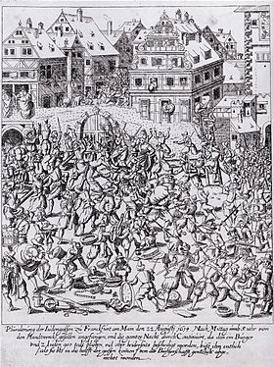
Plundering the Judengasse, a Jewish ghetto in Frankfurt am Main, on 22 August 1614
Target | Predominantly Jews
A pogrom is a violent riot aimed at the massacre or persecution of an ethnic or religious group, particularly one aimed at Jews.^{[1]} The Russian term originally entered the English language in order to describe 19th and 20th century attacks on Jews in the Russian Empire (mostly within the Pale of Settlement). Similar attacks against Jews at other times and places also became retrospectively known as pogroms.^{[2]} The word is now also sometimes used to describe publicly sanctioned purgative attacks against non-Jewish ethnic or religious groups. The characteristics of a pogrom vary widely, depending on the specific incidents, at times leading to, or culminating in, massacres.^{[3][4][5][6][7][8][9]}

From <https://en.wikipedia.org/wiki/Pogrom>
History of Solidarity
Description
The history of Solidarity, a Polish non-governmental trade union, began on August 14, 1980, at the Lenin Shipyards at its founding by Lech Wałęsa and others. In the early 1980s, it became the first independent labor union in a Soviet-bloc country. Wikipedia

From <https://www.google.com/search?q=solidarity+movement&oq=Solidarity+Movem&aqs=chrome.0.0l3j69i57j0l2.6886j1j4&sourceid=chrome&ie=UTF-8>

