12.Reunion, March 2019,
1st Angel Empowered

Parminder Biant

Much of our study this week, has been of an introductory nature. As we begin to try to make some application of what we've been learning, the material might become a little bit more detailed perhaps, maybe more difficult. So, if things don't make sense the first time that you watch them, I'd recommend you go over these materials again, and also maybe view other material that we've done in the past, to help to explain some of the things that we're teaching.

I’d like us to turn to Revelation 10, we're also going to be looking at 7 Bible Commentary, page 971, paragraph 4. This Spirit of prophecy reference is a commentary on this chapter.

We've already identified that the time of the end is 1798. And this was preceded by a history of 1260 years which began in the year 538. And that event was when the Beast of Revelation 13 began to rule supremely the then known world. It was able to do that because it had overcome opposition. There were powers in Europe that were preventing it from ascending to the throne. You turned to Daniel, we’ve mentioned this verse before, Daniel 7:8.

7:8 I considered the horns, and behold, there came up among them another little horn, before whom there were three of the first horns plucked up by the roots: and behold, in this horn [were] eyes like the eyes of man, and a mouth speaking great things.

You see in this verse that there was an iron beast, symbol of pagan Rome, which has ten horns, symbolizing ten European nations. And in verse eight we're told that three of those powers or, Kingdoms, were destroyed. And they were destroyed at the behest of the little horn. And that little horn was papal Rome. By the time those three kingdoms were destroyed we get to the year 538. The three kingdoms were the Heruly, the Vandals and Ostrogoths. Most of that is pretty standard Adventist teaching, most of you will be aware of that. So, we arrived at the Year 1798, and we see that the everlasting gospel begins to be preached. And it's preached in three steps
culminating in the year 1844. And we have a shot door. This door that is shot, is a symbol of the work that Christ is doing in heaven as he transitions from the Holy place to the Most Holy place. As he transitions from these two compartments, we see that there is a door shot. We understand that this event, October 22nd, is the Day of Atonement.

The everlasting gospel occurs in three steps. I want to put a little bit more detail here. One of the most important events that occurs in this history, occurs in the year 1840. If we had the charts, I'll be able to show you graphically what's being portrayed here.
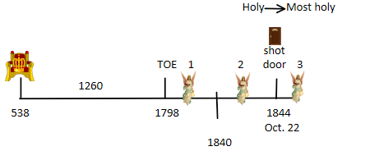
This year 1840 it's a fulfillment of Revelation 9. We’re in Revelation 10,
and this is the fulfillment of Revelation 9. If you want to understand the context of Revelation 9 you need to go to chapter 8, beginning with verse 2
it says that there are seven angels. These angels are standing before God and each of them was given a trumpet. So, these are the trumpet angels and what we'll see is that each of these angels in turn begin to blow their trumpets one after the other. Go to verse 7 of chapter 8 it says the first angel blew his trumpet; verse 8 the second angel; verse 10 the third and verse 12 the fourth.

Chapter 8 deals with the first four of those angels. Chapter 9 deals with the next two angels, number five and six, and chapter 10 and chapter 11 deal with the seventh and last of those angels that have trumpets. Those last three angels, number five six and seven are addressed in verse 13 of chapter eight.

Revelation 8:13 “And I beheld and heard an angel flying through the midst of heaven, saying with a loud voice, Woe, woe, woe, to the inhabiters of the earth by reason of the other voices of the trumpet of the three angels, which are yet to sound!”

So, there are three angels yet to blow their trumpets and there's a pronouncement that's made upon the world, which is given by the statement of woe, woe, woe. Each one of these angels as it blows its trumpet, it is connected to this woe. So, angel number five, six and seven, each has a woe connected to it.

5T 6T 7T

Woe Woe Woe
_______________ ______
9 10-11

Revelation 9 deals with the subject of the first two, and chapters 10 and 11 deal with this third woe, or the seventh trumpet. The subject of these trumpets at one level is relatively straightforward but there's a lot of details to learn. If we go to chapter 9 verse 5 and 10, what you'll see in those verses is the time period that's connected to this first woe. Chapter 9:1 the fifth angel blows its trumpet, and you see things begin to happen. We’ll read verse 5 and verse 10.

9:5 And to them it was given that they should not kill them, but that they should be tormented five months: and their torment [was] as the torment of a scorpion, when he striketh a man.
9:10 And they had tails like unto scorpions, and there were stings in their tails: and their power [was] to hurt men five months.

So, what I want us to see, that there's a time period that's given, it says five months. If I were to say five months is 150 years, how many of us would be able to do that mental calculation? Five months, and there are 30 days in one-month, prophetic month. So, five months is five times 30 days is 150 days, or years.
5 m x 30 d = 150 days/ years
We know that one day is one year therefor, five months is 150 years. So, we have a time period given to us. Let me sketch this out for us, this is our 150 years, we read verses 5 and 10, now we read verse 12

9:12 “One woe is past; [and], behold, there come two woes more hereafter”.

In verse 5 it says to torment and in verse 10 it says to hurt. By the time you get to the end of the five-month period it says that first woe it comes to its end. And there are two more to follow afterwards. So, this 150 years period is the period of the first woe. But this time period of 150 years is connected to the history of this fifth angel in verse one. So, the fifth trumpet began sometime before. 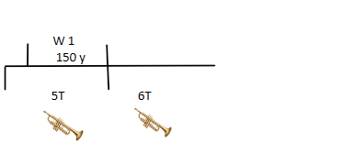 It’s not given a time prophecy connected to it, but there's an intensity of activity which the Bible calls a woe, which is connected to a time period. And when that time period comes to an end, the woe finishes and the fifth trumpet finishes. And then we get to verse 13, and it begins by saying the sixth angel sounded. So, here's the sixth angel, it begins to blow its trumpet.

Revelation 9:13 “And the sixth angel sounded,”

In verse 14 it says that there's a message given to the sixth angel, but it's required to loose four angels. So, if you had four angels doing something what would they be doing based upon the number four? They will begin to bring a progressive destruction. Remember we've seen that the number four is a symbol of destruction that happens progressively.

9:15 “And the four angels were loosed, which were prepared for an hour, and a day, and a month, and a year, for to slay the third part of men.”

So, these four angels are prepared to do a work for one hour, one day, one month and one year.
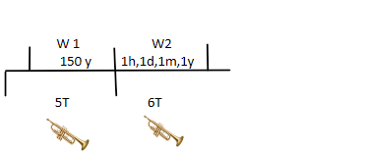

They do their work, and we see again a time prophecy that's given. Now, the rest of the wording, as we begin to transition from Chapter 9 to chapter 10 becomes slightly more complicated to track how these angels begin to do their work.

11:14 “The second woe is past; [and], behold, the third woe cometh quickly”.

But if you go to chapter 11:14 it tells us that the second woecomes to its end and as it comes to its end,it saysthat the third woe comes quickly. Nowthe third woe doesn't come immediatelyafter the second. Ifwe go to verse 15 it says that the seventh angel begins to sound.

11:14 “The second woe is past; [and], behold, the third woe cometh quickly.”
11:15 “And the seventh angel sounded; and there were great voices in heaven, saying, the kingdoms of this world are become [the kingdoms] of our Lord, and of his Christ; and he shall reign for ever and ever”.

So, here's the sixth angel and then you'll have the seventhangel. So,these are the last three trumpet angelsand sometime afterthe second woe, we'll see that the third woebegins. Iwant to give you some dates, this is the year 1299, these are all AD dates, this is the year 1449, will quickly do this calculation 1h1d1m1y; one year is 360 days, one month is 30 days, one day is one day. So, if you add all of this up it turns to be 391 days, which we will turn into years. So, it's 391 years this period. It has one hour. Sometimes this confuses people of how to calculate that. I'll just show you briefly. One day is one year; one day is 24 hours; so, 24 hours is one year. One hour therefore is one year over 24 hours. We already know that one year is 360 days. If you did 360 over 24, you'll see that it's 15 days.
Days
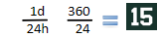

So, this prophecy is 391 years and 15 days long. I haven't given you the dates, we could go through them but I’m just concentrating on the years. I don't know how many of you can do the mental math to add 1449 to 391, these two numbers together, but you'll see that you get to the Year 1840. So, this year 1840 is the fulfillment of this prophecy that's given in Revelation chapter 9. And we've gone through the verses that we need to see to understand how this prophecy comes together.
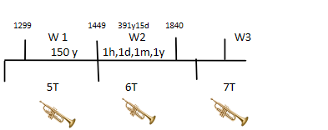
If we were to go through a study like this, normally will take three or four maybe five classes to do this amount of work. If you have your chart books you go to the beginning of the book, it's the first chart in your books. By the way if you were to place this chart and its publishment in this history, it was here in the year 1842. That's when this document was created. The document itself is a graphical representation of the beliefs of God's people at that time period.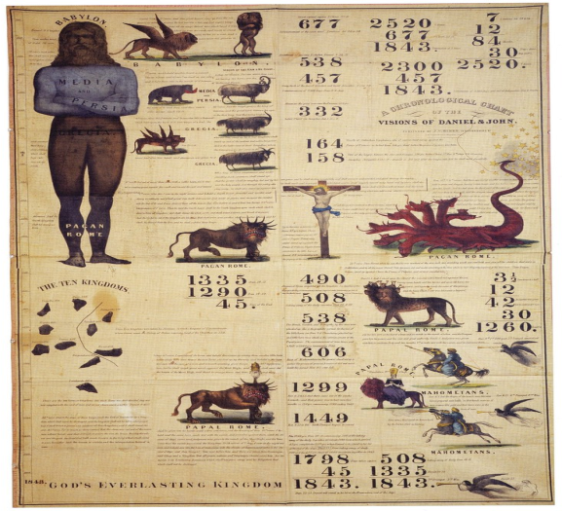
If you're not familiar with this chart, you'd see that this is Daniel chapter 2, Daniel chapter 7, Daniel chapter 8, there's a central column and then you go into Revelation, and you have Revelation 12 Revelation 13 and Revelation 17. So, it's 12, 13, and 17 and if you were to read the verses, you'll know that this is the dragon that we've spoken about, this is the beast and there's this woman who rides the beast. Even though the picture work looks different it was created in agreement with what the verses describe. If you read past the details, you'll see that this animal looks identical. It has seven heads and ten horns in each chapter. Then there is one more piece of information and that's here in the bottom right-hand corner. If you were to look at that, you'd see that it's a fulfillment of Revelation 9. You'll see that there's three angels. Those three angels are these three angels here
5T 6T 7T

Woe Woe Woe
_______________ ______
9 10-11

or these three angels.
REVELATION 9

You’ll see that they all have trumpets, helps us to identify them; and then next to each of the first two it gives a little graphic of the history that's involved during the time period of the first and second woes which is all
Revelation 9. So, this picture work here at the bottom right-hand corner is a
graphical representation of chapter 9 that we've just quickly studied. What
you'll see is the understanding that God's people had of chapter 9 at the beginning of Adventism. You'll see that's the symbol of the fifth trumpet-the first woe, the sixth trumpet-the second woe, is a man on a war horse. You'll see that there are subtle differences, the first one has a spear, the second one has a gun. And he also identifies what this is a symbol of. Clearly tells you Islam, so, we know according to the studies that our forefathers did that the fifth and sixth trumpet with its associated woe, and this woe is a period of intense anguish for the kingdom that these trumpets are attacking.

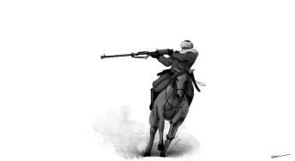
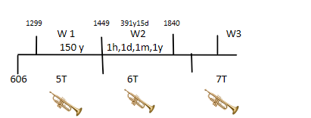

This is Islam this is Islam?????

This is a lot of history; if you're able to read the chart and we were to go back to verse one and verse two it talks about a star falling from heaven, and it talks about smoke coming out of a bottomless pit. You see this in the first three verses. And then in verse 3 it says out of the smoke comes locusts. If you were to review most evangelical understanding of this chapter they come up with strange ideas, as though these locusts are
war planes or helicopters. And what they don't understand is the historical
fulfillment of this history. Because the chapter begins in the year 606 which
was the rise of Islam. And our forefathers correctly identified what those locusts were. They symbolized cavalry, which was a graphical representation of the nature of the army that Islam was in that history. Now we already studied that upon the testimony of two a thing is established. So, when you get Jerusalem destroyed once, and then Jerusalem destroyed the second time it’s pointing to the fact that Jerusalem will be destroyed a third time. Or if we see a Sunday law happening twice, they're pointing to a Sunday law at the end of the world.

J1 J2 = J3
SL1 SL2 = SL3
Rome pagan Rome papal = Rome, Modern Papal

What I've alluded to, but I haven't explicitly stated, if you see Rome as pagan and then Rome as papal this will point to Rome again, which I'm calling Modern Papal. We know that the papacy after receives a deadly wound will resurrect. All of this modeling I've given a name to, it's a triple application, because it comes three times. I'm saying that when you have three woes, that the first and the second equal the third.
= 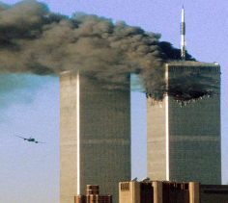

W1 + W2 = W3

These histories (pointing to the woes) are going to be repeated at the end of the world. We can see how over and over again, we use this technique, to understand end time prophecy. I have to inform you that our church, the theologians of our church, these are not regular pastors, we would call them scholars, University lecturers, those who study the Bible at an academic level, and they teach and train our pastors when they go to university, which we call seminaries. Today our church no longer believes that the application that I just put on the board is correct. The understanding that our forefathers had; when I say our forefathers, I'm talking about this history which I'm going to call the Millerites. They were the people who created this chart and developed all the foundational truths that Adventists believe. I've already explained after 1844 at the arrival of the third angel’s message, both the sanctuary and the Sabbath were understood, which were the final components of the belief system the Adventists had. Another chart was made after this one, in the year 1850. This chart even though it looks slightly different has all the same information.
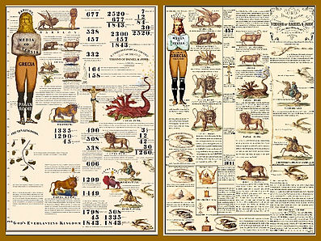

You can see pagan Rome and papal Rome. Revelation 12 and Revelation 13. You can also see Revelation 9 being brought to view here. It says woe, woe, woe. Same graphics. The only difference that is on this chart is brought to you here on the bottom left-hand corner. It mentions Revelation 14, the three angels’ messages, then you'll see a symbol of Christ sitting on the cloud, the second advent, and I'm not sure if you can see it clearly, he has something in his hand, it's a sickle for harvesting crops. And then beneath him at the very bottom there's another angel with an identical instrument. So, Christ is going to be doing some gathering, and harvest and so is this other angel. I want us to see that there are other angels involved in this story.

We've seen a picture of the sanctuary before, what all of this picture work is showing, is the understanding of God's people after 1844. This chart was produced in 1850. By 1850 we were fully established in the doctrine of the sanctuary and the Sabbath. As I said, our church no longer holds to these belief systems. Our prophetic understanding at the beginning, or alpha of Adventism is no longer believed. Of course, you obviously know that I believe them and I'm going to use a triple application to understand what's going to occur at the end of the world. I ask you, if you have a candied, reasonable mind, you're open-minded, why is there so much news activity that's dealing with Islam today? And it's not only today, it's been going on for a number of years. We could easily mark the last 18 years. And in fact, there's been interaction between the west and Islam for years before that. Do you think that the world is distressed?

When I’m looking at this congregation here, a number of people are quite young. So, those of us who are older, I’m sure you all remember, not in the 21st century but in the 20th century, not that long ago, the world was a different place. There wasn't the collapse of society that we see today. I think most of us who are old enough would agree that there's been a rapid and sudden change. A lot of it is unexplainable. And what we have seen, over the last thirty years, is a rise in the activities in the Middle East. Islam has become radicalized and is the war with the West, and I'm saying that that conflict between these two worldviews, is the fulfillment of end-time prophecy. It's the fulfillment of this triple application. Our church teaches that all of this is a distraction from the true gospel. I want us to read a verse, Luke 21:24-25

Luke 21:24 “And they shall fall by the edge of the sword and shall be led away captive into all nations: and Jerusalem shall be trodden down of the Gentiles, until the times of the Gentiles be fulfilled.”
21:25 “And there shall be signs in the sun, and in the moon, and in the stars; and upon the earth distress of nations, with perplexity; the sea and the waves roaring;”

We already read verse 24 yesterday if you remember, just only refresh our minds; Jerusalem was destroyed in 70 AD, it continues to be trodden underfoot from the year 70 AD for the next 500 years by pagan Rome and then for 1260 years by the combination of church and state, we read that in Revelation 11:2. This was the times of the Gentiles, brings us to 1798, and then we come to verse 25. There's a lot of information and symbology in these verses, but it talks about signs in the Sun, Moon and stars.
This is my symbol of the Sun, the moon, and the stars. Without proving it, which we could do if you went to the Great Controversy, I'll give you the dates for this, I want to use the word cluster; all of these events, they cluster around the Year 1798. This happens in the year 1780, both events, this happens in the year 1833. So, this is a few years before and this is the few years afterwards. So, we have the year 1780, and we have the year 1833. 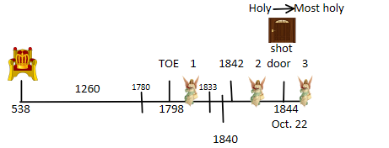

1780

1780

1833
These are well-documented events, they were in the secular newspapers, but they were particularly in the religious newspapers, because all Christians, and most of this was seen in North America, recognized that these events were a fulfillment of these verses. The verse says more, it says that there was a distress of Nations. This distress of nations, I'm just going to give a brief history about. We’re in the Year 1798, and what has just happened? Napoleon, the general of the French army has gone to Rome after they had broken an alliance that they had together, took the Pope captive, brought him to France and put him in prison. He died very soon afterwards. But the same year 1798, France in its attempt to control Europe, decided to make a strategic move, against his arch enemy, England. England and France had been at war for centuries. We haven't discussed in our class, but I have discussed in private conversations with some people hear, the concept of spheres of influence. France and England had tried to destroy each other but they were unable to do so. The way that they would attack each other was to destroy the spheres of influence they had. So, France is going to send Napoleon to North Africa, to Egypt. Why would they send Napoleon the great general to Egypt if they want to take over Europe and England is their major nemesis or problem? What's Egypt got to do with anything? Perhaps some of you know, if I do a very crude map, this is Spain this is the southern coast of Europe, Italy, Croatia coming into Greece, coming into Turkey, the Black Sea, coming back into Turkey coming to the coast of Israel, and then the north coast of Africa.
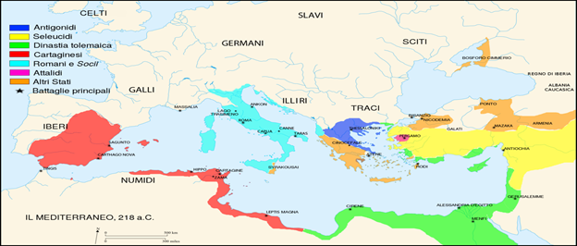
This is the Mediterranean Sea, the Black Sea, and this is the Atlantic. This is the Straits of Gibraltar, and this is the Bosporus straits. The Bosporus straits, this is where Constantinople was seated. Which was the capital of the eastern pagan Roman Empire in this time history, 1260. Napoleon is going to come with a Navy to Egypt. And why did he want to do that? The UK is up here. I'm sure all of us know, today there's a canal that joins the Mediterranean in the Red Sea together. This is Sinai Peninsula and this is the Suez Canal.
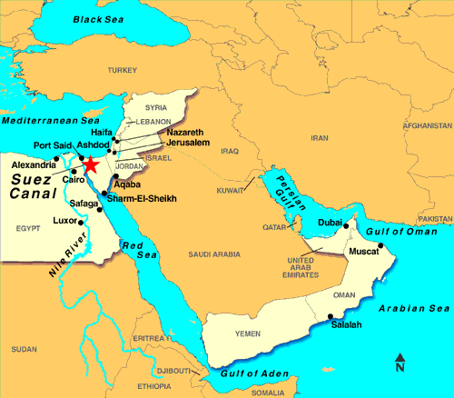
Now in this history the Suez Canal didn't exist. But they did have some canals. If you follow all the landmass and go into Asia, you get to one of the most important countries, India.
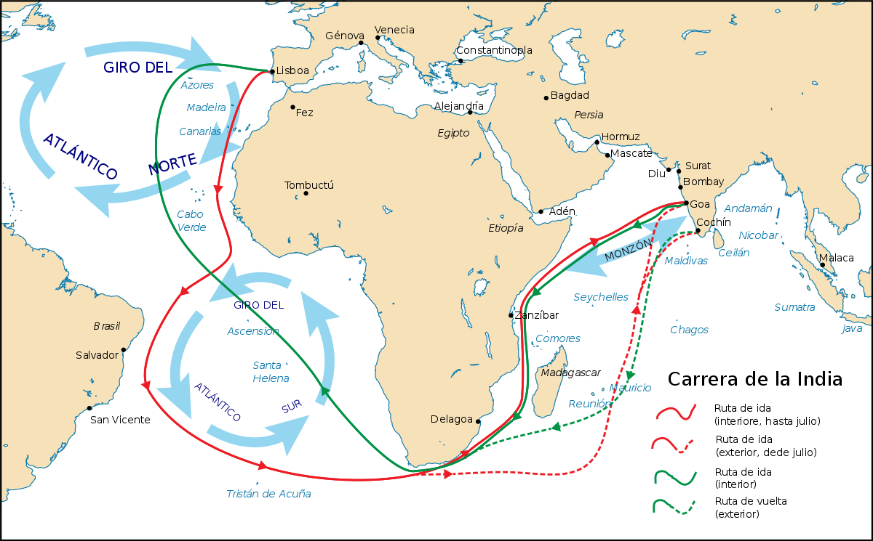
And India was the jewel in the crown of the British Empire. This is where England was making most of its money in this history. If you know anything about marine travel, you'll know that Cape Horn, South Africa is a treacherous route to navigate. Not only that, but it’s extremely long.
So, England would take their Navy, protect the Mediterranean Sea so that they could do trade from England through the Mediterranean cross the Sinai Peninsula which isn't very far, pick up shipping again and go to India.
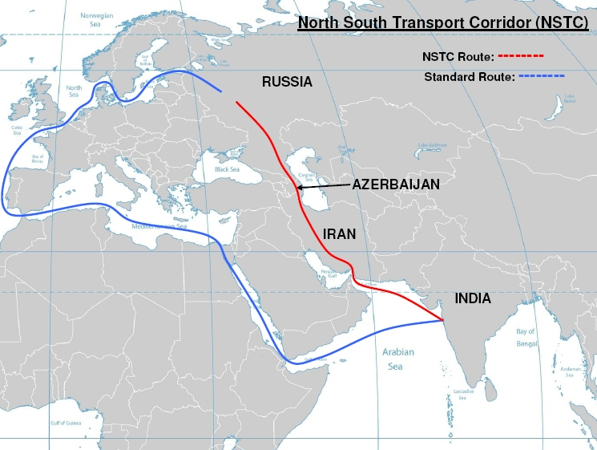
This was the trade route. And what does France want to do? It wants to strangle and stop that trade route. So, they're going to try to take Egypt. This is well-documented history. Unfortunately, when Napoleon tries to do this, he isn't very successful. He's a proud, arrogant man and even though he was a genius as a general, his pride and arrogance often led him to not prepare sufficiently. That's what happened here, he received stiff resistance. And he was ill-prepared to meet the climate, the disease, and the military opposition. It wasn't only Egypt that he ended up dealing with, he also went into Syria, and this was part of the Turkish Empire. He was stopped dealing with Egypt, and he was stopped dealing with Syria. What happens is, he eventually leaves. But when he leaves, he upsets the balance of power in this region, and it sparks a number of wars between Egypt and Turkey. They were called the Egypt-Turkish Wars, or the Syrian Wars, because they were fighting over Syria. We've heard of the Syrian war today, it’s not a coincidence that there was war over this area in this history. I'll give you some years, in the year 1821 to 1823 there was a two-year war in this history. There was a break in the war, and the war began again in 1839 and lasted to 1841. And what's in the middle of these two dates? 1840.
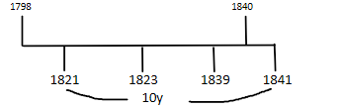

The war itself, the intricacies is quite complex, I’m going to mark that this is a 10-year period.!!!! So, there's a war in the Middle East and this war in the Middle East between Egypt and Turkey, over this 10-year period is upsetting the balance of power in Europe. What we need to remember is geography.
If I were to put the north coast of Europe here, and I said this was Russia, every country wants to have a coast, so that it can trade easily. Countries that are landlocked, struggle to prosper economically. Every nation that has a commercial shipping fleet, succeeds economically, and it's no coincidence that in the Bible, ships, are a symbol of economic strength. If you see ships as a symbol of end-time prophecy its dealing with economic power. Now there's many seas up here, they've got different names (on top of Europe) but I’m just going to call this the North Pole. It’s a treacherous sea, that you're not able to navigate in winter. If you're Russia and you want to navigate and do economic business, and this is not a reliable shipping route, what is, can you all see? It's the Black Sea, through the Bosporus straits, and then out through the Straits of Gibraltar. This is why Turkey is such a strategically placed country. And as this struggle is happening between Egypt and Turkey, there's a disturbance in the balance of power in Europe. If Russia supports Turkey, so that Turkey becomes a puppet, Russia will have control of the Bosporus Straits, and the other European powers will see this as a threat, or the balance of power moving. If England supports Turkey, then they’re going to block the Bosporus straights, Russia won't be able to have a shipping route, so, Russia will not allow England to take control of Turkey. The European powers, they want control of Turkey, but it comes with a price. If England takes over, Russia will go to war, if Russia takes over England will go to war. So, what the European powers decide is that they say no one will have Turkey. Turkey will remain as an independent government, and what they will do is support Turkey in its war against Egypt, because Egypt was winning the war. They threaten Egypt, they say if you attack Turkey, we’ll attack you. So, what I wanted you to see is that there is distress in Europe over the activities of Islam, in this 10-year period which was connected to the work of Napoleon of France as he disturbed the balance of power, when he came and interfered in the activities of Egypt. It had a ripple effect. So, there's a connection between the deadly wound to the papacy and the activities of Napoleon when he goes to Egypt upsetting the balance of power in Islam. Egypt begins to make war with Turkey, beginning a 10-year war, and each one of these parties begins to get supported by some of the European powers.
Like a game of chess where you have chess player moving the chess pieces. These people are fighting against one another (the chess players) but they're not fighting directly. They're fighting through a game. The pieces on the board become proxies which is a fancy world of saying substitute. Instead of two people fighting, the two chess pieces will fight. What is the everlasting gospel, Genesis 3:15, who's fighting against whom? The seed of the serpent, and the seed of the woman. Seed means children. The human people and the human people will fight. Who are these people serving? Satan. Who are these people serving? Christ. Because there's war in heaven isn't there? Christ and his angels fought against Satan and his angels. That war spiraled out of control and fell to the earth. And now on earth Christ and Satan don't fight. Who fights? It's Satan's followers and Christ's followers, that’s called a proxy war. We are living in a proxy war, we're the victims of this war. So, there's a proxy war going on here in this history and in the midst of all of this there is this trouble that Europe is going to get involved in, we read that in Luke 21:25

Luke 21:25 “And there shall be signs in the sun, and in the moon, and in the stars; and upon the earth distress of nations, with perplexity; the sea and the waves roaring;”

Soon after the Sun, Moon and stars, seven years after 1833, you had the distress of nations. The European nations are distressed, because there is war in the Middle East. And this insurrection that's occurring, needs to be
dealt with. So, we have a scenario, hear in 1840 where the second woe is coming to its end. The European powers are going to give support to Turkey. Turkey becomes a vassal state, or a puppet country. These four angels that were to kill, to hurt, for 391 years come to their end in 1840. Because Islam is now weakened so much, it comes under European power, or control. They support one part of Islam, Turkey, and threaten to go to war with another part of Islam, Egypt.

So, we know that in the history of 1840 there is a distress of nations. The European Nations. These European nations are concerned about the balance of power, all centered around economic activity. They bring one Islamic power into their pocket, Turkey, while going to war with another Islamic power, restraining them, Egypt. That’s what 1840 is all about.

And we've marked 1798, and we’ve marked 1840. Now 1840 we've seen is a fulfillment of all of this prophecy, 391 years. An interesting phenomenon happened, I've marked all of these battles, this war. One year before 1839 in the year 1838 one of these Christians who was an associate of William Miller, his name was Josiah Litch.

Josiah L
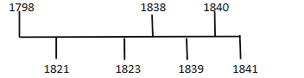

This man went to Revelation 9, went through all of these calculations and worked out that Islam was going to be restrained in the year 1840, in two years. He continued to study, and close to the event he actually gave the exact date, which was August the 11th. When his prophecy, his prediction was fulfilled, the followers of the Millerites were all happy because they knew that their prophetic understanding was correct. What had happened, is in 1840, this principal, one day quals one year, was confirmed. Why was that important? Because what were the Millerites doing from 1798? You remember that we have three messages. The first message says fear God because the judgment is about to happen in 46 years. And the 46 years was going to end in 1844, at the end of the prophecy that's given in Daniel 9, 2300 days, not years. So, William Miller had to change from days to years. But nobody was sure whether he was correct. Are you allowed to change from days to years? People weren't sure, they didn't have any proof. Who gave them proof? Josiah Litch, he proved in 1840 that William Miller's prophecy, his methodology was correct. And so, in the next four years they were sure that their prophecy was correct. They began to do this work from 1798 onward. But in 1840, power came into this movement because Litch proved the day for the year is correct. And if it's correct in Revelation 9, it must also be correct in Daniel 8. So, there was power given to the message here in 1840. That power that’s being discussed in chapter 10, is introducing the symbology of this angel coming down from heaven.

Revelation 10:1 “And I saw another mighty angel come down from heaven, clothed with a cloud: and a rainbow [was] upon his head, and his face [was] as it were the sun, and his feet as pillars of fire:”

I want to show you a nice pattern. This is 1798, and this is the first angel’s message, Revelation 14. If you check the words of the verse, it says this angel is flying around the earth. Here's the earth, and this angel flying around.
1798
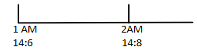

If you go to verse 8 it says that the second angel is also flying around the earth. And if you would go to verse 9, you’ll see that angel flying around the earth. Ellen White is commenting on these verses, confirms that these angels are flying around the earth. All of them are doing the same thing. We are only going to focus on these two.

When this angel is identified in verse 8 it's flying around the earth even though it doesn't say in the verse itself, when Ellen White comments on it she says that they're all flying around the earth. And all of you have seen the logos that Adventists have, three angels flying around the earth. This angel, the second one, what is it say? Babylon is fallen. Go to chapter 18, I wanted us to see something.

Revelation 18:1” And after these things I saw another angel come down from heaven, having great power; and the earth was lightened with his glory. “

You're going to see that an angel is not flying around the earth. This angel comes down from heaven to earth and when he comes, what does he say in verse 2?

And he cried mightily with a strong voice, saying, Babylon the great is fallen, is fallen, and is become the habitation of devils, and the hold of every foul spirit, and a cage of every unclean and hateful bird.

The same thing as in Revelation 14. He says the same thing it's the same angel. So, this is also the second angel, he flies in chapter 14, he lands in chapter 18. Do you think you're going to see the same thing for the first angel? You will.
1798
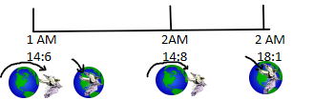

First angel is a little bit harder. You need to go to spirit of prophecy quotes to prove this. What was William Miller's message here at the beginning in 1798? He said, I'm going to use day for a year, because I want to make a prediction about 1844. So, the first angel’s message is predicated or built upon the day for the year principle. Is it correct? We don't know. How do you know if it's correct or not? There’s no way of knowing. 42 years later Josiah Lich is going to come, in 1840, and he's going to use a day for a year principle and he's going to say it's correct, he's going to prove that it's true. Revelation 10 what's this angel doing?

10:1 And I saw another mighty angel come down from heaven, clothed with a cloud: and a rainbow [was] upon his head, and his face [was] as it were the sun, and his feet as pillars of fire:

He comes down from heaven. So, I'm saying that this is the first angel. So, the first angel flies and lands, the second angel flies and lands. When he lands, he cries with a loud voice, when the second lands he cries with a loud voice. So, what we're seeing here is that this angel begins to do a work, the angel is a messenger, that has a message. It begins its work here, 1798, but in 1840 this message is going to have power because it's proven to be true, so that God's people can have confidence that the message that was given here, 1798, is indeed a true message. So, this is the first angel when it arrives, and this is the first angel when it's going to receive power. The same message, but now it's receiving power. This is the second angel when it arrives and then this is the second angel when it receives power.

April
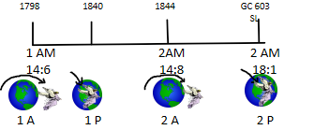

So, I what us to see we're dealing with these angels, they have an arrival and an empowerment. The third angel is exactly the same. We don't have the time to go into all the details, but the second angel arrives in the year 1844 but not October, it arrives six months before, in April. This angel (second) is going to receive power, and Ellen White is going to tells us when.
If we were to go to the Great Controversy page 603, chapter 38. We're going to see this chapter is called The Final Warning. Remember we spoke about the introduction, the body, the conclusion. The introduction to this chapter, which is the final warning, and if you see the context of this chapter, it's the Sunday law, she begins this chapter not with her own words. She quotes Revelation 18 verses 1, 2 & 4, the very verse that we identified. So, the second angel is going to become empowered at the Sunday law. This Sunday law is this Sunday law here, number three. When we start considering the work of these angels particularly this angel here in 1840, we want to see that it's the empowerment of the first angel preceding the arrival and then the empowerment of the second. Tomorrow we're going to talk about the empowerment and the arrival of the third, in fact I've already given you the arrival of the third it’s 1844, October, and this is the
third angel's arrival
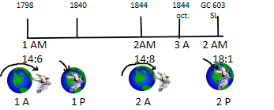

By the way this shot door, Oct. 1844, I'm going to give you a Bible verse for that, Revelation chapter 3. Revelation 2 and 3 it is dealing with the experience of God's church through seven histories. Begins with Ephesus and it ends with Laodicea. If you track through those experiences, we’ll come to number six.

The 6th experience, Philadelphia. If you want to know where Philadelphia is in history, we'll see the symbols. Talking about the angel of Philadelphia, the person that is holy, and that is true he says the following: he's the one that has the key of David. What do we do with keys? Open and lock doors.

Rev. 3:7 “And to the angel of the church in Philadelphia write; These things saith he that is holy, he that is true, he that hath the key of David, he that openeth, and no man shutteth; and shutteth, and no man openeth;”

3:8 “I know thy works: behold, I have set before thee an open door, and no man can shut it: for thou hast a little strength, and hast kept my word, and hast not denied my name.”

There are two doors, a shot door and open door. Do you remember when we spoke about Caiaphas, opening or tearing his clothes, what other government was opened the same time period? It was the curtain of the sanctuary that goes into the most holy place. The high priest tore his
Clothes, God tore his clothes, indicating that the high priest was no longer to serve, and the sanctuary, the Temple in Jerusalem was no longer God's house.
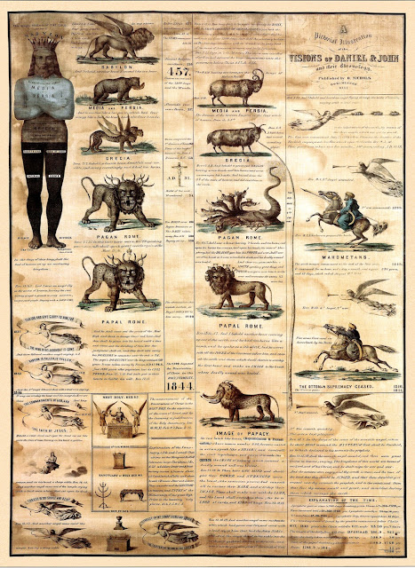
So, in this picture work here, 1850 chart, we've got the courtyard, the holy place, the most holy place. There are two doors, understand they’re curtains, the first door is here, the holy place, the second door is here, the most holy place. In 1844 Christ left the holy place, he shot the door behind him and locked it. He went to the most holy place, unlocked that door and opened it, so, that you and I could enter into the most holy experience leading to the glorification of the body, glory two. And that door no one can shut. Who wants to shut that door? The papacy and Apostate Protestantism, and unfortunately because of ecumenism, our churches
invite many ideas from apostate Protestantism. There are some people in our church who don't even believe that there's a sanctuary in heaven. In these verses it calls the people who oppose God, in verse nine, as being members of the synagogue or Church of Satan.
Letme summarize; third angels message arrives in 1844, first angels message arrives in 1798. Its arrival is connected to the work of Napoleon, as he brings the Pope down, as he begins to take control of Europe, and tries to shut off the shipping route of England. He destabilizes the Middle East. It initiates a proxy war. Two Islamic powers are fighting. This is the distress of nation that the Bible speaks about Luke 21:25.
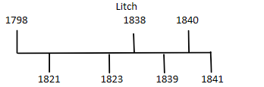

Josiah Litch one of the Millerites, in 1938 using the day-year principal, predicts in 1840 that Egypt will lose, and Turkey will become a puppet state of the European powers, or the kings of the earth. One Islamic power becomes a puppet of the West, and one sets itself up to go to war with the West. All of this is prophesied. He uses the same principles that Miller is using; therefore, if his conclusions are truth, Miller’s must be. The message of Miller receives power from Josiah Leches work in 1840; the first angels’ message, people got scared now because they believe that this was a true message. Unfortunately, there were some problems in their message, they had made some mistakes, singular mistake; they had predicted the wrong date. Instead of going to October 1844, they had gone to April 1844. They were six months out. When April came and nothing happened, Jesus hadn't returned, the judgment hadn't begun, people laughed at the Millerites, they mocked them, and many of the people who used to believe, they turned away from the message and they went back to their filthiness. Where was their filthiness? In the 1260 years, 538 to 1798, who’s ruling Europe?
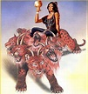
Mystery Babylon

There's a woman who's riding a beast, brought to view here in Revelation 17:5. What's on her forehead? Mystery Babylon. Who is this woman? Papal Church. So, we know that this is Mystery Babylon. God's people had come out of that captivity. Can we see how we're drawing all of the truths that we've been discussing and beginning to make application in this history before we make application in our own. God's people came out of this experience, 1260, and got freedom “after those days I will enter into a new covenant, I will give you the everlasting gospel” three steps, one, two, three: but now we're refining how those steps work.
We got one, two, three, with the first as an arrival and empowerment. The second angel, he has two voices, unlike the first or the third. The second angel, if you get on his right side, he says what to you? Righteousness. If you get on his wrong side, what would he say? You have fallen into Babylon. If you disobey- Babylon. If you obey – righteousness.
God's kingdom -Satan's Kingdom. If you passed the test, you'll receive righteousness, failed the test you’re going to go into Babylon. When they made a miscalculation here, 1844, these people, they say we're going to reject this message, we don't care what Josiah Litch said, it’s all false. So, where did they go back to? Back to Babylon. These people that came out of Babylon go back to Babylon. That's what happened six months before October 1844. Those people who rejected the first and second angels’ messages never walked with God’s people again.
In this history, these six months, they understand the mistake, correct it, and they correctly understand it's October 1844. Third angel’s message arrives when Christ goes from the holy place to the most holy place. All of that is the beginning of Adventism which we called the Alpha, and how many steps does it take you? Three steps. The third step is at the very end.1798,1844, the Alpha is like the Omega. The Omega is going to end, we said, Daniel 11:45. But now I'm saying this is the Sunday law, one, two, three. This was the arrival of the third angel’s message.

TOE TOE

What we're going to show is that this is the empowerment of the third angel. We're beginning to put together, how we construct end-time. We still need to understand this date.”?” What happens in this history, what do we call that? Captivity, remember that? 1260 years. This event here, 1798, is the time of the end. Captivity, the Dark Ages, leads to the time at the end when the first angels message comes. This is the first angels’ message; therefore, this is also the TOE. Before the time of the end what must you have? Captivity. Do you believe that God's church has been captive to Roman influence, we could call it the papacy, call it the world, however you want to describe it, we’ve been in captivity, yes, what do we call it? Because you haven't heard, you never know that we are in captivity to someone. We're like God's church in the time of Christ. Jesus said that you are captive, and the Jews as they tried to kill him said we're not captive to anyone, we're not in bondage to anyone, because our Father was Abraham, and he was a free man. And who's all around them? The Roman army, the banners of Rome were above the temple. Everywhere you could see the signs of captivity were there, but they pretended that they were not in captivity. That's the situation that we’re in today. Today in this history (before TOE) God's people were captive and they're in captivity to roman influences. And as my brother just said, quietly, we don't call it captivity, we call it Laodicea. The Laodicean experience, is not some laziness, some worldlines, some kind of bad behavior that we just invented, this was a satanic attack upon God's people by Satan. This Satan fights human beings? No, he does not. Do the human beings that serve Satan fight against Christ? No, they don't. The seed of Satan fights with the seed of Chris. It's human against human. So, when we talk about this Laodicean condition, we understand that we've gone into captivity to Satan. It's not Satan, it's the seed of the serpent, the false doctrines that the papacy has. The things that excite us about the world, power, money, fame, those things drag us into the world, it's the Laodicean condition. I want to ask you a question. We saw that 1260 was the same as 70, the same as 430, was the same as 400, was the same as 490.

1260 = 70
= 430
= 400
= 490

We have time prophecies. If this is a time prophecy, Millerite history, do you think this (our time) would be any different? Has all the identical properties and characteristics.
So, we need to understand how you get from 1844 to this date (our TOE) and also when we go into captivity. We have to understand how we work out the symbology, according to the Bible to work out this information. Tomorrow, we’re going to finish off Laodicea. I want to show us what it meant to go into Laodicea which I already done for you. I want to give you the dates when we went into Laodicea, the consequences of that, and how we come out of this situation, and how we need to understand the empowerment of the second angel and the empowerment of the third angel.

We also want to understand the role of radical Islam as identified in 1840. So, these are some of the things we're going to be discussing tomorrow. These are four presentations and hopefully we'll get through this material. As I said at the beginning of this presentation, there's a lot of information, and it’s quite detailed, and some of the dates and the numbers can become confusing. But I'm trying to keep it as simple as I can, I want us to see that when we come to the beginning of Adventism, we come out of captivity, the time of the end, we enter in covenant with God and he wants to give us a new heart. Not just individually, not just at an individual moral level, but at a prophetic level, at the level of a movement. God is not saving one or two people here and there; He wants to save a people. We saw that these three angels’ messages, between 1798 in 1844 this 46-year history, was quite detailed. One of the major things that was happening in that history, was the work of France and how it disrupted the power of balance in the Middle East. How Europe was dragged into a war because they were distressed about what was happening in Turkey. God's people, Josiah Litch, successfully decoded Revelation chapter 9, and he understood that this history would be fulfilled on August 11th, 1840, using the exact same methodology that Miller was using to predict another date. When his message came true, it gave power to the first angel. Then we saw how the first angel flies and lands, the second angel flies and lands, indicating arrival and empowerment, arrival and empowerment. So, the message that Christ is about to return that was given in 1798, receives a boost, or power in 1840, connected to the work of Islam, when Islam was restrained. When Islam was restrained, it was the marker where the first angels’ message was given power, which means that the message of the first angel was proved to be correct.

Some people, after a mistake in the message occurred, when I say some -most, they rejected the first angels’ message and they fell back into Babylon. That was the arrival of the second. Its empowerment is going to happen at the Sunday law, where once again God's people, that's you and I, when we reject the work of these angels, we too will go into Babylon, back into captivity. There was no need for that to happen if we can see and understand what God is teaching and showing us. Every single one of us is in mortal danger. If we don't understand this message, how can we accept or reject it? How can we understand this message if you don't apply yourself, study the message? There's a lot of information, it's hard work. We have a false gospel in our church, the salvation is cheap, but the last time I read the parable about the pearl of great price, the man who wanted that treasure, he sold everything that he had. That pearl was truth. If you want to purchase the truth you have to sacrifice your time, your energy, your efforts. First you need to understand, then you need to accept. It's already prophesied, the vast majority of God's church will fail this test, many wouldn’t even accept what we're teaching. Ask yourselves, considering the material that we shared with you this week, is what we are teaching you not only reasonable, is it in agreement with the Bible and the spirit of prophecy? Are we using rules and methods that we can identify in Scripture, that we can go into history and see how prophecy was fulfilled, tie up major historical events, the key Bible passages showing the development of how we've been brought from ancient Israel, time of Moses, to the time of Christ, to the time of the Millerites, bringing us down to our time? If all that sounds reasonable then you know this is the conviction of the Holy Spirit that's coming upon you. It's not any wisdom that I possess, if you feel the conviction, I urge you not to resist, because the vast majority of God's people will not accept these truths. Upon the testimony of two a thing is established. Only a remnant will be saved. And also, don't be deceived, if you feel unqualified, if you think you don't even know how to read properly, if you feel inexperienced, in every history where there's been a remnant, these were composed of the uneducated, the simple men and women, who had enough faith in God to trust in him and not in man.
AMEN!

