Review

Elder Tess Lambert France SOTP Video 37

Key
- = Audience
Italics = difficult to here portion of audio OR difficulty understanding translation

So When we started this subject, we went to the Civil War. Can someone give the dates.

- 1861, 1865, 1863, 1868.

How did we get to this history? To 1864?

- Sister J. So we are looking at midway from 2014.

So 1863. We came here from 2014. For 1863? what is our logic? How did we go from 2014 to 1863?

- We use the 151 and the 126.

So 1863 is the 151 to 2014 so we have a midway point. So 1861 is 9/11 and 1865 is 2019. Also 1861 is 9/11 and April 19, 1844 and then 1865 is 2019 and also Oct 22, 1844. And as sister J. said this is based on the midway point.

What brought us to 1868?

- 151

The 151. Sister A. we went from the Civil War to what history? I someone could give me the dates? Sister T.? We went from the Civil War to another history. So we did the history of the Civil war based on the 151. We are picking two phrases up from this history. What are those two phrases? Sister T.?

- Don't know

In 1861 they want to come up with a religious phrase that represents the nation and can be stamped on the coins. In 1863 they choose that phrase. So that phrase is "In God We Trust". Does that bring back memories? Then in 1863 Abraham Lincoln says the Gettysburg address and he uses the words "Under God" when speaking about pledging to the U.S. So "Under God" and "In God WE Trust". Then we went to this other history and it is the 1950's. Brother J. can you give me the dates?

- 1948, 1951, 1954 and 1956

Yes. So what brought us here?

- 63.

The 63. So 63 is a 151 and then we saw that this was a midway point. 1948 and 1954 are 9/11 and 2019 respectively. And also April 19 and Oct 22. So we are taking this midway point from our understanding of Millerite History.

1956 is again based on the 63. We brought this into our own history and where is the midway point? Where is midway in the reform line of the priests? 2014. 9/11 which for Millerite History was April 19 and then 2019 which for them was Oct 22. And the last date? What do we do with 1956 and 1868? How did we come to 1956?

- We went 63 years backward

So what date did it take us from?

- 2019

What date does 1954 takes us to?

- 2019

So 2019. What is our basis for taking 1954 to this date?

- the midway structure.

The midway structure because you can mark a clear period of history that is bookending a particular subject. It is a beginning and end. The midway point takes you to 2014. So when we overlay Millerite history, April 19, Oct 22 and the Midway point is July 21. So we know this is midway. First the literal then the symbolic which makes 1861 and 1948 = 1948 9/11 and the culmination of these time spans 1865 and 1954 = 2019.

We come to these dates ( 1868 and 1956) not through a midway point but by the same method we came to 53 and 151.

So 1954 is 2019 and 1856 is 2019 and 1868 is 2019. Does everyone understand how we did that?

Figure 1. 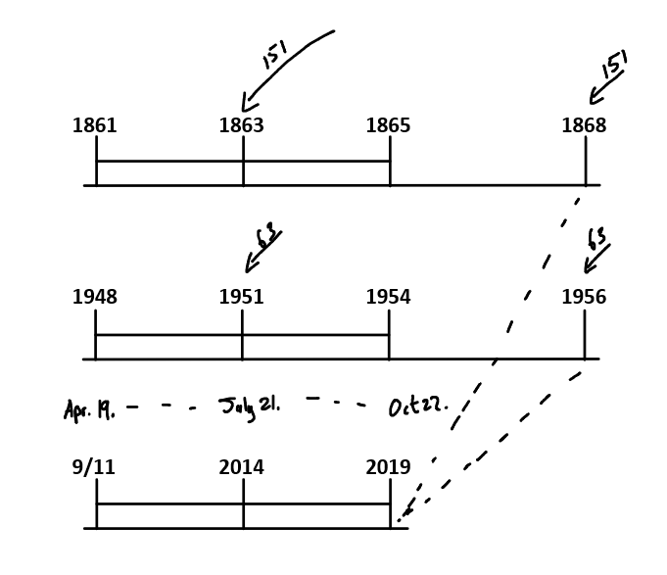

Were you here when we did the midway points? So we went 151 years from 2014. And it takes us to 1863. 2014 is what way mark in our reform line? Midway. Why do we call it midway?

- Because we associate it with SL.

Why would you call SL midway?

- When we use the model of the 10 virgins.

That takes you to SL?

- I'm not sure.

Sister A.? 2014 what waymark is that in our reform line?

- We say the SL and Midway.

SL and Midway? So when we construct out reform line how many waymarks do we have? 5 primary waymarks. So if we did our reform line of the priests what are these 5 primary waymarks?

Figure 2.
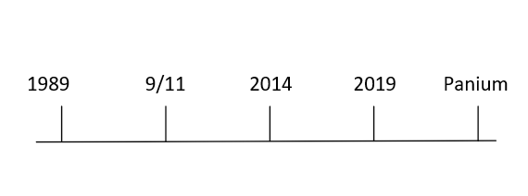

So We have 5 primary waymarks. 1989 is the Time of the End. 2014 is SL. 2019 is COP and 2021 is 2nd Coming. Five primary waymarks and 4 dispensations. We take that to Millerite History. What are these five primary waymarks?

Figure 3.

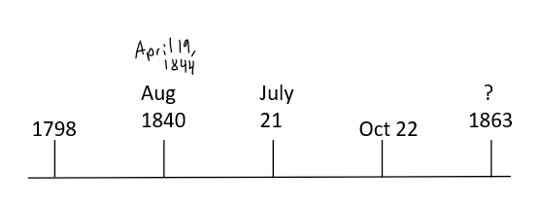

I'm going to put a question mark over 1863 for now and we will explain why in another class. But we put our five primary waymarks. We lay them out like this and we can see that it is a replica of ours. What is missing? April 19. Where do you want to put that brother E.

- 1840.

So you want to combine April 19, 1844 with Aug 11, 1840? We have a combining in this history. In our history. In their history it depends on their story. And what's our story? What story do we want to tell?

- The ten virgins.

The 10 virgins. So if this is the story of the 10 virgins what is happening here at this waymark ( the one with 1840 and April 19, 1844?

- Tarrying.

Tarrying? Why are they tarrying?

- They are waiting for the Bridegroom.

They are waiting for the bridegroom. So is that 1840 or April 19?

- I think April 19.

Yes. So here they are tarrying. The bridegroom is tarrying because they thought he was meant to come but he doesn't arrive. So they say he tarried. Then here at July 21?

- He is on His way.

How do they know that?

- Because there is a cry.

So there is a cry. When is that cry made? How does the Parable say it? The cry is made? They said midway but what does the parable say? Where do they get midway from? Does anyone else have a verse?

- In the middle of the night.

What is the verse?

- Verse 6

Verse 6? Can you see that Sister A? When is the cry made?

- Midnight.

Midnight. So the cry is made at midnight. So July 21 they see as the midnight point when the cry is made. Is this the MC?

- No.

So what do we do with this history? If this isn't the midnight cry? What happens to that cry?

- It swells.

So the cry is given July 21 but it is soft and not many people can here it. It has to grow. It is going to swell. This is Boston and then Concord and then Exeter. So that cry begins quietly and is going to swell. You mark three camp meetings in that history all leading you to Oct 22. This is the structure we have been laying out. When we speak about an increase of knowledge and a formalization. The repeating patterns. So we see 1844 July 21 as this midway point when a cry begins to swell. That becomes significant for the Millerites because they connect all this history to the 10 Virgins. They see midnight and they go from midnight and take a small step and say midway. They say midway in the dark of the night, between when the thought the bridegroom was supposed to come to Oct 22 to when he did come. And midnight or midway is July 21. So this is how they connect midnight to Boston. Is that ok?

Figure 4.

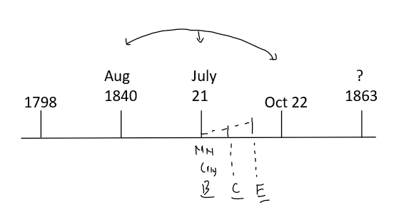

If we were to go to another reform line, the 144K. Can someone give me the five waymarks? The five waymarks of the 144K? Where does it begin?

- 1989, 9/11, 2019?

For the 144K? What comes after 9/11 for the 144K?

- 2014?

Work your way backwards. If this is the 144K what do you think is the last waymark?

- 2nd Advent.

So this one is the 2nd Advent and this next one before it?

- SL?

Before the second advent is a time of trouble. So if we were to work backwards, the 2nd Advent before we go through the time of trouble. In here we mark a death decree we have a waymark. It is not the SL

- Close of Probation.

It is the close of probation. No intercessor. These are the waymark that EGW gives us. Other than 1989 and 9/11 she gives us the rest of this reform line. So what reform line does EGW give us?

- SL

SL. So this is how EGW lays it out.

Figure 5.

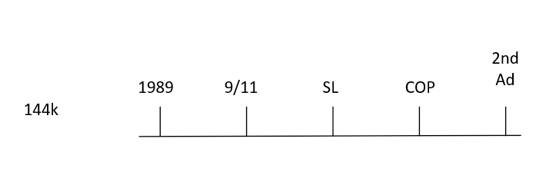

From her history she goes straight to the SL history. Then she lays out SL, COP, and 2nd Advent. This is the pattern. From this we reconstruct our fractals. So again we have 5 waymarks and 4 histories. When we come to the reform line of the 144k, you come to the Midway and it is SL. It's the middle waymark of the 5. What begins at SL?

- Loud Cry

So a loud cry. Is SL the Loud Cry?

- The latter rain

The latter rain yes. Is it the Loud Cry?

- It starts there but gets bigger

So there is a cry given at SL here on 144k line and there is a cry given in July 21. But that cry is soft. What does it have to do? It has to swell until the Loud Cry. So we can see that we are talking about the same histories. July 21 is the beginning of a cry that says your probation is about to close but is has to swell. SL is the beginning of a Cry because it is saying that your close of probation is coming and it is time to get out of Babylon. That cry is going to swell until we hit Exeter or the Loud Cry. Or in our history we call it the Midnight cry. With some variation it is the same waymark. So we have these different symbols for this one waymark. July 21, midnight, midway, Boston, SL. They are all different Symbols for the one waymark.

From there we saw 2014 and connected it to July 21. It is a repeat of their history. July 21 in their history is literally midway. Then we said first the literal then the symbolic or spiritual. So in their history it is literally midway between April 19 and Oct 22, which means it is midway. When we bring it in our history as a symbol it is a midway point between 9/11 or April 19 and Oct 22 or 2019. It becomes a midway point. Millerite history is literal. Our history is the spiritual. Then to understand it we use the 151 and the 126 taking us from 1863 and 1888. So Millerite history is the literal and takes us to the spiritual. Now 1863 is the literal taking us to the spiritual. So 1863 must be a literal midway point. When we go into the history what history is it?

- Civil War.

It's the Civil War and it's literally midway. The study of midway gives us the ability to see the history of 9/11 to 2019 as the history of the Civil War. We take 1863 to 2014 and we spoke about the battle of Gettysburg and "Under God" and "In God We Trust". We spoke about the national reform movement determined to make America great again. We spoke about the Democrats winning and the Republicans panicking. Church and state coming together. We took all of that from the history of the Civil War into our own because of the midway. Then we went to the 1950's and did the same thing. The same logic based on the 63. And if it fit our study we could do the same thing to 1888, the French Revolution and other histories. But the two we are focusing on are the Civil War and the 1950's.

Figure 6.

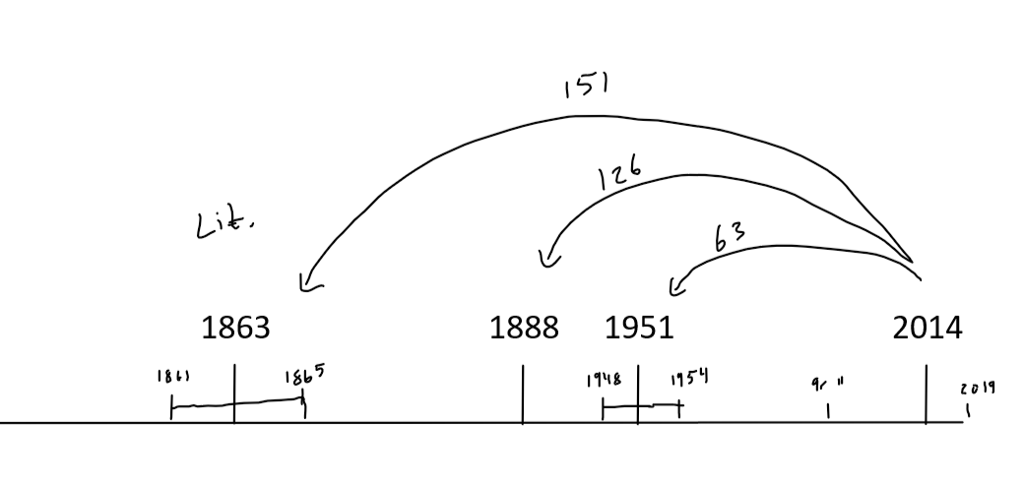

So we have gone to our history and seen an explanation of what has been happening particularly since 2014. 1951 what court case begins?

- Brown v. Board.

Brown v. Board of education. Someone summarize that court case.

- So there is a group of black families. They make trial to be able to put their children in the white school.

Yes it is a collection of families. There are actually other court cases at the time but they name the most famous and the most prominent. That was the Brown family. They are suing the board of education. In 1951 it's just the school district they are fighting. They lose the court because of the laws of segregation. When did those laws of segregation come in? It is quite a while after slavery ends.

- 1803

No. This is quite end in the 1800's. Slavery ended in 1865. EGW says that even if slavery ends, the racist mindset isn't going away. They are just going to find other ways to oppress the fallen slaves. She says that if anything it will be worse than it was before. So She expected this. So instead of slavery they brought in laws of segregation. The first one in the state is 1890. Then it goes from the level of Washington in 1896. It's particularly this 1896 law that the court case is all about. It starts in 1951. They lose so they take it to the supreme court. It is one of the most famous court cases in U.S. history. Brown v. Board of Education. And in 1954 they win. Segregation ends. So we went through that history and we saw that the mindset never went away just like it didn't after 1865. To get out of ending segregation they either closed schools or made private schools. Particularly Christian Private schools in the South.

So 1951-1954 is the Issues of Segregation. We connected that into our history. So we are bringing in all the issues of race into our history to explain the dynamic of what has been going on. Then we went back to the beginning. We went all the way back to what dates?

- 1989.

1989 and we went back further to 1979. So this ten year history. 1979 what person are we speaking about?

- Jerry Falwell.

Jerry Falwell. This is the ten year of the Moral Majority. We place Jerry Falwell in 1979 and 1989 and 1996, 9/11 and then you place his son. This is all about liberty University. They form this movement because they are fighting three other movements. What are those three other movements? This is in retaliation response to three movements in this history.

- Civil Rights.

We quoted Jerry Falwell. He called Martin Luther King Jr. What did he call him? A leftist socialist and dangerous communist infiltrating, trying to upset America's social order. Those are his attacks on Martin Luther King JR. He is against the ending of segregation. What other movement?

- Feminism

Feminism and? Homosexuality. So Civil Rights, Feminism and Homosexuality. It was 1969 when really the homosexual revolution began where they stood up and started fighting for their rights. It is in the news a lot today because it is the 50 year anniversary. So it is in response to these issues they form the Moral Majority. Particularly what they are against is the ending of Segregation.

So we went from the issue tracing all of that history. This is our homework. We spoke about their response to 9/11 and connected it to the response in 1861 and 1948. That is these four people. Anna Graeme Lotz, Franklin, Pat Robinson, Jerry Falwell. We talked about the attacks on Obama because of his response to church and state. Project Blitz down in our history from 2016 attacking the same three issues that were begun at the beginning. There was an article in the Washington post today connecting Trump and Raegan showing their similarities in response to race. So externally they are recognizing. Jerry Falwell lead the Christian right to the election of Ronald Reagan. Jerry Falwell in this history lead the Christian right to the election of Donald Trump. Even without seeing it physically you know what they are attacking must be the same issues. Because it is one reform line and it is connecting the waymarks. So the issues they are fighting today, once under attack by the Christian right, are the rights of the different races or nationalities or skin color, women, and homosexuality. Do I have any questions so far?

- Regarding the 1979 ten years before 1989. Because on the model of the agriculture, the ploughing is the preparation and begins at 1989 so why then would there be two times of preparation.

I think we need more than just the agricultural model. Different models to show different things.

Elder Parminder: This is a different model. You can't use the agricultural model for everything.

So in this history we see there are ten years. We see that in other histories where Gods people are given a chance to wake up. That is why we went over the history of 2004 to 2014. The Nethinims are required to wake up and they are in a better condition then we are because they actually did wake up. They had someone in place here to wake them up. Michael Moore. But we take it to our history and the church is meant to be awake before the time of the end. For the Nation of Israel is it when Christ is born, is that the time when they are meant to begin understanding their history? Studying the prophecies? No. An angel comes down over Jerusalem and asks the question "Who can I tell?" Does the angel find anyone to tell? No. Because they haven't prepared before the birth of Christ. Because they have not prepared before and understood that prophecy was about to be fulfilled, they couldn't receive the message of His birth. Instead it went to Shepherds and Maji. Because what had they been doing? What are the Maji doing well before the time of the end.

- they were studying.

They are studying the prophecies and looking at the signs of the times. So there are signs that take you to the time of the end. And in Christs history, the failure of the church to study and recognize those signs, showed at the time of the end they had to be bypassed. You are only bypassed here if you have been tested. You are only tested here if you have had an opportunity. So their opportunity must come before the test. We mark that as the signs. Millerite History the signs that lead up to 1798. So what the church is meant to see in this history is the formation of the Moral Majority. And if A.T. Jones was alive in this history there is no way he wouldn't have recognized what was happening. He said that the constitution is there to protect the minority from the morality of the majority. He would have recognized this but all the A.T. Jones's are long gone. We also can talk about Afghanistan, the internet. Depends on your story. But I think the thing we were most required to see was the Moral Majority and Raegan with Church and state.

Any other thoughts or questions?

This is just some revision to get us back up to speed. Remind us why we are talking about peoples rights. 1798 the U.S. rises and it's whole rise with the writing of the constitution to when they start adding states, the issues are all about slavery. What rights people have. You can trace that through Millerite history. When you get to the end of their history, the judgement on the U.S. because of how they treated rights of freedoms. So it shouldn't surprise us today to see the same thing. The same issues. 1798 they are already arguing about peoples rights. It's not something that began in 1861. So 1989 you already have the same argument. We will look at those histories more closely.

We went from here into our columns. We started working our way through some logic. We particularly used some logic that the South used in the Civil War to justify slavery. Instead of doing columns we will go back to our line of progression. On this reform line how did we begin it? How did we begin this reform line?

- Eden

Eden. End from beginning. How is it going to end?

- Eden.

Between these two we have dispensations. I want to mark four. We would mark Moses. Then we would mark Christ. Then we would mark the Millerites. And then we would mark ours. What ever line we want to do that on. So we have four dispensations. And over these we also considered the glorious land. When we talk about the glorious we can go alpha and omega. Beginning and end. So to talk about glorious land we are going to end it here in Christ time and then it goes to gentiles. We will begin it here at Moses. This is the Alpha glorious land. Omega from Millerites to us. So we have marked progression from Eden to Eden. We have four dispensation. Moses and Christ first Glorious land. Millerites and us final Glorious land. Alpha and Omega. And then when we look at these histories, we spoke about slavery. We saw that it was instituted in the time of Noah to Canaan. Canaan was made a slave. It was a curse pronounced upon him. Then at the time of Moses through this history it is instituted. I will go back. Noah Canaan and then Abraham whose wealth ran on slavery. We read the quotes. How he bought and sold. People were bought with his money or born in his house.

Moses. Here it is instituted for Israel. Then we went to Solomon. He is following all the instructions. They don't have an Israelite passport, the other option is slavery. The time of Christ we have Philemon. There is nothing against slavery. So this from Eden to New testament is the Bible. All through it you have the acceptance of slavery. Then you have 1260 hears and you come down to the Millerites in 1798. So alpha glorious land slavery is instituted by God. We come down to ours. 1798 and this glorious land also has slavery. What is God's approach to them?

- The have to get rid of slavery.

They have 63 years to end slavery or EGW says that God will do it for them through a brutal Civil War. He will force them to do what they weren't willing to do themselves. We are marking the progression of race and how it is treated with equality. So we could go to Christs dispensation and what is the fear of the Pharisees?

- That everyone should be treated equal.

Everyone is equal. Why would that thought frighten them?

- They are afraid of losing the identity

They are afraid of losing their identity. They are special. They have a social structure that places certain people beneath other people. They are afraid that their social structure is under threat. Where did they get that social structure from? From God and the old Testament. Yes? They got their social structure from the old testament. Now they see it under threat and it causes them to reject Christ. That is the fear of the Pharisees. Come down to the Civil War. What is the fear of the South? What is the South so afraid of?

- Equality

The south is afraid of Equality. Why? They have a social order. A structure that puts some people beneath others. They are afraid because it is under threat. If black and white are equal, the poor white people might lose their jobs. The economy might be damaged. So they are afraid of breaking down their social order. Where did they get that order from?

- The Bible

From the Bible. They have got it from the structure of the former Glorious land. They have taken that history to us and they have said "We the South are in alignment with the Bible". They are afraid that their social order is under threat. So they need to protect it. They say "The North either gives up their religion and their Bible or agree with us on slavery. Then we come to the 1950's and what are they afraid of? What is it all driven on? Segregation is being stirred up. It is hard to disconnect our history from theirs. In fact it is hard to disconnect any of it. But the same fear in 1798 lasts the entirety through this history. Through the Civil War and all through WWI and WWII, 1950's and 1989. Jerry Falwell. They are afraid of their social order being deconstructed and what that means when everyone is equal. Because as we said before, they have a concept of what their social order is. It is white, Christian, male, definitely not homosexual. They think that's the proper hierarchy. Because they think that is the proper hierarchy, when they start seeing these three movements (Civil rights, Feminism, Homosexual.), they are driven bey fear. And we traced Jerry Falwell all the way from 1979, you can trace him through Steve Bannon and through Trump. And in this history (our history), just like the Civil War, you have two streams of information. So here you have the Southern States and EGW. In our time you have our message and apostate Protestantism. Conservative Protestantism. So one side is agreeing with this fear logic. and it's the fear of losing their structure, the fear of losing their power. And EGW is saying "I don't care what is happening to your economy, I don't care if people can't find jobs, I don't care if you have to give so much money to the black people to build them schools and homes and churches, I don't care if it damages your economy because it is the right thing to do". But it is the Southern side that is driven, like the Pharisees, by their reading of scripture. By their misreading of inspiration. We come to our time and we can talk about this movement but we can make it larger than that. Fox News. CNN. One is driven by fear of a breakdown of their social order and of their structure.

I want to make a point. Do we need Fox news? It's just a title for a particular type of stream. There are many other avenues to be able to drink in that same conservative logic. I maybe speaking to the camera now, has anyone in this room heard of Jordan Peterson? Raise your hand if you have. No one here has heard of Him? So I am speaking to the camera. People say we don't have Fox news so we don't take in this conservative channel. I want to make the point that it makes no point whether you live in America or any other country. You can put different channels underneath Fox News. There is a popular conservative speaker. He is a professor called Jordan Peterson, and when I speak to people in this movement, they don't even have to tell me that they listen to him, because you can pick the signs of it just based on their world view. They don't even realize what they are listening to. Jordan Peterson is a right wing channel. He is very popular on YouTube. So people go to YouTube to here his lectures. He put on up yesterday. It already has 111,00 views. He is extremely popular inside and outside of this movement. He says he is not right wing. But everything he shares is conspiracy theories that are very popular on another site called Bright Bart. If anyone is quoted by Bright Bart or defended by Bright Bart, which was Bannon's publication, you know you are dealing with the wrong stream of information. So they probably are not listening but all those people watching Jordan Peterson, Romania, Australia, Canada, Worldwide, you are listening to right wing stream of information. He is against Gender Identity and any question of it. That is right wing. Socialism and human rights organizations, political correctness, practically anything nice and decent. He is right wing. And he puts out these lectures that are very popular. And he uses conspiracy theories. One of the subjects that he pushes is the differences between genders. The difference between men and women. That is another subject that we went into. For those listening to him you are listening to someone who has, if you type him into Bright Bart, you have pages in his defense. So you know he stands with Bannon. And Bannon stands with Trump. And you are as much into the wrong stream as you can possibly get. He says he is not like that but he also says, he is Canadian not America, if a had to of voted in the 2016 I don't know why I just have this feeling I would have voted for Trump. He doesn't even realize that he is on the wrong side or right wing. He doesn't realize that even if it is subconscious, everything Trump says resonates with him. And Clinton irritates him. So it might not be so popular here but I assure you he is popular in many places. We don't need to listen to Fox News. If anything there are worse channels on our internet.

So we traced the issue of race. The wrong side in our history has all the same logic as the wrong side in Millerite history and the wrong side in Christ history. So we have to consider how we read. We overlaid over this the issues with gender. Because you cannot disconnect racism and sexism. You start to see it immerge externally in Millerite history. But we went back to the bible but we went back to the history of Abraham and we saw that we have circumcision. Covenant is only heald by men. Abraham Isaac and Jacob. Then we see priesthood. Only heald by men. Levites, Kings are all men. Then we come into Christs history and we start to see changes. What are those changes? We mark baptism. Someone gave a couple of quotes, we will put them up later, to show baptism. Now a covenant does not depend on gender male or female. We come through our history all into our own. We see EGW breaking down barriers but not all of them. We come into our own 1989 and we have the beginning of the priesthood. Male or female? Both! So we know when we deal with race it is a line of progression. And we know when we are dealing with gender it is a line of progression. We have gone from Priests and Levites male, kings male. Internally in our time Priests and Levites male and female. Presidents? Male or female? We are required to accept a woman president. Internally and externally you can see the progression as walls start to come down.

Figure 7.

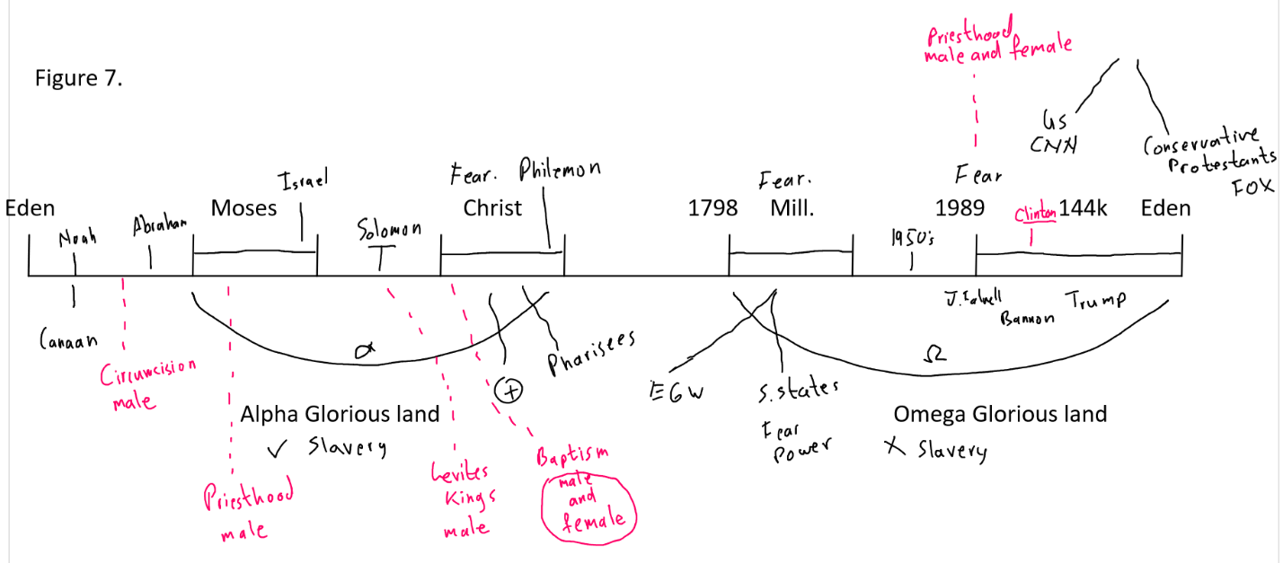

Race is coming to equality and gender is coming to equality. That’s as far as we got and then we went into dress. Before that we drew up two columns. We said male and female. What is the Difference? Now I want us to consider the difference. When we went through it we said some are bigger physically and some are usually smaller. But that is very general. There is a great deal of variation. Then we saw that when it comes to making babies there are some difference organs. Connected to that are estrogen and testosterone. Everyone has both of those but in different quantities. There has been a lot of scientific studies done trying to demonstrate the difference between male and female. Most of the studies that make a big difference between male and female are either old or very poorly conducted. Back in the dark ages they would say male had bigger brain and women smaller brain therefore one is more smart and one less. Science has also developed and now they will take a human brain of male and female. They are still trying to see the differences. Some studies do who differences. A study done recently that says male brains are wide in a certain way. It just means the connections seem to go a certain way and womens connections seem to go a different way. They came out that they can finally see the big difference between male and female. Then other scientist said that this is as much poor science as understanding big and small brains. Because our understanding of the Human brain is so far behind that you have no idea what this even means. They use it as an excuse to define the differences between male and female. This must be why some men are better at spatial differences. This must be why some men are generally better at math. And women they say are more nurturing. So they use this logic. It must be because of the structure of the brain according to these scientists.

It is a terrible way to conduct science. Other scientists who are much more thorough, will say you have a little boy and you throw him a ball. Whatever that ball is, soccer ball or tennis ball. You make him run on a field and everything about sport is spaces all creating spatial awareness. Basketball and the distance between your hands and the hoop. Everything they are doing from a young age is created that change in the brain. Because our brain is wired, in a large degree, after we are born when we are developing. This is social training. Then they take little girls and give them a doll and say here care for it. They have some Barbie dolls that have a string at the back that you pull and they speak. One of the first ones they made what did it say to all the little girls over and over again? It said "Math is hard". So little girls are growing up nursing a doll and it's telling them over and over and over again "math is hard math is hard". Then they wonder why they are wired differently while they are caring for babies they have not developed the same understanding of space. All of a sudden they hit their teen years struggle with math. Then some right wing guy writes a book titled men are from Mars and women are from Venus. Apparently we are made differently. All they are highlighting is training.

They do the same thing with race. They will say, black people must not be as strong because they seem to have more instances of diseases. We would say that maybe that is because you don't give them the same health care or the same schools. Maybe that is a result of segregation that they didn't rise to the same job positions. Maybe that is the issue of racism in the work place. But when we take things back to the brain we end up in trouble because a good scientist won't say that it's just because they are male and female or black and white. They look at the factors that cause wiring in the first place. But as you come to our history and women are realizing that they can do math and black people are realizing they can be president, and they can leave their homes and challenge white men in job positions, it has created more and more fear that the social order is under attack. This is why it gives rise to Donald Trump. We will come back this afternoon. I know we want to speak more about dress and more about the differences. If you will kneel with me we will pray.

