Right or Wrong Side—Which?
I call heaven and earth to record this day against you, that I have set before you life and death, blessing and cursing: therefore choose life, that both thou and thy seed may live.
Deuteronomy 30:19. {UL 140.1}

Those who are carrying forward the work of God must stand firm and steadfast, as faithful sentinels in the Lord’s army. They must stand under the bloodstained banner of Prince Emmanuel.... The last message of mercy is to be proclaimed. Men and women are to be aroused to prepare for the great issues before them.... {UL 140.2}
The reason why men and women today do not believe the truth is because it condemns their life practices. They see that the truth calls for a reform, and they fight it because they hate the work involved in sanctification.... {UL 140.3}
He whose conscience is a sure guide will not stop to reason [i.e., rationalize away] when light shines upon him out of God’s Word. He will not be guided by human counsel. He will not allow worldly business to stand in the way of obedience. He will lay every selfish interest at the door of investigation and will approach the Word of God as one whose eternal interest is hanging in the balance. {UL 140.4}

There is a right side—the side of Him who declared, “I have kept my Father’s commandments” (John 15:10). “The law of the Lord is perfect, converting the soul” (Psalm 19:7). There is a wrong side—the side of the one who in heaven rebelled against God. With his sympathizers he was expelled from the heavenly courts, and from his action we may understand that no matter how high a position a man may occupy in the church or in the world, if he is disloyal to God, if he accepts human laws instead of the laws of Jehovah, he can never enter heaven, for he is living in direct opposition to God. He will receive punishment in accordance with the power of influence which instead of being placed on the side of God was placed on the side of Satan. The greater the talents and influence given him; the greater will be his punishment. God will require at his hands the souls he has turned aside from truth to falsehood. Instead of leading them to God, he led them away from God, and their blood will be charged to him.... {UL 140.5}

In the day of judgment those who have refused the light and have led others to honor the false sabbath will see the course Satan has pursued in causing men to transgress the law of God. They will see and fully comprehend the virtue of God’s sign.... {UL 140.6}
God’s people have a serious, solemn work to do. He bids them, “Lift up thy voice like a trumpet, and shew my people their transgression, and the house of Jacob their sins” (Isaiah 58:1).—Manuscript 27, May 6, 1900, “Obedience and Disobedience.” {UL 140.7}

Take my life and let it be

Take my life, and let it be
Consecrated, Lord, to Thee;
Take my moments and my days,
Let them flow in ceaseless praise,
Let them flow in ceaseless praise.
Take my hands and let them move
At the impulse of Thy love;
Take my feet and let them be
Swift and beautiful for Thee,
Swift and beautiful for Thee.
Take my voice, and let me sing
Always, only, for my King;
Take my lips, and let them be
Filled with messages from Thee,
Filled with messages from Thee.
Take my silver and my gold;
Not a mite would I withhold;
Take my intellect, and use
Every power as Thou shalt choose,
Every power as Thou shalt choose.
Take my will and make it Thine;
It shall be no longer mine.
Take my heart; it is Thine own;
It shall be Thy royal throne,
It shall be Thy royal throne.
Take my love; my Lord, I pour
At Thy feet its treasure-store.
Take myself, and I will be
Ever, only, all for Thee,
Ever, only, all for Thee.

OPENING PRAYER

He whose conscience is a sure guide will not stop to reason when light shines upon him out of God’s Word. He will not be guided by human counsel. He will not allow worldly business to stand in the way of obedience. He will lay every selfish interest at the door of investigation and will approach the Word of God as one whose eternal interest is hanging in the balance. Lord let this be the prayer of your people. In Jesus name, Amen
The Secret to Gaining Strength — Without Moving a Muscle
Believe it or not, you can build serious strength without even moving a muscle.
It is called isometrics. In these exercises, your muscles tense up but do not actually move.

How isometric exercises work
Press your hands together in a prayer position as hard as you can for 10 seconds. You will feel tension in your chest and arms, but your arms will not move at all. There — you just did an isometric exercise.

Benefits of isometric exercises
Isometric exercises have been found to have a range of health benefits. For example, researchers found that an 8-week isometric exercise program was linked to lower blood pressure.
A 2014 study showed that older adults had an increased pain threshold after isometric exercises.
A 2016 study found that lower-body isometric exercises improved jump height and kicking ability in soccer players.
Besides all that, you do not need any equipment, and these exercises are fun! So, if you are looking to take a break from yet another set of heavy lifting, chill out and stay home.

Tips for isometric exercise

Remember to squeeze
Since you’re not relying on movement to fatigue your muscles, you’ve got to squeeze them, hard. The technical term for this is “maximal voluntary contraction,” which means you should tighten up your muscles as much as you can.

Breathe correctly
When doing isometric exercises, the natural tendency is to completely tense up and hold your breath. But do that and you will cut off the very thing you need to enhance your performance: oxygen.
Instead, try this. Place your right palm over your low belly and close your eyes. As you inhale, imagine you are filling up a balloon behind your belly button (your belly should get rounder).
As you exhale, push air out through your nostrils. Notice how your low belly contracts. Keep inhaling and exhaling for five counts to get the hang of it. Feel your hand rise and fall with your breath. This is how to breathe during your isometric exercises.

Maintain proper form
Form is very important in isometric exercises too. You do not have a ton of weight pushing against you, so it’s difficult to get injured, but positioning is still important.
There is also some research to suggest that testing out various angles can increase muscle strength. While the research is a bit older, it is still sound, so be sure to switch up your exercises.
For example, when you place your arm at a 90-degree angle and tense up, you are strengthening the biceps muscle at one length. Try positioning your arm at a 120-degree or 45-degree angle and see how that benefits your upper-body strength.

Mix it up
Now that you know you can work out with, zero equipment, should you throw out your running shoes and let the dog use your resistance bands as chew toys? Tempting, but no way.
Aerobics are still better than isometrics for improving overall cardiovascular health. And if you are looking for bigger muscles, lifting progressively heavier weights is the way to go.
Think of isometrics as another tool to add to your toolbox to help you live a fitter, healthier life.

Isometric exercises
Below are seven favorite isometric exercises to work your entire body.

1. Bent-over press against wall
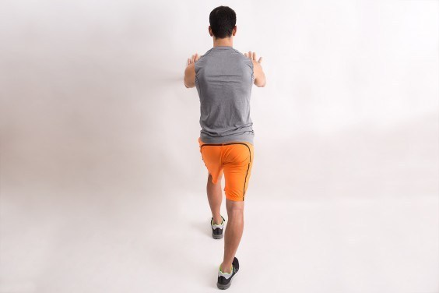Share on Pinterest
Muscles worked: Shoulders
Start in a low lunge position. Place hands on the wall at about chest level. Lean into the wall and push. The farther down you bend, the more the exercise will target your shoulders. The more you stay upright, the more the exercise will target your chest.
Pro tip: Relax any tension stored in your face (like your brow and your jaw). Be sure to breathe throughout this exercise.

2. Prayer pose
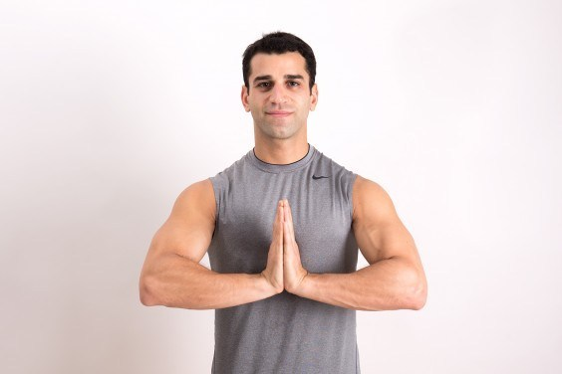Share on Pinterest
Muscles worked: Chest
Place palms together. Your elbows can be flaring out or pointed toward the ground. Press your hands together. The tighter you press, the harder it will be.
Pro tip: Keep your shoulders level — raising them while you push can cause unnecessary strain.

3. High plank
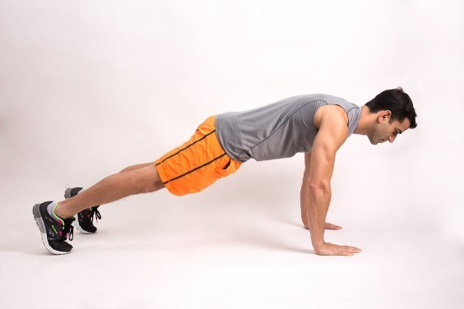Share on Pinterest
Muscles worked: Core, back
Get into push-up position, making sure your spine is in a straight line. Press the floor away from you, broadening across your chest. Engage your core and breathe deeply.
Pro tip: Avoid lifting your butt too high or dropping your hips too low in this position.

4. Self-arm wrestling
Share on Pinterest
Muscles worked: Biceps, triceps
Bend your right arm at a 90-degree angle. Grab your right hand with your left hand. Push them together as hard as you can. While your right biceps prevent your arm from dropping, your left triceps is trying to push your right arm down. Repeat on the other side.
Pro tip: People often tense their upper bodies in this position, so be sure to ease up on your shoulders.

5. Triceps extension against wall

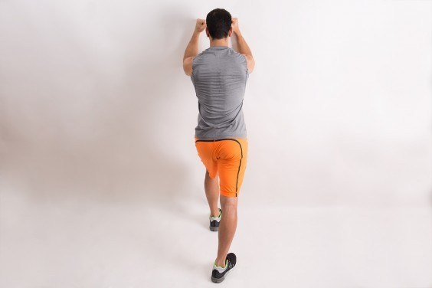Share on Pinterest
Muscles worked: Triceps
Get into a lunge position with your fists on the wall at head level. Use your triceps to push your fists into the wall.
Pro tip: Avoid tensing your shoulders in this exercise. Also, do not forget to breathe deeply.

6. Forearm plank
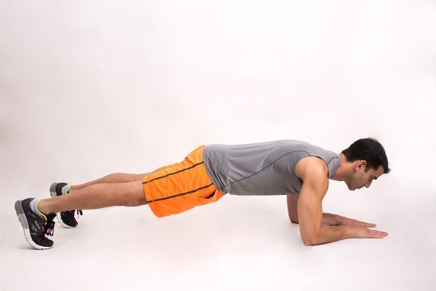Share on Pinterest
Muscles worked: Abs
Get into a forearm plank position. Keep spine is in a straight line and tighten abs as much as you can. Normally, people try to just hold this position, but contracting your abs will provide even more benefit for your core.
Pro tip: Instead of letting your butt fall down or hiking it too high, keep your shoulders, hips, knees, and ankles in line.

7. Low squat

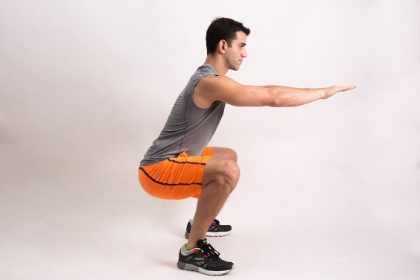Share on Pinterest
Muscles worked: Glutes, quads, adductors
Stand with your feet about shoulder-width apart. Squat so thighs are parallel to the floor. Instead of just holding this position, try to squeeze your feet together. This will force your inner thigh muscles to contract even more.
Pro tip: One common mistake with this exercise is not sitting back far enough. To fix it, prevent your knees from going over your toes.
Total-body isometric workout
Perform 3 reps of each exercise below, contracting for 10 seconds in each rep. If your goal is fat loss, use less force (60 to 70 percent of your max contraction) and take short rest periods between sets (20 to 30 seconds).
If you are doing it for strength and muscle growth, use more force (80 to 90 percent of your max contraction) and take longer rest periods between sets (45 to 60 seconds). Here are the exercises:
- Bent-over press against wall
- Prayer pose
- High plank
- Self-arm wrestling (each side)
- Triceps extension against wall
- Low plank
- Low squat
This is a great routine to do first thing in the morning before you head to work or as a finisher at the end of a workout.
CLOSING THOUGHTS
Those who are carrying forward the work of God must stand firm and steadfast, as faithful sentinels in the Lord’s army. They must stand under the bloodstained banner of Prince Emmanuel.... The last message of mercy is to be proclaimed. Men and women are to be aroused to prepare for the great issues before them....

