Sacrifice as Christ Sacrificed
But this I say, He which soweth sparingly shall reap also sparingly; and he which soweth bountifully shall reap also bountifully. 2 Corinthians 9:6. {UL 113.1}
The possession of riches opens the way to great temptation to become covetous and selfish, to add riches to riches, and to bury in houses and lands the means that should be returned to God. Many use their means to gratify the demands of appetite, to follow the fashions, and to build for themselves grand houses. They do not follow the example of Christ, who gave Himself with all He had for the benefit of the world to deliver men from the power of Satan. {UL 113.2}
But if those who possess means will follow the example of Christ, their hearts will be filled with benevolence, and they may help in the proclamation of the truth in the cities, in the highways and the byways, and in carrying the gospel to all nations.... {UL 113.3}
God’s work must be sustained by tithes and gifts and offerings. The Lord now calls for the means that He has entrusted to His stewards. There should be a constant stream flowing into the treasury, that the work may not be hindered. To some, God has entrusted earthly riches to be held in trust and to be returned to Him as they may be required to carry forward His work in the earth. He requires from His stewards a faithful tithe of all their capital, and in addition to the tithe, He calls for gifts and offerings. {UL 113.4}

The Lord Jesus requires nothing more from His followers than He Himself has performed. Those who practice self-denial and self-sacrifice for the cause of God are but following His example. He laid off His royal robe and kingly crown and stepped down from His high command. He became poor, that through His poverty we might come into possession of the eternal treasures. He gave not only His riches, but His own life in self-denial and self-sacrifice, that He might remove every hindrance from those who seek an entrance into the kingdom of God. {UL 113.5}
Those who are not exposed to the temptations of those who are rich in this world’s goods have no reason to complain, for the Prince of life has shared with them a life of poverty. He was tempted in all points like as we are. In our behalf He placed Himself as one with us in poverty, to show us how we may withstand the temptations of satanic agencies.... {UL 113.6}

The Lord Jesus invites us to become laborers together with Him. He is the owner of and has claims upon all that we possess. By our willingness to help in His work, we may now show our love for Him. —Manuscript 40, April 9, 1905, “Faithful Stewardship.” {UL 113.7}
OPENING PRAYER:
Heavenly Father there is so much we are grateful for, you have given us your word, written and living. So much is going on worldwide, situations not one was not ready for. Father we see this as a test, character is the only thing were taking to heaven. Through this pandemic we see two streams, two sides; those who care for others and those who care for themselves. Those who love you and those who careless. Father I ask that you send us your Comforter, forgive us for being weary, afraid and anxious, we ask for your strength in measure. It is only by faith and your promises and a constant connection with you that we will get through every test, every burden and every trial…. Lord you have brought a people together, brothers and sisters united in the three angels’ message, united in love, united with one goal in mind. We love you Father, not because you loved us first, but because you, seen in us what we could not see for ourselves, and took us out of the darkness into your marvelous light. We are in your debt, forgive and cleanse us, in Jesus precious name, Amen
___________________________________________________________________________
What is the gut in the human body?

All bilaterians have a gastrointestinal tract, also called a gut or an alimentary canal. This is a tube that transfers food to the organs of digestion. ... The human gastrointestinal tract consists of the esophagus, stomach, and intestines, and is divided into the upper and lower gastrointestinal tracts.

What are the symptoms of an unhealthy gut ?
7 Signs of an unhealthy gut
- Upset stomach. Stomach disturbances like gas, bloating, constipation, diarrhea, and heartburn can all be signs of an unhealthy gut. ...
- A high-sugar diet. ...
- Unintentional weight changes. ...
- Sleep disturbances or constant fatigue. ...
- Skin irritation. ...
- Autoimmune conditions. ...
- Food intolerances.

The gut-brain connection

Pay attention to your gut-brain connection – it may contribute to your anxiety and digestion problems
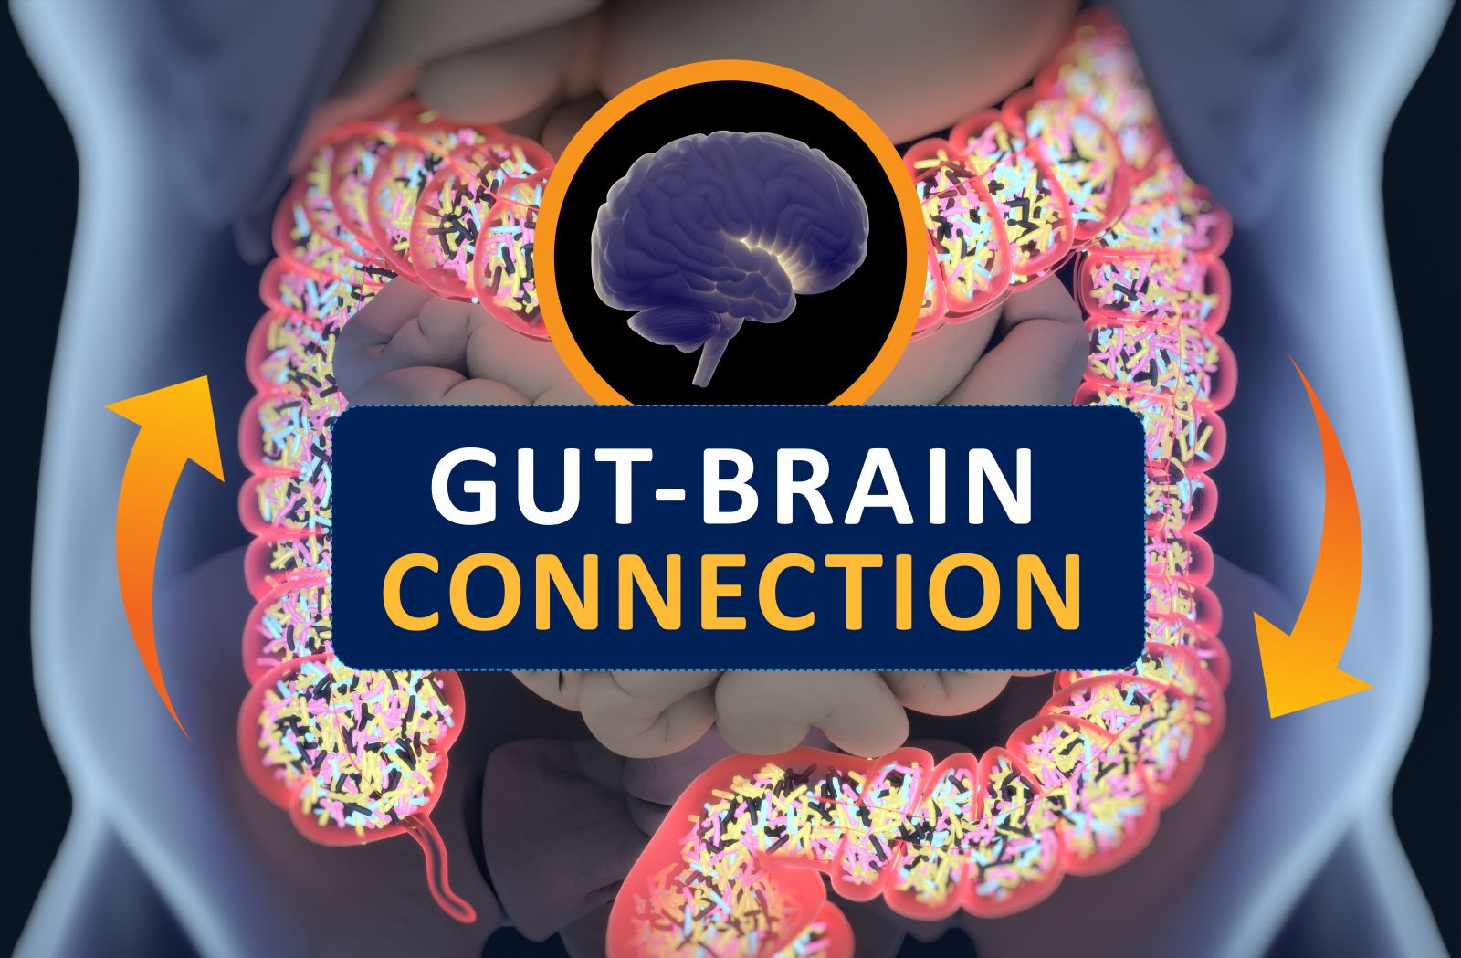
The gut-brain connection is no joke; it can link anxiety to stomach problems and vice versa. Have you ever had a "gut-wrenching" experience? Do certain situations make you "feel nauseous"? Have you ever felt "butterflies" in your stomach? We use these expressions for a reason. The gastrointestinal tract is sensitive to emotion. Anger, anxiety, sadness, elation — all these feelings (and others) can trigger symptoms in the gut.
The brain has a direct effect on the stomach and intestines. For example, the very thought of eating can release the stomach's juices before food gets there. This connection goes both ways. A troubled intestine can send signals to the brain, just as a troubled brain can send signals to the gut. Therefore, a person's stomach or intestinal distress can be the cause or the product of anxiety, stress, or depression. That's because the brain and the gastrointestinal (GI) system are intimately connected.
This is especially true in cases where a person experiences gastrointestinal upset with no obvious physical cause. For such functional GI disorders, it is difficult to try to heal a distressed gut without considering the role of stress and emotion.

Gut health and anxiety
Given how closely the gut and brain interact, it becomes easier to understand why you might feel nauseated before giving a presentation or feel intestinal pain during times of stress. That doesn't mean, however, that functional gastrointestinal conditions are imagined or "all in your head." Psychology combines with physical factors to cause pain and other bowel symptoms. Psychosocial factors influence the actual physiology of the gut, as well as symptoms. In other words, stress (or depression or other psychological factors) can affect movement and contractions of the GI tract.
In addition, many people with functional GI disorders perceive pain more acutely than other people do because their brains are more responsive to pain signals from the GI tract. Stress can make the existing pain seem even worse.
Based on these observations, you might expect that at least some patients with functional GI conditions might improve with therapy to reduce stress or treat anxiety or depression. Multiple studies have found that psychologically based approaches lead to greater improvement in digestive symptoms compared with only conventional medical treatment.

Gut-brain connection, anxiety and digestion
Are your stomach or intestinal problems — such as heartburn, abdominal cramps, or loose stools — related to stress? Watch for these and other common symptoms of stress and discuss them with your doctor. Together you can come up with strategies to help you deal with the stressors in your life and ease your digestive discomforts.

CLOSING THOUGHTS:
The Lord Jesus requires nothing more from His followers than He Himself has performed. Those who practice self-denial and self-sacrifice for the cause of God are but following His example. He laid off His royal robe and kingly crown and stepped down from His high command. He became poor, that through His poverty we might come into possession of the eternal treasures. He gave not only His riches, but His own life in self-denial and self-sacrifice, that He might remove every hindrance from those who seek an entrance into the kingdom of God.

