SCHULE MARZ 2020
VIDEO 21
NEW LIGHT ON THE LINE OF CHRIST
PART I
ELDER TESS
We looked at our key reform line that we have, the beginning and the end of ancient Israel, and the beginning and the end of modern Israel. This is how our reform line began. Everything is built upon it. They also help us to refine our understanding toward the end of our reform line. It is the end of ancient Israel that is particularly relevant to our own time. Not our own time as in the line of the priest, but this particular point in our experience. Particularly last year, 2019, as we headed toward our COP, it became very important to understand the line of Christ. Everyone who accepts the line of Christ chose not to leave the movement. Everyone who rejected the line of Christ left the movement. So, if you trust the reform lines, it becomes impossible to leave. 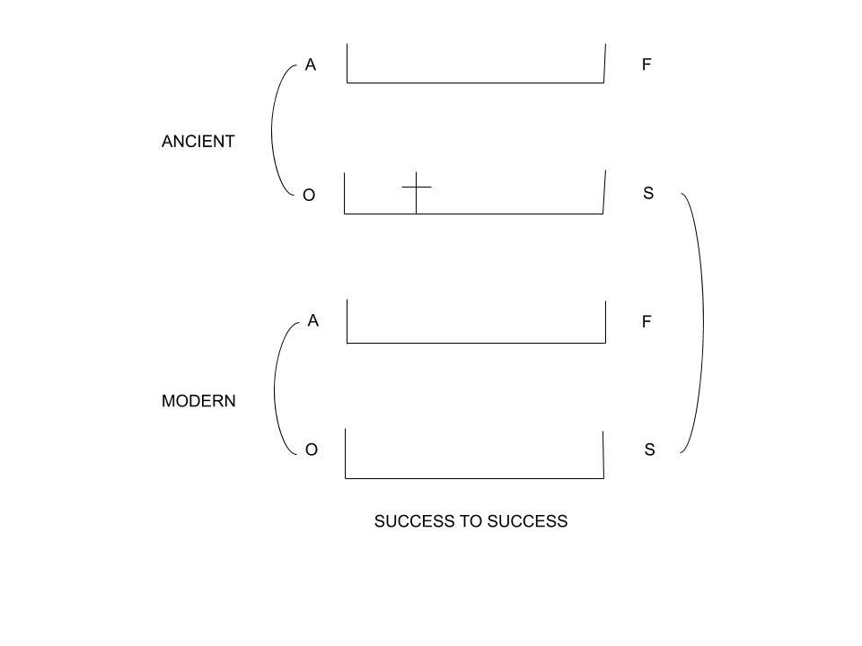

The reform lines were given to us at the TOE. People have left over many issues. There have been some key issues. What I am saying is that if everyone understood and accepted the reform line, there would never have been a shaking in this movement. Not POJ; not TOL; not FFA. So, our faith hangs on these reform lines. We know what we’re experiencing based on these reform lines. We know how to behave based on these reform lines. So, if you are in the movement, and you’re looking over at your sister, and you’re thinking, she’s behaving differently. Why? The reform line will tell you why. If you’re seeing influential people leaving this movement, and you want to know why, the reform line will tell you why. If you have questions about how to behave, for example, do I witness to my Catholic neighbor? That is an obvious example, but there are many more subtle examples. The reform lines tell us how to behave. They anchor us. These lines are powerful.
The line of Christ is especially for this time period. I have also suggested that next will come the line of the Millerite as we wrestle with what a test looks like. But, at this point, it is the line of Christ, the Omega history of ancient Israel to the Omega history of modern Israel; success to success.
On our reform line, what does 1989 represent? Birth. What does 2019 represent? Baptism. Baptism of whom? Priest. How many years between 1989 and 2019? 30 years. The movement turns 30 years. What should we call this line? Line of Christ? Traditionally, we call the end of ancient Israel the line of Christ. We call the Alpha history the line of Moses. But, I don’t think that is very precise language to call the line of ancient Israel the line of Christ. And, when we’re not precise, it’s ok for only so long but eventually introduce confusion. Because now, when people say the line of Christ, people are not always aware to which line we’re referring.

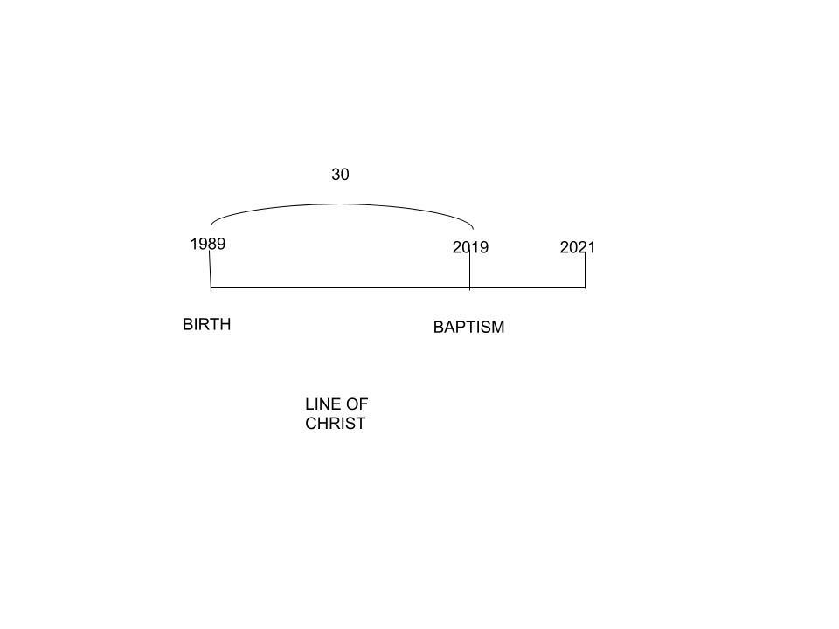So, we talk about the line of Moses, and in this history, who is Moses? The Alpha history? The beginning of ancient Israel, who is Moses? Moses is the first angel. Who is the second angel? Joshua. Now, the end of ancient Israel, the one we call the line of Christ, who is Christ in that history? The second angel. Who is the first? John, So, when we say the line of Moses, the line of Christ, we’re not being consistent. We call the Alpha history of ancient Israel, the reform line of Moses, and the end of ancient Israel, the line of Christ. That is not precise language because Moses is the first angel but he dies before they ever go into Canaan. Moses dies way before that line is complete. Then we go to the end of ancient Israel, the line of Christ. So, we’re not consistent on how we name these lines. Then, when we understand the 30 years from Christ’s birth to His baptism, because that is particularly about Christ as a priest, we call that the line of Christ.
In the beginning history, we call it the line of Moses, because he just seems to be a bigger personality than Joshua. So, ignore Joshua and just focus on Moses. In the line of ancient Israel, we just feel that Jesus is such a bigger personality than John. Sister Tamina speaking-In GC 343 where she speaks about God’s dealing with men are ever the same, it says that every religious movement, I would suggest that Moses is not the religious movement or reformation. He is part of that history but he is not the entire history. So, when we look at reform lines, we would have to find a name which describes the entire reform time period.
So, for the purposes of our study, I’ll try to call this the end of ancient Israel. The problem is, it’s a lot like changing the name of the SL because all of us were introduced to the line of Christ. I am aware that it can create confusion if I’m not careful. (What was known as the line of Christ, will now be referred to as the line of the end of ancient Israel). Part of the damage I think it did was to narrow our idea of how far our reform line extended.
So, if we were to do a reform line, if we were to make this the line of 144k, and we come over to the COP, people try to put the cross at the COP for the 144k. One of the reasons I think that they thought that way is subconscious because when they think about it as the line of Christ, the history after Christ’s death and resurrection, become somehow less important. They think that the cross way-mark, in that final history of Christ with His disciples, the end of Christ’s work on earth, the line of Christ, they naturally expect those events to be the end of the line.
Question. Could Christ have come back in the Omega history of ancient Israel? Not the first advent but the Second Advent. Could Christ have returned in ancient history of Israel? No. Why not? Why the delay? Do we have a verse? 2Thes2:3. What problems do the Thessalonians have? In verse 1, he beseeches them. In verse 2, he’s beseeching them that they are not to be shaking in their minds. Don’t be troubled by the saying that the Christ is about to come back. In verse 3, don’t let anyone deceive you in telling you that Christ is about to come back. So, what problems do the Thessalonians have? They believe that Christ is about to come back. He is particularly warning them to be aware of that deception.
What has to happen? Christ can’t come back because the man of sin has to be revealed. So, to say that abruptly, the 1260. You have to have all these other things happen first. In verse 5, he says, don’t you remember? I have already told you all of this before. He is saying things in person to them, but when he writes, he is quite careful. So Paul is instructing them that Christ is not about to come back. So, you couldn’t have an actual literal second advent on this reform line, the line of ancient Israel. But it is still a reform line which means that it has five primary way-marks and four dispensations.

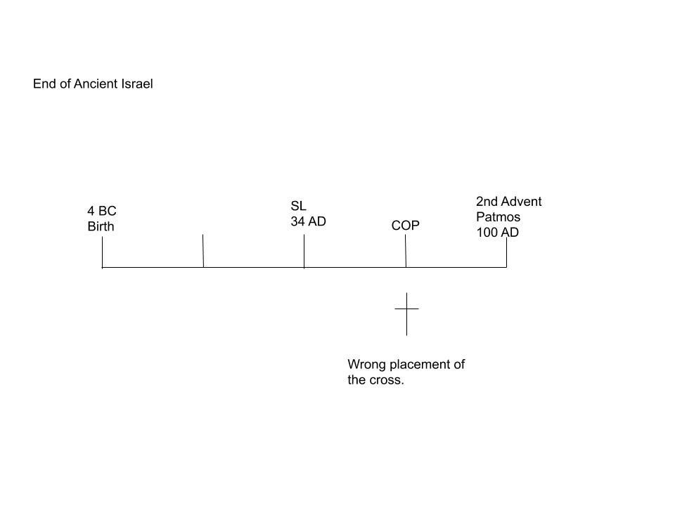So, we would expect that you would see a fit representation that we can overlay with the 144k. We would see the COP and the Second Advent. It is still a full reform line and a history of success. This is what makes this special. A history of success is one where it completes. Paul is warning the Thessalonians not to be deceived. Don’t let anyone tell you that Christ is about to come back. I have already told you that there are things that have to happen first. So, there was not going to be a second advent on this reform line of ancient Israel. However, we still need to see a full reform line. It’s a history of success so it’s complete to lay over the line of the 144k.
This is the line of the end of ancient Israel. Working backwards, what is the Second Advent for the end of ancient Israel? Patmos. 19MR40.4. “In the days of the early Christians, Christ came a second time. His first advent was in Bethlehem when He came as an infant. His second advent was at the Isle of Patmos when he revealed Himself in glory to John the Revelator”. So, the final Second Advent, when Christ returns and takes us home, we know that couldn’t have happened in the days of the early Christians. But we’re still given the type, and what is the type? In the days of the early Christians, Christ couldn’t have come back and put an end to this world because the man of sin hasn't been revealed yet. So, the 1260 hasn’t yet happened. But at the same time, this reform line of the end of ancient Israel, it typifies the end of modern Israel. So, it must end with a way-mark that typifies the Second Advent. That is the type of the second advent of our line.
So, we’re constructing the end of ancient Israel to understand the end of modern Israel. We are beginning with the end, the way-mark of the Second Advent. The beginning we all understand. It is the birth, 4B.C. But the end is the Second Advent. To understand the type of the Second Advent, we have to look at 19MR, 40.4. What does Ellen White call the coming of Christ to Patmos? He revealed Himself in glory. That is the type. What does she call that? She calls it the Second Advent, when Christ came the second time. Ancient Israel is the type of our line. The Second Advent at the end of ancient Israel is the type of the Second Advent that we will experience. So, the end of ancient Israel is the Second Advent on the island of Patmos. She says that when Christ returned the second time it was the Second Advent.
So, 2Thessalonians, what are they expecting? They are expecting Christ to come to bring them home. We know that He can’t do that. But, this reform line, ancient Israel, is the history of success. So it still has to give us a type to meet the antitype. Otherwise, we won’t have a complete line to learn of our own. So, we are still given a second advent even though it’s not the Second Advent on our line. It’s for our benefit that Ellen White calls the coming of Christ to Patmos the Second Advent. Now we have a whole line, a type to meet the antitype.
We’ll mark Christ’s return to Patmos as 100 A.D. The Christ’s coming the second time to the island of Patmos occurred in 100 A.D. So, we have the beginning and the end of this reform line. The middle way-mark is the SL, and then the cross. Here is the problem with putting the cross on the next way-mark which is the COP. We place the cross on this way-mark, and then after the cross, you have the disciples, they go into the upper room, they’re given a message, and then what do they do at Pentecost? So, if you’re going to put the cross here, at the COP, then when is the giving of the message? There is no point in giving the message after the COP.
So, in the line of the 144k, we divided into two parts. What are those two parts? The church and the world. What is that way-mark when we go from the church to the world? SL. So, that was the end of modern Israel. Now, we go to the end of ancient Israel. We divide it into two parts, the church and the world. What is that way-mark when we go from the church to the world? 34 A.D. Our reform line is being refined, step by step, just as we need them. So, the understanding of Christ’s history is the key, one we need to have all put in place now. We are looking back at the way we were taught is no longer fit for purpose because we have grown. Part of the mistakes that we have made, we start on our reform line, 1989, with a very simple idea. Somewhere along this line, we add 9-11 as a way-mark. We know that the SL is coming. Then there will the COP, followed by the Second Advent.

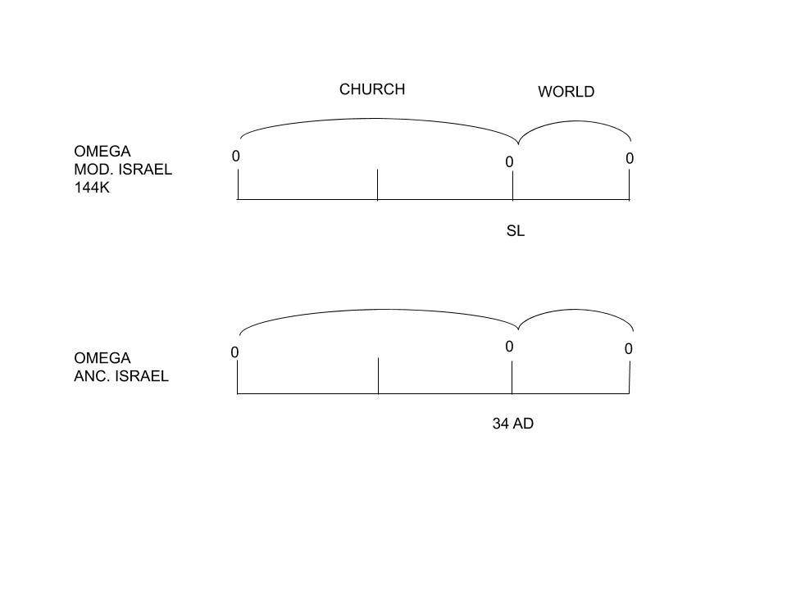So, we had reform lines for 31 years now. Then we come to 2012, and someone predicts 2014 as the SL. Then we come to 2014, and what was introduced to this movement? What did we learn? Fractals. So, what we learned, in 2014, was fractals. We have three groups, and then the 144k. We learn all that in 2014. So, our understanding of our reform line has become more and more refined, particularly from 2014. We go from this reform line to the church and the world, and then we see that the church is in two parts. The understanding of our reform line has been refined. And as we had more information on this one, Omega history of modern Israel, what we needed to do and have done is to add this to these, the Omega history of the ancient Israel. And we needed to go back and refine the Omega history of ancient Israel. Both of the Omega histories of the ancient and the modern needed to be refined and better understood.

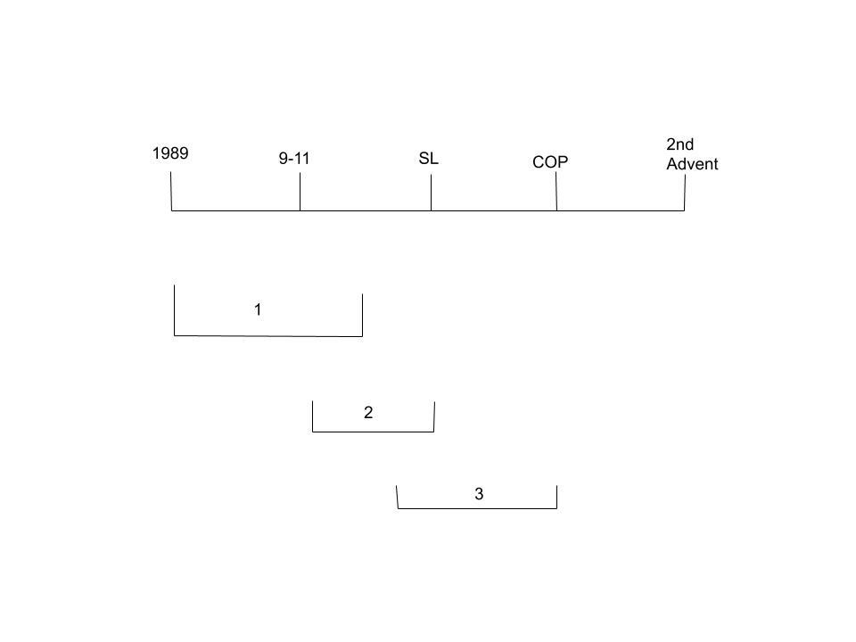(There is a discussion where to place the cross)
For six years now, we have understood priests, Levites, and Nethinims; first the church and then the world; divided by the SL; it is so clear that first it’s the Jewish nation and then the gentiles; and yet, people would put the cross here, COP, after the SL. I don’t want to say that that is another application until someone proves it to me but that doesn’t make sense to me. But the primary application of the cross cannot be here, at the COP. It has to happen here, before the SL, before the end of 490.
(There is a discussion whether ancient reform lines refine modern reform lines or do modern reform lines refine ancient reform lines. What Elder Tess seems to be saying is that she is not looking at the Alpha histories of neither ancient nor modern reform lines, the histories of failures, because they have their own peculiarities, but she is only focusing on the Omega histories, the histories of success, of ancient and the modern reform lines, and she is refining the Omega history of ancient Israel.)
The Omega history of ancient Israel has not been studied properly from the start, and that is why it is being looked at more critically and being refined. When we look at the Omega line of ancient Israel, isn’t it clear that there are three groups? The disciples, back to the church at Pentecost, and then the Gentiles. From 2014, we should’ve gone back to that line to prove it. We have Ezra. When we go back to the Levites, I’m sure that we will show them Ezra. But, if I want to reach someone in the church, it is so clear just from the history of end of ancient Israel. So, yes. We are going back to refine the reform line; our understanding of it. It was already there.
I believe that part of the shaking in this movement that we experienced last year is because, particularly those who have left, for some time now they have not been using reform lines correctly. This was not something that just happened last September. It has been a good while since they used reform lines correctly, and that has held us back. I believe that the way these reform lines opened up seems quite providential to me, the work of God in His timing. These reform lines showed us the shaking that happened before the cross. And it explained all of that history just when we needed it.
I like the thoughts of how everything builds. Everything naturally refines in each dispensation. We have reform lines of Dan. 11:40-45. In our ER, we have time setting. What that is going to do is to add much more information to 1989 to 9-11. It will build on these, add 126 to 1989, it’s all building upon Dan 11:40-45. When it builds upon them, it refines them. When we come to our LR, we also have time setting. So, our LR refines our understanding of time setting, refines our understanding of Dan. 11-40, which is all about Raphia, Panium, and it explains the reform lines. So, all of the lines are constantly being refined or built upon each dispensation. The progress does not stop. So, we should be expecting to continue to build upon what we have thus far.

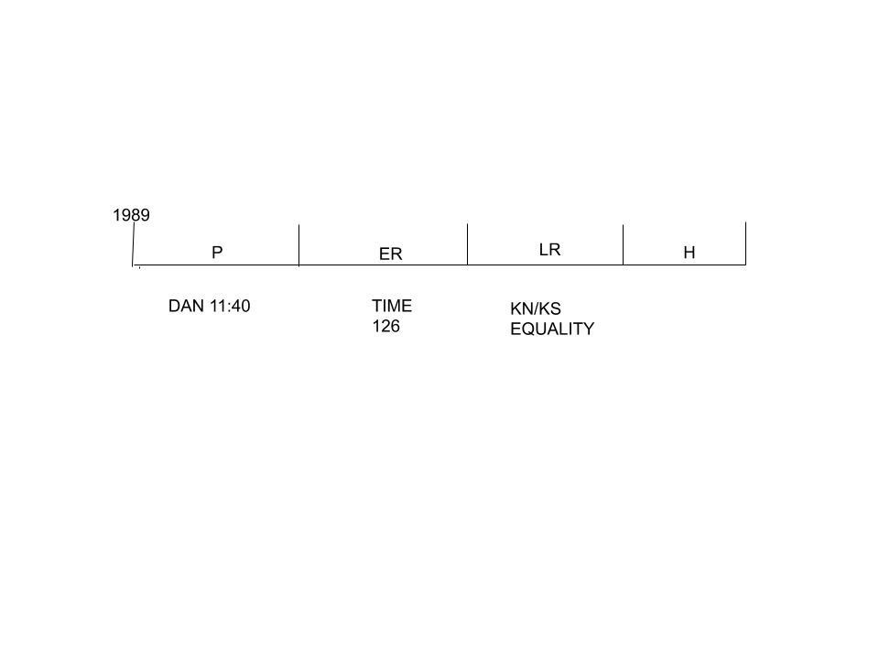Part of the reason that we are able to do that is that our methodology is becoming more and more precise. As we become more precise with parables and the rules that we use, we’re able to go back and refine. There are still reform lines that have not yet been completed. They are not yet set in place. There are still things that we don’t understand about Dan. 11:40 and 41. We have more to learn about time setting and how it operates. We certainly don’t fully understand about equality. So, when light shines in the time of the harvest, it also sheds light backwards. So, at each step, all of these subjects are touched upon.
If it was dark outside, you were walking on the road, and you’re worried about falling, you’re not going to shine the torch neither behind you nor directly at your feet. You will project the light forward. It is in front of you where the danger lies. But, that doesn’t stop some of the light from disseminating backwards. It is the nature of the light that you just can’t contain it in just one direction. So, in this history of plowing, where is the focus of the information? In 1996, where is the people’s focus point? In 1996, it’s in the Time of the End magazine. This is the magazine to the Adventist to point them, to draw their attention, to something that God specifically wants them to see. A particular event. What is that? 1996, what is the focus? Is it the SL? Dan. 12:1? Is it pointing you back to the TOE, 1989, for the purpose of pointing you forward to the SL?
We said that the focus of the message is forward. You want to shine the torch in front of the path, not behind you because it is in front of you where the danger lies. Then we went to the Time of the End Magazine in 1996. Does the magazine shine its light forward, backward, or straight down? What does the Time of the End Magazine in 1996 tell you about 9-11? So far, the options are 9-11, SL, and Dan 12:1. Or, is the light shining backwards in order to point you to something that is in front, the SL. All Adventists are waiting for the SL. 1989 would be a meaningless date if it didn’t point you to the SL. So, it is relevant to go back and see that. But the point of seeing the TOE is so that you can give the warning that the SL is coming. It is warning you about the future, the SL.
When we have an increase in knowledge in a dispensation, it also causes us to refine our methodology. Each increase of knowledge is a refinement of our methodology. Each IK points forward, but it builds on everything that was done before. The message of equality was built upon the message of the KN and the KS. But this message was also built upon the past dispensations; time setting, Dan. 11:40, and reform lines. And as it goes back and builds on these, as we refine our methodology, it also adds to these. So, when we are time setting in 2018, we are doing more than what was done in 2012. We are also understanding Dan. 11:40 in a more comprehensive way than it was understood in 1996. In the dispensation of the LR, we have expanded verse 40 with Raphia, Panium, and the WWs. And, we are still building Dan. 11:40.
To summarize, the line of Christ explains clearly our reform line. It is a type of our reform line. Therefore, it must have a type of a second advent. So, just to give us some foundation, we recorded the first way-mark, the birth, the last way-mark, the island of Patmos which Ellen White describes as the Second Advent. As we understood fractals, we go back to the end of ancient Israel, and we refine it because there are clearly three groups, four groups if you include the 144k, at the end of ancient Israel. It is a perfect representation of our whole reform line. So, someone wanted to put the cross at the COP to make the point that that is what we have done before. So, we showed the line of 144k, first the church and then the world. The transition point between the church and the world is the SL. If you go back to the end of ancient Israel, you have first the Jews and then the Gentiles, first the church and then the world. The transition point is 34 AD, at the end of the 490. So, the SL way-mark must be 34 AD.
A reform line has five key way-marks and four dispensations. The middle way-mark is the way-mark that we associate with the SL. For the Omega history of ancient Israel, that is 34 AD. Therefore, the COP cannot be the cross. Everything that we read in the Gospels-Matthew, Mark, Luke, and John, and the first part of Acts, when you put them in a reform line, it’s all the history before the SL. So, when the Adventists think that nothing happens before the SL, they are cutting out the entire Gospel history which is all about the preparation of the church, not the work for the world. So, when we do the history of the end of ancient Israel, all the history of Christ on earth, it happens before 34 AD. And calling it the line of Christ, is part of what has made us, to treat this line differently and expand it the way it should be. Amen
QUESTIONS-
- What two histories are failures and what two histories are successes?
- To what history do we compare our history?
- To what name does Elder Tess want to change the big line of Christ?
- What is the logic behind the motivation to change the names?
- Some people want to place the cross at the COP, but Elder Tess wants to place it where?
ANSWERS-
- Alpha histories are failures and Omega histories are successes.
- The end of the ancient Israel.
- End of ancient Israel.
- To decrease confusion. Currently, there are two lines that are referred to as the line of Christ-the 30 year line from birth to baptism and then the 100 year plus line from birth to Patmos.
- Before 34 AD.

