SCHULE MARZ 2020
VIDEO 23
NEW LIGHT ON THE LINE OF CHRIST
PART 2
ELDER TESS

As we go back over the history of how our reform line began, the issues become more and more clear. Let’s turn our attention to those court cases. There was a response to segregation. A number of Black families in America, what was that court case called? Beginning in 1951. What was that key court case called? It is the first court case that is going to start dismantling segregation in America. Brown vs. Board of Education. Brown vs. Board of Education, that was a case before the Supreme Court. But before we get to the Supreme Court, it went before a lower court. And the families lost that court case which is why they took it to the Supreme Court.
We spoke of 1919. What happened in 1919? This is the first wave feminism. This is about sexism and the right to vote. But, behind this really good event there was a hidden ugliness. What was that ugliness? Only white females were allowed to vote to gain more white votes. So, behind this good ruling, was this ugly racism.

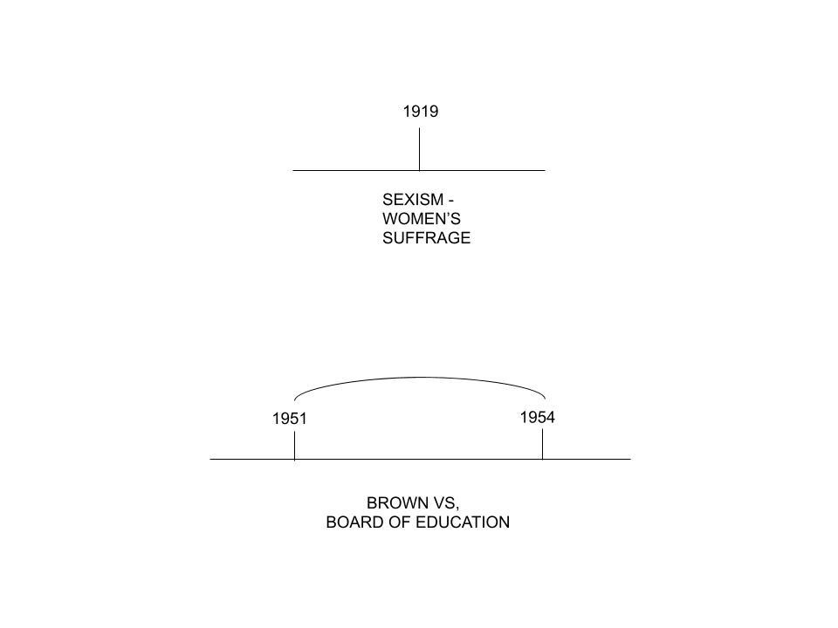Let’s come back to Brown vs. Board of Education. It begins in 1951 where it comes to the Supreme Court and the battle is won in 1954. So, why was it called Brown vs. Board of Education? It is about desegregation in the schools. Who is Mr. Brown? His name is Oliver Brown. He wanted to enroll his daughter into the most acceptable school. It had the best teachers, best facilities, it was closer, but he wasn’t permitted because of segregation. So, he takes part in this court case. However, he wasn’t the only person of the families. When this court case comes to Kansas, he is just one of thirteen different families that all came together to fight segregation. Here are the names of the parents who took part in this court case-Oliver Brown, (he is no more important than the others. He is just one of many) Darlene Brown, (No relationship) Lena, Sadie, Marguerite, Shirley, Zelma, Shirley, Maude, Alma, Iona, and Lucinda. There is one name missing.
In the list of plaintiffs, there is only one male and the rest are females. So, why is it named Brown vs. Board of Education? The “Brown” is not referring to Darlene Brown but Oliver Brown. The argument was that the plaintiffs’ names are placed in alphabetical order. Technically, Darlene Brown should have been placed on top of the list so the “Brown” should have been Darleen Brown. So, why is the court case named after Oliver and not Darleen? Because he was the only male even though he was black, and they felt that if they wanted the court to take them seriously, (after all, the court was not going to listen to a bunch of black women) he should be the visible face. The name attached to the case had to be a man. So, we made the point that in 1919, there was hidden racism. When it comes to this court case as it stands in Kansas, it is a race issue. But what is under the surface? Sexism.
So, there are issues in 1919, and there are issues in the Civil Rights Movement. If you look into the history of Martin Luther King, he is a hero when it comes to the race issue, but he is no hero when it comes to the sexism issue. What I want us to see is how interconnected these issues are. These three movements. There is a fundamental problem, whether it’s because of someone’s color, or their accent, because they are somehow different to us, because of gender, because of someone’s sexual preference, we devalue that person. So, the subject of equality, it covers a number of different subgroups. It isn’t just race nor just gender. There is this fundamental problem with how we view and treat people. And the people who are studying these issues know that they are not disconnected. You might have these different plants called racism, sexism, and homophobia. But it’s a little bit like fungus. Underneath the surface, it’s all one thing. They are all interconnected.
If you want to summarize it, we have this real issue where we devalue other people. We can do this without even knowing that we’re doing it. We have learned that God is forced to work with His people. We are His instruments to accomplish His purpose. He has to work through His people. He is stuck. He has no choice but to work through us, and we are not that easy to work with.
So, when we look at these issues of equality, we need to recognize how deep inequality run. Even through these positive things, human beings are incredibly stubborn. We don’t unlearn very easily. So, these prejudices against these people are very hard to remove. We need to look at the history of Brown vs. Board of Education to see how difficult it was just to get this case to the Supreme Court with the most hope of even winning. Oliver Brown’s daughter for whom he fought to get her into the good school, she made it a part of her life work to draw attention to all the women behind him, who were equal with him in this work. The women were smart in knowing that being represented by a man was the only way that they can be taken seriously by the Supreme Court and to possibly win. At this point, all the justices were white men. 1981, 30 years after the beginning of this court case was the first female justice (Sandra Day O’Connor) placed.
Racism, sexism, homophobia. They are all the same under the surface. When we look back in history and see how hard they had been to deal with, how slow humanity has been, to see something wrong with someone who looks different, treating them badly.
A questioner asked, “Is it a conspiracy theory to believe that the Corona Virus is not as serious as we were told in the media?” The numbers show that it kills less people than the common flu.” The fatality rate means that if you got sick by the flu, you’re more likely to die than if you got the Corona Virus. “We know that there are two streams of information, and all the media are pointing in the same direction on this subject. We have been discussing conspiracy theory a lot in the past 18 months. People feel safe from the conspiracy theories. Now, there are new issues, and there are these conspiracy theories coming up. In general, we have been so attached to conspiracy theories, we got rid of some of our old ones, but now when there is a new case, we tend to automatically think, this is different. We go back to our bad habits.
So, the point here is that you are more likely to die from the flu than the Corona virus. All the media is saying that this is dangerous. It is a conspiracy theory to say that it is not. Connected with that, there has been some things posted on social media from people in this movement to indicate that we have not learned our lessons. This is one of the reasons why we are not fit for work yet. It is reported that this report came from a doctor’s office but that is unlikely. But, this can’t be proven.
It said that every election year there is a disease, and it starts listing them. The first one is SARS in 2004. 2004 is an election year. This is their proof why all this is some sort of conspiracy theory. So, what is the problem with their very first statement? When did SARS begin? 2002. It started in 2002 and ended in the summer of 2003. This is an easily researchable fact. So, their very first statement which is their proof that this is some sort of election year fear mongering is completely wrong. The very last proof is the Corona Virus. They say that the Corona, 2020. What’s the problem? They are saying election year. The Corona Virus started in 2019, not 2020. Some of the mentioned viruses in between do fit either in the election or the mid-term election year. But if you use just the mid-term and the election years, that’s every second year. So, of course, you’re going to pin it to some election year. But their very first and their very last are easily disproven. Yet the people in the movement are already buying into the same conspiracy theory type of logic.
Let’s look at another statement.” You are more likely to die from the flu than if you catch the Corona Virus.” Is this true? No. If you are to look at the chances of death, let’s look at some simple statistics. If you were to catch the flu, there is a 0.1% chance that you will die. So, for the flu, it’s 0.1%. So, this is one in a thousand. But, if you catch the Corona Virus, what are the chances of dying? 2.3 %. So, you are going from one in a thousand to 23 in a thousand. This is what has been demonstrated thus far. So, the theory that you are less likely to die if you catch the Corona Virus as opposed to catching the flu is incorrect. You are 23 times more likely to die from the Corona Virus than the flu.
Let’s look at the spread-ability issue. If you have the flu, the spread is from one person to 1.3 other persons. This is called the basic reproduction number. The Corona Virus, on the other hand, one person can spread it to two to three other people. So, the numbers show, not that it’s less likely to kill you, but it’s twice as contagious and 23 times more deadly. There is no vaccine. It mutates and spreads. Scientists don’t know how it operates. They barely know where it comes from. There is no certainty that they can even contain it.
Also, another statement. ”All the media is saying the same thing” is incorrect. There are some, like Fox News and Donald Trump are down-playing the seriousness of this virus saying that this is some ploy to damage his reputation. So, Fox News, this stream of information, for the most part, they are saying not to be worried about this virus. So, all the media is not saying the same thing. We need to be careful that we don’t slip back into our old conspiratorial way of thinking. Charts like this that says SARS 2004, is another stream of information. It’s not just no evidence for something, because who cares that it started in 2004, it’s also just wrong. Easily proven to be wrong. To think that is not so bad is a conspiracy theory. Be very careful that we don’t slip back into old habits. Part of the fear is that no one knows how this virus behaves. Even if just 1% of the earth’s population get this virus, and 2% of them die, we’re still talking about hundreds of thousands of people. Part of the seriousness of this virus is there are many unknowns.
When we talk about racism, sexism, and homophobia, a large part of that discrimination is based on conspiracy theories. Women are emotional. How can anyone take them seriously in a court case? African-Americans can’t make good political decisions. They need to be kept under control. They can’t vote. It is all about these conspiracy theories. Homosexuality is contagious. Don’t let them into the military. They are weak people. They will weaken the army. This is all conspiracy. There was a study that was conducted in 1989 that showed that they were just as good soldiers. All conspiracies. This is the methodology behind racism, sexism, and homophobia. We can’t deal with those three issues if we can’t keep guard against conspiracy theories. Conspiracy theory is another way of saying false stream of information. We are afraid of what we don’t understand. When we look at someone, and they look, speak, and act differently, we find ourselves being afraid of them. When we fear them, we treat them badly.
Let’s study the line of Christ. Though we have used this name in the past this is not the proper name for this line. This line is a type to our reform line. It must have five primary waymarks and four dispensations. There is the plowing (P), early rain (ER), latter rain (LR), and harvest (H). There was a discussion on where to place the cross. We recognize that in the past, we have placed the cross in multiple locations but particularly at the COP. We have drawn up the reform line and overlaid modern Israel over ancient Israel. In the Omega history of modern Israel, we know that the work is done in two parts. What are those two parts? God is going to do this work in two separate steps. Who does God have to deal with before He deals with the world? The church. He has to deal with the church before He has to deal with the world. So, we have these two steps-church and world. The transition point between the church and the world is what waymark? SL.

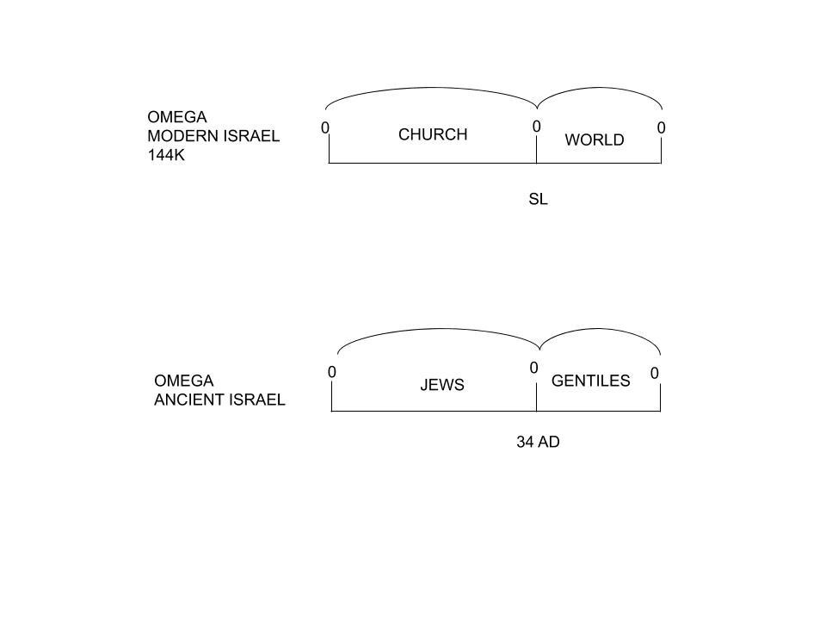Our reform line is the antitype of the line of ancient Israel. The whole purpose of the Jewish nation is to reach who? The Gentiles. That’s the whole purpose of the Jewish nation. It’s all about the Gentiles. But, before they go to the Gentiles, what must they do? Clean up the church. The Jews. So, first the Jews and then the Gentiles. First the church and then the world. The transition point is the SL. For modern Israel. So, for the ancient, the transition point is 34 AD. So, the waymark of the SL for the 144k line, not dealing with any fractals, is Dan 11:41. So, the transition point for ancient Israel is 34AD. So, if we construct our five primary waymarks, the middle waymark is 34AD, the same as the SL.

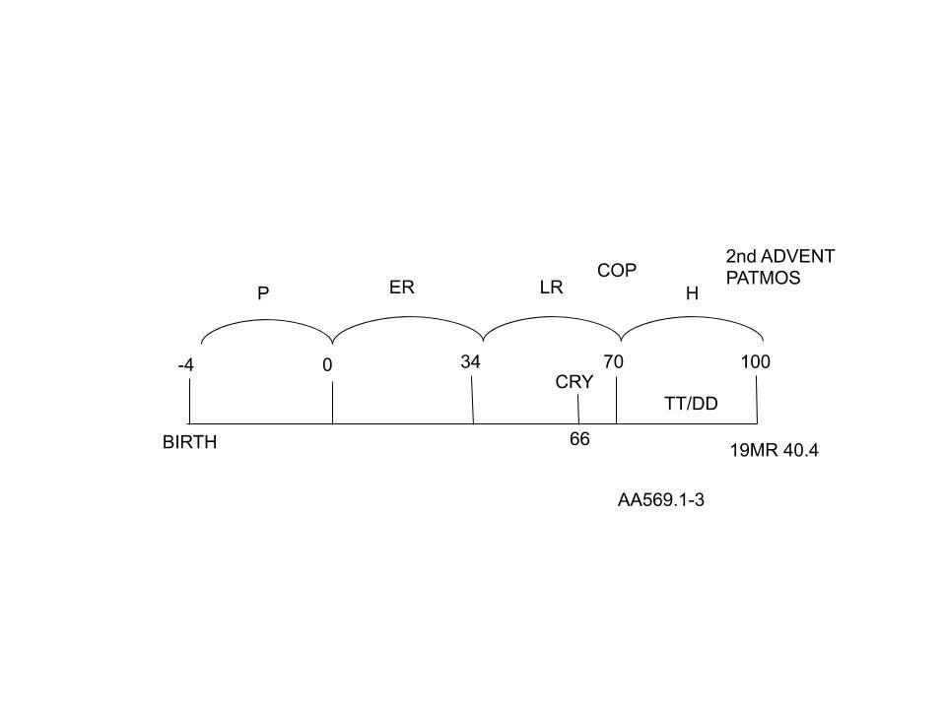So, on our reform line, we have placed the first, the middle, and the last waymark. What is the last waymark? What waymark is the last waymark for us? This is the Second Advent. So, in their history, could they have had a Second Advent? Where Christ returns and takes everyone back to heaven? Could this have happened in their history? No. Why? In 2Thess. 2, Paul said not to look for Christ’s Second Advent. It will not happen. Why? The man of sin has not been revealed. Who is the man of sin? The 1260; the Papacy. So, you have 2300 days, and what ancient Israel has experienced is just the 490. There was the entire 1810 yet to be fulfilled so Christ couldn’t have returned in the time of ancient Israel.

So, we went to 19MR 40.4, and it said that on the island of Patmos, Christ came back for the second time. She called it the Second Advent. So, we said that even though He couldn’t come back in that literal application, this is still a full and complete reform line. So, we still have the Second Advent in type. So, we have the first waymark, the middle waymark, and the last waymark. What is the waymark between the SL and the Second Advent? Destruction of Jerusalem. What date? 66AD or 70AD? In 66AD, there was a siege but the siege was abandoned, and everyone had a chance to leave. In 70AD, there was a second siege, the city was completely destroyed, and all who didn’t escape in 66AD were all killed. So, where do we mark the COP? 70 AD. In 4SP 440.3, Ellen White is talking about the Time of Trouble. The actual title is “The Time of Trouble'' in 4SP, Ch. 34. She marks the COP with the destruction of Jerusalem. If the COP is in 70AD, then between 70AD and 100AD is the Time of Trouble. 70AD marks the destruction of Jerusalem but not the COP. The Time of Trouble begins in 66AD. (There is a discussion between sister May and elder Tess regarding the COP, TT, and the destruction of Jerusalem which I found quite confusing. It is between the one hour and one hour and two minute marker. I recommend that each of you watch it to get a clear understanding of this matter and be settled in your mind when these events take place.)

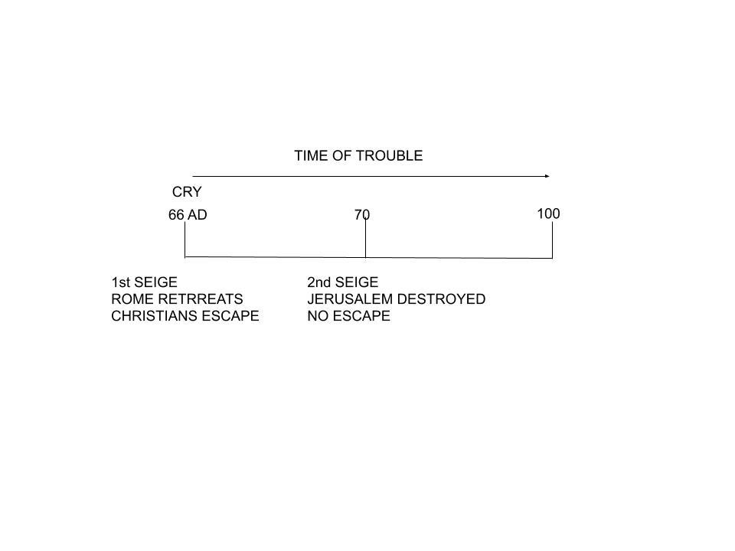In RH, 11-05-18s89.11, titled, “God Warns Men of His Coming Judgments” so, if God is warming men of His coming judgments, what does that mean? LC. If God is warning His people of the coming judgment, the judgment is not there yet. He is warning people of the coming judgment, and we would line up that warning of the coming judgment with the MC or the LC. She talks about those who have living faith and have escaped the judgments. The word comes to Noah, he goes into the ark, and Noah flees. The message comes to Lot, he got out of the city, and he fled. So, she is going to line up three histories-Noah, the flood is coming. Prior to the flood, he is given a warning. Get out of the world into the ark. Then, she talks about Lot. There is a coming judgment on Sodom. The message comes, get out. Then she lines these two with the third history, the destruction of Jerusalem. She says, “Those who obey the warning of Christ in fleeing Jerusalem were not involved in her destruction”. So, prior to the destruction of 70 AD, there was a cry. Then, she compares these to our own time.
So, she gives us three histories-Noah, Lot, and the destruction of Jerusalem. She says that prior to the destruction in our own time, there is also going to be a cry. What does it say? Babylon is fallen, is fallen. Come out. So, she lines up these three histories-Noah, Lot, and the destruction of Jerusalem, with our own history, the 144k. Before that final destruction, there is this cry to get out. The next paragraph talks about the sins of the world that reaches to heaven. The law of God is made void. The Sabbath is trampled in the dust. She is talking about the SL, and the cry begins to swell. The cry is going to warn the people to get out prior to the destruction. So, 70AD marks the COP, and 66AD marks the cry to get out. Paragraph 11 is talking about coming out of Babylon. It is the cry before the COP. 70AD is the beginning of the TT. Just as 66 AD was the LC to get out of the city, so it is the same in our time between the SL and the COP. Get out of Sodom, and get into the ark. All four histories are saying the same thing.

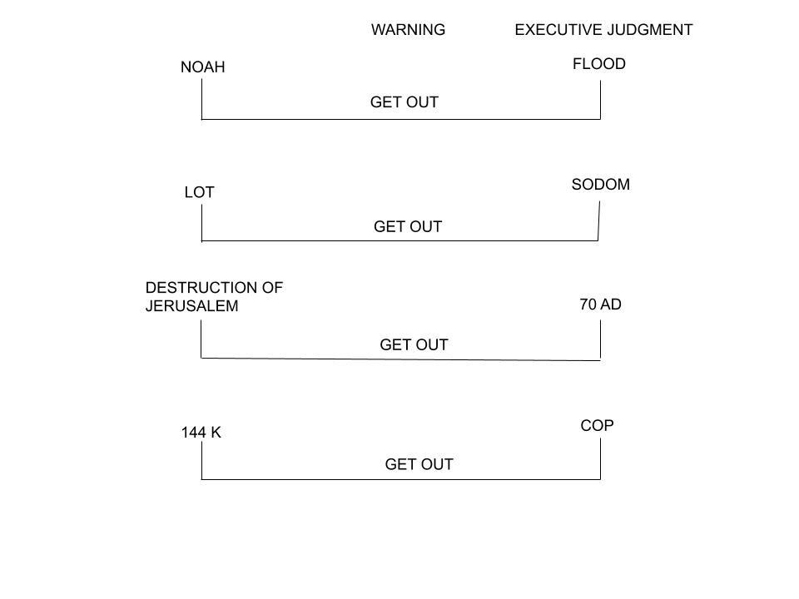Let’s look at the final history between 70 AD and 100 AD. We have spoken about the cry to get out in 66 AD, the executive judgment in 70 AD, and the TT. Let’s look at AA 569: 1-3. When we speak about the Second Advent on the island of Patmos, to whom is Christ coming down? Who is on the island of Patmos? John. So, this is all about John. So, you know that in this final history, there have been many martyrs, John is the only surviving disciple, he is standing on the island of Patmos, and he is the one left alive to witness the Second Advent. So, who does John represent? 144k. He is the one alive to witness the Second Advent. Who was the only disciple to stand at the foot of the cross? John. So, there is a special symbol represented by John. He represents the 144k. You see him standing, not fully understanding, but still standing faithfully at the foot of the cross when all the other disciples ran away. AA 569. “John lived to be very old. He witnessed the destruction of Jerusalem and the ruin of the stately temple. He is the last survivor of the disciples who had been intimately connected with the Savior.” “John was summoned to Rome to be tried for his faith. Here before the authorities the apostle’s doctrines were misstated. False witnesses accused him of teaching seditious heresies. By these accusations his enemies hoped to bring about the disciple’s death.”
So, he is being accused of sedition and heresy. Where have we seen that before? Sedition and heresy? These were the accusations made against Christ. He said that He is God, and He speaks out against the government. He is a little too political. 570.1. “John was cast into a cauldron of boiling oil; but the Lord preserved the life of His faithful servant, even as He preserved the three Hebrews in the fiery furnace.” So John was one of the original disciples. He stood faithful at the cross when all the others ran away. He lives through all of the persecution. All the other disciples are dead. He comes to 70 AD. He witnesses the COP and the destruction of Jerusalem. In the history of the TT, what do they do? They try to kill him. They put him in boiling oil but cannot kill him. So, there is a death decree (DD) against John. They can’t kill him so they exile him to the island of Patmos where he is the only one to witness the Second Advent. So, throughout this line, John becomes the representative of the 144k. He stood faithful in the testing time. He survived the persecution. He is trained from the beginning. He witnessed the destruction. He survived the DD. And he witnessed the Second Advent.
In Summary, we talked about the destruction of Jerusalem, the warning to escape, the TT, John, his representation of the 144k, his survival of the TT and the DD, and the Second Advent. So, tidying up the end of this line, if we could line all this up simply, our focus is of course on us. We just want this established because our focus is on the church. We want to know where we are right now. So, we will finish the end of this line. Then we’ll talk about the birth to the 34 AD, and what we’re meant to be doing right now, to try to understand our experience. Amen.

REVIEW-
- Briefly explain why in the Brown vs. The Board of Education, Brown was named after Oliver.
- Reform lines have how many waymarks and how many dispensations?
- What is the middle waymark?
- What does God give prior to the destruction?
- What is the methodology behind racism, sexism, and homophobia?
- TRUE OR FALSE
- Females are inferior to males.
- Whites are superior to Blacks.
- Homophobia is a good thing.
- Corona virus is less dangerous than the flu.

ANSWERS-
- Oliver Brown was the only male plaintiff, and the rest of the plaintiffs were female. Even though all the plaintiffs were Black, the women believed that they would be taken more seriously if they were represented by a man.
- Five waymarks and four dispensations.
- SL or 34 AD.
- Warning.
- Conspiracy theories.
- TRUE OR FALSE.
- F
- F
- F
10 F

