STRENGTH FOR TODAY
SONG;
You Are My Hiding Place
Selah
You are my hiding place
You always fill my heart
With songs of deliverance
Whenever I am afraid
I will trust in You
I will trust in You
Let the weak say I am strong
In the strength of the Lord
You are my hiding place
You always fill my heart
With songs of deliverance
Whenever I am afraid
I will trust in You
I will trust in You
Let the weak say I am strong
In the strength of the Lord
I will trust in You
You are my hiding place
You always fill my heart
With songs of deliverance
Whenever I am afraid
I will trust in You
I will trust in You
Let the weak say I am strong
In the strength of the Lord
I will trust in You
You are my hiding place (I will trust in You)
You always fill my heart (Let the weak say I am strong)
With songs of deliverance (In the strength of the Lord)
Whenever I am afraid
I will trust in You

OPRNING PRAYER; Heavenly Father, we thank you, with praises we honor your name, with gladness we worship at your feet. By faith we believe and follow. Father forgive us our sin, cleanse us from all that defiles within and without. Continue Father trying us, that we would rather die than sin against you. Christ is our pattern, may we have your strength, your wisdom; so, that we may reflect His lovely image. In Jesus precious name we pray, Amen
Strength for Today

Take therefore no thought for the morrow: for the morrow shall take thought for the things of itself. Sufficient unto the day is the evil thereof. Matthew 6:34. {UL 44.1}

Edson, temptations will come to me and to you. I have been struggling with the tempter for some time, but I will not give the enemy the victory. It is my privilege to have perfect faith and confidence in God. Jesus of Nazareth was above all others the Son of man.... Christ is the pattern of what the Lord would have us become.... {UL 44.2}

I have been tempted, sorely tempted, as I see how little many who profess to love God are really loving Him. Our obedience to His commandments testifies whether we are indeed children of God. We are inclined to worry at the outlook of things transpiring in our world. All the forces of the powers of darkness are working against the human race to restrict religious liberty and to compel service and the worshiping of an idol Sabbath. God knows all about the outcome. {UL 44.3}

I am so glad the Father understands every phase of the difficulties we shall have to meet. Believing Him and knowing Him to be God, we know that He sees with a larger vision than is possible for us. His ideals are higher than any of our conceptions. He can read every purpose of hearts that are leaguing against God, and cooperating with the evil angels to overthrow the righteous. All the forces of evil angels combined with evil men will be in action to suppress truth and liberty to believe truth. We will not fail now in our work; we will not be discouraged. Every question is open as the day to the Heart Searcher. He sees the effort made to influence a child in the wrong direction. The high and lofty One who inhabiteth eternity will not overlook the one who would work counter to His will in tainting and corrupting human minds. We must consider that God knows, God understands.... {UL 44.4}

Children, do not limit the Holy One of Israel in your individual cases. You can be connected with God. Grow in faith and trust and unshaken confidence in God. The Lord hath done much for you, my children, and your own selves given to the Lord without reserve will make you channels of light. As you seek first the kingdom of God and His righteousness, all things else shall be added unto you. Godliness hath promise of the life that now is as well as that which is to come. As you receive the rich grace of God you will diffuse it. The faithful discharge of today’s duties will be the best preparation for tomorrow’s trials. We will not gather together all tomorrow’s liabilities and cares to add unto the burdens of today. Sufficient for the day is the evil thereof. God gives us strength for each day.—Letter 141, January 30, 1896, to Edson and Emma White. {UL 44.5}
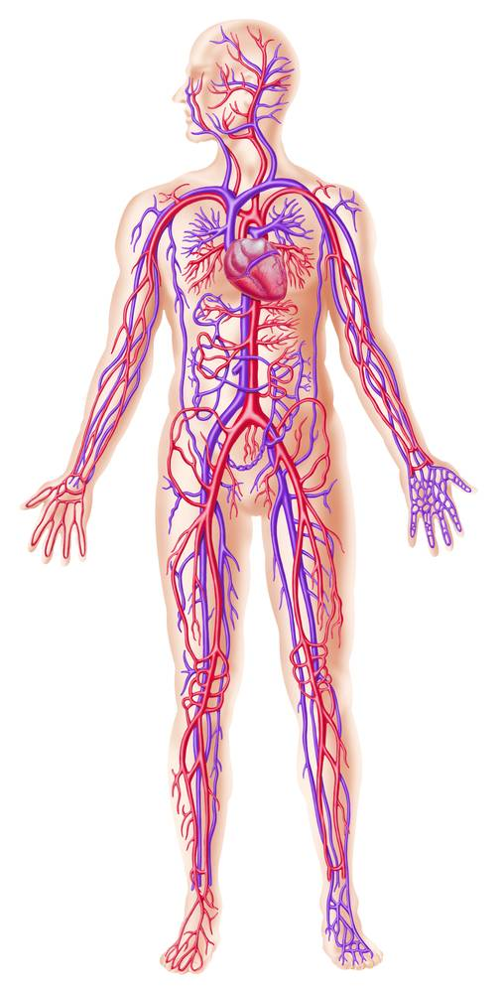

10 Awesome And Little-Known Facts About The Body

Your body is many things: a mechanical device, a walking chemistry set, a sustainable life form, and an ever-changing biological phenomenon. There's a lot to know about the body. Were you aware of these ten amazing facts?

1. For every pound of fat gained, you add seven miles of new blood vessels.
New tissue needs blood supply, so your vascular system expands to accommodate it. This also means your heart must work harder to pump blood through the new network, which may reduce oxygenation and nutrient replenishment in other tissues. Lose a pound? Your body will break down and reabsorb the unneeded blood vessels from the previous tissue.

2. Muscle tissue is three times more efficient at burning calories than fat.
This is why possessing more muscle should be a training goal for most people. More muscle = more calories burned = less fat = being more fit looking. Simple goals and simple math.

3. You are taller in the morning than in the evening.
When you crawl out of the sack in the morning you are at your tallest. On average, you are approximately one half inch taller when you wake in the morning, thanks to excess fluid between within your spinal discs. While you are sleeping, these fluids replenish. During the day your body has to deal with the stress of standing, so the discs become compressed and the fluid seeps out. This results in you losing a small amount of extra height.

4. Your stomach manufactures a new lining every three days to avoid digesting itself.
As a part of the digestive process, your stomach secretes hydrochloric acid (HA). HA is a powerful corrosive compound also used to treat various metals. The HA

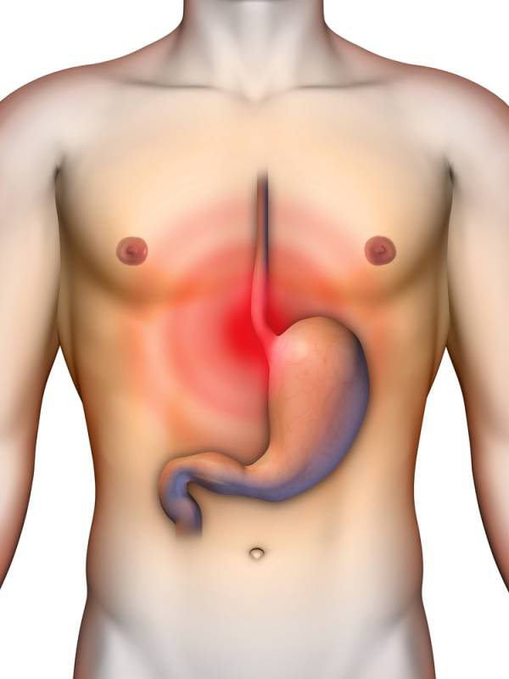

5. Your body produces enough heat in only thirty minutes to boil a half-gallon of water.
Your body is the epitome of a study on the laws of thermodynamics. You produce heat from all that is going on - exercise, metabolizing food, maintaining homeostasis – and as you sweat, exhale, excrete, and urinate (lovely thoughts, all of them).

6. Human bone is as strong as granite, relative to supporting resistance.
Would you believe a matchbox-size chunk of bone can support 18,000 pounds? Compared to concrete, human bone is four times greater in support strength.

7. Your skin is an organ.
Just like the liver, heart, and kidneys, your outer covering is an organ. An average man has enough skin on his body to cover approximately twenty square feet. For an average woman it is approximately seventeen square feet. Approximately 12% of your weight is from your skin. And, your skin replaces 45,000+ cells in only a few seconds. It's constantly growing new skin and shedding old skin.

8. By the age of eighteen your brain stops growing.
From that age forward it begins to lose more than 1,000 brain cells every day. Only two percent of your body weight is occupied by your gray matter but is uses up to 20% of your overall energy output (it needs carbohydrates). Your brain works continuously and never rests, even when you're asleep. Aside from producing REM dreams, your brain works overtime to replenish its ability to function normally during your daytime waking hours.

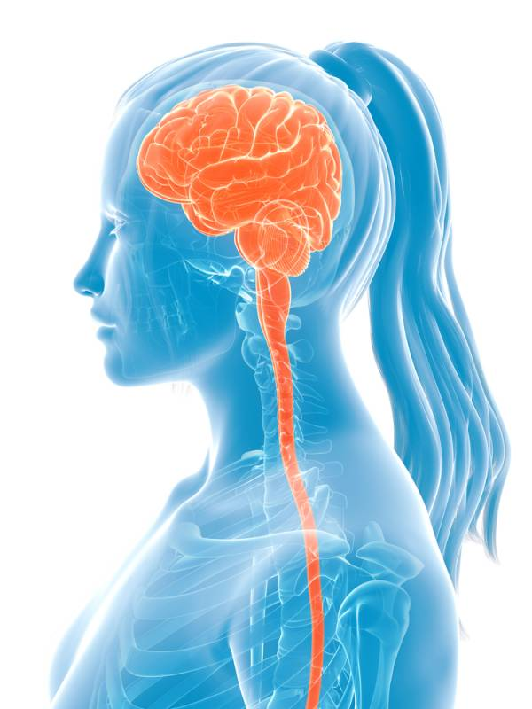

9. There are more than 600 individual skeletal muscles and 206 bones in your body.
If all 600+ muscles contracted and pulled in the same direction, you could lift over twenty tons of resistance. Additionally, the adult skeleton is composed of 206 bones, but at birth an infant skeleton contains approximately 350 bones. Over time, some of the 350 bones fuse together and eventually grow to the 206 adult figure.

10. You need to consume a quart of water each day for four months to equate to the amount of blood your heart pumps in one hour.
Additionally, over a lifetime, at your normal (resting) heart rate you will have pumped enough blood to fill thirteen oil super tankers. To further expound on this fact, on average, your heart beats 40,000,000 times per year. Doing the math, over your lifetime (both men and women averaged), that results in 2,600,000,000 heartbeats (two billion, six hundred million). This does not even factor in your increased heartbeats due to your love of exercise.

These are only ten things you probably did not know about body. Pretty amazing stuff! There is plenty more to know about the human body, and I recommend you discover these facts by being inquisitive.

CLOSING THOUGHTS: The faithful discharge of today’s duties will be the best preparation for tomorrow’s trials.

CLOSING PRAYER; Father, thank you for another day of life. I pray that we continue to walk where you have us walking. Help us to stay faithful and grounded on the path you have been leading us on. Father we need your direction and your guidance all along this journey, for on our own we can-do no-good thing. We are in your dept. In the Jesus precious name, we pray, Amen.

