Summary of what has been covered up to this presentation:
We looked at the reform lines, with focus on the reform lines of the priests and of the world. I wanted to specifically consider the world and how they have behaved in our last dispensation
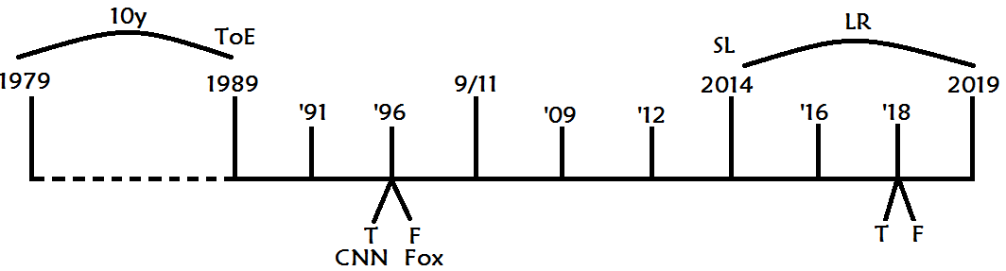
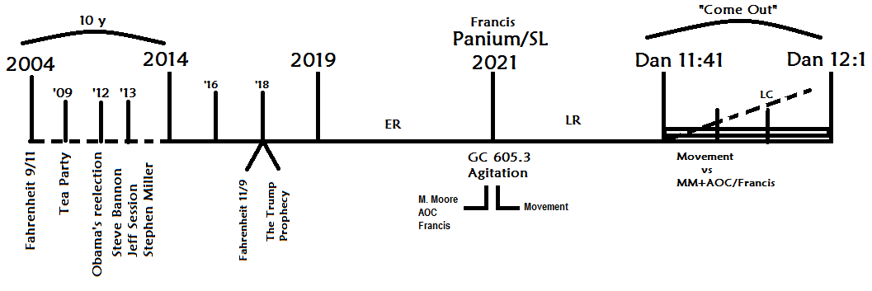
the dispensation of their plowing, and what we expect to be in our relation to them in the future.
so we understood their history, their dispensation of ‘14 to ’19, their plowing by comparing it and contrasting it with our plowing, and when we did that we were able to see that there must be a 10-year history of warning, then there must be an increase of knowledge given to a messenger a leader who is raised up at their time of the end (2014).
There must be two streams of information: a stream that is true, and that is false, and it must be a division between two groups. The two groups in their plowing are liberals and conservatives. If we removed Trump from equation you could title, there Michael Moore and Steve Bannon. They're symbols of two different ideologies. So, lined up Michael Moore his movement, and Steve Bannon and his movement.
We traced how Steve Bannon began in 2012, ‘13 all leading up to ’14, the beginning of the purging of the Republican Party, leading to the end of the purging of the Republican Party.
Then we went to the movement of Michael Moore we talked about Flint Michigan, “Fahrenheit 9/11”, the ten years, Fahrenheit 11/9. When Michael Moore does his first documentary in 1989, we threaded him through our reform line.
We spoke about Alexandria Occasio – Cortes. How she comes in at the time of the end, born October 13, 1989, how she gets elected in 2018 at the same time. These become the leadership of the Nethinims. They're leading that group that is diametrically opposed to Steve Bannon and his movement.
So, it is focused on their plowing, and that the world in this time period undergoing the polarization of society.
So, we left that then we came down to the Sunday law time period, their harvest. When we get to their harvest we ask the question “first of all, what message do we bring to them?” People had various ideas on that:
- biblical only (message not relating to external events)
- prophetic message that is a mixture of the two relating to external events
- prophetic plus inspiration (it's kind of saying the same thing and we asked
- “what we’re requiring of them?”
  - No other requirements
  - All truths are required + Test
Some said no other requirement, so when they say no other requirement, they're saying that the message is only external events we bring to them no message based on inspiration or Christianity purely external events, external I guess an external catalyst that will divide two groups. If that is the case, if it's purely an external message based on external events, do we give to them any other requirement? Some people said NO. Some people said we give them ALL information. We require everything off of them so we don't just say “practice equality,” we say you have to be vegan, you have to dress right, you have to eat right, you have to do all these other all these other requirements. After we identified these two groups: liberals and conservatives, we went on to the study of the deadly wound and the papacy.
We had a number of classes where we discussed what the healing of the deadly wound is. Does it relate at all to the papacy or is it purely Protestantism? Most of us concluded that the healing of the deadly wound is the rising up of the papacy at the end of the world. Separate and distinct from Protestantism.
So, if it's the papacy, people already started to have a problem with this history. We left that and focused on the study of papacy with the intention of returning to this.
Then we did the study of the counterfeit we worked our way through two and a half centuries of the counterfeit from 1773 when they go into rebellion to their boss lining that up with Israel, God's church, comparing and contrasting two churches. They went into apostasy then they were taken into captivity, and then we traced their coming out of captivity. Modern Israel comes out in two parts Millerites, 144,000.
Alpha of Modern Israel | Alpha of Modern Babylon
Starts in 1798 | Starts in 1899
In 1798 William Miller is a teenager, 1AM not doing anything | Warfare Rules adopted in Hague Convention of 1899, but actual war starts later, takes time
Ends in Great Disappointment of 1844 | Ends in disappointment for the King of the North (Papacy) in 1945
46 years | 46 years
3rd AM that starts from 1844 restores God’s people | World War 3 starts with the Cold War. Papacy richer after the war
10 Commandements: 4 and 6  Commandements also typify 2 charts of 1843 and 1850 | WW1: 1918 - 1914 = 4  WW2: 1945 - 1939 = 6

Modern Babylon therefore must come out in two parts, we traced 1798, 1899 both of them begin Alpha history. 1798 the Alpha history for modern Israel, 1899 the modern history of modern Babylon. First and second angels’ messages did a work first, and second world wars did a work. The rising up of a leadership restructuring at the inside the giving of a prophet Ellen White, Lucia, we traced the reorganization of the Catholic Church, the organization of the Adventist Church 1863, 1962 the Second Vatican Council. The papacy at the end of the world a good organization in 1773 they silenced the Jesuits. At the Second Vatican Council who is bringing the message? The Jesuits. At the end of the world who are their prophets? The Jesuits.
You can trace them through from the very beginning of our study in 1773, then you can see the theology, the message they begin to develop around the time of the Second Vatican Council, and what does the Second Vatican Council line up with? 1863. Then they fight with Jesuits and restrained by John Pail II.
Then you have a clash between this radical message, the Jesuits, and the leadership in 1989. 1989 internally is 1888 – Jones and Waggoner vs. Butler, radical new message coming into conflict with leadership, traditionalists.
So, we trace the Jesuits John Paul II, lining up with Jones and Waggoner vs. Butler. So, we traced that 1989 (counterfeit) = 1888 (true).
Then we come to our time of the end time of the Omega history of modern Israel. In 1989 we have two leaders. In the history of success to you have John the Baptist and Christ born at the same in the same year, similar point in time, the time of the end. They're both there, you don't get all those gospel stories about the three wise men going to the birth of John at the time of the end, it's about the second leader just as much as the first. they're both there, but John does the work first.
In the Omega of modern Babylon there are two leaders at the time of the end: Pope Benedict Ratzinger and Bergoglio, who become Benedict and Francis, neither of them are Popes in 2001. Instead you're going to see the death of the leadership in 2005, and the election of Pope Benedict - the first angel.
So, 2001 is their time of the end. 2005 is the death of leadership lining up with 9/11. and then we're back on course.
What is the difference between the ancient glorious land modern glorious land?
Ancient glorious land is Israel. Modern glorious land is the United States.
What type of government did the ancient glorious land have?
Ancient glorious land combined church and state.
Modern glorious land separated church and state.

That's what happened in the history of Christ, separation of church from state. If you go back to Samuel, he leads Israel religiously and politically, embodied in one man.
We that with Samuel then we saw that with the counterfeit – Darius. In Daniel chapter 6 Darius wears two hats: he is a king and he is a God. What he does as God he cannot undo as king. In the story of Daniel 6 Darius as king wants to undo what he did as God, and he's not able to. Church rules the state, even when embodied in one person.
So, you go through Babylon, Medo – Persia, Greece, Rome, and there this combination of church and state. Christ separated the church and state, and Satan separated them in 538. How many years did it take him to counterfeit? Five hundred years. So in alpha of modern Babylon it took Satan 500 years to counterfeit Christ. In Omega of modern Babylon it takes him 100 years.
Then we come into Omega of modern Babylon, we start off differently 1989, 2001 but who’s catching up? 2001, 2005 and then this movement trips, we reject time setting, and who gets the jump 2013-2014, and in that history of 2013 and 14 we’re now on a collision course. We're running at the same time.
We compared and contrasted the histories of the true and the counterfeit in different ways. Then we spoke about Benedict and Francis. Francis’ name means Francis of Assisi or restructure the church. He is known for caring for the less privileged, people often talk about his relation to animals, and with all those suffering or the poor. What would you call that? Liberation theology. So, Pope Francis chose his name wisely. In 2013 the second Angel is empowered; Pope Francis becomes Pope. 2014 he begins that restructuring of the Catholic Church, 2014 he begins stacking the College of Cardinals. John Paul II was a pope for 27 years, he appointed 19 cardinals. In 6 years, Pope Francis has appointed 67 cardinals. So, 19 in 27 years, 67 in 6 years. He is rebuilding the Catholic Church after his own mold. We spoke about how he restructured the church on three different levels: in 2014-2019 he appoints the first liberal cardinals for the College of Cardinals, second level on the Synod of the Family introduces the Liberation theology, and Amazonian Synod trying to introduce married priests.
So, then we bookended this dispensation of what the second angel is doing and who starts to oppose him? The first angel. There is a split within the Catholic Church between those who support the first angel, and those who support the second, and there are people who now have for the first time in six hundred years another living Pope they can turn to if they don't like the one who is the actual practicing Pope. They don't like Francis, they can say he's an apostate, he is an intruder. Benedict is still the Pope. So, people have a choice between the leader and the former leader who is still living, that splits internally the Catholic Church. The entire time there were these two groups, but before Benedict starts to give them a voice, archbishop Vegano begins attack on Francis, by speaking out.
Internally, the midnight cry message is presented, elder Jeff is silent, but his disciples are already speaking out in 2018. The true and the counterfeit both disciples of the first angel begin to attack the message. Then the first angel himself begins to speak, when, what month? April 2019 Benedict attacks the second leader. April 2019 elder Jeff attacks the second leader, a couple of days apart you come down to the final months of 2019. Elder Jeff speaks in open opposition final months of 2019, the same time is the Amazonian Synod on married priests. Pope Francis is giving his message, and Pope Benedict begins to speak in open opposition. In September and October, he writes his portion of that book that attacks Pope Francis’s position on married priests. In September and October, elder Jeff records presentations that attack the message of the midnight cry. So, we compared and contrasted that history and it is watertight. If people don’t accept this movement and the new leadership what elder Jeff has to say is that Francis and Benedict are as bad as each other. We are saying if Pope Francis and Pope Benedict are as bad as each other, then he has to say that Jeff and Parminder are as good as each other, but he doesn't use compare and contrast, he doesn't believe in the watertight nature of the study of the counterfeit anymore. He used to, but he can't, because it becomes an untenable position.
So, we traced the line of the counterfeit, then we looked into the future and based on that watertight nature we made some conclusions. Right now, we have been through the Gethsemane, through the cross, and this movement is smitten and torn. What do we know is coming prophetically? Pentecost, a binding up this movement as a history of success, and from Pentecost to 34 AD they did the last work for the church, and then they were fully ready, empowered movement to take on the world.
So, we know that we rise from Panium to Sunday law. whatever trouble looks like it exists now. What about the counterfeit? They rise from Panium to Sunday law, which is exactly what we had been saying, Sunday law in a simplistic fashion, the healing of the deadly wound.
Then we went to the third Diadochi war. The third Diadochi war told us that whole story, but it added details, it gave evidence to the rise of the papacy, and it added details about the relationship between the papacy, and the king of the north and the King of the South. They begin as friends at the time of the end, and then their friendship is destroyed, then follow the years of tension and fighting, and then Seleucus takes Babylon and sets up for a war beginning at Panium. Panium to Sunday law if fought between Seleucus and Antigonus, or the papacy and Donald Trump, the United States. At the Sunday law beginning of the Seleucid dynasty Seleucus goes East and he establishes his empire. So, at the Sunday law the papacy has won, it has established itself, its deadly wound is healed, and it's going to go forward and do a work. All of that was to show the rise of the papacy within the history from Panium to Sunday Law, and then doing a work for the world after the Sunday Law.
THE purpose of doing all of this was to bring us down to the harvest of the world, this history of Sunday Law a close of probation. What we want to understand is what two groups are going to develop there, and we’d said conservatives and liberals, so we came back to this study that we’d left, and we said okay so it's Francis here, now we start to have a problem saying that the two groups are conservatives and liberals. So, we went back to another compare or contrast, and we saw that in the history of our (priests’) plowing it's elder Jeff with his movement ministry vs. the Adventist structure, because this is the history of Daniel chapter 2 and the story of being cut out of the mountain. So, the theme of this whole reform line is that the separation of a movement from the Adventist Church structure. At the time of the end, in this increase of knowledge you see that begin to happen, the Adventist Church structure, the mountain as elder Jeff and future for America begin the cutting out of this stone.
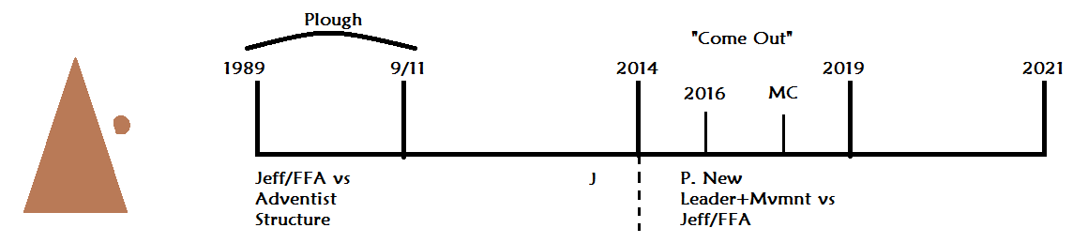
So, we could in a simplistic fashion see this whole reformed line as being just that it's movement cut out of Adventism, but we got to the history when we're given the midnight cry and told to come out nearly all of us have come out in the history of ‘14 to ’19, because that's when we're told to come out of Adventism. But what split, shaking happened in this history was not a split and a shaking between us and Adventism, but between the new leadership of this movement and elder Jeff/FFA.
When we have five key waymarks, the middle waymark marks the Sunday law and on every reform line we have at that way mark - change of leadership: John to Jesus well before they ever go back to the church in the history of the first of the three groups called out. It goes from John to Jesus, it goes from Miller to Snow, Moses to Joshua. Every one of our reform lines is consistent on that point, so 2014 there’s a change in leadership and the threat this movement faces that splits the movement of the priests is not this movement vs. Adventism, we were already cut out of them. It is the new leadership vs. those who did the plowing.
When we compared and contrasted that we had to allow for some differences with the line of the Nethinims, the difference being that they're called to come out in their harvest, we're called to come out in our latter rain.
That means that the Nethinims middle waymark must have a transition in leadership: Michael Moore and AOC that led the Nethinims from ‘14 to ’19.
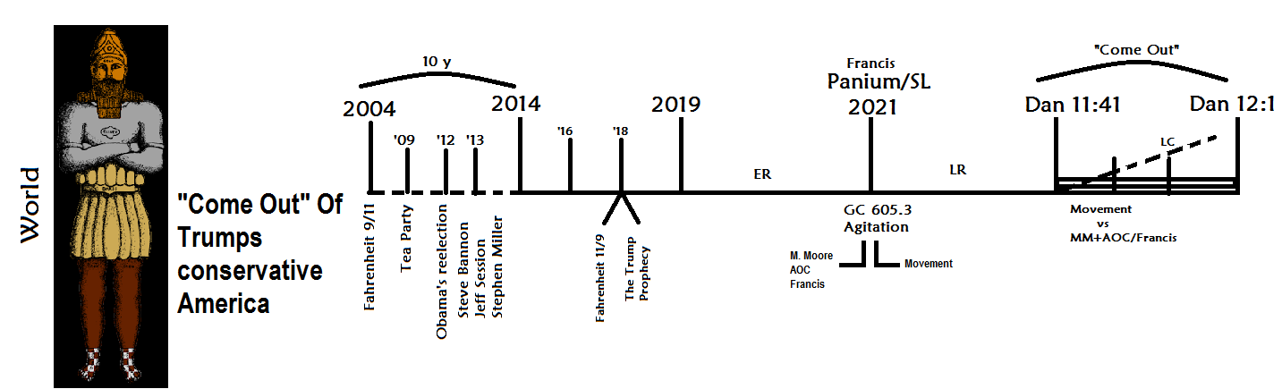
This is the story of something being beaten out wheat being beaten out of the statute of Daniel chapter 2: the stone is being cut out of the mountain are priests being cut out of the Adventist structure; the wheat being beaten out of the statue.
The wheat coming out of the statue is the story of the Trump’s America, wheat coming out of the Trump’s conservative America. At the very beginning you have this movement and elder Jeff vs. the mountain; the very beginning you have Michael Moore versus the statue: Donald Trump's America.
When you get to their Sunday law history and there is a transfer in leadership and who becomes their new leadership this movement if we’re telling them to come out and join us, we're telling them where to go and what to do. So, you know we're leading them here (between SL and LC of Nethinims), but we don't begin that at Sunday law (Nethinim’s SL).
In 2014 no one in this movement knows that elder Parminder is the new leader of the movement, they don't have to, it's marked in prophecy, it takes people a while to figure that out. No one knew in 1989 that elder Jeff was a leader of a movement either, he didn’t even know that doesn't matter, its marked in prophecy.
So, 2014 at the Sunday law waymark we have transfer of leadership, the same way in 2021 Sunday law for the world, Nethinims, they have a transfer of leadership from Michael Moore and AOC to us. So, when we get to the history when Nethinims are called to come out it's the new leadership (movement) versus Michael Moore and AOC. their message is formalized in September October 2018, at the same time the Midnight Cry given which begins in September and ends in October. In October 2018 Michael Moore meets Pope Francis at the Vatican, and they are together, they are in unity. So, Michael Moore is on whose side? Francis’.
When Frances begins to rise in this history (from Sunday Law to Close of Probation for Nethinims) is Michael Moore going to take our side or his? His side. So, who becomes our greatest threat? It was elder Jeff in our history, and it will be Michael Moore is in the Nethinims’ history. Because the split happened within the priesthood, Adventism is long gone, the split happens within the Nethinims, and the conservatives, Trump they're already swept away, they’re already gone. the split happens within the movement and when the split happens within the movement of the Nethinims it’s between the new leadership, you and I, this movement, and modern Babylon. So, the papacy instead of being a secondary threat to Protestantism, Donald Trump’s conservative America, it becomes much more serious, when we consider the Nethinims in the history of their harvest.
It begins to be a quite loaded point when you think of what people’s ideas of this history are, in the last months. Especially, since late last year we have just entered a new dispensation, and people are looking at this line of the world and making their conclusions, about their own spiritual experience. What I’m concerned is their errors in understanding their own spiritual experience. You first need to go and show them what their understanding wrong about the world, the reform line of the Nethinims.
This is the history of their ploughing the history of their first angel. What's the problem with the first angel? He is half right and half wrong. Moses, John the Baptist, William Miller, elder Jeff, does any one of them understand the nature of the kingdom? No. Our problems is that the external movement (Nethinims) being ploughed by external events. Their message, the message Michael Moore and AOC are giving it must be half right and half wrong, and people have not understood that, or they have not behaved as if they understood that. Going back to the line of Christ you see the transfer of John to Christ, does John understand the nature of the kingdom? No. Who does Christ represent? He represents this movement; he represents the new leadership of this movement. So, do the faithful of this movement, the new leadership ,do they have it a half right half wrong message? Do they misunderstand the nature of the kingdom? No. But people have swapped those two they’ve said we must be half right and half wrong, because we're conservatives, and we think like conservatives, we have all of these issues, so we have to go to the world and understand from AOC, and Michael Moore, and all of these secular people about what to do and how to think, because people are saying, not directly, but they're implying we’ve got all these errors and they have it all figured out. I would be quite forthright in the other way: WE HAVE IT ALL FIGURED OUT (theoretically; I know we have an increase of knowledge). We don’t have a misunderstanding about the nature of Christ's Kingdom. THEY are half right and half wrong. So, we've left the presentation by asking people to think where are THEY half right and have wrong, because if you can’t tell me where they're half wrong, you can't look to them as some type of compass about what we should think, or what we should wear, or what we should do. People are looking to this model (on the line of the Nethinims before Sunday Law) to say they have it all figured out, there is grand political movement, we can't go to them because we have all the problems, and we're going to come into this harvest period, and finally we’ll have figured out all of our errors and we all can come into some type of grand political unity, that's the type of narrative they're sharing. The problem with that is, first of all, we are the leaders, they're not. The second problem is they're half wrong, so WE must have something to teach them because we are not half wrong.
What we think the period of Sunday Law to Close of Probation of Nethinims looks like impacts the decisions that people are making right now. It impacts how people are reading the vows, because if they have it all figured out, do they need vows about reforms? No. So, we must be the ones that are wrong, we need to change come in line with them.
Where are they half wrong?
We think they have figured out the issue of equality, and we're behind, and they're saying that by pointing to people like Beyoncé, and saying, “look Beyoncé sings about equality, she has it all figured out, and what did WE say? Line up Beyoncé with her husband, who takes care of their appearance? Who HAS to? If you switched what they look like would Beyoncé have any of her influence and power? No. Is that equality? No. Do they understand equality in the world? Not very well. They're able to go so far, but the minute they’re looking at AOC, and she has a certain image, and with that image has given her a certain following and power, if she looked like Michael Moore would she have that? No. Does he have to look like her to have a voice? No. Why? Because he’s a man. So the Nethinims, the world, those are on the right side of the issue, how good is their understanding of equality in reality? Really poor. It is only this movement that can deal with that issue in a fashion that is comprehensive. So, when it comes to the nature of the kingdom, what's their mistake, because it always comes down to the nature of the kingdom? They are dreaming about the utopian society. Their idea of the nature of the kingdom is a utopian society. Michael Moore wants a socialist society, a multipolar system, that is entirely secular. There are no spiritual requirements for entering this utopian society. It is here, on this earth. It is a literally earthly Kingdom, that has no requirements, no religious elements, no reforms, that is why some of us think that when we give them a message, we give them no requirements to enter into this movement. All because we believed Michael Moore’s definition of the kingdom. Some people are going so far as to thinking that heaven is on this earth, that somehow, we're going to have this secular society on earth, and that heaven is just a spiritual application.
So, people are doing different degrees of this but they’re all doing the same thing. None of these views existed before we started speaking about Michael Moore and what he's doing. Because we've discussed him in the ploughing time, people have looked into him there's they've seen the nature of the kingdom Michael Moore is trying to set up, and they've brought that into this movement. Does that make sense? I want us to see where we've got that from, we've got that from the world, from the Nethinims. So, when we come into their history, we are telling them about the kingdom of heaven, not on this earth.
When it becomes a kingdom in heaven, all of a sudden what problem do you have? To get to there there's a list of requirements that you might not need here. But when we understand the nature of the kingdom, that it's a spiritual Kingdom, that it’s a kingdom in heaven, then there starts to be a list of requirements to get there. Somebody could accept equality, I could accept men and women are equal, and then I could go and kill my sister. I've just committed a murder. Do I go to heaven? No. Because there's a standard, a list of requirements.
In the Millerite history if we were to talk about Miller right history I'll erase this board and it's on the other side in elder pomander study so I want to just remind us of that not go through it remind us of that priest equals equals
P = L = N
So, if we want to talk about our Alpha history, the history of the Millerites we build their reform line based on five key waymarks.
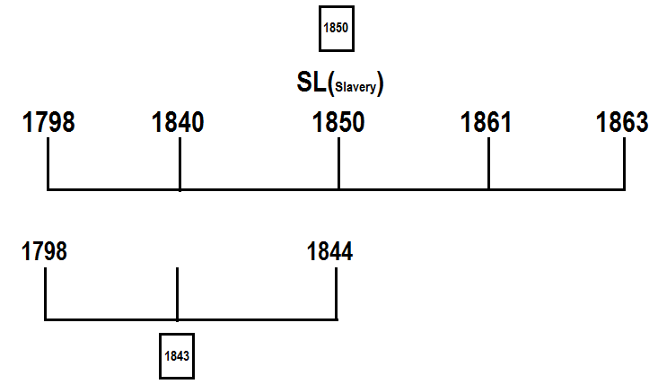

I have plotted a fractal level of the first group. So, for this first group what's given to them? What was the message of the first group? Whole message was summarized into the 1843 chart. When you come down to 1850 and they are to go back to the world, and the issue in 1850 is slavery. Does Ellen White get to this history and say we’re just going to give them a message on slavery, if they're right on the issue of slavery, we have nothing else to give them, it's purely secular? What does she say? “We need to take this 1843 chart and correct it”, and they produced the 1850 chart. Do they say the testing message is slavery? What people are saying is, “we can understand all of this stuff, we are priests, but when we go to the world if the external testing message is equality, we need any of our accumulated baggage.” What’s the problem with that? The 1850’s chart is everything. What the priests have to understand, the chart for the first group, became the chart that went to the world. It is separate to the testing issue, and the testing issue was slavery, but they didn’t have a message based only on slavery. They wrote about it, they published it. So, can we discard anything that we’ve accumulated over the last 31 years? When we go to the world how much are they required to see and accept? Everything. If you have 6,000 years of progression, God is giving light after light, after light. And when we get down into our dispensation we need to have the accumulated light of 6,000 years, and when we go to the world, does that 6,000 years get put aside? They have to accept the accumulated light of 6,000 years as well, otherwise it's not an increase of knowledge, you're going backwards not forwards.
In the Millerite history all the things that they have accumulated were put on the chart and sent to the world. At the same time the external issue is slavery, and those who are wrong about slavery left the movement and lost their salvation, Ellen White tells us that. People lost their salvation based on how they stood on the issue of slavery. It tested them and the United States, the glorious land. But to be part of the movement they had to accept everything on the 1850 chart.
E. Parminder’s comment: “testing message of their time was not codified on the chart, and that is what caught them by surprise.”
The issue of slavery is not on the charts, it's not codified, it’s separate, and we have the same dynamic. What is codified is the Sabbath and our rules and regulations. Equality is not codified, so it becomes in some ways a difficult test. But we can see that slavery was not codified on the charts, at the same time it separated.
So, I want us to consider WHY we're going through what we're going through. How do you know how to behave, how do you know what to do?
Audience: By studying the past history on the lines.
So, how do we know how to behave based upon where we are on a reform line? You know what you’re supposed to do everything that you do is dictated by where you are in a reform line, whether or not you’re sharing the gospel with your Muslim neighbor, it's all dependent upon you knowing where you are on a reform line.
I wanted us to come back to our reform line and I wanted to do us to consider the issue of priests.
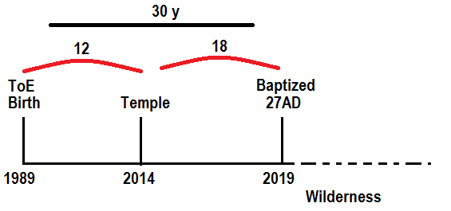
In 27 AD Jesus is baptized, he's 30 years old. He must be ready to go to work, but he go he goes into the wilderness. I want us to consider where we are on our reform line in this story. Where are we? We are in the wilderness between his baptism and when he goes into active ministry, but we could call it the first temple cleansing. We know that we’re in the history of Christ in the wilderness so that should start to tell us about what we're experiencing, and how to behave. I want us to look at Christ’s experience here.
CSA 32.6: In the wilderness of temptation the destiny of the human race had been at stake.
Do you think we're in a dangerous time period? Yes if the priests fail, what hope is there for Levites or Nethinims? So, you know right now, in this dispensation, in the dispensation of our harvest, there must be issues which put the whole plan of salvation, the whole line of the 144,000 at stake. The whole gospel at stake.
Christ was then conqueror. Now the tempter had come for the last fearful struggle. For this he had been preparing during the three years of Christ's ministry. Everything was at stake with him. If he failed here, his hope of mastery was lost; the kingdoms of the world would finally become Christ's; he himself would be overthrown and cast out.
So, she is talking about Christ in the wilderness, and she compares and contrasts that through this paragraph with Christ in Gethsemane and the cross.
So, she is saying that at Gethsemane and the cross Satan made his last final assault on Christ. Wilderness is the last final assault prior to his death on the cross. We all know that this movement has been through Gethsemane, it's been through the crucifixion into the tomb, the final months of our dispensation were fraught with danger. But then she says the first assault of Satan which also she also uses the same quote “his form was married more than the forms of men...” She uses that same sentiment to apply to the wilderness time period. So, the Gethsemane is an assault that puts the plan of salvation in jeopardy, and wilderness puts the plan of salvation in jeopardy. So, do any of us feel safe, like we’ve gone through November 9, and we are in a nice calm period now? Gethsemane was danger. Wilderness was danger. Christ was weak and emaciated in the Gethsemane, Christ was weak and emaciated in the wilderness.
If you take both of them you bring them into our experience as a movement and you can see the danger we are faced towards the end of the last dispensation, and the danger that we're still in. That comes as a warning that we know that we are in a time period where we must watch, and pray, and consider our position carefully. I'll give an evidence for how she talks of this history in CTR 192.4:
When Jesus was led into the wilderness to be tempted, He was led by the Spirit of God. He did not invite temptation. He went into the wilderness to be alone, to contemplate His mission and work. By fasting and prayer He was to brace Himself for the bloodstained path He must travel.
She talks of this as being the final steps of preparation. So, even though he's 30 year old and baptized there was one final step in his preparation, that was the wilderness. For the movement of the priests it's the same thing. It's our final step of preparation.
But Satan knew that the Saviour had gone into the wilderness, and he thought this was the best time to approach Him. Weak and emaciated from hunger, worn and haggard with mental agony, Christ's “visage was so marred more than any man, and his form more than the sons of men.”
So, she's quoting that passage about Jesus visage being married, that we applied to Gethsemane and the cross, and she applies that to the wilderness. So, can we see that we can put place that it in two different places, when Christ is in the wilderness and when Christ is in Gethsemane.
I want to make a point about this how this is recorded in the Gospels because you find it in Matthew and you find it in Luke, and what's the difference between how it’s recorded in Matthew, and how it’s recorded in Luke? They put the temptations in a different order, so if we want to understand the correct order that they went through in the actual history, we have to go to the Desire of Ages. So, if you were to go to the Desire of Ages 117.3, she tells us the order that those temptations came.
First temptation: DA 117.3 – Bread (Satan disguised)
Second: DA 124.3 – Cast down from Temple (Satan disguised)
Third: DA 129.1 – Kingdoms (Satan in his true form of a mighty angel)
Jesus was victor in the second temptation, and now Satan manifests himself in his true character. But he does not appear as a hideous monster, with cloven feet and bat's wings. He is a mighty angel, though fallen. He avows himself the leader of rebellion and the god of this world.
Placing Jesus upon a high mountain, Satan caused the kingdoms of the world, in all their glory, to pass in panoramic view before Him. The sunlight lay on templed cities, marble palaces, fertile fields, and fruit-laden vineyards. The traces of evil were hidden. The eyes of Jesus, so lately greeted by gloom and desolation, now gazed upon a scene of unsurpassed loveliness and prosperity. Then the tempter's voice was heard: “All this power will I give Thee, and the glory of them: for that is delivered unto me; and to whomsoever I will I give it. If Thou therefore wilt worship me, all shall be Thine.”
So it's here the only reason that Satan can offer him the kingdoms is his saying that these kingdoms already belong to him, so to do that he's had to give up this pretense of being some messenger from God. He had to show his true form as Satan. The Desire of Ages gives us the correct order of these temptations, he couldn’t offer him the kingdoms until he’d thrown off his pretense, he's acting. he only did that in the 3rd, so if you go to Luke ,it won't give the correct order for these. The order in Luke will be the bread, the kingdoms, and then cast down from the temple. So, if you go to Matthew 4:
- Take a stone and make it bread.
What is Christ's condition? He's starving hungry, what is he hungry for? bread and what does a bread symbolize in the Bible? Bread of life, or the message. If you were to go 5T 206.3.
The third angel of Revelation 14 is represented as flying swiftly through the midst of heaven crying: “Here are they that keep the commandments of God, and the faith of Jesus.” Here is shown the nature of the work of the people of God. They have a message of so great importance that they are represented as flying in the presentation of it to the world. They are holding in their hands the bread of life for a famishing world. The love of Christ constraineth them. This is the last message. There are no more to follow, no more invitations of mercy to be given after this message shall have done its work. What a trust! What a responsibility is resting upon all to carry the words of gracious invitation: “And the Spirit and the bride say, Come. And let him that heareth say, Come. And let him that is athirst come. And whosoever will, let him take the water of life freely.”
She says the third angel’s message is the bread of life for a starving world. But the message is the bread. How is Christ? He is starving, hungry, he has no bread. When is the last time he had bread? At the baptism. Who is Christ, who does he represent? The movement of the priests. So, I want to make application all through the last 18 months we've had a message, the growing midnight cry message that all of us have had trouble keeping up with, then we come to the camp meeting in Germany, began with World War II, closed with World War 1, that whole midnight crime message book ends and closes. Then Parminder and I through no planning, there is no school at that time, and we’re relatively silent, everything goes quiet. November 9 comes around and people are all saying, “explain to us November 9 explain to us Raphia,” now, I could have gone straight to this conclusion and said, “no, this is the papacy and the division is between two groups,” but we took three weeks of classes to get to that point. So, I'm not going to talk about November 9 because we would need at least three weeks of more classes. I don't think giving conclusions is helpful, and Parminder and I are silent, and in this comparative silence people are hungry for a message. They've had 18 months of the midnight cry, and they are hungry. And what's the temptation? Take a stone and force it to become a message, and what did Christ say? “I can’t use my power, to make your stone a message.” So, in the history when it's quiet, people start to develop this idea that they have some type of stone and it's a message needed for this movement, do we have a message right now? No, we don't the history of the wilderness tells you that clearly, explanations of our questions will come, but for whatever reason whether it’s Christ in the tomb, or Christ in the wilderness, we're in a period where we are to hang on to the light God has given us, we trust in His leading, and we understand that right now He has not given to us a message. But there are people who think that they have a stone, and that stone is a message to this movement, and what is that stone that they're sharing? It's the idea of the reforming of our vow.
People believe that they have a message of liberalism to come and teach this movement, that's what is being developed. E. Parminder: “a stone is a symbol of the Gentiles.
Stone=Gentiles, Bread = Message.
“we’re being offered a message that comes through the Gentiles.” What Gentiles specifically? Michael Moore and his half wrong message. So, something that belongs to the Gentiles, a stone, is being given to a starving movement, and saying force this and make it bread. How to know that that's wrong? because the people saying that either they say it explicitly or less explicitly what's the pregnant thought they give with that? If you’re different to FFA, if you're so different, if you're the movement, if Elder Parminder and Elder Tess are the leadership, they’re going to make this stone this liberal message, and make it bread. That should be the first sign that something has gone seriously wrong.
We have this message of liberalism, when I say that it comes down to those vows that elder Parminder was speaking about. What God requires of us, what type of movement we're all to be? All of that is being encapsulated into message and you see that being promoted and developed and this is taking a stone, something they got from the Gentiles in a time period when we have no message, and saying if you're different to FFA, if you really believe in freedom, you'll endorse this, and we don’t.
The second test. If you go back to Matthew 4:4
But he answered and said, It is written, Man shall not live by bread alone, but by every word that proceedeth out of the mouth of God.
Christ's response: “it is written”. So, what does Christ go back to? A Thus saith the Lord, can you see where we're under attack already? Again, people take what we’ve taught whether it's about liberalism or dress reform and they manipulated it and twisted it not necessarily maliciously, through misunderstanding they’ve twisted it. Do we believe in Thus Saith the Lord? Yes, we do, when we take methodology to it. He says, “thus saith the Lord, man shall not live by bread alone but by every word that proceedeth out of the mouth of God” On our reform line we meant to have a message right now, when I change Thus Saith the Lord - something that I feel like is an exact equivalent thus saithe the line, do we have a message right now? No. Go to the next temptation, Matthew chapter 4:5.
5 Then the devil taketh him up into the holy city, and setteth him on a pinnacle of the temple,
6 And saith unto him, If thou be the Son of God, cast thyself down: for it is written, He shall give his angels charge concerning thee: and in their hands they shall bear thee up, lest at any time thou dash thy foot against a stone.
So, Satan has learned a lesson from the first temptation what does he change in the second? he's going to give him back “it is written”. He is going to give him back a quote, and he says this says God will take care of you, if you come to harm, God will send His angels to protect you. So, the second says “cast thyself down and God will protect”, what does Ellen White call that? Ellen White calls that presumption. I want to refer you to what elder Parminder taught about the nature of man. So, what people are saying is essentially this: “do you have to cast yourself down from the temple?” if I was to say don't cast yourself down am giving you law or a good advice? I'm giving you a good advice. I'm saying I am going to give you a good advice don't cast yourself down from the temple. If you don’t follow that good advice what's going to happen? Satan says no consequences. You don’t need to follow the good advice, so people are saying Beyoncé believes in equality, I can listen to her music, it passes the test, we know it's all about the external events, we don't need the 1850 chart, Beyoncé believes in equality, I can listen to our music and feel no consequence. I can wear earrings and no consequence, I can eat eggs if I choose to, its only good advice, and there will be no consequence. Doing something that God has said don't do, it will hurt you, and thinking we're not to suffer consequences, that's the sin of presumption. There is a good advice that says don’t cast yourself down because if you do, you are placing yourself in a position where there will be consequences, and will God protect you from the consequences? No. And when we looked at the nature of man study what are the consequences? You go back to what elder come into taught about the outer man and the inner man. So, this is the sin of presumption, it says I can adorn, listen to music, watch worldly movies if they have some semblance of a message of equality, I can wear makeup, I can do all of these things with no consequences. They're only good advice. That’s essentially what people are saying, and Jesus says, “it is written thou not tempt the LORD, thy God.” Because will God protect you? No. There are consequences.
The third Temptation. Again, the devil taketh him up into an exceeding high mountain, and sheweth him all the kingdoms of the world, and the glory of them;

9 And saith unto him, All these things will I give thee, if thou wilt fall down and worship me.
10 Then saith Jesus unto him, Get thee hence, Satan: for it is written, Thou shalt worship the Lord thy God, and him only shalt thou serve.
So, in the third, Satan offers Him the kingdoms of the earth. What is Satan offering him what is Satan offering him? A utopian socialist society, where there is no requirements of reforms. He is wrong geographically, where does Jesus say his kingdom is? In heaven. Satan is saying, “I'll give you a kingdom on earth, I'll give you a kingdom where you're going to be this political movement with secular power, where people have none of these troublesome requirements or reforms.”
The fact that they think it is this earthly secular society that’s being raised up, that somehow we're going to join, and become a force for good without bringing to them a spiritual message, all of the requirements, all of the increased light that we find in all of our vows.
So, it is this idea that we can place ourselves in harm's way with no consequences, and God will protect us, when we have clear stipulations that these external things whether it’s jewelry, earrings, makeup, what we eat, what we listen to, what we watch, that somehow that doesn't affect us spiritually.
When we think of where we are in our form line and that's to tell us how to behave we understand that we went through a shaking, a difficult painful history leading up to our close of probation November 9, what I want to suggest is it then if you use the lines of Christ the suffering He went through and Gethsemane Ellen White lines up with the suffering in the wilderness, and we have no time to be complacent, and feel that we're in a position of safety. As a movement we know that it's a history of success, but God can do that with as few, or as many people as choose to be part of that movement, so individually, we need to be aware of the danger that we're in. What I'm saying is that this misunderstanding about the line of the world, about the dangers or the tests in their harvest period, not between conservatives and liberals, but between a true liberality and counterfeit liberality, is what will separate in that time period. The problem is we have been bringing into the movement, imbibing counterfeit liberality, counterfeit liberalism, and passing that as the true liberalism.
We looked at where they are half wrong, the nature of the kingdom they're trying to set up, what they expect of people, and then we went to the history of Christ in the wilderness. If those are the three temptations he faced in this history, you know they're the three temptations that every one of us in this movement faces. Are we taking a message that comes from the Gentiles, their error, from the stone, and trying to make it food for us, because we're hungry? Some are. We are thinking that we can do all of these things which God advises us not to do, and somehow there are no consequences and we will be protected, that's the second temptation the third temptation is about the nature of their kingdom, do we want the kingdom that they're wanting to set up, in their half wrong idea of the first angel, or do we understand that God raised up the priests to set up a different type of Kingdom. And that in this history we are not half wrong in our understanding of that, we’re a hundred percent correct, and the world has nothing to teach us.
I want us to consider that some of the risks that we were in.
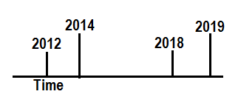
When we come down to a reformed line 2012 is the formalization of a message on time. Does elder Jeff accept time in 2012? No. In 2018 does he accept time? Yes, he did. Did it do him any good? No. Why? Was too late? It was too late by the time it came into this history the door had already shut. So that sounds doom and gloom. It is. I don't think it has to be that hopeless. Was he part of the movement that entire history? So, it took him seven years to leave, but in 2012 it's already a done deal.
So, we leave with two warnings:
- Just because people seemed to accept the message of equality many of us haven't. We claim to accept it, we don't practice it, we don't live it, when it's pointed out to us we don’t like it, and is that actual acceptance? So, does being part of the movement for seven years give you any comfort? No. I don’t enjoy arranging people's lives or interfering but think for yourself whether or not you understand the message of equality, and whether or not you’re practicing it. Because it hasn’t stopped being life and death. You may think that you passed it, if you're not practicing it, if you're not properly understanding it, if you’re not liking when it's pointed out to you and being reminded of it, if you think it's fine to excuse sexism, you can give seven years, you're a dead man walking. Elder Jeff was. That dynamic has not changed. I want to leave us with that thought not to depress us but to warn us because it's life and death.
- At the same time people are battling with that subject of equality we have these three temptations to face, and we're in much danger with this, as we were in the last months of 2019. We have to be careful that we understand the world and our relationship to it correctly. Only by doing that can we be safe, to understand who we are. While we see Christ, the movement, smitten and torn both before and after November 9, we know that it's a history of success. What I want is that all of us are part of that history.

