20. World War I - Tess Lambert - 9-11-19
https://www.youtube.com/watch?v=HerxXL64BKw
Presented on November 9, 2019

Introduction
Hello everyone; we are back together again. In our last presentations we were in a different location. [Note: They had to move the Camp Meeting to another venue since they were evacuated due to the wildfires in Australia.]
We were just completing the introduction into World War I. So, I want to conduct a short revision/review of what brought us here and then this afternoon I hope we can discuss the First World War. It is a subject that really needs more time than we have to do it justice. So, we are going to try and move fairly quickly. There are presentations online on the subject to fill in any gaps left to the logic.

U.S. Presidents on Our Reform Line
Before we do that, I want to just address one subject. We know the date today is November 9, 2019; we know the significance.
If we were to think about our reform line, how many U.S. Presidents have we had? Where do we want to start from? From 1989, we had Reagan, next George Bush Senior, next Clinton, then George Bush Junior, then Obama, then Trump.
So how many presidents? Six presidents are featured on our reform line.
If we wanted to connect these presidents to who they had the most in common with, who would you connect them to? Start with Clinton.
Who do you want to connect Bill Clinton to, what political party was he? Democrat.
Who is the other Democrat? Obama. So, you have a Democrat, Clinton, and a Democrat, Obama. It is the first link.
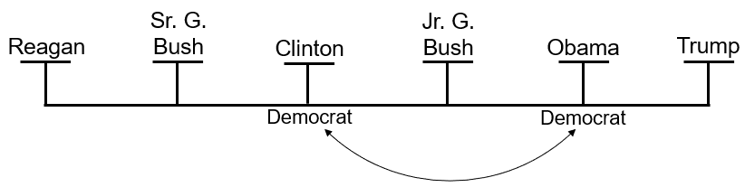
Who do we connect George Bush Senior to? Father with son.
What is this George Bush Senior known for, what war did he put America into? Desert Storm.
Desert Storm was a war with who? Iraq. There is an Iraq war known as the Gulf War or Desert Storm.
The American public did not want this war; what did he have to do to convince them that this was a justified war? Lie.
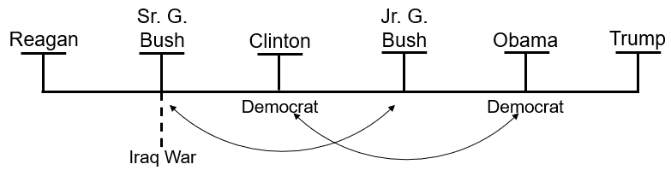
They had a young girl stand up in front of Congress and say how those Iraqi troops in Kuwait had been taking babies from incubators throwing them on the floor and leaving them to die and stealing the incubators. This was a conspiracy theory that was stirred up to cause the American people to agree with an Iraq war. It was later realized that this poor girl from Kuwait, who everyone thought was this poor girl who worked in a hospital and had cried through her testimony and saw all those awful things, was actually the daughter of the Ambassador of Kuwait to the United States. She had been put there by a firm that was paid hundreds of thousands of dollars to convince the American public for an Iraq war. She was a daughter of the Ambassador, that was trained for that role. That part is not a conspiracy theory. The US government recognized that the Ambassador from Kuwait had orchestrated this show in Congress to convince the American public.
That first Iraq war against Saddam Hussein is all based on lies. Like father like son.
Who is the son going to go to war with? There is going to be another Iraq war. In fact, they called the war George Bush Senior started the Iraq War until George Bush Junior started an Iraq war, then they had to think of another name. So, they started calling the one Bush Senior started the Gulf War or the first Iraq War.
What is the Iraq War Bush Junior started based upon? Weapons of Mass Destruction, another conspiracy theory.

Making the Connections:
Like father, like son; one Iraq war, another Iraq war. Bush Senior, father; Bush Junior, son.
Clinton, Democrat; Obama, Democrat.
We teach in this movement what principle? How do you know what the end looks like? The end is based on the beginning. We have that all through inspiration on whatever level we want to look at it.
We began on the diet of Eden; what are we going to finish on? Diet of Eden.
We began with equality; what are we going to finish on? Equality. We see that, the end from the beginning, all through inspiration and all through prophecy; God illustrates the end from the beginning.
What does the first president on our reform line look like? The last president on our reform line.
What was Reagan’s occupation before he became involved in politics? He was a celebrity, a television actor. He was best known for portraying Cowboys, but he was a celebrity and an actor. Reagan, outside the political establishment, is a celebrity in Hollywood. So, you have a celebrity.
How does Reagan get elected? Let us go back to previous studies. There is a history before Reagan this 10-year history and we tied that back to the Civil Rights Movement. You have the Civil Rights Movement in America with people like Martin Luther King Jr. fighting for the end of segregation and the introduction of equality. And within this Civil Rights Movement they start to force the Christian conservative schools in the southern States of America to desegregate; they start forcing them to do that through withholding or abolishing tax exemption for any private schools that segregate.
What did those southern evangelicals believe about segregation? They believed that it was a biblically mandated principle. So, for them to desegregate was to go against their religious convictions. So, from the very beginning, they are fighting against the Civil Rights Movement. It is that exact same mentality in the South where a hundred years before they used the Bible to justify slavery. They used the Bible to justify slavery and 100 years later they used the Bible to justify segregation. And when the state starts to prevent them from segregating their private Christian academies, they all come together. They all unite in an organization known as the “Moral Majority”. Go onto YouTube and you will find the people involved in that speaking about it openly. The leading evangelicals of the time formed the organization called the Moral Majority. Their purpose was to turn the evangelical leaders and the evangelical church from being just a religious organization to an active political organization.
With which party of the U.S. Government did they intend to unite? The Republican Party. They did not unite with both; they chose the Republican Party because it had close to the same ideals as they had regarding the Civil Rights Movement. So, they all unite. Then in 1979 they form the Moral Majority and they start turning the evangelical churches into tools of political activism. They start calling on their church members to vote.
In past presentations we read through all the quotes straight from their mouth where they speak about how they want to reshape the United States after Christian principles, and they are going to do that through the US government. Just another way of saying break down the separation of Church and State; make the Church use the State to enforce the morality of the majority where the majority is the evangelical churches in America.
What evangelical leader led the charge of the Moral Majority? Jerry Falwell. Jerry Falwell was the leading evangelical who led that charge. He was extremely conservative and deeply set into racism. Connected to this, with their issues with the Civil Rights Movement, you also have this white nationalism. We read quotes of Jerry Falwell where he spoke in anger that there were communities in the cities where his friends lived, nice white families, friends of his pastor, and a black couple moved next door. He was angry that there were black couples moving in next to white couples in these communities. There is this connection to white nationalism. And connected to this white nationalism is this evangelical charge known as the Moral Majority, plus it is the end of the Cold War.
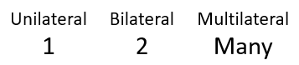
What kind of power did the United States become as the Cold War ended? We use the term unilateral. In prior presentations we have gone through the three different types of powers: unilateral, bilateral, and multilateral.
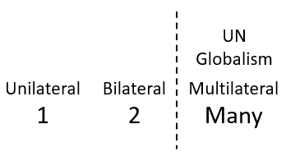
In a unilateral World Order, how many superpowers do you have? One
In a bilateral, how many? Two
In a multilateral, how many? Many.
At the beginning of our reform line the world goes from what type of order to what type of order? It goes from bilateral to unilateral. It goes from two world superpowers, the United States and the Soviet Union, to one world superpower, the United States. It becomes a unilateral system, where just the United States is the world superpower, which really became, quite quickly, a world dictatorship until they were again restrained.

History of 1989-1991 & The New World Order
We are going to discuss this history of 1989 to 1991 and what that looks like.
Who wanted a multilateral world? Mikhail Gorbachev. So, in this history when we talk about 1989 you have the world going into what you could call a new World Order. The New World Order is bilateralism changing into a different type of lateral-ism. Gorbachev called for multilateralism and the United States called for unilateralism. So, you have two world superpowers. Gorbachev says if the Soviet Union is not going to be a superpower, then we just have to have many superpowers because we cannot have the United States having that much control. So, multilateralism is Gorbachev’s type of World Order; that is what he wants.
What is another word for multilateral? Globalism. Gorbachev, at the end of the Cold War starts talking about a new World Order. And when he says a new World Order, he sees that the time in which the world is bilateral with the Soviet Union and the United States holding each other in check is coming to an end. As it is coming to an end, Gorbachev starts to speak about his desire for a new World Order; a new World Order where the UN and globalists run the world affairs.
Is this what happened? No. When Gorbachev starts talking about this new World Order, George Bush Senior steals this term of Gorbachev's. Bush Senior publicly stated later in his autobiography that he would never accept a multilateral world.
Why? Because he said there is no substitute for American leadership. He wanted a unilateral World Order. So, Gorbachev starts talking about this multilateral world run by the United Nations, what we would term globalism. This idea dies in the water because as the United States becomes the world's superpower in the 1989-1991 history, they steal that phrase from Gorbachev’s new World Order and they give it another definition. So, they suddenly twist it. On September 11, 1990 George Bush gives his speech in Congress titled ‘Towards A New World Order’ and what he does is he takes Gorbachev's definition of the new World Order and says we are not going to accept that type of World Order. He says there is no substitute for American leadership and from then on determines to have a unilateral World Order.
This is where Adventism starts to trip up, over conspiracy theories about globalism, especially as Adventism has imbibed the conspiracy theories of Walter Veith. We keep saying this is the threat, that somehow globalism and the United Nations (UN) are the threat and that that is what defines the new World Order. But the New World Order as multilateralism was Gorbachev's idea and he was just the dying King of a dying Kingdom. The United States reinvented the New World Order into unilateralism or what you would call Nationalism, a one-world superpower. So, that is a brief introduction to the history of the 1989-1991 new World Order that begins to be introduced.
As we go into our application of the two World Wars, we are going to discuss that history which is why we needed this revision/review. You see that in this history with Reagan and Bush the world is heading into this new World Order, this nationalistic World Order, that is headed or led by a largely unrestrainable United States.

Back to The U.S. Presidents on Our Reform Line
If this (here at Reagan) is how our reform line begins how is it going to end? The same.
Is Donald Trump part of the political establishment? No.
What was his job function before he became the president of the United States? We could say businessman, but he had actually stopped doing proper business deals long before. He made most of his money off television and reality shows; he was a celebrity. Reagan comes out of Hollywood; Trump comes out of Hollywood.
Because of their racism, Jerry Falwell united the religious right to elect Reagan with the majority of the white evangelical vote. Early on in 2016 not many evangelical leaders have endorsed Donald Trump, there has been a sense of fear to do that. But then one man stands up and says, I am endorsing him and you all have to endorse him too.
Who was that that endorsed Trump? Jerry Falwell Jr. His father, Jerry Falwell Sr., endorsed Reagan, and the son, Jerry Falwell Jr, endorses Donald Trump in 2016. He leads the evangelical world into unity on that subject and wins Donald Trump the presidency with 81% of the evangelical vote. Celebrity elected by this evangelical drive, driven by white nationalism.
What do we expect to see? What do we already see signs of happening? It is heading back to a nationalistic World Order and we know prophecy foretells it will be unilateral. And as we have been saying throughout the year, we need to let go of our conspiracy theories that call globalism the threat. Globalism is the restraint not the threat.
When we see our reform line and we see the structure, we know that God works by telling us the end from the beginning. You see the connection with Bush Sr. and Bush Jr. and with Clinton and Obama. But if you want to understand Trump, the first place to go back to is Ronald Reagan. See how Reagan was elected, what type of man he was, how he got elected, and what eventuated from his election, the fall of the Soviet Union, the fall of the King of the South. So at the end, we will have a fall of the King of the South, the completion of Daniel 11:40.
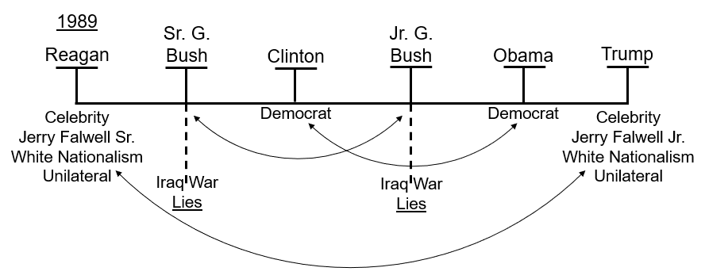
We can also see in this structure, just why it had to be Donald Trump who won the 2016 election. We were saying earlier in 2016 that we knew that whatever president won that race they would be the last President of the United States. We identified that prophetically.
Then we come to the days before the vote, the days before November 8 and 9, 2016. Who were we saying would win? Some places were bold enough to say Donald Trump.
But many areas of the movement failed, they were saying it could be either Trump or Clinton. Why? Because Clinton is a UN connected, George Soros connected, Rothschild connected, globalist. And we still had our conspiracy theories; they blinded us from being able to identify that it could not be anyone other than Donald Trump. Because we were still holding on to that baggage, we could not see clearly who had to win that election. The structure tells us it was a Republican that brought about Church and State in the history of 1989, a Republican in 2001 with 9/11 and the Patriot Act, and it was the Republican government even in the Obama years of 2014 that did that work. So, we should have known that the party that has begun to work with the Protestant churches of America is the Republican Party. The structure tells us that it had to be Donald Trump.

November 9, Impeachment, & the 1st & 2nd Angels Message
In the last few days our movement, now that we have had this shaking and those who used to be among us have left, I keep feeling like we are turning into a bit of the tabloids. I keep finding out things about myself that I did not know about. So apparently, I am autistic and all kinds of things; so daily it is quite a surprise. But one thing that they are attacking this movement with is they are saying that I predicted last year that Donald Trump would be impeached and removed from office on November 9, 2019. Elder Jeff, FFA particularly, are saying that I made this prediction that Donald Trump would be impeached and by impeach, completely remove from office, and that he would be impeached on November 9 which is today or about to be today in the United States [2019].
The problem that they are having in attacking us is, what did we say about the messages? If you reject the first can you be benefited by the second? No.
If you reject the second therefore can you be benefited by the third? No
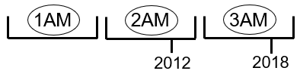
The problem they have, is they rejected the message in 2012. This shaking, this split, has been seven years in the making. It is prophetic. It is not moral. It is not a disagreement between people who do not get along. It is a prophetic issue. And because they could not be benefited by the Second Angels Message that was formalized in 2012, when we come to this history of 2018 it is not just that they cannot be benefited by it, Elder Jeff has said that from the time I started presenting last October not only did he intentionally pay no attention to what I was teaching he very quickly stopped watching me altogether. So, most of what I have taught this year he has never watched and what I taught at the very beginning, that he may have watched, he has said that he intentionally did not pay attention to those presentations.
So now he comes to a time when he wants to attack what I am saying and the problem he has is he doesn't actually know what I am saying. So, first of all they have to invent our message, so they will actually have a message they can attack. This is why we keep finding out that they are saying certain things that we have never said. They stopped listening to the message a long time ago. And the reason why they just could not even watch it, I would suggest, is because of the issue at 2012. It has been years in the development.
Most of those people who have left, they reject the message of the two streams of information presented last October and throughout the year. The issue they have with the message is that when you address the subject of two streams of information you make the subject very clear without thinking of morality, like morally good or morally bad, like Trump is bad and Clinton is good. And when you come to this 2016 election, we teach that it had to be Trump, and they reject that. They would say this could be Trump or Clinton, they are both as wicked as each other prophetically. We teach it had to be Trump; he is the only one that fits the prophetic narrative.
Based on our understanding that it had to be Trump, why would we teach that he is going to be removed from office? We are the ones saying the last president had to be Trump; it can be no other. I want us to see, even just on this simple chiasm, this simple structure of the Presidents on the line, not how we knew that Trump was the last president, we had other logic for that, but just how the structure supports that. With the end from the beginning you have the perfect picture.
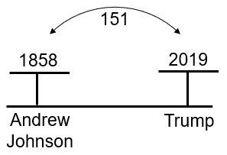
In answer to those who are perhaps hearing these things and confused, I have never taught that Donald Trump would be a peach on November 9, 2019. What I did say on tape last year since October 2018 is that based on the 151 and our understanding of time spans that this year 2019 that Donald Trump has to be impeached. Prophecy shows us Donald Trump would face an impeachment proceeding. An impeachment does not mean someone is removed from office. We used for this logic the impeachment of Andrew Johnson, who in 1858 was the first U.S. President ever impeached. It does not mean he was removed from office; all that it means is there were impeachment proceedings. We used this understanding of 1858, our understanding of the 151-year principle, 2019, and we made the claim that in this year in 2019 Donald Trump would face impeachment proceedings. One of the many things that we expected that has been and is being fulfilled. But to say that he is removed from office is a fabrication of our message. There is no prophetic license for that. This movement more than any other group recognizes exactly who Donald Trump is prophetically; we are not expecting his removal.
So, I wanted to do this for two reasons, first of all to give us this picture so we can see Donald Trump connected to Ronald Reagan, and just in this simplistic way see the connection between Reagan and Trump, how much of their history starts to line up. The second reason that I wanted to briefly mention this, was to again mention the history of the Gulf War, that first Iraq war, with Saddam Hussein, because as we go into the history of World War I we must revise/review that.

Triple Application of Prophecy
Just to remind us of a second prophetic principle that we use, the Triple Application of Prophecy.
How do we know what the Third Woe looks like, because it is not described in the Bible? Triple Application of Prophecy, the 1st Woe, plus the 2nd Woe, equals the 3rd Woe. Simple mathematics.
The first plus the second equals the third.
Can anyone think of any others? We have a few ones in history, but we use the Triple Application of Prophecy. The first Woe plus the second Woe teaches us what the third Woe looks like. So, we recognized for a long time that to understand the final war between the King of the North and the King of the South at the end of the world, a World War, there has to be World War I plus World War II equals World War III.
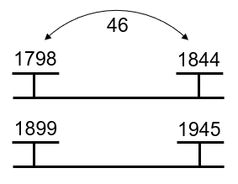
Again, what was the threat in World War I and World War II? Was it globalism? Multilateralism? No. You had a unilateral superpower that started to act like a global bully or a global policeman, Germany in both histories. We have gone into the history of Germany. We have seen the Millerite history 1798 to 1844, a 46-year history. You start to see the resurrection, the coming up of Modern Israel. We connected that to 1899 to 1945, this first attempt to resurrect Modern Babylon. First and Second Angels Message, the history of 1798 to 1844, the history of the first and second World War, 1899 to 1945. The First Angels Message is not public knowledge in 1798; William Miller is about 16 or 18 years old in 1798. It takes years for him to start studying that message.
In 1899, World War I, the groundwork was laid for that with the first hate[?] conference. It takes years before it begins, but you can trace it to these dates. There are 46 years of Modern Israel, and 46 years of Modern Babylon. There is an overthrow within the leadership of Protestantism of God's church. As you see a new leadership take up that mantle, Adventism. You see a new leadership rise up within the Catholic Church, overthrow it, and reconstruct it under Pope Pius XII. We have made all those parables between the true and the counterfeit. In this history we recognized the significance of World War I and World War II, the impact they had globally, and the impact they also had within the churches.

World War II
In our last presentations before we closed yesterday, we had a revision of the history of World War II. I just want to lay out what our conclusion was.
In the Iron Age what type of weapons did they fight with? Iron.
In the Stone Age what type of weapons? Stone.
The Bronze Age? Bronze weapons.
What age are we in now? Information Age.
What year was the information ages Big Bang? In 1989 with the invention of the World Wide Web. So, we are in the information age and it is an information war. You fought with stone weapons in the Stone Age, so in the Information Age they fight with Information weapons. That is a whole different study; I am just reminding us of the conclusion.

History of Pyrus
Then we went to the history of Pyrus. We will turn to Daniel 11:4, it is the same history as in Daniel 8:8, but we will read from Daniel 11:3, 4.
11:3 And a mighty king shall stand up, that shall rule with great dominion, and do according to his will.
11:4 And when he shall stand up, his kingdom shall be broken, and shall be divided toward the four winds of heaven; and not to his posterity, nor according to his dominion which he ruled: for his kingdom shall be plucked up, even for others beside those.
“And a mighty king shall stand up”, who is that? Who is the mighty King that stands up? Alexander the Great.
In verse three and four it gives us the history of Alexander the Great and his death. And after his death his kingdom is divided up between four generals. So, he dies in 323 BC.
How historically accurate does that account seem? I would suggest it is not that accurate.
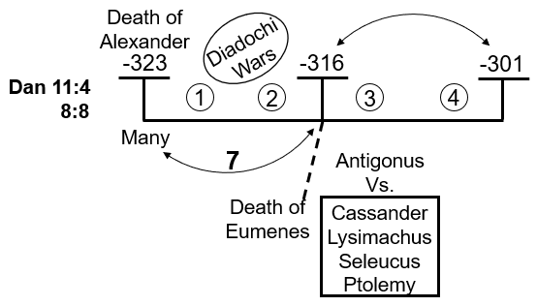
In 323 BC when Alexander dies, there are many generals. Then over four wars, known as the Wars of the Diadochi, those many generals quarrel and war against each other over that territory, splintering his kingdom, until the number goes down. Over the first two Diadochi Wars from 323 to 316 BC, about seven years, the number goes from many generals down to five key generals in 316 BC.
Prior to 316 BC they have been fighting against the general known as Eumenes. At the death of Eumenes in 316 BC one general becomes the most powerful of any after the death of Alexander that existed in that Kingdom, Antigonus. Antigonus was so powerful, the other four, remember we have five generals, the other four united to oppose him and those four were Cassander, Lysimachus, Seleucus, and Ptolemy. The four that comprised the four winds of heaven; these are our four famous generals. But in 316 BC there are not four, there are five, Antigonus being so powerful that he is equal in strength to the four of these combined. So, from 316 to 301 BC these four generals in an alliance known as the Allies fight against this most powerful general, Antigonus, in the 3rd and 4th Diadochi Wars.
How many years is that? 15 years, 301 BC being the battle of Ipsus. In the battle of Ipsus Antigonus was killed and we have the kingdom divided into the four winds of heaven.
So how many years was it divided into four? 4 years. Around 297 BC Cassander dies. So, from 301 to 297 BC there are four generals.
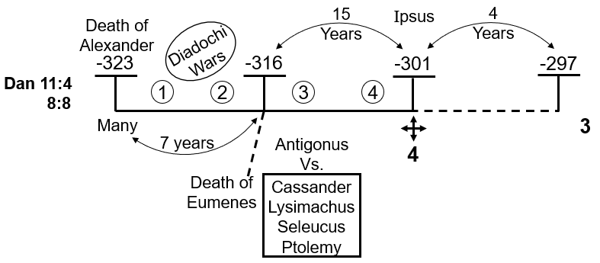
How many generals do you have after Cassander dies in 297 BC? Three. And then after that, for a long time, there are three generals.
This is what the history of Alexander’s territory or kingdom looks like after his death. You have the death of Alexander, seven years of many generals fighting over a completely splintered Empire, until 316 BC when there is five. Then you have 15 years of war between the most powerful Antigonus and these other four generals. In 301 BC at the battle of Ipsus the empire is divided into the Four Winds of Heaven as Daniel predicts. It is only divided into four for a maximum of four years. Some people place the death of Cassandra in 298 BC which means it was only divided into four for this tiny blip of time in the history of the fall of that Empire, then for many years it is just three generals.
Daniel takes this history and treats it like a parable. The only reason he could possibly have to skip the most momentous events, the most powerful general of that time, and go straight for one King, Alexander, to four generals who become Kings Cassander, Lysimachus, Seleucus, and Ptolemy, and to skip all of that other history, to skip the long period of time where there are three generals and just go straight to Seleucus and Ptolemy in the two, the only reason he can have to do that is because he is creating a parable. He wants to give us a particular prophetic framework. When he gives us that particular prophetic framework, we use it as a parable. And we understand now that we can have four winds of heaven; we get our understanding of the King of the North and the King of the South and of East and of West. It gives us all of this prophetic significance.
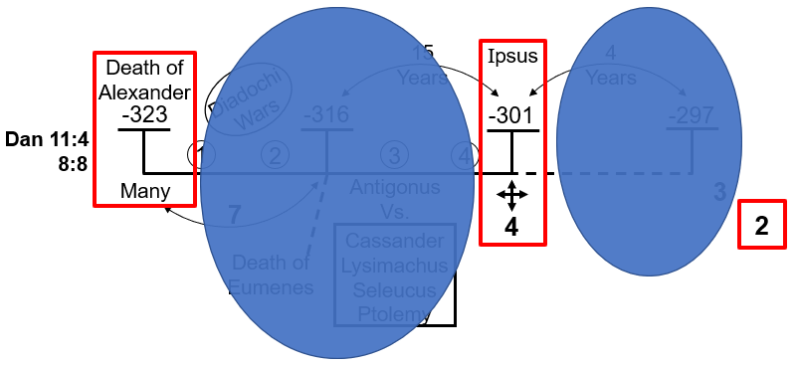
That is why Daniel would go into this history and just describe 323 BC, none of this between 323 and 301 BC exists, then go to 301 BC, none of this after 301 BC exists, and then there are the two generals left in the end, Seleucus and Ptolemy. He wants to give us a particular prophetic parable and that is just typical; it is a perfect example of how you can create a parable from a history. Daniel can look at this history through God's leading and say, I do not care about these four wars; I do not care about this incredibly powerful general; I do not care about the 15 years or the 22 years; I want to create a prophetic narrative. All of the rest becomes noise, irrelevant to his story. And he will just go from 1 to 4 to 2 generals.
Through our understanding of the World Wars, what we did is we went back into this history of the five generals and we did that through Acts 27 and an understanding of Pyrus.
We understood that this fourth Diadochi War led us into what history and application? The fourth Diadochi War took us to World War II. The fourth Diadochi War was Antigonus, the superpower, versus what were known even at that time as the Allied forces. We connected World War II and the fourth Diadochi War and made the application that you saw in the last presentations.
I also introduced us to this point, we know that the Triple Application of Prophecy dictates that the first World War, plus the second, must equal the third.
When we made that application of World War II, what dates did it take us to? We saw 1989. And in 1989 you have the fall of the King of the South.
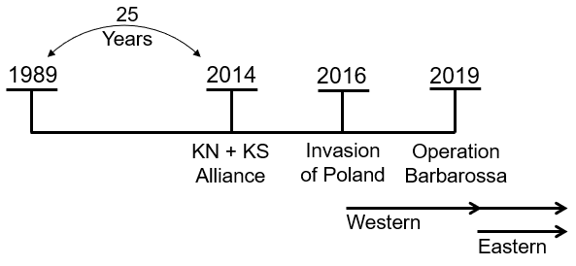
What is the next Waymark on that reform line? The application of World War II. The next Waymark on the reform line was 2014. And we placed in 2014 that the King of the North and the King of the South would work together. They would go into an alliance for the purpose of the 2016 election typified in the history of Pyrus as a war or a battle, Ipsus in 301 BC most directly connecting with 2016.
It goes from 1989 to 2014 to 2016. The year 2014 being the Molotov Ribbentrop Pact of World War II.
What happened in World War II that connects to the year 2016? The invasion of Poland.
How many fronts existed in World War II? Two fronts existed. There is a Western Front and in Eastern Front.
The invasion began World War II on which front? The Western Front. So, in 2016 began the history of the application of World War II on the Western Front.
In 2019 Operation Barbarossa, World War II, was on what front? The Eastern Front.
What type of weapons are used today? It is Information war, so Information Weapons.
If you turn on your news and since 2014 it looks like it is so much more volatile; it looks like a war zone. If you went back to Obama years, those were the years of peace compared to what you see if you turn on the news now. The reason why you turn on the news and you see, particularly the political situation in the United States but across the world, the rise of nationalistic governments. It is with Brexit, with Bolsonaro in Brazil, with Modi in India, and with all of these nationalistic governments who are in their own way uniting Church and State in their own countries.
If you start to see the chaos, the battleground, that is politics today across the world, you can know why it looks so chaotic, you are looking at the war on the Western Front. There are two fronts to this war, it is not all Russia and the United States. It is the United States against the United States, and the United States against the West and against their former allies. There is the Western Front that we have been following for a few years now and there is the Eastern Front. We know that the Eastern Front will look a lot like the Western Front. So, this was our understanding of World War II in a nutshell.
What did we say was the problem? Why was understanding World War II not enough? There are 25 years of a 30-year reform line that is missing. We came to the conclusion that for a proper Triple Application of Prophecy we not only have to understand World War II, we also have to have a prophetic understanding of what World War I has to teach us.
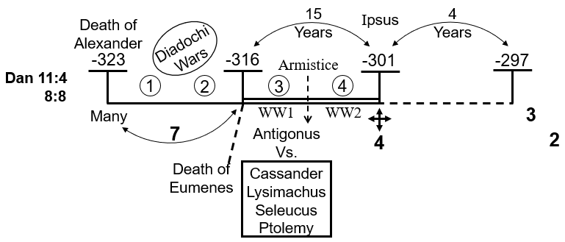
When we went back into this period of 316 BC, which is what Acts 27 and the history of Pyrrhus took us to, that led us to World War II originally. The fourth Diadochi War brought us to World War II. And the suggestion I would make, the reminder first, is that this third war as well as the fourth war was a war between Antigonus and the Allied forces. So, the third and the fourth Diadochi War had all the same players, Antigonus the superpower against the Allied forces. And all that they had was an armistice in the middle.
In the third Diadochi War Antigonus goes to war against the Allies. Then the war stops; they go into an armistice. They have a few years of peace and then the war restarts in the history of the fourth Diadochi War.
If the fourth Diadochi War is the second World War, where is the First? In World War I, you have Germany vs. an Eastern and a Western Front, and that comes to an end, then you have a period of peace before it all starts up again. World War I and World War II were one war with an armistice in the middle. And World War II was a direct result of World War I. Diadochi War three and four was one war with the same parties fighting, and World Wars I and II was one war with the same parties fighting.
Before we go into the history of World War I to apply it to our time, I want us to first look at this third Diadochi War. The fourth plus World War II taught us of our own history today. The third Diadochi War and World War I will both teach us about history today, and they will fill in the 25-year gap we have before the application of World War II.
Now I want us to look at the history of the third Diadochi War and then World War I. I have said before that in the Millerite history it is the First and the Second Angels Messages that in those 46 years prepared God's people to do a work, that they failed to accomplish. In the 46 years of the rise of Modern Babylon in that history of 1899 to 1945 you had two World Wars that resulted in 1945, a bitter disappointment. And they failed to do the work. But we understand that World War I and World War II had significance for the Papacy in that time; they essentially resurrected the papacy. Yet, like the Millerites they failed to bring that work to a completion. So, when we come to our own history we are expected to see within our own reformed line, not just World War II but also World War I that will give us more detail.
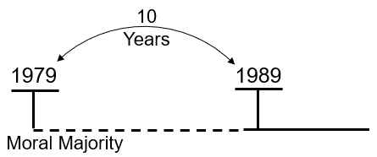
We will first go into the third Diadochi War. As an introduction to that, part of the difficulty with teaching this is trying to connect the history, because even the recent history can really cause quite a migraine. So, before going into that I am going to give some history of what led up to 1989.
This is 1989. We talk about a history prior to it that is how long? It is a 10-year history.
What do we place here for this 10-year period? The Moral Majority.
When was the Moral Majority formed? In 1979.
When did they dissolve the Moral Majority? In 1989. They said that they accomplished their purpose. They got Reagan elected; then they got George Bush elected. And then Jerry Falwell said, I accomplished what I set out to do. So, the Moral Majority was a ten-year movement from 1979 to 1989.
We talked about Daniel 11:40 and a proxy war, the Afghanistan War.
When did the Afghanistan War begin? In 1979.
When did it end? In 1989.
We do not talk a whole lot in our movement about Iran, but I can guarantee you it has a place. We have to understand Iran. If we understand Iran. It went through a revolution that turned itself around.
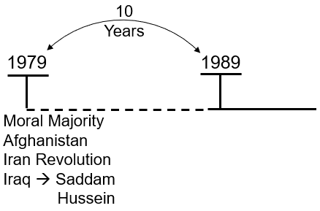
When was Iran's revolution? In 1979. But there was another revolution in the same year; it is that revolution that I want us to see.
In 1979 in what country was the other revolution? Iraq.
In 1979 there is a revolution inside Iraq that places what dictator? Saddam Hussein. He takes power in 1979. And immediately, with these two events, with this Iranian Revolution and Saddam Hussein within Iraq, the Middle East is destabilized. Two different factions within Islam begin to war against each other. Iraq goes to war with Iran from 1979 through the history of the 1980s.
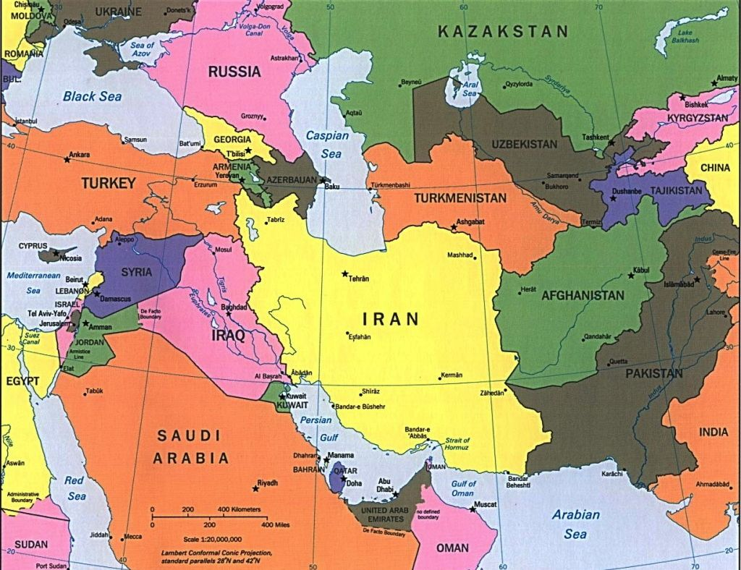
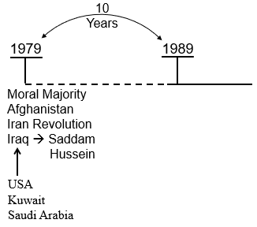
And who supported Iraq in this war? Iraq was supported by the United States; it was supported also by Kuwait and Saudi Arabia. So, Saddam Hussein for those first years was an ally of the United States, and the United States armed and assisted him in that war against Iran.
The U.S. did this partly because this is still the history of the Cold War, and Iran had sided with who? Russia, with the Soviet Union. Because Iran had sided with the Soviet Union and was an ally of theirs, the United States naturally supported Iraq and wanted to see Iran overthrown.
Throughout this war Iraq is being given bank loans, what becomes relevant, the loans are particularly from Kuwait and Saudi Arabia.

I am quoting here from an online article, Saddam Hussein's Rise to Power.
“Ronald Reagan supported Iraq during the war. He and other American leaders were worried that the religious fundamentalism of Iran's government might spread throughout the Middle East. Kuwait, Iraq’s small neighbor to the South, also sided with Iraq. Kuwait's government like Iraq's was controlled by Sunni Muslims who wanted to prevent Iran Shiites from gaining too much power in the region. The Kuwaiti government loaned billions of dollars to Iraq during the war.”
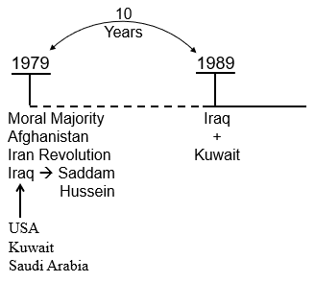
In 1988 the war ends between Iran and Iraq without victory for either side; it essentially ended in a stalemate. In 1989 tension between Iraq and the other countries begins, particularly between Iraq and Kuwait. Remember Kuwait, Saudi Arabia, and these other Middle Eastern countries, want to see Iran defeated, but they do not want to go to war themselves. So, they loan Iraq money and Iraq goes to fight Iran. In 1988 Iraq has not been able to have a solid victory against Iran; that war ends and Kuwait wants their money back. Iraq says hold on, I was not just fighting to protect myself; I was fighting against Iran to protect Kuwait, Saudi Arabia, and all of these other countries. So, why do I have to pay back the money you loaned me?! He does not feel that it is fair. So, that creates this tension that arises between Iraq and Kuwait in 1989. Iraq does not want to pay back the loans it took out from Kuwait to fund that war or from other countries as well including Saudi Arabia, but particularly Kuwait.
Iraq had another issue with Kuwait; the economies of both countries rely on their oil fields and there were OPEC agreements. They agreed that Kuwait or that any country in the Middle East would not sell above a certain quantity of barrels of oil, because if they did, they drive the price down. Through OPEC they had come to agreements about the quantity of oil they would sell. Kuwait was not keeping to those agreements; it was selling so much oil to enrich itself that it had driven the price of oil down and it was costing Iraq's economy, I think they estimated about, a billion dollars a year. So, there is also the oil issue.
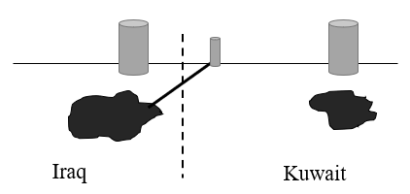
Another issue Iraq highlighted is Kuwait’s drilling. If this in the middle is the border between Iraq and Kuwait, the left is Iraq, and the right is Kuwait. Iraq accused Kuwait of something called slant drilling. So, this is an oil field in Iraq on the left and there is some oil. And here is an oil field in Kuwait on the right. They have their own oil fields. But Kuwait had learned to do something. Over here on the right, near the border, they had built a drill, and they had learned how to slant drill down below the surface under the border into Iraq. So, they were taking oil from Iraq's land by driving the pipe sideways. That was essentially stealing Iraq's oil. So, Saddam Hussein had logical reasons to get more and more frustrated with Kuwait.
“Leaders from both countries met on several occasions during 1989, but never reached an agreement. Iraq-Kuwait relations became even more strained. In the Ramallah oil fields Iraq insisted that Kuwait had developed advanced drilling techniques capable of this slant drilling. According to Iraqi officials, Kuwait's use of slanted drilling allowed the country to steal over 2.4 billion dollars in oil and in 1989 Iraq demanded repayment for the lost oil. Kuwait, Saudi Arabia, and other countries had loaned Iraq money to fund its war with Iran. Now they wanted their loans repaid. But Saddam Hussein believed his war restrained Iran and protected the rest of the Arab world from a fundamentalist Islamic state power. And Saddam Hussein wanted the loans forgiven as he had fought on behalf of all of them, but Kuwait would not forgive the loans. Then there is the OPEC agreement. The agreement that they would not release more oil to drive down the price per barrel. The oil prices had been $20 a barrel, by early 1990 they were down to just over $13 a barrel. Every dollar drop in the price per barrel cost Iraq an estimated 1 billion per year.”
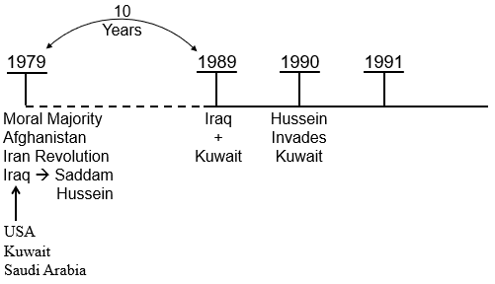
So, every $1 drop in price Iraq lost 1 billion per dollars, really seven billion dollars a year. So, Saddam Hussein is becoming more and more frustrated with Kuwait and he starts testing the waters to see whether or not he is going to be able to go to war with Kuwait, without the United States, or the west, or any other country preventing him. He comes to the conclusion that it is safe to do so. And it appears that the United States, whether they intended to or not, at least at the time gave him the impression that they would not interfere in any of the Middle Eastern politics.
So, in 1990 Saddam Hussein invades Kuwait. He quickly takes over the country. And now begins all of those politics within the U.S. Government.
How do we respond? At first many people did not want to get involved, but then they started to see the issue. By taking over Kuwait, Iraq now controlled 20% of the World's oil supply.
This is quoting President George Bush,
“Iraq's invasion of Kuwait posed a geopolitical oil crisis. Our jobs, our way of life, our own freedom, and the freedom of friendly countries around the world, would all suffer if control of the world's great oil reserves fell into the hands of Saddam Hussein.”
The United States, particularly individuals within the government and within the armed forces, start to push for a U.S. response. But the public will not buy it; the public does not want a war with Iraq, especially over something as abstract as controlling an oil supply.
They have come out of which war? The Vietnam War. They have come out of the Vietnam War feeling extremely burnt and seeing the damage and the pointlessness of war. And now when they see this conflict in the Middle East that looks like both sides may have a point, that does not directly impact the United States, the opinion of the vast majority of the population is, why would we send our sons to die on that battlefield. So, what they have to do is manipulate public opinion, and this happens in the history of 1991.
There was a 15-year-old girl from Kuwait known only by her first name at that point in time, Nayirah. In the girls testimony before a congressional caucus, it is well-documented you can go online and see the videos, she described how as a volunteer in a maternity ward in Kuwait she had seen Iraqi troops storm a hospital, steal the incubators, and leave 312 babies on the cold floor to die. Seven U.S. Senators later referred to the story during debate. The motion for war passed by just five votes. In the weeks after the girl spoke, President Bush senior invoked the incident five times saying that such ghastly atrocities were like Hitler revisited. But just weeks before the U.S. bombing campaign began in January a few press reports began to raise questions about the validity of the incubator tale. Later it was learned that Nayirah was in fact the daughter of the Kuwaiti ambassador to Washington and had no connection to any hospital in Kuwait. She had been coached along with a handful of others who would corroborate the story by senior executives of Hill and Knowlton in Washington, the biggest global Public Relations firm at the time, which had a contract worth more than ten million with the Kuwaitis to make the case for war with the U.S. Government.
This is quoting Brent Scowcroft, Bush's National Security Adviser of the time. He said, at the time we did not know that it wasn't true. He acknowledged it was useful in mobilizing public opinion. They recognized soon after, that it had been a manipulated fabrication, but it was helpful to their campaign.
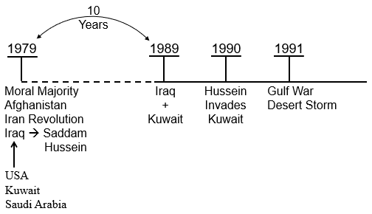
In 1991 you have what was known as the Iraq war before 2003 and you have the Gulf War, also known as Desert Storm. People within the U.S. Military made the point in 1991 that they did not want to just drive Iraq out of Kuwait, they had an agenda. They spoke of that, not just to drive Iraq out of Kuwait, they also wanted post-war leverage over Iraq. They also wanted to decimate Iraq to such an extent that after the war was over, they would be able to control Iraq's affairs.
I am quoting one Washington Post article,
“Some targets especially late in the war were bombed primarily to create post-war leverage over Iraq, not to influence the course of the conflict itself. Secretary of State James Baker had warned that Iraq was going to be bombed back to the pre-industrial age. And the economic loss of the 43-day bombing campaign undertaken by the United States was almost a quarter of a trillion dollars. They crippled Iraq's infrastructure, destroyed 134 bridges, 18 of their 20 power plants, industrial complexes, oil refineries, sewage pumping stations, telecommunication facilities, everything.”
They absolutely decimated Iraq, intentionally, separate to just freeing Kuwait. The intention being to decimate the country to such an extent that it could be easily manipulated. So, you can see why after this Gulf War / Desert Storm, Saddam Hussein did not easily forgive and he did not go away. In fact, if you were to see the mess Iraq is in now, compared to what it was back in its earlier history, they decimated the country.
This is quoting Colonel John Ward in the third Deputy Director Strategy Doctrine and Plans for the Air Force.
“He agreed that one purpose of destroying Iraq's electrical grid was that you have imposed a long-term problem for the Iraqi leadership that it has to deal with at some point. Saddam Hussein cannot restore his own electricity; he needs help. If there are political objectives that the UN has it can say Saddam when you agree to these things, we will allow people to come in and fix your electricity. It is to give us a long-term leverage.”
This is just reinforcing my previous point.
This is an article from CNN dated January 17, 2001 before 9/11. It is talking about that war. They quote James Baker, his warning that Iraq was to be bombed back to the pre-industrial age. They did almost a quarter of a trillion-dollar damage within Iraq. And they say, they are quoting an analyst from the Moscow Carnegie Center, Dmitri Trenin.
“He says a lot of people sitting in Moscow would say this was the first time that the United States started to act as a global policeman, that there was no counterweight to the great might of the United States. Since then Russia has endeavored to maintain a level of influence in the region.”
As we said before, the cold war is ending, the United States is beginning to act in an unilateral fashion. They begin to demonstrate that immediately. This was the first time the United States started to act as a global policeman. There was no counterweight to the effect of the United States, because there was no way that Iraq could go to the Soviet Union, who they had an alliance with, and ask the Soviet Union to protect them. The Soviet Union was already in the 1990-1991 history; it was already crippled and about to die. So, there was no restraint to the United States.
So, we have this early history, the beginning of our reform line. We often talk about Afghanistan and the Soviet Union. I want us to see that thread with Iran, Iraq, and Kuwait.

Line of the Third Diadochi War
For time we are going to skip through this really quickly. We talked about the third and fourth Diadochi War, one war with a break in the middle, and World War I and World War II, they are one war with a break in the middle.
This 3rd Diadochi War is the war that causes Antigonus, our superpower, to go to war against the Allies. Prior to this there had been no major conflicts between our allies and Antigonus. Antigonus as well as the allies had a common threat; they had one common enemy and that was a general known as Eumenes. There has been this ongoing war between Antigonus versus Eumenes. At this point in the breakdown of Alexander's Empire there are two superpowers, it is a bilateral World Order. Eumenes had the most specialized fighters that had fought for Alexander the Great; they were known as the Silver Shields. By the time they are fighting in Eumenes ranks they are men well into their 70s. But they were so highly trained they were still the most formidable force that was at that time. They were what you might call today like the Special Ops Team or Navy SEALs. They were Alexander's Navy SEALs. They were fighting on behalf of Eumenes; it made him extremely powerful. Antigonus was also extremely powerful. They were the two most formidable generals and they were going to head-to-head.
Eumenes was the most powerful general in the East; he controlled much of the Eastern part of Alexander's Empire. And he had united the Eastern Satrapies all against Antigonus. Plus, he controlled the Silver Shields, Alexander's elite fighting force.
Eumenes and Antigonus had been fighting in the time previously up to this point. There are a few different battles, we will not go into them. It finally comes to its completion, the final battle, it was the Battle of Gabiene. Now in this battle, and the ones prior, Eumenes was fighting against Antigonus, but Antigonus had a couple of allies. There was a couple of other generals fighting on behalf of Antigonus, supporting him in this war; I want us to consider those two generals briefly.
The first general was Seleucus. Seleucus at this stage did have Babylon, but he did not have it to such a great extent; they do not mark the beginning of the Seleucid Dynasty here. We will see it begins some years later. He did have Babylon, but he quickly loses it at this time.
The other general is Peithon. Eumenes unites the Eastern Satraps against Antigonus. Eumenes is expecting that Seleucus or Peithon might join him but they do not, they continue to support Antigonus and they make Eumenes’ life hard. At one point, Eumenes was trying to conduct a river crossing and Peithon and Seleucus catch him and they attack his forces. He just manages to get his whole train across the river.
We see in his history Antigonus being supported by these two other generals. Eumenes comes across Seleucus, and Seleucus also attacks his army. The Battle of Gabiene ends the second war of the Diadochi.
Regarding Peithon, just quoting here,
“After the second war Peithon was among the most powerful Diadochi in the eastern part of out the empire and he started to build his power again.”
Seleucus and Peithon held a fair degree of power. They are supporting Antigonus who is one of the two superpowers.
At this battle, the Battle of Gabiene, Eumenes and Antigonus go face to face.
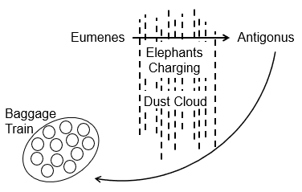
Eumenes charges Antigonus, using what mode of warfare? What did we say was a characteristic all through the battles of the 4th war and Pyrrhus? Eumenes charges Antigonus with elephants. If we went back into their history you would see the same mode of warfare that you see at this battle.
At 2016, 2018, 2019, and 2021, all of those where we see elephants as the mode of warfare, you can place at the very beginning of our reform line.
Eumenes charges Antigonus with elephants, but as the mass of elephants charge across this dusty salt plain a huge dust cloud arises that blocks the view. Then the two armies cannot see each other. Eumenes has made a very foolish mistake, he has left his baggage-train unprotected. As this dust cloud starts blocking the view of the enemies, Antigonus sends men all around the back and he takes the baggage train. This baggage train was everything that the Silver Shields had earned and accumulated over the decades of fighting for Alexander and for Eumenes. It contained all of their wealth, as well as their wives, their children, their families, everything.
Eumenes does not lose this war with Antigonus, because there is no real conclusive victor. But at the end of it, what Antigonus has is all of the belongings and families of the Silver Shields. This formidable force of Eumenes, they come to a deal; they go to Antigonus and say, we have worked all of our lives, we want it all back, what do we have to do? So, the Silver Shields surrender their general to Antigonus, who kills him, and Antigonus gives back the baggage train to the Silver Shields. He then punishes them for being traitors to their boss and they all end up being killed anyway.
How is one overthrown? You have elephants.
What do elephants represent? It is a type of warfare. We saw it through the history of Pyrrhus. It is an information type of warfare. It is the mode of warfare.
Through this information war how does Antigonus manage to overthrow his opponent? From within.
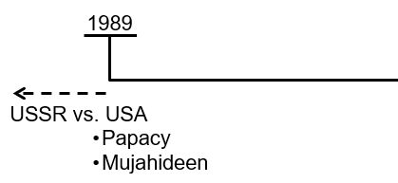
What I want us to see is this is the history, the beginning, of the fourth Diadochi War that we are going to line up with 1989. We will make some applications immediately. You have two superpowers; it is bilateral.
How is the Soviet Union overthrown? Daniel 11:40 calls it a battle, but what does a battle look like? The Soviet Union was overthrown from within; their own people gave up the government. So, we have that history.
In this history of 1989, does the United States go into it alone? What does Time magazine tell us? What ally did the United States have in 1989 that they called the Holy Alliance on the cover of Time magazine? Pope John Paul II.
In the history of 1989, you have a bilateral World Order, two superpowers. You have the Soviet Union versus the United States. You see they take the baggage train at that battle and this opposing superpower is overthrown from within. But the United States have two key allies in that history. One was the papacy, John Paul II. The second ally was the Mujahideen. We know that Time Magazine article well; the front-page cover has Reagan and John Paul II, and they called it the Holy Alliance. It is how John Paul II united with the United States to help bring about the end of the Soviet Union through the Solidarity movement or to bring about this end of the Soviet Union by overthrowing it from within. So, you have one superpower.
What territory does Seleucus become king of? He is the King of the North. The Papacy is also the King of the North.
Then you have Peithon. Now also in this history one of the ways that they weakened the Soviet Union economically to such an extent that the people were giving up on it, perhaps the main way, was through the Afghanistan War.
Who was fighting on the side of the United States in the Afghanistan War? The Mujahideen. The Mujahideen were used by the United States to prevent the Soviet Union from victory in the Afghanistan War. And they dragged it out for so long, until it decimated the economy of the Soviet Union.
But then we find Antigonus after the second war comes to an end, he has been aided by Seleucus, by Peithon, the other generals have been his allies, and all has been peaceful.
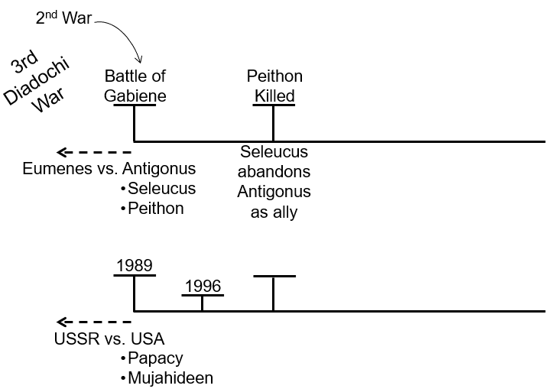
Now how does Antigonus feel? He has defeated Eumenes, he has taken over Eumenes territory, and all of a sudden, he is by far the most powerful general since Alexander the Great. He decides that he is going to unite the whole of Alexander’s splintered Empire underneath himself. So, he starts going into other generals, like the little guy’s territory, and he is either killing them, or overthrowing them, or forcing them into subjection under himself. He quickly starts to feel unhappy with Peithon, so he has Peithon killed. We read before that Peithon, after the Battle of Gabiene, started to expand his power base and he started to become actually really powerful.
What did the Mujahideen do after 1989, what organization did they form into? Al-Qaeda. The Mujahideen formed directly into Al-Qaeda.
They took over the government of Afghanistan in what year? In 1996. Antigonus has become dictatorial, he attacks Peithon, and has him killed. I am quoting here from A.T. Jones, Great Empires of Bible Prophecy,
“After the death of Eumenes, Antigonus considered himself master of all Asia and began to destroy all governors who possessed any considerable ability, of whom Peithon was one. He attempted to destroy Seleucus with the others but, Seleucus escaped and fled to Ptolemy.”
Antigonus kills Peithon, and he is lording other generals. So, Seleucus abandons Antigonus as an ally.

What was the relationship between John Paul II and the United States after the fall of the Soviet Union? Quoting from Livius,
“Antigonus Monophthalmus was the sole ruler in the east and the strongest of the Diadochi. Ptolemy was alarmed by the growth of his power knowing that he would be unable to retain the independence of Egypt against the United forces of Asia or of Antigonus.”
The conflict between Antigonus and Ptolemy was not new. For a long time, they had this tension between them; they have hated each other. But now Ptolemy recognizes Antigonus as being this great threat. Ptolemy writes to Cassander and Lysimachus and the three men, Ptolemy, Cassander, and Lysimachus, all come into an alliance against Antigonus. They send Antigonus an ultimatum which reached him in the winter of 316 BC. The ultimatum said that all the money that Antigonus had earned through his campaign against Eumenes was to be redistributed among them, and he also had to redistribute the land that he had conquered. Antigonus refuses to accept the terms of this ultimatum and the third Diadochi War breaks out. This being a war between Antigonus and the united three Allied forces.
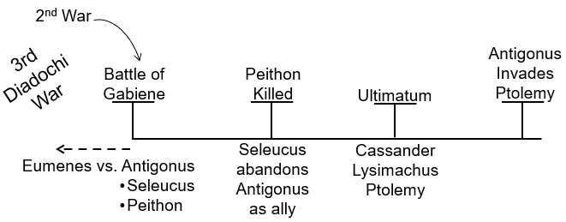
Peithon is killed. Seleucus abandons Antigonus and then we have those other three generals send an ultimatum to Antigonus saying redistribute that power.
What are they asking for? Stop acting unilaterally. We want a multilateral World Order with all the generals sharing the spoil. Antigonus will not accept that type of World Order.
“The three unit against Antigonus and Antigonus immediately seizes the initiative. He invades Syria to secure Phoenicia with its naval resources which were needed for anyone who had to invade the Aegean world. And in the summer Antigonus lay siege to Tyre, which had become independent, but was supported by Ptolemy.”
Antigonus is making a direct attack on the sphere of influence of Ptolemy. So, you have an ultimatum and then war. You have an ultimatum and then Antigonus invades the sphere of influence of Ptolemy.
And now as we enter the third Diadochi War, who is Ptolemy? The King of the South.

Application
We have to close now so I am just going to make a quick application. We lined the Battle of Gabiene up with 1989. The world at that time goes from bilateral to unilateral. Antigonus has two allies, Seleucus and Peithon. We see the Papacy and the Mujahideen in 1989. Peithon starts to become powerful. The Mujahideen formed Al-Qaeda, took over the government of Afghanistan, and become powerful. In 2001, we see the United States blamed Al-Qaeda, the government of Afghanistan, for 9/11 and they invaded them, even though they were previously their allies. They overthrew the Al-Qaeda government of Afghanistan. In this history the alliance between John Paul II and the United States is completely destroyed. We do not have time to go into that now, but it is interesting how it so quickly crumbled.
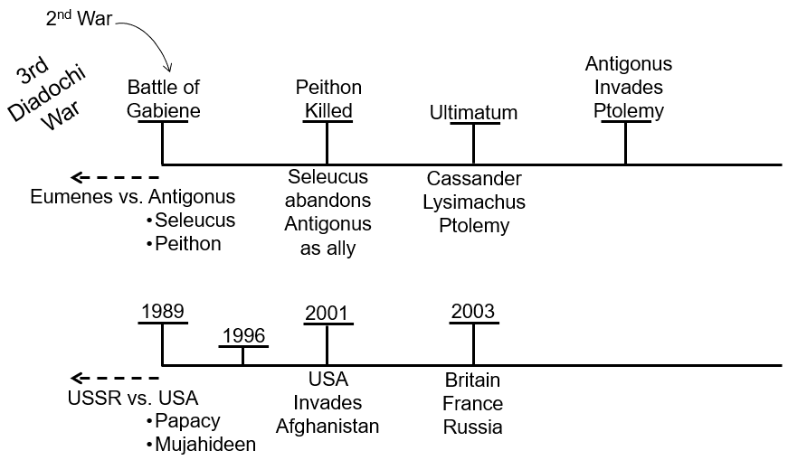
With this history you see an ultimatum between three allied forces saying to Antigonus, stop behaving in this dictatorial fashion, and redistribute the power you have gained. In 2003, as this war intensifies you have three powers, Britain, France, and Russia. We already said this ultimatum, you had Cassander, Lysimachus, and Ptolemy. King of the South, Ptolemy, King of the South, Russia. And they go and send an ultimatum to the United States and they say you are not allowed to invade Iraq; the UN will not let you. If you attempt to do it, through the power of the UN, we are going to block you. And we see that Iraq, is a Sphere of Influence at that time in Russia, the United States invades anyway against international law. Beginning this conflict between Russia and the United States, between other countries and the United States, but particularly between Russia and United States, that was sparked as a result of the Iraq War.
This is where becoming more familiar with our history can be quite helpful. There are good documentaries that we should all be familiar with; it was the Iraq war that turned Vladimir Putin against the west. And everything he has done since stems back to that Iraq War. He never forgave America for breaking international law in that fashion. And now when they say Vladimir Putin, you invaded Ukraine, how dare you. He says, you invaded Iraq, I am not breaking any laws you have not already broken. So, his sticking point, what he holds against the United States, all stems from the Iraq war. This is the beginning of the explanation of the third Diadochi War.

Written transcript of George Bush’s September 11, 1990 speech to Congress: https://www.presidency.ucsb.edu/documents/address-before-joint-session-the-congress-the-persian-gulf-crisis-and-the-federal-budget Speech on YouTube: https://youtu.be/2wOfECOvYEs?t=760
Armistice = an agreement made by opposing sides in a war to stop fighting for a certain time; a truce.
Formidable = inspiring fear or respect through being impressively large, powerful, intense, or capable.
Satrapies = plural for satrap. Satrap = (noun) A governor of a province in the Hellenistic empire. The word is also used metaphorically to refer to leaders who are heavily influenced by larger superpowers or hegemonies, and regionally act as a surrogate for those larger players.

