TWO CALLS TO THE CHURCH PART 2
Parminder Biant September 26, 2020

https://www.youtube.com/watch?v=vv00mhVLnhU

This is the last presentation for this camp meeting but it's just a continuation of a series of studies that I’ve been doing in the two preceding camp meetings and whatever we don't finish today I hope to continue at the next camp meeting which will be in one month's time and it's a camp meeting that's going to be hosted by the French ministry. I believe its October the 25th. I think its October the 24th but details will come out before that.

So in our last presentation we spoke of the information from Uriah Smith. We saw how he had exactly the same model as Andrews 42 years before that. Babylon was composed of three parts, three religious elements, paganism, Papalism and Protestantism. The closing point that we discussed was that one of the characteristics of Babylon is that it traffics people. We didn't read everything that Uriah Smith said on the subject and the point or the example that he gave is different from the one that we are dealing with in our movement, but the principle is the same. Babylon believes that human beings are up for sale and that is the very definition of dowry. It’s the same issue and it’s one that is alive and well in our movement. In some languages it's called Lobola. My pronunciation may not be correct but it's the same issue and it's one that is alive and well today in our movement. While we have tried to be sympathetic and I think generous to the real needs of our members, if you see it the way that we see it, that this is part of the wine of Babylon, you would begin to see how serious this is. The more you think about it the more you see how sick God’s people are. The bible calls it drunk and what I want to encourage every single one of us to understand is that this should not be something that we tolerate. From the lowest member to the head of the movement we should be seeing this the same way. The problem is we don’t. Why is that?

Andrews seems to see it really clearly. He said in TAR 57.2, I’m just going to read one sentence. You don’t have to look it up, the test of the church was the following, your test, the test that you’re confronted with is to show what is in your heart, or to show if your heart is with the world or with God, and I want to argue this. There are people in our movement who have challenged the authority and ministry of Elder Tess and if you needed clear evidence of her role in prophetic history you couldn’t have clearer evidence than on this issue, because this has been a sustained battle. The two sides have consistently defended their positions. If you are clear that the dowry system is part of the Babylonian ideology, the trafficking of human beings, and if you know someone fights against that, they are testing where your heart is, and we know that is the work of the angel of Revelation 14. It should be abundantly clear that if you want to see where the truth is, where it resides in this movement, just ask yourself who has been resisting and who has been at the forefront of resisting the dowry system. We all know the answer to that question. Therefore, the bible says by their fruits you shall know them.

I want to move on now. I want to make a small comment about this wine of Babylon. It's first brought up in Revelation 14:8, and what we want to do is trace a word and the word that we're tracing is not wine. It's the word wrath. I took you to Revelation 14 but I want us to first read Revelation 16. So if you will turn to Revelation 16:19, it's on the board. Revelation 16:19, “The great city was divided into three parts and the cities of the nation’s fell and Great Babylon came in remembrance before God to give unto her the cup of the wine of the fierceness of his wrath.” This wrath that we see here, if you go and check its meaning, it means “anger, violence or punishment.” We might call it ‘Executive Judgment’ because it's a punishment that's given by a judge. So that's what this word wrath means, “the wine of the fierceness of God's wrath.”

Now I wanted us to go back to Revelation 14. So in Revelation 14:8 we read, “And there followed another angel saying Babylon is fallen is fallen that great city because she made all nations drink of the wine of the wrath of her fornication.” I want to read Revelation 14:10, “The same shall drink of the wine of the wrath of God which is poured out without mixture into the cup of his indignation and he shall be tormented with fire and brimstone in the presence of the holy angels and in the presence of the lamb.” I want to read Revelation 18:3, “For all nations have drunk of the wine of the wrath of her fornication. The kings of the earth have committed fornication with her and the merchants of the earth are waxed rich through the abundance of her delicacies.” Now this wrath in Revelation 14:8 is different from the wrath of Revelation 16:19. The wrath of Revelation 14:8, “the wine of the wrath of her fornication” means “passion,” or “something that boils over.” So this wine is something that is extremely passionate and is uncontrollable.

So we've spoken often about this wine of Babylon and its wrath and I wanted to explain what it really was referring to. I want us to read another quote from the spirit of prophecy. This too is taken from 1888 materials. I'm going to put it onto the zoom chat. It's 1888 Messages page 725.2. As usual this is not that straightforward because I also want us to read page 720.1. So 720 is the introductory paragraph to this section chapter 93. The title of this is “The Brethren in Responsible Positions.” It's a letter that was written in 1890. This is the passage that all of us are familiar with.

We’ll read page 725. Hopefully you've had enough time to translate it. “When Jesus began his public ministry he cleansed the temple from its sacrilegious profanation. Almost the last act of his ministry was to cleanse the temple again. So in the last work for the warning of the world two distinct calls are made to the churches.” This passage comes up in a number of different passages from inspiration and I’ve chosen two of them. This is the first one.

So she's (EGW) going to compare the cleansing of the temple that happened twice in the ‘Reform line’ of Christ in Christ’s Ministry. She then says in the last work for the warning of the world two distinct calls are made to the Churches and then she's going to tell us what those two calls are and when they are made. She's made her statement and then puts a semicolon which is the break. She then says the following: The second angel's message and the voice heard in heaven; Come out of her my people for her sins have reached unto heaven and God has remembered her iniquities. So I'm going to stop there. Don't quote that. After telling about two distinct calls made to the churches, she tells you what the two calls are. The second angel's message and the voice from heaven. These are the two calls to the churches.

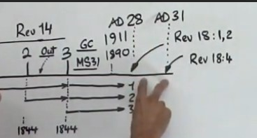
She (EGW) doesn't quote the first call but she quotes the second one. The second call is Revelation 18:4-5 and she says it here, “Come out of her my people.” Now remember this is an application that Ellen White wants to make, and therefore it's one that we would want to understand. So she's going to compare in Christ’s ministry that spans 3 years, AD 28 and AD 31, two Passovers AD 28 and AD 31 and she compares these two cleansings of the sanctuary with these two calls to the churches and therefore the churches she's referring to are what we all know as the churches of Babylon not Adventism. I want to go back to page 720 which is the opening paragraph of this letter. I’m not going to read from the whole of the paragraph, only certain portions. This is written in 1890. This is not manuscript 31. This is a letter that's written. This is two years after the Minneapolis general conference. It's in the same year that this manuscript was written and she says that these two events are imminent in the near future.

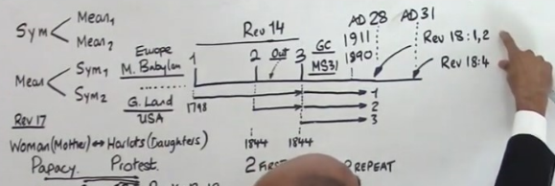
Now she’s going to write to the leaders of the church, the brethren in responsible positions. So let's be honest and frank. Who is the leader of the church in this history? Who’s at the top? I’ll wait for the first answer. Good. The first answer I like that one, Ellen White. Have we lost our translators? Two videos are down. German we're back. So Ellen White is at the top and who is she writing to? What would we call them? No not the pioneers. Middle management good. Just to quickly recap, we’re looking at a document that's the book 1888 Materials page 725 and 720. We read 725 and what it compares is the two temple cleansings from the ministry or the reform line of Jesus with these two calls to the churches of Babylon. I’m not sure if people have seen that comparison before. She's writing to the brethren in responsible positions. This is Ellen White writing to them.

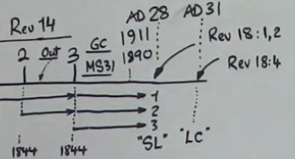
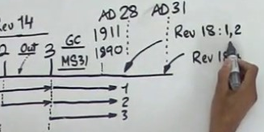
Now I know there is a General Conference President etc., but in the context of our study this week, I'm saying she's writing to middle management. So that we're all clear this way mark here Revelation 18:1 is the Sunday Law, and Revelation 18:4 is the Loud Cry. So she's writing to brethren in responsible positions in the history just before the Sunday Law and I’m saying this is the history in which we are either in or about to enter into. People have asked what about everyone else? The focus of this camp meeting has been upon these people not the others. It's not the sheep it's the under shepherds. They are and always have been the problem as well as the solution. “Brethren in responsible positions you are in danger.” I want to drop down a couple of sentences. “It is now no time to hide your colors. No time to turn traitor when the battle presses sore.” So we've come to a time period when middle management either want to hide or become traitors, and this is at the time when the battle is already raging. It’s already starting to press upon us and we haven’t even gotten to the Sunday Law yet.

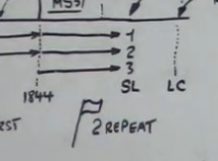
So we're not going to do a study on what it means to hide your color or to turn traitor except to say the following. What do people think, we can do it quickly, your colors are? Not character. It's of course not your country’s flag but the flag of the army. So it's the flag that represents what your army or military unit is. We would call it the Lord's army. So someone has called it a banner and that's a good description. So when it says to hide your banner this is your war flag. Hide your war flag. So now we know what it’s like to hide your color. This is a bipolar issue. It's either. There are two armies who are in battle. You are supposed to be carrying a banner. If you hide your banner what are you saying? You're saying I’m no longer on this side of the issue and therefore I like that someone said that you're a spy, and therefore if you hide your war banner you become a traitor and this idea of being a spy I think is a good way of describing it. Someone else said it’s compromising. So I agree if you hide your color it's like compromising, being a spy or being a traitor. In the language of war it's called being the fifth columnist. You can check it up on the internet and it will tell you what it means. It’s a synonym of spy basically.

All good? Okay. So, we're just coming to the Sunday law period and we are not supposed to hide who we are. By hiding your war banner you automatically become a traitor. Okay? There is no neutrality in the time of crisis. So maybe someone could post that Spirit of Prophecy quote.

“Brethren in responsible positions, you are in danger. I lift my voice in warning. Beware. Unless you watch, and keep your garments unspotted from the world, Satan will stand as your captain. It is now no time to hide your colors, no time to turn traitor, when the battle presses sore. It is no time to lay down or hide our weapons, and give Satan the advantage in the warfare. Watchmen on the walls of Zion must be wide awake. Call to your fellow-watchmen in no sleepy terms, “The morning cometh, and also the night.” Isaiah 21:12. If no response is made, then know that the watchman is unfaithful. It is now no time to relax our efforts, to become tame and spiritless; no time to hide our light under a bushel, to speak smooth things, to prophesy deceit. No, no; there is no place for sleepy watchmen on the walls of Zion. Every power is to be employed wholly and entirely for God. Maintain your allegiance, bearing testimony for God and for truth. Be not turned aside by any suggestion that the world may make. We can make no compromise. There is a living issue before us, which will be of vital importance to the remnant people of God, to the very close of this earth’s history; for eternal interests are here involved. We are to look constantly to the Lord Jesus Christ, the Captain of our salvation. All that Jesus did on the earth was done with an eye single to the glory of His Father. He says, “As the Father gave me commandment, even so I do.” (John 14:31.) “This commandment have I received of my Father.” (John 10:18.) In all He did, He was working out the will of His Father, so that His life on earth was a manifestation of the divine perfection. The union of divinity with humanity in Christ, was to reveal to us God’s purpose to bring man into the closest connection with Himself. We cannot possibly be happy without Him.” {1888 720.1}

I'm going to drop down to, near the end now about the middle of this paragraph. There's a living issue before us that is the Sunday Law, which will be of vital importance to the remnant people of God to the close of this earth’s history because eternal interests are involved. She uses military language now. We are to look constantly to the Lord Jesus Christ the captain of our salvation. Okay so the introductory thought is to middle management that they are in danger and the reason they're in danger is because they are not wanting to stand on the side of right. They're hiding their colors. Their garments are spotted with worldliness. Tell me what worldliness is.

Worldliness is nationalism, sexism and homophobia. She (EGW) says don't let your garments, your character be spotted with these elements. So if in any way you sanction such behavior or you turn a blind eye to it, it means you take down your banner and you become a traitor to the cause, and she's speaking to middle management because the responsibility is upon your shoulders for good or for bad. So, someone's giving us the Wikipedia definition of what a fifth columnist is.

Wikipedia definition: A fifth column is any group of people who undermine a larger group from within, usually in favor of an enemy group or nation. The activities of a fifth column can be overt or clandestine. Forces gathered in secret can mobilize openly to assist an external attack. This term is also extended to organized actions by military personnel. Clandestine fifth column activities can involve acts of sabotage, disinformation, or espionage executed within defense lines by secret sympathizers with an external force. Synonyms for fifth column. Trojan horse. collaborators. collaborators of enemy. infiltrators. saboteurs. subversives. underground. The term “fifth column” originated in the Spanish Civil War in 1936 and means a group of people that seek to undermine a larger group, such as a nation.

So it's as I said. It's a spy but it's not espionage. It's very, it's a very specific form of this. She goes through her letter about five pages down. She speaks about Christ’s ministry as he cleanses the sanctuary twice and he cleanses it from its sacrilegious profanity or profanation. He has to do this twice and she compares that to the two calls to the world. Two calls to the churches; Babylon is fallen, second angel's message and come out of her. So I’m hoping that we understand some of the implications of this issue. She isn’t done with us yet. Two years later she's going to write another statement. So this is taken from the same document. This is now chapter 132 pages 1077-1078. So, someone gave the reference for this earlier on from the Review and Herald article but I want to read it from the book 1888 Materials.

So this one is called “Let the Trumpet Give a Certain Sound.” We’ll read page 1078.7. “When Jesus began his public ministry he cleansed the temple from its sacrilegious profanations. Among the last acts of his ministry was the second cleansing of the temple so in the last work for the warning of the world two distinct calls are made to the churches.” She goes on to say, she's going to tell you what the two calls are. The second angel's message is “Babylon is fallen is fallen that great city because she made all nations drink of the wine of the wrath of their fornication and in the loud cry of the third angels message a voice is heard from heaven saying come out of her my people that ye may be not partakers of her sins, that you receive not of the plagues for her sins have reached unto heaven and God has remembered her iniquities.”

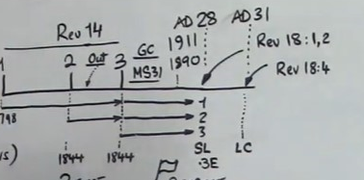
So instead of quoting all of that I just want us to say the following. It’s the second angel’s message. That’s the first call. The second call is the loud cry of the third angel's message. If you noticed I didn't quote it correctly. It's not the loud cry of the third angel. It says and in the loud cry of the third angel's message a voice is heard from heaven. We'd have to go to another portion of inspiration to prove this, but this is the loud cry of the third angel. We’ll call it 3E or the third angel with increasing power. The loud cry of the third angel and in that loud cry history a voice is heard from heaven saying “Come out of her my people.” So this statement that we're reading is virtually identical to the previous one two years before but here she actually quotes the passages and tells you what the second call is.

Let's go to the top of this chapter. This is page 1077.1. In 1892 Ellen White has changed the focus of her attention. This is no longer to middle management. Now it's to rank and file members. It's sad to say that she has bypassed them and she is now forced to deal directly with the membership having bypassed the structure. She says this in 1077.1, “We are pressing on to the final conflict and this is no time to compromise. It is no time to hide your colors.” What you're going to see is that she's going to have virtually identical language to the passage that she said two years prior. I want us to carefully consider the implications of what is being said here. At first the message goes to the leadership and then it goes directly to the members. I will leave you to work out why that happens. Next sentence. “When the battle wages sore let no one turn traitor. It is no time now to lay down and conceal your weapons.” She then goes on to speak about keeping your garments unspotted from the world. I want to drop down to near the end of the paragraph. “There is a living issue before us of vital importance to the remnant people of God to the very close of this earth history for eternal interests are involved on the very…. We'll stop there. This is almost word for word what she wrote to the leaders two years before. On the very eve of the crisis it is no time to be found with an evil heart of unbelief departing from the living God. Then she speaks to the people all the way through these next pages. In fact it's the next page. I don't know how they publish this but this is, these pages are long. This section is only two pages long. I think it's around 14 paragraphs because it's taken from like a newspaper article and then it's that last paragraph that we've already read, the conclusion of this section.

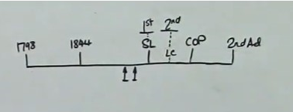
So I’m hoping that we understand the context of this passage. There are these two calls to the church. She calls them the churches of course. So, if we were to draw a line, 1798, 1844, Sunday law, close of probation, second advent. So we are here, in these two passages. One is in 1890 and the other is in 1892. This is the first call. This is the loud cry. This is the second call. The two calls to the churches. So they're going to be cleansed twice with two separate messages. So the first one says what is the first call? The first call says that because Babylon is fallen you need to come out of it, or it just says Babylon is fallen. Then the second call is because it's fallen you need to come out. So the first message is a statement of how bad Babylon has become and then the second call tells you what you are supposed to do. Now because we all understand line upon line and we understand about fractals, we can take this model and fractalize it. Already you saw how we can do that to the Millerite history.

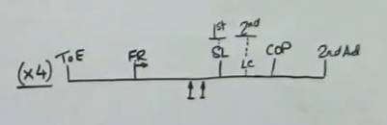
What we didn't do is take it down to the true Millerite line which would be 1798 to 1863, and we didn't do that because Ellen White never wrote about that history in that framework. The reason she didn't do it is because the church had gone into a Laodicean condition and now in the 1888 history there's an opportunity, I'll call it for redemption, but we know all too well that it becomes a history of failure. So all I’ve done is generalize the story that we read here in this line. I’m not giving it any dates. So, I’ve just stripped away all the dates and just taken the principle which remains intact, and if you then take that model and fractalize it into the line of the Priests, Levites, Nethinims and 144,000 you get this repeating pattern that happens four times. So I’m going to take these two dates out and I’ll mark it this way. We’ll call this one the Time of the End (‘ToE’) and we’ll call this one the Former Rain (‘FR’) and therefore this generic line can be used at four different levels. Priests, Levites, Nethinims and 144000 and there are two calls made in what we read is 1890 and 1892.

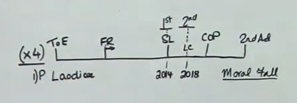
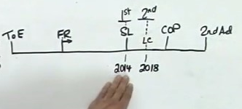
So she has a message to the leaders and then a message to the rank and file members and she says that as Jesus cleanses the temple twice we will receive two messages. Now if we take the line of the priests, we know the dates of this well. This will be 2014 and 2018. So we know that for the priests we had two calls. We had a call in 2014 that Babylon had fallen and four years later we needed to come out. Now when you fractalize something you have to be careful how you handle the data, the information. When you fractalize things not everything remains the same. The language doesn't translate from one fractal to another. So we can't say that Babylon is fallen and to come out of Babylon. The principle remains intact but the wording has to change. So, we're going to say what it is which is Laodicea. So there's a call that Laodicea has fallen. It completely fell in 2014 and having completely fallen four years later, there was a call to come out of that system and I want us to remember what we read from Andrews and Smith. What did they both argue? What is the fall? They both agreed with each other and said it was a moral fall. So to come out of Laodicea because Laodicea has fallen is not about geography. Remember they said two things that it's not the city and it's not the Roman Church. They said it is a worldwide religious ideology, a way of thinking. Now someone has to give this call, the two calls. In Christ’s history it was Christ and he speaks to the Jewish church. When Ellen White speaks about this subject, she says two messages to the world. So those two messages to the world we need to understand in the context that she gives it.

So we can understand it in the context of the priests. So we've got a number of points that we need to hold on to, that Laodicea is a moral issue, and Laodicea in its morality has completely fallen by 2014. Therefore the church or the priests need to completely come out of that system by 2018. Now when you view it in that context you can begin to see what Elder Tess has been teaching for some time now, especially when she comments on the mindset and the response of not only Elder Jeff Pippenger but Future for America and its adherence to the people who followed it.

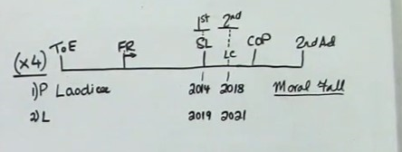
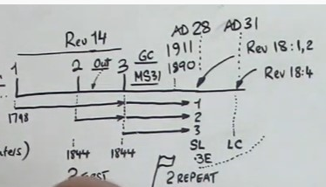
When she (Elder Tess) speaks about a change of leadership in 2014 you can understand it in a different way by realizing that Laodicea had completely fallen that year. That was a message that came to the priests in 2014 that this way of thinking was completely derelict. I want us to remember in our model here in 1890 and 1892 that the leadership was warned and the members were warned that this was about to happen. So the Sunday law does not come without a warning. We read in GC 605 that there's an agitation on the subject before the event. So this movement had already been warned before that in 2014 it was about to come. So having pronounced that the Laodicean mindset was completely derelict in 2014, by the time you get to 2018 you only have one choice, to leave or stay. That's what happened in the history of what we call the “Midnight Cry.” The reason the movement split is because there was a call to come out of the Laodicean mindset. That's why on September 7, 2019 Elder Jeff was forced to say he will not come out of that mindset. He will remain in it. He testified publicly to the fact of what he was going to do. In fact what he was not going to do. He'd already begun to fail the test in 2018 where he began to resist the call to come out, and the reason for that is because the people rejected the first calling in 2014. Once you get to the line of the Levites things become complicated. They become complicated because now you're dealing with multiple groups.

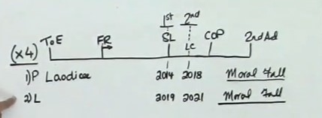
The priests are required to give a message to the Levites. Two calls. The problem is we don't have ready access to the Levites so not only are the priests doing this job the world is also participating in this. The world is instructing the Levites of the fall of their ideology and then to come out. The priests are also doing this job but the complexity of what's confronting the priests is not only that we’re giving a message but just as we were in the previous dispensation we’re also the recipients of this message. If you like, history is repeating and this Laodicean mindset or the moral fall, are not only confronting the Levites, the priests are still having to confront this as well. This is why on August 19, 2020 Elder Tess did a presentation where she compared and contrasted this history or this dispensation with our dispensation, and she showed that the issues that confronted this movement in the previous dispensation are the same ones that are confronting this movement in our present dispensation.

So not only is there a recognition that Laodicea has fallen for the Levites and they need to come out of it, this issue still confronts the Priests and I gave one example of this in the last presentation. Dowry or Lobola. That this mindset is completely derelict and worthless. I'm not sure why, having gone through this experience now for the second time that we are still resistant. You’d think having gone through this once, none of us would want to fail the test this time, but far too many of us are still struggling. I don’t want to focus on the issue of dowry because that’s just an example of a principle. The principle that this movement hasn't recognized, that the Laodicean mindset has completely fallen, is derelict and offers nothing, and if you're not prepared to come out of that soon, we all know what the result will be. You will drink of the wine of the wrath of God. If you still have not come to terms with the issues of nationalism, sexism and homophobia, and I know we haven't dealt with homophobia and the reason is because this movement is on a low gradient dragging its feet. Unless you're willing to give up these ideas that have been proven to be derelict way back in 2019, and I want us to remember that this call to come out, even though it's marked as a point in history, is a progressive call. The problem that's confronting this movement today is that we in too many ways are still in our Laodicean condition.

Whatever continent you live on it's the same history, the same pattern. Sorry not history, issue, it's the same issue, the same pattern. Nationalism and sexism is still something that priests are holding on to, and until we're ready to let go of these things and come out of that mindset, I can't say until that happens, we won't move on because we will move on. The issue is how many people we will take with us and how ugly this movement will look. So, if you want to understand what's going on in the movement today, why things don't seem to be going well it is because the message to Laodicea that's given to the Levites in their Sunday law history is not something that's just confined to the Levites. The priests are experiencing it a second time.

I want to encourage every single one of us to examine themselves, whether you're a man or a woman. If you're holding on to nationalistic or sexist ideas, realize the danger you are in. Look at the results of FFA, and how they got swept away. The same is going to happen to this movement. You will be swept away unless you take heed to these warnings. In my closing thoughts I wanted to say the following. The greatest responsibility lies upon those leaders in middle management. As it was in Ellen White’s day so is it today.

Let's pray. Our heavenly father we thank you and want to ask and pray that you would guide and direct us as the test comes closer. Help each of us to realize where we are failing. Help us to understand about the work of organization. The role of those leaders that you have put into positions of responsibility. You have already told us a second time that this whole system of thinking is completely desolate. So few of us are listening. On every continent of this planet this movement is struggling. It's my hope and my prayer that each of us bow before you and examine our own hearts and don't become a traitor. We ask for your help and assistance not only to help us see who and what we are but to give us the strength and the power to overcome. In Jesus name we pray amen.

